Influence of fertilization, season, and forage species in presence of
arbuscular mycorrhizae in a degraded Andisoil of Colombia

Influencia de la fertilización, la época y la especie forrajera en la presencia
de micorriza arbuscular en un Andisol degradado de Colombia

Arnulfo Gómez-Carabalí1, Idupulapati M. Rao2, and J. Tupac Otero 3, 4

1Departamento de Ciencia Animal, Facultad de Ciencias Agropecuarias, Universidad Nacional de Colombia, Apartado Aéreo 237, Palmira, Valle del Cauca, Colombia.
2Centro Internacional de Agricultura Tropical (CIAT), Apartado Aéreo 6713, Cali, Colombia.
3Departamento de Ciencias Biológicas, Universidad Nacional de Colombia, Apartado Aéreo 237, Palmira, Valle del Cauca, Colombia.
4Instituto de Estudios Ambientales, Universidad Nacional de Colombia, Apartado Aéreo 237, Palmira, Valle del Cauca, Colombia.

Corresponding author: Arnulfo Gómez-Carabalí, Full telephone +1 57-2-2717000 ext 35748, Fax. No. +1 57-2-
2717077 and E-mail agomezc@palmira.unal.edu.co

Recibido: 11-02-2009 Aceptado: 18-03-2011

Resumen

Para determinar la influencia de la fertilización, época, y especies forrajeras en la producción de micorrizas arbusculares se realizó un experimento con una graminea C4, (Brachiaria dictyoneura), dos leguminosas forrajeras C3 (Arachis pintoi y Centrosema macrocarpum) y la vegetación nativa; cultivadas en dos sistemas de siembra (monocultivo y asociación), dos niveles de fertilización (alto y bajo) y cuatro edades de cosecha. Se uso un diseño de parcelas sub-sub divididas, en el cual la parcela principal fue la especie, los niveles de fertilización como subparcelas y la edad de rebrote como la sub-sub parcela. El número de esporas de hongos micorrizicos en el suelo y el porcentaje de infección en las raices se incrementó con la edad y varió con la especie y la época del muestreo (seca o húmeda). Se encontraron diferencias en la capacidad para formar simbiosis micorrízica entre las especies de gramíneas y leguminosas bajo condiciones de campo.

Palabras clave: Arachis pintoi, Brachiaria dictyoneura, Centrosema macrocarpum, conservación de suelos, Glomus ocultum, vegetación nativa.

Abstract

In the Colombian coffee zone much of the land has infertile soils with an ongoing accelerated degradation. As vegetation has changed from forest to transitory base (cassava cropping) and overgrazed pastures, ground cover has decreased resulting in increasing runoff. These changes have contributed to severe erosion, decline in soil fertility, productivity, soil structure, and water quality as well as loss of biodiversity. A field study was conducted at the farm “La Esperanza” (Mondomo, Department of Cauca, Colombia, South-America). The main objective was to determine the influence of fertilization, season and forage species in Arbuscular Mycorrhyzae in a degraded Andisol. One C4 forage grass (Brachiaria dictyoneura) and two C3 forage legumes (Arachis pintoi and Centrosema macrocarpum) and native vegetation grown under two fertilization levels, cultivated either in monoculture or in association and harvested at four different ages were evaluated. The numbers of mycorrizal spores in the soil and percentage of root infection of arbuscular mycorrhiza increased with age and varied with the species and season. We founded differences among forage grass and legume species under field conditions to form symbiosis with mycorrhizal fungi. Knowledge on these interspecific differences could contribute to developing better adapted forage systems to contribute recuperating the degraded soils of the Andean hillsides of Latin America.
Key-words: Arachis pintoi, Brachiaria dictyoneura, Centrosema macrocarpum, Glomus ocultum, native vegetation, soil conservation.

Introduction

The soils of Mondomo in the northern part of the Department of Cauca show an accelerated degradation process. As forests have changed from a perennial to transitory base (cassava cropping), ground cover has decreased resulting in weed invasion and increased runoff. In turn, these changes have contributed to severe soil erosion, decline in soil fertility, soil structure, and water quality as well as loss of biodiversity. The development of arbuscular mycorrhyza (AM) AM fungi in the roots of plants and their spore populations in the soil are influenced by environmental factors such as season, soil type and condition, stage of host development, fertilization and crop species (Hayman et al., 1975; Mohammad et
al., 2003). Therefore, it is important to select forage species that more efficiently take up and use nutrients and form mycorrhyzal symbiosis (Friesen et al., 1997; Malagón et al., 1992; Reining, 1992; Rao et al., 1999; Rao, 2001).
In this study we asked how the AM symbiosis in poor acid, infertile soils is affected by a low P fertilization. Our hypothesis was: moderate fertilization help to develop mycorryzal symbiosis in low nutrient acid soils. To test that, we performed a field experiment in a degraded Andisol using two fertilization levels. We evaluated one C4 forage grass, Brachiaria
dictyoneura and two C3 forage legumes
Arachis pintoi and Centrosema macrocarpum and native vegetation expecting an increace of AM formation after moderate fertilization.

The main objective of this study was to determine the influence of fertilization, season and forage species in AM under cultivated conditions, either in monoculture or in association, and harvested at four different ages.

Materials and methods

The experimental site was located in Mondomo, Department of Cauca, Colombia (2°54’ N; 76°34’ W), at 1500 m above sea level, with a mean annual temperature of
18°C and a mean annual rainfall of 1800 mm, which has bimodal distribution with maximum values in April/May and October/ November during the year. The area was under a 3-year fallow period after cassava cropping before establishment of the field experiment.
This part of the Andean Cordillera is characterized by an irregular, rough topography with steep slopes, where large- scale land clearing for agriculture and ranching has left behind leached, degraded, acid and infertile soils. Soils in the area are Andisols with high Al saturation, high acidity and low available P (Malagón et al., 1992). The soil characteristics of the experimental site are shown in Table 1.
Two fertilization rates, low and high, were used. The high fertilization level consisted of
50 kg ha-1 P, 50 kg ha-1 K, 50 kg ha-1 Ca, 40 kg ha-1 Mg, 2 kg ha-1 Zn, 2 kg ha-1 Cu, 0.5 kg ha-1
B, and 0.2 kg ha-1 Mo. The low fertilization level consisted of 20 kg ha-1 P, 20 kg ha-1 K, 25 kg ha-1 Ca, 20 kg ha-1 Mg. The fertilizer were TSP write it in full first, then in parenthesis the abbreviation, KCl, Lime (CaO, Ca(OH)2,
CaCO3), MgO, ZnSO4, CuSO4, Na2B407 and Na2Mo04 2 H20, respectively. The high rate of fertilization is recommended for crop-pasture
rotations and the low rate is for establishing pastures in acid soils (CIAT, 1982). The root study data were analyzed as a split-split block design with the species as the main plots, fertilization rates as subplots, age at harvest as sub-subplots. The experimental site was first plowed and harrowed using a team of oxen according to local cultivation practices. The experimental unit was a plot of 4.0 x 4.0 m. Each subplot was sampled at 16, 29, 38 and 55 weeks after planting. Fertilization was done by broadcasting before planting (CIAT, 1981). Six seeding treatment combinations were used 1) Brachiaria dictyoneura CIAT 6133, 2) Arachis pintoi CIAT 17434, 3) Centrosema macrocarpum CIAT 5713, 4) B. dictyoneura + A. pintoi, 5) B. dictyoneura + C. macrocarpum, and 6) the naturally growing vegetation. Soil samples were collected before the experiment started and when the experiment was completed. For AM spore extraction, the method outlined by Sieverding (1983) for separating spores from soil was used.
To measure root infection, the procedure outlined by Phillips and Hayman (1970) was used. An auger with a diameter of 4.8 cm diameter x 20 cm length was used. Four cores were taken directly above the root crown after the plant was cut to ground level. Soil cores were refrigerated and later in the laboratory, soil was separated and roots washed. The analysis of variance was carried out with the SAS computer program (SAS/STAT, 1990). A probability level of
0.05 was considered statistically significant.

Table 1. Chemical soil properties of the study site in 4 randomly located profiles. P was extracted using the Bray

II method.

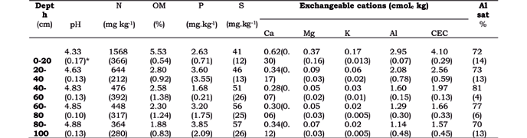

‡ Mean (standard deviation) of four profiles.

Results and discussion

Spore density
Before the experiment started the numbers of spores, (911 per 100 g of dry soil) and the percentage of infection of AM (7%) was very low (Table 2). During the following months, a rapid increase in spore density was observed. Because of the high variability in the number of spores (Table 2), a lack of normality in the variance was detected and therefore no analyses of variance were carried out. Ponder (1979) pointed out that AM colonization of disturbed sites of humid regions is relatively rapid. Medve (1984) found 76% AM colonization in plants growing on a site that had all the top soil and subsoil removed.
The numbers of spores were highly variable but had no significant differences within the species treatments during the study period (Table 3 and Figura 1). Seasonal variation in the abundance of AM spores has been previously reported in different environments (Saif, 1986; Sieverding, 1991; Abbott and Robson,
1991). At the first sampling date (16 weeks of age) spore numbers were higher than at
29 weeks of age. This decrease between 16 to 29 weeks of age was probably because of environmental seasonal changes. A decrease in rainfall accompanied by an increase in soil temperature could have caused this (Figura 1). There after, total number of AM spores increased again until reaching the highest population at the end of the study
period (55 weeks of age).

Table 2. Microbial soil characteristics of the study site conformed by the mean of six samples. Vesicular Arbuscular Mycorrhizae 20 cm depth before treatments.

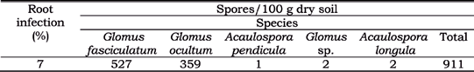

Table 3. Spore density of AM of one grass and 2 legumes growing alone and in associations at

0-20 cm depth at 4 age levels.

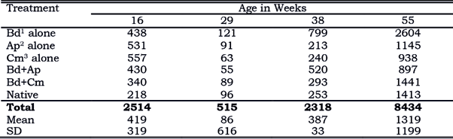

1 Brachyaria dictyoneura.
2 Arachis pintoi.
3 Centrosema macrocarpum.

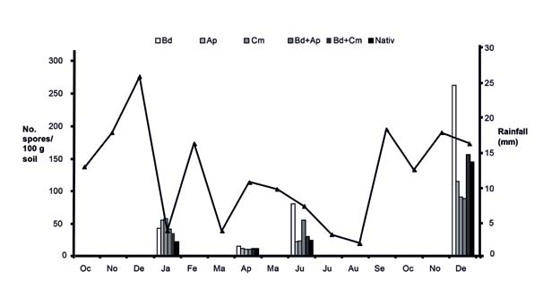

Figure 1. AM spore density at 0-20 cm soil depth at 4 ages Bd= B. dictyoneura; Ap= A. pintoi; Cm= C. macrocarpum.

It seems, during the study period, spore number was associated with different host species. The grass alone treatment, B. dictyoneura, had the highest spore density followed by the native vegetation. The legumes in monoculture and their mixtures
with the grass, both had similar spore density.
The ANOVA detected significant differences (P<0.05) in the host species related to percentage of infection by AM. This indicates that host species influence

the development and abundance of AM fungi. AM infection varied also with age and season. A successive increase in AM infection throughout the different collection dates was observed (Figura 2). At the end of the study period, the legume A. pintoi had the highest percentage of AM infection. The native vegetation and the legume C. macrocarpum had the second value of AM root infection (Table 4), and B. dictyoneura had the lowest AM infection. This result agrees with the general point of view that grasses depend less on mycorrhiza than legumes (CIAT, 1982). Rao and Kerridge
(1994) reported that, although A. pintoi
appeared to depend less on mycorrhizal fungi for P acquisition than other species such as the grass B. dictyoneura and the legume Stylosanthes capitata, this was only for relative young plants (8-10 weeks of age) and could be different in more mature stands.
The effect of P supply on AM infection may differ for different species. In this experiment there was not significant difference among species related to the influence of fertilization rate on AM infection. It has been recognized that relative low rates of soil P such as that used in this experiment help to improve AM
populations.

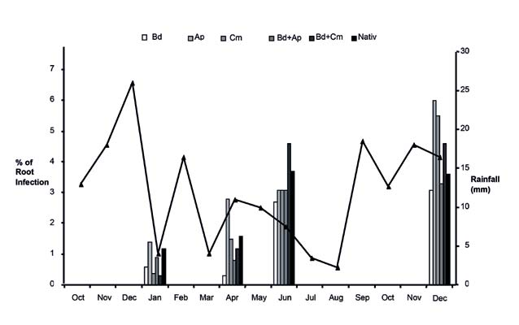

Figure 2. AM infection in roots at 4 ages Bd= B. dictyoneura; Ap= A. pintoi; Cm= C. macrocarpum.

Table 4. Percentage of AM infection in 1 grass and 2 legumes growing alone and in association at 0-20 cm soil depth at 4 ages. Means with different letter were significantly different using an ANOVA.
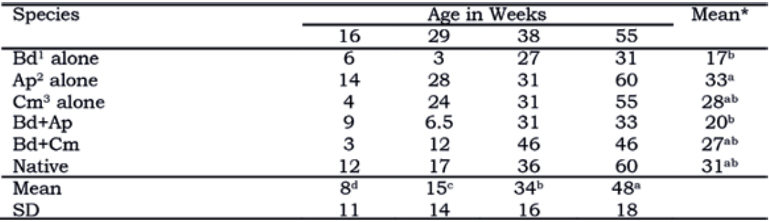

1 Brachyaria dictyoneura.
2 Arachis pintoi.
3 Centrosema macrocarpum

CIAT (1982) reported that in Oxisols with low rates of P supply (11 and 22 kg ha-1 P) similar to the used in this study, AM infection was highest in the mixtures of forage grass and legume species. With fertilization rates of 48 and 88 kg xha-1 P, a decrease in AM infection was observed. No significant relationship was found between percentage of AM infection and soil available P. The number of spores and percentage of AM infection at the end of the experiment compared to that found before the experiment started was markedly higher.

Conclusions

The effect of P supply, although in low amounts, could helps to increase number of spores and AM infection; it differs for different forage host species according to the season. This suggests that introducing agronomic practices consisting of sowing improved and adapted grass and legumes species with low rates of fertilization could help in the restoration of AM on disturbed sites with nutrient-poor acid soils.
In rainy season there was an increase in AMF spore numbers and mycorrhizal infection.
The treatment with the grass Brachiaria dictyoneura had the highest spore numbers. The treatment with the herb Arachis pintoi
had the highest mycorrhizal infection.

Aknowledgments

To the International Center of Tropical Agriculture (CIAT) for the support to this research. We are indebted to Gustavo Figueroa, Argemiro Dominguez, and Cesar Cano for their valuable technical assistance. Collaborative research partially supported by the Colombian Institute for the Development of the Science and Technology (COLCIENCIAS).

References

Abbott, L. K.; and Robson, A. D. 1991.
Factor influencing the occurrence of vesicular-arbuscular mycorrhizas. Agric. Ecosystems and Environ. 35 (2-3):

121-150.
CIAT. 1981. Programa de Pastos Tropicales: Informe 1980. Cali, Colombia. 116 p.
CIAT. 1982. Manual para la evaluación agronómica. Red Internacional de Evaluación de Pastos Tropicales. CIAT Palmira. 168 p.
Friesen, D. K., I. M. Rao, R. J. Thomas, A. Oberson, and J. I. Sanz. 1997. Phosphorus acquisition and cycling in crop and pasture systems in low fertility tropical soils. Plant and Soil 196: 289-
294.
Hayman, D. S., A. M. Jonson, and I.
Ruddlesdin. 1975. The influence of phosphate and crop species on Endogone spores and vesicular-arbuscular mycorrhiza under field conditios. Plant and Soil 43: 489-495.
Malagón, C. D.; Pulido, R. C.; and Llinas, R. R. 1992. Génesis y taxonomia de los Andisoles colombianos. In: Suelos ecuatoriales, Revista de la Sociedad Colombiana de la Ciencia del Suelo 22 (1): 50-68.
Medve, R. J. 1984. The mycorrhizae of pionner species in disturbed ecosystems in Western Pennsylvania. Amer. J. Bot.
71: 787-794.
Mohammad, M. J., S. R. Hamad, and H. I.
Malkawi. 2003. Population of arbuscular mycorrhizal fungi in semi-arid environment of Jordan as influenced by biotic and abiotic factors. Journal of Arid Environments 53: 409-417.
Phillips, J. M., and D. S. Hayman. 1970.
Improved procedures for clearing roots and staining parasitic and vesicular- arbuscular mycorrhizal fungi for rapid assessment of infection. Trans Br. Mycol.
Soc. 55: 158-161.
Ponder, F. Jr. 1979. Presence of endomycorrhizal fungi in recently graded coal mine spoil. J. Soil Water Conserv.
34: 186-187.
Rao, I. M. 2001. Role of physiology in improving crop adaptation to abiotic stresses in the tropics: The case of common bean and tropical forages. In: M., Pessarakli (ed.). Handbook of Plant and Crop Physiology. Marcel Dekker, Inc., New York, USA, p.
583-613.
Rao, I. M.; and Kerridge, P. C. 1994. Mineral nutrition of forage Arachis. In: P. C., Kerridge; and W., Hardy (eds.). The Biology and Agronomy of forage Archis. Centro Internacional de Agricultura Tropical (CIAT) Cali, Colombia, p. 71-83. Rao, I. M.; Friesen, D. K.; and Osaki, M.
1999. Plant adaptation to phosphorus- limited tropical soils. In: M., Pessarakli (ed.). Handbook of Plant and Crop Stress. Marcel Dekker, Inc., New York, USA, p. 61-96.
Reining, L. 1992. Erosion in Andean Hillside farming: characterization and reduction of soil erosion by water in small scale cassava cropping systems in the southern central cordillera of Colombia. Center for Agriculture in the Tropics and Subtropics, University of Hohenheim, Germany. 219 p.
Saif, S. R. 1986. Vesicular-arbuscular mycorrhizae in tropical forage species as influenced by season, soil texture, fertilizers, host species and ecotypes. Angew. Bot. 60: 125-139.
SAS/STAT. 1990. SAS/STAT. User guide.
Version 6. SAS Institute, Cary, NC. USA. Sieverding, E. 1983. Manual de métodos

para la investigación de la micorriza vesículo-arbuscular en el laboratorio. Centro Internacional de Agricultura Tropical (CIAT), Cali.
Sieverding, E. 1991. Vesicular-arbuscular mycorrhiza management in tropical agrosystems. Schriftenreihe der GTZ: No 224, p 20-22.

