***Research article***

**Phosphorus fractions in Valle del Cauca soils under different coffee cropping systems**

**Fracciones de fósforo en suelos del Valle del Cauca con diferentes sistemas de cultivo de café**

*Diana Milena Mejía-Umaña*, Diego Iván Ángel-Sánchez*†*, and Juan Carlos Menjivar-Flores*‡

Department of Agricultural Sciences, Universidad Nacional de Colombia - Palmira, AA. 237. Palmira, Valle del Cauca, Colombia.

*Corresponding author: [dmmejiau@unal.edu.co](mailto:dmmejiau@unal.edu.co); †[dangels@unal.edu.co](mailto:dangels@unal.edu.co); ‡jc[menjivarf@](mailto:menjivarf@)unal.edu.co

Rec.: 24.03.11 Acept.: 29.11.11

**Abstract**

This study was conducted in the coffee growing zone of Valle del Cauca (Colombia) to evaluate the effect of planting coffee under different cropping systems: organic, conventional and organic-mineral, on soil phosphorus (P) fractions. Adapted sequential fractionation methodology was done by the International Center of Tropical Agriculture. The statistical analysis consisted of a Complete Randomized Block Design under a split plot arrangement with three treatments and three replications. The results showed that contents of the organic fraction of available P and the moderately available P had significant differences (P > 0.5) among the conventional and organic systems, in which the conventional system had the lowest values. The organic-mineral system showed the highest contents of organic and inorganic P and the conventional system showed the lowest for these fractions of P. For the non-available P fraction, it was found that organic systems had higher P content than the conventional system and, the organic-mineral system showed significant differences with respect to the rest. Total P showed a similar pattern than the fractions described above. The low content in the conventional system can be explained by specific aspects of management such as the use of synthetic chemical fertilizers, planting in monoculture without shade and lack of soil coverage between plants.

**Key words:** Coffee crop, cropping systems, phosphorus fractions, soils with volcanic influence.

**Resumen**

El trabajo tuvo como objetivo evaluar la influencia de los sistemas de siembra de café: orgánico, convencional y orgánico-mineral, sobre las fracciones de fósforo (P) en suelos del Departamento del Valle del Cauca, Colombia. Las mediciones por fraccionamiento secuencial adaptado se hicieron en el Laboratorio de Suelos del Centro Internacional de Agricultura Tropical (CIAT). El análisis estadístico se ajustó a un modelo de diseño completamente aleatorio bajo un arreglo en parcelas divididas con tres tratamientos y tres repeticiones. Los resultados mostraron que los contenidos de las fracciones orgánica de P disponible y P moderadamente disponible variaron (P < 0.05) entre los sistemas de manejo orgánico y convencional presentando, este último, los valores más bajos. El sistema orgánico-mineral mostró los mayores contenidos de P orgánico e inorgánico y el sistema convencional presentó los valores más bajos de ambas fracciones de P. La fracción de P no-disponible fue más alta en los sistemas orgánicos comparado con el sistema convencional, mientras que en el sistema orgánico mineral se encontraron diferencias (P < 0.05) con respecto a los restantes sistemas. El P total mostró un comportamiento similar al de las fracciones. Los bajos contenidos de P en el sistema convencional se deben, posiblemente, a prácticas de manejo como uso de fertilizantes de síntesis química, la siembra a libre exposición en monocultivo y la ausencia de coberturas entre plantas.

**Palabras clave:** Cultivo de café, fraccionamiento de fósforo, sistemas de cultivo, suelos con influencia volcánica.

**Introduction**

Phosphorus (P) is a chemical element highly reactive on nature and it is found on more than 170 mineral compounds with variable solubility, since they evolve naturally from chemical forms with a moderate solubility to less soluble forms. In consequence, from all the macronutrients P is the least movable element and the one with highest issues on bioavailability (Holford, 1997).

Crops need a regular addition of P, however, it is accumulated in low availability forms in the soil. This low availability of P is associated with a high stabilization and low mineralization rate of phosphate compounds (Daza *et al.*, 2006). A high proportion of the phosphate fertilizers applied is accumulated on the soil, which is worst when organic matter levels are reduced or when pH extreme values occurred (Montesinos, 2002).

P content on tropical soils is highly variable. Parental material determines such variability; e.g. Andisols soils, which occupy 40% of the total area on the Colombian coffee area, have a high capacity to immobilized P on the surface of amorphous minerals. This is an important characteristic since these minerals can control the soil capacity to absorb and release P, they can affect P availability and in consequence determine soil productivity (Fassbender and Bornemisza, 1994).

Apparently, P fixation in Andisols soils fluctuates with the clay type present, and this, in turn, changes the residual effect of phosphate applications. Mechanisms to fix P in allofane and imogolite clay include chemi-adsorption, displacement of structural silicon and precipitation (Espinosa, 2007). The larger fraction of P is accumulated by means of P macromolecular complexes with organic matter, possibly by Al and Fe bridges; between 71% and 93% of organic P (Po) is related to humus (Redel, 2007). The carbon (C) trapped in those complexes is inactive and is no longer part of the active C in the organic fraction.

Sustainable and reasonable management of soils fertility requires the enhancement on P availability, which is not dependent on higher rates of fertilization but on tilling practices for P recycling and solubilization on soils (Montesinos, 2002).

This work aimed to establish the effect on P fractions of coffee planting on soils with volcanic influence in the coffee area of Valle del Cauca, in which different cropping systems: organic, conventional and organic-mineral were used. The P fractions evaluated were: available P, biologically available P, easily mineralizable organic P, Al and Fe-bound inorganic P, organic P bound to humic substances, Ca-bound inorganic P, and not available or occluded P. It also aimed to contribute to the knowledge, in the national context, in the positive effects of cropping systems that include an organic management in the availability of P fractions on soils with volcanic influence.

**Materials and methods**

**Localization**

The study was done in three soil types located on the town of Sevilla (4º 16´N, 75º 55´O), Va–lle del Cauca (Colombia), 1612 m.a.s.l, average temperature of 20 ºC, and 2121 mm annual rainfall.

**Cropping systems**

System 1 (organic crop) consisted on a coffee variety called Suprema, grown under the partial shade of leucaena (*Leucaena leucocephala*) and some associated crops like maize, bean, onion, citrus and medicinal plants; it has a living mulch of weeds and crop residues. It is an Andisol (Typic Melanudand), fertilized twice per year with 200g/plant of coffee beans pulp, poultry manure and manure.

System 2 (conventional crop) consisted on a coffee variety called Colombia without shade, in bare soil on a monoculture system. It is an Inceptisol (Typic Dystrudept) fertilized three times per year with 120g/plant with an equal parts mix of 1 kg of urea, magnesium sulphate (Kieserita) and Agrocafé (N 25%, K2O 24%, P2O5 4%).

System 3 (organic-mineral crop) consisted on a coffee variety called Caturra with a light shade of avocado and orange plants. It is an Andisol (Typic Melanudand) fertilized with 4 packages of organic fertilizer including coffee beans pulp, banana rachis and bovine manure compost, and 1 package (50 kg) of fertilizer for coffee (N, P, K, Mg) on a rate of 100g/plant every three months.

**Field sampling**

For P fractionation, three places with 30 m distance were chosen on each crop system. 500g of soil at 10, 20 and 30 cm depth were taken from each location. For the chemical analysis of soil, three samples of 1 kg at 20 cm depth were taken randomly in 10-12 di-fferent locations.

**Analysis**

Chemical analyses of soil fertility were deve–loped in the soil chemistry lab at the International Center for Tropical Agriculture (CIAT) in each of the three samples taken. They include the determination of pH, organic matter (M.O.), cationic capacity exchange (CIC), phosphorus (Bray II), calcium, magnesium, suffer, sodium, aluminum, iron, manganese, zinc, copper, boron and minor elements. Physical analyses of soil were done in labs at the Universidad Nacional de Colombia, they include texture (Bouyoucos method), bulk density (nuclear method), particle density (picnometer), aggregates stability (Yoder method), porosity and water content (dry out in oven).

P fractionation was done in 0.5 g of each of the 27 samples, it was determined the fractionation content for available, moderately available and occluded P. P determination was done in the Soil chemistry lab at CIAT by the sequential P fractionation method modified by Hedley *et al.* (1982); Tiessen and Moir (1993) and Oberson *et al.* (1995). This procedure was done on 0.5 g of each sample using extraction buffers to sequentially increment P separation (available inorganic and organic, moderately available and occluded P). The sequential order of the solutions from thelowest to strongest extraction power was: water (Po-H2O) and resins for ionic exchange (Resin Pi), NaHCO3 0.5 M (Bic Pi-Po-Pt), NaOH 0.1 M (NaOH Pi-Po-Pt), HCl 0.1 M and concentrated HCl (Resid Pt).

**Experimental design and information analysis**

P fraction analysis was adjusted in a Complete Randomized Block Design under a split plot arrangement, where the main plots were the treatments (crop system) and the subplots were the locations. P fractions were subjected to a variance test, and to a Duncan´s mean comparison test (P < 0.05). For the statistical analysis SAS 9.1 software (SAS Institute, North Caroline, USA) was used.

**Results and discussion**

The physical and chemical properties of the soils analyzed are in Table 1. In the **organic cropping system**, the soil had a highly acidic pH and low contents of K, Ca, Mg, Fe, Mn, Cu and Zn. Ca + Mg + K summation (1.74 Cmol/kg), Mg/K ratio (3.08 cmol/kg) and percentage of saturated bases showed low values as well, confirming the high acidity of this soil. High levels of M.O. could be a consequence of the cropping system used. This soil has very high aluminum content (35.3% in relation to CICE) and a very low value of available P (Bray II), this indicates that P could be retained by Fe and Al oxides and hydroxides and/or humus-Al complexes, which is a typical feature on Andisols soils (Espinosa, 2007). Its high CIC could be due to a high M.O. content which is not completely mineralized because the weather conditions (mean temperature of 20°C) do not help with decomposition (Picone and Zamuner, 2002). Physical properties, as expected from an Andisol, were a sandy loam texture, low bulk density (0.76 g/cm3) and high porosity (65.9%).

The soil in the **conventional cropping system** had a moderately acid pH. K, Mg, Ca, B, Mn and Zn content were high since they come from a soil fertilized with mineral fertilizers. Ca + Mg + K (24.92 cmol/kg) summation was high and the Mg/K (12.43 cmol/kg), (Ca + Mg)/K (32.7 cmol/kg) and Ca/K (20.24 cmol/kg) ratios were adequate. The bases sum was high, meaning that this soil was saturated. M.O. and P contents were low and CIC was high. The texture of this soil was clay loam, bulk density (1.26 g/cm3) and porosity (42.2%) showed intermediate values.

|  |  |  |  |  |  |  |
| --- | --- | --- | --- | --- | --- | --- |
| **Table 1.** Chemical and physical properties of the studied soils. | | | | | | |
| **Property** | | **Units** | | | **Cropping system** | |
|  |  | | **Organic** | **Conventional** | | **Organic-mineral** |
| pH | ― | | 5.28 | 5.91 | | 6.08 |
| MO | g/kg | | 117.45 | 29.54 | | 71.82 |
| P-Bray II ) | mg/kg | | 2.81 | 8.02 | | 1.16 |
| K | cmol/kg | | 0.13 | 0.74 | | 0.26 |
| Ca | cmol/kg | | 1.21 | 14.98 | | 6.05 |
| Mg | cmol/kg | | 0.40 | 9.20 | | 1.13 |
| Al | cmol/kg | | 0.95 |  | |  |
| Na | cmol/kg | |  | 0.06 | | 0.02 |
| CIC | cmol/kg | | 29.05 | 34.50 | | 32.30 |
| S | mg/kg | | 67.65 | 24.32 | | 47.01 |
| B | mg/kg | | 0.65 | 0.85 | | 0.49 |
| Fe | mg/kg | | 2.13 | 11.80 | | 0.90 |
| Mn | mg/kg | | 3.56 | 43.10 | | 17.18 |
| Cu | mg/kg | | 0.14 | 1.54 | | 0.17 |
| Zn | mg/kg | | 1.37 | 3.29 | | 5.56 |
| Texture | ― | | Sandy loam | Clay loam | | Silt loam |
| Bulk density | ― | | 0.76 g/cm3 | 1.26 g/cm3 | | 0.79 g/cm3 |
| Porosity | ― | | 65.9% | 42.2% | | 64.8% |

The soil in the **organic-mineral cropping system** had a slightly acid pH. P, Fe and Cu levels were low and Mg, S, B, Zn and CIC contents were high. Ca, Mg and K ratios were adequate. It had a high level of M.O. due to the use of both organic materials and mineral fertilizers. The texture was silt loam, the bulk density was low (0.79 g/cm3) and porosity was high (64.8%).

**P fractions in the cropping systems**

|  |  |  |  |  |  |  |  |  |  |  |  |  |  |  |  |  |  |  |
| --- | --- | --- | --- | --- | --- | --- | --- | --- | --- | --- | --- | --- | --- | --- | --- | --- | --- | --- |
| **Table 2.** Significance level (P > 0.05) in the P fractions for the three cropping systems (n=27). | | | | | | | | | | | | | | | | | | |
| **V.S.1** | **Available P2** | | | | | |  | | **Moderately available P** | | |  | **Occluded P** |  | | **Total** | | |
|  | **Po-H2O** | **Resin-Pi** | **Bicarbonate** | | | |  | | **NaOH** | | |  |  |  | | | |  |
|  | **Pi** | **Po** | **Pt** | |  | | **Pi** | **Po** | **Pt** |  |  | **PiT** | **PoT** | | **PT** | |
| **S.C** | 0.1480 | 0.1621 | 0.1387 | 0.0312 | | 0.0726 | | 0.0254 | | 0.0002 | 0.0030 | 0.0008 | | 0.0029 | 0.0002 | | 0.0013 | |

Variance analysis for the P content in the three cropping systems (Table 2) did not show any difference (P > 0.05) in the Po fractions extracted with water, resin and Pi extracted with bicarbonate that were affected by the cropping system. Contrastingly, fractions of moderately available P, occluded P and total P showed differences (P < 0.05), which indicates that at least one of the systems had an important effect on the P content of these fractions.

**Phosphorus fraction in the cropping systems**

**Available phosphorus.** Figure 1 shows the different available P fractions for the three cropping systems studied. The organic-mineral system (3) showed the highest contents for that fraction, followed by the organic cropping system (1), whereas the lowest values were presented in the conventional system (2). Individually, the Bic-Pi and Bic-Po fractions had a similar behavior; both frac-tions had presented differences (P < 0.05) in comparison with the system 2. P content on system 1 doubled the one of system 2. In the same fashion, P content in the system 3 was three times higher than the one of system 2. A similar situation was observed for the Bic-Po and Bic-Pt (P < 0.05). H2O-Po, Resin-Pi and Bic-Pifractions did not showed differences (P> 0.05) in P content as a result of the different cropping systems (Table 1 and Fi-gure 1).

**Moderately available P.** The content of the moderately available P fraction indicated that the highest values are in the organic-mineral system and the lowest are in the conventional system (Figure 2), which is consistent with Pi and Po contents for that fraction. Fractionation showed a higher content for Po than Pi. Differences (P < 0.05) in NaOH-Pi and NaOH-Po fractions among the cropping systems were found for the organic-mineral system compared to the conventional system, but not with the organic system.

Organic P showed the highest content on the systems 3 and 1, they were not different (P < 0.005) among them, but with the system 2 (P < 0.005) which content was seven times lower. Inorganic P of system 3 was the highest, and although it was not different with system 1 (P > 0.05), it was two times higher.

**Occluded phosphorus.** In figure 3 are depicted the occluded P contents for the three cropping systems studied. In general, the organic-mineral system presented the highest value for occluded-P (inorganic and inorganic P, chemically stable and insoluble). The conventional system, which only includes mineral fertilizers, showed the lowest value for this fraction. There were no differences (P > 0.05) between the organic and conventional systems, but between them and the organic-mineral system. Occluded P on the organic-mineral and organic systems exceeded four and two times, respectively, the one on the conventional system.

**Figure 1.** Available P fractions in three cropping systems (S). S1: organic, S2: conventional and S3: organic-mineral).

Values with different letters in the same P form are significantly different (P < 0.05).

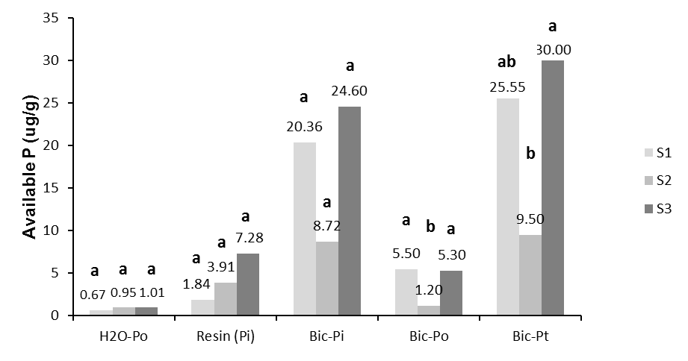

Total P presented highly variable contents on the studied soils (P < 0.05); the lowest value was on the conventional system (153.2 mg/g) and the highest was on the organic-mineral system (887.5 mg/g) (Figure 4). According to Fassbender and Bornemisza (1994) the total P on soils is related to the M.O. content. This confirms the findings on the organic systems (S1 and S3) which had the highest M.O. contents as well as total P, as such there is an important relationship between this component and the edaphic P.

Total P results (Figure 4) are consistent with the findings on the available, moderately available and occluded P fractions. The organic-mineral system included a fertilization with organic materials and chemical ferti-lizers, which contributes to increase the avai-lable P in most of the fractions. This is in agreement with Boschetti *et al.* (2003) who found a high correlation between organic carbon and available P in soils located at the Argentinian Mesopotamian.

Inorganic fractions of P had higher contents than the organic ones, which coincides with the high levels for both fractions on the organic-mineral system, perhaps due to the combination of organic and inorganic materials. The high Pi content is explained by the use of organic amendments which enhance microbial activity and favors mineralization, in such way it contributes to an adequate P level in the soil (Tejada et al., 2006). Micro-bial activity is influenced by temperature, pH, water and M.O. content (Fassbender and Bornemisza, 1994), these factors are favored on the organic-mineral system (Table 1).

**Figure 3.** Non-available P fractions in three cropping systems (S). S1: organic, S2: conventional and S3: organic-mineral).

Values with different letters in the same P form are significantly different (P < 0.05).

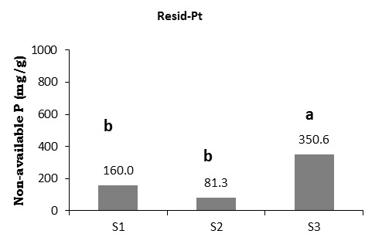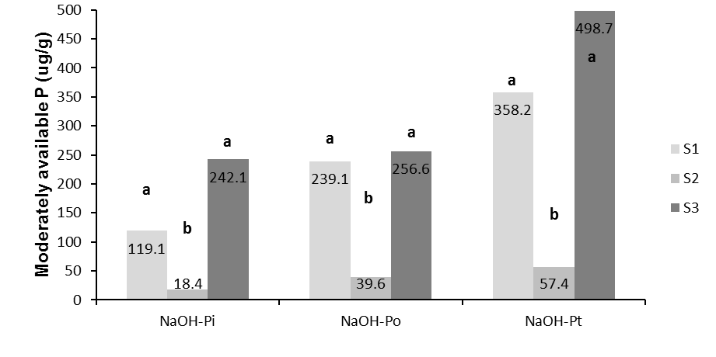

**Figure 2.** Moderately available P fractions in three cropping systems (S). S1: organic, S2: conventional and S3: organic-mineral).

Values with different letters in the same P form are significantly different (P < 0.05).

On the other hand, the extracting agent used, NaOH, has the capacity to solubilize inorganic P associated with Fe phosphates (Bowman y Cole, 1987). Buechler *et al.* (2002) used a sequential fractionation of P to determine the effect of different use systems on an Oxisol soil with phosphorous fertilization on the P fractions. They found that in treat-ments with synthetic fertilizers inorganic P was accumulated in Pi-NaOH fractions.

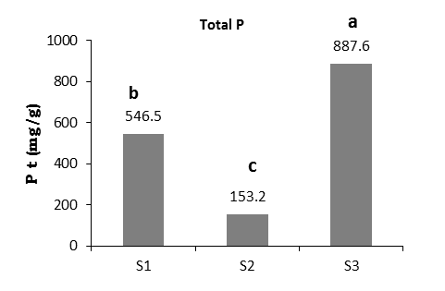

**Figure 4.** P total fractions in three cropping systems (S). S1: organic, S2: conventional and S3: organic-mineral).

Values with different letters in the same P form are significantly different (P < 0.05).

P contents on the conventional system were low, which correlates with the low P content (4%) of the fertilizer (Agrocafé) added to the soil, moreover, the mineralization process is affected by the low M.O. content presented in this soil. Palm (1995) highlights the key role of the organic materials as P and other nutrients source, and as providers of the energetic substrate for microbial activity to generate mineralization-immobilization patterns and reduce P absorption on the soil.

The coincidence that the occluded P and the available and moderately available P fractions reached the highest levels on the orga-nic-mineral and organic systems, is explained, according to Burbano (1989), by the fact that in tropical soils the very labile fractions (immediately available) are in equilibrium with the labile fractions (available), moderately available and with the ones of low or none lability.

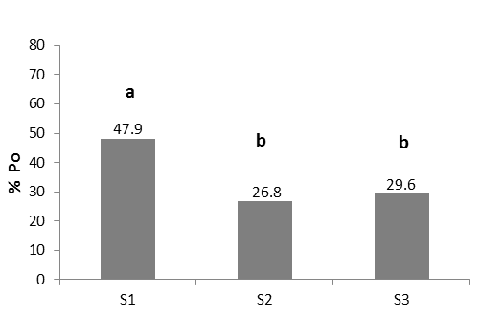

**Figure 5.** Organic P percentage in three cropping systems (S1: organic, S2: conventional and S3: organic-mineral).

Different letters indicate significant differences.

The high contents of occluded P in the organic system are also the result of the time (10 years) in which coffee has been growing under such management. The previous statement is confirm by Lehmann *et al*. (2001), who mentioned that the P fraction only increases at long term with application of mineral fertilizers and organic matter.

Organic P can reach levels that vary among 25 and 75% from the total P (Fassbender and Bornemisza, 1994). The mean content of organic P found in this study is between those levels (36%), and significantly differences among the organic system with the highest value, and the other two systems are observed (Figure 5). This is explained by the addition of organic materials in this system and it coincides with studies done by Zheng *et al.* (2002), who showed that in systems fertilized for 8 years with an amendment of organic fertilizer, the P added with that fertilization, goes to the available and moderately available organic fractions.

According to Redel (2007), the majority of P is accumulated as macromolecular complexes of P associated with organic matter, perhaps by Al and Fe bridges. It has been found that 71-93% of Po is associated with humus.

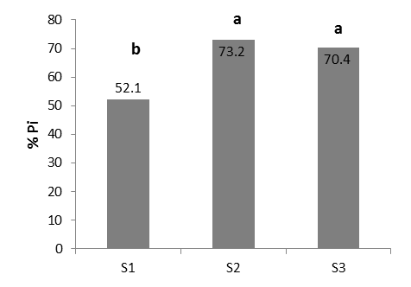

**Figure 6.** Inorganic P percentage in three cropping systems (S1: organic, S2: conventional and S3: organic-mineral).

Different letters indicate significant diffe-rences.

Inorganic P presented high values, as percentage (64%) and absolute values from the total P. The organic system presented a significant difference in the inorganic P percentage with respect to the conventional and organic-mineral systems (Figure 6) which had the highest values. This is in agreement with the different Pi fractions, and is related to the contributions and processes that happen in the soil caused by chemical fertilizer amendments, which is done as an agronomic practice on these cropping systems.

**Conclusions**

* The systems that included organic fertilizations as part of their management, contributed to soils with high available and moderately available P contents.
* The lowest contents on the different P fractions were found on the conventional cropping system.
* The addition of both, organic and chemical fertilizers, together with complementary agronomic practices, generate adequate conditions in the soil to ensure a suitable P level for coffee crop.

**Acknowledgments**

Thanks to the Universidad Nacional de Colombia and the International Center for Tropical Agriculture for allowing us to do the experimental part in the physics and chemistry of soils. Thanks to the UNAL - Research group on Soil and Water management with emphasis on soil degradation for the funding.

**References**

Boschetti, N.; Quintero, C.; Benavidez, R.; and Giuffre, L. 2003. Cuantificación de las fracciones orgánicas e inorgánicas de fósforo en suelos de la Mesopotamia Argentina. *Ciencia del suelo* 21: 1 - 7.

Bowman, R. and Cole, C. 1987. Transformations of organic phosphorus substrates in soils as evaluated by NaHCO3 extraction. Soil Sci. 125: 49 - 54.

Buechler, S.; Oberson, A.; Rao, I. M.; Friesen, D. K.; and Frossard, E. 2002. Sequential phosphorus extraction of a P-33-labeled Oxisol under contrasting agricultural systems. *Soil Sci. Soc. Am. J.* 66: 868 - 877.

Burbano, H. 1989. El suelo. Una visión sobre sus componentes bioorgánicos. Pasto: Serie Investigaciones No. 1 Universidad de Nariño. Pasto. Colombia. 447p.

Daza, M.; Álvarez, J.; and Rojas, A. 2006. Efecto de materiales orgánicos e inorgánicos sobre las fracciones de fósforo de un Oxisol de los Llanos Orientales colombianos. *Agronomía Colombiana* 24 (2): 326 - 333.

Espinosa, J. 2007. Fijación de fósforo en suelos derivados de ceniza volcánica. Quito: INPOFOS.

Fassbender, H. and Bornemisza, E. 1994. Química de Suelos con énfasis en suelos de América Latina. Costa Rica: IICA. 420p.

Hedley, H.; Steward, J.; and Chauhuan, B. 1982. Changes in organic and inorganic soil phosphorus fractions induced by cultivation practices and by laboratory incubations. *Soil Sci. Soc. Am. J.* 46: 970 - 976.

Holford, I. C. R. 1997. Soil phosphorus: Its measurement, and its uptake by plant. *Aust. J. Soil Res.* 35: 227 - 239.

Lehmann, J.; Günther, D.; Socorro da Mota, M.; Pereira de Almeida, M.; Zech, W.; and Kaiser, K. 2001. Inorganic and organic soil phosphorus and sulphur pools in an Amazonian multistrata agroforestry system. *Agroforestry Systems* 53: 113 - 124.

Montesinos, C. 2002. Manejo biológico del fósforo en el suelo. *Revista de Agroecología y Desarrollo* 8: 31 - 34.

Oberson, A.; Besson, J. M; Maire, N.; and Sticher, H. 1995. Microbiological processes in soil organic phosphorus transformations in conventional and biological cropping systems. *Biology and Fertility of Soils* 21: 138 - 148.

Palm, C. A. 1995. Contribution of agroforestry trees to nutrient requirements of intercropped plants. *Agrofor. Syst*. 30: 105 - 124.

Picone, L. and Zamuner, E. 2002. Fósforo orgánico y fertilidad fosfórica.XVIII Congreso de la Ciencia del Suelo. *Informaciones Agronómicas del Cono Sur* N° 16, pp.11.

Redel, Y. 2007. Fraccionamiento de fósforo en suelos volcánicos provenientes de ecosistemas agrícolas y forestales del Centro Sur de Chile. Tesis para optar al grado académico de Doctor en Ciencias de Recursos Naturales. Universidad de la Frontera, Temuco, Chile. 126p.

SAS version 9.1.3. 2010 Copyright © 2011 SAS Institute Inc., SAS Campus Drive, Cary, North Carolina 27513, USA.

Tejada, M.; García, C.; González, J. L.; and Hernández, M. T. 2006. Organic amendment based on fresh and composted beet vinasse: influence on soil properties and wheat yield. *Soil Sci. Soc. Am. J.* 70: 900 - 908.

Tiessen, H. and Moir, J. O. 1993. Characterization of available P by sequential extraction, pp. 75-86. En: Soil sampling and methods of analysis. Center MR (Ed.). CSSS Lewis Publishers, Boca Ratón, Fl.

Zheng, Z; Simard, R. R.; Lafond, J.; and Parent, L. E. 2002. Pathways of soil phosphorus transformations after 8 years of cultivation under contrasting cropping practices. *Soil Sci. Soc. Am. J.* 66: 999 - 1007.