***Research article***

**Prediction of soils penetration strength using artificial neural networks**

**Estimación de la resistencia a la penetración de suelo usando redes neuronales**

**artificiales**

*Nidia Johana Valdés-Holguín1, Luis Octavio González-Salcedo2*, and Adrián L. E. Will3*

1,2Departament of Engineering, Research Group on Materials and Environment, Department of Engineering and Management, Universidad Nacional de Colombia – Palmira.

3Assistant Professor, Department of Mathematics, Universidad Nacional de Tucumán, Avenida Independencia 1800, San Miguel de Tucumán, Tucumán, Argentina.

*Corresponding author: [logonzalezsa@unal.edu.co](mailto:logonzalezsa@unal.edu.co)

Rec.: 04.04.11 Acept.: 06.12.11

**Abstract**

Artificial Neural Networks simulate the learning process of biological neurons, and they have been successfully used in the computation of parameters on several engineering problems where a strong nonlinear relation among the variables exists. In soil science, estimation of some properties involves variables that are complicated to estimate using mathematical models, so the solution for the problems fall into the field of Artificial Intelligence. The present paper reports the elaboration of an Artificial Neural Network for the estimation of soil penetration resistance at different depths, considering as influential variables humidity, density, static load, and inflate pressure. The best estimation results were obtained at a depth of 20-30 cm.

**Key words:** Artificial intelligence, artificial neural networks, soils, soil compaction, soil penetration strength.

**Resumen**

Las redes neuronales artificiales, simuladoras del proceso de aprendizaje de las neuronas biológicas, han sido utilizadas con éxito en el cálculo de parámetros en diversos problemas de ingeniería, donde las variables involucradas tienen una alta relación no lineal entre sí y la modelación no permite representar el problema mediante una función matemática de fácil deducción. En la ciencia del suelo, la predicción de algunas propiedades involucra diversas variables que hacen de su estimación por medio de modelos matemáticos un proceso complejo, trasladando la solución del problema al campo de la inteligencia artificial. En el presente artículo se reporta la elaboración de redes neuronales artificiales para la estimación de la resistencia a la penetración a diferentes profundidades de un suelo; se consideran como variables influyentes el contenido de humedad, la densidad, la carga estática, y la presión de inflado. Los resultados muestran una mejor estimación para profundidades entre 20 cm y 30 cm.

**Palabras clave:** Compactación del suelo, inteligencia artificial, redes neuronales artificiales, resistencia a la penetración, suelo.

**Introduction**

Soil compression consists on the reduction of its volume by applying a heavy load. It is called consolidation when it happens on saturated soils and water is excluded, and it is compaction when it occurs on dry soils and air is excluded (Bradford and Gupta, 1986; Pinzón and Amézquita, 1991). Compaction causes changes on water content and gas exchange between soil and atmosphere, and it prevents root growth (Horn *et al.*, 1995; Colmer, 2003; Foloni *et al.*, 2003) (Picture 1) and in the upper layer causes physical and pedogenetic changes (Pinzón and Amézquita, 1991).

It is considered that compaction by transit is associated with a serious damage on soil structure, due porosity loss leading to mechanical impedance generated by such load (Gerster and Bacigaluppo, 2004). As an alternative to reduce impedance, mechanical decompaction has been suggested, however the results of such experience have been contradictory (Balbuena, 2009). In some studies it has been suggested to use the mechanical resistance to penetration as an indicator to determine the degree of physical impedances in the soil, because above certain value, it shows a reduction in crop yield (Díaz-Zorita, 2004). In consequence, mechanical resistance to penetration could be a sensitive indicator to study the effects of mechanical decompaction and, soil preparation sequence for a crop, related to yield (Gerster *et al.*, 2010).

The wide use of mechanical resistance to soil penetration as a method to identify and characterize densified layers due to tillage, have shown that its results correlate with root growth and crop productivity (Ehlers *et al.*, 1983), horizons water content (Cerana *et al.*, 2005), and soil moisture and bulk density as indicators of soil quality (Díaz *et al.*, 2010). Nonetheless, some variables involve in soil characterization under penetrance resistance remain unexplored, and not all the variables can be resolved on a single mathematical mo–del able to show a complex relationship among them. A cause of this scientific ignorance is the high no-lineal relation and the dynamic of the variables on the estimation of parameters related to science problems (Valdés, 2010).

**Artificial** **intelligence** is a research area which unifies a series of techniques for computer use aiming to develop its capacity to perform learning and autocorrecting functions, by using algorithms or computational programming codes to resolve diverse problems, in a similar way as a human being could think. The main paradigms for artificial intelligence are: Artificial Neural Networks, Evolutive Algorithms, and Diffuse Logic (Trujillo and Gómez, 2007; Ponce-Cruz, 2010).

In modeling, artificial neural networks are black box models, develop to resolve problems in which the different components have a complex relation, the variables or relation rules are not easy to get, knowledge is scare but there is a series of data experience (López and Caicedo, 2006). These networks are a simulation of a biological neural network, therefore, from a functional point of view, they are processors of information with a channel for information entrance and an exit channel, with a high capacity to communicate and connect among them, which union is known as synapsis (Trujillo and Gómez, 2007; Ponce-Cruz 2010).

**Figure 1.** Negative effects of soil compaction on the limitation of root development zones

**Source:** Taken from Alliaume and Hill, 2008.

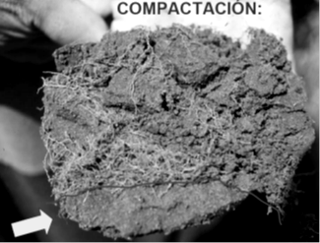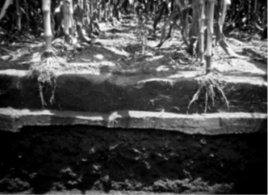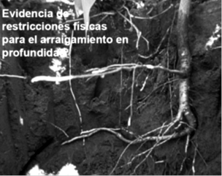

Artificial neural networks have been used to estimate parameters on different soil science struggles, like vegetation cover (Kimes *et al.,* 1998; Buendía *et al.*, 2002; Mena and Montecinos, 2006; Bocco *et al.*, 2007), soil hydrodynamics (Maneta and Schnabel, 2003; Rubio, 2005), soil erosion hydrodynamics (Mas *et al.*, 2002), underground water contamination (Rebolledo *et al.*, 2002; Rodríguez, 2009; García *et al.*, 2010), however there are no reports on variables related to mechanical properties of the soil. The state of art shows that, it is of interest to estimate penetrance resistance from an artificial neural network. This document presents a first approximation to estimate such parameters using different artificial neural networks, which have been done with that aim.

**Materials and methods**

**Database**

A database done by Váldes (2010) was used, it covers the available information on mechanical resistance to penetration on diverse soils (Pérez, 1997; Gómez and Torres, 1997; Vidal, 1997; Bonilla, 1998; Viveros and Jaramillo, 2003), located on different thermal floors and climatic conditions. The database is used for teaching, training and validation on computational programs for artificial neural networks; it consists of 192 records which form the vectors of complete information from the database matrix array for the variables involved. The mechanical resistance experiment is based on the cone index standard methodology using impact penetrometer (Saravia, 1997; Rangeon *et al.*, 2008), which measures the hit depth and number of hits that will be translated in pressure units (KPa).

Database variables are: water content (H) in %, soil mass in humid state (MSH) in g, soil mass in dry state (MSS) in g, bulk density (Da) in g/cm3, static load applied to the soil (Ce) in KN, wheels inflate pressure (Prin) in psi, porosity (pores) in %, void ratio (Rel_Vacios) in %, and cone index for penetrance resistance measured at depths of 0 - 0 cm (IC-H0), 10-20 cm (IC-H10), 20-30 cm (IC-H20), and 30-40 cm (IC-H30) in KPa.

**Artificial neural networks development**

In the Mathematics department of the Universidad Nacional de Tucumán, it was constructed a computer program with the algorithm for an artificial neural network used in the estimation of cone index for penetrance resistance of soil. Information gathered on a general database was arranged to form six subsets with 192 information vectors for the first three sets and 64 vectors for the other ones. This in turn, forms six new specific databases which associate penetrance resistance values on the mentioned depths (IC-H10, IC-H20, y IC-H30) as information of interest for its estimation. As programming language to write the artificial neural network algorithm it was used Matlab®; the neural network was created using the neural network tool box of the mentioned program (The Math Works Inc., 2000) and the information vectors were read by files on an Excel® sheet (The Math Works Inc., 2002). Artificial neural network typography belongs to a multilayer network (‘feedforward’) and the learning method was backpropagation, a data division technique of cross validation (K-Fold Cross Validation) with k=3, which is used to teach – train – validate. Se utilizó una técnica de división de datos para enseñanza-entrenamiento-validación denominada validación cruzada (K-Fold Cross Validation) con k = 3.

**Artificial neural network architecture**

According to the theorem of Kolmogorov (Kurkova, 1992; Haykin, 1999) any conti-nuous increasing function in **n** variables can be analyzed using only lineal sums and a continuous no-lineal function that increases in a variable; this demonstrates that the group of neural networks in three layers (entrance, hidden and exit) is dense in the space of all the continuous functions in **n** variables and, therefore, a multilayer with a unique hidden layer can approximate any continuous function till the desired level on an interval, being these ones the universal function takers.

Feedforward typology with backpropagation learning, defined by Rumelhart *et al.* (1986) corresponds to a parallel computational type structure where little calculation units called neurons, are massively interconnected with the anterior layer from which they receive information, and with the posterior layer to which they transmit it. Such kind of networks consist of a first layer of entrance with selected variables –called entrance or perceiving neurons-, which influences the problem results; this is connected to one or more hi-dden layers, where calculations are performed; and finally, the transformed information reaches an exit layer, from where the results of the exit variables are obtained –called exit neurons-, those exit variables interpret the problem behavior according to the entrance variables. In the estimation using trained neural networks the exit variable corresponds to the estimated variable. Their hidden layers have an activation function which limits the exit to a short range, and from this exit layer all the estimated values can be produced. The exit from the layer is represented as:

$Y_{Nx1}=f\left(W_{NxM}X_{M,1}+b_{N,1}\right)$ (**1**)

where, *Y* is a vector containing the exit from each one of the *N* neurons on a given layer, *W* is the matrix with the synaptic weights (importance) for each one of the *M* exits for all the *N* neurons, *X* is the vector with the entrances, *b* is the vector containing the biases, and *f* is the activation function. For the cons-tructed artificial neural network, the no-lineal activation function is a sigmoidal function expressed as:

$f\left(Z\right)=\frac{1}{1+e^{-Z}}$ (**2**)

being *Z* the expression contained between the equation **1** parentheses.

For network typology, the choice on the number of neurons of the hidden layer depends on factors like problem nature or data quality and size; a small number of data largely simplifies the network and does not have enough capacity to learn, and large amount of data causes overlearning, meaning a good adjustment with low power to predict new data (Tam and Kiang, 1992; Brockett *et al.*, 1997).

In multilayer networks, practice has suggested that hidden layers should have a neuron number in a 10:1 ratio to entrance layer neurons, with acceptable results for the training and validation processes in the artificial neural network, using as indicator the calculated error value. This relation is determined with preliminary tests which start with a low neuron number that increment gradually until a maximum number. The optimal amount of neurons in the hidden layer is the one that gives the lowest possible error (Buendía *et al.*, 2002). The minimal neuron number (*N*hidden), is given as a value between the neuron number in the entrance layer (*N*entrance) and the exit layer (*N*exit) (Fritz, 1999; Kimes *et al.*, 1998):

$N_{hidden}=Rounding\left(\sqrt{N_{entrance}*N_{exit}}\right)$ (**3**)

For the case of this study, Váldes (2010) performed training tests in one of the conformed networks; he used a hidden layer with 5 to 80 neurons, and repeated the procedure for 50, 60, 80 and 100 generations. He found that the best results are achieved for 100 ge-nerations and before 50 neurons you get the lowest error. When that number of neurons is increased there are no better approximations with a continuous increasing error. The present work chose a hidden layer with 40 neurons.

**Artificial neural network learning and trai–ning**

Backpropagation learning technique consists in using an optimization based on derivatives, in which error is derived not only in function of the exit layer weight, but also in function of the entrance layer weight, by using the chain rule (Hinton, 1989). This rule minimizes the training error of the neural network –the di–fference between the calculated values for a training using a determinate weight set, and the original values. The error and the corrections made to the weights are moved from the exit layer back to the entrance layer, from which comes the name backpropagation. As training method it was chosen the conjugated gradient or descending gradient method, co-rresponding to the scale conjugate gradient (SCG).

SCG has been defined by Moller (1993) and replace the lineal search for a step scaling, which depends on the success reducing the error and its good performance of its square approximation. This is motivated to accele-rate the typical low convergence associated with the descendent gradient method while the information requirement, like evaluation, storage and inversion of the Hessian matrix, for the association are admitted, as it is required by the Newton method. SCG is considered as the fastest method from other exis-ting ones (Moghassem *et al.*, 2010).

**Artificial neural network performance eva–luation**

The performance of the artificial neural network during its training and validation steps, can be evaluated using diverse techniques, such as root mean squared error RMSE, sum of squares of error SSE, mean error ratio MER, mean square error MSE, R2 correlation factor (Goyal and Goyal, 2011). For the training process this study used MSE, during validation it was used RMSE and MRE (the last one was used as a final error report, which were calculated as:

$MSE=\sum_{t=1}^{N}{{\left(\frac{Y_{t}-O_{t}}{T}\right)}^{2}}$ (**4**)

$RMSE=\sqrt{\frac{1}{T}\left[\sum_{t=1}^{N}{{\left(\frac{Y_{t}-O_{t}}{Y_{t}}\right)}^{2}}\right]}$ (**5**)

$MER=\frac{1}{T}\left[\sum_{t=1}^{N}{\left(\frac{Abs \left[Y_{t}-O_{t}\right]}{Y_{t}}\right)}\right]$ (**6**)

where, *Yt* is the expected exit, *Ot* is the obtained exit, *T* is the number of records on the database, and *N* is the number of neurons in the hidden layer.

**Random division of the database**

The decision technique ´K-Fold Cross Validation´ with k=3 divides each specific database of the same length on three groups of information vectors randomly chosen, using alternatively two groups as educational set for the network (learning and training) and a third one as validation (Refaeilzadeh *et al.*, 2008). The technique uses a Bayesian statistical regulation, and eliminates the biases on selection, it also gives a better idea on the validation errors and the existence of outliers that are masked due to data division and other effects (Varmuza and Filzmoser, 2009).

|  |  |  |
| --- | --- | --- |
| **Table 1.** Relation between the entrance and exit variables (neurons) for the constructed and trained artificial neural networks to estimate soil resistance to mechanical penetrance. | | |
| **RNA** | **Entrance** | **Exit** |
| RNA_1 | H, MSH, MSS, Da, Ce, Prin, IC-H0 | IC-H10 |
| RNA_2 | H, MSH, MSS, Da, Ce, Prin, IC-H0, IC-H10 | IC-H20 |
| RNA_3 | H, MSH, MSS, Da, Ce, Prin, IC-H0, IC-H10, IC-H20 | IC-H30 |
| RNA_4 | H, MSH, MSS, Da, Ce, Prin, Poros, Rel_Vacios, IC-H0 | IC-H10 |
| RNA_5 | H, MSH, MSS, Da, Ce, Prin, Poros, Rel_Vacios, IC-H0, IC-H10 | IC-H20 |
| RNA_6 | H, MSH, MSS, Da, Ce, Prin, Poros, Rel_Vacios, IC-H0, IC-H10, IC-H20 | IC-H30 |
| RNA: Artificial Neural Network. | | |

|  |  |
| --- | --- |
| **Table 2.** Specific characteristics of the artificial neural network constructed and trained to estimate penetrance resistance in soil, for 20-30 cm depth. | |
| **Concept** | **Characteristic** | |
| Type: | Multilayer Perceptron |
| Architecture: | 3 layers: entrance layer, a hidden layer, exit layer. |
| Training algorithm : | Bayesian Regulation Backpropagation |
| Entrance layer (neurons): | 8 neurons: H, MSH, MSS, Da, Ce, Prin, IC-H0, IC-H10 |
| Hidden layer neurons): | 40 neurons |
| Exit layer (neurons): | 1 neuron: IC-H20 |
| Error: | Learning phase: 10.7389%  Training phase: 13.4008%  Validation phase: 11.9886% |

**Artificial neural network development**

For this study, six artificial neural networks were done and trained. They had a multilayer typology with an entrance layer, a hidden la-yer of 40 neurons, and an exit layer with one neuron corresponding to the value of mecha-nical resistance to penetration on a reference depth (IC-H10, IC-H20, and IC-H30). The entrance and exit variables (neurons) in each artificial neural network made and trained are displayed on Table 1.

**Results and discussion**

The six artificial neural networks to estimate soil penetrance resistance at different depths (Table 1) were constructed and trained accor–ding to the procedure mentioned above. As a performance indicator of the artificial networks, the computational behavior of the data in the training and validation phases was analyzed together with the reported error for each validation phase.

The best data performance on the validation phase was presented in the RNA_2 network, which estimates penetrance resistance at 20-30 cm depth (IC-H20), its specific cha-racteristics are depicted in Table 2. In Figure 2 it is shown the performance result on the validation phase for the RNA_1, RNA_3, RNA_4 and RNA6. As it can be observed when comparing to the data of the same phase on RNA_2 (Figure 3a), the networks approximation to a correlation line (R2=1) is highly dispersed. With the aim to help a be-tter understanding of the estimated results of a trained neural network, the performance indicator is shown as a graphic.

For the network with best performance, RNA_2, it is included in Figure 3a the compa–rative between the real data vs. estimated data on the computational training and validation phases. Data out of a performance pa-ttern are observed, however they are not erroneous data on the original experiment, and cannot be identified to be excluded from the databases, to allow a process replication and error reduction. It is important to name that in the training database used it is possible to eliminate the records with such kind of data, which is done by using other specific techniques in the computational tool but, inclu-ding them on the constructed algorithm (Valdés and González 2011).

**Figure 2.** Validation results for three artificial neural networks RNA_1, RNA_3, RNA_4 y RNA_6, respectively.

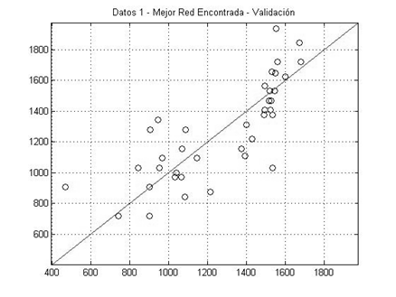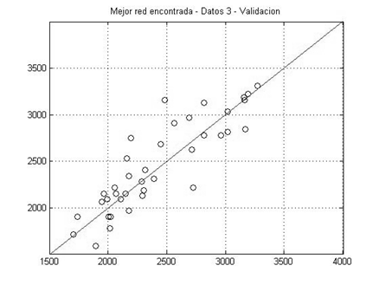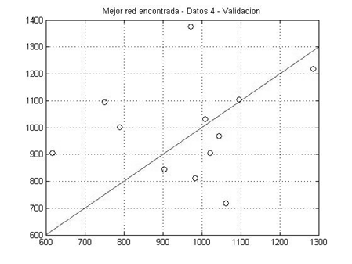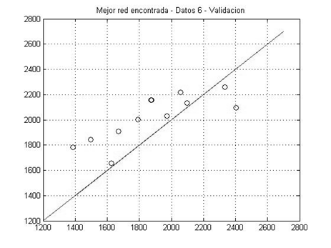

To analyze the relation type (lineal or no-lineal) between variables, the network with best performance (RNA_2) was computationally trained and validated by using a function for lineal activation expressed as:

**Figure 3.** Behavior of the artificial neural network with best performance, RNA_2: **(a)** Interrelation of the entrance variables with no-lineal activation function for the training and validation phases, respectively; **(b)** Interrelation of the entrance variables with lineal activation function for the training and validation phases, respectively. In circles are the values that were identified to follow a different behavior pattern.

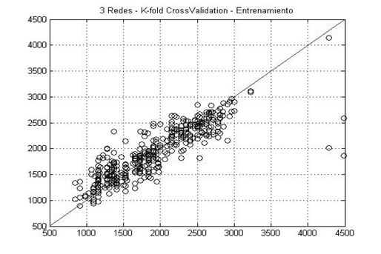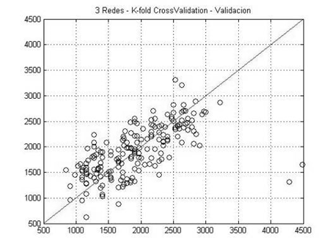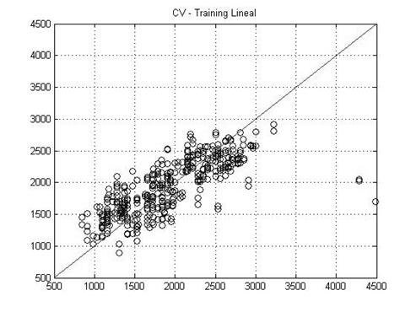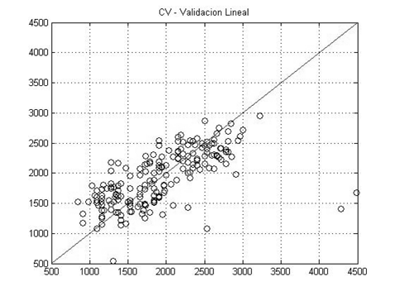

**(b)**

$f\left(Z\right)=Z$ (**7**)

being *Z* the expression that appears between the equation parentheses (**1**). The training and validation phase using a function for li-neal activation, is shown non Figure 3b; where it is exposed a similar behavior when the activation function is lineal, therefore from this specific estimation case, it could be concluded that variables relationship is based on a lineal dependence and such prediction is not affected if the variables relationship is no-lineal.

**Conclusions**

* The possibility to use artificial neural networks on the prediction of penetrance resistance at different soil depths was explored. The artificial neural networks with feedforward typology, backpropagation learning and multilayer architecture were constructed and evaluated using as performance indicators the relative error in the validation phase. According to this indicator, the artificial neural network to predict penetrance resistance at 20 – 30 cm depth is the one with better performance.
* Despite of the error obtained in the prediction, is important to notice that the best estimation for one of the greater depths (20 – 30 cm), in which the values of penetrance resistance at lesser depths (0 – 0 cm and 10 – 20 cm) was added as an entrance va-riable, suggests that the experiment should be done at lesser depths, reliving time and costs.
* The results of the present study show that using new artificial neural networks with better predictions, is an important contribution to research and professional application of soil science, because of: (1) Mechanical penetrance resistance, obtained with the standard cone index method, is used as a reliable indicator to correlate yield and soil; however, it should be done extensively on tilling areas and at four different depths. The option of using a prediction tool saves time and costs on experimental execution. (2) Rooting depth is defined as the thickness of the best zone for root development (Alliaume and Hill, 2008), it is classified into three groups: superficial (0 - 15 cm), media (15 cm - 30 cm), and deep (> 30 cm). It is important that the tool can report reliable predictions on resistance to mechanical penetrance at greater depths, since it allows knowing the soil conditions for a suitable development on those species of high economic importance which require more than 30 cm for rooting.
* It is suggested that the new artificial neural networks, take into account, additionally, as entrance variables, soil type, thermic floor location, tilling type, climate conditions, among others. Although some of these are qualitative variables, when treated as class variables they can be recognized by the artificial neural network and be associated to a behavior pattern.

**References**

Alliaume, F. and Hill, M. 2008. Propiedades físicas ¿en qué influyen?: dinámica del aire, dinámica del agua, crecimiento radicular. Presentación, Curso de Física de Suelos, Universidad Nacional de Colombia sede Palmira (Palmira – Colombia). (manuscrito).

Balbuena, R. 2009. Alternativas para la descompactación mecánica de los suelos. Taller Física de Suelos. Rio cuarto, Argentina. Actas III.

Bocco, M; Obando, G.; Sayago, S.; and Willington, E. 2007. Neural network models for land cover classification from satellite images. Agric. Téc. 67(4):414 - 421.

Bonilla, A. B.-H. 1998. Evaluación de la compactación de dos tipos de suelos causados por el tráfico del tractor en función de la presión de inflado de las llantas y del contenido de humedad del suelo. Tesis, Ingeniero Agrícola. Universidad Nacional de Colombia sede Palmira.

Bradford, J. M. and Gupta, S. C. 1986. Soil compressibility, methods of soil analysis. Madison. p. 479 – 492.

Brockett, P. L.; Cooper, W. W.; Golden, L. L.; and Xia, X. 1997. A case study in applying networks to predicting insolvency for property and casualty insurers. J. Operat. Res. Soc. 48:1153 - 1162.

Buendía, E.; Vargas, E.; Leyva, A.; and Terrazas, S. 2002. Aplicación de redes neuronales artificiales y técnicas SIG para la predicción de coberturas forestales. Serie Ciencias Forestales y del Medio Ambiente. Rev. Chapingo 8 (1):31 - 37.

Cerana, J.; Wilson, M.; Pozzolo, O.; De Battista, J. J.; Rivarola, S.; and Díaz, E. 2005. Relaciones matemáticas entre la resistencia mecánica a la penetración y el contenido hídrico en un Vertisol. Estudios de la Zona no Saturada del Suelo 7:159 - 163.

Colmer, T. D. 2003. Long-distance transport of gases in plants: a perspective on internal aeration and radial oxygen loss form roots. Plant, Cell Environ. 26:17 - 36.

Díaz, C. G.; Osinaga, R.; and Arzeno, J. 2010. Resistencia a la penetración, humedad del suelo y densidad aparente como indicadores de calidad de suelos en parcelas de largo plazo. XXII Congreso Argentino de la Ciencia del Suelo, Rosario, Argentina.

Díaz-Zorita, M. 2004. Effects of subsurface soil compaction of a typic hapludol on sunflower (*Helianthus annus* L.) Production. Ciencia del Suelo 22:40 - 43.

Ehlers, W.; Köpke, U.; Hesse, F.; and Bohm, W. 1983. Penetration resistance and root growth of oats in tilled and untilled loess soil. Soil Tillage Res. 3:261 - 275.

Foloni, J.; Calonego, J.; and De Lima, S. 2003. Efeito da compactação do solo no desenvolvimento aéreo e radicular de cultivares de milho. Pesqu. Agropec. Brasil. 38(8):947 - 953.

Fritz, L. W. 1999. High resolution commercial remote sensing satellites and spatial information systems. ISPRS Highligths 4(2).

García, I.; Rodríguez, J. G.; López, F.; and Tenorio, Y. M. 2010. Transporte de contaminantes en aguas subterráneas mediante redes neuronales artificiales. Inf. Tecnol. 21(5):79 - 86.

Gerster, G. and Bacigaluppo, S. 2004. Consecuencias de la densificación por tránsito en argisoles del sur de Santa Fe. Actas XIX Congreso Argentino de la Ciencia del Suelo, Paraná, Argentina.

Gerster, G.; Bacigaluppo, S.; Bodrero, M.; and Salvagiotti, F. 2010. Secuencia de cultivos, descompactación mecánica y rendimiento de soja en un suelo degradado de la región pampeana. Para Mejorar La Producción 45:59 - 61.

Gómez, O. Y. and Torres V. D. 1997. Efecto de la carga estática y presión de inflado en el grado de compactación del suelo. Tesis Ingeniero Agrícola. Universidad Nacional de Colombia sede Palmira.

Goyal, S. and Goyal, G. K. 2011. Cascade and feedforward backpropagation artificial neural network models for prediction of sensory quality of instant coffee flavoured sterilized drink. Can. J. Artif. Intell. Machine Learn. Pattern Recog. 2 (6):78 - 82.

Haykin, S. 1999. Neural networks: a comprehensive foundation. 2nd edition. Prentice Hall.

Hinton, G. 1989. Connectionist learning procedures. University Toronto.

Horn, R.; Domzal, H.; Slowinska-Jurkiewickz, A.; and Van Ouwerkerk, C. 1995. Soil compaction processes and their effects on the structure of arable soils and the environment. Soil Till. Res. 35:23 - 36.

Kimes, D. S.; Nelson, R. F.; Manry, M. T.; and Funk, A. K. 1998. Attributes of neural networks for extracting continuous vegetation variables from optical and radar measurements. Intern. J. Remote Sensing 19(14): 639 - 2663.

Kurkova, V. 1992. Kolmogorov theorem and multilayer neural networks. IEEE.ASSP Magazine 1:4 - 22.

López, J. A. and Caicedo, E. 2006. Una aproximación práctica a las redes neuronales artificiales. Conferencias. Curso de Redes Neuronales Artificiales, Universidad del Valle, Cali, Colombia. (manuscrito).

Maneta, M. and Schnabel, S. 2003. Aplicación de redes neuronales artificiales para determinar la distribución espacial de la humedad del suelo en una pequeña cuenca de drenaje: estudios preliminares. Estudios de la Zona no Saturada del Suelo 6:295 - 304.

Mas, J. F.; Puig, H.; Palacio, J. L.; and Sosa, A. 2002. Modelado del proceso de deforestación en una región del sureste de México. Memorias del II Seminario Latinoamericano de Geografía Física, Maracaibo, Venezuela, Julio 24-27. CD.

Mena, C. and Montecinos, R. 2006. Comparación de redes neuronales y regresión lineal para estimar productividad de sitio en plantaciones forestales, utilizando geomática. Bosque 27(1):35 - 43.

Moghassem, A. R.; Gharehaghaji, A. A.; Shaikhzadeh, S.; Palhang, M.; and Shanbeh, M. 2010. Application of artificial neural nets in carpet thickness loss prediction. World Appl. Sci. J. 9(2):167 - 177.

Moller, M. 1993. Efficient training of feed-forward neural networks. Ph.D. tesis. Arhus Univ. Daimi, Iran.

Pérez, V., S. 1997. Efecto de la carga estática del tractor en la compactación de un suelo franco y arcilloso. Tesis Ingeniero Agrícola. Universidad Nacional de Colombia sede Palmira.

Pinzón, A. and Amézquita, E. 1991. Compactación de suelos por el pisoteo de animales en pastoreo en el piedemonte amazónico de Colombia. Pasturas Tropicales 13(2):21 - 26.

Ponce-Cruz, P. 2010. Inteligencia artificial con aplicaciones a la ingeniería. Alfaomega, México.

Rangeon, N. I.; Aciar, L. M.; Osinaga, R.; Arzeno, J. L.; and Sánchez, C. 2008. Análisis de la resistencia a la penetración y humedad de suelo como indicadores de calidad en distintos sistemas de labranza. Actas XXI Congreso Argentino de la Ciencia del Suelo. Potrero de Los Funes, Argentina.

Rebolledo M., F. J.; Obregón N., N.; and Duarte, C. 2002. Ecohidroinformática: un nuevo paradigma para la gestión inteligente de los recursos hídricos. XXVIII Congreso Internacional de Ingeniería Sanitaria y Ambiental, Cancún, México, Octubre 27-31.

Refaeilzadeh, P.; Tang, L.; and Liu, H. 2008. Cross-Validation. Arizona State University. Tempe, USA.

Rodríguez O., J. G. 2009. Pronóstico de la migración de contaminantes en aguas subterráneas mediante redes neuronales artificiales. Tesis MSc. en Ingeniería Ambiental. Instituto Politécnico Nacional. México.

Rubio, C. 2005. Hidrodinámica de los suelos de un área de montaña media mediterránea sometida a cambios de uso y cubierta. Tesis Ph.D. en Ciencias del Suelo. Universidad Autónoma de Barcelona, Barcelona, España.

Rumelhart, D. E.; Hinton, G. E.; and Williams, R. J. 1986. Learning internal representations by error propagation. D.E. Rumelhart and J.L. McClelland (eds.). Parallel distributed processing, 1. MIT Press, Cambridge.

Saravia, S. 1997. Evaluación de las propiedades físicas del suelo en lo referente a la resistencia a la penetración y densidad aparente en distintos manejos de suelo. Universidad Nacional de Salta. Salta, Argentina).

Tam, K. Y. and Kiang, M. Y. 1992. Managerial applications of neural networks: The case of bank failure predictions. Manag. Sci. 38(7):926 -9 47.

The Math Works Inc. 2000. Neural Networks Toolbox. Version 4.0. User’s Guide. Natick, USA.

The Math Works Inc. 2002. Excel Link for use with Matlab®. Version 2.0. User’s Guide. Natick, USA.

Trujillo H., A. D. and Gómez A., L. E. 2007. Inteligencia artificial: emulación de mecanismos. TecnoIntelecto 4(2):116 - 120.

Valdés, N. J. 2010. Exploración y elaboración de una red neuronal artificial para determinar propiedades específicas en los suelos. Tesis Ingeniera Agrícola.Universidad Nacional de Colombia sede Palmira.

Valdés H., N. J. and González S., L. O. 2011. Una aplicación de redes neuronales artificiales en la estimación de la resistencia a la penetración en suelos. Castro, L.R.; Maciel, M.C.; and Castro, S.M. (eds.). Anales del III Congreso de Matemática Aplicada, Computacional e Industrial –MACI, Bahía Blanca, Argentina, Mayo 9-11. 3:227 - 230.

Varmuza, K. and Filzmoser, P. 2009. Introduction to multivariate statistics in chemometrics. (CRC Press).

Vidal, F. J. 1997. Efecto del contenido de humedad del suelo en la compactación causado por el tráfico de máquinas. Tesis Ingeniero Agrícola. Universidad Nacional de Colombia sede Palmira.

Viveros A., R. A.; and Jaramillo O., R. 2003. Caracterización e impacto físico en un Vertisol bajo uso intensivo del CIAT. Tesis Ingeniero Agrícola. Universidad Nacional de Colombia sede Palmira.