***Research article***

**Compaction on sugarcane cultivated soils in the south area of**

**Valle del Cauca, Colombia**

**Compactación de suelos cultivados con caña de azúcar en la zona sur del**

**Valle del Cauca, Colombia**

*Edgar Madero-Morales1*, Jorge Armando Ramírez-Alzate2†, Álvaro Albán2‡, Betsy Yadira Escobar3**, Luís Fernando García3††, and María Elvira Peña-Artunduaga3‡‡*

Associate Professor. Department of Engineering, Faculty of Engineering, Universidad Nacional de Colombia - Palmira. 2Universidad Nacional de Colombia -Palmira.

3Universidad del Valle, Cali, Colombia.

*Corresponding author: [eemaderom@unal.edu.co](mailto:eemaderom@unal.edu.co); †[jara85@gmail.com](mailto:jara85@gmail.com); ‡[alvaroalban75@gmail.com](mailto:alvaroalban75@gmail.com); **[betsyyadira@gmail.com](mailto:betsyyadira@gmail.com); ††[luisfega2@hotmail.com](mailto:luisfega2@hotmail.com); ‡‡[maripena@univalle.edu.co](mailto:maripena@univalle.edu.co)

Rec.: 08.04.11 Acept.: 26.11.11

**Abstract**

In 2008, the degree of compaction of the best land (Classes I and II agrologic) cultivated with sugarcane among the municipalities of Palmira, El Cerrito and Candelaria in Valle del Cauca, Colombia was measured. First, an index mapping compaction (IC) based on the bulk density from 0 to 15 cm deep in 144 sampling points was performed. The mapping of these classes was obtained from the detailed study of soils in this area with the help of ArcGIS® software. Se–cond, we assessed the influence of compaction rates prevailing on some hydrodynamic properties and soil moisture regime (R.H.S), for that, two measurement points were located in each of the three soils for 75 days. Third, we found the effectiveness of R.H.S prediction by the simulation model SOMORE. The study showed that the soils do not have high levels of compaction, and also exhibited high organic matter content (4% to 6%). It was found that the hydrological characteristics and moisture retention are at adequate workability, additionally, the R.H.S is negatively affected by rainfall, but did not differ between treatments. The SOMORE model was acceptable and practical to estimate the R.H.S.

**Key words:** Soil compaction index, soil consistency, soil moisture regime, SOMORE.

**Resumen**

En el estudio se midió la compactación de suelos agrupados en las clases agrológicas I y II cultivados con caña de azúcar entre los municipios de Palmira, El Cerrito y Candelaria en el Valle del Cauca, Colombia. Inicialmente se hizo la cartografía de un índice de compactación (IC) con base en la densidad aparente entre 0 y 15 cm de profundidad en el suelo, en 144 puntos de muestreo. La cartografía de estas clases se obtuvo del estudio detallado de suelos de este sector con la ayuda del software ArcGIS®. Posteriormente se evaluó la influencia de los índices de compactación predominantes sobre algunas propiedades hidrodinámicas y el régimen de humedad del suelo (R.H.S). Para ello se ubicaron dos puntos de medición en cada uno de los tres suelos durante 75 días. Finalmente, con el uso del modelo de simulación Somore se confirmó la efectividad de predicción del R.H.S. El estudio mostró que los suelos no presentan altos grados de compactación, pero sí altos contenidos de materia orgánica (4% - 6%). Se encontró que, las características hidrológicas, retención de humedad y de laborabilidad son adecuadas; el R.H.S fue afectado negativamente por el régimen de lluvias, pero no presentó diferencias entre tratamientos. El modelo Somore resultó aceptable y práctico para estimar el R.H.S.

**Palabras clave:** Consistencia, índice de compactación, régimen de humedad, SOMORE.

**Introduction**

Valle del Cauca is located at the southeastern of Colombia and is part of the Andean and Pacific regions. Due to the high natural ferti-lity of soils, a flat topography and warm weather, this area grows around the 60% of the sugar agroindustry (Carbonell *et al.*, 2001), which is the main agricultural sector on the regional economy. Intensive land use and agricultural practices under high humidity conditions, generate problems with physical degradation on the structural stability, porous space organization and arable layer density. Those characteristics could difficult soil water and nutrient use, and originate changes on moisture regime, fertility and irrigation frequency (Greenland and Lal, 1977; Greenland and Szabolcs, 1994).

Taking into account the above, it was considered important to evaluate the degree of compaction on sugarcane cultivated soils in Palmira, El Cerrito and Candelaria in Valle del Cauca, Colombia, and to estimate its influence on some soil hydrodynamic properties and moisture regime (Lozano *et al.*, 2005). Additionally, the simulation model SOMORE (Pla, 1997) was validated. It is a free software that predicts the soil moisture regime in function of the daily water balance and the physical properties of the soil such as, average ratio of infiltration, saturated hydraulic conductivity under the root zone, characteristic moisture curve, liquid limit and plastic limit.

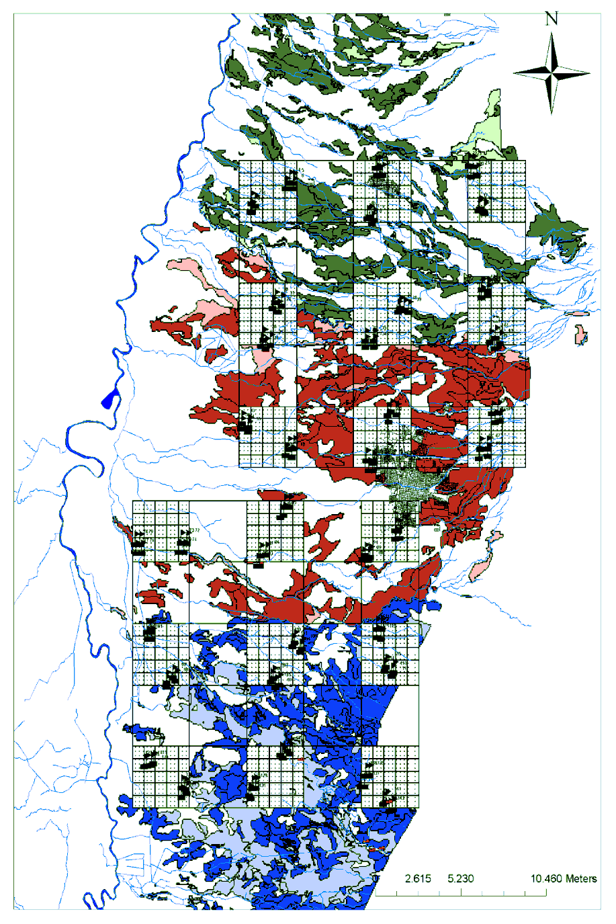

0.7 Km

7 Km

**Figure 1.** Sampling distribution in a natural logarithm pattern. Grid located between Palmira and Candelaria

**Source**: From the Detailed Study of Soils (IGAC, 1969 - 1971a, b).

**Materials and methods**

## Compaction, rapid infiltration and hydraulic conductivity cartography

## The cartography of a compaction index (IC) in organic matter (M.O.) homogeneous areas and size particle distribution (DPT) was done based on bulk density in the field (Lozano et al., 2005). The studied soils –agrologic classes I and II- have been cultivated with sugarcane for several years and are considered to have a high use capacity according to the Soil Conservation Service of US. (Klingebiel and Montgomery, 1961). The areas belonging to those classes were obtained from a detailed soil study on the flat part of Palmira, El Cerrito and Candelaria (IGAC, 1969) by the ArcGIS application. There were in total 144 sam–plings in about 50000 Ha. distributed on a grid of points that follow a natural logarithm distribution pattern (Riezebos, 1989), this, with the aim of taking into account the variable range length (7000 m), middle (700 m), short (70 m) and very short (7 m) (Figure 1). Each point was measured for: bulk density (D.A.) by the excavation method (USDA, 1999), soil moisture and rapid infiltration (TIr) (USDA, 1999), saturated hydraulic conductivity (Kh) under 15 cm of depth (USDA, 1999), size particle distribution (Jaramillo, 2002) and organic carbon (modified from Walkey Black), dividing in the laboratory, where possible, the organic fractions without decomposition from each sample.

To develop the IC, 10% of the samples were discarded since they had larger fragments (>2 mm) in more than 25% of their volume, which significantly affects the D.A.

## Physical properties and R.H.S. in function of the modals IC

For each IC –IC4 or friable consistency, IC3 or very friable consistency, or IC2 or soft consistency- two locations were selected. Sampling points were located in three sugarcane farms in Palmira: La Josefina farm in Km. 3 to Candelaria, La Gertrudiz farm 10 Km north from Palmira, and El Porvenir farm located in La Reforma, Amaime. They belong to median terraces on the Cauca river alluvial valley, 1000 m.a.s.l, annual rainfall average between 1000 and 2000 mm, average temperature 24 °C, 75% R.H. and life zone of tropical rain fo–rest. Soils are classified as loamy fine Pachic Haplustoll isohyperthermic mixed (La Josefina farm), loamy coarse Fluventic Haplustoll isohyperthermic mixed (La Gertrudiz farm), and loamy fine Cumulic Haplustoll isohyperthermic mixed (IGAC, 1969).

To measure R.H.S. daily samplings were done between 9 and 11 a.m. to avoid high evaporation rates caused by solar radiation. Soil samples from 0-15 cm were taken with a punch during 75 days, they were weighted on the field and dry out at 105 °C in an oven for 24 hours. Infiltration was determined with a ring infiltrometer and once the test was done it was covered with a black plastic for 48 hours. After that time, samples at 15 cm depth were taken (200 – 300 gr.) to determine field capacity moisture (Jaramillo, 2002).

Saturated hydraulic capacity was measured by the ´raising/falling head´ method (Bagarello *et al.*, 2004). Water retention curves were determined by the pressure method at 0.1, 0.3, 1, 5 and 15 bar (Jaramillo, 2002). Liquid and plastic limits were obtained by the standard Casagrande method and soil rolls, respectively (Jaramillo, 2002). Soil moisture was plotted in a Cartesian axis vs. time, having into account the retention curves for each soil.

## Somore software validation

## Soil daily moisture retention curve was estimated with the software Somore and compared graphical and statistically with the real moisture curve for the same days. To compare, the variables number of days with readily available water (LAFA) and number of days under the plastic limit definitions were used.

The experimental design was a randomly complete design with two replicates, and the treatments were the three compaction types on the studied soils. The LAFA and days under the plastic limit variables were compared by variance analysis and Duncan mean comparison test (P < 0.05) between the real LAFA and the one simulated by Somore, this allows the establishment of differences or approximations between the models.

Additionally, an Andeva was done using other physical characteristics like mean infiltration ratio (TI), permeability (Ib), accumulated water (La), sand percentage (A), dispersion coefficient (CD), readily available water (LAFA) over available water (LAA) index, number of days in LAFA and accumulated water between field capacity and moisture at 1.5 bar (PMT).

**Results and discussion**

## Compaction, rapid infiltration and hydraulic conductivity cartography

The most frequent D.A. values (89%) were < 1.35 gr/cm3, it means that these soils with a high usage capacity have relatively low densities. Around 11% of the soils presented densities >1.45 gr/cm3 due to a high sand content and/or coarse fragments, which favors a low compaction and as such were discarded from the analysis. The latest is related to both a conservationist agricultural management to soils innate resilience (IGAC, 1969; Greenland and Lal, 1977; Greenland and Szabolcs, 1994)(Figure 2).

According to the density values and the acceptable values for hydraulic conductivity at 15 cm depth, good conditions for superficial infiltration of water through the soil were predominant and therefore, for irrigation (Pla, 1997) in a range around 2 and 5 mm/h. These properties were not mapped due to the low spatial dependence presented (Figure 3 and 4).

The majority of the samples (97%) presented IC values in the first four levels of a scale up to 9 that coincide with friable and soft consistencies, this indicates low compaction between 0 and 15 cm depth and good structural and tillage conditions. The highest ICs were detected in the eastern part of the map due to the superficial increments of sand fractions coming from alluvial contributions on these higher lands (Figure 5).

**Figure 2.**  Percentage distribution of bulk density in the field (g/cm3).

**Figure 3.** Infiltration ratio frequencies (mm/h).

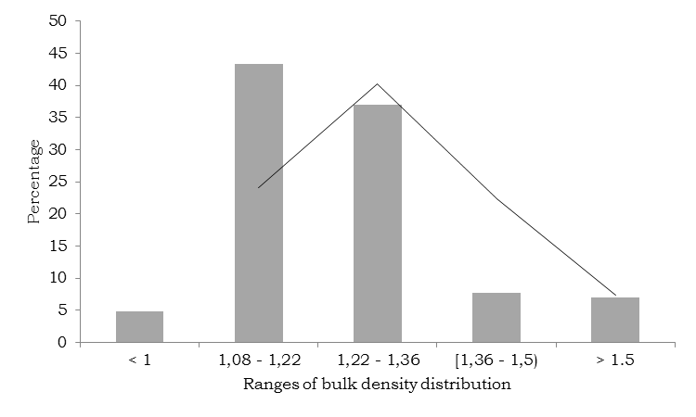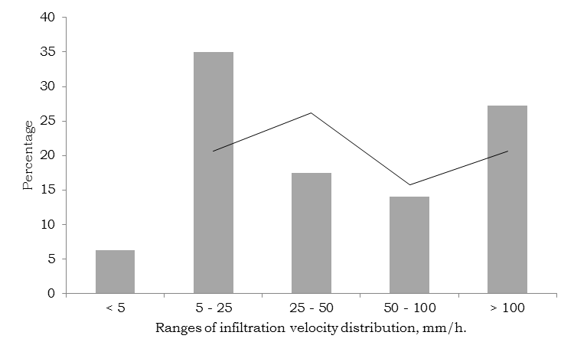

The average M.O. was 4.85 ± 25%. The most frequent range was 2.5 – 5 % (70%), which shows a significant increment if it is compared to the 60’s and 70’s when it was around 1.5% on flat lands (IGAC, 1969). According to Greenland and Szabolcs (1994) the critical level on sustainable systems should be around 5% to ensure the good quality of the soils in the time. These results suggest that a sustainable soil management is being done in terms of physical soil properties and sugarcane residues (leaves, compost, vinasse) recycling, since these elements contribute to soil M.O. especially in sugarmill owned properties (Figure 6).

|  |  |  |  |  |  |  |  |  |  |  |  |  |  |  |
| --- | --- | --- | --- | --- | --- | --- | --- | --- | --- | --- | --- | --- | --- | --- |
| **Table 1.** Average values – Physical properties for three compaction degrees. | | | | | | | | | | | | | | |
| **Pointa** | **Compaction degree** | **I.C.** | **LA** | **VI** | **Ib** | **Ar**  **(%)** | **A**  **(%)** | **C.D.** | **M.O**  **(%)** | **Lp** | **C.C.** | **1.5 bar** | **15 bar** | **LAFA/**  **LAA** |
| 42 | Friable | 4/9 | 91.3 | 14.2 | 8.8a* | 29.0 | 34.3 | 7.3 | 4.3 | 36.9 | 49.1 | 34.4 | 20.8 | 0.6 |
| 95 |
| 136 | Very friable | 3/9 | 70.1 | 11.8 | 6.8a | 35.8 | 23.6 | 9.3 | 4.0 | 35.9 | 50.3 | 30.9 | 21.2 | 0.7 |
| 137 |
| 92 | Soft | 2/9 | 105.7 | 12.9 | 24.0b | 29.8 | 31.0 | 6.9 | 3.8 | 30.0 | 45.3 | 31.2 | 20.5 | 0.6 |
| 94 |
| LA: Stored water, VI: Infiltration velocity, Ib: Basic infiltration, % Ar: Clay percentage, % A: Sand percentage, CD: Dispersion coefficient, M.O: Organic matter, Lp: Plastic limit, CC: Field Capacity, 1.5 bar: Temporal Wilting Point, 15 bar: Wilting Point, LAFA: Readily available water, LAA: Available water.  a. Data point number in the original database, total 144.  * Values on the same column followed by equal letters do not differ statistically (P < 0.05), according to Duncan test. | | | | | | | | | | | | | | |

**Figure 4.** Hydraulic conductivity frequencies (mm/h), 0 - 15 cm.

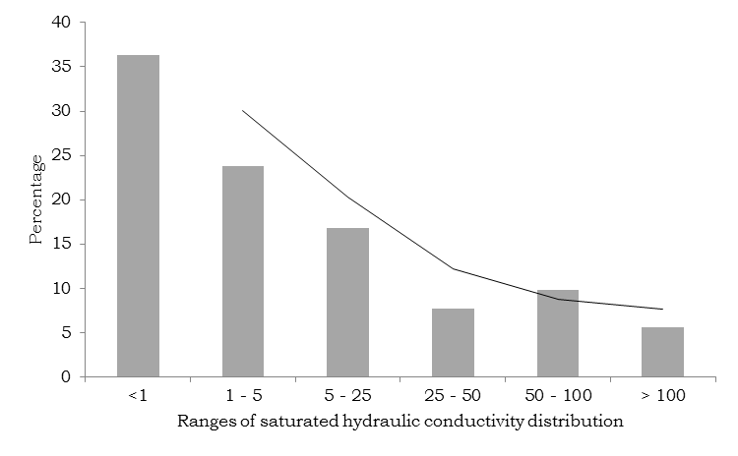

## Physical properties and R.H.S in function of the modals IC

## Studied soils had an arable layer with high M.O. contents (4%) and clay between 30 and 35%, which is enough to classify them as soils with very good workability (Table 1).

IC showed values < 5, which belong to no-compacted soils, as it is shown with adequate and similar physical properties and hydrologic and water retention parameters (Table 1).

The available water accumulated in the soil by the moisturizing process reached values around 70 and 100 mm, which are considerate suitable for rainfed or irrigated agriculture. The infiltration average value was > 10 mm/h, with basic infiltration > 5 mm/h, which are expected values for soils with high capacity usage (Jaramillo, 2002)**.**

In the three compaction degrees, dispersion coefficients were < 10, which are really low in relation to the critical level that is 25; therefore, the analyzed soils have high structural stability (Castillo et al., 2000).

LAFA:LAA ratio (readily available water: available water) was around 60%. It is a value close to the desirable one for high yield agriculture and it is directly proportional to high field capacity levels, which were in average, 50% of the total porosity.

The plastic limit was close to the moisture at 1.5 bar, which is similar to the temporal wilting point, meaning that the soil has good workability capacities allowing crop practices without degradation damages (Jaramillo, 2002)**.**

The number of days with readily available water varied between 20 and 40 days for the 75 days included in this analysis, this was in agreement with the low rainfall regime presented, nonetheless, treatments had no effect on this characteristic (P < 0.05) (Table 2).

|  |  |  |  |  |  |
| --- | --- | --- | --- | --- | --- |
| **Table 2.** Soil moisture regime mean comparison on the three compaction levels (P > 0.05). | | | | | |
| **Point** | **Compaction degree** | **I.C.** | **Days**  **(CC – PMT)** | **Lam.**  **(CC – PMT)** | **Days ≤ Lp** |
| 42 | Friable | 4/9 | 26.5 | 1553.7 | 72.5 |
| 95 |
| 136 | Very friable | 3/9 | 39.5 | 1954.4 | 71.5 |
| 137 |
| 92 | Soft | 2/9 | 19.5 | 848.8 | 51.5 |
| 94 |

|  |  |  |  |
| --- | --- | --- | --- |
| **Table 3.** Mean comparison for the Somore model. (P > 0.5). | | | |
| **Method** | **Days**  **(CC – PMT)** | **Lam.**  **(CC – PMT)** | **Days ≤ Lp** |
| REAL | 28.5 | 1452.3 | 65.1 |
|
| SOMORE | 22.8 | 1307.5 | 58.2 |
|

Readily available water (LAFA = Lam CC – Lam in 1000 cm) fluctuated, approximately, between 850 and 2000 mm (P > 0.05) and was correlated with the number of days with readily available water, hence the consequences cannot be attributed to soil conditions but, to the water balance (Table 2). The results relate to soils with good workability, since most of the time, including rainfall seasons, soils showed real moisture contents under this limit without statistical differences among them (P > 0.05) (Table 2).

## Somore validation

According to the variables studied, the Somore model was valid to predict soil water regimes (Table 3). However, it tends to underestimate the parameters, perhaps due to the methodology used to measure evapotranspiration, since a radiometer was not used.

**Conclusions**

* El Cerrito, Palmira and Candelaria soils included in this study did not show compaction according to the I.C., physical properties and R.H.S.
* Soils showed increments in the M.O. content compared to previous data, with ranges between 4 and 6%.
* R.H.S. did not vary among the predominant compaction indexes (I.C.) of this study. Soil water properties have not been altered and their levels are optimal for intensive agriculture, which suggest good management practices through time. Somore simulation model predicted reasonably the arable layer R.H.S.

# Acknowledgements

To the Universidad Nacional de Colombia – Sede Palmira for funding and support on the Project; to the physics of soil lab for the collaboration doing the analysis, and to the sugarcane mills MANUELITA, PROVIDENCIA and INCAUCA for their generous and prompt collaboration to perform the test son the farms.

**References**

Bagarello, V.; Iovino, M.; and Elrick, D. 2004. A simplified falling-head technique for rapid determination of field-saturated hydraulic conductivity. Soil Sci. Soc. Am. J.68: 66 - 73.

Castillo, J.; Amézquita, E.; and Müller-Sämann, K. 2000. La turbidimetría una metodología promisoria para caracterizar la estabilidad estructural de los suelos. Suelos Ecuatoriales 152 - 156p.

Carbonell, J.; Amaya, A.; Ortiz, B.; Torres, J.; Quintero, R.; and Isaacs, C. 2001. Zonificación agroecológica para el cultivo de caña de azucar en el valle del río Cauca, tercera aproximación. Cali: Centro de Investigación de la Caña de Azúcar de Colombia (Cenicaña).

Greenland, D.; Lal, R. 1977. Soil conservation and management in the humid tropics. International Institute of Tropical Agriculture, Agricultural Research Council of Nigeria. Wiley. 283 p.

Greenland, D.; Szabolcs, I. (eds.). 1994. Soil resilience and sustainable land use. CAB International. Wallingford, Oxon. UK.

IGAC (Instituto Geográfico Agustín Codazzi). 1969. Estudio detallado de suelos del sector plano de los municipios de Cali y Jamundí. Mapa de unidades agrológicas escala 1:40.000. Santa Fe de  Bogotá.

IGAC (Instituto Geográfico Agustín Codazzi). 1971a. Estudio detallado de suelos del sector plano de los municipios de Candelaria. Mapa de unidades agrológicas escala 1:40.000. Santa Fe de  Bogotá.

IGAC. (Instituto Geográfico Agustín Codazzi). 1971b. Estudio detallado de suelos del sector plano de los municipios de El Cerrito, Guacara y Ginebra. Mapa de unidades agrológicas escala 1:40.000. Santa Fe de Bogotá.

Jaramillo, D. F. 2002. Introducción a la ciencia del suelo, Universidad Nacional de Colombia, Medellín, Antioquia, Colombia. p. 216 - 248.

Klingebiel, A. A.; Montgomery, P. H. 1961. Land-capability classification. Agri. handb. 210. USDA. Soil Conservation Service, Washington, DC.

Lozano, J.; Madero, E.; Herrera, O.; Tafur, H.; and Amézquita, E. 2005. Puesta a prueba de un indicador sencillo de degradación en suelos histeréticos del Valle del Cauca, Colombia. Acta Agronómica 54(2):1 - 13.

Pla, I.1997. A soil water balance model for monitoring soil erosion processes and effects on steep lands in the tropics. En: I. Pla (editor). Soil Erosion Processes on Steep Lands. Special Issue of Soil Technology. Elsevier. Amsterdam. p. 17 - 30.

Riezebos, H. Th. 1989. Application of nested analysis of variance in mapping procedures for land evaluation. Soil use manag. 5(1):25 - 30.

USDA (United States Department Agriculture). 1999. Soil quality test kit guide. Trad. Inst. Suelos Arg. Julio 2000. 88p.

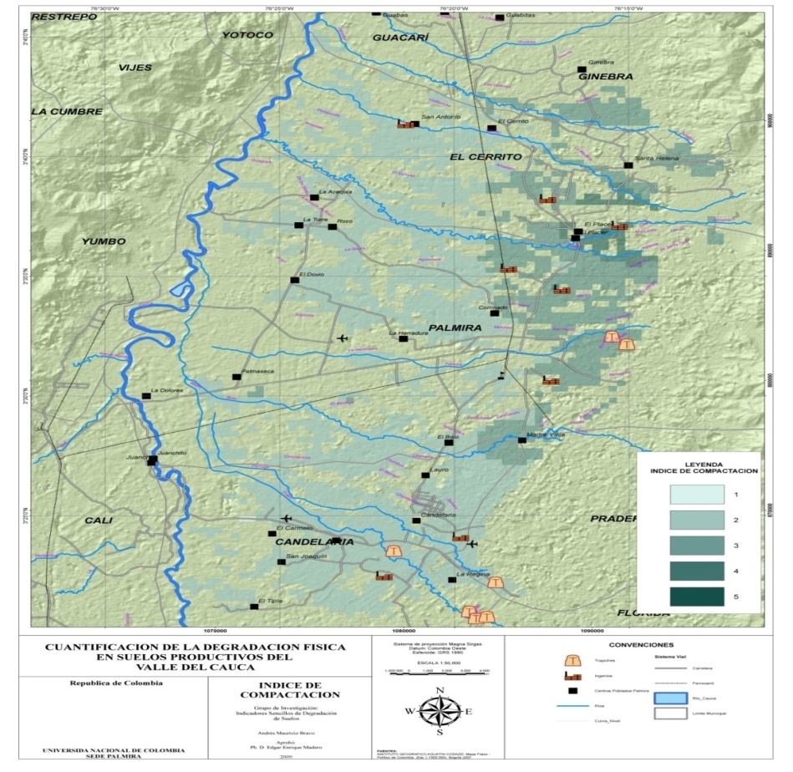

**Figure 5.** Compaction index – I.C. cartography (scale 1-5) between 0 to 15 cm.

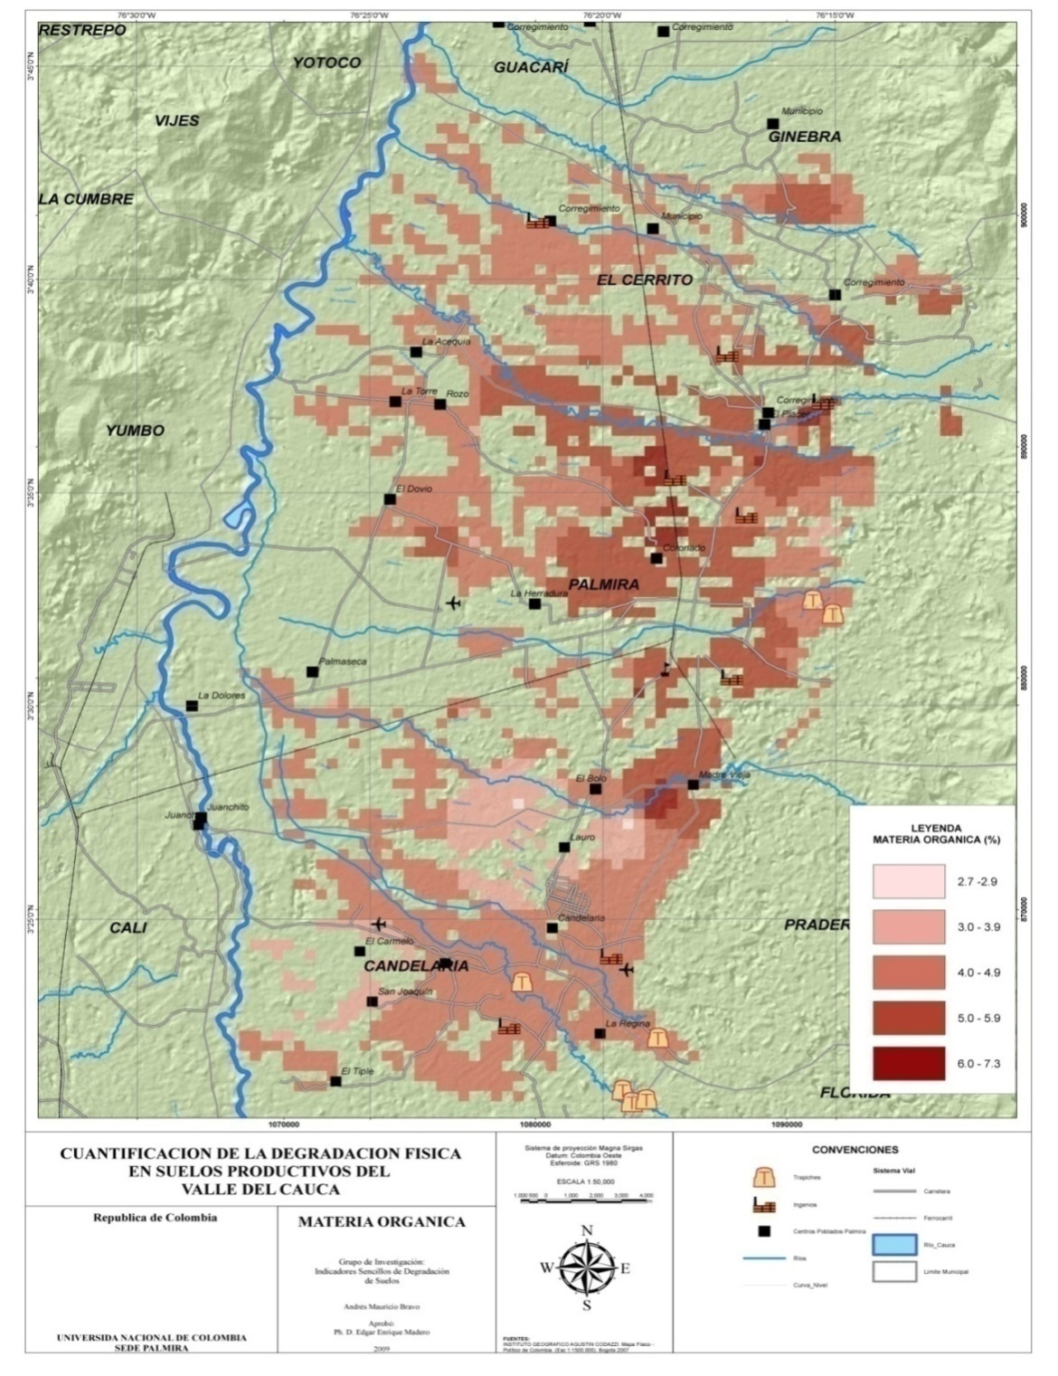

**Materia Orgánica**

**Figure 6.** Soil organic matter-M.O.(%) cartography between 0 and 15 cm.