Artículo científico

Effect of the immersion in 1-Metylciclopropene on the physicochemical and physiological properties of yellow pitahaya fruit (Selenicereus megalanthus How) with minimum processing
Efecto de la aplicación de 1-Metilciclopropeno por inmersión sobre las características fisicas, quimicas y fisiológicas de pitahaya amarilla (Selenicereus megalanthus How) mínimamente procesada

Liliana Serna-Cock1, Diego Fernando Segura-Rojas1, y Alfredo Ayala-Aponte2

1 Facultad de Ingeniería y Administración, Universidad Nacional de Colombia sede Palmira
2 Escuela de Ingeniería de Alimentos, Universidad del Valle, Cali, Colombia
*Autor para correspondencia:lserna@unal.edu.co

Rec.: 05.04.11 Acept.: 27.10.11

Resumen

La pitahaya amarilla (Selenicereus megalanthus How) es una fruta exótica con gran potencial comercial. No obstante, sólo ha sido aprovechada comercialmente como fruta entera, sin procedimientos que le den valor agregado y mayor tiempo de vida de anaquel. En este trabajo se evaluó la aplicación de 200 mg/lt de 1-MCP (Metylciclopropene) en pitahaya amarilla mínimamente procesada (rodajas con cáscara y sin cáscara), empacada al vacío y almacenada bajo refrigeración, sobre la intensidad respiratoria y parámetros de calidad como sólidos solubles, acidez total titulable, pérdida de peso, azúcares totales, firmeza y color. La aplicación de 1-MCP aumentó la producción de C02, lo cual se manifestó en mayores contenidos de sólidos solubles y azúcares totales, pero no incidió en la pérdida de peso, variación de la acidez total titulable, cambios de color y retención de la firmeza. En ambos tipos de procesamientos se logró reducir durante el almacenamiento la pérdida de vitamina C.

Palabras clave: Color, firmeza, fruta tropical, sólidos soluble, tasa respiratoria, vitamina C.

Abstract

Yellow pitahaya (Selenicereus megalanthus How), is an exotic fruit with great commercial potential, it has been commercialized without using methods that add value and/or prolong its shelf-life. The effect the application of 200 mg/lt 1-MCP on the respiratory rate and quality properties of vacuum sealed minimally processed yellow pitahaya slices during shelf-life under refrigeration was evaluated. Soluble solids, total titratable acidity, weig%t loss, total sugars, firmness and color were measured in fruit slices with and without skin. The application of 1-MCP before storage increased the respiratory rate and consequently increased soluble solids and total sugars, and did not show any detrimental on weight loss, total titratable acidity, color c%anges and firmness. &owever, t%e application of 1-MCP reduced loss of vitamin C in yellow pitahaya slices with and without skin during storage time.

Key words: Color, firmness, respiratory rate, soluble solids, tropical fruit, vitamin C.

Introduction

Global changes in food habits have genera- ted a consumer sector demanding healthier, additives–free, and fresh-like food products. Minimally processed food products have ex- perienced growing demand (Rico et al., 2007) since consumers recognize t%eir benefit and quality (Djioua et al., 2009). This tendency has stimulated research and development of new technologies focused on conservation and storage of minimally processed fruits and ve- getables (Oms-Oliu et al., 2010; Soliva-Fortuny and Martin-Belloso, 2003).
the shelf-life of yellow pitahaya (Selenicereus megalanthus How).
Yellow pitahaya is an exotic fruit with increasing worldwide acceptance due to its pleasant taste and attractive shape and color (Baquero et al., 2005). The application of 1-MCP prior to minimal processing, could be an alternative for preserving nutritional and organoleptic quality of fruits (Arias et al.,
2009; Mao et al., 2007).
The objective of this study was to assess the effect of minimal processing (slicing with and without skin) and the application of 200
-1

In minimal processing, fruits and veg-
mg.L
of 1-MCP on the respiratory rate (RR),

etables are subjected to one or more unit operations, including peeling, cutting and slicing (Hong et al., 2000). These processing operations cause the rupture of cell walls and tissues (Watada and Qi, 1999) which in turn accelerate physiological and biochemical pro- cesses such as respiration and ethylene pro- duction (Ahvenainen, 1996; Soliva-Fortuny and Martin-Belloso, 2003). Such reactions reduce fruit shelf-life due to appearance, texture, flavor, and8or aroma degradation (Ahvenainen, 1996; Rico et al., 2007).
1-methylcyclopropene (1-MCP), an ethyl- ene inhibitor, is used to extend the shelf-life and maintain the quality of plant products (Dong et al., 2002). 1-MCP reduces matura-
tion by partially blocking ethylene receptors
weig%t loss, color c%ange <=E), soluble sol-
ids (SS), total sugars, total titratable acidity
<TTX), vitamin C <ascorbic acid) and firmness of yellow pitahaya fruits.

Materials and methods

Plant material
Yellow pitahaya fruits with a maturity stage three, according to the NTC 3554 standard classification, were selected <ZC0NTEC, 1996). The fruit orchard is located in Roldadillo, Valle del Cauca, Colombia (4°24’37’’ N and
75°93’72’’ W, 1500 masl). Harvested fruits were selected, scrubbed using soft-bristle brushes to remove spine residues and organic matter, washed and sanitized using chlorina-
-1

in plant cells, thus increasing available time
ted water (200 mg.L
), and then rinsed with

for proper fruit storage (Osuna et al., 2005).
1-MCP at various concentrations was used to effectively extend the shelf-life of fruits such as bananas (50 nL.L-1; Jiang et al., 1999), strawberries (2μL.L-1; Tian et al., 2000), kiwis (0.5 μL.L-1; Koukounaras and Sfakiotakis,
2007), pears (300 nL.L-1; Spotts et al., 2007), plums and apricots (500 μL.L-1 concentrated stock in a 1L sealed bottle; Dong et al., 2002), and vegetables such as broccoli (12 μL.L-1; Able et al., 2002), avocados (30-70 nL.L-1; Feng et al., 2000) and tomatoes (250 nL.L-1; Mostofi et al., 2003). There are also reports combining 1-MCP and minimal processing in pears (300 nL.L-1 and 1μL.L-1; Arias et al.,
2009; Lu et al., 2009), pineapples (1μL.L-1;
Rocculi et al., 2009) and kiwis (1μL.L-1; Mao et al., 2007). However, these combined methods had not been previously reported to extend
distilled water. Finally, the fruits were classi-
fied and grouped based on specific treatment, dried using a paper towel, and immersed in the 1-MCP solution.

1-MCP preparation
A powder 1-MCP formulation (3.8% w/w) ob- tained from Rohm and Haas (Philadelphia, Pennsylvania) was used. The 1-MCP appli- cation was made by immersion following instructions by the manufacturer. Forty liter solutions were prepared in a plastic container with a 200 mg.L-1 concentration at 25±1°C.
The immersion time for each treatment was
10 minutes. The selected 1-MCP concentration and immersion time were based on previous studies in pitahaya where the commercial life of the whole fruit was extended (Serna-Cock et al., 2011). After each immersion, the fruits

were rinsed in distilled water (5 min) and dried using absorbent paper.

Minimal processing and packaging
After treatments, fruits were subjected to two cutting protocols: slicing with skin (S) and slicing without skin (NS). Slices (1 cm thick and 4±0.2 cm diameter) were done using a Ja- var (model GE 250, Bogotá, Colombia) cutter.
The minimally processed pitahaya fruits were vacuum packaged (EGAR Vac. S.C.P ba- sic -B, Spain), using a flexible polyamide and low-density polyethylene coextruded with 70 μm thickness, 39 cm3 m-2 24h-1, atm-1 y 23°C-
1, permeability to O2, 107 cm3 m-2 24h-1, atm-1
y 23°C-1, permeability to CO2, and 10.2 gm-2
24h-1 atm-1 y 38°C, water vapor permeabil-
ity. The bags were sealed with a 1.5 kg.cm-2 pressureat 160°C for 3 seconds. The pitahaya fruits were then stored in an environmentally controlled chamber (1000 L Dies, Colombia) at 8±2°C and 85-95% relative humidity.
The following nomenclature was used: S-200 and NS-200 to identify pitahaya fruits pre-treated with 200 μg/lt of 1-MCP and then cut in slices with skin (S) and without skin (NS); S-0 and NS-0 to identify control (un- treated) fruit slices with and without skin (S and NS, respectively).
Respiratory rate (RR)
The respiratory rate was measured by ti- tration and expressed as mg.CO2.kg-1.h-1, following a modification to t%e met%odology described by Parra-Coronado et al. (2006). A refrigerated temperature controlled chamber was used, externally equipped with a com- pressor (Electromec Shulz and Fiat, Colom- bia), CO2 traps placed at the beginning and end of airflow, and a moisture trap saturated with silica grain gel columns. The CO2 traps included 2 bottles containing 50 mL of 2 N KOH each and 6 bottles containing 50 mL of 0.1 N NaOH each. Internally, the chamber contained six desiccators (Bel-Art, Pequan-
nock, New Jersey, USA) equipped with input and output hoses (Figure 1).
The compressor (1) allowed external air to flow for 30 minutes into t%e initial C02 traps (2) to eliminate the CO2 present in the air. Then, the CO2-free air was blown first through the moisture trap (3) to remove the water vapor and second through the desic- cators (4) containing the previously weighed minimally processed pitahaya fruits. The desiccators were hermetically sealed allow- ing the resulting air from fruit respiration to be collected in the secondary CO2 traps (5). Xfter 30 minutes, t%e airflow was stopped and

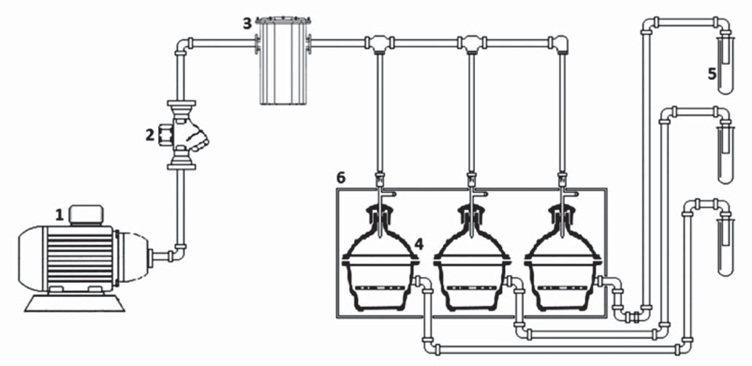
Figure 1. Diagram of the device used to estimate respiratory rate. 1. Air compressor, 2. CO2 Trap (2N KOH), 3. Humidity trap (silica gel), 4.Desiccators, 5. Secondary CO2 Traps (0.1 N NaOH).

the secondary CO2 traps were removed from the system and immediately sealed. A 20 mL aliquot from each CO2 trap was mixed with
15 mL of 10% w/v BaCl2 and 4 drops of phe- nolphthalein. The solution was immediately titrated with 0.1 N HCl.
The respiratory rate was determined us- ing equations 1 and 2.

(Vb-Vm)*NHCL*22*f
ric acid to molybdenum blue by the action of ascorbic acid. The results were expressed in mg.100 g-1 of fles%.

Physical Analysis
Weight loss was determined by measuring the wet weight from three minimally processed pitahaya fruits slices per treatment, using a three-decimal precision scale (Metler Toledo

RR= mgCO2
kg*h

where:

=

f= VNaOH
Valiquot

w*t
(Eq.1)

(Eq. 2)
1200, Columbus, Ohio, USA). Fruits were weighted at days 0 and 12, and weight loss percentage was estimated.
Firmness was determined by uniaxial compression (force vs. distance) using a tex- ture analyzer (Shimadzu, EZ-Test, Somerset,

RR= Respiratory rate expressed in mg.CO2. kg-1.h-1
Vb = Volume (mL) of HCl used in blank titration
Vm = Volume (mL) of HCl used to titrate the sample
NHCl = Normality of HCl used in the titration w = sample weight (kg)
t = test time (hours) (elapsed time were the compressor is turned on)
22 = milliequivalent weight of CO2 (g-meq) f = sample factor = volume of NaOH used in the respiration meter/total solution
volume (BaCl2 and phenolphthalein)

Chemical Analysis
Soluble solids were estimated by extracting t%e juice from t%e %omogenized fles% and using a refractometer (Attago Hand Held
500 HRS, Washington, USA) following AOAC
method 932.12 (AOAC, 2000a). Total soluble
New Jersey, USA). Firmness was determined
as the highest peak after plotting force vs. distance. A cylindrical geometry (40 mm diameter), penetrating at 10 mm.min-1 and maximum deformation distance of 8 mm was used. Pitahaya fruit slices (1 cm thickness
and 4 cm diameter) were used to perform the tests.
The surface color of minimally processed pitahaya fruit slices was estimated by mea- suring the CIE-L*, a*, b* coordinates, with a D65 standard illuminant and 10º observer, using a Color flex colorimeter <&unter Lab., Reston, Virginia, USA). Thirty six measure- ments were made for each storage time cor- responding to three measurements per slice, three slices per treatment, and four treat- ments. Differences in color <=E) were esti- mated comparing a fresh sample as shown in equation 3 (Mendoza et al., 2006).

solids, total titratable acidity, and vitamin C content were determined by mas%ing t%e fles% from three pitahaya packages. The total ti-

where:
AE =
(AL*)2 + (Aa*)2 + (Ab*)2
(Eq. 3)

tratable acidity was determined at 20±2°C by using X0XC official met%od 942.15X <X0XC,
2000b), and was reached and expressed as equivalents gram of citric acid. Total sugars were determined by spectrophotometry (Ge- nesis UV10 Thermo Spectronic, Boston, USA) following the Antrona method (DuBois et al.,
1956). Vitamin C content was estimated with a reflectometer <RQflex 10 plus, Merck, Darm- stadt, Germany) with a 25-450 mg.L-1 mea- suring range for ascorbic acid. The method consists of reducing yellow molybdophospho-
L*: Luminosity
a*: red to green color b*: blue to yellow color

Experimental design and statistical analysis
To determine the effect of minimal processing and 1-MCP pretreatment on physicochemical and physiological characteristics of yellow pi- tahaya fruits, a complete randomized design with a 23 factorial arrangement was used. The three factors were: (1) 1-MCP concentration with two levels (0 and 200 mg.L-1), (2) product

presentation with two levels (with skin, S; without skin, NS) and (3) storage time at two levels (0 and 12 days). Polyamide bags con- taining 6 slices of pitahaya were considered as an experimental unit.
Total sugar, weight loss, and color change, and firmness determinations were done at day
0 and day 12of storage. Respiratory rate and vitamin C content were measured at days 0,
1, 2, 3, 6, 9, 12 and 15. Total soluble solids and total titratable acidity were measured at day 0, 4, 8, 12 and 15.Experiments were done in triplicates and a statistical analysis by using the SAS version 9.13 (SAS Institute, Inc., Cary, NC, USA, 2008) GLM procedure (General Linear Models) was carried out. Comparison among means was done using the multiple range Duncan test (a=0.05).

Results and discussion

The respiratory rate during storage ranged from 0.54 to 24.1 mg CO2.kg.-1.h-1, with the lowest values (0.9 to 8.2 mg CO2.kg.-1.h-1) ob- served between the second and sixth day of storage (Figure 2). The application of 1-MCP significantly increased t%e respiratory rate of pitahaya fruit slices. While the NS-0 treat- ment control exhibited an oscillating reduc- tion in respiratory rate until the 15th day, the
S-0, NS-200 and S-200 treatments showed respiratory rate peaks in the 12th, 11th and 9th days, respectively. These results agree with reports from Bower et al., 2003, where CO2 production was higher in strawberries treated with 1mL.L-1 1-MCP than in control fruits. Moreover, these authors found that 1-MCP applications at low concentrations were not statistically significant w%en compared wit% untreated controls. In studies with limes (Win et al., 2006) and pears (Lu et al., 2009), the application of 1-MCP did not affect the production of CO2. Product presentation (S and NS) resulted in significant differences in respiratory rate in pitahaya fruits (p<0.0007).
Agar et al. (1999) noted that the CO2 and ethylene production as a result of processing cuts was higher in kiwi slices with skin than in those without skin.
Respiratory activity and ethylene produc- tion of plant tissues are associated with an increase in physiological and biochemical activity (Wiley, 1994). In the case of minimally processed products, the respiratory activity and ethylene production increase depend- ing on processing, degree of cutting and temperature (Ahvenainen, 1996), suggesting that fruit slices without skin would have a shorter shelf-life compared with those with

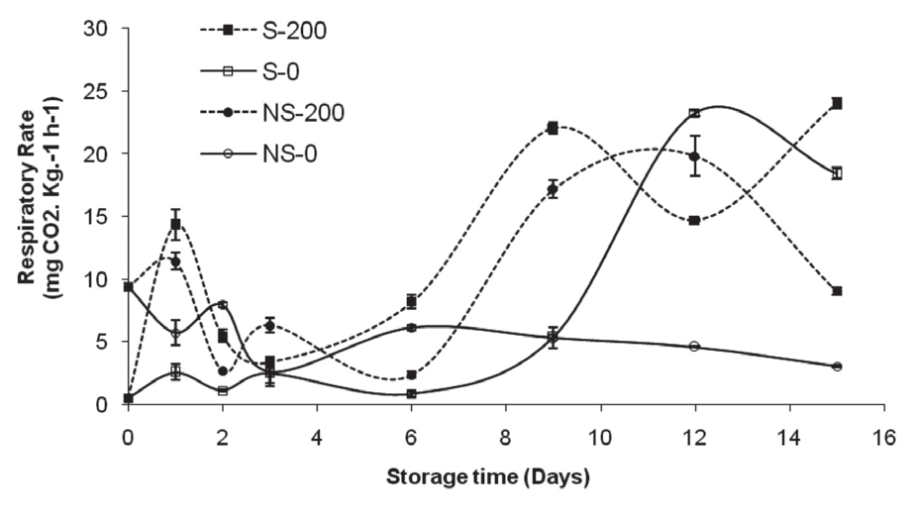
Figure 2. Effect of pretreatment with 1-MCP on respiratory rate of minimally processed yellow pitahaya fruits during storage (8±2 °C, HR 85-90%). Vertical bars represent the mean ± SD (n = 3).

skin. The treatment application time (e.g.,
1-MCP application before or after minimal processing) (Rico et al., 2007) and concentra- tion (Manganaris et al., 2008) may also alter CO2 production. Fruits treated with 1-MCP exhibited a climacteric respiratory curve, in agreement with reports from Rodriguez et al. (2005) and in disagreement with Nerd and Mizrahi (1997, 1999), who reported that yel- low pitahaya did not show a climacteric peak when stored at 20 °C.
Fruits sliced with skin (S) showed lower soluble solids values than fruits sliced with- out skin (NS). However, only NS fruit kept soluble solids close to initial values (17.9
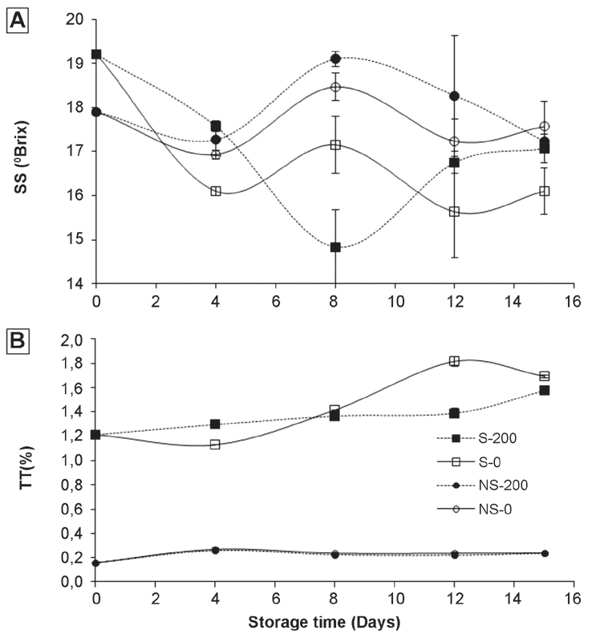
°Brix) during the storage time (Figure 3A). Control treatments, S-0 and NS-0, showed a simila r soluble solids pattern dur ing storage but fr uit slices

pre-treated with 1-MCP exhibited higher soluble solids content than their respective control. Studies done with golden berries (Gutierrez et al., 2008), kiwis (Koukounaras and Sfakiotakis, 2007), ap- ples (Pre-Aymard et al.,
2005) and oranges (Porat et al., 1999), showed no significant differences in soluble solids content be- tween 1-MCP and control treatments. The product presentation (S and NS) showed signif icant dif- ferences in soluble solids content (p <.0001). The high variation on soluble solids obser ved during storage time (14.8 to 19.20
°Brix) was similar to re- sults found by Rodriguez et al. (2005) working with pit a haya fr uits w it h a maturity degree number three and stored at 8 ºC. S oluble sol ids content
pending on product conditions and storage. Watkins (2006) noted that starch degrada- tions were not always delayed by 1-MCP ap- plications. Low temperature damage causes alterations in normal metabolic processes such as respiratory rate and ethylene pro- duction (Wang, 2000), which could be related to the observed oscillation phenomenon. A possible cause for the °Brix decline may be sugar fermentation promoted by anaerobic conditions inside packages.
An increase in acidity during storage, from 1.21 to 1.58% and from 1.21 to 1.69%, was observed in S-200 and S-0 fruit slices, respectively (Figure 3B). Fruit slices with and without skin (S and NS) did not show sig- nificant differences in total titratable acidity due to the pre-treatment with 1-MCP. Similar

in fruits and vegetables
treated with 1-MCP may show different patterns, de-

Figure 3. Effect of pretreatment with 1-MCP on (A) Soluble Solids and (B) Total Titratable Acidity of minimally processed yellow pitahaya fruits during storage (8±2 °C, HR 85-90%). Vertical bars represent the mean ± SD (n = 3).

results were observed in apricots (Dong et al.,
2002), kiwis (Koukounaras and Sfakiotakis,
2007), plums (Menniti et al., 2004) and or- anges (Porat et al., 1999). On the other hand, product presentation <S and NS) significantly affected the total titratable acidity during the entire storage time (p<.0001).
A reduction of total sugars for all treat- ments was observed during storage (p<0.05, Table 1). The application of 1-MCP had higher effect on pitahaya fruit slices with skin (S-
200; p<0.047). Golding et al. (1998) found no differences in total sugars content in bananas treated with 1-MCP vs. controls. Similarly, Bregoli et al. <2005) found no significant differences between treated and control nec- tarines stored at 4 °C for 3 days. In addition, they reported higher sugars content in con- trol fruits that in those treated with 1-MCP when fruits were stored at 25 °C for 3 days. Total sugars content in control samples with and without skin (S-0 and NS-0) followed the same pattern as observed for soluble solids.
Fruit slices without skin (NS-0 and NS-
200) exhibited higher weight loss compared with slices that were not peeled before storage (S-0 and S-200) (P <0.0001, Table 1). Vargas y Vargas et al. (2005) reported similar weight losses in sliced pitahaya fruits (Hylocereus undatus) stored at 8 °C. No significant ef- fects on percent weight loss was observed
when 1-MCP was applied before storage (P
=0.68), as reported in oranges (Manganaris et al., 2008) and plums (Porat et al., 1999). However, Bassetto et al. (2005) found higher weight losses in guava treated with 1-MCP.
Fruit slices without skin (NS-0 and NS-
200) showed the highest color differences during storage (P<0.0001; Table 1) and no significant differences were observed due to the 1-MCP application. Dong et al. (2002) reported similar results in apricot when ap- plying 10, 100 and 1000 nL.L-1 1-MCP. These
results are in contradiction with those re-
ported by Feng et al. (2000), who found that the pre-treatment with 30, 50 and 70 nL.L-1
1-MCP delayed color changes in avocados and results by Arias et al. (2009), who observed a slowdown of browning in pears treated with
300 nL.L-1 1-MCP.
A reduction in vitamin C content was ob- served during t%e first 3 days of storage for all treatments (Figure 4). However, pre-treatment wit% 1-MCP significantly reduced <P<0.0001) the loss of vitamin C in sliced pitahaya fruits and a faster vitamin C loss was observed in untreated fruit slices (from 16.7 to 7.1 mg.100 g-1 in S-0 and from 16.7 to 9.3 mg.100 g-1 in
NS-0). From day 3 until day 15 of storage, the fruit slices exhibited little variability in their vitamin C content. Moreover, no significant differences were observed when storing fruit

Table 1. Total sugars, weight loss and color change of minimally processed yellow pitahaya fruit slices during storage (8±2ºC and 85-90% relative humidity). S: slices with skin; NS: slices without skin; 0 no 1-MCP pretreatment; 200: slices pretreated with 200 μg/lt 1-MCP.

Variables
Treatments

 | S-0 | S-200 | NS-0 | NS-200
Total Sugars (%)  Day 0 | 5.77 Aa* | 5.77 Aa | 7.79 Ab | 7.79 Ab
Day 12 | 3.41 Bc | 4.30 Bb | 4.86 Ba | 5.44 Ba
Weightloss (%) Day 0 | 0.00 Ba | 0.00 Ba | 0.00 Ba | 0.00 Ba
Day 12 | 0.46 Aa | 0.50 Aa | 0.86 Aa | 0.61 Aa
Color <=E) Day 0 | 0.00 Ba | 0.00 Ba | 0.00 Ba | 0.00 Ba
Day 12 | 6.42 Ac | 5.68 Ac | 23.22 Aa | 23.99 Aa
*Values are average of t%ree replications. Different upper and lower case letters denote significant
differences <P 0.05) due to storage time and treatments, respectively.

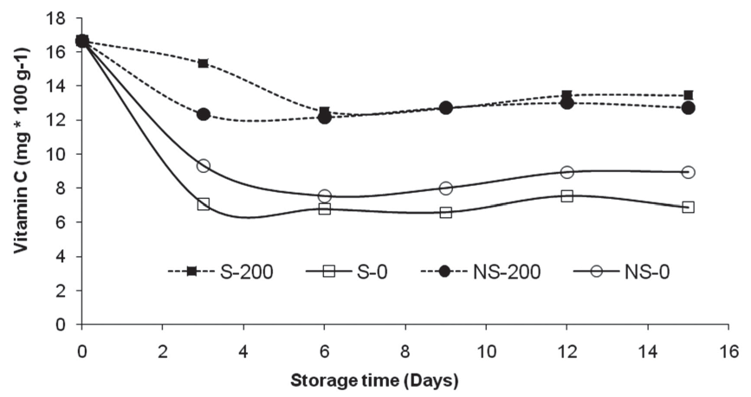
Figure 4. Effect of pretreatment with 1-MCP on vitamin C content (mg*100 g-1) of minimally processed yellow pitahaya fruits during storage (8±2 °C, HR 85-90%). Vertical bars represent the mean
± SD (n = 3).

slices with and without skin (S vs. NS; P=0.63). Similar loss of vitamin C content was reported by Selvarajah et al. (2001) in pineapples treat- ed with 4.5 nmol.L-1 1-MCP and by Win et al. (2006) in limes treated with 250 nL.L-1 1-MCP. Singh and Pal (2008) found that a 300 and 600 nL.L-1 1-MCP application helped maintaining high vitamin C content in Psidium guajava (Guavas) stored at 10°C for 25 days.
Fruit slices with skin and treated with
1-MCP <S-200) ex%ibited greater firmness than those without skin (NS) after 8 days of storage (Figure 5). Fruit slices stored without skin s%owed a gradual reduction in firmness regardless of receiving 1-MCP pre-treatments. Although the pre-treatment with 1-MCP did not significantly affect firmness retention, product presentation %ad a significant effect

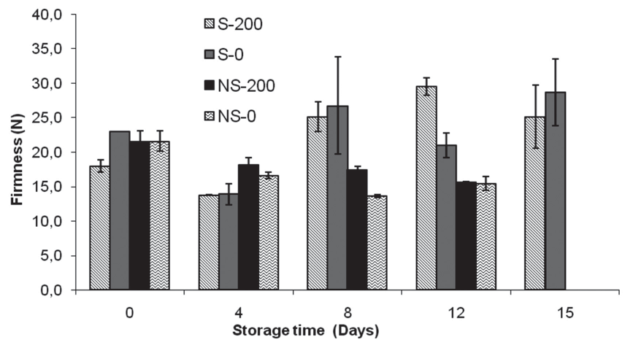

Figure 5. Effect of pretreatment wit% 1-MCP on firmness <N) of minimally processed yellow pita%aya fruits during storage (8±2 °C, HR 85-90%). Vertical bars represent the mean ± SD (n = 3).

on firmness <p<.0001).T%ese results are simi- lar to those obtained by Rocculi et al. (2009), who studying the effect of 1mL.L-1 1-MCP ap- plication in minimally processed pineapples, did not observe improvements in firmness preservation during storage. Koukounaras and Sfakiotakis (2007) obtained comparable results working with kiwis treated with 0.5 mL.L-1 1-MCP. On the other hand, Mao et al.
<200‘) found a delay in firmness loss in w%ole and minimally processed kiwis treated with 1 mL.L-1 1-MCP and stored for 8 days. Arias et al. (2009) also reported a softening reduction in minimally processed pears treated with
300 nL.L-1 1-MCP.
Unlike whole fr uits and vegetables, minimally processed plant products suffer tissue damage that accelerates deterioration. Mechanical operations destroy subcellular compartments and bring together substrates and enzymes that are normally separated, and accelerate reactions that are naturally slower on whole fruits, e.g., enzymatic cell wall degradation which is the main cause of fruit softening (Oms-Oliu et al., 2010).

Conclusions

t The results from this study show that the application of 200 mg/lt 1-MCP did not reduce the respiratory rate in minimally processed pitahaya fruit slices and increa- sed the production of CO2. Furthermore, soluble solids content and total sugars increased in pre-treated samples, confir- ming that 1-MCP did not delay the matu- ration process. Fruit total titratable acidity, weig%t loss, firmness, and color, did not s%ow significant effects due to 1-MCP pre- treatments. However, the 1-MCP applica- tion reduced the loss of vitamin C content in pitahaya fruit slices stored with and without skin.
t The application of 1-MCP (200 mg/lt), did not extend the shelf-life in minimally processed pitahaya fruits. It is recommen- ded to evaluate additional concentrations and exposure times to elucidate whether
1-MCP treatments can potentially extend the shelf-life of minimally processed pita- haya fruits.
Acknowledgements

T%e aut%ors acknowledge t%e financial sup- port by the Colombian Ministry of Agriculture and Rural Development and the Association of pitahaya producers (Asoppitaya).

References

Able, A.J.; Wong, L.S.; Prasad, A.; y O’Hare, T.J.
2002. 1-MCP is more effective on a floral brassica (Brassica oleracea var. italica L.) than a leafy bras- sica (Brassica rapa var. chinensis). Postharvest Biology and Technology 26: 147-155.
Agar, I.T.; Massantini, R.; Hess-Pierce, B.; y Kader, A.A. 1999. Postharvest CO2 and ethylene produc- tion and quality maintenance of fresh-cut kiwi- fruit slices. Journal of Food Science 64: 433-440. Ahvenainen, R. 1996. New approaches in improving the shelf life of minimally processed fruit and vegetables. Trends in Food Science & Technology
7: 179-187.
X0XC. 2000a. 0fficial met%ods of analysis of t%e
Xssociation of 0fficial Xnalytical C%emists“ 932.12
Fruits and fruit products. Solids (Soluble) in Fruits and Fruit Product: Refractometer Method. S Arlington, Virginia, USA. 7p.
X0XC. 2000b. 0fficial met%ods of analysis of t%e Xs- sociation of 0fficial Xnalytical C%emists“ 942.15X Fruits and fruit products - Acidity (Titratable) of
”ruit Products. Xssociation of 0fficial Xnalytical
Chemists, Arlington.11p.
Arias, E.; Lopez-Buesa, P.; y Oria, R. 2009.Extension of fresh-cut “Blanquilla” pear (Pyruscommunis L.) shelf-life by 1-MCP treatment after harvest. Postharvest Biology and Technology 54: 53-58.
Baquero, E.; Castro, J.; y Narvaez, C. 2005.Catalasa, peroxidasa y polifenoloxidasa en pitaya amarilla (Acanthocereus pitajaya): Maduración y senescen- cia. Acta Biológica Colombiana 10: 49-60.
Bassetto, E.; Jacomino, A.P.; Pinheiro, A.L.; y Kluge, R.A. 2005. Delay of ripening of ‘Pedro Sato’ guava with 1-methylcyclopropene. Postharvest Biology and Technology 35: 303-308.
Bower, J.H.; Blasi, W.V.; y Mitcham, E.J. 2003.
Effects of ethylene and 1-MCP on the quality and storage life of strawberries. Postharvest Biology and Technology 28: 417-423.
Bregoli, A.M.; Ziosi, V.; Biondi, S.; Rasori, A.; Ciccioni, M.; Costa, G.; y Torrigiani, P. 2005. Postharvest 1-methylcyclopropene application in ripening control of ‘Stark Red Gold’ nectarines: Temperature-dependent effects on ethylene pro- duction and biosynthetic gene expression, fruit quality, and polyamine levels. Postharvest Biology and Technology 37: 111-121.

Djioua, T.; Charles, F.; Lopez-Lauri, F.; Filgueiras, H.; Coudret, A.; Freire, M.; Ducamp-Collin, M.N.; y Sallanon, H. 2009. Improving the storage of minimally processed mangoes (Mangiferaindica L.) by hot water treatments. Postharvest Biology and Technology 52: 221-226.
Dong, L.; Lurie, S.; y Zhou, H.W. 2002.Effect of
1-methylcyclopropene on ripening of ‘Canino’ apricots and ‘Royal Zee’ plums. Postharvest Bio- logy and Technology 24: 135-145.
DuBois, M.; Gilles, K.A.; Hamilton, J.K.; Rebers, P.A.; y Smith, F. 1956. Colorimetric method for determination of sugars and related substances. Analytical Chemistry 28: 350-356.
Feng, X.Q.; Apelbaum, A.; Sisler, E.C.; y Goren, R.
2000. Control of ethylene responses in avocado fruit with 1-methylcyclopropene. Postharvest Biology and Technology 20: 143-150.
Golding, J.B.; Shearer, D.; Wyllie, S.G.; y McGlasson, W.B. 1998.Application of 1-MCP and propylene to identify ethylene-dependent ripening processes in mature banana fruit. Postharvest Biology and Technology 14: 87-98.
Gutierrez, M.S.; Trinchero, G.D.; Cerri, A.M.; Vilella, F.; y Sozzi, G.O. 2008. Different responses of gol- denberry fruit treated at four maturity stages with the ethylene antagonist 1-methylcyclopropene. Postharvest Biology and Technology 48: 199-205. Hong, G.; Peiser, G.; y Cantwell, M.I. 2000.Use of controlled atmospheres and heat treatment to maintain quality of intact and minimally pro- cessed green onions. Postharvest Biology and
Technology 20: 53-61.
Jiang, Y.; Joyce, D.; y Macnish, A.J. 1999. Responses of banana fruit to treatment with 1-methylcyclo- propene. PlantGrowthRegulation 28(2): 77-82.
ICONTEC. 1996. NTC 3554 - Frutas frescas: pitaya.
Instituto Colombiano de normas técnicas y cer- tificación. Ministerio de Xgricultura y Desarrollo Rural, Federación Nacional de Cafeteros de Co- lombia, Bogotá, Colombia.
Koukounaras, A.; Sfakiotakis, E. 2007.Effect of
1-MCP prestorage treatment on ethylene and CO2 production and quality of ‘Hayward’ kiwifruit du- ring shelf-life after short, medium and long term cold storage. Postharvest Biology and Technology
46: 174-180.
Lu, C.W.; Cureatz, V.; y Toivonen, P.M.A. 2009.
Improved quality retention of packaged ‘Anjou’ pear slices using a 1-methylcyclopropene (1-MCP) co-release technology. Postharvest Biology and Technology 51:378-383.
Manganaris, G.A.; Crisosto, C.H.; Bremer, V.; y Holcroft, D. 2008.Novel 1-methylcyclopropene immersion formulation extends shelf life of ad-
vanced maturity ‘Joanna Red’ plums (Prunussali- cinaLindell). Postharvest Biology and Technology
47: 429-433.
Mao, L.C.; Wang, G.Z.; y Que, F. 2007.Application of 1-methylcyclopropene prior to cutting redu- ces wound responses and maintains quality in cut kiwifruit. Journal of Food Engineering 78:
361-365.
Mendoza, F.; Dejmek, P.; y Aguilera, J.M. 2006.
Calibrated color measurements of agricultural foods using image analysis. Postharvest Biology and Technology 41: 285-295.
Menniti, A.M.; Gregori, R.; y Donati, I. 2004.1-methyl- cyclopropene retards postharvest softening of plums. Postharvest Biology and Technology 31:
269-275.
Mostofi, Y.;Toivonen, P.M.X.;Lessani, &.;Babalar, M.;y Lu, C.W. 2003. Effects of 1-methylcyclopro- pene on ripening of greenhouse tomatoes at three storage temperatures. Postharvest Biology and Technology 27: 285-292.
Nerd, A.; Mizrahi, Y. 1997.Reproductive biology of cactus fruit crops. Horticultural Reviews 18:
321-346.
Nerd, A.; Mizrahi, Y. 1999.The effect of ripening sta- ge on fruit quality after storage of yellow pitaya. Postharvest Biology and Technology 15: 99-105. Oms-Oliu, G.; Rojas-Grau, M.A.; Gonzalez, L.A.; Va r ela, P.;Soliva-Fortuny, R.; Her nando, M.I.H.;Munuera, I.P.;Fiszman, S.; Martin-Bello-
so, O. 2010. Recent approaches using chemical treatments to preserve quality of fresh-cut fruit: A review. Postharvest Biology and Technology
57: 139-148.
Osuna, J.A.;Beltrán, J.A.;y Urías, M.A. 2005.Effect of 1-methylcyclopropene (1-MCP) on shelf life and quality of exporting mango.RevistaFitotecnia Mexicana 28: 271-278.
Parra-Coronado, A.; Hernandez-Hernandez, J.E.; y Camacho-Tamayo, J.H. 2006. Comportamiento fisiológico de la pera variedad Triunfo de Viena (Pyruscommunis L.) durante el período poscose- cha. Revista Brasileira de Fruticultura 28: 46-50. Porat, R.; Weiss, B.; Cohen, L.; Daus, A.; Goren, R.; y Droby, S. 1999. Effects of ethylene and
1-methylcyclopropene on the postharvest qua- lities of ‘Shamouti’ oranges. Postharvest Biology and Technology 15: 155-163.
Pre-Aymard, C.; Fallik, E.; Weksler, A.; y Lurie, S.
2005. Sensory analysis and instrumental measu- rements of ‘Anna’ apples treated with 1-methylcy- clopropene. Postharvest Biology and Technology
36: 135-142.
Rico, D.; Martin-Diana, A.B.; Barat, J.M.; Barry- Ryan, C. 2007. Extending and measuring the

quality of fresh-cut fruit and vegetables: a review. Trends in Food Science & Technology 18: 373-
386.
Rocculi, P.;Emiliano, C.;Romani, S.;Sacchetti, G.;y Rosa, M.D. 2009.Effect of 1-MCP treatment and N2O MAP on physiological and quality changes of fresh-cut pineapple.Postharvest Biology and Technology 51: 371-377.
Rodriguez, D.; Patiño, M.; Miranda, D.; Fischer, G.;y Galvis, J. 2005. Efecto de dos índices de madurez y dos temperaturas de almacenamiento sobre el comportamiento en poscosecha de la pitaya ama- rilla. Revista Facultad Nacional de Agronomia, Medellín 58: 2837-2857.
SAS Institute Inc. 2008.SAS® 9.1.3 Intelligence- Platform: Web ApplicationAdministration Guide, ThirdEdition.Cary, NC: SAS Institute Inc.
Selvarajah, S.; Bauchot, A.D.; y John, P. 2001.
Internal browning in cold-stored pineapples is suppressed by a postharvest application of
1-methylcyclopropene. PostharvestBiology and
Technology 23: 167-170.
Serna-Cock, L.; Torres, L.; y Ayala, A. 2011.Efecto del empaque y del 1-MCP sobre características fí- sicas, quimicas y fisiológicas de pita%aya amarilla. Revista Biotecnología en el sector agropecuario y agroindustrial. 9(2). In Press.
Singh, S.P.; Pal, R.K. 2008.Response of climacteric- type guava (Psidiumguajava L.) to postharvest treatment with 1-MCP. Postharvest Biology and Technology 47: 307-314.
Soliva-Fortuny, R.C.; Martin-Belloso, O. 2003.New advances in extending the shelf-life of fresh-cut fruits: a review. Trends in Food Science & Tech- nology 14: 341-353.
Spotts, R.A.; Sholberg, P.L.; Randall, P.; Serdani, M.; y Chen, P.M. 2007. Effects of 1-MCP and hexanal on decay of d’Anjou pear fruit in long-term cold storage. Postharvest Biology and Technology 44:
101-106.
Tian, M.S.; Prakash, S.; Elgar, H.J.; Young, H.; Bur- meister, D.M.; y Ross, G.S. 2000. Responses of strawberry fruit to 1-Methylcyclopropene (1-MCP) and ethylene. Plant Growth Regulation32: 83-90. Vargas y Vargas, M.L.; Centurión-Yah, A.; Sauri- Duch, E.;y Tamayo-Cortez, J. 2005. Industriali- zación de la pitahaya (Hylocereusundatus): Una nueva forma de comercialización. Revista Mexi-
cana de Agronegocios. 9 (16): 498-509.
Wang, C.Y. 2000. Postharvest techniques for redu- cing low temperature injury in chilling sensitive commodities. In: Improving postharvest tech- nologies of fruits vegetables and ornamentals (F.Artes, M.I. Gil, M.A. Conesa, eds.).Int. Inst. Refrigeration.467-473p.
Watada, A.E.; Qi, L. 1999. Quality of fresh-cut pro- duce. Postharvest Biology and Technology 15:
201-205.
Watkins, C. 2006. The use of 1-methylcyclopropene (1-MCP) on fruit and vegetables. Biotechnology Advances 24: 386-409.
Wiley, R.C. 1994.Introduction of minimally proces- sed refrigerated fruits and vegetables. In: Minima- lly processed refrigerated fruits & vegetables, (R.C. Wiley, ed.), Chapman & Hall, New York.373p.
Win, T.O.; Srilaong, V.; Heyes, J.; Kyu, K.L.; y Kan- layanarat, S. 2006. Effects of different concentra- tions of 1-MCP on the yellowing of West Indian lime (Citrus aurantifoliaSwingle) fruit. Postharvest Biology and Technology 42: 23-30.

