*Research article*

Effect of the immersion in 1-Metylciclopropene on the physicochemical and physiological properties of yellow pitahaya fruit

(*Selenicereus megalanthus* How) with minimum processing

Efecto de la aplicación de 1-Metilciclopropeno por inmersión sobre las características físicas, químicas y fisiológicas de pitahaya amarilla (*Selenicereus megalanthus* How) mínimamente procesada

*Liliana Serna-Cock1*, Diego Fernando Segura-Rojas1, and Alfredo Ayala-Aponte2*

1 Department of Engineering and Management, Universidad Nacional de Colombia - Palmira.

2 School of Food Enginnering, Universidad del Valle, Cali, Colombia.

*Corresponding author: [lserna@unal.edu.co](mailto:lserna@unal.edu.co)

Rec.: 05.04.11 Acept.: 27.10.11

Abstract

Yellow pitahaya (*Selenicereus megalanthus* How), is an exotic fruit with great commercial potential, it has been commercialized without using methods that add value and/or prolong its shelf-life. The effect the application of 200 mg/lt 1-MCP on the respiratory rate and quality properties of vacuum sealed minimally processed yellow pitahaya slices during shelf-life under refrigeration was evaluated. Soluble solids, total titratable acidity, weight loss, total sugars, firmness and color were measured in fruit slices with and without skin. The application of 1-MCP before storage increased the respiratory rate and consequently increased soluble solids and total sugars, and did not show any detrimental on weight loss, total titratable acidity, color changes and firmness. However, the application of 1-MCP reduced loss of vitamin C in yellow pitahaya slices with and without skin during storage time.

Key words: Color, firmness, respiratory rate, soluble solids, tropical fruit, vitamin C.

Resumen

La pitahaya amarilla (*Selenicereus megalanthus* How) es una fruta exótica con gran potencial comercial. No obstante sólo ha sido aprovechada comercialmente como fruta entera, sin procedimientos que le den valor agregado y mayor tiempo de vida de anaquel. En este trabajo se evaluó la aplicación de 200 mg/lt de 1-MCP (Metylciclopropene) en pitahaya amarilla mínimamente procesada (rodajas con y sin cáscara), empacada a vacío y almacenada bajo refrigeración, sobre la intensidad respiratoria y parámetros de calidad como: sólidos solubles, acidez total titulable, pérdida de peso, azúcares totales, firmeza y color. La aplicación de 1-MCP aumentó la producción de CO2 lo cual se manifestó en mayores contenidos de sólidos solubles y azúcares totales, pero no incidió en la pérdida de peso, variación de la acidez total titulable, cambios de color y retención de la firmeza. En ambos tipos de procesamientos se logró reducir durante el almacenamiento la perdida de vitamina C.

Palabras clave: Color, firmeza, fruta tropical, sólidos soluble, tasa respiratoria, vitamina C.

**Introduction**

Global changes in food habits have generated a consumer sector demanding healthier, additives–free, and fresh-like food products. Mi-nimally processed food products have experienced growing demand (Rico *et al.*, 2007) since consumers recognize their benefit and quality (Djioua *et al.*, 2009). This tendency has stimulated the research and development of new technologies focused on conservation and storage of minimally processed fruits and vegetables (Oms-Oliu *et al*., 2010; Soliva-Fortuny and Martin-Belloso, 2003).

In minimal processing, fruits and vegetables are subjected to one or more unit operations, including peeling, cutting and slicing (Hong *et al.*, 2000). These processing operations cause the rupture of cell walls and ti-ssues (Watada and Qi, 1999) which in turn accelerate physiological and biochemical processes such as respiration and ethylene production (Ahvenainen, 1996; Soliva-Fortuny and Martin-Belloso, 2003). Such reactions reduce fruit shelf-life due to appearance, texture, flavor, and/or aroma degradation (Ahvenainen, 1996; Rico *et al.,* 2007).

1-methylcyclopropene (1-MCP), an ethylene inhibitor, is used to extend the shelf-life and maintain the quality of plant products (Dong *et al.*, 2002). 1-MCP reduces maturation by partially blocking ethylene receptors in plant cells, thus increasing available time for proper fruit storage (Osuna *et al.*, 2005). 1-MCP at various concentrations was used to effectively extend the shelf-life of fruits such as bananas (50 nL.L-1; Jiang *et al.,* 1999), strawberries (2µL.L−1; Tian *et al*., 2000), kiwis (0.5 µL.L−1; Koukounaras and Sfakiotakis, 2007), pears (300 nL.L−1; Spotts *et al.,* 2007), plums and apricots (500 μL.L−1 concentrated stock in a 1L sealed bottle; Dong *et al*., 2002), and vegetables such as broccoli (12 µL.L−1; Able *et al.*, 2002), avocados (30-70 nL.L-1; Feng *et al.*, 2000) and tomatoes (250 nL.L-1; Mostofi *et al.*, 2003). There are also reports combining 1-MCP and minimal processing in pears (300 nL.L−1 and 1μL.L−1; Arias *et al.*, 2009; Lu *et al.*, 2009), pineapples (1μL.L−1; Rocculi *et al.,* 2009) and kiwis (1μL.L−1; Mao *et al.,* 2007). However, these combined methods had not been previously reported to extend the shelf-life of yellow pitahaya (*Selenicereus megalanthus* How).

Yellow pitahaya is an exotic fruit with increasing worldwide acceptance due to its pleasant taste and attractive shape and color (Baquero *et al.*, 2005). The application of 1-MCP prior to minimal processing, could be an alternative for preserving nutritional and organoleptic quality of fruits (Arias *et al.*, 2009; Mao *et al.*, 2007).

The objective of this study was to assess the effect of minimal processing (slicing with and without skin) and the application of 200 g.L-1 of 1-MCP on the respiratory rate (RR), weight loss, color change (∆E), soluble solids (SS), total sugars, total titratable acidity (TTA), vi–tamin C (ascorbic acid) and firmness of yellow pitahaya fruits.

Materials and methods

Plant material

Yellow pitahaya fruits with a maturity stage three, according to the NTC 3554 standard classification, were selected (ICONTEC, 1996). The fruit plantation is located in Roldadillo, Valle del Cauca, Colombia (4°24’37’’ N and 75°93’72’’ W, 1500 m.a.s.l.). Harvested fruits were selected, scrubbed using soft-bristle brushes to remove spine residues and organic matter, washed and sanitized using chlorine–ted water (200 g.L-1), and then rinsed with distilled water. Finally, the fruits were classified and grouped based on specific treatment, dried using a paper towel, and immersed in the 1-MCP solution.

1-MCP preparation

A powder 1-MCP formulation (3.8% w/w) obtained from Rohm and Haas (Philadelphia, Pennsylvania) was used. The 1-MCP application was made by immersion following manufacturer ´s instructions. Forty liter solutions were prepared in a plastic container with a 200 g.L−1 concentration at 25 ± 1°C. The immersion time for each treatment was 10 minutes. The selected 1-MCP concentration and immersion time were based on previous studies in pitahaya where the commercial life of the whole fruit was extended (Serna-Cock *et al.*, 2011). After each immersion, the fruits were rinsed in distilled water (5 min) and dried using absorbent paper.

Minimal processing and packaging

After treatments, fruits were subjected to two cutting protocols: slicing with skin (S) and slicing without skin (NS). Slices (1 cm thick and 4±0.2 cm diameter) were done using a Javar (model GE 250, Bogotá, Colombia) cu-tter.

The minimally processed pitahaya fruits were vacuum packaged (EGAR Vac. S.C.P basic -B, Spain), using a flexible polyamide and low-density polyethylene coextruded with 70 μm thickness, 39 cm3 m-2 24h-1, atm-1 y 23°C-1, permeability to O2, 107 cm3 m-2 24h-1, atm-1 y 23 °C-1, permeability to CO2, and 10.2 gm-2 24h-1 atm-1 y 38°C, water vapor permeability. The bags were sealed with a 1.5 kg.cm2 pressure at 160°C for 3 seconds. The pitahaya fruits were then stored in an environmentally controlled chamber (1000 L Dies, Colombia) at 8 ± 2°C and 85-95% relative humidity.

The following nomenclature was used: S-200 and NS-200 to identify pitahaya fruits pre-treated with 200 μg/lt of 1-MCP and then cut in slices with skin (S) and without skin (NS); S-0 and NS-0 to identify control (untreated) fruit slices with and without skin (S and NS, respectively).

Respiratory rate (RR)

The respiratory rate was measured by titration and expressed as mg.CO2.kg-1.h-1, following a modification to the methodology described by Parra-Coronado et al. (2006). A refrigerated temperature controlled chamber was used, externally equipped with a compressor (Electromec Shulz and Fiat, Colombia), CO2 traps placed at the beginning and end of airflow, and a moisture trap saturated with silica grain gel columns. The CO2 traps included 2 bottles containing 50 mL of 2 N KOH each and 6 bo–ttles containing 50 mL of 0.1 N NaOH each. Internally, the chamber contained six desiccators (Bel-Art, Pequannock, New Jersey, USA) equipped with input and output hoses (Figure 1).

The compressor (1) allowed external air to flow for 30 minutes into the initial CO2 traps (2) to eliminate the CO2 present in the air. Then, the CO2-free air was blown first through the moisture trap (3) to remove the water vapor and second through the desiccators (4) containing the previously weighed minimally processed pitahaya fruits. The de-siccators were hermetically sealed allowing the resulting air from fruit respiration to be collected in the secondary CO2 traps (5). After 30 minutes, the airflow was stopped and the secondary CO2 traps were removed from the system and immediately sealed. A 20 mL aliquot from each CO2 trap was mixed with 15 mL of 10% w/v BaCl2 and 4 drops of phenolphthalein. The solution was immediately titrated with 0.1 N HCl.

The respiratory rate was determined using equations 1 and 2.

|  |  |
| --- | --- |
| $$\text{RR =}\left(\frac{\text{mg}{\text{CO}}_{\text{2}}}{\text{kg*h}}\right)\text{=}\frac{\left({\text{V}}_{\text{b}}\text{-}{\text{V}}_{\text{m}}\right)\text{*}{\text{N}}_{\text{HCl}}\text{*22*f}}{\text{w*t}}$$ | (Eq.1) |
| $$\text{f}\text{=}\frac{{\text{V}}_{\text{NaOH}}}{{\text{V}}_{\text{aliquot}}}$$ | (Eq. 2) |

where:

RR= Respiratory rate expressed in mg.CO2.kg-1.h-1

Vb = Volume (mL) of HCl used in blank titration

Vm = Volume (mL) of HCl used to titrate the sample

NHCl = Normality of HCl used in the titration

w = sample weight (kg)

t = test time (hours) (elapsed time were the compressor is turned on)

22 = milliequivalent weight of CO2 (g-meq)

f = sample factor = volume of NaOH used in the respiration meter/total solution volume (BaCl2 and phenolphthalein)

Chemical Analysis

Soluble solids were estimated by extracting the juice from the homogenized flesh and using a refractometer (Attago Hand Held 500 HRS, Washington, USA) following AOAC method 932.12 (AOAC, 2000a). Total soluble solids, total titratable acidity, and vitamin C content were determined by mashing the flesh from three pitahaya packages. The total titratable acidity was determined at 20 ± 2 °C by using AOAC official method 942.15A (AOAC, 2000b), and was reached and expressed as equivalents gram of citric acid. Total sugars were determined by spectrophotometry (Genesis UV10 Thermo Spectronic, Boston, USA) following the Antrona method (DuBois *et al.*, 1956). Vitamin C content was estimated with a reflectometer (RQflex 10 plus, Merck, Darmstadt, Germany) with a 25-450 mg.L-1 measuring range for ascorbic acid. The method consists of reducing yellow molybdophosphoric acid to molybdenum blue by the action of ascorbic acid. The results were expressed in mg.100 g-1 of flesh.

Physical Analysis

Weight loss was determined by measuring the wet weight from three minimally processed pitahaya fruits slices per treatment, using a three-decimal precision scale (Metler Toledo 1200, Columbus, Ohio, USA). Fruits were weighted at days 0 and 12, and weight loss percentage was estimated.

Firmness was determined by uniaxial compression (force vs. distance) using a texture analyzer (Shimadzu, EZ-Test, Somerset, New Jersey, USA). Firmness was determined as the highest peak after plotting force vs. distance. A cylindrical geometry (40 mm diameter), penetrating at 10 mm.min-1 and maximum deformation distance of 8 mm was used. Pitahaya fruit slices (1 cm thickness and 4 cm diameter) were used to perform the tests.

Figure 1. Diagram of the device used to estimate respiratory rate. 1. Air compressor, 2. CO2 Trap (2N KOH), 3. Humidity trap (silica gel), 4.Desiccators, 5. Secondary CO2 Traps (0.1 N NaOH).

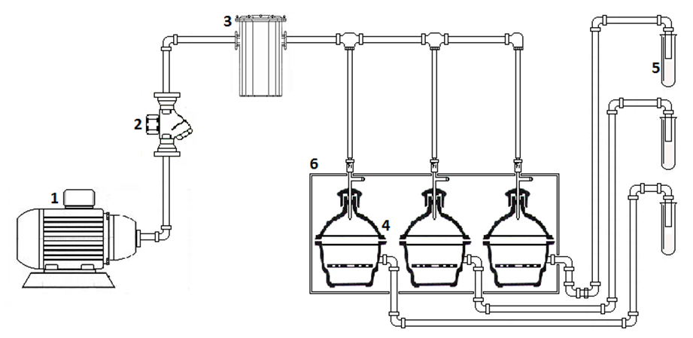

The surface color of minimally processed pitahaya fruit slices was estimated by mea-suring the CIE-L*, a*, b* coordinates, with a D65 standard illuminant and 10º observer, using a Color flex colorimeter (Hunter Lab., Reston, Virginia, USA). Thirty six measurements were made for each storage time corresponding to three measurements per slice, three slices per treatment, and four treatments. Differences in color (∆E) were estima-ted comparing a fresh sample as shown in equation 3 (Mendoza et al., 2006).

 (Eq. 3)

where:

L*: Luminosity

a*: red to green color

b*: blue to yellow color

Experimental design and statistical analysis

To determine the effect of minimal processing and 1-MCP pretreatment on physicochemical and physiological characteristics of yellow pitahaya fruits, a complete randomized design with a 23 factorial arrangement was used. The three factors were: (1) 1-MCP concentration with two levels (0 and 200 g.L−1), (2) product presentation with two levels (with skin, S; without skin, NS) and (3) storage time at two levels (0 and 12 days). Polyamide bags containing 6 slices of pitahaya were considered as an experimental unit.

Total sugar, weight loss, and color change, and firmness determinations were done at day 0 and day 12 of storage. Respiratory rate and vitamin C content were measured at days 0, 1, 2, 3, 6, 9, 12 and 15. Total soluble solids and total titratable acidity were measured at day 0, 4, 8, 12 and 15. Experiments were done in triplicates and a statistical analysis by using the SAS version 9.13 (SAS Institute, Inc., Cary, NC, USA, 2008) GLM procedure (General Linear Models) was carried out. Comparison among means was done using the multiple range Duncan test (α=0.05).

Results and discussion

The respiratory rate during storage ranged from 0.54 to 24.1 mg CO2.kg.-1.h-1, with the lowest values (0.9 to 8.2 mg CO2.kg.-1.h-1) observed between the second and sixth day of storage (Figure 2). The application of 1-MCP significantly increased the respiratory rate of pitahaya fruit slices. While the NS-0 treatment control exhibited an oscillating reduction in respiratory rate until the 15th day, the S-0, NS-200 and S-200 treatments showed respiratory rate peaks in the 12th, 11th and 9th days, respectively. These results agree with reports from Bower *et al.,* 2003, where CO2 production was higher in strawberries treated with 1mL.L−1 1-MCP than in control fruits. Moreover, these authors found that 1-MCP applications at low concentrations were not statistically significant when compared with untreated controls. In studies with limes (Win *et al.*, 2006) and pears (Lu *et al.*, 2009), the application of 1-MCP did not affect the production of CO2. Product presentation (S and NS) resulted in significant differences in respiratory rate in pitahaya fruits (p<0.0007). Agar *et al.* (1999) noted that the CO2 and e-thylene production as a result of processing cuts was higher in kiwi slices with skin than in those without skin.

Figure 2. Effect of pretreatment with 1-MCP on respiratory rate of minimally processed yellow pitahaya fruits during storage (8±2 °C, HR 85-90%). Vertical bars represent the mean ± SD (n = 3).

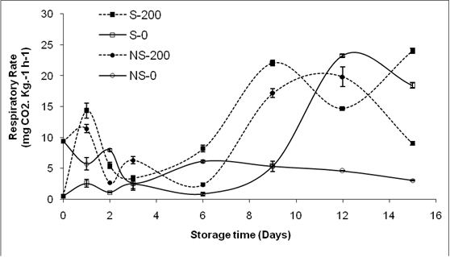

Respiratory activity and ethylene production of plant tissues are associated with an increase in physiological and biochemical activity (Wiley, 1994). In the case of minimally processed products, the respiratory activity and ethylene production increase depending on processing, degree of cutting and temperature (Ahvenainen, 1996), suggesting that fruit slices without skin would have a shorter shelf-life compared with those with skin. The treatment application time (*e.g.,* 1-MCP application before or after minimal processing) (Rico *et al.*, 2007) and concentration (Manganaris *et al.*, 2008) may also alter CO2 production. Fruits treated with 1-MCP exhibited a climacteric respiratory curve, in agreement with reports from Rodriguez *et al.* (2005) and in disagreement with Nerd and Mizrahi (1997, 1999), who reported that yellow pitahaya did not show a climacteric peak when stored at 20 °C.

Figure 3. Effect of pretreatment with 1-MCP on (A) Soluble Solids and (B) Total Titratable Acidity of minimally processed yellow pitahaya fruits during storage (8±2 °C, HR 85-90%). Vertical bars represent the mean ± SD (n = 3).

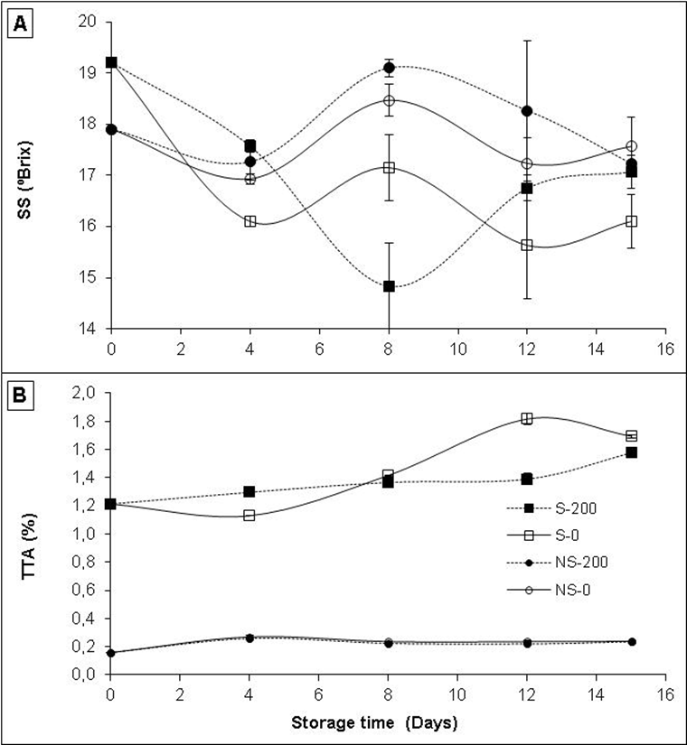

Fruits sliced with skin (S) showed lower soluble solids values than fruits sliced wi-thout skin (NS). However, only NS fruit kept soluble solids close to initial values (17.9 °Brix) during the storage time (Figure 3A). Control treatments, S-0 and NS-0, showed a similar soluble solids pattern during storage but fruit slices pre-treated with 1-MCP exhi-bited higher soluble solids content than their respective control. Studies done with golden berries (Gutierrez *et al*., 2008), kiwis (Koukounaras and Sfakiotakis, 2007), apples (Pre-Aymard *et al.*, 2005) and oranges (Porat *et al.*, 1999), showed no significant differences in soluble solids content between 1-MCP and control treatments. The product presentation (S and NS) showed significant differences in soluble solids content (p <.0001). The high variation on soluble solids observed during storage time (14.8 to 19.20 °Brix) was similar to results found by Rodriguez *et al.* (2005) working with pitahaya fruits with a maturity degree number three and stored at 8 ºC. So-luble solids content in fruits and vegetables treated with 1-MCP may show different pa-tterns, depending on product conditions and storage. Watkins (2006) noted that starch degradations were not always delayed by 1-MCP applications. Low temperature damage causes alterations in normal metabolic processes such as respiratory rate and ethylene production (Wang, 2000), which could be related to the observed oscillation phenomenon. A possible cause for the °Brix decline may be sugar fermentation promoted by anaerobic conditions inside packages.

An increase in acidity during storage, from 1.21 to 1.58% and from 1.21 to 1.69%, was observed in S-200 and S-0 fruit slices, respectively (Figure 3B). Fruit slices with and without skin (S and NS) did not show significant differences in total titratable acidity due to the pre-treatment with 1-MCP. Similar results were observed in apricots (Dong *et al.*, 2002), kiwis (Koukounaras and Sfakiotakis, 2007), plums (Menniti *et al.*, 2004) and oranges (Porat *et al.*, 1999). On the other hand, product presentation (S and NS) significantly affected the total titratable acidity during the entire storage time (p < 0.0001).

A reduction of total sugars for all treatments was observed during storage (p < 0.05, Table 1). The application of 1-MCP had higher effect on pitahaya fruit slices with skin (S-200; p < 0.047). Golding *et al.* (1998) found no differences in total sugars content in bananas treated with 1-MCP vs. controls. Similarly, Bregoli *et al.* (2005) found no significant differences between treated and control nectarines stored at 4 °C for 3 days. In addition, they reported higher sugars content in control fruits that in those treated with 1-MCP when fruits were stored at 25 °C for 3 days. Total sugars content in control samples with and without skin (S-0 and NS-0) followed the same pattern as observed for soluble solids.

|  |  |  |  |  |  |
| --- | --- | --- | --- | --- | --- |
| Table 1. Total sugars, weight loss and color change of minimally processed yellow pitahaya fruit slices during storage (8±2ºC and 85-90% relative humidity). S: slices with skin; NS: slices without skin; 0 no 1-MCP pretreatment; 200: slices pretreated with 200 μg/lt 1-MCP. | | | | | |
| Variables | Treatments | | | |  |
| S-0 | S-200 | NS-0 | NS-200 | |
| Total Sugars (%) |  |  |  |  | |
| Day 0 | 5.77 Aa* | 5.77 Aa | 7.79 Ab | 7.79 Ab | |
| Day 12 | 3.41 Bc | 4.30 Bb | 4.86 Ba | 5.44 Ba | |
|  |  |  |  |  | |
| Weightloss (%) |  |  |  |  | |
| Day 0 | 0.00 Ba | 0.00 Ba | 0.00 Ba | 0.00 Ba | |
| Day 12 | 0.46 Aa | 0.50 Aa | 0.86 Aa | 0.61 Aa | |
|  |  |  |  |  | |
| Color (∆E) |  |  |  |  | |
| Day 0 | 0.00 Ba | 0.00 Ba | 0.00 Ba | 0.00 Ba | |
| Day 12 | 6.42 Ac | 5.68 Ac | 23.22 Aa | 23.99 Aa | |
| *Values are average of three replications. Different upper and lower case letters denote significant differences (P ≤0.05) due to storage time and treatments, respectively. | | | | | |

Fruit slices without skin (NS-0 and NS-200) exhibited higher weight loss compared with slices that were not peeled before storage (S-0 and S-200) (P <0.0001, Table 1). Vargas and Vargas *et al.* (2005) reported similar weight losses in sliced pitahaya fruits (*Hylocereus undatus*) stored at 8 ºC. No significant effects on percent weight loss was observed when 1-MCP was applied before storage (P =0.68), as reported in oranges (Manganaris *et al.,* 2008) and plums (Porat *et al.,* 1999). However, Ba–ssetto *et al.* (2005) found higher weight losses in guava treated with 1-MCP.

Fruit slices without skin (NS-0 and NS-200) showed the highest color differences during storage (P < 0.0001; Table 1) and no significant differences were observed due to the 1-MCP application. Dong *et al.* (2002) reported similar results in apricot when applying 10, 100 and 1000 nL.L-1 1-MCP. These results are in contradiction with those reported by Feng *et al.* (2000), who found that the pre-treatment with 30, 50 and 70 nL.L-1 1-MCP delayed color changes in avocados and results by Arias *et al.* (2009), who observed a slowdown of browning in pears treated with 300 nL.L-1 1-MCP.

A reduction in vitamin C content was observed during the first 3 days of storage for all treatments (Figure 4). However, pre-treatment with 1-MCP significantly reduced (P<0.0001) the loss of vitamin C in sliced pitahaya fruits and a faster vitamin C loss was observed in untreated fruit slices (from 16.7 to 7.1 mg.100 g-1 in S-0 and from 16.7 to 9.3 mg.100 g-1 in NS-0). From day 3 until day 15 of storage, the fruit slices exhibited little variability in their vitamin C content. Moreover, no significant differences were observed when storing fruit slices with and without skin (S vs. NS; P=0.63). Similar loss of vitamin C content was reported by Selvarajah *et al.* (2001) in pineapples treated with 4.5 nmol.L-1 1-MCP and by Win *et al.* (2006) in limes treated with 250 nL.L-1 1-MCP. Singh and Pal (2008) found that a 300 and 600 nL.L-1 1-MCP application helped maintaining high vitamin C content in *Psidium guajava* (Guavas) stored at 10°C for 25 days.

Figure 4. Effect of pretreatment with 1-MCP on vitamin C content (mg*100 g-1) of minimally processed yellow pitahaya fruits during storage (8±2 °C, HR 85-90%). Vertical bars represent the mean ± SD (n = 3).

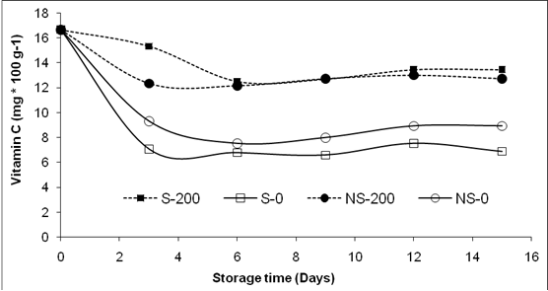

Fruit slices with skin and treated with 1-MCP (S-200) exhibited greater firmness than those without skin (NS) after 8 days of storage (Figure 5). Fruit slices stored without skin showed a gradual reduction in firmness regardless of receiving 1-MCP pre-treatments. Although the pre-treatment with 1-MCP did not significantly affect firmness retention, product presentation had a significant effect on firmness (p<.0001). These results are similar to those obtained by Rocculi *et al.* (2009), who studying the effect of 1mL.L−1 1-MCP application in minimally processed pineapples, did not observe improvements in firmness preservation during storage. Koukounaras and Sfakiotakis (2007) obtained comparable results working with kiwis treated with 0.5 L.L−1 1-MCP. On the other hand, Mao *et al.* (2007) found a delay in firmness loss in whole and minimally processed kiwis treated with 1 mL.L−1 1-MCP and stored for 8 days. Arias *et al.* (2009) also reported a softening reduction in minimally processed pears treated with 300 nL.L-1 1-MCP.

Unlike whole fruits and vegetables, minimally processed plant products suffer tissue damage that accelerates deterioration. Mechanical operations destroy subcellular compartments and bring together substrates and enzymes that are normally separated, and accelerate reactions that are naturally slower on whole fruits, e.g., enzymatic cell wall degradation which is the main cause of fruit softening (Oms-Oliu et al., 2010).

Conclusions

* The results from this study show that the application of 200 g/lt 1-MCP did not reduce the respiratory rate in minimally processed pitahaya fruit slices and increased the production of CO2. Furthermore, soluble solids content and total sugars increased in pre-treated samples, confirming that 1-MCP did not delay the maturation process. Fruit total titratable acidity, weight loss, firmness, and color, did not show significant effects due to 1-MCP pre-treatments. However, the 1-MCP application reduced the loss of vitamin C content in pitahaya fruit slices stored with and without skin.

Figure 5. Effect of pretreatment with 1-MCP on firmness (N) of minimally processed yellow pitahaya fruits during storage (8±2 °C, HR 85-90%). Vertical bars represent the mean ± SD (n = 3).

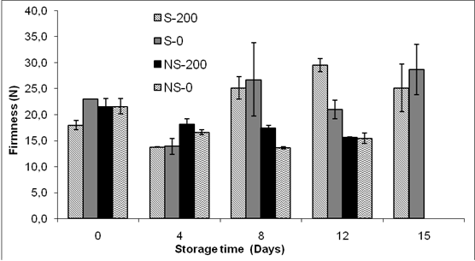

* The application of 1-MCP (200 g/lt), did not extend the shelf-life in minimally processed pitahaya fruits. It is recommended to evaluate additional concentrations and exposure times to elucidate whether 1-MCP treatments can potentially extend the shelf-life of minimally processed pitahaya fruits.

Acknowledgements

The authors acknowledge the financial su-pport from the Colombian Ministry of Agriculture and Rural Development and the Association of pitahaya producers (Asopitaya).

References

Able, A.J.; Wong, L.S.; Prasad, A.; and O'Hare, T.J. 2002. 1-MCP is more effective on a floral brassica (*Brassica oleracea* var. *italica* L.) than a leafy brassica (*Brassica rapa* var. *chinensis*). Postharvest Biology and Technology 26: 147-155.

Agar, I.T.; Massantini, R.; Hess-Pierce, B.; and Kader, A.A. 1999. Postharvest CO2 and ethylene production and quality maintenance of fresh-cut kiwi fruit slices. Journal of Food Science 64: 433-440.

Ahvenainen, R. 1996. New approaches in improving the shelf life of minimally processed fruit and vegetables. Trends in Food Science & Technology 7: 179-187.

AOAC. 2000a. Official methods of analysis of the Association of Official Analytical Chemists: 932.12 Fruits and fruit products. Solids (Soluble) in Fruits and Fruit Product: Refractometer Method. S Arlington, Virginia, USA. 7p.

AOAC. 2000b. Official methods of analysis of the Association of Official Analytical Chemists: 942.15A Fruits and fruit products - Acidity (Titratable) of Fruit Products. Association of Official Analytical Chemists, Arlington.11p.

Arias, E.; Lopez-Buesa, P.; and Oria, R. 2009.Extension of fresh-cut "Blanquilla" pear (*Pyruscommunis* L.) shelf-life by 1-MCP treatment after harvest.Postharvest Biology and Technology 54: 53-58.

Baquero, E.; Castro, J.; and Narvaez, C. 2005.Catalasa, peroxidasa y polifenoloxidasa en pitaya amarilla (*Acanthocereus pitajaya*): Maduración y senescencia. Acta Biológica Colombiana 10: 49-60.

Bassetto, E.; Jacomino, A.P.; Pinheiro, A.L.; and Kluge, R.A. 2005. Delay of ripening of 'Pedro Sato' guava with 1-methylcyclopropene. Postharvest Biology and Technology 35: 303-308.

Bower, J.H.; Blasi, W.V.; and Mitcham, E.J. 2003.Effects of ethylene and 1-MCP on the quality and storage life of strawberries. Postharvest Biology and Technology 28: 417-423.

Bregoli, A.M.; Ziosi, V.; Biondi, S.; Rasori, A.; Ciccioni, M.; Costa, G.; and Torrigiani, P. 2005. Postharvest 1-methylcyclopropene application in ri–pening control of 'Stark Red Gold' nectarines: Temperature-dependent effects on ethylene production and biosynthetic gene expression, fruit quality, and polyamine levels. Postharvest Biology and Technology 37: 111-121.

Djioua, T.; Charles, F.; Lopez-Lauri, F.; Filgueiras, H.; Coudret, A.; Freire, M.; Ducamp-Collin, M.N.; and Sallanon, H. 2009. Improving the storage of minimally processed mangoes (*Mangiferaindica* L.) by hot water treatments. Postharvest Biology and Technology 52: 221-226.

Dong, L.; Lurie, S.; and Zhou, H.W. 2002.Effect of 1-methylcyclopropene on ripening of 'Canino' apricots and 'Royal Zee' plums. Postharvest Biology and Technology 24: 135-145.

DuBois, M.; Gilles, K.A.; Hamilton, J.K.; Rebers, P.A.; and Smith, F. 1956. Colorimetric method for determination of sugars and related substances. Analytical Chemistry 28: 350-356.

Feng, X.Q.; Apelbaum, A.; Sisler, E.C.; and Goren, R. 2000. Control of ethylene responses in avocado fruit with 1-methylcyclopropene. Postharvest Biology and Technology 20: 143-150.

Golding, J.B.; Shearer, D.; Wyllie, S.G.; and McGlasson, W.B. 1998.Application of 1-MCP and propylene to identify ethylene-dependent ripe–ning processes in mature banana fruit. Postharvest Biology and Technology 14: 87-98.

Gutierrez, M.S.; Trinchero, G.D.; Cerri, A.M.; Vilella, F.; and Sozzi, G.O. 2008. Different responses of goldenberry fruit treated at four maturity stages with the ethylene antagonist 1-methylcyclopropene. Postharvest Biology and Technology 48: 199-205.

Hong, G.; Peiser, G.; and Cantwell, M.I. 2000.Use of controlled atmospheres and heat treatment to maintain quality of intact and minimally processed green onions. Postharvest Biology and Technology 20: 53-61.

Jiang, Y.; Joyce, D.; and Macnish, A.J. 1999. Responses of banana fruit to treatment with 1-methylcyclopropene. Plant Growth Regulation 28(2): 77-82.

ICONTEC. 1996. NTC 3554 - Frutas frescas: pitaya. Instituto Colombiano de normas técnicas y certificación. Ministerio de Agricultura y Desarrollo Rural, Federación Nacional de Cafeteros de Colombia, Bogotá, Colombia.

Koukounaras, A.; Sfakiotakis, E. 2007.Effect of 1-MCP prestorage treatment on ethylene and CO2 production and quality of 'Hayward' kiwifruit during shelf-life after short, medium and long term cold storage. Postharvest Biology and Technology 46: 174-180.

Lu, C.W.; Cureatz, V.; and Toivonen, P.M.A. 2009.Improved quality retention of packaged 'Anjou' pear slices using a 1-methylcyclopropene (1-MCP) co-release technology. Postharvest Biology and Technology 51:378-383.

Manganaris, G.A.; Crisosto, C.H.; Bremer, V.; and Holcroft, D. 2008.Novel 1-methylcyclopropene immersion formulation extends shelf life of advanced maturity 'Joanna Red' plums (*Prunussalicina*Lindell). Postharvest Biology and Technology 47: 429-433.

Mao, L.C.; Wang, G.Z.; and Que, F. 2007.Application of 1-methylcyclopropene prior to cutting reduces wound responses and maintains quality in cut kiwifruit. Journal of Food Engineering 78: 361-365.

Mendoza, F.; Dejmek, P.; and Aguilera, J.M. 2006.Calibrated color measurements of agricultural foods using image analysis. Postharvest Biology and Technology 41: 285-295.

Menniti, A.M.; Gregori, R.; and Donati, I. 2004.1-methylcyclopropene retards postharvest softe–ning of plums. Postharvest Biology and Technology 31: 269-275.

Mostofi, Y.;Toivonen, P.M.A.;Lessani, H.;Babalar, M.;y Lu, C.W. 2003. Effects of 1-methylcyclopropene on ripening of greenhouse tomatoes at three storage temperatures. Postharvest Biology and Technology 27: 285-292.

Nerd, A.; Mizrahi, Y. 1997.Reproductive biology of cactus fruit crops. Horticultural Reviews 18: 321-346.

Nerd, A.; Mizrahi, Y. 1999.The effect of ripening stage on fruit quality after storage of yellow pitaya. Postharvest Biology and Technology 15: 99-105.

Oms-Oliu, G.; Rojas-Grau, M.A.; Gonzalez, L.A.; Varela, P.;Soliva-Fortuny, R.; Hernando, M.I.H.;Munuera, I.P.;Fiszman, S.; Martin-Belloso, O. 2010. Recent approaches using chemical treatments to preserve quality of fresh-cut fruit: A review. Postharvest Biology and Technology 57: 139-148.

Osuna, J.A.;Beltrán, J.A.;y Urías, M.A. 2005.Effect of 1-methylcyclopropene (1-MCP) on shelf life and quality of exporting mango.RevistaFitotecnia Mexicana 28: 271-278.

Parra-Coronado, A.; Hernandez-Hernandez, J.E.; and Camacho-Tamayo, J.H. 2006. Comportamiento fisiológico de la pera variedad Triunfo de Viena (*Pyruscommunis* L.) durante el período poscosecha. Revista Brasileira de Fruticultura 28: 46-50.

Porat, R.; Weiss, B.; Cohen, L.; Daus, A.; Goren, R.; and Droby, S. 1999. Effects of ethylene and 1-methylcyclopropene on the postharvest qualities of 'Shamouti' oranges. Postharvest Biology and Technology 15: 155-163.

Pre-Aymard, C.; Fallik, E.; Weksler, A.; and Lurie, S. 2005. Sensory analysis and instrumental measurements of 'Anna' apples treated with 1-methylcyclopropene. Postharvest Biology and Technology 36: 135-142.

Rico, D.; Martin-Diana, A.B.; Barat, J.M.; Barry-Ryan, C. 2007. Extending and measuring the quality of fresh-cut fruit and vegetables: a review. Trends in Food Science & Technology 18: 373-386.

Rocculi, P.;Emiliano, C.;Romani, S.;Sacchetti, G.;y Rosa, M.D. 2009.Effect of 1-MCP treatment and N2O MAP on physiological and quality changes of fresh-cut pineapple.Postharvest Biology and Technology 51: 371-377.

Rodriguez, D.; Patiño, M.; Miranda, D.; Fischer, G.;y Galvis, J. 2005. Efecto de dos índices de madurez y dos temperaturas de almacenamiento sobre el comportamiento en poscosecha de la pitaya amarilla. Revista Facultad Nacional de Agronomia, Medellín 58: 2837-2857.

SAS Institute Inc. 2008.SAS® 9.1.3 IntelligencePlatform: Web ApplicationAdministration Guide, ThirdEdition.Cary, NC: SAS Institute Inc.

Selvarajah, S.; Bauchot, A.D.; and John, P. 2001. Internal browning in cold-stored pineapples is suppressed by a postharvest application of 1-methylcyclopropene. PostharvestBiology and Technology 23: 167-170.

Serna-Cock, L.; Torres, L.; and Ayala, A. 2011.Efecto del empaque and del 1-MCP sobre características físicas, químicas and fisiológicas de pitahaya amarilla. Revista Biotecnología en el sector agropecuario and agroindustrial. 9(2). In Press.

Singh, S.P.; Pal, R.K. 2008.Response of climacteric-type guava (*Psidiumguajava* L.) to postharvest treatment with 1-MCP. Postharvest Biology and Technology 47: 307-314.

Soliva-Fortuny, R.C.; Martin-Belloso, O. 2003.New advances in extending the shelf-life of fresh-cut fruits: a review. Trends in Food Science & Technology 14: 341-353.

Spotts, R.A.; Sholberg, P.L.; Randall, P.; Serdani, M.; and Chen, P.M. 2007. Effects of 1-MCP and hexanal on decay of d'Anjou pear fruit in long-term cold storage. Postharvest Biology and Technology 44: 101-106.

Tian, M.S.; Prakash, S.; Elgar, H.J.; Young, H.; Burmeister, D.M.; and Ross, G.S. 2000. Responses of strawberry fruit to 1-Methylcyclopropene (1-MCP) and ethylene. Plant Growth Regulation32: 83-90.

Vargas and Vargas, M.L.; Centurión-Yah, A.; Sauri-Duch, E.;y Tamayo-Cortez, J. 2005. Industrialización de la pitahaya (*Hylocereusundatus*): Una nueva forma de comercialización. Revista Mexicana de Agronegocios. 9 (16): 498-509.

Wang, C.Y. 2000. Postharvest techniques for reducing low temperature injury in chilling sensitive commodities. In: Improving postharvest techno–logies of fruits vegetables and ornamentals (F.Artes, M.I. Gil, M.A. Conesa, eds.).Int. Inst. Refrigeration.467-473p.

Watada, A.E.; Qi, L. 1999. Quality of fresh-cut produce. Postharvest Biology and Technology 15: 201-205.

Watkins, C. 2006. The use of 1-methylcyclopropene (1-MCP) on fruit and vegetables. Biotechnology Advances 24: 386-409.

Wiley, R.C. 1994.Introduction of minimally processed refrigerated fruits and vegetables. In: Minimally processed refrigerated fruits & vegetables, (R.C. Wiley, ed.), Chapman & Hall, New York.373p.

Win, T.O.; Srilaong, V.; Heyes, J.; Kyu, K.L.; and Kanlayanarat, S. 2006. Effects of different concentrations of 1-MCP on the yellowing of West Indian lime (*Citrus aurantifolia*Swingle) fruit. Postharvest Biology and Technology 42: 23-30.