*Research article*

Study of the extraction process of papain from latex of papaya

(*Carica papaya* L.) fruits cv. Maradol

Estudo do processo de extração de papaína a partir do látex do fruto de mamão

(*Carica papaya* L.) cv. Maradol

*Margarita M. Andrade-Mahecha1, Olga Morales-Rodriguez2, and Hugo A. Martinez-Correa3\**

1Department of Food Engineering, Universidade Estadual de Campinas –UNICAMP, Campinas, SP, Brasil.

2 Department of Agronomic Engineering, Universidad del Tolima, Ibagué, Tolima, Colombia.

3 Department of Enginering and Management, Universidad Nacional de Colombia - Palmira, Palmira, Valle, Colombia. *Corresponding author: hamartinezco@unal.edu.co

Rec.: 04.04.11 Acept.: 24.10.11

# Abstract

In this work, we studied the extraction process of papain, present in the latex of papaya fruit (*Carica papaya* L.) cv. Maradol. The variables studied in the extraction of papain were: latex:alcohol ratio (1:2.1 and 1:3) and drying method (vacuum and refractance window). Papain enzyme responses were obtained in terms of enzymatic activity and yield of the extraction process. The best result in terms of enzyme activity and yield was obtained by vacuum drying and a latex:alcohol ratio of 1:3. The enzyme obtained was characterized by physicochemical and microbiological properties and, enzymatic activity when compared with a commercial sample used as standard.

**Key words:** Extraction method, latex, papain.

# Resumo

Neste trabalho foi estudado o processo de extração da papaína presente no látex de frutos de mamão (*Carica papaya* L*.*) cultivar Maradol. As variáveis estudadas na extração da papaína foram proporção de látex:álcool (1:2.1 e 1:3) e tipo de secagem (à vácuo e por refractance window). As respostas obtidas foram atividade enzimática da enzima e rendimento do processo de extração. O melhor resultado em termos de atividade enzimática e rendimento foi obtido nas condições de secagem à vácuo e proporção látex:álcool de 1:3. A enzima obtida foi caracterizada por testes físico-químicos, microbiológicos e de atividade enzimática e comparada com uma amostra comercial usada como padrão.

**Palavras chave:** Látex, papaína, processo de extração.

## Introduction

Papaine (E.C. 3.4.22.2) is a proteolytic enzyme with molecular mass of 23.406, and a 212 aminoacids polypeptide chain. Its commercial importance is due to its diverse uses in textile, pharmaceutics, cosmetics and food industries (Galindo-Estrella *et al.*, 2009).

In the food industry it stands out for its activity as meat tenderizer, acting in the muscle fibers and connective tissue components; in the drink industry it is used to hydrolyze high molecular weight proteins in clarification of beer, to prevent its turbidity during storage and prolonged cooling (Aehle, 2007). Latex obtained from unripe papaya (*Carica papaya* L.) fruits is a mix of proteolytic enzimes including papain, chymopapain A and B (EC 3.4.22.6), endopeptidase papain III, endopeptidase papain IV and endopeptidase papain omega (Azarkan *et al*., 2003). Diverse studies have reported papain extraction using differ-rent reagents during the precipitation phase (Marrero, 1977; Monti et al., 2000). The drying phase in the production of this enzyme is highly important since, during this process the enzyme can loss its native structure ha-ving an effect on its enzymatic activity. (Sloth et al., 2008). This work aimed to study the effect of the extraction process conditions, i.e. latex:alcohol ratios (1:2.1 and 1:3) in the precipitation phase and, drying method (vaccum (50°C) and refractance window (95°C for medium heater)) in papain production from unripe fruits. The variable of response evaluated was the yield of the extraction process. Enzymatic activity was determined by the methods of tyrosine production and milk coagulation. Additionally, the obtained enzyme was tested in beer clarification processes.

Materials and methods

**Material**

The material used was 5 to 6 months old unripe fruits of *Carica papaya* L. cv. Maradol from a crop located at 240 m.a.s.l., with a 28°C average temperature, and sandy loam soil in the region of Flandes (Tolima, Colombia). For fruit sampling, 59 plants were selected randomly, from each plant 4 fruits with a diameter between 15 to 35 cm, length between 35 to 41 cm and weight between 1.8 and 2.5 Kg. were chosen. All the reagents used (ammonium sulphate, EDTA, ethanol (96% v/v) and sodium metabisulfite) were analytical grade (Merck chemicals), and the commercial papain used as standard was provided by Merck Chemicals (Germany).

**Latex extraction**

Latex was extracted from 4 longitudinal incisions through the papaya skin done with stainless steel tools, it was collected by dripping and preserved by adding sodium metabisulfite (0.5% w/w) and storage at -5°C till further use.

**Papain extraction**

Papain was obtained through a series of processes drawn on Figure 1. The first phase eliminates small organic and inorganic molecules and other proteins present on the extracted latex by adding ammonium sulphate and EDTA. During this phase the latex was solubilized and later diluted on alcohol (ethanol, 96% v/v) until it had 10% alcohol concentration. The impurities precipitated from the previous phase were eliminated by filtration on diatomaceous earth. The filtrated li–quid was added to ethanol (96% v/v) in two proportions latex:alcohol, 1:2.1 or 1:3, to obtain a precipitate which was recovered by va-ccum filtration using Wathman paper N°1. Finally, the solid was dried out using two different methods: (1) Vacuum drying (at 50 °C, Lab live duo-vac oven, Lab Line Instruments) or (2) Drying by refractance window (MCD Technologies, Inc.) using 95 °C water as heating medium. The enzyme was grinded to get a fine powder.

**Physicochemical and microbiological analyzes**

Final moisture was done by the method 925.09 (A.O.A.C., 2005), a second method was used for ashes 923.03 (A.O.A.C., 2005), pH determined with a pHmeter (Schoot-gerate CG818), solubility obtained with solvents such as water, ethyl ether, hydrochloric acid, sodium hydroxide, sodium bicarbonate and sulfuric acid. To detect protein presence the Biureto test and infrared absorbance electroscopy (FTS-2400) were used with the aim to verified the functional groups characteristic of papain. Microbiological analysis of mesophilic (UFC/g), NMP of total coliforms/g, molds and yeast (UFC/g) were performed.

**Enzymatic activity**

**Tyrosine method**

Proteolytic activity was determined using caseine as substrate at 37 °C and pH 8.2. Tirosyne and caseine are released and can be measured by spectrophotometry at 280 nm, the activity is measured by the equation 1.

$\text{AU= }S ampl ing *\frac{Tyrosine μmol}{\begin{aligned}Absorbance of \\ 1μmol of Tyrosine\end{aligned}}*T_{incubation}$

*Sampling absorbance*

## Disolution

Partial precipitation

## Filtration

Filtrated liquid

## Precipitation

## Filtration

## Drying

**Papain**

## Cooling

**Figure 1.** Papain extraction process.

(1)

Under this method, a unity of enzyme is defined as the activity of a determined amount of enzyme degraded to caseine, under specific conditions of temperature and pH, to produce one mol of tyrosine per minute (Afaq and Iqbal, 2001).

**Milk coagulation method**

This test measures the potency of an enzyme to break the protein structure of milk (substrate). In this method 10 mg of papain solution in a concentration of 1 g enzyme in 10 g acetic acid (0.01%) was added to 10 ml of milk solution (2.5 g powder milk in 100 g water) which was heated in a water bath at 50 °C (Ming et al., 2002). The tube was agitated until the first sign of coagulation. The time used to form a clot was registered and used in equation 2. Enzyme activity is expressed in units of potency to coagulate milk per gram of dry enzyme (Upe).

|  |  |  |
| --- | --- | --- |
| **Table 1.** Experimental design. | | |
| **Treatment** | **latex:alcohol** | **Drying method** |
| 1 | 1/2.1 | Refractance window (RW) |
| 2 | 1/2.1 | Vacuum |
| 3 | 1/3 | Refractance window (RW) |
| 4 | 1/3 | Vacuum |

$\text{Upe}\text{ =(1000/E*t) }$ (2)

where, *E*: miligrams of papain used to precipitate 10 ml of substrate (milk) in the time *t* (min).

**Implementation of papain in beer**

During beer fermentation and maturation colloidal networks are formed, they can precipitate and develop turbidity in the packaged beer during cool storage. Those colloidal precipitates are fractions of colloidal compounds as polyphenol and proteins, papain helps with beer stabilization by hydrolyzing those compounds and inhibiting the formation of such network between proteins and polyphenol. (Rehmanji et al., 2005).

10 mg of enzyme were added to 100 ml of beer without enzymatic treatment, it stand quiet during 1 h, and turbidity index was measured (turbidity meter HACH model 2100N) and compared with the one of a fini-shed product (beer after enzymatic treatment) (Rehmanji et al., 2005). Turbidity is expressed in NTU (Nephelometric Turbidity Units).

**Experimental design**

An experimental design with 4 treatments and 2 repetitions (Table 1) was used to evaluate the influence of two factors: (1) latex:alcohol ratio (1:2.1 or 1:3) and, (2) drying method ( vacuum (50°C) and refractance window (water at 95°C as heater medium)). The response variables were: yield (expressed as amount of dry enzyme obtained in relation to the amount of fresh latex), and enzymatic activity. The analytic variables were done in duplicate and the mean values were compared by Tu-key´s (P < 0.05) test using Statistica software (V.7.0).

**Results and discussion**

Figure 2 shows the extraction yield (papain (g)/100 g latex) for the treatments experimented. It is observed that the highest yield for papain extraction was obtained with treatments 2 and 4 which used vacuum drying in latex:alcohol ratios of 1:2.1 and 1:3. Yield (g papain /latex) were 10.83 ± 0.04 and 11.53 ± 0.2, respectively. Significant differ-rences (P < 0.05) were found when they were compared with treatments 1 and 3 which used refractance window as drying method. The studied factors allow us to confirm the high influence of the drying method in the final yield of the process, the relation between variables resulted highly relevant as well. Treatment 4 showed the highest papain extraction yield (papain g/ latex g) 11.53/100. This value was different from the one reported by Monti et al. (2000) who found a yield around 1.51 mg/g latex with a method that uses nitrogen and EDTA in a series of cooling and crystalizing phases, using papaya fruits from Sao Paulo (Brazil). This difference could be explained by the fruit source or origin and the technical process for the extraction, in this sense, Galindo-Estrella *et al.* (2009) confirmed that *C. papaya* L. cv. Maradol has a higher proteolytic activity when compared to leaf and stem extracts.

**Figure 2.** Papain yield in the different treatments. Means with the same letter are not significantly different (P < 0.05).

$$\text{AU=}Sampling absorbance*\frac{Tyrosine μmol}{\begin{aligned}Absorbance of \\ 1μmol of Tyrosine\end{aligned}}*T_{incubation}$$

(1)

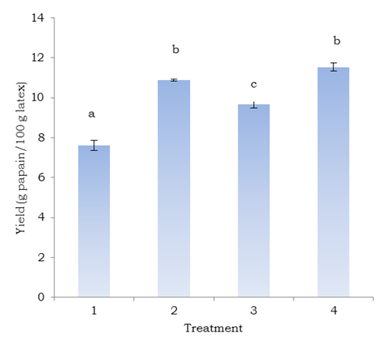

Figure 3 shows the results of the enzymatic activity experiments by the tyrosine production method (Figure 3a) and milk coagulation (Figure 3b). It is evident that treatment 4 has the same enzymatic activity as the commercial enzyme (standard) and significant differences are observed when it is compared to treatments 1, 2 and 3 (P < 0.05). Thus, the proportion latex:alcohol and drying method are important factors for the enzymatic activity. This results are in agreement with Puig *et al.* (2008) results, who studied different me-thods to dry out raw papain (latex) and found high enzyme activity when it was vacuum dried (50 °C) and lyophilized (-30 °C). The differences in enzymatic activity by vacuum and refractance window drying methods could be due to loss of activity because of changes in the enzyme native structure during the drying process, as it was reported by Devakate *et al.* (2009) and Sloth *et al.* (2008).

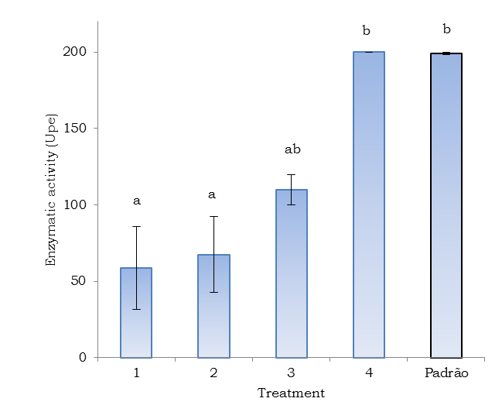

**Figure 3.** Papain enzymatic activity. **A.** Tyrosine production method, **B.** Coagulation method. Means with the same letter are not significantly different (P < 0.05).

## Standard

**B**

**A**

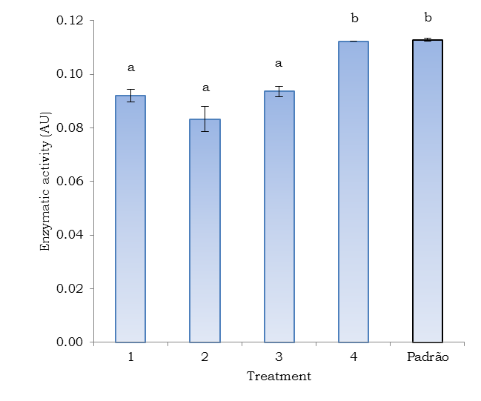

Standard

The results of the physicochemical characterization done in the extracted papain are presented in Table 2. The physicochemical tests were done on a sample of treatment 4 which has a pH, moisture and solubility va-lues close to the commercial enzyme (standard). Differences in ashes content can result from the action of the chelating agent EDTA during the extraction process which forms a complex with metallic ions increasing their solubility, also the different origin of the samples explains the differences.

A reaction with biureto confirms the pre-sence of aminoacids and proteins, since the biureto reagent reacted with the peptide links in polipeptides of both, the extracted enzyme and the commercial one. The presence of the functional groups of the papin was confirmed by infrared espectometry which reports two carboxyl groups, aliphatic amino, carbon and hydrogen in both, the extracted enzyme and the standard one (Table 2).

The results presented in Table 2 reveal the microbiological quality of the extracted enzyme in comparison with the standard enzyme in relation to mesophyll microorga-nisms, total coliforms and molds, and yeast presence. These results are in agreement with the accepted standards in the Colombian regulations.

|  |  |  |
| --- | --- | --- |
| Table 2. Physicochemical and microbiological properties of the extracted papain. | | |
| Properties | Standard enzyme | Sample(treatment 4) |
| Moisture (%) | 6±0.1 | 6.1 ± 0.1 |
| pH | 5.09± 0.3 | 4.96 ± 0.2 |
| Ashes (%) | 9.46± 0.6 | 0.92 ± 0.4 |
| Solubility | Soluble in water  Partial solubility in NaHCO3  Insoluble in ether, HCl, NaOH and H2SO4 . | Partial solubility in water and NaHCO3  Insoluble in ether, HCl, NaOH and H2SO4 . |
| Biureto´s reaction test | Positive | Positive |
| Infrared spectro | C=O: aminoacids  N-H: aminoacids and proteins  C-H: Aliphatic | C=O: aminoacids  N-H: aminoacids and proteins  C-H: Aliphatic |
| Mesophil microorganisms (UFC /g) | < 10 | < 10 |
| N.M.P  Total coliforms / g | <3 | <3 |
| Molds and yeast  (UFC /g) | < 10 | < 10 |

As for the results in the beer clarification test (Table 3), it was observed that the papain extracted by treatment 4 reduced beer turbi-dity to a comparison level with the final pro-duct (commercial). This experiment allows us to conclude that the enzyme obtained had an effective action breaking protein-polyphenol colloidal complexes of high molecular weight (measured by the decrease in turbidity), improving beer clarification.

|  |  |  |
| --- | --- | --- |
| Table 3. Beer turbidity results. | | |
| Sample | Turbidity  (NTU ) |
| Beer with enzymatic treatment | 77 ± 0.3 |
| Beer treated with the standar enzyme | 4.0 ± 0.2 |
| Beer treated with the obtained enzyme | 4.2 ± 0.2 |
| Commercial beer (Finished product) | 3.2 ± 0.1 |

Conclusions

* It was proven that latex:alcohol ratio and drying method are determining factor in papain extraction from *Carica papaya* L. cv. Maradol latex. With a drying treatment by vacuum and a latex:alcohol ratio 1:3, it was possible to obtain a better yield (dry enzyme g / 100 g raw latex) in the extraction process: 11.53 ± 0.2 and an enzyme activity at the same level as the standard enzyme.
* The physicochemical properties of the extracted papain were very similar to the ones of the standard enzyme (pH, solubility and moisture). Infrared spectrometry confirmed the presence of the characteristic functional groups of this enzyme. By means of the beer clarification test, the papain efficiency breaking high molecular weight proteins which cause turbidity in cool stored beer, was confirmed.

References

Aehle, W. 2007. Enzymes in industry, production and applications. Weinheim: WILEY-VCH Verlag GmbH & Co. 517 p.

Afaq, S. and Iqbal, J. 2001. Immobilization and stabilization of papain on chelating sepharose: a metal chelate regenerable carrier. Electronic J. Biotech. 4 (3): 120 - 124.

AOAC. Official methods of analysis of AOAC. 2005. 18th edn. Association of Official Analytical Che-mists. Washington (DC).

Azarkan, M.; Moussaoui, A. E.; Wuytswinkel, D.; Dehon, G.; and Looze, Y. 2003. Fractionation and purification of the enzymes stored in the latex of *Carica papaya*. J. Chrom. B. 790:229 - 238.

Devakate, R. V.; Patil, V. V.; Waje, S. S.; and Thorat, B. N. 2009. Purification and drying of bromelain. Separation and Purification Technology 64 (3):259 - 264.

Galindo-Estrella, T.; Hernández-Gutiérrez, R.; Mateos-Díaz, J.; Sandoval-Fabián, G.; Chel-Guerrero, L.; Rodríguez-Buenfil, I.; e Gallegos-Tintoré, S. 2009. Proteolytic activity in enzymatic extracts from *Carica papaya* L. cv. Maradol harvest by-products. Proc. Biochem. 44(1):77 - 82.

Marrero, M. 1977. Obtención industrial de papaína purificada a partir del látex del fruto de la *Carica papaya* L. Rev. Cubana de Farmacia 11(1):35 - 39.

Ming, C. C.; Bono, A.; Krishnaiah, D.; and Han, T. S. 2002. Effects ionic and non-ionic surfactants on papain activity. Borneo Sci. 12:71 - 77.

Monti, R.; Basilio, C. A.; Trevisan, H. C.; and Contiero, J. 2000. Purification of papain from fresh latex of *Carica papaya*. Braz. arch. biol. technol. 43(5):501 - 507.

Puig, A.; Gil, I.; and Sánchez, O. 2008. Evaluation of drying techniques measuring proteolytic activity of papain obtained from unripe fruit and skin juice. Ind. Biotechn. Intern. Conference. June 8-11, Italy.

Rehmanji, M.; Gopal, C.; and Mola, A. 2005. Beer stabilization technology—clearly a matter of choice. MBAA TQ. 42(4):332 - 338.

Sloth, J.; Bach, P.; Jensen, A. D.; and Kiil, S. 2008. Evaluation method for the drying performance of enzyme containing formulations. Bioch. Eng. J. 40(1):121 – 129.