**Potassium effect on production and forage quality of *Brachiaria decumbens* Stapf in the Eastern plain piedmont of Colombia**

**Efecto del potasio sobre la producción y calidad de forraje de Brachiaria decumbens Stapf en el piedemonte de los Llanos Orientales de Colombia**

*Álvaro Rincón-Castillo*

Research center La Libertad Corpoica, Km 17 vía a Puerto López, Villavicencio, Meta, Colombia.

Corresponding author: [arincon@corpoica.org.co](mailto:arincon@corpoica.org.co), forrajestropicales@gmail.com

Rec.: 25.05.11 Acept.: 06.12.11

**Abstract**This experiment was conducted at the Research Center La Libertad CORPOICA, located in Villavicencio, Meta, Colombia, in an Oxisol of middle terrace with a potassium content of (K) 0.08 cmol.kg-1. The statistical design consisted of a randomized complete block in a split plot arrangement with four replications, four K levels (30, 60, 90 and 120 kg/ha) were evaluated in the forage production of *Brachiaria* *decumbens*. As main plot was assessed basic fertilization (fertilized and unfertilized). The basic fertilization (in kg/ha) consisted of 100 of P2O5, 60 N, 30 S, 3 Zn, 0.1 Cu and 0.5 for B. There were no significant differences in forage production due to the levels of K applied. In the studied conditions *B. decumbens* respond well to 30 kg.ha-1 of K, however, basic fertilization applied together with K, contributed to the improvement of *B. decumbens* forage production until 12 months after application. K content in soil was higher than 0.10 cmol/kgof soil, a level considered appropriate for the development of grasses such as *B. decumbens*.

**Key words:** Acid soils, *Brachiaria decumbens*, grass fertilization, grass minerals.

**Resumen**

En el Centro de Investigaciones La Libertad, de la Corporación Colombiana de Investigación Agropecuaria (Corpoica), localizado en Villavicencio, Meta (Colombia), en un Oxisol de terraza media con un contenido de 0.08 cmol/kg de potasio (K), en un diseño de bloques completos al azar en parcelas divididas con cuatro replicaciones, se evaluó el efecto de cuatro niveles de K (30 kg/ha, 60 kg/ha, 90 kg/ha y 120 kg/ha) en la producción de forraje de *Brachiaria* *decumbens*. Como parcela principal se evaluaron la aplicación de fertilización básica y sin fertilización básica. La primera consistió en (kg/ha) de 100, 60, 30, 3, 01 y 0.5 de P2O5, N, S, Zn, Cu, y B, respectivamente. No se encontraron diferencias significativas en la producción de forraje entre los niveles de K aplicados. En las condiciones del ensayo *B. decumbens* responde bien a 30 kg/ha de K. No obstante, la fertilización básica aplicada junto con el K contribuyó a mejorar la producción de forraje hasta los 12 meses después de su aplicación. La concentración de K en el suelo, en los tratamientos evaluados, fue > 0.10 cmol/kg, un nivel adecuado para el desarrollo de pastos poco exigentes como *B. decumbens*.

**Palabras clave:** *Brachiaria decumbens*, fertilización de pastos, minerales en pastos, suelos ácidos.

**Introduction**

Potassium (K) is an element known as an enzyme activator, since it is required for more than 50 enzymes to increase reaction speed. It is also important for protein synthesis, photosynthesis and in stomatal aperture and closure (Salisbury y Ross, 1992). It is present in soil as: structural component of primary minerals like micas and feldspars, it is avai-lable only when these minerals are decom-posing, temporarily trapped in expandable clays, interchangeable, and soluble in the soil solution. In highly meteorized soils as Oxisols soils, where the organic matter, kaolinite and iron (Fe) and aluminum (Al) oxides, are responsible for the cation ex-change capacity, interchangeable K is an indi-cative of this element availability for plants, and it is the main K reposition source in the solution absorbed by plants (Mendeset al., 2004; Vilela et al., 2004). In acidic soils of Eastern plains of Colombia, K concentration is not higher than 0.1 cml/kg, thus it is a deficient element for pasture development and produc-tion; however, in foliar analysis K concen-tration is always >0.6%, which is enough to cover cattle requirements, (McDowell et al., 1994), inclusive in native pastures. This situation had created doubts about the need to use K in pasture ferti-lization, since appa-rently, these soils have the capacity to restore fixed K in clays and release it on an available form for plants (Dávila et al., 1998). This work aimed to evaluate K effect on production and quality of *B. decumbens* Stapf forage in oxisols soils from the Eastern plain piedmonts in Colombia.

**Materials and methods**

This study was done in the Research Center La Libertad (9º 6´N y 73º 34´O, 300 m.a.s.l.), from the Corporación Colombiana de Inves-tigación Agropecuaria (Corpoica), located in Villavicencio, Meta (Colombia). The annual rainfall is 2800 mm, distributed between April and December; average temperature is 26 °C; and relative humidity is 85% in the rainy season and 65% in the dry season. The experiment was performed on *B. decumbens* established pastures with degradation symp-toms like green-yellowish color, poor vigor and slow recuperation after grazing, but with a good plant density.

The evaluated K doses were 30 kg/ha, 60 kg/ha, 90 kg/ha and 120 kg/ha, using K chloride (K 50%) as K source. It was applied in a uniform way P2O5 100 Kg/ha as phosphate rock, S 30 Kg/ha as agricultural limestone, N 60 Kg/ha as urea, Zn 3 Kg/ha, Cu 0.1 Kg/ha, and B 0.5 Kg/ha as BoroZinco.

Treatments were distributed in rando-mized complete blocks in a Split plot arran-gement with four replications, where the main plot was basic fertilization (with or without) in 200 m2 area, and subplots were K levels in 50 m2 area. Before and after the application of treatments the following measurements were done: (1) K in soil by the ammonium acetate method, 1M pH 7; (2) K concentration at three different depths; (3) Foliar K by atomic absorption; (4) Forage availability for green matter (GM), dry green matter (DGM), height and plant coverage. To evaluate green matter, grass mowing at 20 cm height was done 30 days in advance using a scythe. For eva-luations, a 0.25 m2 (0.5 x 0.5 m) frame was located in three places selected randomly in each experimental unit, grass was harvested at 20 cm height, coverage and height were measured 30 days after grass mowing. Once green matter weight was obtained, samples for dry green matter were taken and placed on an oven at 70 °C for 3 days. Evaluations were done in raining and dry seasons on 2008 and 2009. To know the soil physical properties before treatments were established, real den-sity (IGAC, 1990), bulk density (IGAC, 1990), and porosity. Results were analyzed using analysis of variance and mean comparison with a Duncan test using SAS software (Littell et al., 2002).

**Results and discussion**

**Soil characteristics and forage quality**

Soil analysis at the study starting point showed an organic matter content of 2.5% and a K concentration 0.08 cmol/kg, a bulk density 1.50 g/cm3, real density 2.60 g/cm3 and porosity 42.7%, which indicates soil com-paction, due to more than 15 years of grazing. Availability of forage dry matter (DM) after 40 days of rest, was 689 kg/ha, which is considered low knowing that in the plain piedmonts is around 1.2 t/ha each 35 days. Raw protein in the forage was 8%, fiber in neutral detergent was 63% and in vitro digestibility was 64.2%.

**Forage production**

Seventy days after treatments were applied the highest forage production (P < 0.05) was found in the K and basic fertilization treat-ment (DM 2.4 t/ha) in comparison with treatments without basic fertilization (DM 1.6 kg/ha) (Figure 1). Fifteen months after treat-ments were applied forage production chan-ged (P < 0.05) between treatments in favor of K with basic fertilization (DM 2.2 t/ha), however, 25 months after K was applied there were no differences (P > 0.05) between treat-ments with basic fertilization (DM 2.08 t/ha) and without basic fertilization (DM 2.04 t/ha). Oxisols soils are characterized by their low fertility, therefore, it is important to applied balanced fertilizations for a good plant deve-lopment (Potash and Phosphate Institute, 1997). In the present work, basic fertilization plus K showed a better forage production after 2 months and till 12 months after application. GDM production did not change between dry and rainy seasons as a result of the treat-ments. In the rainy season the average yield was 2.07 t/ha and in the dry season was 0.88 t/ha (Figure 2). Even though the differences in forage production were not significant, in the rainy season was observed a tendency for an increment in biomass availability with higher K fertilization reaching 2266 kg DM/ha under K 120 kg/ha. The mean comparison of the evaluated treatments was performed sepa-rately for the dry and the rainy seasons. In the rainy season values were between DM 1900 kg and 2260 kg, there were no signi-ficant differences and the coefficient of varia-tion was 16.2%. In the dry season there were no significant differences in the mean com-parison of the treatments, the values were between 832 kg DM/ha and 948 kg DM/ha, and a coefficient of variation of 12.4%.

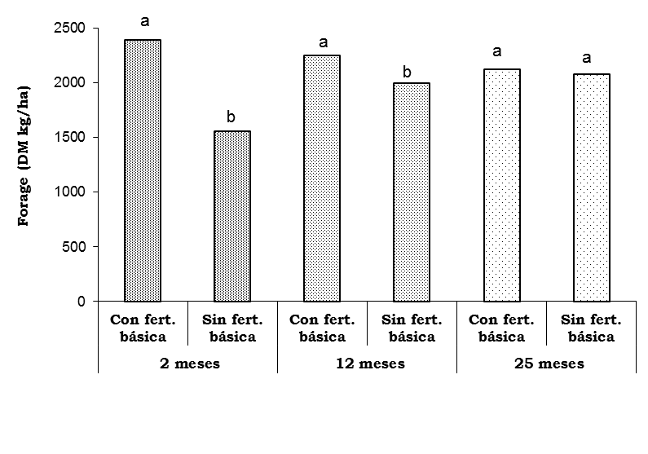

**4 months**

**12 months**

**25 months**

**With basic fertiliza- tion**

**Without basic ferti-lization**

**With basic fertiliza- tion**

**Without basic ferti-lization**

**With basic fertiliza- tion**

**Without basic ferti-lization**

**Figure 1.**  *B. decumbens* forage production with K doses, with or without basic fertilization, 2, 12 and 25 months after application. C.I. La Libertad, Eastern plains piedmont of Colombia. Values in columns of the same time (months) with the same letters are not significantly different (Duncan, P < 0.05).

**Potassium in soil**

Four months after the application, K con-centration in soil was 0.08 cmol/kg, at 15 months was 0.12 cmol/kg, and at 25 months it was reduced to 0.09 cmol/kg (Figure 3 and 4). Salinas and García (1985) consider that 0.13 cmol/kg concentration is high for pas-ture development in acidic soils, and 0.10 cmol/kg is an intermediate concentration. According to this recommendation, in this study, 25 months after treatments addition, K level was still under suitable concentrations to fulfill *B. decumbens* requirements. The highest K concentration in soil was presented between 0 and 5 cm (0.19 cmol/kg) and it was reduced to 0.09 cmol/kg between 5 and 10 cm, and to 0.05 cmol/kg between 10 and 20 cm (Rincón, 2007); therefore, in compacted soils caused by animal trampling there is a need to improve the soil physical conditions by vertical tillage. In this way, better conditions are given to improve nutrient infiltration and mobility.

**Foliar analysis**

Foliar K concentration in pastures was the highest (P < 0.05) when it was applied together with basic fertilization, both at 4months (0.88%) and 15 months (0.89%). When basic fertilization was omitted, those values were 0.84% and 0.79%, respectively (Figure 5).

0

500

1000

1500

2000

2500

30

60

90

120

**K doses (kg/ha)**

Luvias

Seca

**Forage (DM kg/ha)**

Rainy

Dry

**Figure 2.** *B. decumbens* forage production mean with K treatments during the rainy and dry seasons. C.I. La Libertad Eastern plains of Colombia.

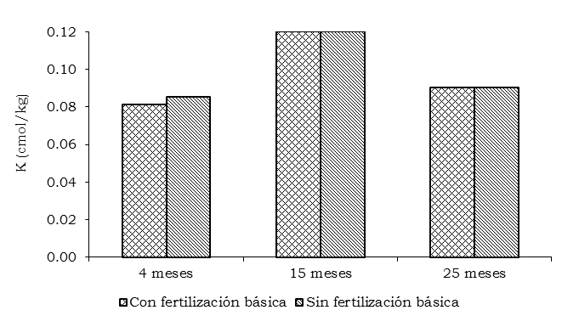

**Figure 3.**  Soil K concentration 4, 15 and 25 months after application with or without basic fertilization. C.I. La Libertad Eastern plains of Colombia.

There were no significant differences (P > 0.05) in foliar K concentrations by the effect of the application of this nutrient (Figure 6). This concentration is suitable to fulfill the requirements of fattening cattle systems, although, it can be deficient for dairy cows (McDowell et al., 1994). However (Mendes et al., 2004), the values found in this study for the aerial part of *B. decumbens* can be considered as deficient.

**Figure 4.** Soil K concentration 4, 15 and 25 months after application.

C.I. La Libertad Eastern plains of Colombia.

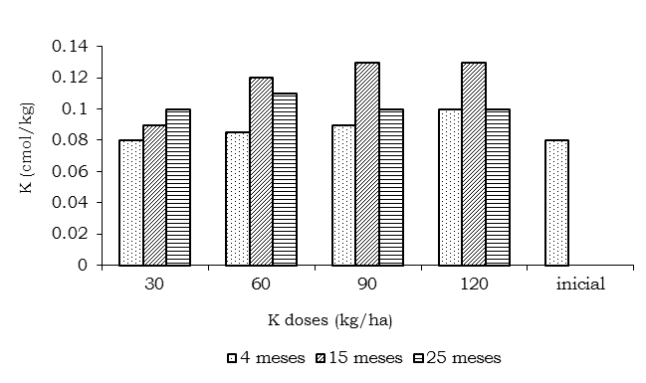

4 months

15 months

25 months

initial

|  |  |
| --- | --- |
| **Table 1.** Soil K concentration at three different depths . Treatment: K 120 kg/ha, with basic fertilization. C.I. La Libertad, Eastern plains piedmont of Colombia. | |
| **Depth**  **(cm)** | **K (cmol/kg)** |
| 0 - 5 | 0.19 a* |
| 5 - 10 | 0.09 b |
| 10 - 20 | 0.05 c |
| CV (%) | 5.10 |
| * Means with different letters show significant differences (P < 0.05) according to Duncan´s test. | |

**Figure 4.** Soil K concentration 4, 15 and 25 months after application.

C.I. La Libertad Eastern plains of Colombia.

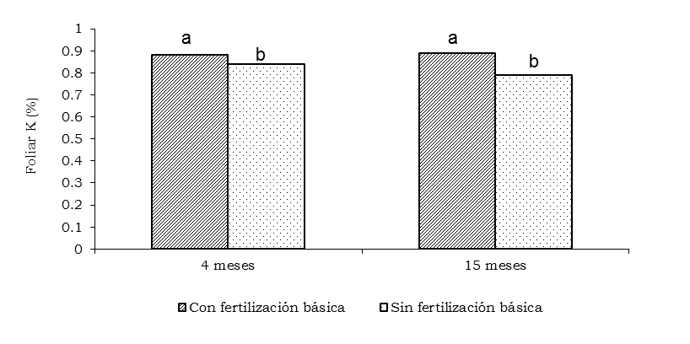

**Figure 5.** Foliar K concentration in *B. decumbens* with or without basic fertilization 4 and 15 months after application. C.I. La Libertad, Eastern plains of Colombia. Values with different letters are significantly different (Duncan P < 0.05).

**Conclusions**

* In an Oxisol soils of the Eastern plains of Colombia, the grass *B. decumbens* on a degraded pasture, responded significantly to the addition of K 30 kg/ha together with a basic fertilization. Higher K doses did not reveal different responses.
* Soil K concentration increased proportionately with applied K till 15 months after its addition. Soil K concentration in all the treatments was higher than 0.10 cmol/kg, which is considered as a suitable level for the development of pastures that are less demanding on soil fertilization, such as *B. decumbens*.
* Foliar K concentration in *B. decumbens* (around 0.9%) reaches the required level for beef cattle.
* Basic fertilization together with K contributed to the improvement of *B. decumbens* forage production till 12 months after its addition.

**Acknowledgments**

To the Ministry of Agriculture and Rural Development and Fedegan for funding this experiment.

**References**

Dávila, G.; Guerrero, R. and Rojas, E. 1998. Disponibilidad de K en algunos suelos palmeros de los Llanos Orientales de Colombia. Suelos Ecuatoriales 28:71 - 80.

McDowell, L. R.; Conrad, J. H.; Ellis, G. L.; and Loosli J. K. 1994. Minerales para rumiantes en pastoreo en regiones tropicales. Departamento de Ciencia Animal, Centro de Agricultura Tropical, Universidad de Florida, Gainesville y Agencia de los Estados Unidos para el desarrollo internacional. 92 p.

IGAC (Instituto Geográfico Agustín Codazzi). 1990. Métodos analíticos del laboratorio de suelos. Bogotá, D.C. 502 p.

Littell, R.; Stroup, W. and Freund, R. 2002. SAS for Linear Models. SAS Press. 492 p.

Mendes, E. L.; da Silva, A. R.; Monteiro, F. A.; and de Andrade, L. R. 2004. Adubação potássica em forrajes. Em: Fertilidade do solo para pastagens produtivas. C. G. Silveira, J. C. de Moura y V. P. de Faria (eds.).. Anais do 21° Simpósio sobre manejo da pastagens. Fundación de Estúdios Agrários Luiz de Queiroz-FEALQ. Piracicaba, SP. Brasil. p: 219 - 278.

Potash and Phosphate Institute. 1997. Manual internacional de fertilidad de suelos. Norcross, G.A. U.S.A. 146 p.

Rincón, A. 2007. Asociación maíz pastos para establecimiento y renovación de praderas en los Llanos Orientales. Boletín de investigación No. 09. Corpoica, Colciencias. Villavicencio. 71 p.

Salinas, J. G.; and García, R. 1985. Métodos químicos para el análisis de suelos ácidos y plantas forrajeras. Centro Internacional de Agricultura Tropical, CIAT, Programa de Pastos Tropicales. Cali, Colombia. 83 p.

Salisbury, F. B.; and Ross, C. W. 1992. Fisiología vegetal. Ed. Iberoamérica S.A. México. p: 319 – 338.

Vilela, L.; Gomes de Sousa, D. M.; and da Silva, J. E. 2004. Adubação potassica. Em: Cerrado, Correção do solo e adubação. Gomes de Sousa, D. M. e Lobato, E. (eds.). 2 ed. Embrapa, Informação Tecnológica, Brasília DF. p. 170 – 185.