# Effect of vacuum frying process on the quality of a snack of mango (*Manguifera indica* L.)

# Efecto del proceso de fritura al vacío sobre la calidad de un pasabocas de mango (*Manguifera indica* L.)

*Rafael Humberto Villamizar V.*1*, *María Cristina Quiceno G.*2,and *Germán Antonio Giraldo G.*3

1Master in Chemistry, emphasis in food . Universidad del Quindío.

2Student of Master in Chemistry, emphasis in food. Universidad del Quindío.

3Director of the Research Group on Tropical Fruit Agroindustry, Lab of new products design. Universidad del Quindío.

*Corresponding author: [rhvillamizar@uniquindio.edu.co](mailto:rhvillamizar@uniquindio.edu.co)

Rec.: 12.01.11 Acept.: 28.02.12

**Abstract**

The latest trends in consumption of snacks, have led to the search for processes that enhance the quality of snacks. The aim of this study was to observe the behavior of quality parameters of a fried snack made from mango (*Manguifera indica* L.), using vacuum on a paste of mango pulp and starch, in their preparation. The frying process was carried out using different vacuum pressures (0.4, 0.5, 0.6 bar), temperatures (100, 110 and 120 ° C) and times (30, 45, 60, 75 and 90s.) The results showed that the vacuum improves the quality characteristics of the snacks, finding very low fat and humidity contents, lower water activity, texture was according to market demands and a small color variation with respect to paste color. The best treatment was to 0.5 bar, 110 ºC y 90s of immersion time.

**Key words:** Color, fat, frying, mango, moisture, temperature, texture.

**Resumen**

El consumo cada vez más creciente de ‘pasabocas’ ha estimulado la búsqueda de procesos para mejorar su calidad. En este estudio se evaluó el comportamiento de los parámetros de calidad de un pasabocas frito hecho con mango (*Manguifera indica* L.), utilizando vacío sobre una pasta elaborada con este fruto. El proceso de fritura se realizó aplicando diferentes presiones de vacío (0.4, 0.5, 0.6 bar), temperaturas (100, 110 y 120 °C) y tiempos (30, 45, 60, 75 y 90 seg). Los resultados mostraron que el vacío mejora las características de calidad del producto, ya que los contenidos de grasa y humedad fueron muy bajos, la actividad de agua fue menor, la textura fue adecuada para las exigencias del mercado y el color presentó cambios muy pequeños con relación al de la pasta. El mejor tratamiento fue 0.5 bar de presión, 110 ºC y 90 seg de inmersión.

**Palabras clave:** Color, fritura, grasa, humedad, mango, temperatura, textura.

**Introduction**

Mango (*Manguifera indica* L.) is a well-known and highly consumed fruit, as fresh fruit, in juices, marmalades and dry snacks (Villamizar and Giraldo, 2010) and different varieties exist like Tommy Atkins, Haden, Manzana, Kent, among others. In 100 g of this fruits there are, in average, 0.7 g of pro­tein, 16.8 g of total carbohydrates, 10 mg of calcium, 13 mg of phosphorus, 0.4 mg of iron, 7 mg of sodium, 189 mg of potassium, 4800 Ul of Vitamin A, 0.05 mg of Thiamine, 0.05 mg of Riboflavin, 1.1 mg of Niacin, and 35 mg of ascorbic.

Frying is a complex process widely used in the food industry. During this process, food is immersed in oil at a higher temperature than the water boiling point in order to pro­duce a vapor contraflow (bubbles) with the oil in the food surface (Bouchon *et al*., 2003). This process generates products with the or­ganoleptic qualities (color, texture and taste) demanded and appreciated by consumers; however these products have high fat content that is not suitable for human consumption (USDA, 2008). Besides the effects of oil and saturated fat consumption on human health, due to the high temperatures and oxygen exposition during the frying process other effects that are not desirable are present such as degradation of important nutritious com­ponents and generation of toxic compounds (acrylamide) in the snack or in the frying oil (Fillion and Henry, 1998). To reduce fat con­tent without losing sensorial qualities, nume­rous complementary processes or alternatives to the frying process have been proposed (Mellema, 2003; Ziaiifar *et al*., 2008). One of them consists of pressure reduction by working on vacuum to reduce water boiling point in the food and eliminate it at low tem­peratures (Mir-Bel *et al*., 2009). It has been proven that besides the reduction on final fat content (Garayo and Moreira, 2002), vacuum frying products have other advantages, like very low acrylamide content (Granda *et al*., 2004) and better organoleptic and nutritious quality (Shyu and Hwang, 2001; Da Silva and Moreira, 2008; Troncoso *et al*. 2009).

Frying process implicates simultaneous mass and heat transfer that make important microstructural changes, both in the surface and in the mass of the product. Heat transfer generates protein denaturation, starch gelati­nization, water vaporization, crust formation and, color development, which are typical phenomena of the combination effect of mul­tiple chemical reactions. Mass transfer is characterized by the interchange of com­pounds like water and other soluble materials occluded in the starch, which allows oil pe­netration in food (Mir-Bel *et al*., 2009).

Oil absorption is not clearly explained due to the multiple variables involved, such as initial product structure, diverse interchanges between the product and heating media, va­riation in oil products and properties, chemi­cal reactions, interactions between food com­pounds and oxidized lipids, and hydrolysis of fats in the frying oil due to humidity (Velasco *et al*., 2008). The aim of this study was to observe the effect of vacuum frying on the quality of mango snacks (texture, color, hu­midity percentage, water activity and fat con­tent) in order to define the best conditions (temperature, time and pressure) of the frying process.

**Materials and methods**

Mango (*Manguifera indica* L.) of the cultivar Tommy Atkins between 6 and 8 days after harvesting were used. Mangos have 14-15 °brix measured on a table refractometer according to AOAC 932.12, they were coming from Tolima and were bought in the Arme­nia´s market in Quindio, 1480 MASL and at­mospheric pressure 640 mmHg.

**Paste characterization and preparation**

Selected mangos were characterized during post-harvesting by physicochemical analysis of soluble solids (°brix), humidity percentage (bh), water activity (aw), acidity %, starch content, color and texture.

With the preliminary characterization re­sults, mangos were washed, peeled and ma­nually pulped to get 230 g of pulp that were homogenized on a blender for 1 min to get a puree type of paste. Next, 46 g of starch and wheat flour (4:1) were added and homoge­nized with the mango puree to fill round molds (2 mm thickness ad 4 cm diameter) that were refrigerated at 7 °C and HR 21% for 48 h.

**Frying process**

Once the paste was extracted from the mold, it was fried in a machine adapted for that purpose, a metal frame with a 250 ml beaker for oil, a pulley system for immersion and a basket to carry samples was placed on a va-cuum oven and the sample was immersed using magnets.

For each test, palm oil on the oven was at process temperatures (100, 110 and 120 °C), then the system was adjusted to the proper vacuum pressure (0.4, 0.5 and 0.6 bar) before the paste immersion and frying was done during specific times (30, 45, 60, 75 and 90 s), kinetic that was used to determine changes in quality characteristics. Snack was taken out and superficial oil was extracted with a paper towel taking into account a ratio paste:oil of 1:15 weight: volume.

Treatments were replicated three times and samples were analyzed by triplicate for humidity percentage (% bh), water activity, color, texture (crunchiness) and fat (%).

**Physico-chemical analysis**

Humidity contents of mango, paste and snack were determined in a vacumm dry oven (J.P Selecta S.A.) according to the method AOAC 20,013, 1980 (A.O.A.C.,1980), in the following way:

$$\%humidity(bh)=\frac{sample weight-sample dry weight}{sample weight}×100$$

Water activity (aw) determinations are measured directly at room temperature (bet­ween 20 and 30 °C) using a Decagon dew point hygrometer (AquaLab 3 TE) with 0.001 sensibility. Color determination was done with a colorimeter (Minolta CR – 10) to eva­luate changes in fruit, paste and snack color by the Cielab system, with D65 illuminant and 10° for the observer.

Taking the values for the coordinates *L*\* (dark-light), *a*\* (green-red), *b*\* (blue-yellow) and calculating the color difference in compa­rison to the paste, represented by *∆E*, according to the following equation

$$∆E=\sqrt{({L^{*}-L_{0}^{*})}^{2}+({a^{*}-a_{0}^{*})}^{2}+({b^{*}-b_{0}^{*})}^{2}}$$

where:

*L*\* = *L* value for the treatment sample.

*L0*\* = *L* value for the standard sample.

*a*\* = *a* value for the treatment sample.

*a0*\* = *a* value standard sample.

*b*\* = *b* value treatment sample.

*b0*\* = *b* value standard sample.

To determine the fracturability point for the mango, paste and snack, a texture analyzer (TA. XT. Plus) was used in compression mode with 5 g strenght, 3 mm distance and 10 mm/seg speed (fracturability of tortilla chips).

Fat content in paste and snack were determined using a fat detector (DET – GRAS P Selecta) by the DG – 01 (without hydrolisis) method reported on the equipment mannual according to the equation:

$$\% fat=\frac{vase weight with fat-empty vase weight}{sample weight}×100$$

**Statistical analysis**

Data for the analysis was organized using Statgraphics Plus 5.1 software (Statgraphics, 2001) to evaluate the effect of the different treatments on the snack characteristics. These effects were guided using ANOVA ana­lysis for one significance (P < 0.05). The expe­rimental design used was an unbalanced factorial design *5x32*, with five time levels (30, 45, 60, 75 and 90 s), three temperature levels (100, 110 and 120 °C) and three vaccumm pressure levels (0.4, 0.5 and 0.6 bar) with the following model:

$$Y_{ijs}=μ+t_{i}+T_{j}+P_{s}+{txT}_{ij}+{txP}_{is}+{TxP}_{js}+{txTxP}_{ijs}+ε_{ijs}$$

where:

$μ$: general mean.

$t_{i}$: ith time level in seconds.

$T_{j}$: jth temperature level in °C.

$P_{s}$: sth vacuum pressure level in bar.

${txT}_{ij}$: first order interaction between time and temperature.

${txP}_{is}$: first order interaction between tem­perature and pressure.

${TxP}_{js}$: first order interaction between tem­perature and pressure.

${txTxP}_{ijs}$: second interaction between the three factors.

$ε_{ijs}$: experimental error associated with the three factors.

Additionally, for comparison, Tukey´s test at 95% was done.

**Results and discussion**

**Fruit characterization**

Analysis showed that mango fruits used in this study had water content in fresh pulp of 87.45 ± 2.15%, water activity of 0.986 ± 0.003, °brix 14.26 ± 0.38, cutting force of 3.93 ± 0.060 kgf, a fat content of 0.00169 ± 0.00018%, results that are similar to the ones found by Stafford (1983).

**Snack characterization**

ANOVA results for all the snack variables studied are presented on Table 1. It is obser­ved that the relation of the factors with those variables is significant, meaning that from this analysis there is not an ideal treatment that can be define as the best. For this rea­son, each one of the snack physico-chemical properties was analyzed separately in relation to the change in vacuum pressure done in each treatment.

**Humidity content**

Results showed that pressure, temperature and time of each treatment affected snack humidity content (P < 0.05) in the different vacuum pressures evaluated (Figure 1 a, b, c). For each one of the treatments, humidity content was reduced when the vacuum pre­ssure was increased (a, b, c), the same ha­ppened when temperature and frying time were increased.

Initially, water loss celerity was high due to its content on the snack surface, but it was accelerated with vacuum pressure increase due to the rise on strength. However, with longer frying times humidity loss was slower due to, in part, the microstructural changes that happen at the beginning of pressuriza­tion that affect the water release from the surface. Additionally, because of the initial dryness (refrigeration) a low concentration of available water is presented and crust forma­tion makes a higher resistance to the water scape (Mariscal and Bouchon, 2008).

**Water activity (aw)**

In table 1 is shown the effect of the vacuum pressure and temperature on the aw (P < 0.05), whereas the time effect is low (P >0.05). In Figure 2 is shown the water activity behavior of the fried snack in each one of the treatments. The observed levels are relatively low which favors product preservation impe­ding oxidation and proliferation of harmful microorganisms, also these levels decrease with temperature increases and tend to stabi­lize with the time. Similarly, even if water activity reaches low levels changes in vacuum pressure do not have an effect in its variation, which could be due to the fact that in the vacuum frying process the boiling water tem­perature decreases (Mir-Bel *et al.*, 2009) eliminating high volumes of free water.**Color**

|  |  |  |  |  |  |
| --- | --- | --- | --- | --- | --- |
| **Table 1.** Analysis of variance for the treatment effect on some properties of mango snacks. | | | | | |
| **Source of variation (treatments)** | **Fat content**  **(%)** | **Humidity content**  **(%bh)** | ***∆E*** | **Cut point**  **(kgf)** | **aw** |
| Model | 0.0002 | 0.0000001 | 0.0001 | 0.0059 | 0.0000001 |
| Pressure | 0.0000003 | 0.0000002 | 0.0000002 | 0.0005 | 0.0000001 |
| Temperature | 0.0000002 | 0.0000001 | 0.0000001 | 0.0049 | 0.00000005 |
| Time | 0.0002 | 0.0119 | 0.1008 | 0.0109 | 0.1329 |
| Pressure x temp. | 0.0000001 | 0.0000001 | 0.0000001 | 0.0000003 | 0.00000002 |
| Pressure x time | 0.0231 | 0.0000001 | 0.0003 | 0.0032 | 0.0000001 |
| Temp. x time | 0.0021 | 0.1649 | 0.0716 | 0.0022 | 0.0000001 |
| Pressure x temp. x time | 0.1473 | 0.1309 | 0.0074 | 0.024 | 0.00000002 |
| Best treatment | 0.6-110-60 | 0.6-120-75 | 0,5-110-45 | 0.5-110-90 | 0.5-110-90 |
| Worst treatment | 0.5-100-30 | 04-100-30 | 0.6-120-90 | 0.4-110-90 | 0.4-100-30 |
| P < 0.05 significant, reliability of 95%.  P < 0.01 highly significant, reliability of 99%. | | | | | |

**Figure 2.** Water activity in mango Tommy Atkins snacks under three vacuum pressures and times x variable temperatures.

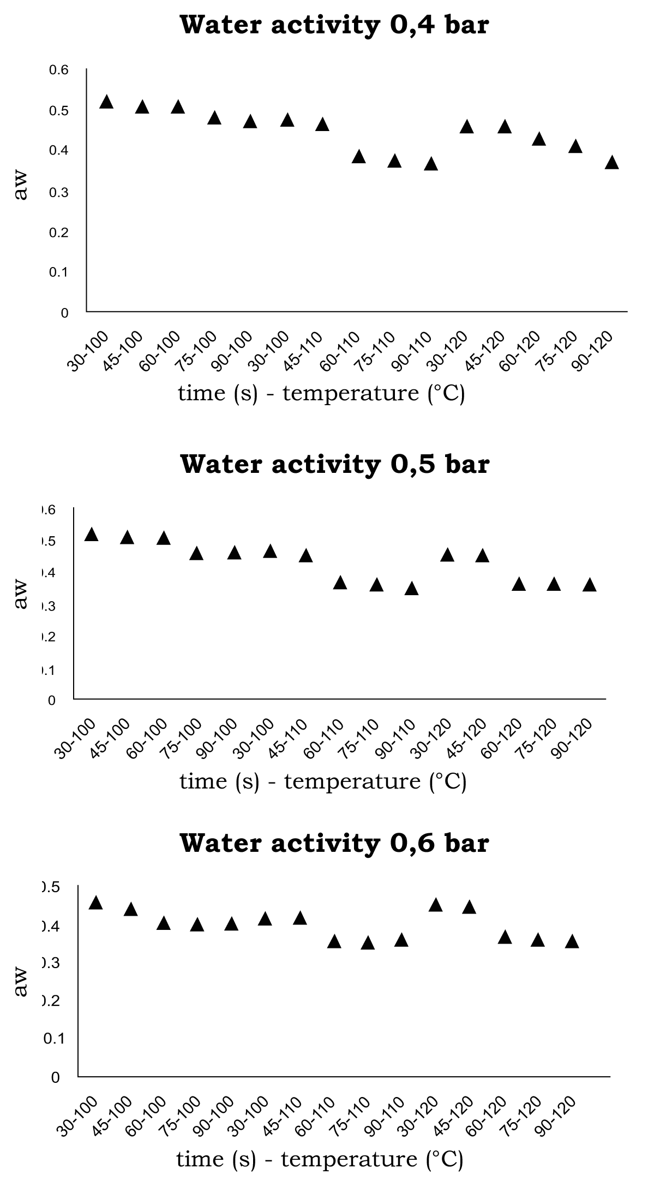

Snack color was affected by temperature and vacuum pressure (P < 0.05); but this was not due to the kinetics originated by temperature and time (P > 0.05) (Table1). Color changes (*ΔE*) in comparison to the ones of the paste for each treatment are shown in Figure 3. Changes are represented by *ΔE* increments that have a slight variation due to relatively low working temperatures in the vacuum pressure treatments that reduce the Amadori products which favors melanoidins. In fried food under atmospheric pressure, darkening is notorious since it requires temperatures > 150 °C (Pokorny, 1999), showing chemicalchanges that generate acrylamide (Fillion and Henry, 1998). Vacuum frying process pre­vents formation of acrylamide and compounds that causes dark colors following Maillard´s reaction, because of the reduce oxidation during the process (Da Silva and Moreira, 2008).

**Figure 3.** Color changes in mango Tommy Atkins snacks under three vacuum pressures and times x variable temperatures.

.

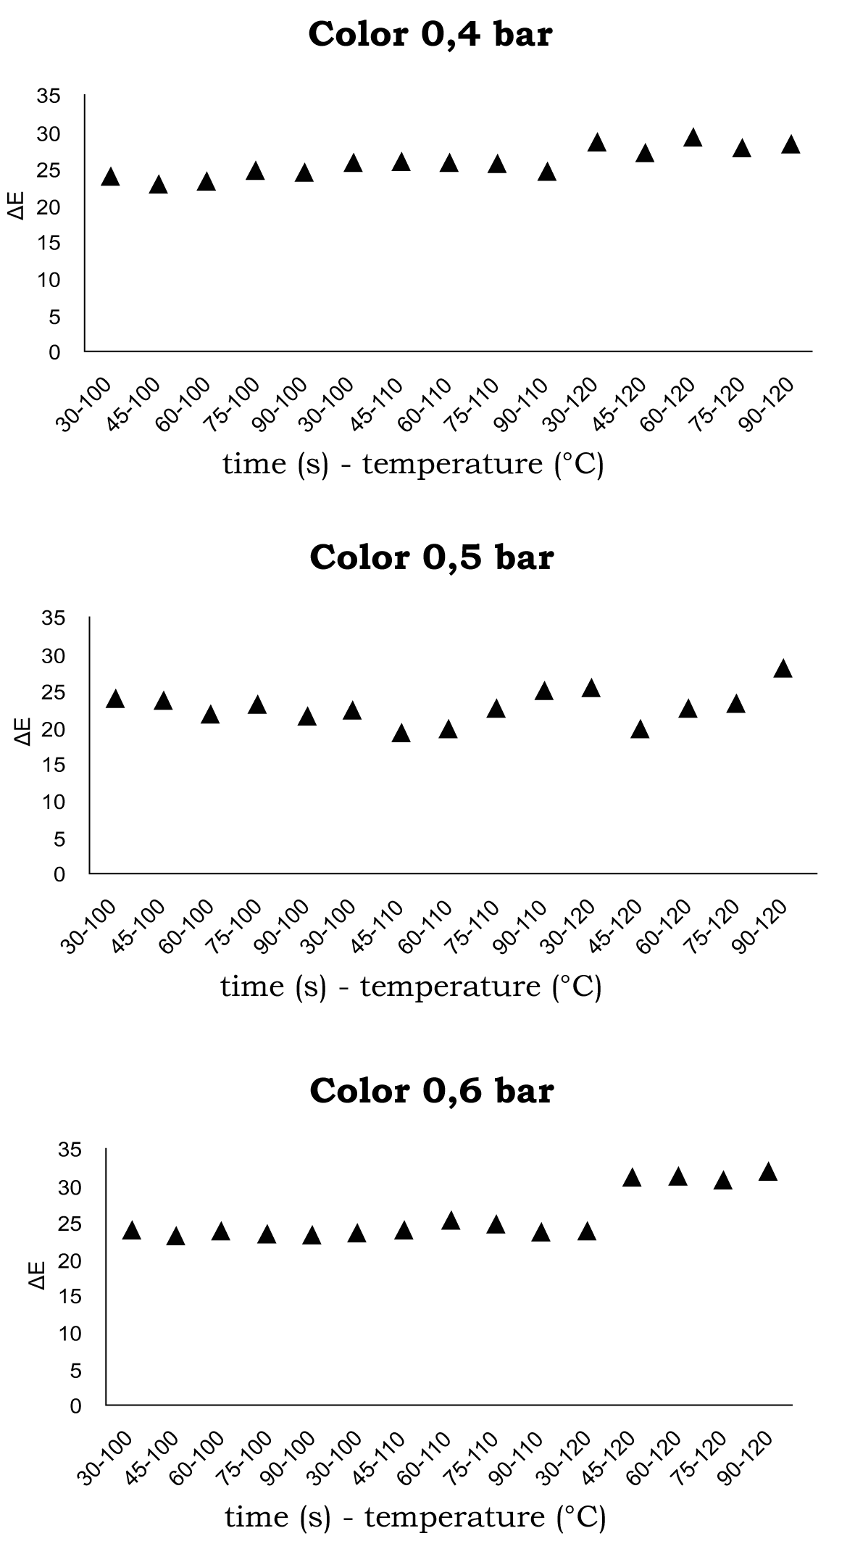

**Texture**

This characteristic was affected by the applied treatments (P < 0.05) (Figure 4). As result of changes in vacuum pressure, texture showed a high variability in the different treatments, this difficult the determination of its influence in the reduction of the strength needed to break the snack showing variation when timeand temperature are increased. This is the result of fast gelatinization of starch granules in contact with hot oil and the transformation of its superficial structure in a crunchy crust (Pokorny, 1999).

**Figure 4.** Texture changes in mango Tommy Atkins snacks under three vacuum pressures and times x variable temperatures.

.

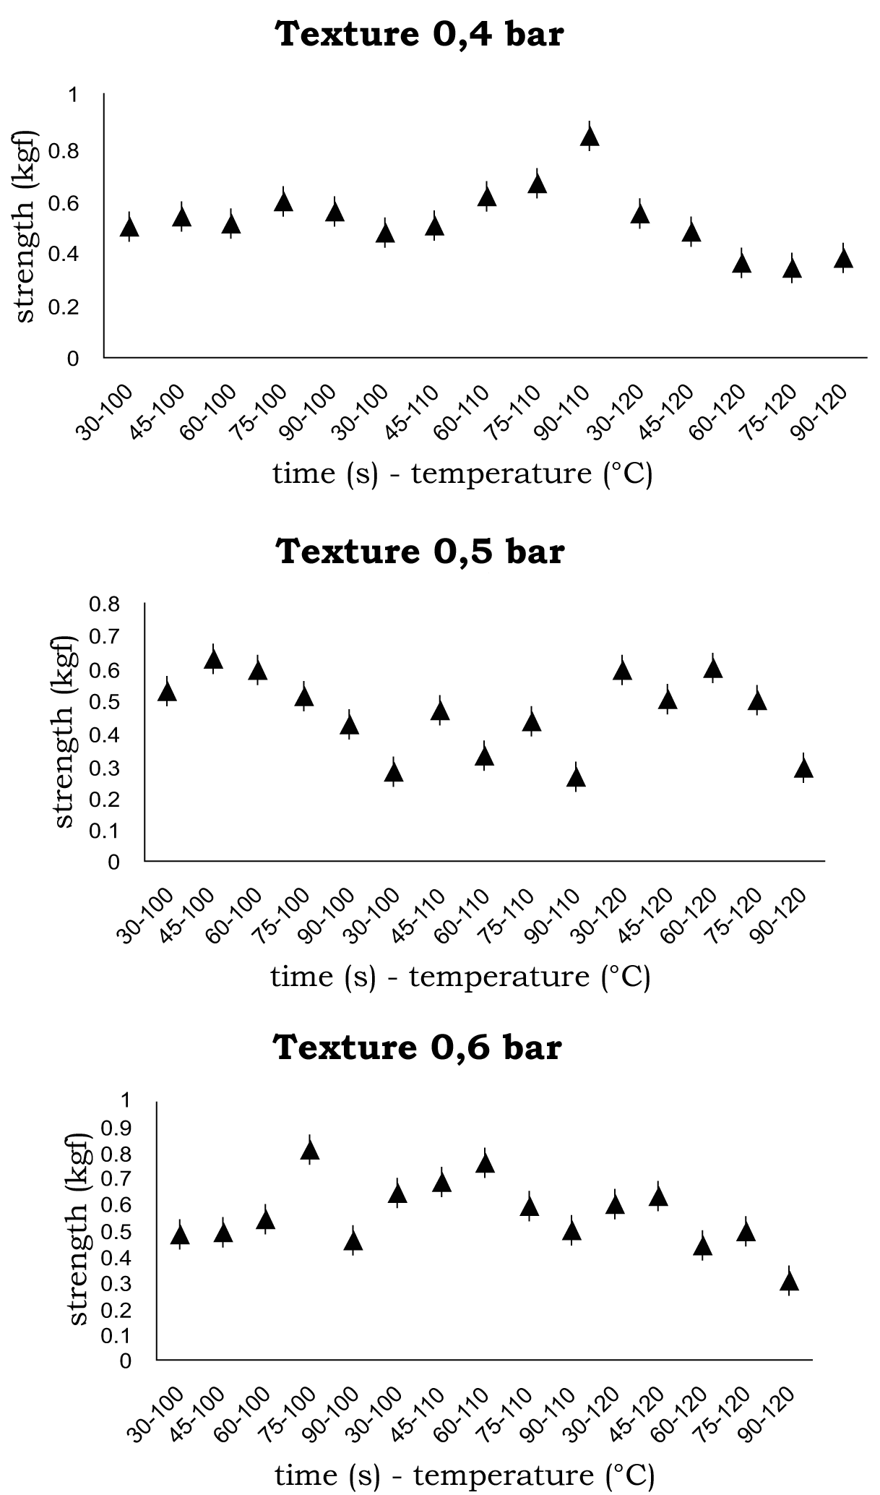

**Fat content**

Vacuum pressure, temperature and time during the frying process affect fat content (P < 0.05). In Figure 5 is shown that while va­cuum pressure and temperature increment, fat content reduces and stabilizes during the process. Fat content behavior in the snack has two phases. In the first one, frying, high temperatures causes a partial evaporation of water removed from the snack interior being partially replaced by oil; this evaporation isintense since the vacuum pressure increases the speed of mass and heat transfer resulting on a water boiling temperature decrease (76 to 86 °C). The second phase, pressurization, happens when the snack is removed from the oil increasing quickly pressure and tempera­ture in the pores; this generates oil adherence to the snack surface and oil penetrance in the snack (sponge effect) until the pressure in the pores equals the atmospheric pressure (Tron­coso *et al*., 2009).

**Figure 5.** Fat contents in mango Tommy Atkins snacks under three vacuum pressures and times x variable temperatures.

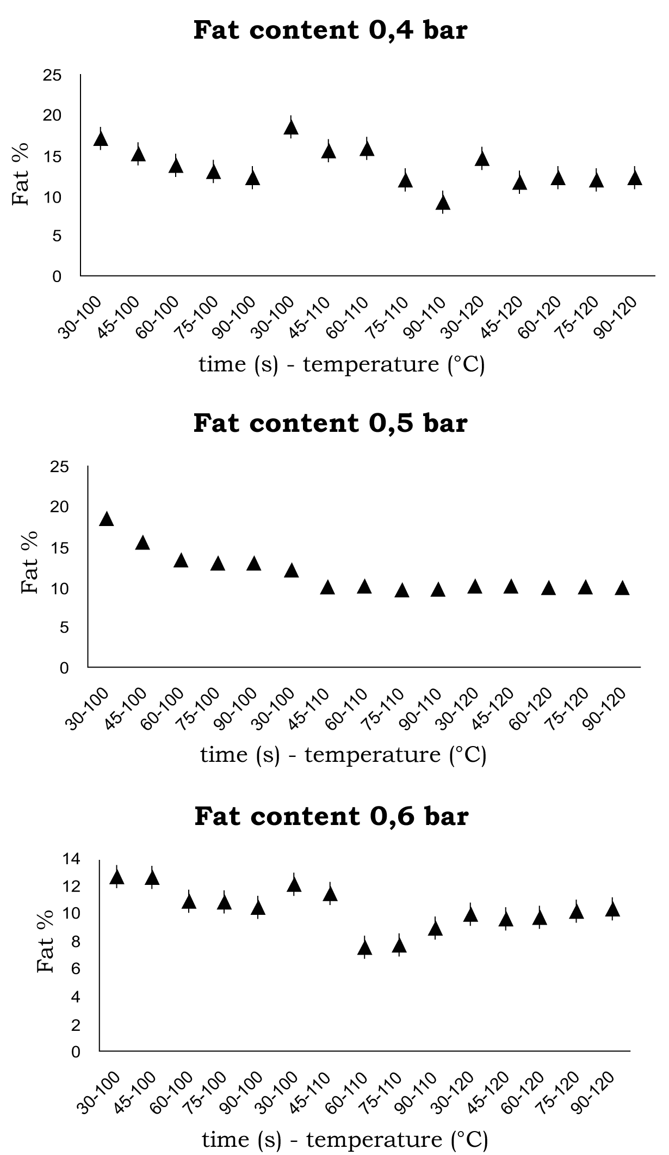

**Best treatment**

Best treatment combinations for each vacuum pressure related to the evaluated characteristics are included in Figure 6. The best results for texture, water activity and color happen at vacuum pressure of 0.5 bar (0.5 bar), whereas for fat and humidity content is at 0.6 bar (-0.6 bar); this means that a vacuum pressure of 0.4 bar is too low for getting a snack with good characteristics. The fat content difference at 0.5 bar vs. 0.6 bar was not significant, the same happened with the humidity content at 0.5 bar vs. 0.6 bar, meaning that the best vacuum pressure treatment corresponds to 0.5 bar, 110 °C temperature and inmersion time of 90 sec.

**Figure 6.** Best treatment combinations for mango Tommy Atkins snacks under three vacuum pressures and times x variable temperatures.

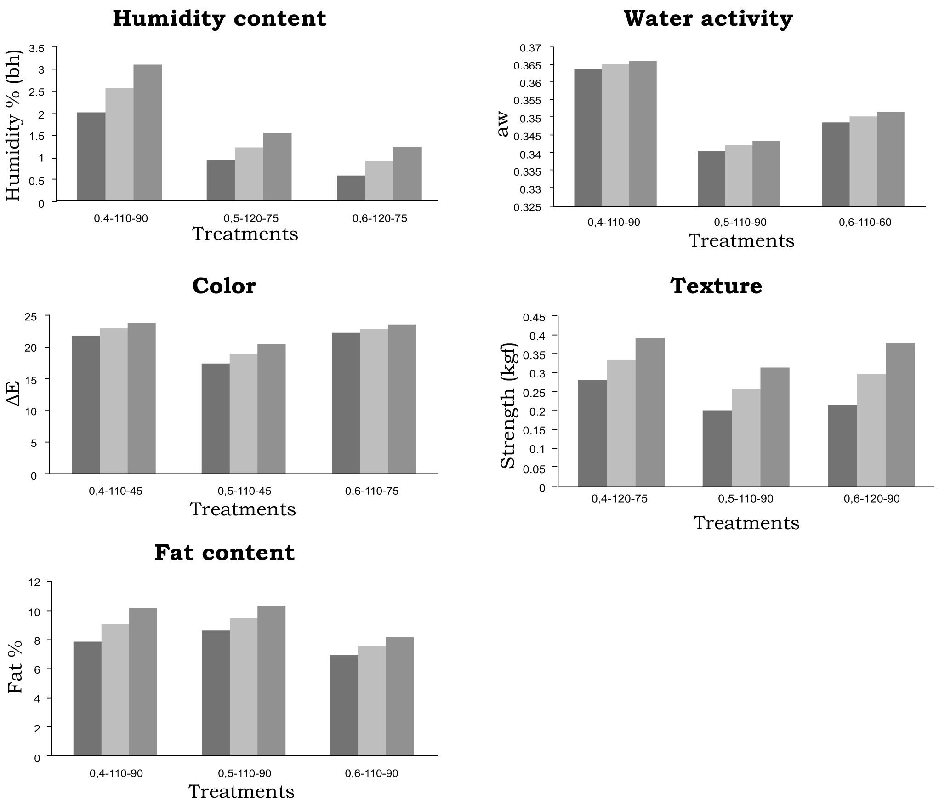

**Conclusions**

* Vacuum pressure positively affects the quality characteristics of fried snacks of mango resulting crunching, with good color and similar to the fruit, with low fat content and adequate humidity for its conservation.
* The best characteristics for the fried snack were color (∆E = 19 ± 1.5635), texture (fracturability strength = 0.256367 ± 0.005736), fat content (%fat = 9.4995 ± 0.8744), humidity content (%humidity bh = 1.25 ± 0.3037) and water activity (aw = 0.342 ± 0.0014), obtained with a vacuum pressure of 0.5 bar, temperature of 110 °C and immersion time of 90 s.
* Snack characteristics are better than the traditional snack characteristics which have humidity content lower than 4% and fat content lower than 30% (Rodríguez *et al*., 1999)

**References**

A.O.A.C. 1980. Método oficial 20.013. Humedad en plantas. Métodos oficiales de análisis AOAC. A Internacional.

Bouchon, P.; Aguilera, J. M.; and Pyle, D. L. 2003. Structure oil-absorption relationships during deep-fat frying. Journal. Food Science. 68:2711 - 2716.

Da Silva, P. F.; and Moreira, R. G. 2008. Vacuum frying of high-quality fruit and vegetable-based snacks. LWT - Food Science Technology. 41:1758 - 1767.

Fillion, L. and Henry, C. J. 1998. Nutrient losses and gains during frying: A review. International Journal of Food Science and Nutrition, 49(2):157 - 168.

Garayo, J. and Moreira, R. 2002. Vacuum frying of potato chips. Journal of Food Engineering. 55(2):181 - 191.

Granda, C.; Moreira, R. G.; and Tichy, S. E., 2004. Reduction of acrylamide formation in potato chips by low-temperature vacuum frying. Journal of Food Science, 69 (8):E405 - E411.

Mariscal, M. and Bouchon, P. 2008. Comparison between atmospheric and vacuum frying of apple slices. Food Chemistry. 107:1561 - 1569**.**

Mellema, M. 2003. Mechanism and reduction of fat uptake in deep-fat fried foods. Food Sci. Technol. 14:364 - 373.

Mir-Bel, J.; Oria, R.; and Salvador, M. L. 2009.Influence of the vacuum break conditions on oil uptake during potato post-frying cooling. Journal. Food Engineering. Laboratory of Vegetal Food, University of Zaragoza, Miguel Servet 177, 50013 Zaragoza, Spain. Journal homepage: [www.elsevier.com/locate/jfoodeng](http://www.elsevier.com/locate/jfoodeng)

Pokorny, J. 1999. Changes of nutrients at frying temperatures. En: Boskou, D. y Elmadfa, I. (eds.). Frying of Food Technomic Publishing Co. Lancaster. p. 69 - 103.

Rodriguez, C.; Vitrac, O; and Dufour, D. 1999. Caracterización del proceso de fritura de chips de yuca (*Manihot esculenta* Crantz) Estudio de algunas variables de proceso. GeoTropica Revista del área de recursos naturales 4: 68 – 79.

Shyu, S. and Hwang, L. S. 2001. Effects of processing conditions on the quality of vacuum fried apple chips. Food Research International. 34: 133 – 142.

Stafford, A. E. 1983. Mango. handbook of tropical foods. En: H.T. Chan, Jr.. (ed.). Marcel Dekker, Inc., Nueva York. p. 399 - 431.

Statgraphics. 2001. Disponible en: <http://www.statgraphics.com>

Troncoso, E.; Pedreschi, F.; and Zuñiga, R. N. 2009. Comparative study of physical and sensory properties of pre-treated potato slices during vacuum and atmospheric frying. Lebensmittel-Wissenschaft und-Technologie. Food Science and Technology. 42:187 – 195.

USDA (U.S. Department of Agriculture, Agricultural Research Service). 2008. USDA national nutrient database for standard reference. Release 21. Nutrient data laboratory home. Page, http://www.ars.usda.gov/ba/bhnrc/ndl.

Velasco, J.; Marmesat, S.; and Dobarganes, C.; 2008. Chemistry of frying. En: Sahin, S. y Sumnu, S.G. (eds.). Advances in Deep-fat Frying of Foods. CRC Press, Boca Raton, Fla. p. 33 - 56.

Villamizar, R. and Giraldo, G. 2010. Obtención y caracterización de un pasabocas a partir de una pasta a base de mango mediante fritura por inmersión. Rev. Tumbaga UT 5:149 - 164.

Ziaiifar, A. M.; Achir, N.; Courtois, F.; Trezzani, I.; and Trystram, G., 2008. Review of mechanisms, conditions, and factors involved in the oil uptake phenomenon during the deep-fat frying process. International Journal of Food Science and Technology. 43(8):1410 - 1423.