Rescue and in vitro germination of immature embryos of
black cedar (Juglans neotropica Diels)
Rescate y germinación in vitro de embriones inmaduros de cedro negro
(Juglans neotropica Diels)

Oscar Darío Quintero-García^{1*} and Sonia Jaramillo-Villegas^{2†}

¹ Agricultural Engineer, Manager of Tissue Culture Laboratory. Ecosystem sub-division, Corporación Autónoma Regional del Centro de Antioquia (CORANTIOQUIA), A.A. 95400, Medellín, Colombia. Tel.: (+57-4) 4938888. ² Agricultural Engineer M.Sc. Retired Profesor Universidad Nacional de Colombia, sede Medellín.
*Corresponding author: odquinte@unal.edu.co; †sjaramal@unal.edu.co

Rec.: 02.06.11 Acept.: 17.02.12

Abstract
Immature embryos of Juglans neotropica (Juglandaceae) with 16 and 20 weeks of development were aseptically removed from the fruits and placed in the following culture media for 60 days, without growth regulators: MS (Murashige and Skoog, 1962), WPM (Lloyd and McCown, 1980) y DKW (Driver and Kuniyuki, 1984). It was observed that embryos with 16 weeks of development did not germinate in any of the three culture media. The embryos with 20 weeks of development germinated 100% in the three culture media. It was found an important effect of the culture media on the growth of the embryos, the MS medium was significantly better than the DKW and WPM medium (P < 0.05), due to the fact that in MS medium embryos had the highest height and a better proportion of stem/root ratio to obtain complete plantlets. After this, seedlings were adapted to environmental conditions (greenhouse).

Key words: Black cedar, culture media, germination, immature embryos, in vitro culture, Juglans neotropica, rescue, tissue culture, walnut.

Resumen
Embriones inmaduros de cedro negro (Juglans neotropica) (Juglandaceae) con 16 y 20 semanas de desarrollo fueron removidos asépticamente de los frutos y sembrados durante 60 días en los medios de cultivo MS (Murashige y Skoog, 1962), WPM (Lloyd y McCown, 1980) y DKW (Driver y Kuniyuki, 1984), sin reguladores de crecimiento. Se observó que embriones con 16 semanas de desarrollo no germinaron en los tres medios de cultivo; por el contrario, los embriones con 20 semanas de desarrollo presentaron una germinación de 100%. Se encontró un marcado efecto del medio en el crecimiento de los embriones, siendo el medio MS mejor (P < 0.05) que los medios DKW y WPM, debido a que en él los embriones presentaron mayor altura y proporción tallo/raíz para la obtención de plántulas completas.

Palabras clave: Cedro negro, cultivo de embriones, cultivo in vitro, embriones vegetales, germinación, Juglans neotropica, medio de cultivo, nogal, rescate.

Introduction
Black cedar (Juglans neotropica Diels), which is a forest species of high Andean forests of Colombia, has suffered the consequences of deforestation and progressive disappearance in some areas caused by the expansion of cattle ranching and agriculture (Humboldt Institute, 1998). Currently, natural populations of this species are in endangered due to intensive exploitation of wood, used in the construction of luxury furniture (Cardenas and Salinas, 2006).
Since 1999 J. neotropica species has been selected in the priority conservation list by the Regional Autonomous Corporation of Central Antioquia (Corantioquia). Then, a research and selection project of seed trees started allowing its propagation in nursery conditions, to promote their ex-situ recovery and use in the development of programs for reforestation in their jurisdiction (Gómez and Toro, 2007). However, the sexual propagation of the species has limitations under nursery conditions such as: low seed production per tree in natural conditions, caused by loss of fruit during development and the difficulty of preserving the few genotypes in the wild. Moreover, the seed has naturally latency, which produces low uniformity in germination under nursery conditions (Gomez and Toro, 2007).
From the statement above, Atwater (1980) mentioned that the main constrain in the germination of J. neotropica is associated with retention of inhibitors, which are contained in the seed coat due to its water permeability and semi or impermeable conditions to certain chemicals or gases, which also exert mechanical resistance to the developing embryo. Lopez (1997) mentions that the lignification degree in testa is associated with latency, limiting the amount of oxygen in the seed. Consequently, the production of growth-inhibiting substances happens in embryonic tissues. Moreover, Ospina et al. (2003) stated that the high oil content in the cotyledons can decrease the capacity and uniformity of germination, especially in high temperature conditions.
Due to this problem in germination, different pre-germinative treatments have been evaluated. Treatments were the primer and stratification as Lopez and Piedrahíta (1999) emphasized. The combination of both treatments, using primer for 15 days followed by 60 days of stratification, lead to 30.8% germination and a germination rate of 40 days (beginning of germination). In contrast, the control treatment reached 18% germination and 95 days to reach germination in 180 days of evaluation. In another study, a beneficial effect of stratification for 40 days at 20-33°C was found. Here, the germination achieved 80% and 24 days before the start of germination (Gomez, 2002).
Rescue techniques and multiplication of embryos in vitro are a complementary alternative solution for the forestry sector in the short term. These techniques have demonstrated to be important in the protection and conservation programs for species that have difficulties with sexual propagation, viability, seed shortages, interspecific crosses, long latency, and recalcitrance problems (Shibu and Gillespie, 1998; Benson, 2000; Azofeifa, 2009).
The technique was also been used to avoid the presence of endogenous contaminants and release phenolic compounds, including juglona alelochemical that interferes with cell growth of Juglans spp. (Rietveld, 1983). Evidence of the establishment and micropropagation difficulties of this genus are the work of Cornu and Jay-Allemand (1989), Revilla et al. (1989), Leslie and McGranahan (1992), Pijut (1997), Cruz and Cruz (2003), Rivers et al. (2007). Moreover, the in vitro culture of Juglans embryos has facilitated the establishment and subsequent micropropagation of J. nigra (-Sudholt Heile et al., 1986), J. regia and interspecific crosses (Jay-Allemand and Cornu, 1986; Scaltsoyiannes et al., 1997, Lopez, 2004; Bosela and Michler 2008).
An important aspect of several studies conducted in vitro with immature and mature embryos of the genus Juglans, is the effect of the culture medium and plant growth regulators on germination. J. regia has shown different responses. Thus, Rodriguez (1982) first used K(h) medium, while in another cultivar of the same species used MS medium (Rodriguez et al., 1989). Allemand Jay (1982) initially used Knop medium in the same species to half concentrations and subsequently the medium Miller (MI). Cossio and Minotta (1983), after comparing eight different combinations of salt nutritious in J. regia, concluded that MS medium was the most suitable for the development and growth of the species. Fernandez et al. (2000) stimulated the growth of J. regia embryos in liquid MS medium, supplemented with 5 mg/l of BA for 7 days, and then the same medium but without hormone. In parallel, Kaur et al. (2006) evaluated different growth regulators (BAP, Kinetin and GA3) on MS medium with five cultivars of J. regia. They only obtained 66% germination with the best treatments (MS, Kin 0.5 mg/l, BAP 0.5 mg/l and GA3 2 mg/l). Sánchez et al. (2006) found significant differences in the percentage of germination of embryos from J. regia cultivar after evaluating the medium WPM, MS, DKW and NGE, free of growth regulators. The highest percentage of germination was obtained with WPM (81%), followed by NGE (62%), DKW (54%) and MS (27%). Besides, the release of phenolics and darkening of the embryos was observed in DKW medium.
Given the diversity of results in the propagation of the genus Juglans, is necessary to standardize the in vitro culture conditions of black cedar (J. neotropica). Therefore, the aim of this study was to evaluate the response of embryos extracted from immature fruits of this species by growing them in vitro in three different media, trying to reduce the problems in its propagation.

Materials and methods
Obtaining the embryos
Black cedar embryos (J. neotropica) came from a seed bank previously identified by Corantioquia (Gómez, 2003), in the municipality of Olaya, located at 2000 MASL (06° 38' N, 75° 45' W), with a rainfall > 1900 mm and average temperature of 17°C (Gómez, 2003). The research was conducted at the Laboratory of Plant Tissue Culture of the Biodiversity Station Corantioquia, located in the village of Santa Elena, east of Medellin, which is located at 2400 MASL and an average annual temperature of 17°C, belonging to the area of lower montane wet forest life (bh-MB) (Holdridge, 1967). Immature fruits of the tree were collected every 4 weeks until the 24th week, after flower pollination. Fruit surfaces of 4, 8 and 12 weeks old, were disinfected with sodium hypochlorite at 2.5% (v/v) for 20 min, and washed thoroughly with sterile water during 10 min. In parallel, fruits of 16, 20 and 24 weeks old were removed from the epicarp and mesocarp with a knife, before proceeding to wash the endocarp (testa) under running water. Then, the endocarp was disinfected in laminar flow by immersing the seeds in 90% ethanol (v/v) and flamed three times with fire.
Subsequently, the hardened endocarp fruits (16 - 24 weeks old) were opened by exerting pressure with a hydraulic press in the binding scar stem to extract the embryos. Then, those embryos were grown on MS medium (Murashige and Skoog, 1962), WPM medium (Lloyd and McCown, 1980) and DKW medium (Driver and Kuniyuki, 1984) (Table 1). Each medium was supplemented with 0.1 mg/l thiamine HCl, 100 mg/l myo-inositol, 2 mg/l glycine, 0.5 mg/l pyridoxine and nicotinic acid, sucrose 3% (w/v) (Table 1). The pH on the media was adjusted to 5.7 and 0.2% (w/v) and, Phytagel was added before dis-pensing them in glass bottles of 128 cc, which were sterilized at 121°C for 30 min. All cultures were incubated in darkness for 15 days to continue its growth for 45 days. Light was supplied by white fluorescent light bulbs of 20 Watts, with 12/12 h photoperiod and a temperature of 22 ± 1°C.

Data analysis
After 60 days of immature embryos growth, in vitro germination rates were determined together with the lengths of the stem and root. Furthermore, the shoot/root ratio of each plantlet was calculated in the three culture media. The treatments (culture medium) were placed in a completely randomized design with 10 replications (embryos) and analysis of variance were performed for each variable, followed by a Tukey´s test, when differences were detected (P <.05). We calculated Pearson coefficients to determine the effect of total nitrogen content and the relationship NO₃-/NH₄+ on stem length and shoot/root ratio. All analyzes were performed with the program Statistica version 7.1 (StatSoft, 2005).

Seedlings adaptation
Table 1. Chemical composition of the culture media.
Compound | MS  mg/lt (mM) | WPM  mg/lt (mM) | DKW  mg/lt (mM)
Macro nutrients
NH₄NO₃ | 1650 (20.6) | 400 (4.9) | 1416 (17.68)
KNO₃ | 1900 (18.8) | ― | ―
MgSO₄.7H₂O | 370 (1.5) | 370 (1.5) | 740 (3.0)
CaCl₂.2H₂O | 440 (2.99) | 96 (0.65) | 149 (1.01)
KH₂PO₄ | 170 (1.25) | 170 (1.25) | 265 (1.95)
Ca(NO₃)₂.4H₂O | ― | 556 (2.35) | 1967 (8.33)
K₂SO₄ | ― | ― | 1559 (8.96)
Micro nutrients
KI | 0.83 (0.005) | ― | ―
H₃BO₃ | 6.2 (0.1) | 6.2 (0.19 | 4.8 (0.078)
MnSO₄.4H₂O | 22.3 (0.13) | 22.3 (0.13) | 33.5 (0.195)
ZnSO₄.7H₂O | 8.6 (0.029) | 8.6 (0.029) | ---
Na₂MoO₄.2H₂O | 0.25 (0.01) | 0.25 ((0.01) | 0.39 (0.0156)
CuSO₄.5H₂O | 0.025 (0.0001) | 0.25 (0.001) | 0.25 (0.001)
CoCl₂.6H₂O | 0.025 (0.0001) | ― | ―
Na₂ EDTA | 37.3 (0.1) | 37.3 (0.1) | 45.4 (0.12)
FeSO₄.7H₂O | 27.8 (0.1) | 27.8 (0.1) | 33.8 (0.12)
NiSO₄. 6H₂O | ― | ― | 0.005 (0.00002)
Zn(NO₃)₂. 6H₂O | ― | ― | 17 (0.057)

After 60 days of in vitro growth, the seedlings were removed from the culture media and roots were washed with distilled water. Then, each seedling was planted individually in 12-ounce plastic cups, containing a mixture of sterile soil and sand in proportion (2:1). The plastic cups were covered with similar plastic cups but transparent to avoid dehydration. Once sown, seedlings were sprayed weekly with MS medium, diluted to 25% of the original concentration, to complete four applications. This stage was conducted in a greenhouse covered with bleak of 65% and laterals made of glass. The seedlings were kept for 1 month under these conditions with a natural light regime and temperature of 23 ± 1°C. After 30 days, perforations were made at the top of the vessel to facilitate the adaptation of the plants. The finalization of the adaptation process was determined when the seedlings formed one or two leafs (90 days).

Results and discussion
Obtaining embryos
Following the development of J. neotropica fruits for obtaining embryos, it was observed that the immature ones collected with4, 8 and 12 weeks of development, had not yet formed the embryo. From the week 16, fruits had formed embryo which were used for the experiments, as well as those with 20 weeks of development. Embryos of these immature fruits had a pearly white color. According to Lopez and Piedrahita (1999), and Gomez (2002), 24 weeks old seeds come from fruits that have reached physiological maturity and are suitable for to start pregerminative treatments for conventional sexual propagation.

Sowing and germination
Immature embryos from 16 weeks old fruits did not develop in the in vitro media. Some of them became necrotic or remained quiescent after 30 days of culture. In contrast, embryos with 20 weeks of development initiated germination between day 5 and 7 after sowing in all culture media, reaching 100% germination after 15 days of culture (Figure 1). These values are higher than the results of Lopez and Piedrahita (1999), and Gomez (2002) for power and speed of germination. These re-sults should be taken into account, mainly because they are suitable for propagating a vulnerable extinction species, which requires prolonged seed pre-germination treatments (40-60 days) to break naturally dormancy, showing that the main restriction for ger-mination is associated with the seed coat.
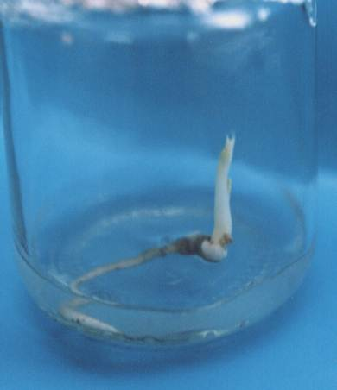No browning was observed in the culture medium, which is caused by the release of toxic exudates by the explant, or by callus formation in seedlings, as found in J. nigra (Heile-Sudholt et al., 1986), in J. regia cultivars (Jay-Allemand and Cornu, 1986, Sanchez et al., 2003, Sanchez et al., 2006), and hybrids of these species (Cornu and Jay-Allemand, 1989). The studied media presented 100% germination of immature embryos of J. neotropica (Picture 1b), opposite to other studies with J. regia (Sanchez et al., 2003, Sanchez et al., 2006; Toosi and Dilmagani, 2010).
Picture 1. Sequence of J. neotropica embryo growth under in vitro conditions. From left to right: (a) Initial embryo growth with 10 days of culture medium, (b) growth at 20 days of culture medium, and (c) 45 days seedling cultivation on MS medium.
a
b
c
Table 2. Mean values for each variable (± SD) in embryos at 60 days, total N and NO₃-/NH₄+ ratios in each culture medium.
Medium | Stem length  (cm) | Root length  (cm) | Shoot/root ratio | Total nitrogen  (mM) | NO₃⁻/NH₄⁺ | Time of in vitro conditions (days)
MS | 7. 22 (±0.81) a | 6.41 (±0.71) a | 1 (±0.08) a | 60.00 | 1.91 | 60
DKW | 3.3 (±0.69) b | 7.5 (±0.45) a | 0.4 (±0.08) b | 52.14 | 1.95 | 120
WPM | 1.42 (±0.69) c | 5.54 (±0.75) b | 0.2 (±0.12) c | 14.50 | 1.96 | 150

* Different letters show significant differences (P <0.05) between the culture media.
Values in parentheses represent the standard deviation (± SD) for each variable (n = 10).

The culture media results showed significant differences (P < 0.05) of growth and development of embryos after 60 days (Table 2). Embryos grown in MS medium showed the highest stem length and the best value or seedling conformation (shoot/root), compared to DKW and WPM media. Moreover, root length between DKW and MS medium was different (P < 0.05) in relation to WPM medium. Embryos that grew in DKW and WPM medium presented higher root length (2 and 5 times, respectively) with respect to the stem (Table 2).
Acclimation was done 60 days after for seedlings that came from MS medium. Embryos that came from WPM and DKW medium had to be sown again once or twice in their culture medium to reach a larger size after 120-150 days in order to have an ex vitro adaptation. This means a reduction of 2 to 3 months in the process of in vitro establishment and less expenditure of culture media by using MS medium. Macronutrients are essential for growth Juglans explants (Amiri, 2004), which was confirmed in this study with J. neotropica on MS medium, which is rich in high salt concentrations, followed by DKW medium and contrasting with WPM medium that has no sufficient nitrogen concentration to maintain growth of embryos (see Table 2). Similar results were found with MS and DKW media, in J. regia (Revilla et al., 1989, Fernandez et al., 2000; Saadat and Hennerty 2002; Kaur et al., 2006) and J. nigra (Bosela and Michler, 2008).
Table 3. Correlation coefficients matrix between growth and nitrogen variables.
Variable | (NO₃⁻)/(NH₄⁺) | N total
Shoot/root | -0.9986* | 0.8007
Stem length | -0.9912 | 0.8463
Root length | 0.1251 | 0.7312
* P < 0.05.

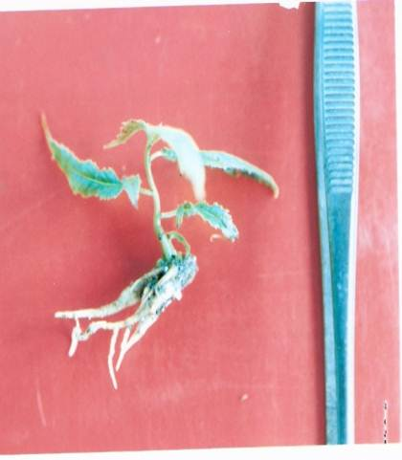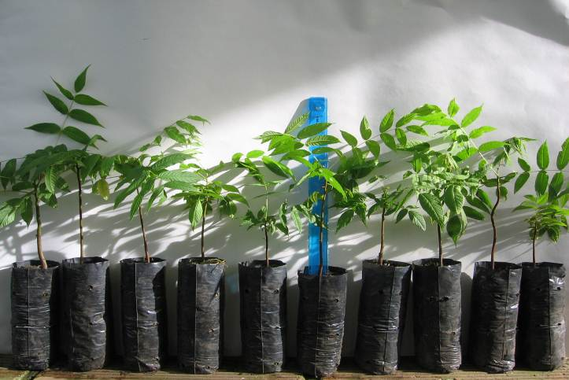One of the most important nutrients for in vitro culture is the amount of total nitrogen in the culture medium as well as the oxidized nitrogen (NO₃-)/reduced nitrogen (NH₄+) ratio. Results of several studies suggest that the culture media is more important than the ratio of the total nitrogen in the medium. Calculations of Pearson correlation coefficient (r) were performed in this study for each of the variables: stem length, root length and shoot/root ratio, with total nitrogen content and the ionic (NO₃-)/(NH₄+) ratio (Table 3).
a
b
Picture 2 Ex vitro adaptation ex vitro of black cedar (Juglans neotropica) seedling obtained from in vitro immature embryos. (a) Growth of new roots after 30 days in the greenhouse. (b) Black cedar plants adapted to greenhouse conditions with 120 days (20 to 25 cm).
Correlation values were close to 1 for the shoot/root ratio and length of the stem, compared to ionic (NO₃-)/(NH₄+) ratio than the obtained with total nitrogen content of the culture media, but only causality was found with P < 0.05 for seedlings that showed better growth (shoot/root) on MS medium, followed by DKW and WPM medium in the negative sense (Figure 1). This is similar to observations made by George et al. (2007), who argue that in vitro plantlets respond better to the relationship of both types of ions (NO₃)/(NH₄+) than to the total content of total nitrogen.

Ex vitro acclimatization of seedlings
Seedlings adaptation to ex vitro conditions was evident when new leaves appeared together with root growth (creamy white color). After seedlings transplanting, they remained covered for 30 days to prevent dehydration. Then, 120 days were needed to decrease moisture to nursery conditions. A feature of plant material produced by the embryo rescue technique is the homogeneity of growth under greenhouse conditions (Picture 2).
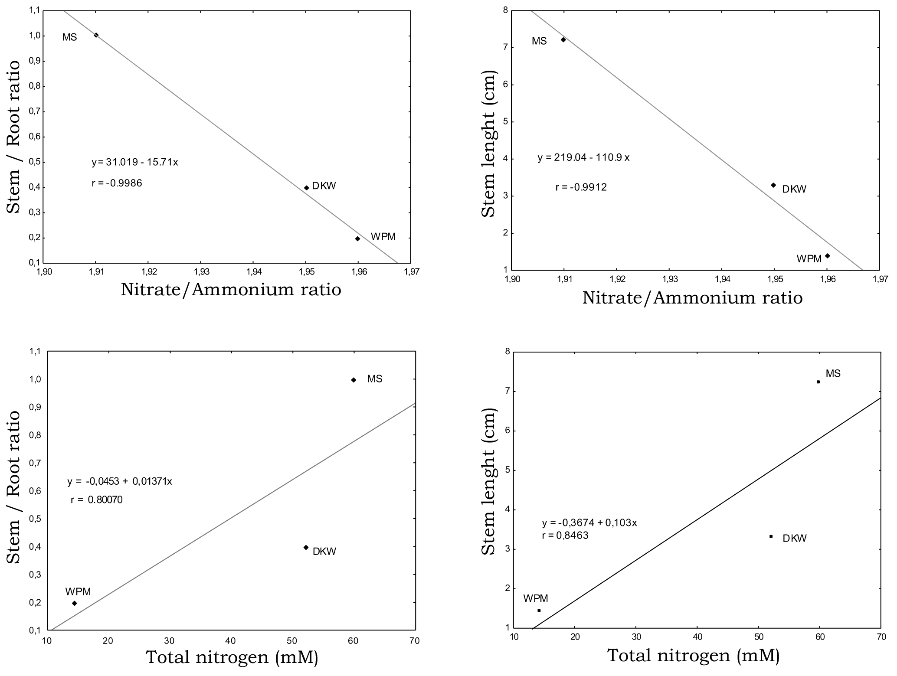Conclusions
Figure 1. Correlations between (NO₃-) / (NH₄+) ratio and total nitrogen of the three culture media with respect to the shoot/root ratio and stem length variables, of seedlings that came from immature embryos of Junglans neotropica..

- This study reports the first J. neotropica plants developed from embryos that came from 20 weeks old immature fruits. MS medium (Murashige and Skoog, 1962) provided the best support for the in vitro growth and development of seedlings to finally be ready for ex vitro adaptation process, reducing a time equivalent of 2 to 3 months with respect to the means of the DKW and WPM media. Therefore, MS medium can be regarded as the standard medium for the cultivation of immature embryos and to the propagation of this species.
- The in vitro planting of immature embryos prevent latency issues and pre-germinative issues that seeds normally present in natural conditions for nursery propagation.

Acknowledgements
Thanks to Juan Lazaro Murillo Toro (Forestal Engineer), Project Manager of Conservation and Sustainable Management of Forests, Flora and Fauna, assigned to the sub-direction of Ecosystems of the Regional Autonomous Corporation of Central Antioquia (CORANTIOQUIA) for the funding and the opportunity to participate in his working group. This article is part of a Master's Thesis of in vitro multiplication of Cedar Black (Juglans neotropica Diels).

References
Amiri, M. E. 2004. Effect of mineral concentration on tissue-cultured walnut (Juglans regia var. Zeiabadi) growth. Acta Hortic. 05:383 - 386.
Atwater, B. 1980. Germination dormancy and morphology of seeds of herbaceous. Seed Science and Technology. 8: 523-573.
Azofeifa, A. 2009. Problemas de oxidación y oscurecimiento de explantes cultivados in vitro. Agron. Mesoamer. 20(1):153 - 175.
Benson, E. E. 2000. Special symposium: in vitro plant recalcitrance, an introduction. In vitro Cell Dev. Biol Plant. 36:141 - 148.
Bosela M. J. and Michler C. H. 2008. Medias effects on black walnut (Juglans nigra L.) shoot culture growth in vitro: evaluation of multiple nutrient formulations and cytokinin types. In Vitro Cell Dev. Biol. Plant. 44:316 - 329.
Cárdenas, D. and Salinas, R. (eds.). 2006. Nogal: Juglans neotropica. Libro rojo de plantas de Colombia. Primera parte: Especies maderables amenazadas. La serie de Libros Rojos de Especies Amenazadas de Colombia. Instituto Amazónico de Investigaciones de Científicas ―Sinchi, Ministerio de Ambiente, Vivienda y Desarrollo Territorial. p. 162 - 167.
Cornu, D. and Jay-Allemand, C. 1989. Micropropagation of hybrid walnut trees (Juglans nigra x Juglans regia) through culture and multiplication of embryos. Ann. Sci. For. 113 - 116.
Cossio, F. and Minotta, G. 1983. Prove preliminary di coltura in vitro di embrioni isolate di noce (Juglans regia L.) e conformo tra diferente combinación di sali minerali. Riv. Ortoflorofrutt It. 67:287 - 298.
Cruz, D. Z. and Cruz, D. M. 2003. Inducción de brotación in vitro vía organogénesis de Juglans neotropica Diels. Trabajo de grado. Programa de Biología, Facultad de Ciencias Básicas, Universidad del Tolima.
Driver, J. A. and Kuniyuki, A. H. 1984. In vitro propagation of Paradox Walnut rootstock. HortSci. 19(4):507 - 509.
Fernández, H.; Pérez, C.; and Sánchez-Tames, R. 2000. Modulation of the morphogenic potential of the embryonic axis of Juglans regia by cultural conditions. Plant Growth Regul. 30:125 - 131.
George, E. F.; Hall, M. A.; Klerk, G.; and Springerlink. 2007. Plant propagation by tissue culture: The background. Online service. Dordrecht: Springer. 3rd. ed. vol.1
Gómez, M. L. 2002. Incidencia de la estratificación y el sustrato en la germinación de semillas de Juglans neotropica. Crónica Forestal y el Medio Ambiente 17:41 - 51.
Gómez, M. L. 2003. Estudio fenológico de 25 especies forestales en la jurisdicción de Corantioquia. Informe Final Contrato 3881. Medellín. Corporación Autónoma Regional del Centro de Antioquia (Corantioquia). 2003.
Gómez, M. L. and Toro, J. L. (eds.). 2007. Cedro negro. Boletín Técnico Biodiversidad: Manejo de las semillas y propagación de diez especies forestales del Bosque Andino. Medellín. Corporación Autónoma Regional del Centro de Antioquia (Corantioquia). 1:17 - 24.
Heile-Sudholt, C.; Huettemann, C.; Preece, J.; Van Sambeek, J.; y Gaffney, G. 1986. In vitro embryonic axis and seedling shoot tip culture of Juglans nigra L. Plant Cell Tissue Organ. Culture. (6):189 - 197.
Holdridge, L. R. 1967. Life Zone Ecology. Tropical Science Center. San José, Costa Rica. 206 p.
IAvH (Instituto de Investigaciones de Recursos Biológicos Alexander Von-Humboldt). 1998. Enfrentar el riesgo de extinción en la flora Colombiana. Biosíntesis 6:1 - 4.
Jay-Allemand, C. 1982. Culture in vitro du noger (Juglans sp.). En: Etude Experimentale sur l´ensemencement d´embryons isoles et de bourgeons. Mem D, Univ Sci Tchn Languedoc, Mompelier, Fr. 1982
Jay-Allemand, C. and Cornu, D. 1986. Culture in vitro d’embryons isolés de noyer commun (Juglans regia L.). Ann Sci For. 43(2):189 - 198.
Kaur, R.; Sharma, N.; Kumar, K.; Sharma, D. R.; and Sharma, S. D. 2006. In vitro germination of walnut (Juglans regia L.) embryos. Sci Hortic. 09:385 - 388.
Leslie, C. y Mcgranahan, G. 1992. Micropropagation of persian walnut (Juglans regia L.). En: Bajaj YPS (ed.). Biotechnology in agriculture and forestry, high-tech and micropropagation. 1. Springer-Verlag Berlin Heidelberg. 18:136 - 150.
Lloyd, G. y McCown, B. 1980. Commercially feasible micropropagation of mountain laurel (Kalmia latifolia) by use of shoot tip culture. Comb. Proc. Intl. Soc. 30:421 - 427.
López, J. 1997. Tratamientos pregerminativos aplicados a la semilla de cedro negro (Juglans neotropica) para reducir su periodo de germinación. (Tesis Ingeniería Forestal). Universidad Nacional de Colombia. Sede Medellín. Medellín. Antioquia, Colombia. 75 p.
López, J. M. 2004. Walnut tissue culture: research and field applications. En: Michler, C.H. et al. (eds.). Black walnut in a new century proceedings of the 6th Walnut Council research symposium. St. Paul, MN: U.S. Department of Agriculture, Forest Service, North Central Research Station. Citado 21 de septiembre de 2008. 2004; 146 -152. Disponible en: http://www.ncrs.fs.fed.us.
López, J. and Piedrahíta, E. 1999. Tratamientos pregerminativos aplicados a la semilla de cedro negro (Juglans neotropica) para reducir su periodo de germinación. En: Arboleda, O. (ed.). Segundo simposio sobre avances en la producción de semillas forestales en América Latina. 18-22 de Octubre. CATIE. Santo Domingo, República Dominicana. p. 191 - 199.
Murashige, T. and Skoog, F. 1962. A revised medium for rapid growth and bio-assays with tobacco tissue culture. Physiol. Plant. 15:473 - 497.
Ospina, C.; Hernández, J.; Patiño, J. and Salazar, J. 2003. El Cedro Negro: una especie promisoria de la zona cafetera. Chinchiná-Caldas. Federación Nacional de Cafeteros de Colombia. CENICAFE. Boletín Técnico Nº 25; p. 40. ISSN 0120-047X.
Pijut, P. M. 1997. Micropropagation of Juglans cinerea L. (Butternut). En: Bajaj, YPS (ed.). Biotechnology in agriculture and forestry, high-tech and micropropagation V. Berlin Heidelberg: Springer-Verlag. 39:345 - 357.
Revilla, M. A.; Majada, J.; y Rodríguez, R. 1989. Walnut (Juglans regia L.) micropropagation. Ann. Sci. For. 46:149 - 151.
Rietveld, W. J. 1983. Allelopathic effects of juglone on germination and growth of several herbaceous and woody species. J. Chem. Ecol. 9(2):295 - 308.
Ríos L. D.; Sánchez-Olate, M.; Aviles, F.; Materan, M. E.; Uribe, M.; Hasbún, R.; and Rodríguez, R. 2007. Micropropagación de Juglans regia L. En: Jain, S.M. y Häggman, H. (eds.). Protocols for micropropagation of woody trees and fruits. Dordrech , Netherlands. Springer. p. 381 - 390.
Rodríguez, R. 1982. Stimulation of multiple shoot-bud formation in walnuts seeds. HortSci. 17(4):592.
Rodríguez, R.; Revilla, A.; Albuerne, M.; and Pérez, C. 1989. Walnut (Juglans spp). En: Bajaj YPS. (ed.). Biotechnology in agriculture and forestry Trees. II. Berlin Heidelberg New York: Springer. 5:99 - 126.
Saadat, Y. A and Hennerty, M. J. 2002. Factors affecting the shoot multiplication of Persian walnut (Juglans regia L). Sci Hortic. 95:251 - 260.
Sánchez, M. A.; CosTerrer, J.; Frutos, D.; and García, L. R. 2003. Germinación y desarrollo in vitro de embriones maduros de nueces de la selección Peralta. Actas de Hortic. 39:345 - 347.
Sánchez, M. A.; Cos Terrer, J.; Frutos, T. D.; and García, L. R. 2006. Embryo germination and proliferation in vitro of Juglans regia L. Sci Hortic. 108(3):317 - 321.
Scaltsoyiannes, A.; Tsoulpha, P.; Panetsos, K. P.; and Moulalis, D. 1997. Effect of genotype on micropropagation of walnut trees (Juglans regia). Silvae Genet. 46(6):326-332.
Shibu, J. and Gillespie, A. R. 1998. Allelopathy in black walnut (Juglans nigra L.) alley cropping spatio-temporal variation in soil juglone in a black walnut–corn (Zea mays L.) alley cropping system in the midwestern USA. Plant Soil. 203:191 - 197.
Statsoft. 2005. Statistica data analysis software system [Programa de ordenador] Version 7.1. Disponible en: www.statsoft.com. 2005.
Toosi, S. and Dilmagani, K. 2010. Proliferation of Juglans regia L. by in vitro embryo culture. J. Cell Biol. Genet. 1(1):12 - 19. Disponible en: http://www.academicjournals.org/JCBG.

