Asymbiotic seed germination and in vitro seedling formation of Cattleya mendelii Dombrain (Orchidaceae)
Germinación asimbiótica de semillas y formación in vitro de plántulas de Cattleya mendelii Dombrain (Orchidaceae)

Seir Antonio Salazar-Mercado¹

¹Administrative Department of Science, technology and Innovation (Colciencias), Department of Agricultural Sciences and Environment, REsearch Group Environment and Life, Academic Group on Agrobiotechnological Research (GAIA) , Universidad Francisco de Paula Santander. Avenida Gran Colombia No. 12E-96B Colsag. San José de Cúcuta, Colombia. Corresponding author: Salazar663@hotmail.com

Rec.: 16.01.12 Acept.: 15.03.12

Abstract
Cattleya mendelii is an endemic orchid from Colombia, which has a great ornamental value that is in danger of extinction due to massive collection and their natural habitat destruction by human activities. In vitro culture was an alternative to preserve this specie and carry out its marketing. In this study was evaluated the asymbiotic germination and the orchid seedling formation from seeds of C. mendelii, in several in vitro cultures. Initially, mature capsules were collected and seed viability with tetrazolium test was done; seeds were disinfected at the same time and planted by the syringe method to evaluate the effect of five growth culture media on the development of C. mendelii after 16 weeks of cultivation. It was found that seed viability was 93%, the highest percentage of germination was found in the culture medium Murashige-Skoog plus coconut water (MS+AC) with significant differences compared to other culture media (P<0.05, Tukey). This study showed that MS medium supplemented with coconut water and pineapple juice, were more efficient in asymbiotic germination and seedling formation of C. mendelii orchids compared with other culture media. This could be an option to reduce the costs generated by using plant hormones.

Key words: Cattleya mendelii, culture medium, embryonic development, germination, in vitro culture, tetrazolium.

Resumen
Cattleya mendelii es una orquídea endémica de Colombia con alto valor ornamental que se encuentra en peligro de extinción, debido a la recolección masiva y destrucción de sus hábitats naturales por la acción antrópica. El cultivo in vitro es una alternativa para la conservación de esta especie y/o su comercialización. En esta investigación se evaluaron la germinación asimbiótica y la formación de plántulas de las semillas de orquídeas de la especie C. mendelii, en diferentes medios de cultivos in vitro. Inicialmente se recolectaron cápsulas maduras; posteriormente, se determino la viabilidad de las semillas con la prueba de Tetrazolio; en forma paralela las semillas se desinfectaron y sembraron con el método de jeringuilla, para evaluar el efecto de cinco medios de cultivo en el desarrollo de C. mendelii después de 16 semanas de cultivo. Se encontró que la viabilidad de las semillas fue de 93%. El mejor porcentaje de germinación se encontró en el medio de cultivo Murashige-Skoog más agua de coco (MS + AC) con diferencias significativas (P < 0.05, Tukey) con respecto a los demás medios de cultivo. En este estudio se demostró que los medios de cultivos MS suplementados con agua de coco y jugo de piña fueron más eficientes en la germinación asimbiótica y formación de plántulas en la orquídea C. mendelii con respecto a los otros medios de cultivo, siendo una opción en la reducción de los costos generados por la utilización de las fitohormonas.

Palabras clave: Cattleya mendelii, cultivo in vitro, desarrollo embrionario, germinación, medio de cultivo, tetrazolio.

Introduction

Orchidaceae family has a wide diversity in the Plantae kingdom with 750 genera and between 25,000 and 30,000 species around the world (Thorpe and Yeung, 2011). Thanks to its evolutionary capacity it shows variability in flower size, shape, texture and color (Nagaraju and Mani, 2005). According to the most recent data, Colombia registry 4010 species distributed in 260 genera (Mejía and Pino, 2010). In Norte de Santander there are descriptions of 37 genera and 105 species, highlighting Catleya mendelii (Díaz et al., 2004) which is native of Colombia growing in rocks and in the top of large trees in the Eastern Range of the Andes in Santander and Norte de Santander (1200 – 1800 MASL) (Santos et al., 2010). Plants have large and colorful flowers that give them an ornamental and economic value. It flowers once per year between April and May. This specie is endangered according to the red book of plants of Colombia (Calderón, 2007), meaning that, it is in danger of extinction or population decline in the wild. This threat is caused by its excessive and illegal recollection for marketing and, because of the destruction of host trees and its natural habitat (Salazar et al., 2010; Santos et al., 2010). Additionally, orchid germination in the wild has some limitations, like little nutrient reserves in the seeds which limit germination and survival in vivo. Therefore, it is necessary to establish symbiotic associations, mainly with mycorrizae, to achieve germination in natural conditions (Chen and Chen, 2007.
The first method for orchid seed germination (Moore, 1849) with horticultural interest meant an important and radical change in the way that other seeds of orchids were germinated 160 years ago (Arditti, 1984; Yam et al., 2002; Yam and Arditti, 2009). Half a century after Moore´s discovery, Noёl Bernard formulated a method for symbiotic germination of orchid seeds in vitro (Rasmussen, 1995; Yam et al., 2002).
Lewis Knudson developed a method for asymbiotic germination of orchid seeds in vitro (Knudson, 1921; Yam et al., 2002), which was the first practical procedure for in vitro propagation of any plant in axenic conditions, showing that germination was possible on a simple medium supplemented with minerals and sugar. The research done by Knudson shocked the orchids world demonstrating the Cattleya, Vanilla and other orchids were able to germinate asymbiotically in vitro (Knudson, 1946). Other authors like Arditti (1982) and Fast (1980), have contributed in the formulation of cultivation media for different genera and species.
The MS cultivation media (Murashige and Skoog, 1962) have been tested for germination and growth of several orchid species, getting optimal results because of its content of inorganic salts, carbohydrates, vitamins and amino acids, giving high nitrogen and potassium levels required for nutrition. It is relevant to mention that the in vitro culture of orchid seeds is favored by the addition of organic supplements and hormones to the growth medium (Malgren, 2006; Arditti, 2008; Pedroza, 2009; Cancino and Salazar, 2011).
In vitro methods for growth have been successfully used for conservation and propagation of species of endangered and medicinal orchids (Deb and Pongener, 2011; Stewart and Kane, 2006; Lo et al., 2004). When germination conditions are being evaluated is important to take into account the viability of the studied seeds, which will estimate the rate of seeds that will not germinate as consequence of conditions that prevent germination due to low viability (Muñoz and Jiménez, 2008). In orchids the most used method for seed viability determination is the biochemical test with tetrazolium (Johnson et al., 2007; Lauzer et al., 2007; Vujanovic et al., 2000) which detects signs of life or metabolic activity. Viable seeds are easily identifiable due to the characteristic red coloring (Mweetwa et al., 2008). The present study evaluated seed asymbiotic germination and in vitro formation of C. mendelii seedlings. Moreover, seed viability of this specie was determined and compared to the germination percentage.

Materials and methods
Plant material
Mature dehiscent capsules of C. mendelii were collected in Bochamela, Norte de Santander, Colombia on March 30, 2011. These capsules had been manually pollinized under greenhouse conditions by transferring two pollen grains to the stigma of another flower using fine forceps. A total of 4 plants, 2 donors and 2 receptors, were used. Afterwards, mature seeds were taken out of the capsules for storage on Kraft paper at 4 °C in glass containers with silica gel to avoid seed deterioration by humidity (Dutra et al., 2008; Vogel and Macedo, 2011).

Seed viability
Seeds were subjected to different sodium hypochlorite concentrations 0.5%, 1%, 1.5%, 2.0%, 2.6%, 3.0%. Next, their viability was evaluated with the tetrazolium test [2,3,5- triphenyltetrazolium chloride (TTC: C₁₉H₁₅ClN₄)]. 100 orchid seeds were immersed in a TTC solution (1%) (1 g in 100 ml phosphate buffer: 0.9 % Na₂HP0₄ 2H₂0 + 1.1 % KH₂P0₄, pH 6-7) for 24 hours in the dark (Muñoz and Jiménez, 2008; Ossenbach et al., 2007), before they were examined under the microscope stereoscope (Leica EZ4). The process to determine viability was replicated five times. Viable seeds were dyed red due to the tetrazolium reduction by cell respiration. This test is approved by the International Seed Testing Association (ISTA, 1985).

Seed disinfection and sowing
For seed disinfection and sowing it was used the syringe method (Vendrame et al., 2007), which consists on putting some seeds on a sterile 5 ml syringe with a cloth filter; seeds were submerged on a 70% ethanol solution for 30 seconds; then they were placed on 1% sodium hypochlorite (NaOCl) solution with two drops of Tween-20® (surfactant) for 5 minutes in constant shaking; then they were washed five times with deionized water and, the filter was removed from the syringe to proceed with the sowing under sterile conditions in the flow chamber. 100 seeds were sown on petri dishes containing 25 ml of culture medium.

Asymbiotic medium and culture conditions
Basic culture medium was MS with 100% of macro and micronutrients concentration (Murashige and Sloog, 1962) with 3000 mg/lt sucrose, 700 mg/lt agar, 100 mg/lt myo-inositol and 1000 mg/lt activated carbon. Five culture media were used: MS as control, MS supplemented with pineapple juice (MS+JP), MS with coconut water (MS+AC), MS with 0.5 mg/lt indolacetic acid (MS+AIA) and MS with 0.5 mg/lt giberellic acid (MS+GA₃). Media with organic supplements were prepared adding 200ml/lt (20%) of coconut water or pineapple juice. Pineapple juice was prepared with a blender, then it was filter through gauze, boiled for 10 min and stored in glass flasks 8200 ml) at -80 °C. Medium was adjusted to ph 6.0 with NaOH or 0.5 M HCl. It was sterilized at 15 psi, 121 °C for 20 minutes. Culture media were incubated under controlled conditions (23 ± 2 ºC, 16/8h light/dark, light intensity 25 µmol/m per second using fluorescent light and 60% relative humidity).

Experimental design and statistical analysis
Experimental designed was a completely randomized factorial 6 x 5 (six developmental phases and five culture media), with five replicates and three petri dishes in average (each ne with 100 seeds) for a total of 75 experimental units. Data were subjected to a variance analysis (Anova). Afterwards, means were compared using the HSD (Honestly Significant Difference) multiple range test of Tukey to determine significant differences at P < 0.05 (Tukey, 1994).
The process from seed germination to seedling formation was evaluated every 2 weeks for 16 weeks after sowing using the orchid developmental phases adapted by Vasudevan and Staden (2010) (Table 1). Moreover, the total percentage of in vitro germination was measured to be compared with the viability test, this was done by summing the orchid developmental phases 1, 2,3,4 and 5 of each culture media used (MS, MS+JP, MS+AC, MS+AIA y MS+GA3). Later on, germination average value was obtained (germination percentage). The correlation coefficient between sodium hypochlorite concentration and viability percentage was determined. For the statistical analysis the software Statgraphic Centurión XV version 15.2.05 (2006) was used.

Results and discussion
Viability percentage vs. sodium hypochlorite concentration
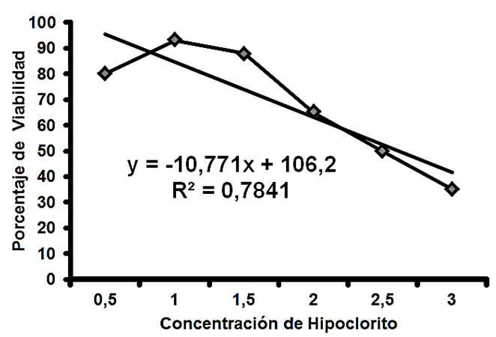The higher viability percentage of C. mendelii was found in seeds treated with 1% sodium hypochlorite, and the lower with the highest concentration of this compound (3%) (Figure 1). According to these results, it is possible to declare with 95% probability that sodium hypochlorite has a moderately strong effect on seed viability and, that there is a correlation coefficient R² = 0.7841 (Figure 1, Picture 1). Alvarez-Pardo et al. (2006) when seed viability and sodium chloride concentrations are associated finding higher viability percentage in C. bicolor. Sodium hypochlorite scarifies seed coat therefore the tetrazolium solution penetrates easily, and in the same way, germination is stimulated (Rännbäck, 2007; Vasudevan and Staden, 2010).
Figure 1. Correlation between sodium hypochlorite concentration and viability percentaje.
Hypochlorite concentration
Viability percentage
Tetrazolium test is a recomended method due to its efficiency and easy use; viable seeds are easily identified with a red color characteristic of the reaction on living cells, because they release hydrogen via dehydrogenase activity during respiration (Vujanovic et al., 2000; Ossenbach et al., 2007; Muñoz and Jiménez, 2008).

Seed viability and germination
In average, the viability of C. mendelii was high (93%). Lauzer et al. (2007) and Vujanovic et al. (2000) demonstrate that viability test is not always a good indicator of germination, since it does not evaluate cell division and development capacities (Padilla, 2011). For this reason, the validity of this test was confirmed with germination test on the nursery (Johnson et al., 2007; Muñoz and Jiménez, 2008).
In vitro asymbiotic germination of C. mendelii seeds in the five media tested was, in average, 94.1% (Table 2). The difference between the germination test and the viability test was 1.1% indicating that there are no differences (P > 0.05) between both tests. This demonstrates that the tetrazolium test could be used to predict the germination capability of C. mendelii. Hosomi et al. (2011) used the tetrazolium test to estimate seed viability of Catleya sp. for propagation and preservation. Also, it has been used to determine the germination capacity and seedling
growth of a vast number of orchids species (Stewart and Kane, 2006; Yamazaki and Miyoshi, 2006; Mweetwa et al., 2008; Cancino and Salazar, 2011). Nonetheless, the test is based only on the internal conditions of seeds and does not revealed the combined behavior of their quality with certain growth characteristics (Ossenbach et al., 2007). Besides, seed viability of different capsules changes considerability and in several orchid species it decreases during storage (Vendrame et al., 2007; Hirano et al., 2011).
Table 1. Developmental phases on orchid seeds.
Phase | Description
0 | Seeds and embryo did nt germinate.
1 | Embryo increases its size.
2 | Testa ruptura.
3 | Protocorm and rhizoids formation.
4 | First leaf emergence.
5 | First leaf elongation and progressive development.
Source: Modified from Vasudevan and Staden, 2010.

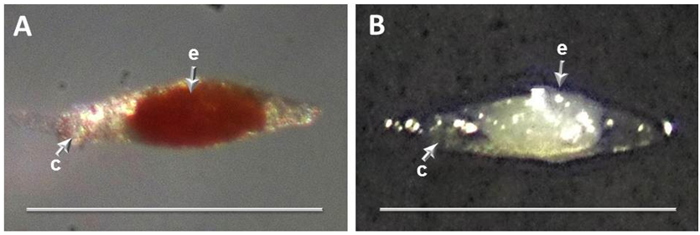
Picture 1. Viability evaluation of Cattleya mendelii, using the tetrazolium test . (A) viable seed. (B) unviable seed. Tetrazolium salt is a transparent, soluble and oxidated solution. In presence of respiratory activity it is reduced, producing an isoluble red precipitate called Formazan. Bar scale 1 mm. c: seed coat; e: embryo.
Culture media, asymbiotic germination and seedling formation
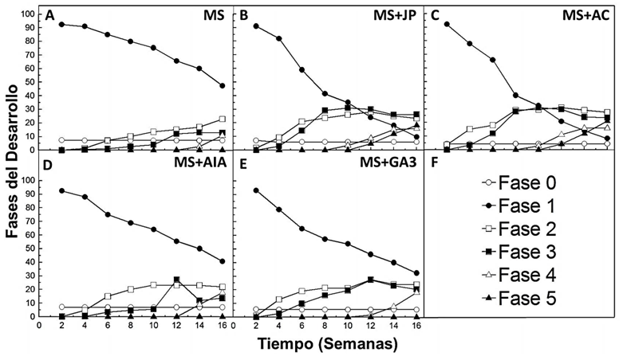Germination percentage of C. mendelii was constant from week 4 on (Figure 2). The highest percentage was found in the MS+AC medium (P < 0.05) (Table 2). The highest per
centage of protocorm formation happened in MS+JP medium that was not different from the MS+AC medium (P > 0.05) (Table 2). Si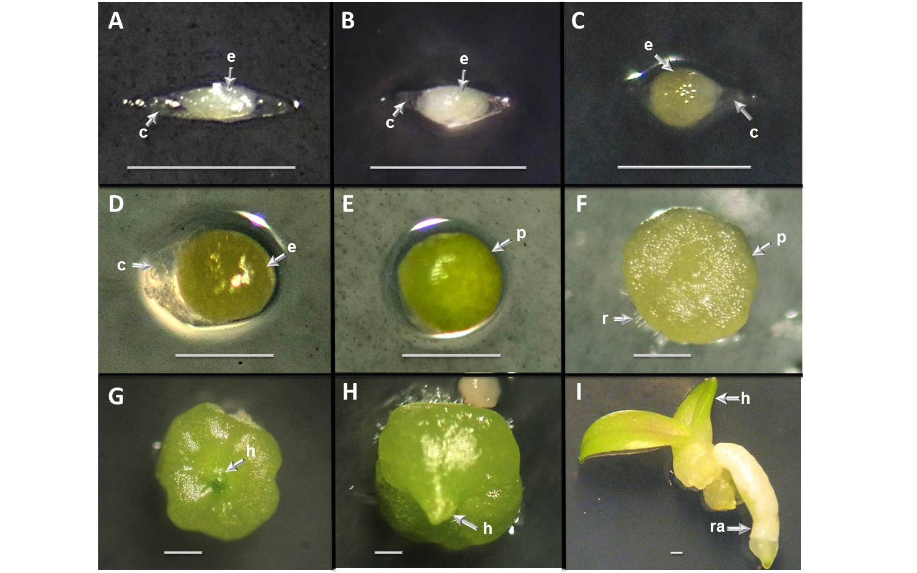milar results were found by Stewart and Kane (2006) in Habenaria macroceratitis (Orchidaceae). Kitsaki et al. (2004) found that culture media enriched with coconut water was more suitable for germination and protocorm formation in Ophys than the one with pineapple juice. Independently from the growth habit and taxonomy, several species can have different requirements for germination (Vogel and Macedo, 2011). Additionally, it is possible to infer that germination is affected not only for the culture media but also for the seed quality and maturity (Lo et al., 2004; Yam and Arditti, 2009).
Figure 2. Developmental phases of Cattleya mendelii culture don five media. (A) MS culture medium (Murashige and Skoog). (B) MS + Pineaple juice. (C) MS + Coconut water. (D) MS + Indolacetic acid. (E) MS + Giberellic acid. (F) Phases symbols.
Time (Weeks)
Developmental phases
Phase 1
Phase 2
Phase 3
Phase 4
Phase 5 Phase 6
Picture 2. Developmental phases on Cattleya mendelii from seed germination till seedling formation in in vitro asymbiotic culture medium. (A) Phase 0: Seed with embryo without germination. (B and C) Phase 1: Embryo increases its size. (D) Phase 2: Testa rupture. (E and F) Phase 3: Protocorm and rhizoids formation. (G) Phase 4: First leaf emergence. (H and I) Phase 5: First leaf elongation and progressive development. Bar scale = 1mm. c: seed coat; e: embryo; h: leaf; p: protocorm; r: rhizoid; ra: root.
C. mendelii developmental phases (Picture 2 and Figure 2) were highly variable in the media treatments during the 16 weeks of evaluation, with the exception of the Phase 0 which did not vary from the week 4 on in all the evaluated media (Picture 2A). In the other developmental phases it was found that the highest percentage in Phase 1 (Picture 2B and C) happened in the MS medium (47.33%; P < 0.05) (Figure 3). In Phase 2 (Picture 2D) development was not equilibrated in the culture media (MS: 22.798; MS+JP: 23.33; MS+AC: 27.57; MS+AIA: 21.864 and MS+GA3: 23.796; Figure 3). In Phase 3 (Picture 2E and F) the highest percentage was on the MS+JP medium (26.198) (Figure 3), however it was not different (P > 0.05) with the development on MS+AC medium (23.464). In Phase 4 (Picture 2G) seedlings on MS medium showed less development (10.794) in relation to other culture media and there were no differences between them (P > 0.05; Figure 3). Development on Phase 5 (Picture 2H and I) was achieved only in MS+JP and MS+AC media, but differences were not significant (P > 0.05).
 | Table 2. Culture media effect on germination percentage and protocorm formation of Cattleya mendelii. Evaluation done at 120 days of culture.
Culture medium |  | Germination percentage | Protocorm formation
MS |  | 92.86 a* | 12.798 a
MS + JP |  | 94.06 bc | 26.198 b
MS + AC |  | 95.7 d | 23.464 bc
MS + AIA |  | 93.34 ab | 13.73 a
MS + GA3 |  | 94.5 c | 20.398 c
*Values in the same column with different letters are significantly different (P < 0.05), according to Tukey´s test.

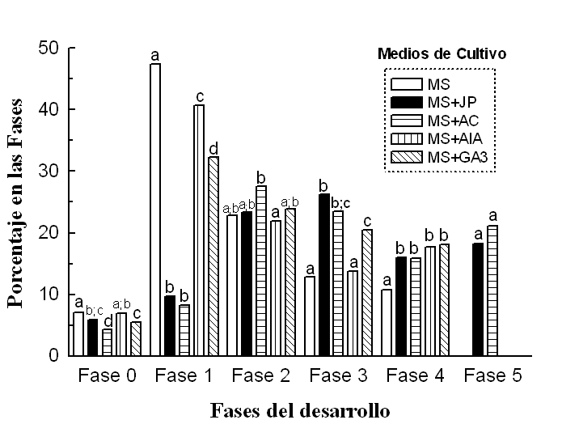Kitsaki et al. (2004) found that culture media supplemented with coconut water is more efficient in the first developmental phases (1, 2 and 3), contrasting with the media supplemented with pineapple juice which is better on Phases 4 and 5. Contrasting, the present research showed that the MS+AC and MS+JP media were the best in all the developmental phases of C. mendelii. However, the other culture media were efficient until Phase 4. Pedroza (2009) showed that the addition of IAA (0.5 mg/lt) to the MS medium promotes development on Epidendrum elongatum (Orchidaceae). In other studies, it was demonstrated, equally, the beneficial effect of IAA when added to MS medium (Farias and Arciga, 2011). Manrique et al. (2005) and Coello et al. (2010) found that GA3 can accelerate orchid germination and growth, which is not what was found in this study, where the effect of the plant hormones IAA and GA3 was not optimal for the developmental phases of the plant. It should be noted that both, pineapple juice and coconut water, are good sources of energy, vitamins, amino acids and plant hormones (Kitsaki et al., 2004; Yam and Arditti, 2009; Yong et al., 2009). In this research was found that the addition of these organic compounds to the MS medium improved its efficiency, and, favored a better growth and development of C. mendelii.
Developmental phases
Phase 0 Phase 1 Phase 2 Phase 3 Phase 4 Phase 5
Percentage in the Phases
Culture media
Figure 3. Effect of culture media on the developmental phases of Cattleya mendelii. Bars with different letters between each phase show statistically significant differences according to HSD Tukey´s test (P<0.05). Evaluation done at week 16 of culture.

Conclusions
- The present study demonstrated that the MS media supplemented with organic compound like coconut water and pineapple juice, favor in vitro asymbiotic germination and seedling formation of C. mendelii, being a suitable combination to produce multiple plants in order to reintroduce endangered species in their natural habitats.
- The use of organic supplements in the culture media could be a possible alternative to reduce high costs of the use of plant hormones in the media. Likewise, the tetrazolium test results on an efficient methodology to predict the germination capacity of C. mendelii seeds.
- There is a need of studies associated to multiplication and hardening of endangered or ornamental orchid species, to help their conservation and/or commercialization. Additionally, it is recommended to keep evaluating other organic components with different orchid species to prove their effectiveness.

Acknowledgments
To the Administrative Department of Science, Technology and Innovation (Colciencias) and to the Universidad Francisco de Paula Santander, for the support during this research. To: A: Fernando Barrientos and Lilian Trinidad for their invaluable contributions ; Yuri Osorio for technical help; Jean Denis for the plant material.

References
Alvarez-Pardo, V. M.; Ferreira, A. G; and Nunes, V. F. 2006. Seed disinfestation methods for in vitro cultivation of epiphyte orchids from Southern Brazil. Hortic. Bras. 24:217 - 220.
Arditti, J. 1982. Introduction, north american terrestrial orchids… En: Orchid biology. II. Reviews and perspectives. Orchid seed germination and seedling culture – a manual. Ithaca, Nueva York: Cornell University Press. p. 245-73, 278-93.
Arditti, J. 1984. An history of orchid hybridization, seed germination and tissue culture. Bot J Linn Soc. 89:359 - 381.
Arditti, J. 2008. Micropropagation of orchids, 2nd edn. Blackwell, Cambridge.
Calderón, E. 2007. Libro Rojo de plantas de Colombia. Vol. 6. Orquídeas primera parte, Instituto Alexander von Humboldt – Ministerio de Ambiente, Vivienda y Desarrollo Territorial, Bogotá, Colombia.
Cancino, G. O and Salazar, S. A. 2011. Evaluación del efecto de suplementos orgánicos en la germinación in vitro de dos especies de orquídeas de la provincia de Pamplona, Norte de Santander, Colombia. Memorias. VI Congreso Colombiano de Botánica Biodiversidad, Desarrollo y Cultura: Una Visión Integradora. Cali, 11-15 de agosto (CD-rom).
Coello, C.; Miceli, C.; Orantes, C.; Dendooven, L.; and Gutiérrez, A. 2010. Plant growth regulators optimization for in vitro cultivation of the orchid Guarianthe skinneri (Bateman) Dressier & W. E. Higgins. Gayana Bot. 67(1):19 - 26.
Chen, W. and Chen, H. 2007. Orchid Biotechnology. World Scientific. Editorial: World Scientific Pub Co Inc.
Deb, C. and Pongener, A. 2011. Asymbiotic seed germination and in vitro seedling development of Cymbidium aloifolium (L.) Sw.: a multipurpose orchid. J. Plant Biochem. Biotechnol. 20(1):90 - 95.
Díaz, J.; Solano, F.; Sánchez, L.; and Espinosa, F. 2004. Riqueza y distribución de las Orquideaceae en la provincia de Pamplona. Bistua 2(1):106 - 112.
Dutra, D.; T. R. Johnson, P.J.; Kauth, S. L.; Stewart, S.; and Kane, M. 2008. Asymbiotic seed germination, in vitro seedling development, and greenhouse acclimatization of the threatened terrestrial orchid Bletia purpurea. Plant. Cell. Tiss. Organ. Cult. 94:11 - 21.
Farias, H. and Arciga, M. 2011. Germinación in vitro de Guarianthe aurantiaca Bateman (Orchidaceae) (Tesis de Biólogo, Michoacana de San Nicolás de Hidalgo).
Fast, G. 1980. Propagation and cultivation. En: Fast, G., Ulmer, Stuttgart (eds.). Orchid culture. Botanical principles, cultural practices, plant descriptions. p. 207 - 23.
Hirano, T.; Yukawa, T.; Miyoshi, K.; and Mii, M. 2011. In vitro germination and seedling development of cryopreserved Dendrobium hybrid mature seeds for seeds of some Cymbidium species. Plant Biotechnol. 28:99 - 102.
Hosomi, S. T.; Santos, R. B.; Custodio, C. C.; Seaton, P. .; Marks, T. R.; and Machado Neto, N. B. 2011. Preconditioning Cattleya seeds to improve the efficacy of the tetrazolium test for viability. Seed Sci. Technol. 39:178 - 189.
ISTA (International Seed Testing Association). 1985. International rules for seed testing. Seed Sci. Technol. 13:300 - 520.
Johnson, T.; Stewart, L.; Dutra, D.; Kane, M.; and Larry Richardson. 2007. Asymbiotic and symbiotic seed germination of Eulophia alta (Orchidaceae)—preliminary evidence for the symbiotic culture advantage. Plant Cell Tiss Organ Cult. 90:313 – 323.
Kitsaki, C.; Zygouraki, S.; Ziobora M.; and Chintziest, S. 2004. In vitro germination, protocorm formation and plantlet development of mature versus immature seeds from several Ophrys species (Orchidaceae). Plant Cell Rep. 23:284 - 290.
Knudson, L. 1921. La germinación no simbiótica de las semillas de orquídeas. Bol. Real Soc. Española Hist. Nat. 21:250 - 260.
Knudson, L. 1946. A nutrient for germination of orchid seeds. Am Orchid Soc Bull 15:214 - 217.
Lauzer, D.; Renaut, S.; Arnaud.; and Barabé, D. 2007. In vitro asymbiotic germination, protocorm development, and plantlet acclimatization of Aplectrum hyemale (Muhl. ex Willd.) Torr. (Orchidaceae). J. Torrey. Bot. Soc. 134(3):344 – 348.
Lo, S.; Wade, S.; Kuo, C.; Chen, C.; and Tsay, H. 2004. Asymbiotic germination of immature seeds, plantlet development and ex vitro establishment of plants of Dendrobium tosaense makino– a medicinally important orchid. In Vitro Cell. Dev. Biol. Plant 40:528 - 535.
Malgren, S. 2006. Orchid propagation. Consultado en Junio 1, 2012, en. http://www.lidaforsgarden.com/Orchids/engelsk.htm
Manrique, J.; Fernandez, C.; and Suárez, A. 2005. Evaluation of the effect of three growth regulators in the germination of Comparettia falcata seeds under in vitro conditions. Vitro Cell. Dev. Biol. Plant. 41:838 - 843.
Mejía, H. and Pino, T. 2010. Diversity of orchids epiphytes in a tropical rain forest (Bh-T) of departament Chocó, Colombia. Acta biol. Colomb. 15(2):37 - 46.
Muñoz, M. and Jiménez, V. 2008. Capsule development, in vitro germination and plantlet acclimatization in Phragmipedium humboldtii, P. longifolium and P. pearcei. Lankesteriana 8(2):23 - 31.
Moore, D. 1849. On growing orchids from seeds. Garden Chron. 35:549.
Murashige, T. and Skoog, F. 1962. A revised medium for rapid growth and bioassays with tobacco tissue culture. Physiol. Plant 15:437 - 497.
Mweetwa, A. M.; G. E. Welbaum, D.; and Tay. 2008. Effects of development, temperature, and calcium hypochlorite treatment on in vitro germinability of Phalaenopsis seeds. Sci Hortic. 117:257 - 262.
Nagaraju, V. and Mani, S. K. 2005. Rapid In Vitro Propagation of Orchid Zygopetalum intermedium. J. Plant. Biochem. Biot. 14:27 - 32.
Ossenbach, C.; Arce. J.; and Warner, J. 2007. Almacenamiento de semillas de diferentes especies de orquídeas para su conservación en un banco de germoplasma: Deshidratación, almacenamiento y pruebas de viabilidad de las semillas. Tierra Tropical. 3(1):47 - 59.
Padilla, J. 2011. Prueba de viabilidad con tetrazolio. Consultado en Diciembre 8, 2011, en http://snics.sagarpa.gob.mx/Documents/pruebaviabilid
Pedroza, J. 2009. The effect of activated charcoal, indol acetic acid (IAA) and benzylaminopurine (BAP) on Epidendrum elongatum Jacq protocorm-like body (PLB) development in in vitro conditions. Rev. Colomb. Biotecnol. 6(1):17 - 32.
Rännbäck, L. 2007. Propagation, cultivation and breeding of terrestrial temperate orchids, with focus on Cypripedium spp. Dept. of Crop Science, SLU. Bachelor project in the Danish-Swedish Horticulture programme. 2007:1.
Rasmussen, H. 1995. Terrestrial orchids, from seed to mycotrophic plant. Cambridge University Press, Nueva York.
Santos, C. G.; Ordoñez, J. C.; and Morales, L. 2010. Colección viva de especies amenazadas. contribución del jardín botánico José Celestino Mutis. (on-line). Bogotá, Colombia: Jardín Botánico José Celestino Mutis. ISBN 978-958-8576-04-6.
Salazar, F. J.; Benavides, O. L.; Trespalacios-González and L. F. Pinzón. 2010. Informe sobre el Estado de los Recursos Naturales Renovables y del Ambiente, Componente de Biodiversidad Continental - 2009. Instituto de Investigación de Recursos Biológicos. Alexander von Humboldt‖. Bogotá, D.C., Colombia. 167 p.
Statgraphics Centurión XV © 2006 by StatPoint, Inc. Version 15.2.05 1. 1982-2007. http://www.statgraphics.com.
Stewart, S. and Kane, M. 2006. Asymbiotic seed germination and in vitro seedling development of Habenaria macroceratitis (Orchidaceae), a rare Florida terrestrial orchid Plant. Cell. Tiss. Organ Cult. 86:147 - 158.
Thorpe, T. A. and Yeung, E. C. 2011. Plant Embryo Culture: Methods and Protocols, Methods in Molecular Biology, vol. 710, DOI 10.1007/978-1-61737-988-8_20, © Springer Science+Business Media, LLC.
Tukey, J. W.. 1994. The problem of multiple comparisons. En: H. L. Braun (ed.). The collected works of John W. Tukey. Nueva York: Chapman and Hall. Vol. VIII, Chapter 1, p. 1 - 300.
Vasudevan, R. and Staden, J. 2010. In vitro asymbiotic seed germination and seedling growth of Ansellia africana Lindl. Sci Hortic. 123:496 -504.
Vendrame, W. A.; Carvalho, V. S.; and Dias J. M. 2007. In vitro germination and seedling development of cryopreserved Dendrobium hybrid mature seeds. Sci Hortic 114(3):188 – 193.
Vogel, I. and Macedo, A. 2011. Influence of IAA, TDZ, and light quality on asymbiotic germination, protocorm formation, and plantlet development of Cyrtopodium glutiniferum Raddi., a medicinal orchid. Plant. Cell. Tiss. Organ. Cult. 104:147 - 155.
Vujanovic, V.; Arnaud, M.; Barabe, D.; and Thibeault, G. 2000. Viability testing of orchid seed and the promotion of colouration and germination. Ann. Bot. 86:79 - 86.
Yamazaki, J. and Miyoshi, K. 2006. In vitro Asymbiotic Germination of Immature Seed and Formation of Protocorm by Cephalanthera falcata (Orchidaceae). Ann. Bot. 98, 1197-1206.
Yam, W.; Nair, H.; Hew, S.; and Arditti, J. 2002. Orchid seeds and their germination: An historical account. In: Kull T, Arditti J (eds.). Orchid biology: reviews and perspectives. Kluwer Dordrecht. vol. 8:387 - 504.
Yam, T. and Arditti J. 2009. History of orchid propagation: a mirror of the history of biotechnology. Plant Biotechnol Rep. 3:1 - 56.
Yong, J.; Ge, L.; Yan, N.; and Tan, S. N. 2009. The chemical composition and biological properties of coconut (Cocos nucifera L.) water. Molecules 14:5144 - 5164.

