Evaluation of two drip irrigation systems in production and fruit quality of pear (Pyrus communis L.) cv. Triunfo de Viena
Evaluación de dos sistemas de riego por goteo en la producción y la calidad de la fruta de pera (Pyrus communis L.) variedad Triunfo de Viena

María Cristina Arenas-Bautista^{1†}, Javier Enrique Vélez-Sánchez^{2*}, and Jesús Hernán Camacho-Tamayo^{3‡}

¹Agricultural Engineer, M.Sc.; Agricultual Engineering Unit, Department of Natural Sciences and Engineering. Fundación Universitaria de San Gil – UNISANGIL. El Yopal, Colombia. ²Agricultural Engineer, M.Sc., Dr.; Department of Civil and Agricultural Engineering, Universidad Nacional de Colombia, , Bogotá, Colombia. ³Agricultural Engineer, M.Sc.; Department of Civil and Agricultural Engineering, Universidad Nacional de Colombia, Bogotá, Colombia.
*Corresponding author: jevelezs@unal.edu.co; †mcarenasb@unal.edu.co; ‡jhcamachot@unal.edu.co

Rec.: 11.01.11. Acept.: 29.02.12

Abstract
Day by day, the rational use of water is becoming more important in fruit production. The aim of this study was to evaluate the effect of using double drip line in pear (Pyrus communis) production, cv. Triunfo de Viena in comparison with the traditional system of one drip line per plant row. The research was based on the application of two specific processes, one consisting of a drip line per plant row with six emitters of 8 lt h⁻¹ and another with two drip lines per plant row with three emitters of 8 lt h⁻¹ each. Watermark sensors were used to measure and control soil matric potential. It covered 100% of potential evapotranspiration, which was 55.5 mm month⁻¹. The results of the variables allow ground water irrigation scheduling and ensure adequate water supply during the period of water deficit. The double-line treatment did not differ significantly from the control in terms of production and fruit quality, which indicates that to use only one drip line will allow to get a similar yield and quality at a lower initial equipment cost.

Key words: Production, Pyrus communis, quality, trickle irrigation.

Resumen
El objetivo del presente estudio fue evaluar el efecto de la utilización del sistema de doble línea de riego vs. el tradicional de una línea por hilera de plantas en la producción y calidad de la pera (Pyrus communis) variedad Triunfo de Viena. La investigación se basó en la aplicación de dos tratamientos definidos, uno consistente en una línea de goteo por hilera de plantas con seis emisores de 8 lt/h y otro, con dos líneas de goteo por hilera de plantas con tres emisores de 8 lt/h cada uno Se utilizaron sensores Watermark para medir y controlar el potencial matricial del suelo. Se cubrió el 100% de la evapotranspiración potencial que fue de 55.5 mm/mes. Los resultados obtenidos de las variables hídricas del suelo permitieron programar el riego y garantizar el suministro de agua adecuado en el periodo de déficit hídrico. El tratamiento de doble línea no difirió significativamente del control, lo que indica que utilizar una línea de riego permite obtener una producción y calidad similares con un menor costo inicial del equipo.

Palabras clave: Calidad, producción de frutos, Pyrus communis, riego por goteo.

Introduction
Climate change has forced fruit farmers to modify cultivated areas according to water availability and rainfall. Some countries are reducing their cultivated areas while others, like China, have increased them (FAO, 2010). World production of fresh fruits is close to 15.5 millions of tons, of which Colombia contributes with 13.579 t/year, which are produced in approximately 1099 ha (FAO, 2010). Water consumption in agriculture represents 87% and the worldwide demand on this resource is increasingly ascending (FAO, 2003). Water resources depletion, high water and energy cost and market globalization, demand improvements on irrigation use efficiency (Vélez et al., 2007). The effect of irrigation deficit and its incidence on crop yield and quality has been widely investigated since 1980 (Dong et al., 2006); however, it was only in 1990 when favorable results were found about the relation between fruit quality with soil type and water deficit index (Shi et al., 1998).
Indiscriminate use of water for irrigation and absence of an appropriate management of the water-soil-plant system, have yield serious risks on soil quality in different regions of the country. Problems like salinity and sodicity, not only reduce productivity but also limit the crop choices that can be produce under those soil conditions (Oster, 1994). The effects of water stress during crop development stages are well known (Lampinen et al., 1995), e.g., it has been observed that fruit physical and chemical characteristics can change (Verreynne et al., 2001); however there is a lack of knowledge in which is the best indicator of the hydric status of fruit trees. Johnson et al. (1992) suggest that plants as such are the best indicator of their water status since they integrate the effect of water supply from soil together with weather conditions. It is an indicator directly related to crop productivity (Fereres and Goldhamer, 2003).
Localized irrigation is the most suitable system for flowers and fruit crops, since it uses low water volumes at low pressure and high frequency without wetting all the soil (Singh et al., 2000), although it requires high capital investment at the beginning and a higher capacity of management than the traditional systems (Cetin and Uygan, 2008). When comparing drip irrigation by one line per plant row vs. double line, some satisfactory responses have been found although few are related to the percentage of wet soil in deciduous fruit trees. For that reason, the aim of this study was to evaluate the effect on fruit yield and quality using double drip line of irrigation vs. one drip line per plant row.

Materials and methods

Study zone and crop location and characterization

The study was done in Sesquilé (Cundinamarca), in a 0.32 ha plot with 185 pear (Pyrus communis L.) trees cv. Triunfo de Viena, at 5º 02’53.65” N and 73º 48’12.78” O, and 2595 MASL. Soil is a clay loam histosol soil with wavy relief. According to Köppen classification (1936) the region correspond to a Cfb climate, wet temperate with moderate rainfall through the year, average temperature of 14 °C and yearly rainfall between 890 and 1500 mm mainly in during April-May and October-November, with a dry weather the rest of the year.

Soil bulk density is 1.06 t/m³, average pH is 4.6, organic matter content os 5.06%, field capacity (FC) is 26.9% and permanent wilting point (PWP) is 15.3%. In February 2010 shaded area was 39.2%. Irrigation water pH was 5.9 and electric conductivity was 2 dS/m at 25 °C. Determination of the irrigation lamina was done based on Penman-Monteith´s equation (Allen et al., 2006), using Watermark meter and data from the meteorological station el Colombiano from IDEAM. Effects on average and net yield and irrigation water use efficiency of pear plants were quantified in fresh fruit.

Sampling and laboratory analysis

The experimental design used was in randomized complete blocks with two treatments – one drip line per plant row –LS vs. two drip lines –LD- and four replications per treatment for a total of eight plots. Each plot was composed of 4 to 5 neighboring lines of 5 to 7 trees. Fruit production and quality were measured in the central trees of each plot.
The study was done in a pear crop variety Triunfo de Viena sowed in 1998, with 4 m of distance between trees. Initially, each tree had two emitters. In 2002, as the experiment started, two additional emitters were installed and, in 2008 a new arrangement with 16 mm drip lines was done in the following way: (1) Treatment 1 (LS), one drip line per plant row with six emitters of 8 lt/ha each one separated 0.5 m from the next and with a line segment with 1.5 m between drips at 0.7 m from the stem; (2) Treatment 2 (LD), two drip lines per plant row with three emitters of 8 lt/ha in each one, with 0.5 m distance and a line segment of 3.5 m between drips at 0.7 m from the stem.
For measurements three random trees from each plot were taken, taking into account the edge effect. During fruit filling stage 12 fruits per tree and plot were selected to determine its size each 21 days per 5 months. At the beginning and ending of the experiment stem diameter of each tree was taken to analyze its variation in time.
Productivity was measured by manual harvesting of fruits in 23 trees per plot. Fruits per treatment were classified like this: Category 1 > 68 mm, Category 2 between 62 mm and 68 mm, y Category 3 < 61 mm.
Quality analysis were done each 15 days in 12 fruits per treatment and repetition, weight was determine with an electronic balance (Metter PC 2000, 0.01 g precision), hardness by a texture analyzer LFRA (CT V1.2 Build 9 from Bookfield), 0.02% precision, average test speed 5mm/s and penetration tip of 3mm diameter; titratable acidity (AT), expressed as percentage of malic acid (C₄H₆O₅); respiratory rate (IR)using respirometers (Cooper method), according to the methodology described by Parra-Coronado et al. (2006b).

Soil water potential were measured with Watermark (Mod. 200ss, Irrometer Co.) installed at 0.3 and 0.6 m of depth. Readings were done during the crop cycle.

Statistical analysis

Results were analyzed by descriptive statistical methods, considering coefficient of variance (CV) as dispersion factor. Analysis of variance and Duncan test were done to compare treatments. Those analyses were done with the program (PAWS 18, 2009).

Results and discussion

Post harvesting characteristics
Pear fruits continuously increase their size and weight through the time thanks to cell division followed by cell development (Figure 1). In the present study, when pear fruits were 1 month old had an average diameter between 16.6 and 15.2 mm for LS and LD treatments, respectively; and weight of 7.25 g for LS treatment and 9.01 g for LD treatment, with variation coefficients (CV) of 8.08% and 2.39% for LS and 5.73% and 1.95% for LD, respectively for diameter and weight. In the second month tissue differentiation was observed due to fruit growth with an average diameter of 29.7 and 31.3 mm for LS and LD respectively according to Mohsenin´s methodology (1986), and weight of 36.2 g for LS and 44.2 g for LD. This trend was observed for two months more before the fruit ripening stage started.
The highest increase in fruit weight was observed in the fifth month after fructification started, with 158.3 g for LS and 158.6 g for LD. CV in both treatments changed between 5.31% and 10.35% for LS and LD respectively, which shows that this physical property is homogeneous among fruits while the plant is developing. A similar behavior was found by Marsal et al. (2000) and Mwaniki et al. (2005) with Bartlett and Le France pear varieties.
Fruit hardness (Figure 2A) during the first month was 31.12 N and 28.65 N for the LS and LD treatments respectively, which are lower to the ones found by Parra-Coronado et al. (2006a) for the same pear variety. However, although in the former study a manual penetrometer was used, the behavior of this characteristic was similar to what was found in this study. As the fruit was developing average values of 12.72 N and 12.64 N for the LS and LD treatments, respectively, were reached close to the harvesting time. These values are equivalent to 18% of the ones found by Seibert et al. (2000) for the pear variety Packmham´s Triumph (72.0 N). This behavior is due mainly to the presence of hardener substances (protopectines and pectines) that give turgor to the fruit and are transformed in pectic acids, soluble in water and sugar, through the respiration process,
which gives the characteristic softness to the ripe fruit (Parra-Coronado et al., 2006a)
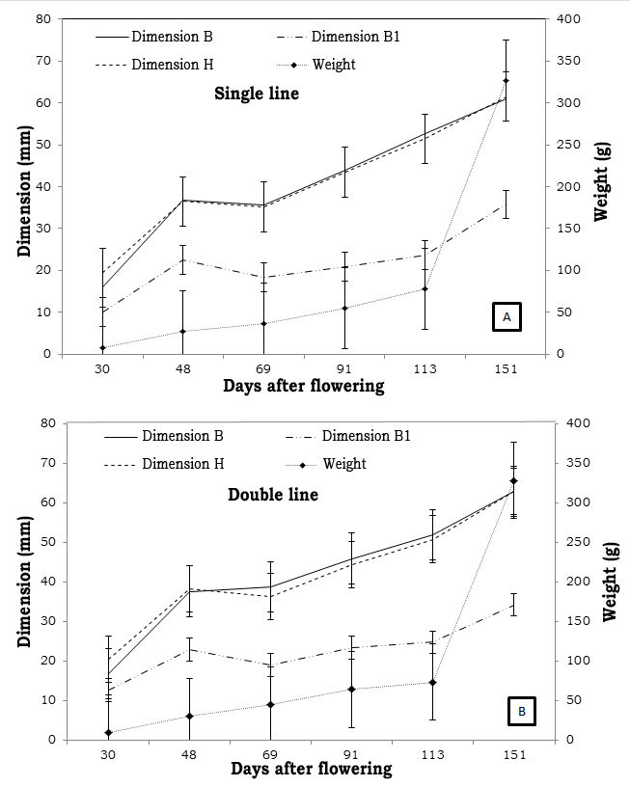
Titratable acidity (Figure 2B) was reduced as the fruit was developed, however in the day 50 there was a slight increase which was decreasing again after day 70, this is due to the transformation of organic acids into sugars.
Figure 1. Equatorial diameter dimensions B and B1, height H, and weight P during growth and development of pear fruits cv. Triunfo de Viena from floration to harvest under two drip irrigation systems. Single line system (A) and double line system (B). Bars indicate average ± SD.

Respiratory rate was high during initial fruit formation and development and it was dispersed among them; but to the extent of their growth, respiratory rate was reduced being more homogeneous among fruits of the same age (Figure 2C).

Physical properties of the fruit during harvesting
Pear variety Triunfo de Viena showed spherical shape with average diameter at harvesting time of 60.98 mm and 61.51 mm in LS treatment and 62.90 mm in the LD treatment, this is confirmed by the values close to 1 found for sphericity (0.83) and roundness (0.97)
(Mohsenin, 1986) (Table 1), with an average diameter of 62.2 mm.
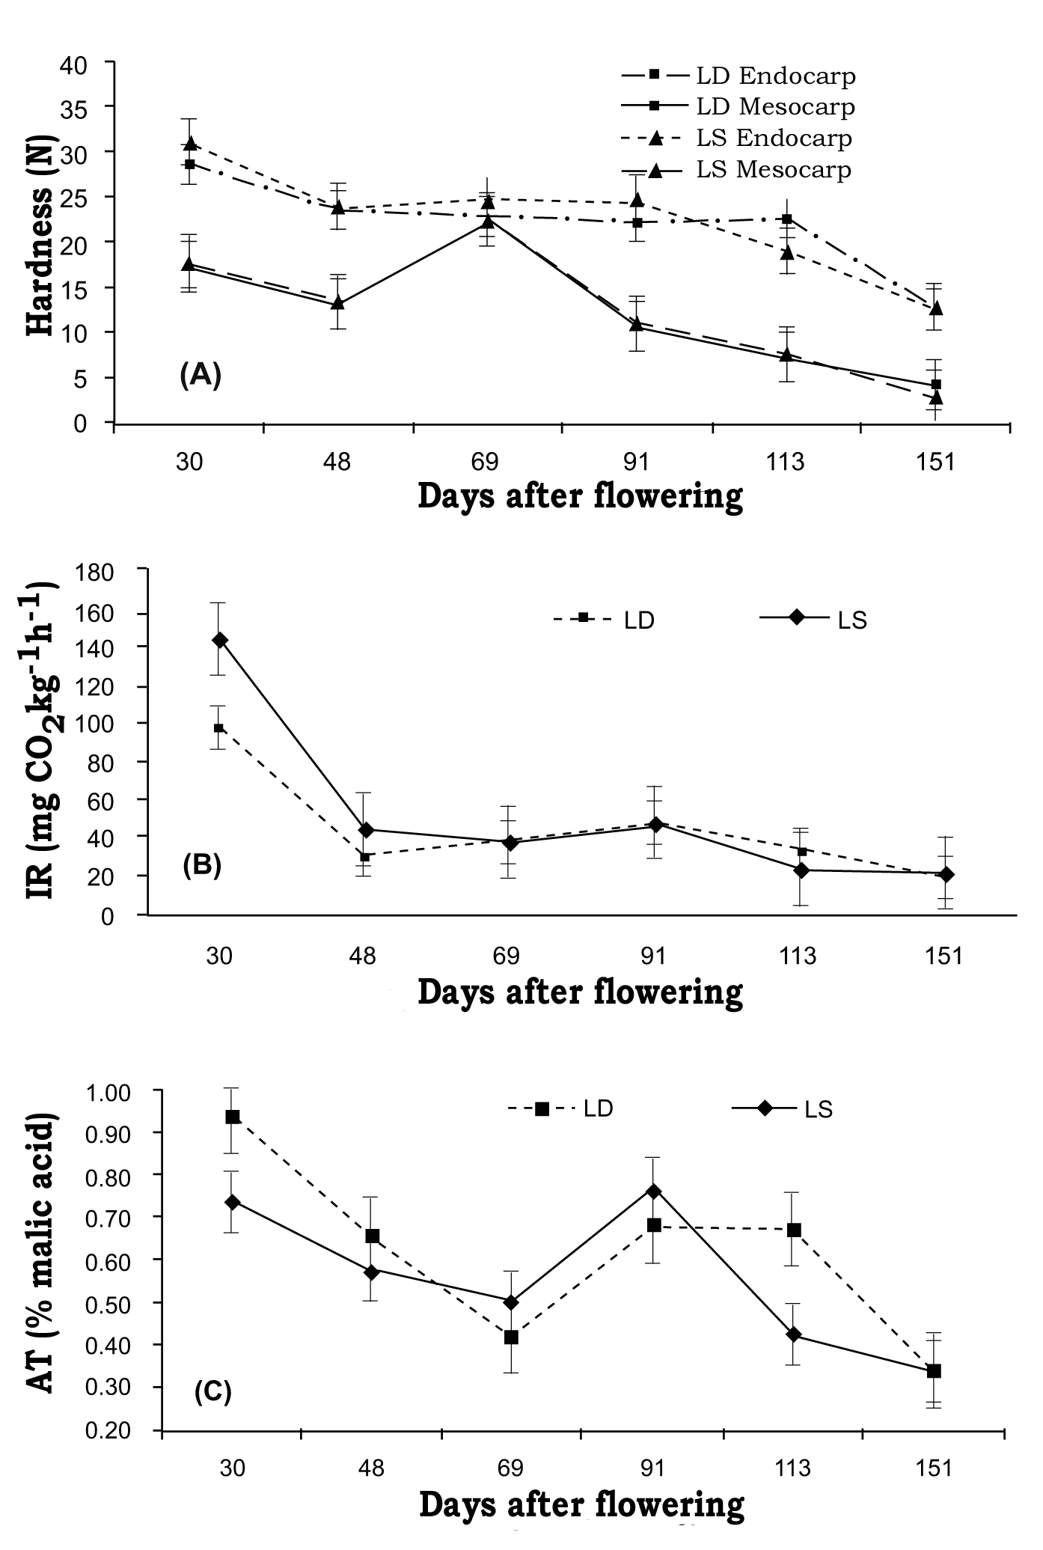
Weight at the harvesting time was the physical parameter with lowest dispersion percentage (CV= 1.28% for LS and 5.21% for LD), which indicates a high fruit size uniformity at harvesting time. Average bulk density was 1.29 t/m³ for LS and0 1.23 t/m³ for LD. Fruit superficial area was 207 cm² for LS treatment and 208 cm² for LD, this parameter showed a direct relation with fruit weight.
Figure 2. Behavior of endocarp and mesocarp hardness (A), respiratory rate (IR) (B) and titrable acidity (TA) (C) of pear cv. Triunfo de Viena under two drip irrigation systems. Bars indicate average ± SD.DS.

Volume of water irrigated
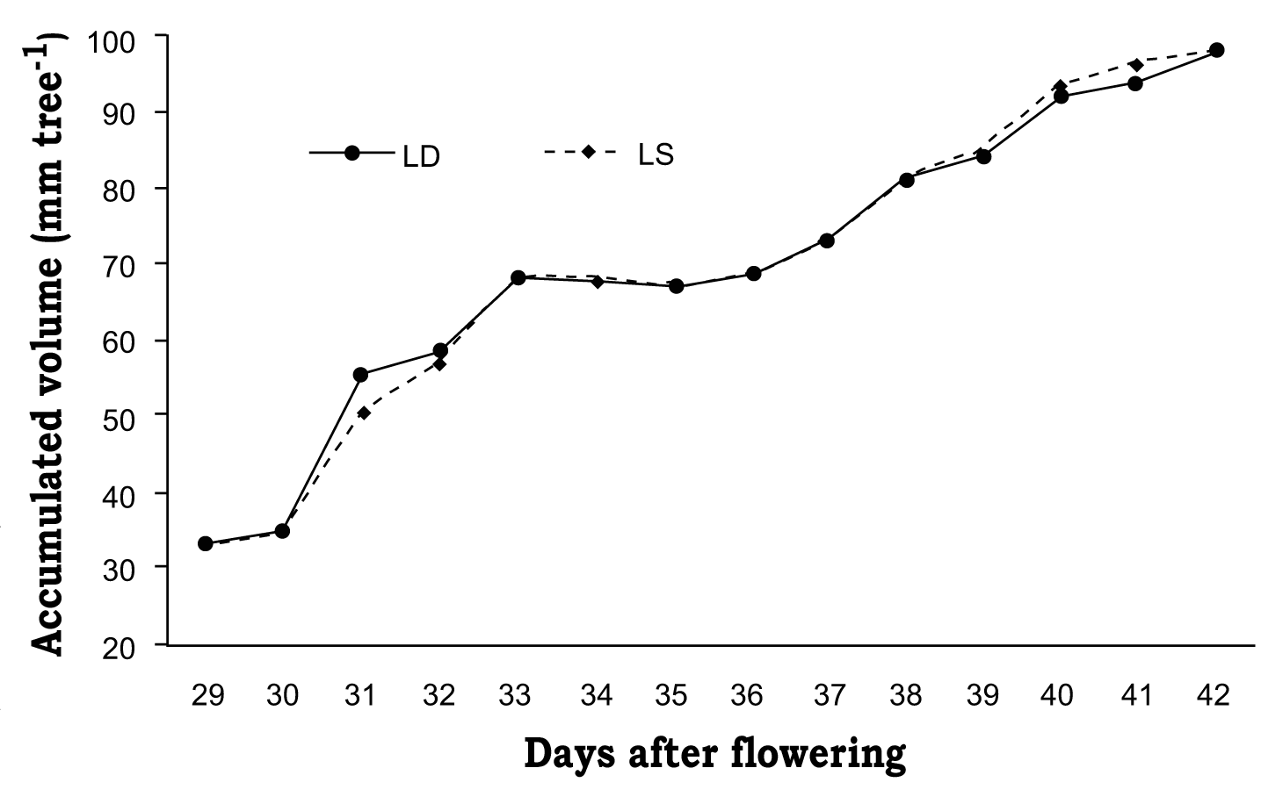
During the fruit development period, between August 2009 and March 2010, the total precipitation was 446.3 mm (Figure 3) which was 10% lower than the one registered the previous year mainly due to El Niño phenomenon. Maximum precipitation was in October with 107 mm and minimum in January with 1 mm. Average precipitation in the experi-mental period was 65.7 mm (Table 2).
Annual potential evapotranspiration (ET_{o}) in 2008 was 662.5 mm and in 2009 was 666.4 mm. The highest values were presented in June-August, with maxims of 1.96 and 2.01 mm/day in July 2008 and 2009, respectively. Water laminas applied by irrigation were 98.8 mm for the LS treatment and 98.9 mm for LD treatment. Average rela-tive humidity was 80% and average vapor pressure was 11.6 Mb. Maximum percenta-ges of shaded areas were in March 2010 with 37.98% for the LS treatment and 40.39% for LD treatment.
Table 1. Production and quality parameters of pear fruits cv. Triunfo de Viena under two drip irrigation systems. Single line system (LS) and double line system (LD).
Parameter | Treatments
Parameter | LS | (CV, %) | LD | (CV, %)
Production, kg/árbol | 38.5 | 34.0 | 37.5 | 39.5
Average fruit weight, g | 327 | 0.26 | 328 | 0.2
Fruit number/tree | 117 | 0.02 | 114 | 1.8
Acidity (% Malic acid) | 0.33 | 2.90 | 0.33 | 0
Endocarp hardness (N) | 12.6 | 0.64 | 12.7 | 0.6
Mesocarp hardness (N) | 4.14 | 0.20 | 4.13 | 0.3
Respiratory rate (mg CO₂/kg/h) | 18.6 | 0.94 | 18.8 | 0.8
Density (t/m³) | 1.074 | 2.70 | 1.048 | 1.7
Superficial area (cm²) | 207.5 | 0.20 | 207.9 | 0.2
Sphericity | 0.82 | 2.019 | 0.84 | 1.7
Roundness | 0.97 | 81.30 | 0.983 | 1
CV: Variation coefficient.

Figure 3. Volume of accumulated water, in mm, applied to each treatment in pear crops cv. Triunfo de Viena under two drip irrigation systems: Single line system and double line system.
Mean values of weather conditions showed that 2010 was drier than 2008 and 2009, showing higher ET_{o}, radiation and mean temperature and, lower precipitation and relative humidity in 2008. Although the weather conditions did not have a direct effect on the treatments, since the treatments were applied in days without rainfall it was possible to observe that the weather has an effect and direct relation on crop development.

Irrigation by using Watermark sensors
In the period of lower rainfall, between December 2009 and January 2010, variable water flows were applied in the LS and LD treatments in order to keep soil tension close to 18 and 22 cbar. This was possible thanks to the sensors that responded to humidity changes during the dry and wet cycles.
Table 2. Total precipitation per month (mm) in 2008, 2009 and 2010 (maximum number of days).
Month | Year
Month | 2008 |  | 2009 |  | 2010
Month | (mm) | days | (mm) | days | (mm) |  | days
January | 33.7 | 10 | 31.9 | 8 | 24.2 |  | 2
February | 55.5 | 7 | 22.4 | 8 | 34.7 |  | 1
March | 68.6 | 14 | 58 | 20 | 62.3 |  | 3
April | 120.9 | 15 | 59.1 | 15 | ― |  | ―
May | 156.6 | 20 | 92.2 | 16 | ― |  | ―
June | 124.9 | 25 | 61.2 | 23 | ― |  | ―
July | 125.6 | 28 | 132.5 | 28 | ― |  | ―
August | 92.2 | 20 | 84.9 | 26 | ― |  | ―
September | 81.1 | 21 | 51.8 | 16 | ― |  | ―
October | 94 | 17 | 94 | 13 | ― |  | ―
November | 67 | 23 | 67 | 9 | ― |  | ―
December | 35.2 | 12 | 35.2 | 3 | ― |  | ―

Table 3. Monthly average of potential evapotranspiration ET_{o}, relative humidity, radiation, temperature and total precipitation between 2008 and 2010 on a pear crop cv. Triunfo de Viena under two drip irrigation systems. Single line system (LS) and double line system (LD).
Parameter | Year
Parameter | 2008 | 2009 | 2010
ETo, mm/day | 1.84 | 1.851 | 1.853
Relative humidity, % | 77.2 | 80.1 | 75.0
Radiation, Cal/cm² | 283 | 284 | 286
Average temperature, °C | 12.4 | 13 | 13.1
Precipitation, mm/mes¹ | 87.9 | 65.9 | 40.4

Stem development
Accumulated development of stem diameter was not different (P > 0.05) between September 4, 2009 and March 13, 2010. In relation to the initial diameter, the average diameter growth of the stem had two contraction values that could be attributed to measurement variations. These values were 0.98% for the LS treatment and 6.08% for the LD treatment. These growth values are low for adult trees when compared to growth in young trees. Similar results were found by Vélez et al. (2007) in adult trees of Clementine with drip irrigation.

Fruit quality and production
In the harvesting period between January and March 2010 there were no differences between treatments in relation to the fruit production and quality by the effect of irrigation. Yield, size distribution and fruit quality in the LS treatment were not different (P > 0.05) in comparison to the LS treatment. However the wet area in the LD treatment was 53.3% while it was 34.1% for the LS treatment.

Conclusion
This study represents the first try to evaluate the behavior of a pear crop cv. Triunfo de Viena under two drip line irrigation vs. traditional irrigation of one drip line. In the experimental conditions, the results of fruit yield and quality after 1 year of evaluations did not show significant differences between drip irrigation systems; therefore, both systems allow similar fruit production and quality. From the economic point of view an irrigation system with one drip line is advantageous.

Acknowledgments
To the Agronomist Engineer Álvaro Castro, specialist in deciduous trees, for his advice in phytosanitary and fertilization management of the crop. To IDEAM for the meteorological information provided.

References
Allen, R. G.; Pereira, L. S.; Raes, D.; and Smith, M. 2006. Crop evapotranspiration guidelines for computing crop water requirements. Irrigation and drainage, Paper 56. FAO, Roma.
Cetin, O.; and Uygan, G. 2008. The effect of drip line spacing, irrigation regimes and planting geometries of tomato on yield, irrigation water use efficiency and net return. Agric. Water Manage. 95 (8): 49 - 958.
Dong, G. F.; Cheng, Z. Y.; Zhang, Z. H.; Wang, X. J.; Liu, X. R.; and Zhang, R. 2006. Effects of RDI on water use efficiency and quality of alfalfa. Trans. CSAE 22 (5):201 - 203.
FAO. 2003. Agricultura 21. Enfoques - Revista Gestión Moderna del Riego. Departamento de Agricultura. FAO, Roma.
FAO. 2010. Informe Programa Internacional para la Investigación y la Tecnología sobre Riego y Drenaje. FAO, Roma.
Fereres, E.; and Goldhamer, D. A. 2003. Suitability of stem diameter variations and water potential as indicators for irrigation scheduling of almond trees. J. Hortic. Sci. Biotechnol. 78(2):139 - 144.
Johnson, S. R.; Handley, D. F.; and DeJong, T. M. 1992. Long-term response of early maturing peach trees to postharvest water deficits. J. Am. Soc. Hort. Sci. 117(6):881 - 886.
Köppen, W. 1936. Das geographische system der climate. En: Köppen W, Geiger R (eds.). Handbuch der Klimatologie. GebrüderBorntraeger, Berlin. Vol. 1, part C. p.1 - 44
Lampinen, B. D.; Shackel, K. A.; Southwick, S. M.; Olsson, B.; and Yeager, J. T. 1995. Sensitivity of yield and fruit quality of French prune to water deprivation at different fruit growth stages. J. Am. Soc. Hort. Sci. 120 (2):139 - 147.
Marsal, J.; Rapoport, H. F.; Manrique, T.; and Girona, J. 2000. Pear fruit growth under regulated deficit irrigation in container-grown trees. Sci. Hort. 85 (4):243 - 259.
Mohsenin, N. N. 1986. Physical properties of plant and animal material. Gordon and Breach Science Publisher. Nueva York. 1:734 p.
Mwaniki, M. C.; Mathooko, F. M.; Matsuzaki, M.; Hiwasa, K.; Tateishi, A.; Ushijima, K.; Nakano, R.; Inaba, A.; and Kubo, Y. 2005. Expression characteristics of seven members of the b-galactosidase gene family in La France pear (Pyrus communis L.) fruit during growth and their regulation by 1-methycyclopropene during postharvest ripening. Postharvest Biol. Technol. 36(3):253 - 263.
Oster, J. D. 1994. Irrigation with poor quality water. Agric. Water Manage. 25(3):271 - 297.
Parra-Coronado, A.; Hernández-Hernández, J. E.; and Camacho-Tamayo, J. H. 2006a. Estudio de algunas propiedades físicas y fisiológicas precosecha de la pera Variedad Triunfo de Viena. Rev. Bras. Frutic. 28(1):55 - 59.
Parra-Coronado, A.; Hernández-Hernández, J. E.; y Camacho-Tamayo, J. H. 2006b. Comportamiento fisiológico de la pera variedad Triunfo de Viena (Pyrus communis L.) durante el período poscosecha. Rev. Bras. Frutic. 28(1):46 - 50.
PAWS 18.0. Chicago: SPSS. Inc; 2009
Seibert, E.; Barradas, C. I. N.; Araújo, P. J.; and Bender, R. N. 2000. Efeito de ethehon e da frigoconservação na maturação de pêras cv. Packham’s Triumph. Pesq. Agropec. Bras. 35(1):55 - 62.
Shi, W. J.; Hu, X. T.; and Kang, S. Z. 1998. The status and prospect of RDI technique in water stress conditions. Agric. Res. Arid Areas 16(2):84 - 88.
Singh, H. P.; Kaushish, S. P.; and Kumar, A. 2000. Micro-irrigation. En: Proceedings of the International Conference on Micro and Sprikler Irrigation Systems, Central Board of Irrigation and Power, New Delhi, February 8-10. 794 p.
Vélez, J. E.; Intrigliolo, D.; and Castel, J. R. 2007. Programación del riego en cítricos con base en sensores de medida del estado hídrico del suelo y de la planta. Ingeniería del Agua 14(2):127 - 135.
Verreynne, J. S.; Rabe, E.; and Theron, K. I. 2001. The effect of combined deficit irrigation and summer trunk girdling on the internal fruit quality of ‘Marisol’ Clementines. Sci. Hort. 91(1-2):25-37.

