**Genetic variability of *Moniliophthora perniciosa* (Stahel) Aime & Phillips-Mora, comb. nov. (**[**Agaricales**](http://74.125.67.132/translate_c?hl=es&sl=en&u=http://en.wikipedia.org/wiki/Agaricales&prev=/search%3Fq%3Dtaxonomia%2Bde%2Bmoniliophthora%2Bperniciosa%26hl%3Des%26safe%3Doff%26sa%3DX&usg=ALkJrhgMn2kPO-k-QSeIJLZuzHhXyzzavg) **– Marasmiaceae) in**

**varieties of cocoa (*Theobroma cacao* L.)**

**Variabilidad genética de *Moniliophthora perniciosa* (Stahel) Aime y Phillips-Mora, comb. nov. (**[**Agaricales**](http://74.125.67.132/translate_c?hl=es&sl=en&u=http://en.wikipedia.org/wiki/Agaricales&prev=/search%3Fq%3Dtaxonomia%2Bde%2Bmoniliophthora%2Bperniciosa%26hl%3Des%26safe%3Doff%26sa%3DX&usg=ALkJrhgMn2kPO-k-QSeIJLZuzHhXyzzavg) **- Marasmiaceae) en variedades de cacao**

**(*Theobroma cacao* L.)**

*Carolina Osorio-Solano1, Carlos Alberto Orozco-Castaño1, Germán Ariel López-Gartner2,*and

*Fredy Arvey Rivera-Páez2\**

1 Biologist, Faculty of Exact and Natural Sciences, Universidad de Caldas, Manizales (Caldas, Colombia).

2 Professors Research Group on Genetics, Biodiversity and Plant Breeding, GEBIOME. Department of Biological Sciences, Faculty of Exact and Natural Sciences, Universidad de Caldas, Manizales (Caldas, Colombia).

*Corresponding author: [fredy.rivera@ucaldas.edu.co](mailto:fredy.rivera@ucaldas.edu.co)

Rec.: 07.07.11 Acept.: 30.05.12

**Abstract**

*Moniliophthora perniciosa,* isthe causal agent of the ‘witch’s broom’ on cocoa (*Theobroma* *cacao* L.) one of the most important diseases in cocoa plantations, causing economic losses close to 70% worldwide and 40% nationwide. It shows a high genetic variability and discrepancies in its taxonomy. Characterization of the genetic diversity of biotypes is important for projects aimed towards the handling of this pathogen and the development of resistant cocoa materials. Twelve isolations of the fungus from different cocoa material were analyzed in this study. Each sample was evaluated with molecular markers directed towards a nuclear ribosomal DNA (rDNA) region known as ITS (Internal Transcribed Spacer), an intergenic region (IGS-1), and five simple sequence repeats (SSR). The IGS-1 allowed the determination of biotype C, however, an evident genetic variability was found within this biotype that has not been reported yet. The genetic diversity analysis of *M. perniciosa* by microsatellite markers gave a total value of 0.4260, a total heterozygosity of 0.6143, and a polymorphism information content (PIC) of 0.3407; these values are considered to be within a medium to high range for the studied isolations, and are an estimation of the genetic variability present in *M. perniciosa*.

**Key words:** Biotype, cocoa, Colombia, fungi, molecular markers, *Moniliophthora perniciosa*, pathogen, *Theobroma cacao*.

**Resumen**

*Moniliophthora perniciosa*,agente causante de la ‘escoba de bruja’ en cacao (*Theobroma* *cacao*), presenta una elevada variabilidad genética y discrepancias en su taxonomía y es una de las enfermedades más importantes en plantaciones cacaoteras que ocasiona pérdidas económicas a nivel mundial cercanas a 70%, y de 40% a nivel nacional. La caracterización de la diversidad genética de los biotipos es importante para la ejecución de proyectos encaminados al manejo de este patógenoy el desarrollo de materiales resistentes de cacao. En este estudio se analizaron 12 aislamientos del hongoobtenidos de diferentes materiales de cacao. Cada una de las muestras se evaluó con marcadores moleculares que tienen como blanco una región del ADN ribosomal (ADNr) nuclear conocida como ITS (Internal Transcribed Spacer), una región intergénica (IGS-1) y cinco secuencias simples repetidas (SSR). El marcador IGS-1 permitió la determinación del biotipo C, no obstante se encontró una variabilidad genética evidente dentro de este biotipo, aún no registrada. El análisis de la diversidad genética de *M. perniciosa* por medio de marcadores microsatélite arrojó un valor total de 0.4260, una heterocigosidad total de 0.6143 y un índice de información polimórfica (PIC) de 0.3407, valores considerados de rango medio a alto para los aislamientos estudiados y que estiman la variabilidad genética presente en *M. perniciosa.*

**Palabras clave:** Biotipos, cacao, Colombia, hongos, marcadores moleculares, *Moniliophthora perniciosa*, patógeno, *Theobroma cacao*.

**Introduction**

Worldwide cocoa (*Theobroma cacao* L.)pro­duction is concentrated in Africa and Tropical America; Ivory Coast is the first producer with 39% of the international market, while Co­lombia with 1% of this market is not an im­portant contributor and holds place number eight. Cocoa production in Colombia is con­centrated in Huila, Tolima, Antioquia, Atlantic Coast, Meta and the coffee growing area that sums 90,000 cultivated hectares in 24,500 farms with an average yield of 450 kg of cocoa beans/hectare. Cacao production has clearly identified problems: farms phytosanitary state, lack of proper technology, poor training of human resources and genetic variability erosion in the farms, which has been an important factor in the producers loss of interest in this crop (MADR, 2004).

Cocoa plants have two major pathogens with high incidence: *Moniliophthora perniciosa* (Stahel) Aime & Phillips-Mora, comb. nov. (Aime and Phillips-Mora, 2005) and *M. roreri* (Cif. and Par.) Evans *et al.*, causal agents of the ‘witch’s broom´ and Moniliasis (frosty pod rot), respectively. These pathogens produce the highest losses on fruit production, close to 70% at world level and 40% at national level (Griffith *et al.*, 2003). The causal agent of witch’s broom was classified initially by Stahel in 1915 as *Marasmius perniciosa*; later, it was reclassified in the genus *Crinipellis* by Singer (1942) and afterwards, in 2005, Aime and Phillips-Mora denoted it as [*Moniliophthora perniciosa*](http://www.speciesfungorum.org/Names/SynSpecies.asp?RecordID=500896). This pathogen has been detected infecting *T. cacao* buds, inflorescences and fruits; it is endemic to other species of *Theo­broma* and *Herrania* genera and to Solana­ceae, Bignoniaceae and Malpighiaceae fami­lies (Resende *et al.*, 2000).

According to the plant host the fungus biotypes have been identified: **C** is present in cocoa plantains and in some Malvaceae plants, **S** infects Solanaceae plants, **L** spe­cially infects *Arrabidaea verrucosa* lianas from the Bignoniaceae family, and **B** infects *Bixa Orellana* (Evans, 1978; Bastos and Ande­brhan, 1986; Griffith and Hedger, 1994).

At the molecular level, ribosomal DNA studies in numerous Basidiomycota have shown that internal transcribed spacers (ITS) had a variation that can be used as taxonomi­cal marker to discriminate among species (Vilgalys and Gonzalez, 1990; White *et al.*, 1990; Miller *et al.*, 1999; Chen *et al.*, 2000). In the same way, intergenic spacers (IGS) have been used as a tool to separate biotypes (Arruda and Marisa, 2003) and the use of mi­crosatellites (SSR) has supported genetic variability studies in *M. perniciosa* biotypes (Gramacho *et al.*,2007). Taking into account the lack of knowledge on *M. perniciosa* in Co­lombia, this work evaluates the genetic varia­bility of this fungus by means of molecular markers in order to strength the taxonomic knowledge of this pathogen. Since it is a seri­ous phytosanitary problem, this pathogen needs studies associated to understand its epidemiology and management mechanisms to plan strategies for reducing its negative impact on cacao plantations in Colombia.

**Materials and methods**

Samples used in this study were basidiocarps presented in stems for *M. perniciosa* and in fruits for *M. roreri*, coming from *T. cacao* (IMC 67, TCA644, EET 8, ICS 95, CAP 34, CCN 51, Escabino, ICS 60, ICS 1, ICS 39, TSH 565 and Luker 40 for *M. perniciosa*;and Escabino and EET 8 for *M. roreri*) collected in the Casa Luker S.A. farm (Palestina, Caldas, Colombia) located at 5º 05’ N and 75º 40’ O, at 1010 MASL. Conditions to get monosporic cultures by spore unloading were evaluated. Basidio­carps samples with different developmental stages were taken from the field to the lab; if some of the brushes had early basidiocarps they were kept on a humid chamber, if they were optimal basidiocarps they were placed on plastic bags and kept at -4 °C.

Once the basidiocarps were out of the hu­mid chambers and fridge, they were kept at room temperature for 30 min in order to avoid frozen basidia when the spores discharge happened. The effectiveness of the DNA ex­traction methods for PCR amplification was evaluated as well (Orozco *et al.*, 2011).

DNA extraction from a monosporic culture of *M. perniciosa* corresponded to 0.5 cm of fungi mycelia that was grinded with 200 µl of lysis buffer (EDTA 0.5 M, NaCl 5 M, SDS 10 mM), heated for 5 min in 96 °C water bath, plus extraction with phenol-chloroform-iso­amyl alcohol and precipitation with ethanol and sodium acetate (Goodwin and Lee, 1993; Orozco *et al.*, 2011). Direct DNA extraction from *M. perniciosa* and *M. roreri* fruiting bo­dies was done using 0.5 cm cuts of basidio­carps previously disinfected with 3% sodium hypochlorite for 1 min and distilled water for 5 min, grinded with 200 μl lysis buffer (EDTA 0.5 M, NaCl 5 M, SDS 10 mM), heated for 1 hour at 56 °C, extracted with phenol-chloro­form-isoamyl alcohol (adding 0.3 g of glass beads at the beginning of extraction) and pre­cipitated with ethanol and sodium acetate. DNA was resuspended in 30 μl of Tris-EDTA pH: 8.0 (Tris HCl 10 mM, EDTA 0.1M) and stored at 4 °C according to NIH (2005) and Orozco *et al.* (2011). DNA quantity and qua­lity were determined by comparison with known concentrations in 1% agarose gels.

|  |  |  |  |
| --- | --- | --- | --- |
| **Table 1.** Molecular markers used to evaluate genetic diversity of *Moniliophthora perniciosa* in cacao. | | | |
| **Primer** | **Marker type** | **Primer sequence 5’ – 3’** | **Source** |
| ITS1  ITS4 | ITS | TCC GTA GGT GAA CCT GCG G  TCC TCC GCT TAT TGA TAT GC | Sartorato *et al.*, 2006;  White *et al.*, 1990 |
| O-1  CNL 12 | IGS | AGTCCTATGGCCGTGGAT  CTGAACGCCTCTAA GTCAG | Mwenje *et al.*, 2006;  Hsiang and Mahuku, 1999 |
| Mscepec_Cp15 | SSR | F:AAAGGGAGGAAGCGAAGTCT  R: TGTCGAGCACTAGCATGTGA |  |
| Mscepec_Cp23 | SSR | F: ACCTCCTCATATGGCGTCAC  R: GCGGTTGGTGACTCTTGATT |  |
| Mscepec_Cp45 | SSR | F: ATGACCAGACAAATGAAAC  R: CAAAGAGAAATCACAGAGC | Gramacho *et al.*, 2007 |
| Mscepec_Cp47 | SSR | F: CAACATCAATCCCACGAC  R: GAAGGCTGCGGAAGTAA |  |
| mMpCena19 | SSR | F: AACAAGGACAGGCACAAC  R: GTATCAATGTAGGGGAGGA | Silva *et al.*, 2007 |

Primers used in this study (Table 1) distinguish *M. perniciosa* and *M. roreri* by the amplification of rDNA repeating sequences containing partial sequences of the spacers ITS1, ITS2 and 5.8S gene; primers were pro­posed by White *et al.* (1990) and Sartorato *et al.* (2006). Biotype differentiation was achieved by the amplification of rDNA repea­ting sequences corresponding to the inter­genic spacer (IGS-1) and the partial regions of 5S and 28S genes, using the primers propo­sed by Hsiang and Mahuku (1999) and Mwenje *et al.* (2006). Genetic variability within biotypes was evaluated with microsa­tellite markers (SSR) proposed by Gramacho *et al.* (2007) and Silva *et al.* (2007).

PCR reactions were done on a final volume of 20 μl containing DNA 100 – 200 ng, dNTPs 200 – 800 μM, Taq polymerase (Invitrogen®) 1.0 - 2.0 units, MgCl2 0.75 - 1.5 mM, 0.2 – 2 μM each primer and 2 μl buffer 10X (Invitro­gen®). PCR program had an initial denatura­tion at 95 °C for 5 min, followed by 35 cycles of denaturation at 95 °C for 1 min, annealing at 55 °C for 1 min, extension at 72 °C for 1 min and final elongation at 72 °C for 1 minu­te. Amplifications were done on a BioRad PTC-200 thermocycler using for their lecture 1 Kb molecular weight marker.

Amplification products were separated on 4% acrylamide denaturing gels and C.B.S. Scientific Corp. sequencing chambers, revea­led with silver nitrate (Sanguinetti *et al.*, 1994) and analyzed by pictures on Corel Photo Paint, 2006 (v. 11,633) software. Se­quences were analyzed based on the genetic distance and using the NJ clustering algo­rithm (Sneath and Sokal, 1973), to generate the similarity matrix with Nei indexes (1983). Variables analyzed were: allelic, phenotypic and distance frequencies; genetic diversity; heterozygosity and PIC (Polymorphic Infor­mation Content) using Power Marker v. 3,25 software (Liu and Muse, 2005).

**Results**

PCR amplification of the partial sequences of spacers ITS1, ITS2 and 5.8S gene of rDNA using primers, confirmed the presence of two isolates for *M. roreri*, with a molecular weight of 710 bp and, 12 isolates for *M. perniciosa* with 750 bp. Amplifications were reproduci­ble and sensitive, which was tested by doing PCR amplifications with serial DNA dilution till 1/400.

Molecular characterization of the biotypes with primers CNL12 and O-1 showed 950 bp amplicons in nine isolates, which can corres­pond to the biotype C (Picture 1). Three iso­lates had diverse sizes from which two had an amplicon close to 900 bp, and the other was close to 980 bp. These isolates have not been reported in literature.

Genetic diversity of *M. perniciosa* evalua­ted with microsatellites Mscepec_Cp15; Mscepec_Cp23; Mscepec_Cp45; Mscepec_Cp47 and mMpCena 19 (Picture 2) presented a good reproducibility, the Mscepec_Cp15 primer was the most polymor­phic with four alleles and molecular weights between 170 to 200 bp; the mMpCena 19 primer behaved like monomorphic with one allele of 195 bp.

The total genetic diversity analyzed by mi­crosatellites was 0.4260, total heterozygosity was 0.6143 and polymorphic information in­dex or PIC was 0.3407, having as most in­formative and polymorphic marker the Mscepec_Cp15.

**Discussion**

PCR amplification of partial regions of spacers ITS1, ITS2 and 5.8S gene allowed the diffe­rentiation of *M. perniciosa* and *M. roreri*, these results are similar to the ones found by Arru­da *et al.* (2003) who highlight this molecular marker for differentiation of Basidiomycetes specie. In the same way, there were no limi­tations for DNA extraction from fruiting bo­dies or cultures, therefore fruiting bodies can be used as direct DNA source for fast diagno­sis of the real phytosanitary state of the crop, as is cited by Orozco *et al.* (2011).

Results obtained with the amplification of the intergenic spacer (IGS-1) and partial re­gions of 28S and 5S genes to identify bio­types, allowed the visualization of nine iso­lates of 950 bp molecular weight, which is corresponding to the studies of Arruda *et al.* (2003). These studies showed a 950 bp am­plicon in *M. perniciosa* isolates from *Theo­broma cacao* (biotype C) and from *Solanun lycocarpum* (biotype S), and an amplicon of 1200 bp from the biotype L corresponding to *Heteropterys acutifolia*. However, two isolates showed an amplicon close to 900 bp and a third isolate showed one of 980 bp; these could be considered as well as biotype C when taking into account the studies of Arruda *et al.* (2003), which registered genetic variability within biotype C and state that it depends on the host and the geographic origin.

Results obtained in the present research are another proof of the intergenic region (IGS) variability as it was registered by Du­chesne and Anderson (1990) when discrimi­nating populations of plant pathogen fungi; thus, in this study was found intraspecific variability for *M. perniciosa* isolates, including samples that were restricted to only one geo­graphical origin. Arruda *et al.* (2003) found variability within IGS regions in terms of mo­lecular weight and polymorphisms presence in restriction sites, which were referable to different arrangements of the tandem repeti­tions or to insertions or deletions. In the other hand, it should be taken into account that in some geographical regions is thought that *M. perniciosa* has coevolved with its *Theobroma cacao* hosts (Purdy and Schmidt, 1996; Evans *et al.*,2002).

Arruda and Marisa(2003) analyzed 120 isolates of *M. perniciosa* (*T. cacao*, *H. acutifolia* and *S. lycocarpum*) coming from the regions of Bahía, Minas, Distrito Federal and the Ama­zon region (Brazil) and found genetic varia­tions according to the host origin. These re­sults are concordant to the ones of Arruda *et al.* (2003) who evaluated molecularly by ERIC PCR 50 isolates of *M. perniciosa* coming from de *T. cacao*, *H. acutifoliae* and *S. lycocarpum* and found clusters of isolates according to the fungi infection host. Additionally, they found a considerable intraspecific variation within the isolates coming from *T. cacao*, and corre­lation between the *M. perniciosa* geographic origin with the group polymorphism. Rin­cones *et al.* (2006) give a general vision of the genetic diversity between *M. perniciosa* bio­types and, their results are used to under­stand how variability affects host-pathogen interactions and disease development; addi- tionally, sequence analysis in that study demonstrated that this pathogen has different transposon families that significantly contri­bute to the diversity found.

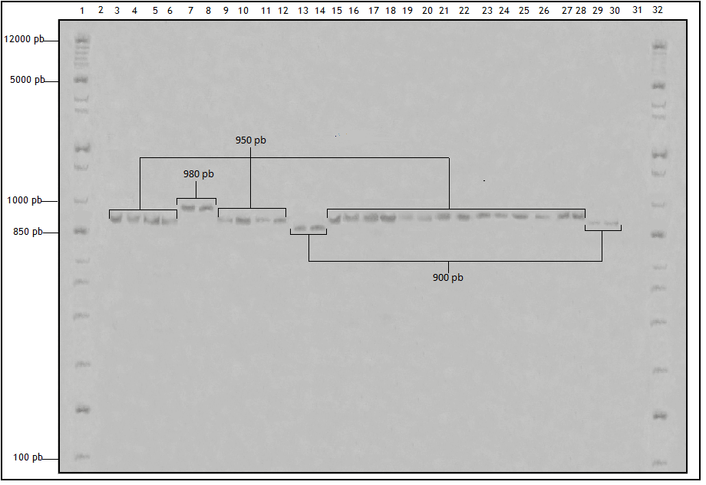

**Picture 1.** Amplification of intergenic spacer (IGS-1) and partial regions of 28S and 5S genes, with primers O-1 and CNL 12. 4% polyacrylamide gel dyed with silver nitrate. . 1. Molecular weight marker (1Kbp), 2. Reaction control, 3 and 4. Monosporic culture of *M. p.* (EET8), 5 and 6. Monosporic culture of *M. perniciosa* (Escabino), 7 and 8. *M. p.* (IMC 67), 9-10. *M. p*. (TCA 644), 11-12. *M. p*. (EET8), 13-14. *M. p*. (ICS95), 15-16. *M. p*. (CAP34), *M. p*. 17-18. *M. p*. (CCN51), *M. p*. (Escabino), 19-20. *M. p*. (Escabino), 21-22. *M. p*. (ICS60), 23-24. *M. p*. (ICS1), 25-26. *M. p*. (ICS39), 27-28. *M. p*. (TSH565), 29-30. *M. p*. (Luker 40), 31. Negative control, 32. Molecular weight marker (1Kbp).

* *M. p*. (*Moniliophthora perniciosa).*

Bartley (1986) affirms that biotype C broke the resistance of cacao materials after few generations; the genetic variability of this biotype was observed at the chromosomal level 15 years after its introduction to Bahía (Brazil). Rincones *et al.* (2003) observed multiple copies of transposons in *M. perni­ciosa* biotype C genome and, proposed that these chromosomal arrangements could be the cause of ectopic recombination causing the activation of transposons, which make the fungi able to break the natural or induced resistance in these cacao materials. This variation on the IGS region of *M. perniciosa* isolates is an indicative of intraspecific diffe­rentiation, not only for the ribosomal genetic composition but also for the chromosomal variation. Kistler and Miao (1992) and Zolan (1995) studied plant pathogen fungi, especially *M. perniciosa,* and demonstrated that these fungi have long chromosomes making them very polymorphic and easy to observe in the sexual and asexual phases, and in the mitotic and meiotic processes of the specie (Griffith and Hedger, 1994).

**Picture 2.** PCR SSR (Simple Sequence Repeats) products. Lane 1: molecular weight marker (1 Kb); Lane 2: negative control; Lane 3 and 4 *M. perniciosa* host EET8 and Escabino, from monosporic culture; Lane 5 - 17 *M. perniciosa* hosts (IMC 67, TCA 644, EET 8, ICS 95, CAP 34, CCN 51, Escabino, ICS 60, ICS 1, ICS 39, TSH 565, Luker40, respectively) coming from direct DNA extraction.

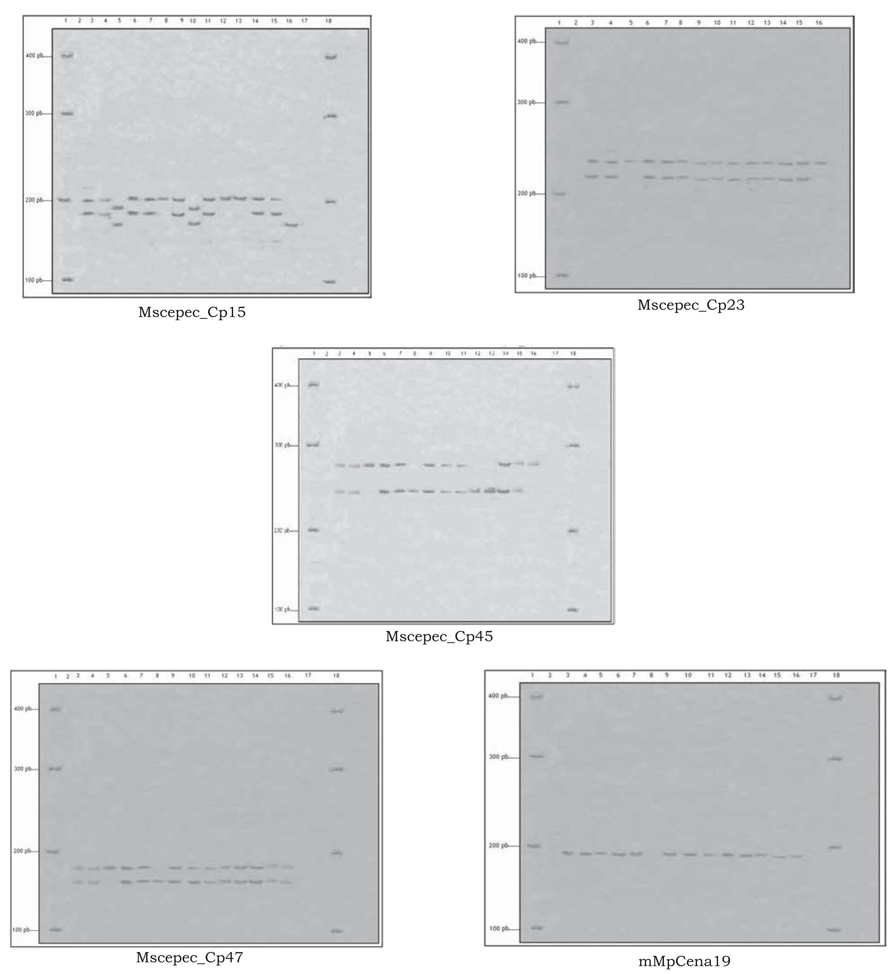

The genetic diversity detected by the mi­crosatellites markers was limited by the low number of primers used in this study, and by the restricted number of samples analyzed, however, results reveal a high heterozygosity rate and good polymorphic information index for some primers. Three of the primers used in this study were trinucleotides [mMpCena 19 - (AAC) 18, Mscepec_Cp47- (CGT)8 and Mscepec_Cp15- (GAT)7(GAA)6], recommended characteristics for microsatellites as stated by Gramacho *et al.* (2007). They achieved the amplification of 12 polymorphic loci and re­commend the use of trinucleotide microsate­llites over tetra and dinucleotide ones, more­over, they recommend them for the analysis of natural population of *M. perniciosa* and in studies with highly related species.

The low number of isolates analyzed in this study indicate the existence of good re­sources of genetic diversity for the plantations in Casa Luker farm, which is in agreement with reports of Lana (2004) who used RAPS markers in 37 isolates of *M. perniciosa* from Piracicaba, São Paulo, Brazil, and found eight different clusters on a grouping study, su­pporting the hypothesis that genetically diffe­rent isolates can occupy the same host plant. The low allelic diversity found by Gramacho *et al.* (2007) reinforced a homothallism strategy, in which the *M. perniciosa* hyphae can auto­fecundate and produce new sexual structures from one genetic strain without intercrossing between individuals of the same species.

Gramacho *et al.* (2007) indicate that micro­satellite markers for *M. perniciosa* are diverse in the genome, but have low variability compared to other fungi. An allele number of 2 to 7 in each locus is considered low when taking into account that the samples analyzed came from different geographic origins and hosts. However, the authors recommend the use of the primers of this study as useful tools to investigate genetic structures of *M. perniciosa* and *M. roreri* populations, consi­dering that the most polymorphic primer was Mscepec_Cp15- (GAT)7(GAA)6. This is in agreement with the study of Silva *et al.* (2007) which found 9 polymorphic loci with an ave­rage of 2.9 alleles per loci on a study of *M. perniciosa* diversity with 30 microsatellites markers. Thus, although the polymorphism level is low, primers allow diversity evaluation of this pathogen and the establishment of genetic profiles to help cacao breeding efforts looking for resistant materials.

This low genetic differentiation could be attributed to topographical barriers, monoclo­nal crops, genetic barriers followed by fungal colonization events, low genetic flux in the *M. perniciosa* populations, homothallism mecha­nisms in the biotype C and in special, to the asexual and sexual cycles of the species. This genetic variability is low because the basi­diospore is haploid and it is the main struc­ture to start the fungal life cycle, in this case *M. perniciosa* (Purdy and Schmidt, 1996).

**Conclusion**

Biotype C of *M. perniciosa* was the only one found on the cacao plantation in Casa Luker farm; however, the genetic diversity within the biotype was evident, but it has not been registered yet.

**Acknowledgements**

The authors express their gratitude to: the Vicerectory of Research and Postgraduate of the Universidad de Caldas for financing this project; to Casa Luker S.A. to facilitate access to the material of study; Luis Eduardo Zu­luaga for his advice in the field work and Ma­ría José Botero for his advice in the lab studies.

**References**

Aime, M. C. and Phillips-Mora, W. 2005. The causal agents of witches’ broom and frosty pod rot of cacao (chocolate, *Theobroma cacao*) form a new lineage of Marasmiaceae. Mycol. 97(5):1012 - 1022.

Arruda, M. and Marisa, A. 2003. Nuclear and mitochondrial rDNA variability in *Crinipellis perniciosa* from different geographic origins and hosts. Mycol. Res. 107:25 - 37.

Arruda, M. C.; Miller, R. N.; Ferreira, M.; and Felipe, M. 2003. Comparison of *Crinipellis perniciosa* isolates from Brazil by ERIC repetitive element sequence based PCR genomic fingerprinting. Plant Pathol. 52(2):236 - 244.

Bartley, B. G. D. 1986. *Theobroma cacao*. En: Breeding for durable resistance in perennial crops. FAO (Food and Agriculture Organization of the United Nations). Roma: p. 25 - 42.

Bastos, C. N. and Andebrhan, T. 1986. Urucu (*Bixa orellana*): nova espécie hospedeira da vasoura-de-bruxa (*Crinipellis perniciosa*) do cacaueiro. Fitopat. Brasil. 11(4):963 - 965.

Chen, W.; Grau, R.; Adee, E.; and Meng, X. 2000. A molecular marker identifying subspecific populations of the soybean brown stem rot pathogen*, Phialophora gregata*. Ecol. Popul. Biol. 90:875 - 883.

Corel Corporation. 2006. Corel Photo Paint (versión 11,633) [Corel DRAW Graphics Suite](http://es.wikipedia.org/wiki/Corel_Graphics_Suite).

Duchesne, L. C. and Anderson, J. B. 1990. Location and direction of transcription of the 5S rRNA gene in *Armillaria*. Mycol. Res. 94:266 - 269.

Evans, H. C. 1978. Witches broom disease of cocoa (*Crinipellis perniciosa*). Ann. Appl. Biol. 89:185 - 92.

Evans, H. C.; Holmes, K. A.; Phillips, W.; and Wilkinson, M. J. 2002. What is in a name: *Crinipellis*, the final resting place for the frosty pod rot pathogen of cacao. Mycol. 16(4):148 - 152.

Goodwin, D. C. and Lee, S. B. 1993. Microwave miniprep of total genomic DNA from fungi, plants, protists, and animals for PCR. Biotech. 15:438 - 444.

Gramacho, K. P.; Risterucci, A. M.; Lanaud, C.; Lima, L. S. and Lopes, U. V. 2007. Characterization of microsatellites in the fungal plant pathogen *Crinipellis perniciosa*. Mol. Ecol. Notes 7:153 - 155.

Griffith, G. W. and Hedger, J. N. 1994. The breeding biology of biotypes of the witches’ broom pathogen of cocoa, *Crinipellis perniciosa*. Heredity 72:278 - 289.

Griffith, G. W.; Nicholson, J.; Nenninger, A.; Birch, N. R.; and Hedger, N. 2003. Witches brooms and frosty pods: two major pathogens of cacao. Nueva Zelandia. J. Botany 41(3):423 - 435.

Hsiang, G. and Mahuku, S. 1999. Genetic variation within and between southern Ontario populations of *Sclerotinia homoeocarpa*. Plant Pathol.48:83 - 94.

Kistler, H. C. and Miao, V. P. 1992. New modes of genetic change in filamentous fungi. Ann. Rev. Phytopath. 30:131 - 152.

Lana, T. G. 2004. Caracterização genética e fisiológica de *Crinipellis perniciosa*. Tese Doutorado em Fitopatologia – Escola Superior de Agricultura, Luiz de Queiroz. Universidade de São Paulo, Piracicaba. São Paulo Brasil. p. 91.

Liu, K. and Muse, S. V. 2005. Power Marker: A integrated analysis environment for genetic marker data. Bioinformatics 21(9):2128 - 2129.

MADR (Ministerio de Agricultura y Desarrollo Rural). 2004. Programa para el Desarrollo de la Amazonia. En: Proamazonia. Manual del Cultivo del Cacao. p. 132 - 139.

Miller, R.; Soares, A.; and Lopes, C. 1999. Molecular comparation of *Fusarium eumartii* populations causing wilt and dry rot of potato in Brazil. Fitopatol. Brasil. 24:149 - 155.

Mwenje, E.; Wingfield, B. D.; Coetzee, M. P.; Nemato, H.; and Wingfield, M. J. 2006. *Armillaria* species on tea in Kenya identified using isozyme and DNA sequence comparisons. Plant Pathol. 55:343 - 350.

Nei, M. L.. 1983. Mathematical model for studying genetic variation. Proceedings of the National Academy of Sciences 76:5269 - 5273.

NIH (National Institute of Health). 2005. DNA preparation from blood. Maryland, US. (Disponible en: http://www.riedlab.nci.nih.gov/publications/DNA%20Prep_Blood%20.pdf/12-01-2009 [Fecha de revisión: septiembre 14 de 2008].

Orozco, C. A.; Osorio, S. C.; Botero, M. J.; Rivera, P. F.; and López, G. G. 2011. Evaluación microbiológica y molecular de *Moniliophthora perniciosa.* Universidad de Caldas. Bol. Cient. 15(1).

Purdy, L. H. and Schmidt, R. A. 1996. Status of cacao witches’ broom: biology, epidemiology, and management. Phytopathol. 34:573 - 594.

Resende, M. L.; Gutemberg, B. A.; Silva, L. H.; Niella, G. R.; Carvalho, G. A.; Santiago, D. V.; and Bezerra, J. L. 2000. *Crinipellis perniciosa* proveniente de um novo hospedeiro *Heteropterys acutifolia* é patogênico ao cacaueiro. Fitopatol. Brasil. 25(10):88 - 91.

Rincones, J.; Mazotti, G. D.; and Griffith, G. W. 2006. Genetic variability and chromosome-length polymorphisms of the witches’ broom pathogen *Crinipellis perniciosa* from various plant hosts in South America. Mycol. Res. 110:821 - 832.

Rincones, J.; Meinhardt, L. W.; Vidal, B. C.; and Pereira, G. A. G. 2003. Electrophoretic karyotype analysis of *Crinipellis perniciosa*, the causal agent of witches’ broom disease of *Theobroma cacao*. Mycol. Res.107(4):452 - 458.

Sanguinetti, C. J.; Dias, N.; and Simpson, A. J. 1994. Rapid silver staning and recovery of PCR products separate on polycrylamide gels. Biotechniques 17:914 - 921.

Sartorato, A.; Kátia, L.; Nechet, B.; and Halfeld, V. 2006. Diversidad e genética de isolados de *Rhizoctonia solani* coletados em feijão-caupi no Estado de Roraima. Fitopat. Brasil. 31:24 - 33.

Silva, A. F.; Gonçalo A. G.; Jurema, R. Q.; and Pereira, P. A. 2007. Development of novel microsatellites from *Moniliophthora perniciosa*, causal agent of the witches’ broom disease of *Theobroma cacao.* Mol. Ecol. Res. 8:783 – 785.

Singer, R., 1942. Monographic study of the genera *Crinipellis* and *Chaetocalathus.* Lilloa Tucuman 8:441 - 514.

Sneath, P. H. and Sokal, R. R. 1973. Numerical taxonomy. En: Freeman W. H. Co., San Francisco. p. 230 - 234.

Stahel, G. 1915. *Marasmius perniciosus*, the cause of the krulloten disease of cacao in Surname. Transl. AMW ter lag, Dep. Van den Landbouw, Suriname Bull. p. 25.

Vilgalys, R.; and Gonzalez, D. 1990. Organization of ribosomal DNA in the basidiomycete *Thanatephorus praticola*. Current Genet. 18:277 - 280.

White, T.; Bruns, T.; Lee, S.; and Taylor, J. 1990. Amplification and direct sequencing of fungal RNA genes for phylogenetics. En: M. A. Innis, D. H. Gelgard, J. J. Sninsky y T. J.White (eds.). PCR Protocols: a guide to methods and applications. Academic Press, San Diego. p. 315 - 322.

Zolan, M. E. 1995. Chromosome - length polymorphism in fungi. Microbiol. Rev. 59:686 - 698.