**In vitro effect of essential oils of three Lippia species on Moniliophthora roreri (Cif. and Par.) Evans *et al.,* causative agent of moniliasis of cocoa (Theobroma cacao L.)**

**Efecto in vitro de aceites esenciales de tres especies de**

***Lippia* sobre *Moniliophthora roreri* (Cif. y Par.) Evans *et al*., agente causante de la moniliasis del cacao (*Theobroma cacao* L.)**

*Betty Stefany Lozada*1, *Laura Viviana Herrera*1, *Janeth Aide Perea*2, *Elena Stashenko*3, and

*Patricia Escobar*1*

1Research Center for Tropical Diseases(CINTROP), Department of Basic Sciences, Medicine School, Universidad Industrial de Santander. 2Research Center in Food Science and Technology (CICTA), Chemistry School, Universidad Industrial de Santander. 3Research Center in Biomolecules, CIBIMOL-CENIVAM, Universidad Industrial de Santander, Bucaramanga, Colombia.

*Corresponding author: pescobarwwww@gmail.com

Rec.: 08.03.11 Acept.: 05.06.12

**Abstract**

The in vitro antifungal effect of five essential oils (EOs) (EO1, EO2, EO3, EO4 and EO5) extracted from *Lippia origanoides*, *L. citriodora* and *L. alba* on isolates of Monilia (*Moniliophthora* spp.) was evaluated. *Lippia* plants were collected at five locations in Colombia, and monilia isolates were obtained from infected cocoa fruits collected in San Vicente de Chucurí, Santander, Colombia. The fungal strains (M1, M2, M3, M4 and M5) were characterized by morphology, germination and growth in culture media. Antifungal activity of different concentrations of EOs was evaluated against the M2 and the isolated strain of *M. roreri* (ATCC 64239) determining their effect on germination and mycelial growth inhibition. The five essential oils studied inhibited 100% germination and mycelial growth when they were used at concentrations from 800 to 1000 µg/ml. Concentrations of 200 µg/ml also showed an effect on fungal isolates, being the EOs obtained from *L. origanoides* (EO2 and EO3) the most active. These were mainly composed of thymol, *p*-cymene, *γ*-terpinene, timilo acetate, carvacrol, β-myrcene, *trans*-β-caryophyllene. Significant differences (P < 0.05) on susceptibility were observed between the two fungal strains studied, being generally more susceptible the isolate M2 than the ATCC strain. The EOs of *L.* *origanoides* are candidates for use as biofungicides to possibly control the moniliasis. Future studies oriented to determine the in vivo antifungal activity of these EOs and its major components are required.

**Key words:** Antifungic agents, aromatic plants, cultural control, frosty pod rot,*Lippia* spp., *Moniliopththora roreri*, pesticide plants, *Theobroma cacao*.

**Resumen**

Se evaluó el efecto antifúngico in vitro de cinco aceites esenciales (AEs) (AE1, AE2, AE3, AE4 y AE5) extraídos de *Lippia origanoides*, *L. citriodora* y *L. alba* sobre aislados de monilia (*Moniliophthora* spp.) obtenidos de frutos de cacao infectados provenientes de San Vicente de Chucurí, Santander, Colombia. Las plantas de *Lippia* fueron colectadas en cinco localidades colombianas. Los aislados de monilia (M1, M2, M3, M4 y M5) fueron caracterizados por su morfología, germinación y crecimiento en medios de cultivo. La actividad antifúngica de diferentes concentraciones de los AEs fue evaluada contra el aislado M2 y la cepa de *M.* roreri (ATCC 64239), determinando su efecto sobre la germinación y la inhibición del crecimiento micelial. Los AEs estudiados inhibieron 100% de la germinación y del crecimiento micelial cuando fueron utilizados en concentraciones de 800 - 1000 µg/ml. Concentraciones de 200 µg/ml también mostraron efecto sobre los aislamientos fúngicos, siendo los AEs obtenidos de *L. origanoides* (AE2 y AE3) los más activos. Estos estaban compuestos principalmente por timol, *p*-cimeno, *γ*-terpineno, acetato de timilo, carvacrol, β-mirceno, *trans*-β-cariofileno. Diferencias significativas (P < 0.05) sobre la susceptibilidad se observaron entre las dos cepas fúngicas estudiadas, siendo en general más susceptible el aislado M2 que la cepa ATCC. Los AEs de *L. origanoides* son candidatos para ser usados ​​como posibles biofungicidas en el control de la moniliasis. Son necesarios estudios futuros orientados a determinar la actividad in vivo antifúngica de estos AEs y sus principales componentes.

**Palabras clave:** Control cultural, fungicidas, *Lippia* spp., monilia, *Moniliopththora roreri*, plantas aromáticas, plantas plaguicidas, *Theobroma cacao.*

**Introduction**

Cacao (*Theobroma cacao* L.) is a tropical tree from which chocolate producing seeds are obtained. It is the third most important agri­cultural product in tropical countries after tea and coffee. Annual production of cacao is of approximately 3,700,000 t, 68% comes from Africa, followed by Indonesia (12%), Latin America (8%) and other tropical countries (10%) (Prabhakaran, 2010; Hebbar, 2007).

The quality and production of cacao crops are limited mainly by phytosanitary problems that can account for 100% of har­vested product losses (Hebbar, 2007). Among the most important diseases there are fungal pathogens infections as “witch´s broom” caused by *Moniliophthora perniciosa* (=*Crinipellis perniciosa*), moniliasis or aqueous rotting produced by *Moniliophthora roreri* (Cif.) H.C. Evans *et al*. (1978) and the black rotting caused by different species of *Phytophthora* (Hebbar, 2007).

In Colombia, moniliasis is a disease two times more destructive than black rotting and harder to control than witch’s broom; it is widely distributed and causes production losses above 90% (Phillips-Mora and Wilkin­son, 2007). The pathogenicity of the disease has been attributed to the penetration and multiplication ability of the fungi in the corti­cal parenchyma of the plant causing tissue necrosis. Moreover, the inoculum in infected fruits is abundant and can preserve its highly infective capacity for nine months (Phillips-Mora and Wilkinson, 2007). Fungal spores infect fruits exclusively and, depending on the age and environmental conditions, can cause early ripening, hypertrophy, deformations, green spots in yellow ripening zones, brown spots covered by white mycelia, complete wilting and drying of fruits (Evans, 2002; Phillips-Mora and Wilkinson, 2007).

Control measurements are oriented to avoid disease spread and to implement good agricultural practices like pruning, drainage, removal of infected fruits, among others. Since these practices are expensive, alterna­tives like use of biocontrolers, cacao clones resistant to the infection and chemical pro­ducts with cupper are recommended as com­plement in highly productive plantations. Natural products from plants, like essential oils (EO), are a good alternative to control di­seases caused by plant pathogens. These products are complex mixes of organic com­pounds in different concentrations (Stashenko *et al.*, 2010). EOs derived from aromatic plants of different families, especially Lamia­ceae family, or main components have shown a good activity against some fungal plant pathogens (Muller-Riebau *et al.*, 1995; Zam­bonelli *et al.*, 1996; Pitarokili *et al.*, 2003; Kordali *et al.*, 2008).

The genera *Lippia* is composed of aro­matics traditionally used to control gastroin­testinal and respiratory diseases (Pascual *et al.*, 2001). These species are widely distri­buted in Colombia being the most frequents *L. origanoides* H.B.K., *L. citriodora* (Ort.) H.B.K.and *L*. *alba* (Mill.) N.E. Brown (Mesa-Arango *et al.*, 2009; Stashenko *et al.*, 2010). *L. alba* plants are classified in different chemotypes (I-VII) according to intraspecific variations in composition patterns (Hennebelle *et al.*, 2006). EOs of this genus have a wide biologi­cal activity spectrum against bacteria, fungi, parasite, virus and insects (Escobar *et al.*, 2010; Meneses *et al.,* 2009; Mesa-Arango *et al.*, 2009; Olivero *et al.,* 2009). Some *Lippia* species have shown activity against some fun­gal plant pathogens (Deka *et al.*, 2010; Linde *et al.*, 2010; Regnier *et al.,* 2010).

The aim of the present research was to determine the activity of EOs from *L. origa­noides*, *L. citriodora* and *L. alba* over *Moni­liophthora* spp. isolates obtained from cacao fruits collected in Santander, Colombia.

**Materials and methods**

**Fruit harvesting, processing and characte­rization**

In January and May 2009 cacao fruits were collected in four producing farms located in the rural area of San Vicente de Chucuri, Santander, 720-1200 MASL (Table 1). From each it was randomly selected a sick fruit with early disease symptoms like humps and brown spots in the fruit rind.

Collected fruits were washed, and frag­ments of the rind were sown in potato-dex­trose-agar (PDA, Merck) and in malt extract agar (MEA, Merck) at 25 °C until growth was observed (Saldarriaga and Pineda, 2001). Colonies were identified by their macroscopic and microscopic characteristics and compati­ble ones were replicated in PDA until pure cultures were obtained. For classification, the criteria described in the manual by Barnett and Hunter (1972) was used.

|  |  |  |  |  |  |  |
| --- | --- | --- | --- | --- | --- | --- |
| **Table 1.** Fungal isolates origin and characteristics from cacao fruits with moniliasis symptoms. . | | | | | | |
| **Isolate** | **Origin** | | | **Germination**  **(% ± SD)\*** | **Colony diameter**  **(cm ± SD)\*\*** | |
| **Origin clone** | **Farm** | **Altitude (MASL)** |
| **MEA** | **PDA** |
| M1 | Hybrid | Chimita | 900 | 10.19±1.55 | 4.2±0.21 | 3.7±0.00 |
| M2 | ICS 60 | Macondo | 1200 | 15.65±0.16 | 5.0±0.00 | 4.1±0.00 |
| M3 | ICS 60 | Macondo | 1200 | 8.87±0.95 | 5.0±0.00 | 4.5±0.07 |
| M4 | CCM51 | Porvenir | 900 | 8.90±0.28 | 5.0±0.00 | 4.5±0.07 |
| M5 | CCM51 | Porvenir | 900 | 8.25±1.20 | 5.0±0.00 | 4.2±0.07 |
| *: 48 h post-inoculation; **: 21 days post-inoculation, SD: Standard Deviation, MEA: Malt extract agar, PDA: Potato-dextrose-agar. | | | | | | |

Five *Moniliophthora* isolates (M1, M2, M3, M4 y M5 -Table 1) were obtained and charac­terized by colony diameter, color and texture, type and size, growth in PDA and MEA and spore production (Table 1). M2 isolate showed the highest growth ratio and germi­nation percentage, essential characteristics to perform the proposed antifungal activity assays, for this reason this one was the unique fungal isolate used. In the study was used as well the registered strain from *M. roreri* obtained from ATCC 6439, herein after ATCC strain. Although there is no informa­tion of the antifungal susceptibility of this strain, it was considered convenient to use it because it is characterized as *M. roreri*, the *Moniliophthora* species involved in cacao mo­niliasis (Phillips-Mora and Wilkinson, 2007).

**Essential oils used**

In this study five EOs (EO1, EO2, EO3, EO4 and EO5) were used, they were obtained from *Lippia* plants collected in different places of Colombia (Table 2). The taxonomic identifi­cation of those plants was done by the Natio­nal Herbarium of Colombia. Plants were cla­ssified by J. L. Fernandez and the plants sheets were deposited in that Herbarium (Ta­ble 2).

EOs were obtained from 300 g of harves­ted leaves and stems by microwave-radiation-assisted hydrodistillation (MWHD). Identifi­cation of components was done by gas chro­matography coupled to mass spectrometry (GC-MS) with a Agilent Technologies 6890 Plus chromatographer (HP, Palo Alto, Califor­nia, USA) coupled to an Agilent Technologies MSD 5973 selective mass detector (Stashenko *et al.*, 2010). It was used amphotericin B (AmB, Sigma-Aldrich) as positive control.

|  |  |  |  |  |  |
| --- | --- | --- | --- | --- | --- |
| **Table 2.** Main essential oils (EO) compositions in *Lippia* species. | | | | | |
| **EO** | **Plant**  **(species)** | **Voucher** | | **Harvesting place** | **Main components**  **(Relative cuantity, %)** |
| 1 | *Lippia citriodora* | | COL 484334 | Rionegro, Antioquia | Geraniol (22.0), neral (18.6), limonene (8.1), espatulenol (4.7), 1,8-cineole (3.5), *trans*-β-caryophyllene (2.5). |
| 2 | *Lippia origanoides* | | COL 520285 | Pedregal, Nariño | Thymol (54.5), *p*-cymene (10.0), γ-terpinene (5.0), thymyl acetate (4.8),  β-myrcene (2.8), *trans*-β-caryophyllene (2.4), carvacrol (1.7). |
| 3 | *Lippia origanoides* | | COL 517741 | Soatá,  Boyacá | Thymol (43.8), carvacrol (17.3), *p*-cymene (12.1), γ-terpinene (6.2), thymyl acetate (4.8), β-myrcene (3.0), *trans*-β-caryophyllene (2.2). |
| 4 | *Lippia alba* | | COL 480750 | Bolívar, Santander | Carvone (38.3), limonene (28.8), biciclosesquifelandreno (6.5), piperitenone (3,5), β-bourbonene (3,0), piperitone (2,0). |
| 5 | *Lippia alba* | | COL 480750 | Bucaramanga, Santander | Carvone (53.0), biciclosesquifelandreno (16.4), limonene (11.0), piperitenone (3.6), piperitone (2.5), β-bourbonene (1.5). |

Stock solutions of EOs and AmB in dime­thyl sulfoxide (DMSO) were prepares and working solutions were done in saline solution pH 7.4. Final DMSO concentration in the stock solution was lower than 0.05%. Serial dilutions of EOs were prepared in liquid PDA culture medium. Each dilution was placed on Petri dishes or in microscope slides according to the assay type.

**Antifungal activity determination**

Antifungal activity was evaluated by mycelia growth and germination inhibition by the mi­croculture technique. Fungal spores (1 x 106 spores/ml) were placed on microscope slides with PDA and different dilutions of EOs (200 to 1000 µg/ml). Sporulation was determined by microscopic counting every 6 h for 48 h. It was considered a germinated spore those showing an initial or fully developed germ tube. As control preparation without EOs were prepared.

Germination percentage was determined dividing the number of germinated spores by the total of spores found which was 300. Germination inhibition percentage was cal­culated with the following equation: *100-[(Tx100)/C],* where *T* are the treatment values and *C* the control values (Saldarriaga and Pineda, 2001). Each assay was performed twice.

Mycelial growth inhibition was determined macroscopically by placing a fragment of the fungal colony on a petri dish with PDA su­pplemented with different EOs dilutions (200 a 500 µg/ml), and on an additional experi­ment, there were evaluated lower dilutions (25 y 50 µg/ml) but only with the ATCC strain. Mycelial growth was determined by measuring colony diameter (cm) during 21 days. Prepa­rations without EOs were negative controls. Mycelial growth inhibition was calculated using the previous equation ―*100-[(Tx100)/C]―* where *T* are the treatment values and *C* the control values (Saldarriaga and Pineda, 2001). Each assay was performed twice.

**Results analysis**

To measure fungal activity each EO concen­tration was evaluated by triplicate and the assays were done twice. To measure diffe­rences within treatments Student’s ‘t’ test was performed with 5% significance.

**Results and discussion**

Morphological and growth characteristics between *Moniliophthora* isolates obtained di­rectly from sick cacao fruits show high varia­bility, this is in agreement with Grisales and Afanador (2007). Colonies had a dusty aspect with beige to brown colors (Picture 1). Under the microscope it was observed septate hya­line hyphae and catenate ovoid or rounded conidia (Barnet *et al.*, 2002). Significant di­fferences were found in fungal mycelial growth in both cultures (P < 0.05); 21 days after inoculation, MEA isolates had a radial growth around 4.2 and 5.0 cm and in PDA was between 3.7 and 4.5 cm (Table 1).

**Picture 1.** Macroscopic and microscopic characteristics of *Moniliophthora* M2 isolate.

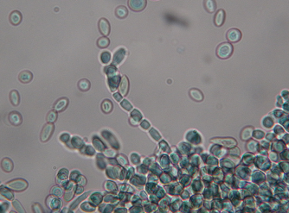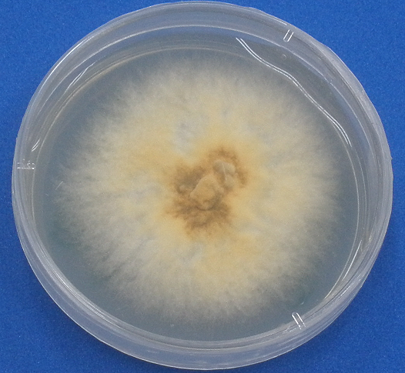

**A.** Macroscopic aspect of the colonies.

**B.** Microscopic morphology of the colonies.

All EOs evaluated showed antifungal acti­vity and totally inhibited spores germination when used in high concentrations (600 – 1000 µg/ml). EOs obtained from *L. origanoides* (EO2 and EO3) were the most active when added at 200 µg/ml concentrations inhibiting germination of the M2 isolate in more than 90% (Table 3, Figure 1). Inhibition degree presented by the EOs in the M2 isolate was similar to the one presented in the ATCC strain (P > 0.05), except for the EO3 that in 200 µg/ml concentration was seven times more active in the M2 strain (Table 3). EOs similar activity on the evaluated strains evi­dences the conservation of susceptibility characteristics on the fungi despite of the adaptation to laboratory conditions. On the other hand, the high activity of the *L. origa­noides* EOs over spore germination of *M. roreri*, could be related to the effect of thymol as the main component of this EO. Previous studies demonstrated that this component affects mainly conidia´s cellular wall inhibi­ting their germination and growth (Svircev *et al.*, 2007).

|  |  |  |  |  |  |  |  |
| --- | --- | --- | --- | --- | --- | --- | --- |
| **Table 3.** Essential oils (EO) effect on germination and mycelial growth of M2 isolate and ATCC reference strain. Results in fungi treated with 200 µg/ml EO. | | | | | | | |
| **Plant/control** | **Germination inhibition (% ±SD)\*** | |  | **Mycelial growth inhibition (% ±SD)\*\*** | | |  |
| **M2** | **ATCC strain** | | | **M2** | **ATCC strain** | |
| *L. citriodora* (EO1) | 42.27±1.09 | 41.56±0.50 | | | 31.71±1.13 b | 11.22±0.07b | |
| *L. origanoides* (EO2) | 93.86±1.39 | 86.11±3.30 | | | 100c | 59.18±2.83c | |
| *L. origanoides* (EO3) | 96.90±0.70a | 12.71±0.28a | | | 100d | 59.18±2.83d | |
| *L. alba* (EO4) | 36.89±0.53 | 66.04±2.38 | | | 2.94±0.18 | 22.45±0.99 | |
| *L. alba* (EO5) | 70.17±0.00 | 38.04±6.17 | | | 6.40±0.02 | 32.14±0.46 | |
| AmB1 | 100 | 100 | | | 100 | 100 | |
| * 48 h post-inoculation; ** 21 days post-inoculation; SD: Standard deviation; 1 AmB concentration used was 0.01 µg/ml. a, b, c, d: P values between M2 isolate and ATCC reference strain with statistical significance (P < 0.05). | | | | | | | |

**Figure 1.** Essential oils (EO) effect on germination inhibition of M2 isolate (A) and the ATCC strain (B). EO1 from *L. citriodora*, EO2 from *L. origanoides*, EO3 from *L. origanoides*, EO4 from *L. alba* and EO5 from *L. alba*.

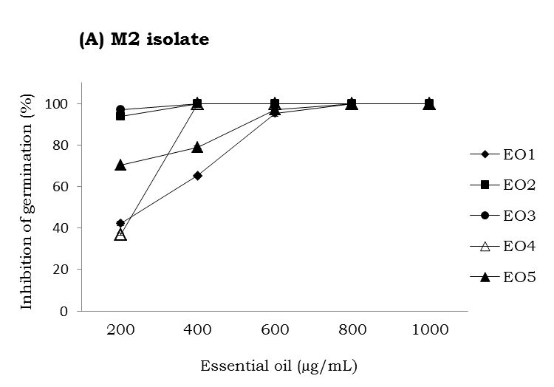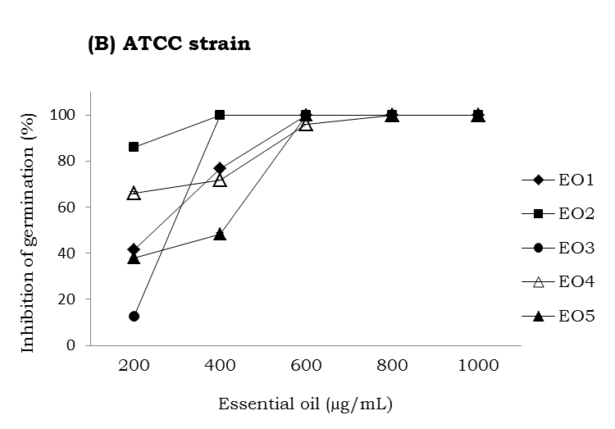

All the EOs included in the study inhibited fungal growth by 100% when used in 800 and 1000 µg/ml, except for the EO4 that inhibited fungal growth by 53.43 and 76.47% in the same concentrations. In the same way to the effect showed in inhibition of germination, EOs from *L. origanoides* (EO2 and EO3) at 200 µg/ml concentration were the most active inhibiting 100% of mycelial growth (Table 3). Differences were found (P > 0.05) in the EOs inhibitory capacity for the M2 and ATCC strains, EO1, EO2 and EO3 were the more active for the M2 isolate than for the ATCC strain (Table 3). In lower concentrations than 25 and 50 µg/ml the growth inhibition on the ATCC strain was about 20% (Figure 2); for the M2 isolate there were no evaluations at EO concentrations lower than 200 µg/ml.

AmB at 200 µg/ml concentration showed an inhibition level of 100% in germination and mycelial growth for both the isolate and the reference strain. Inhibitory activity of this product has been widely demonstrated for fungi affecting humans or plants (Mesa-Arango *et al.*, 2009).

EO main components used in this study are shown in Table 2. Most actives oils (EO2 and EO3) from *L. origanoides* show a similar chemical composition but in different per­centages: thymol, carvacrol and *p*-cymene at 54.5, 1.7 and 10.0% in EO2 and43.8, 17.3 and 12.1% in EO3. These components are found pure or as main components of EOs from plants like *Origanum vulgare*, *Thymus vulgaris*, *Thymbra spicata*, *Satureja thymbra*, *Salvia fruticosa* Lavandula, *Mentha piperita* and previously have shown activity against plant pathogen fungi (Muller-Riebau *et al.*, 1995; Zambonelli *et al.*, 1996; Lee, 2007). Thymol has been used as to vaporize *Monilinia fructicola* infected fruits to reduce spore via­bility when altering cell membrane, also to reduce germ tube formation and appresoria, which are indispensable structures for the onset of infection in plant tissue (Svircev *et al.*, 2007).

**Figure 2**. Essential oils (EO) effect on growth inhibition of the ATCC strain. EO1 from *L. citriodora*, EO2 from *L. origanoides*, EO3 from *L. origanoides*, EO4 from *L. alba* and EO5 from *L. alba*.

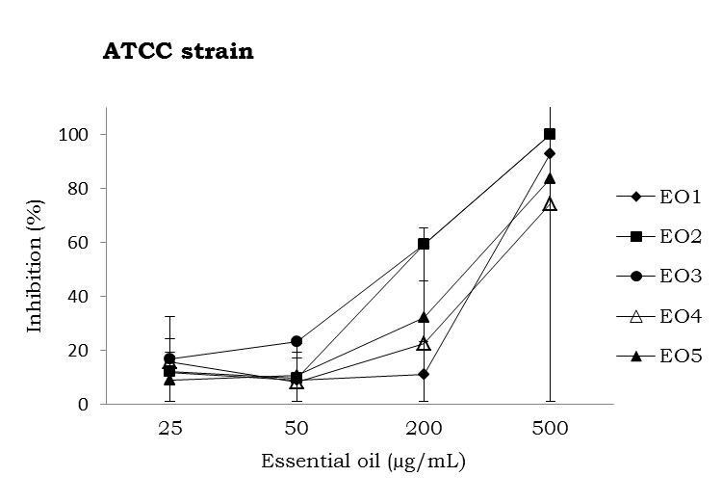

In this work, the EO4 and EO5 from *L. alba* composed mainly by carvone and limo­nene, although they inhibited germination and fungal growth, they were the least active. *L. scaberrima* EO composed mainly by car­vone and limonene as well, have shown acti­vity against plant pathogen fungi when used at 2000 mg/ml concentration (Regnier *et al.*, 2010).

**Conclusions**

* All EOs showed antifungal activity at 200 μg/ml. EOs from *L. origanoides* were the most active.
* Due to the findings of the EO activity in growth and germination of the plant pa­thogen fungus *M. roreri*, mixes of natural component are proposed as possible con­trol agents for cacao moniliasis.

**Acknowledgements**

Thanks to the logistic support of Dr. Fabio Aránzazu and Darwin Martínez of the Re­search Department of the Cacao National Federation – Fedecacao. The current work was financed by the Vicerector of Research and Extension of the Universidad Industrial de Santander (Proyect code 5648) and the National Center of Research for Agroindus­trialization of Tropical Medicinal Aromatics Plants (Cenivam), Contract RC-2445-2011 Colciencias (Autonomous Patrimony of the National Funding for Science, Technology and Innovation, Francisco José de Caldas).

**References**

Barnett, H. L. and Hunter, B. B. 1972. Illustrated genera of imperfect fungi. 3th edition. Minneapolis: Burgess Publ. Co. p. 241.

[Deka Bhuyan](https://springerlink3.metapress.com/content/?Author=P.+Deka+Bhuyan), P.; [Chutia](https://springerlink3.metapress.com/content/?Author=M.+Chutia" \o "View content where Author is M. Chutia), M.; [Pathak](https://springerlink3.metapress.com/content/?Author=M.+G.+Pathak" \o "View content where Author is M. G. Pathak), M. G.; and [Baruah](https://springerlink3.metapress.com/content/?Author=P.+Baruah" \o "View content where Author is P. Baruah), P. 2010. Effect of essential oils from *Lippia geminata* and *Cymbopogon jwarancusa* on in vitro growth and sporulation of two rice pathogens. J. Am. Oil Chem. Soc. [87 (11](https://springerlink3.metapress.com/content/0003-021x/87/11/)):1333 - 1340.

Escobar, P.; Leal, S. M.; Herrera, L. H.; Martínez, J.R.; and Stashenko, E. 2010. Chemical composition and antiprotozoal activities of Colombian *Lippia* spp. essential oils and their major components. Mem. Inst. Oswaldo Cruz 105:184 - 190.

Evans, H. C. 2002. Invasive neotropical pathogens of tree crops. En: Watling, R; Frankland, J. C.; Ainsworth; A. M.; Isaac, W.; y Robinson. C. H. (eds.). Tropical mycology. 2: Micromycetes. Wallingford, Oxon. CABI Publishing. Pp. 83-112.

Evans, H. C.; Stalpers, J. A.; Samson, R. A.; and Benny, G. L. 1978. On the taxonomy of *Monilia roreri*, an important pathogen of *Theobroma cacao* in South America. Can. J. Bot. 56:2528 - 2532.

Grisales, S. and Afanador, L. 2007. Análisis de variabilidad genética de *Moniliophthora roreri* con AP-PCR y RAPD en Antioquia, Colombia. Rev. Col. Biotec. 9:15 - 32.

Hebbar, P. K. 2007. Cacao diseases: A global perspective from an industry point of view. Phytopath. 97:1658 - 1663.

Hennebelle, T.; Sahpaz, S.;Dermont,, C.; Joseph, H.; and Bailleul,, F. 2006. The essential oil of Lippia alba**:** Analysis of samples from French overseas departments and review of previous works. Chem. Biodivers. 3:1116 - 1125.

Kordali, S.; Cakir, A.; Ozer, H.; Cakmakci, R.; Kesdek, M.; and Mete, E. 2008. Antifungal, phytotoxic and insecticidal properties of essential oil isolated from Turkish *Origanum acutidens* and its three components, carvacrol, thymol and p-cymene. Bioresour. Technol. 99:8788 - 8795.

Lee, S. O.; Ja, G. K.; Soo, K. J.; Kyoung, H. L.; Yun, K. C.; and Jin–Cheol, K. 2007. The antifungal activity of five plant essential oils as fumigant against postharvestand soilborne plant pathogenic fungi. Plant Pathol. J. 23:97 - 102.

Linde, J. H.; Combrinck, S.; Regnier, T. J. C.; and Virijevic, S. 2010. Chemical composition and antifungal activity of the essential oils of *Lippia rehmannii* from South Africa. SudAfr. J. Bot. 76:37 - 42.

Meneses R.; Torres F.; Stashenko E.; and Ocazionez, R. 2009. Aceites esenciales de plantas colombianas inactivan el virus del dengue y el virus de la fiebre amarilla. Salud UIS. 41:236 - 243.

Mesa-Arango A.; Montiel-Ramos J.; Zapata B.; Durán C.; Betancur-Galvis E.; and Stashenko, E. 2009. Citral and carvone chemotypes from the essential oils of Colombian *Lippia alba* (Mill.) N.E. Brown: composition, cytotoxicity and antifungal activity. Mem. Inst. Oswaldo Cruz 104:878 - 884.

Muller-Riebau, F.; Berger, B.; and Yegen, O. 1995. Chemical composition and fungitoxic properties to phytopathogenic fungi of essential oils of selected aromatic plants growing wild in Turkey. J. Agric. Food Chem. 43:2262 - 2266.

Olivero, J.; Caballero, G. K.; Jaramillo, C. B.; and Stashenko, E. 2009. Actividad repelente de los aceites esenciales de *Lippia origanoides*, *Citrus sinensis* y *Cymbopogon nardus* cultivadas en Colombia frente a *Tribolium castaneum*, Herbst. Salud UIS. 41:244 - 250.

Pascual, M. E.; Slowing, K.; Carretero, E.; Sánchez, M. D.; and Villar, A. 2001. *Lippia*: traditional uses, chemistry and pharmacology: a review. J. Ethnophar. 76:201 - 214.

Phillips-Mora, W. and Wilkinson, M. J. 2007. Frosty pod of cacao: A disease with a limited geographic range but unlimited potential for damage. Phytopath. 97(12):1644 - 1647

Pitarokili, D. P.; Tzakou, O.; Loukis, A.; and Harvala, C. 2003. Volatile metabolites from *Salvia fruticosa* as antifungal agents in soilborne pathogens. J. Agric. Food Chem. 51:3294 - 3301.

Prabhakaran, K. P. 2010. The agronomy and economy of important tree crops of important developing world. Amsterdam, Boston: Elsevier. Pp. 131 - 180.

Regnier, T.; Combrinck, S.; and Du Plooy, W. 2010. Evaluation of *Lippia scaberrima* essential oil and some pure terpenoid constituents as postharvest mycobiocides for avocado fruit. Postharvest Biol. Technol. 57:176 - 182.

Saldarriaga, Y. and Pineda, F. 2001. Aislamiento de hongos fitopatógenos. Manual de Micología Aplicada. Medellín: Universidad de Antioquia (eds.). Pp. 65 - 74.

Stashenko, E.; Martínez, J. R.; Ruíz, C. A.; Arias, G.; Duran, C.; Salgar, W.; and Cala, M. 2010. *Lippia origanoides* chemotype differentiation based on essential oil GC-MS and principal component analysis. J. Sep. Sci. 33:93 - 103.

Svircev, A.; Smith, R.; Zhou, T.; Hernandez, M.; Liu, W.; and Chu, C. L. 2007. Effects of thymol fumigation on survival and ultraestructure of *Monilia fructicola.* Postharvest Biol. Technol*.* 45:228 - 233.

Zambonelli, A.; D'Aulerio, A. Z.; Bianchi, A.; and Albasini, A. 1996. Effects of essential oils on phytopathogenic fungi in vitro. J. Phytopathol. 144:491 - 494.