Production of cystosori of Spongospora subterranea (Walk.) Lagerh f. sp. subterranea Tomlinson during a potato crop cycle in three soil types
Producción de quistosoros de Spongospora subterranea (Walk.) Lagerh f. sp. subterranea Tomlinson durante un ciclo de cultivo de papa en tres tipos de suelo

Wilmar Pérez-Pérez¹, Elizabeth Gilchrist-Ramelli¹, and Sebastián Reynaldi^{1,2*}

¹BioDes Group, Department of Agricultural Sciences, Universidad Nacional de Colombia, Calle 59a 20-63, Medellín, Colombia. ²Department Bioanalytical Ecotoxicology, Helmholtz Centre for Environmental Research – UFZ, Permoserstraße 15, D-04318 Leipzig, Germany. *Corresponding author: sreynaldi@unal.edu.co

Rec.: 28.06.11 Acept.: 04.06.12

Abstract
The powdery scab is caused by the protist Spongospora subterranea (Walk.) Lagerh f. sp. subterranea Tomlinson, which is an obligate parasite that replicates in roots and tubers of potato (Solanum tuberosum). This replication results in resistant structures which are denominated cystosori. Production of cystosori was investigated in the potato variety Diacol Capiro, which was cultivated in three types of soil (Inceptisol, Entisol, and Andisol) that were infested with cystosori. Concentration of cystosori was determined at planting (Initial), at plant senescence (Harvest), and at plant disintegration (Postharvest). The experimental design was completely randomized with two treatments and three levels each. Soil type with the levels Inceptisol, Entisol and Andisol, was one treatment; and the sampling time with the initial, harvest and postharvest, was the other. Additionally, a test of simple regression to analyze correlation of the initial and final concentration of cystosori was performed. In all types of soil, cystosori concentration increased significantly (P ≤ 0.05) from planting to postharvest; the mean increase was 48%. There was no significant (P ≤ 0.05) difference among types of soil at any time sampling. The final concentration of cystosori (Postharvest) was significantly (P ≤ 0.05) which correlated with the initial concentration of cystosori (Initial). These results suggest that cystosori concentration can have a substantial increase after a single potato crop cycle, and harvest residuals, such as contaminated tubers, can contribute to this increase.

Key words: Cystosori, potato, powdery scab, soil types, Solanum sp., Spongospora subterranea (Walk.) Lagerh f. sp. subterranea Tomlinson.

Resumen
La sarna polvosa es causada por el protista Spongospora subterranea (Walk.) Lagerh f. sp. subterranea Tomlinson, un parásito obligado el cual replica en raíces y tubérculos de papa (Solanum tuberosum). Esta replicación resulta en estructuras de resistencia denominadas quistosoros. En este estudio se investigó la producción de quistosoros en papa variedad Diacol Capiro, cultivada en tres tipos de suelos: Inceptisol, Entisol, y Andisol, infestados con quistosoros. La concentración de este parásito se determinó en el suelo a la siembra (inicial), a la senescencia de las plantas (cosecha) y 2 meses más tarde cuando las plantas estaban desintegradas (poscosecha). El diseño experimental fue completamente al azar con dos tratamientos y tres niveles cada uno. Un tratamiento fue el tipo de suelo con los niveles Inceptisol, Entisol y Andisol; y el otro, el tiempo de muestreo con los niveles Inicial, Cosecha y Poscosecha. Adicionalmente, se realizó un ensayo de regresión simple para analizar la correlación de la concentración inicial y final de quistosoros. En todos los tipos de suelo la concentración aumentó (48%) (P ≤ 0.05) desde el inicio a la poscosecha. No se observaron diferencias (P ≤ 0.05) en la concentración de quistosoros entre los suelos durante los muestreos realizados. La concentración final de estos (poscosecha) se correlacionó (P ≤ 0.05) con la concentración inicial (inicio). Estos resultados sugieren que la concentración de quistosoros puede sufrir un incremento significativo en un solo ciclo de cultivo de papa en todos los suelos estudiados y que los residuos de cosecha como tubérculos infectados pueden contribuir a este incremento.

Palabras clave: Papa, quistosoros, sarna polvosa, Solanum sp., Spongospora subterranea (Walk.) Lagerh f. sp. subterranea Tomlinson, tipos de suelo.

Introduction
Powdery scab is a pathology caused by the protist Spongospora subterranea (Walk.) Lagerh f. sp. subterranea Tomlinson (Braselton, 1995). S. subterranea reproductive cycle produces pustules over the tubers surface giving an scab aspect, this affects the cosmetic quality of tubers and reduces their price in the market (Falloon, 2008).
This pathogen is part of a protist group called plasmodiophorids that unites obligate parasites sharing various characteristics, among them the capacity to form resistance structures that can stay dormant on soil for long periods of time. These resistance structures are formed by encysted zoospores that when active unfold two flagella of different length, which help them move through soil water until plant tissue to infect is found; then they generate a multicellular plasmodium that gives origin to cystosori (Braselton, 1995).
Spongospora subterranea (Walk.) Lagerh f. sp. subterranea Tomlinson not only reproduces in tubers by mean of pustules, it also does it on plant roots producing galls (Harrison et al., 1997), however it is believed that this disease was spread by marketing of infected tubers as seeds for new crops. The infective inoculum, cytosori, increased in soils of the main potato producing areas in the world because there are neither effective treatments nor resistance varieties (Merz and Falloon, 2009).
In Colombia, the powdery scab is spread in the main potato producing areas in the country (Guerrero, 2000; García and Navia, 2002). Producers estimations referred to a strong reduction in production caused by this disease (García and Navia, 2002). Gilchrist et al. (2009) found that infected plants suffer leaf area reductions when compared to control plants. Reduction in plant growth could go up to 32% of leaf dry weight and precedes a reduction up to 0% in tuber weight (Gilchrist et al., 2011). This changes radically the importance of the disease, mainly in development countries where the production volume of tubers can be more important than the losses in cosmetic quality. Under this context, the aim of this work was to determine the concentration increase in cytosori in different soil type after a potato crop cycle.

Materials and Methods
Potato crops, Diacol Capito variety, were established in Inceptisols, Andisols and Entisols in producing areas of Antioquia (Jaramillo et al., 1994). The experimental units were established in the Agricultural Center Paysandú at the Universidad Nacional de Colombia in Santa Elena (6°12′ 37″ N and 75°30′11″ O), Antioquia, Colombia. They consisted of plots of 1 m² area and 30 cm depth that were filled with different soil types for a total of six plots per soil type. 24 certified small tubers were sown in each plot. Two weeks before tubers were sown, it was applied 100 g of chicken manure, 5 g of magnesium sulfate and 32 g of a nitrogen, phosphate and potassium mix in 1:2:2 proportions (NPK). Six weeks after tubers were sown, it was applied 48 g of the
NPK mix in each plot and hilling was done with 15 cm of soil to each plant. Once per week, weeds were manually removed and pesticide lamba cialotina (Oma) and fungicide Mancozeb (DuPont) were applied. Plots were irrigated at a rate of 5 cm³/min each 4 hours.
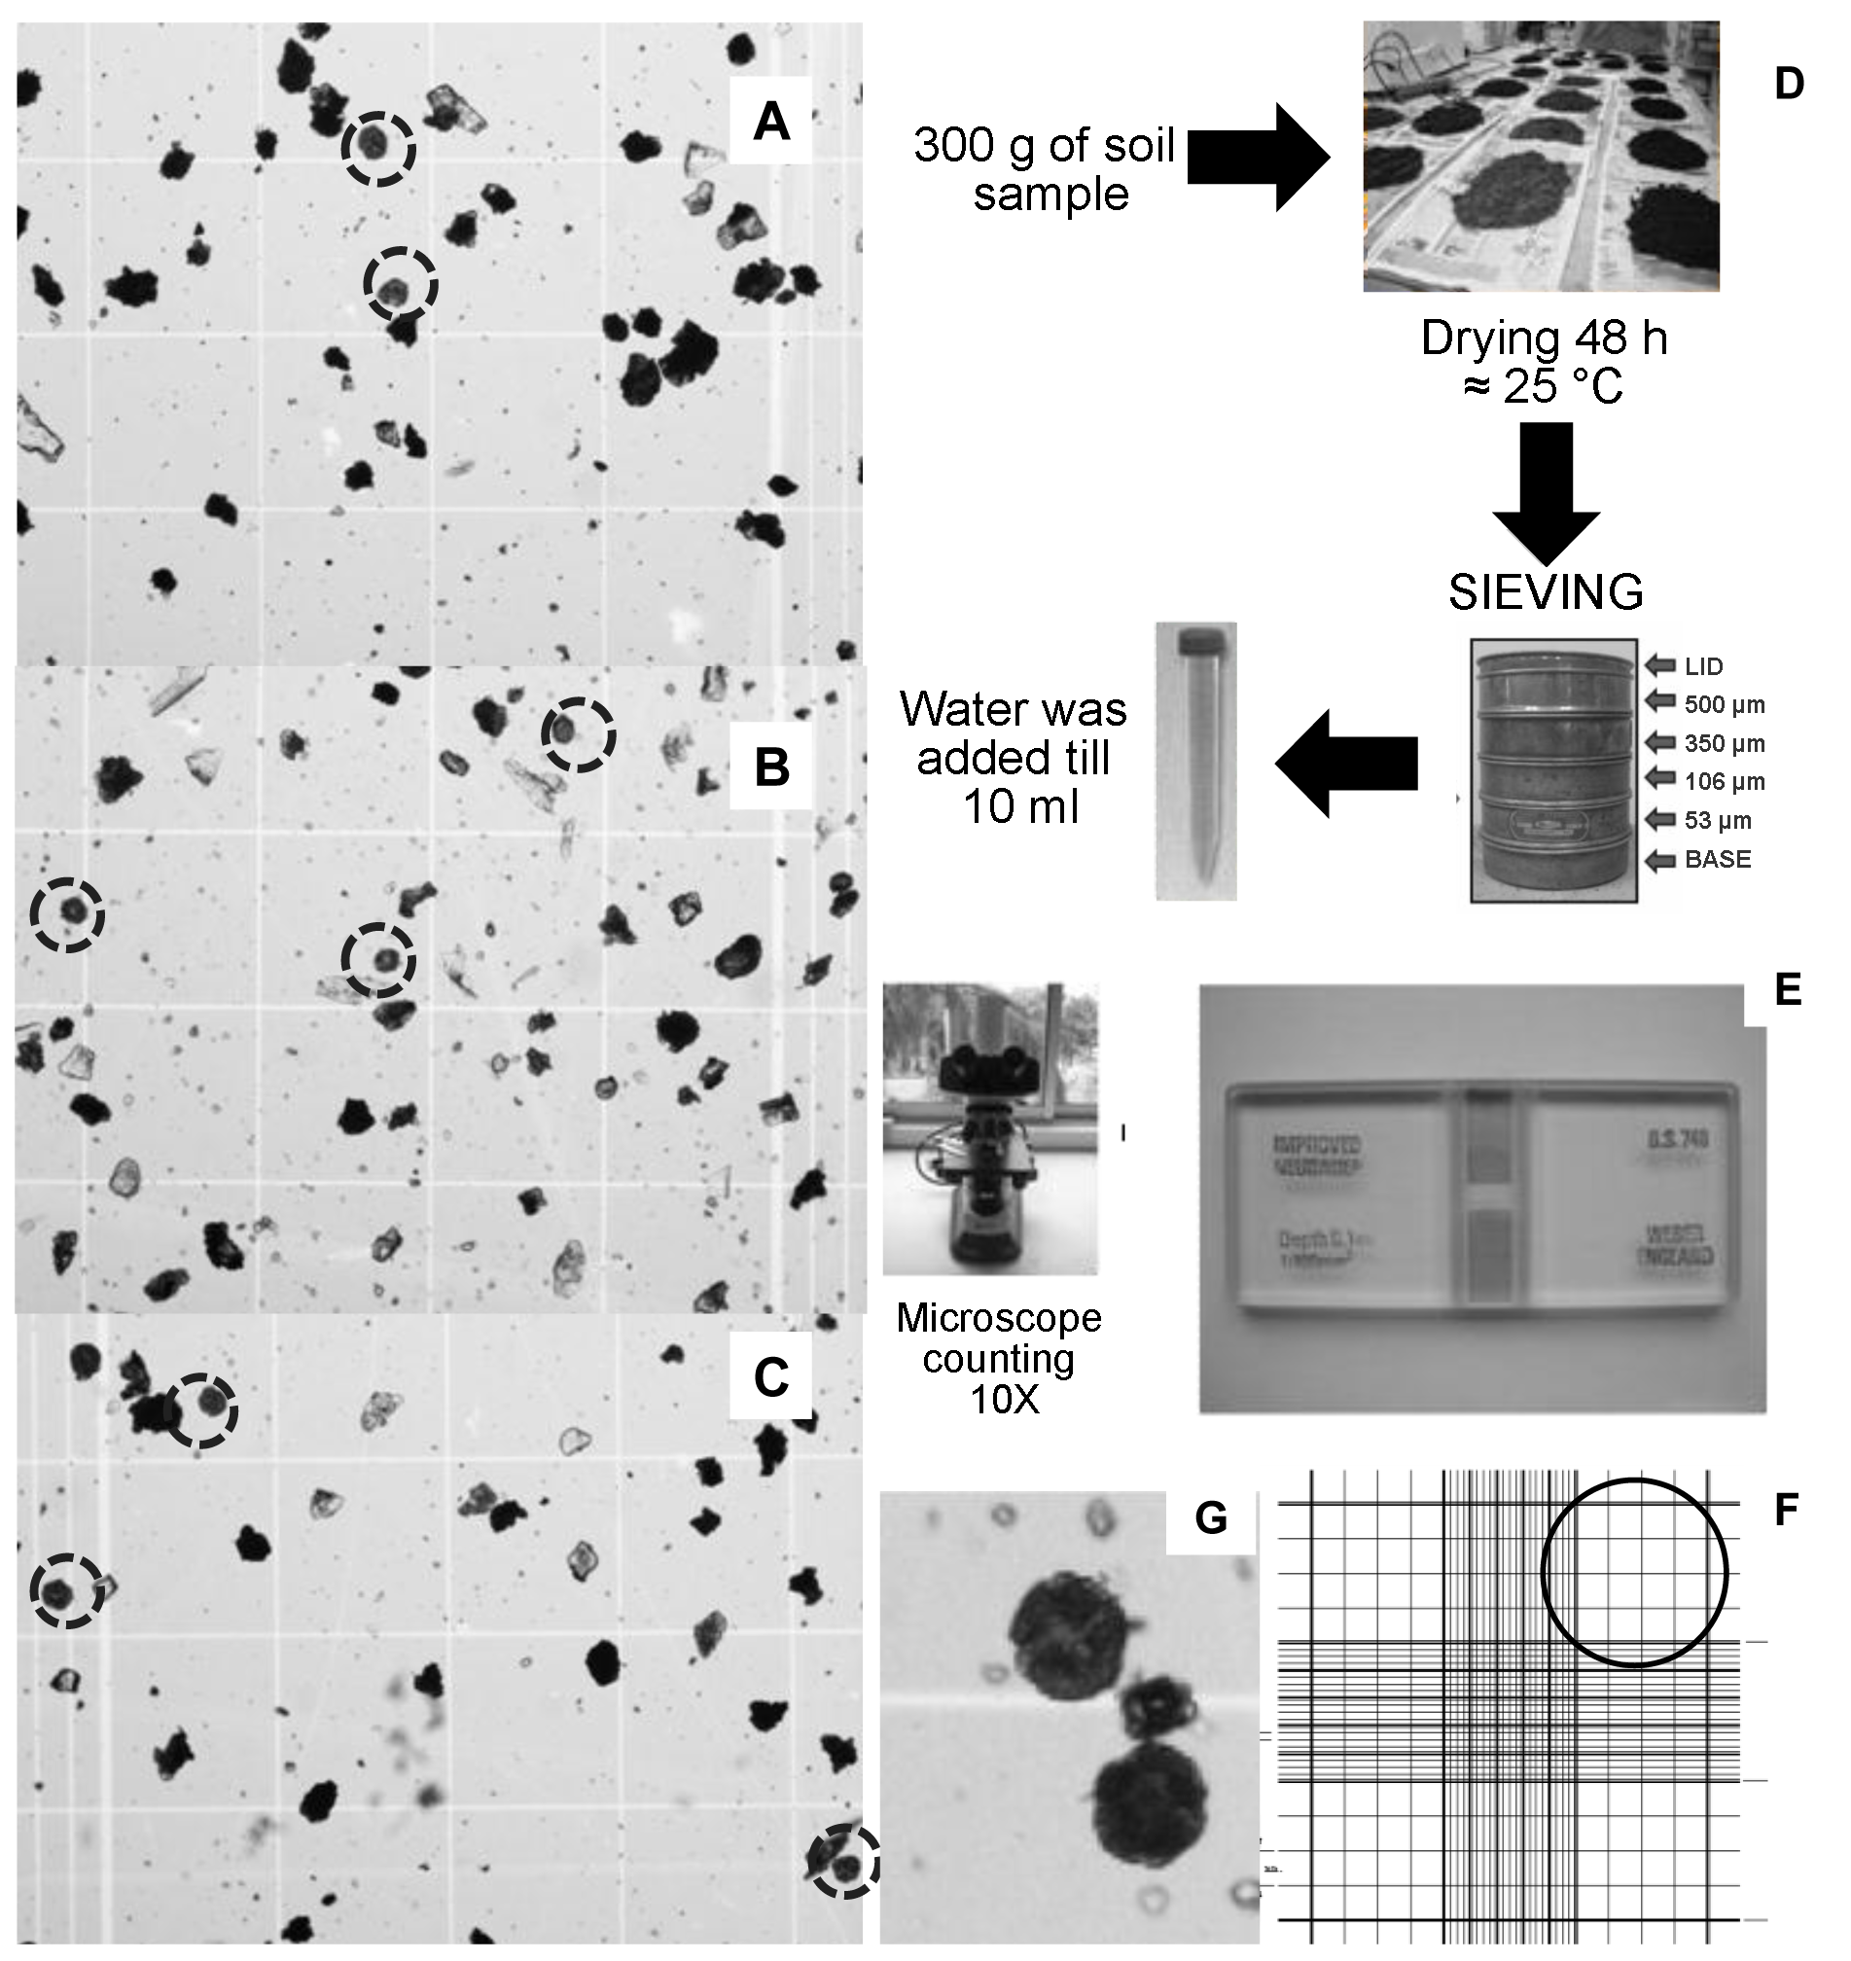Soils were contaminated with cystosori isolated from infected roots (Jaramillo et al., 2006). Their concentration was determined according with Van de Graaf et al. (2005) at the beginning of the experiment (initial), during senescence of potato plants (harvest) and 2 month after when plants were totally decomposed (postharvest). Concentration was determined by triplicate in each plot by taking 300g of sample that was dried out for 48 h at 25 ± 3 ºC. After drying, soil was passed successively through four sieves with 500, 350, 106 y 53 µm pores. Once sieved, 1 g sample was placed on a plastic tube and filled with tap water till 10 ml (Picture 1D). This suspension was shaken before taking an aliquot for counting cystosori in a Neubauer chamber under the microscope at 10X magnification (Picture 1E). Cystosori were counted in the main squares at the edges of the Neubauer chamber where leucocytes are normally counted (Picture 1F). In order to calculate the cystosori concentration in the 10 ml suspension the following equation was used:
Picture 1. Cystosori counting images (in full line circles) in the Neubauer chamber for Inceptisol (A), Entisol (B) and Andisol (C). Step sequences to get the suspension for analysis in the Neubauer chamber (D). Magnification under the microscope and Neubauer chamber picture (E). Circle shows one of the four squares where cystosori were counted in the Neubauer chamber (F). Reference image to recognize cystosori (G).
Cystosori number/ml = Cystosori number in the four main squares x 50
To calculate the cystosori number/ g of soil, the result value of the formula was multiplied by 10 ml of soil suspension and divided by 300 g of soil used to sieve. Cystosori were identified by their size, shape and color (Harrison et al., 1997) by standardization of light and the concentration of the quantified suspensions in the Neubauer chamber (Beltrán et al., 2009).
Pustules severity in the harvested tubers
was qualified using the scale proposed by Falloon et al. (1995). Experimental design was completely randomized with two treatments and three levels each. One treatment was soil type with levels Inceptisol, Entisol and Andisol; and the other was sampling time with levels Initial, Harvest and Postharvest. Mean differences in the combinations between treatment levels were analyzed by a two way variance analysis followed by a Tukey’s test. A simple regression assay was performed to analyze the initial and final concentration of cystosori. All the assays were performed using the free use software R, version 2.11.1.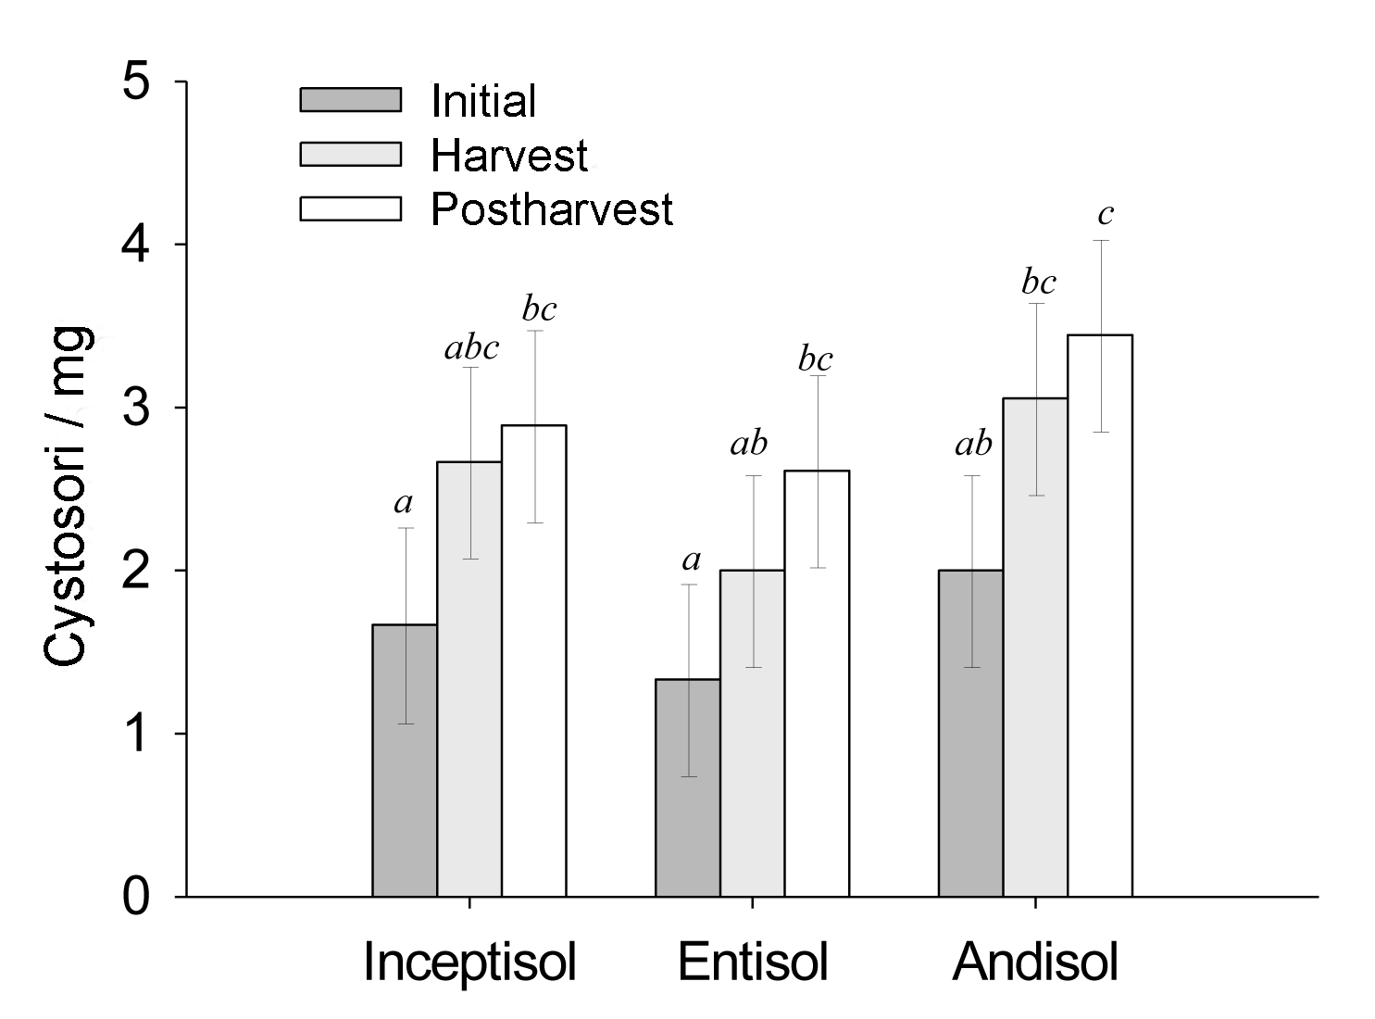
Figure 1. Cystosori concentration expressed as cystosori per miligram of soil in the three soil types in three samplings. Bar high is the average value and error lines are 95% confidence intervals. Different letters indicate significant differences (P ≤ 0.05).
Table 1. Percent increase in cystosori concentration in each experimental soil expressed as percentage of initial concentration and, pustules severity and incidence in the produced tubers.
Soil | Increment (%)ª |  |  | Pustulesª
 | Harvest | Postharvesta |  | Severity | Incidence (%)
Entisol | 33 | 49 |  | 2.3 | 33
Iceptisol | 38 | 42 |  | 2.7 | 60
Andisol | 35 | 42 |  | 2.0 | 50
Average | 35 | 44 |  | 2.3 | 48
a. ns (P > 0.05).

Results and discussion
In all the samplings performed there were no significant differences (P > 0.05) neither in cystosori concentrations between soil types (Figure 1) nor in percentage increase, which was calculated taking as reference the average initial value in each soil type (Table 1). Gilchrist et al. (2009) worked with soils that were similar to the ones of this study, did not find significant differences when analyzing galls severity in potato roots. Similarly, in this work there were not differences (P > 0.05) in pustules severity and incidence in tubers
surface (Table 1). It should be mention that in both cases irrigation was used, this could minimize the differences in retained water in each soil (Jaramillo et al., 1994). Water content in each soil is relevant for cystosori because their biflagellated zoospores swim in soil water until they find roots and tubers to infect (Braselton, 1995).
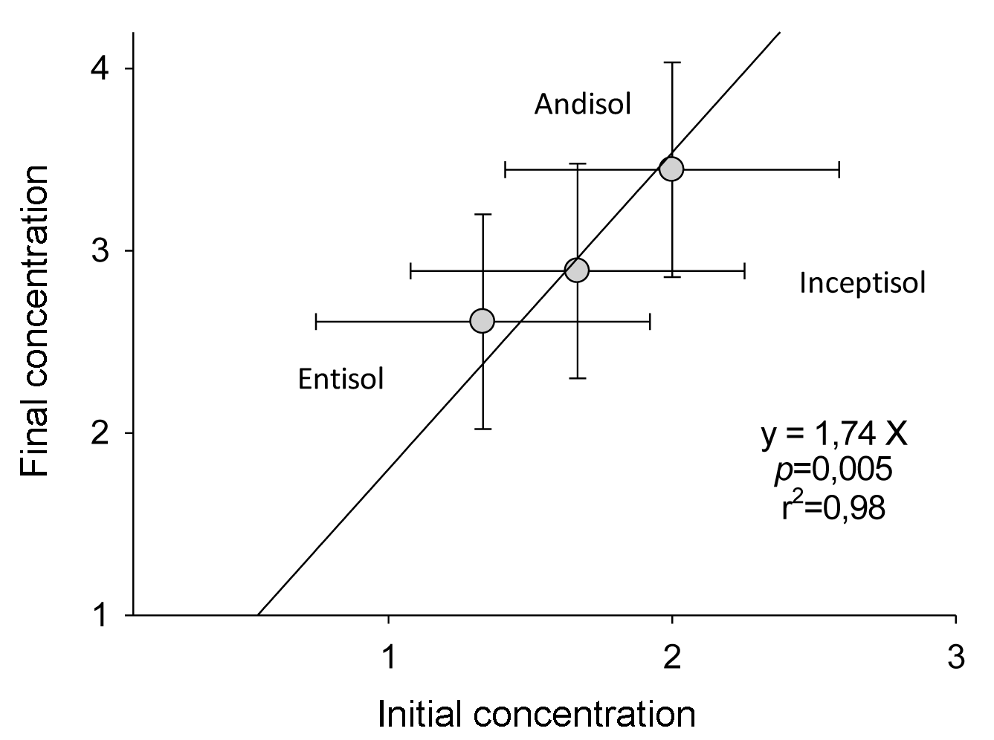In this work, the final concentration of cystosori was correlated with the initial concentration (P ≤ 0.05) (Figure 2), which suggest that they were multiplied at a similar rate in all soils. Additionally, this rate was high enough to increment significantly their concentration from the beginning of the experiment until 2 months after harvesting (Figure 1). This is explained because Spongospora subterranea (Walk.) Lagerh f. sp. subterranea Tomlinson can reproduce in both, roots and tubers (Harrison et al., 1997) which has to be taken into account when selecting resistant varieties and when it is decided to avoid harvesting of infected tubers.
Figure 2. Correlation between the initial and final cystosori cncentration in the different soils expressed as cystosori per miligram. Horizontal and vertical error lines represent 95% confidence intervals.

Conclusion
Spongospora subterranea (Walk.) Lagerh f. sp. subterranea Tomlinson reproduction can be high enough to increase cystosori concentration in soil during one potato crop cycle. Harvest residues can help to the increase in cystosori concentration.

Acknowledgements
This work was part of the research on ‘potato powdery scab’ financed by the Ministry of Agriculture and Rural Development and the National Fund for Vegetables and Fruits, Colciencias and DIME (UNAL) through the project “Powdery scab severity in two potato varieties, Capiro (Solanum tuberosum) and Criolla (Solanum phureja)” QUIPU 20201007168.

References
Beltrán, E.; Gilchrist, E.; Jaramillo, S.; and Reynaldi, S. 2009. Influencia de las condiciones de incubación sobre la activación de zoosporas de Spongospora subterranea, en busca de un inóculo para el estudio de la sarna polvosa. Medellín. Rev. Fac. Nal. Agron. 62:5055 - 5062.
Braselton, J. P. 1995. Current status of the plasmodiophorids. Crit. Rev. Microbiol. 21:263 - 275.
Falloon, R. E. 2008. Control of powdery scab of potato: towards integrated disease management. Am. J. Potato Res. 85:253 – 260.
Falloon, R. E.; Viljanen-Rollinson; S. L.; Coles, G. D.; and Poff, J. D. 1995. Disease severity keys for powdery and downy mildews of pea, and powdery scab of potato. N. Z. J. Crop Hortic. 23:31 - 37.
García, C. and E. Navia. 2002. Evaluación de estrategias de manejo de la roña polvosa (Spongospora subterranea) en las tres regiones más productoras de papa en Colombia. Disponible en: http://www.redepapa.org/practicasculturalesred3.html Fecha revisión: Junio 4 de 2012.
Gilchrist, E.; Jaramillo, S. M.; and Reynaldi, S. 2009. Influencia del tipo de suelo en el potencial infectivo de Spongospora subterranea en cultivos de papa. Medellín. Rev. Fac. Nac. Agron. 62:4783 - 4792.
Gilchrist, E.; Soler, J.; Merz; and Reynaldi, S. 2011. Powdery scab effect on the potato Solanum tuberosum sp. andigena growth and yield. Trop. plant pathol. 36(6):350 - 355.
Guerrero, O. 2000. La roña o sarna polvosa en el departamento de Nariño. En: Fedepapa (eds.). Papas colombianas con el mejor entorno ambiental. Segunda edición. Bogotá, Colombia. p. 127 - 129.
Harrison, J. G.; Searle, R. J.; and Williams, N. A. 1997. Powdery scab disease of potato- A review. Plant Pathol. 46:1 - 25.
Jaramillo, D. F.; Parra, L. N.; and González, H. 1994. El recurso suelo en Colombia: distribución y evaluación. Universidad Nacional de Colombia, ICNE. Medellín. 88 p.
Jaramillo, S.; Cotes, J.M.; González L. H.; Zapata, R.; and Ruiz, O. 2006. Proyecto: Efecto de las enmiendas y el tipo de suelos sobre la producción y expresión de síntomas de la sarna polvosa (Spongospora subterranea) en tres cultivares de papa. Universidad Nacional de Colombia, Sede Medellín. Cevipapa, Ministerio de Agricultura y Desarrollo Rural (MADR). 110 p.
Merz, U. and Falloon, R. E. 2009. Review: powdery scab of potato-Increased knowledge of pathogen biology and disease epidemiology for effective disease management. Potato Res. 52:17 - 37.
Programa R, The R Project for Statistical Computing, http://www.r-project.org/. Fecha revisión: Junio 4 de 2012.
Van de Graaf, P.; Lees, A. K.; Wale, S. J.; and Duncan, J. M. 2005. Effect of soil inoculum level and environmental factors on potato powdery scab caused by Spongospora subterranea. Plant Pathol. 54:22 - 28.

