**Identification of fatty acids contained in oils extracted from three different fruit seeds**

**Identificación de ácidos grasos contenidos en los aceites extraídos a partir de tres diferentes semillas de frutas**

*Andrés Felipe Cerón1†*, *Oswaldo Osorio M.2\**, and *Andrés Hurtado B.2‡*

1Agroindustrial Engineer. Faculty of Agroindustrial Engineering, Research Group on Emerging Technologies in Agroindustry (TEA), Universidad de Nariño, Pasto, Colombia.

2Associated Proffesor, Faculty of Agroindustrial Engineering, Research Group on Emerging Technologies in Agroindustry TEA), Universidad de Nariño. Pasto, Colombia.

*Corresponding author: Osorio_oswaldo@udenar.edu.co, Tel.+057-27314481, Fax.+057-2731448; †andre5505@hotmail.com; ‡ahurtadob@hotmail.com

Rec.: 21.08.11 Acept.: 30.05.12

**Abstract**

The objective of the study was to determine oil yield and fatty acids composition present in three different seeds from Andean fruits: Lulo cultivar castilla (*Solanum quitoense*); blackberry cultivar castilla (*Rubus glaucus*), and passion fruit or maracuya (*Passiflora edulis*). The extraction was carried out by solvent extraction method with a Soxhlet extractor using ethyl ether as solvent at 99.8% purity and boiling point of 40 - 60 °C. To identify the fatty acids, gas chromatography with FID detector (GC-FID) was used. Oil yields obtained were 8.5% for lulo, 12.2% for blackberry and 21.2% for maracuya. The fatty acids found were: In seeds of lulo palmitic acid 15.6% and linoleic acid 58.1%; in seeds of blackberry 50.1% of linoleic acid and linolenic acid 25.1%; in seeds of maracuya palmitic acid 15.44%, oleic acid 15.47% and linoleic 63.1%. The fat content of the studied seeds evidence their potential as oleaginous raw material and the identification of the previous fatty acids makes them an important source of components for the food, pharmaceutical or cosmetic industry.

**Key words:** Chromatography, fatty acids, *Passiflora edulis*, *Rubus glaucus*, *Solanum quitoense*.

**Resumen**

En este estudio se midió el rendimiento de aceite y la composición de ácidos grasos presentes en semillas de las frutas andinas tropicales: lulo de la variedad castilla (*Solanum quitoense*), mora de la variedad castilla (*Rubus glaucus*) y maracuyá (Passiflora edulis). La extracción se hizo con solventes en un extractor Soxhlet utilizando éter etílico al 99.8% de pureza y punto de ebullición 40 - 60 ºC. Para identificar los ácidos grasos se empleó cromatografía de gases con detector FID (GC-FID). Los rendimientos en aceite fueron de 8.5% para lulo, 12.2% para mora y 21.2% para maracuyá. Los ácidos grasos encontrados en semillas de lulo fueron palmítico (15.6%) y linoléico (58.1%); en semillas de mora linoléico (50.1%) y linolénico (25.1%) y en las de maracuyá palmítico (15.44%), oleico (15.47%) y linoléico (63.1%). El contenido graso de las semillas evaluadas evidenció su potencial como materia prima oleaginosa y por sus contenidos de ácidos grasos se pueden considerar una fuente importante de componentes para las industrias alimentaria, farmacéutica y cosmética.

**Palabras clave:** Ácidos grasos, cromatografía, Passiflora edulis, *Rubus glaucus*, *Solanum quitoense*.

**Introduction**

Tropical andean fruit croops comprised espe­cies with different developmental levels and high potential for consumers acceptance. Among them stand out blackberry (*Rubus glaucus* Benth.), lulo (*Solanum qui­toense* Lam.) and some passiflora like passion fruit (Passiflora edulis Sims) (Lobo, 2006).

Blackberry belongs to the rosaceae family, fruit consist of an agglomerate of little purple drupes joined to a conical receptacle that can be easily separated from the plant; seed has a kidney shape and its color varies from purple to intense red (Vanarsdel, 1963). Lulo be­longs to the Solanaceae family and to the *So­lanum* genus which is the largest and diverse (Bedoya and Barrero, 2009), fruit is ovoid with yellow, orange or brown peel, covered by fine spines or hair; internally, it is divided in four compartments filled with greenish flesh and numerous seeds (Schultes and Cuatrecasas, 1958). Passion fruit belongs to the Passiflora­ceae family and to the *Passiflora* genus, fruit is a globose berry with rounded base and apix; peel is yellow, dark, smooth and waxy; contains 200-300 black or dark violet seeds(García, 2002).

Nowadays these fruits have high demand in juice and pulp industry (Lobo, 2006), that is why they generate a large amount of resi­dues which raw material is not well known (Brennan *et al.,* 1998). Among these residues we have seeds that are characterized by their high fiber content, mainly composed of cellu­lose, pectic substances and hemicellulose (Basui, 1999), besides their wide variety of components according to seed type and spe­cific tissues (Stroshine and Hamann, 1993).

In Nariño, Colombia, is urgent to develop techniques for using seeds coming from pro­cessed fruits, this in order to obtain oils for pharmaceutical and cosmetic industries. Boucher (1999) considers the urge to realize and define research plans to use the richness of autochthonous promissory products. Ob­taining oils from residual seeds of processed fruits is an agroindustrial alternative to give value to this type of residue.

García *et al.* (2003) found oil and fat acids residues in blackberry, and Ocampo *et al.* (2007) found trygliceride from saturated and unsaturated fats (linoleic, oleic, stearic and linolenic) in soursop seeds, which represent a potential for industrial use (Solis *et al.*, 2010).

This work aimed to determine oil yield and fat acids composition present in black­berry, lulo and passion fruit, as an alternative for agroindustrial development by using these subproducts in food, pharmaceutical and cosmetics industry.

**Materials and methods**

**Location.** This research was done in the Pilot Plant of the Faculty of Agroindustrial Engi­neering in Universidad de Nariño, Torobajo, Pasto, Nariño, located at 2527 MASL, with 14 °C average temperature and 70% relative hu­midity.

**Raw material.** 1 kg seed samples of lulo (*Solanum quitoense*) cv. Castilla, blackberry (*Rubus glaucus Benth*) cv. Castilla and pa­ssion fruit (Passiflora edulis) were used. They were supplied by Inpadena factory in Pasto that is dedicated to pulp extraction of these fruits.

**Processing.** Initially, pulp excess adhered to seeds was removed; for that, seeds were washed with tap water and at the same time empty seeds were eliminated. After that, seeds were dyed out in trays at 60 °C with 20 m/s air speed for 8 h. Finally, dried seeds were passed through hammermill (Hsiao Lin Machine model 61060), by a sieve (PS-35 se­ries 1182) and by a sieve series 10-30, A.S.T.M.E. for 5 min.

**Oil extraction.** For oil extraction 15.00 ± 0.01 g of seeds of each fruit were processed with particle diameter between 0.5943 and 0.8407 cm. For this, a Soxhlet extractor was used, ethyl eter (99.8%) was used as solvent and boiling point was between 40 and 60 °C (Bernal, 1998) with 8h reflux. Solvent reco­very was done by distillation on a rotatory evaporator (Eyela Oil Bath OSB-2000). Ex­tract was dried out at 60 ± 2 ºC on electrical oven (Thermolab Dies) for 30 min until resi­dual solvent was evaporated, it was cooled down and weighted to determine yield. Fina­lly, the obtained oil was conserved in vials (amber glass bottles with screw cap).

**Humidity determination.** To determine sample humidity, 2.00 ± 0.01 g of samples were weighted and heated at 100 °C on elec­trical oven (Thermolab Dies) during 24 h until a constant weight was reached, then their dry weight was determined (Less, 1998).

Sample weight, yield determination and humidity were done on analytical balance Precisa 310M 3000 g and ± 0.01 g precision

**Fatty acids determination.** To prepare the samples the derivatization method was used in the specialized lab at the Universidad de Nariño, which is based on the trans-esterifi­cation catalyzed with acid technique. 200 μl of each oil were extracted, 1 ml of hexane HPLC grade was added, then 10 ml of 5% HCl in CH3OH were prepared. This solution to­gether with the samples were in reflux for 2 h at 70 °C; then 5 ml distillated water were added and left to stand for 10 min; 2 ml of hexane HPLC grade were added to separate the sample on a special funnel.

**Analytical procedures.** Fatty acids analysis on seeds was done using a gas chromatogra­pher Shimadzu GC-17.A, with a Supelcowax column (30m x 0.25mm ID 0.25μm) and a FID detector at 280 °C. Injection mode: split, rate 20:1, flux 1.0 ml/min, injector tempera­ture 250 °C; Temperatures programmed in column: 40 °C till 130 °C at 15°C per minute, then incremented to 240 °C (10 min) at 30 °C per minute, finally incremented to 250 °C at 10 °C per minute.

Fatty acids metyl sters standards were used for respective comparisons, including retention indexes for those components not identified by standard chromatography. Ex­perimental design was totally randomized, measurements were done by triplicate and results are shown as average values.

**Results and discussion**

**Oil yield**

The lowest humidity contents and highest oil percentages were found in passion fruit seeds, followed by blackberry seeds (Table 1). In this study the fatty acids value was higher than the one (9.2%) obtained by García *et al.* (2003). According to the fat percentage in the evaluated seeds is possible to predict its higher potential as oilseeds for food, pharma­ceutical and cosmetic industry, which are high consumers of vegetable oils.

**Fatty acids identification**

In the analyzed samples there were found the corresponding ‘picks’ to fatty acids metyl ster standards at different retention times, identi­fying the following: palmitic, stearic, oleic, linoleic and linolenic acids in the three types of seeds (Figure 1). Palmi­toleic acid is only in lulo (*Solanum quitoense*) seeds (Table 2). Chromatograms show six signals in *Solanum quitoense* oil (Figure 2), and five signals in *Rubus glaucus Benth* (Figure 3) and in Passi­flora edulis (Figure 4). Analysis of each pick in the chromatogram showed the fatty acids present in each type of seeds (Table 2). Re­sults allow the comparison of oils based on their composition by fatty acids percentage, which was different (P < 0.05) between the seeds of the different fruits. It is important to notice the presence of palmitoleic in *Sola­num quitoense* seeds.

The most abundant fatty acid in seeds was

|  |  |  |  |  |  |
| --- | --- | --- | --- | --- | --- |
| **Table 1.** Oil yield in tropical fruits seeds. | | | | | |
| **Fruit** | **Humidity\***  **(%)** | **Yield**  **(% oil)** | **Average**  **(% oil)** | **Standar deviation** | **CV**  **(%)** |
| Blackberry | 6.137 | 12.321  11.683  12.634 | 12. 213 | 0.484 | 3.962 |
| Passion fruit | 5.051 | 19.630  21.460  22.545 | 21.212 | 1.473 | 6.945 |
| Lulo | 6.760 | 7.762  9.030  8.842 | 8.545 | 0.684 | 8.008 |
| * Average of three samples/fruit. | | | | | |

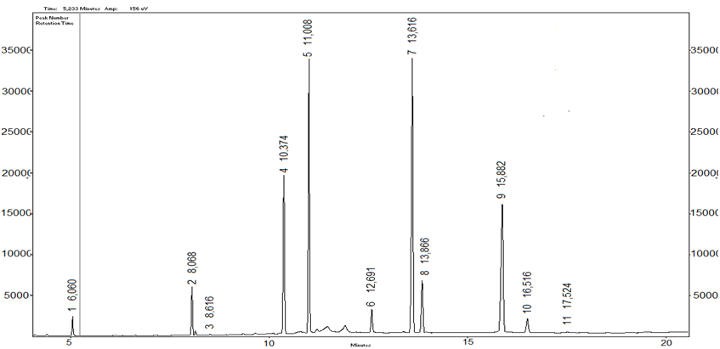

**Figure 1.** General chromatogram of methyl ster fatty acids (standard 99.98%).

1, 2, 3 N.I.,4 Undecanoic, 5 Dodecanoic acid, 7 Palmitic, 8 Palmitoleic, 9 Oleic, 10 Linoleic, 11 Linolenic

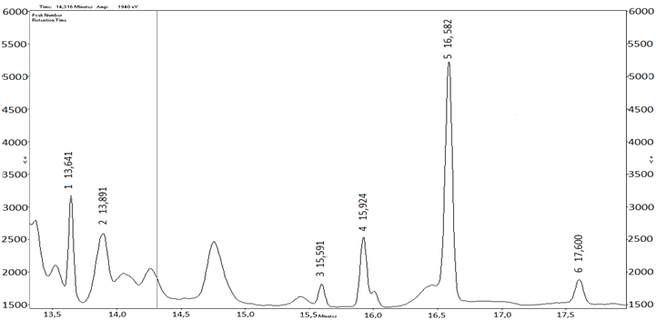

**Figure 2.** General chromatogram of a lulo (*Solanum quitoense*) seed oil sample.

1 Palmitic, 2 Pamitoleic, 3 Stearic, 4 Oleic, 5 Linoleic, 6 Linolenic.

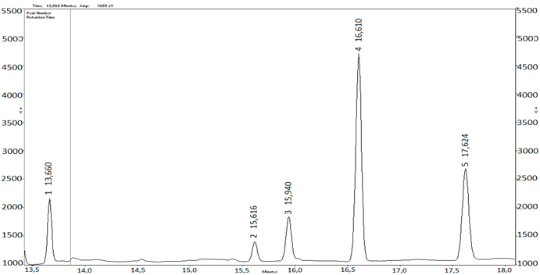

**Figure 3.** General chromatogram of blackberry mora (*Rubus glaucus*) seed oil sample.

1 Palmitic, 2 Stearic, 3 Oleic, 4 Linoleic, 5 Linolenic.

the linoleic in concentrations > 50%. This acid is essential for humans since they lack of enzymes needed to insert double bounds in carbon atoms that are further than carbon 9. (Ronayne de Ferrer, 2000; Sanhueza *et al.*, 2002; Galgani, 2004; Tapia, 2005), and its importance lies primarly in its role as precur­sor for long fatty acids chains, like arachi­donic acid, this characterized the acid as essential for food metabolism (Simopoulos*,* 1991; Peterson *et al.*, 2006).

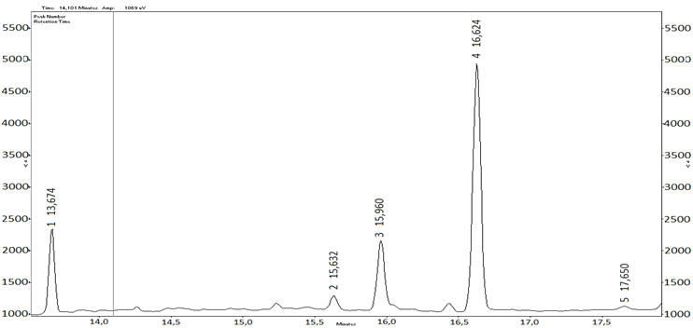

**Figure 4.** General chromatogram of a passion fruit (Passiflora edulis) seed oil sample.

1 Palmitic, 2 Stearic, 3 Oleic, 4 Linoleic, 5 Linolenic.

|  |  |  |  |  |
| --- | --- | --- | --- | --- |
| **Table 2.** Fatty acids in tropical fruit seeds. | | | | |
| **Fruit** | **‘picks’ number** | **Retention time**  **(min)** | **Acid type** | **\*Percentage** |
| Lulo | 1 | 13.641 | Palmitic ME | 15.6 a |
| Blackberry | 1 | 13.660 | Palmitic ME | 11.24 b |
| Passion fruit | 1 | 13.674 | Palmitic ME | 15.44 c |
|  |  |  |  |  |
| Lulo | 2 | 13.891 | Palmitoleic ME | 2.35 |
| Blackberry | - | - | - | - |
| Passion fruit | - | - | - | - |
|  |  |  |  |  |
| Lulo | 3 | 15.591 | Stearic ME | 3.65 a |
| Blackberry | 2 | 15.616 | Estearico ME | 4.11 b |
| Passion fruit | 2 | 15.632 | Estearico ME | 3.00 c |
|  |  |  |  |  |
| Lulo | 4 | 15.924 | Oleic ME | 14.00 a |
| Blackberry | 3 | 15.940 | Oleic ME | 9.42 b |
| Passion fruit | 3 | 15.960 | Oleic ME | 15.47 c |
|  |  |  |  |  |
| Lulo | 5 | 16.582 | Linoleic ME | 58.10 a |
| Blackberry | 4 | 16.610 | Linoleic ME | 50.1 b |
| Passion fruit | 4 | 16.624 | Linoleic ME | 63.1 c |
|  |  |  |  |  |
| Lulo | 6 | 17.600 | Linolenic ME | 6.21 a |
| Blackberry | 5 | 17.624 | Linolenic ME | 25.1 b |
| Passion fruit | 5 | 17.650 | Linolenic ME | 1.10 c |

*Average values for three observations.

*For each percentage, no common letters mean differences between averages according to the LSD Fisher´s test at 95% confidence.

According to Pariza (1999) poly-insatura­ted fatty acids (linolenic and linoleic) have nutraceutical ingredients that are essential for growth and good state of skin and hair (Ziller, 1994). These and the other oils identi­fied in the fruits studied in this research, have different industrial uses like oleic acid in cosmetic formulas and in mixtures with mine­ral oils (Martini, 2005), and palmitic acid as consistency factor or to acidify emulsions (Martini, 2005). Linoleic acid participates in prostaglandins synthesis, in membrane gene­ration and, in other biological processes rela­ted to cellular regeneration (Moreno, 1990). Linoleic, oleic and linolenic acids are emo­llient components commonly used in cosme­tics and dermopharmacy (Benaiges, 2008).

**Conclusions**

* Average oil yield in lulo seeds was 8.545&, in blackberry 12.213% and in passion fruit 21.212%. Fatty acids content in these seeds show their potential as oilseed raw material for industry based on vegeta­ble oils, this gives extra value to this type of residues from pulp and juice industry.
* Common fatty acids present in seeds of these fruits were palmitic, stearic, oleic, linoleic and linolenic acids; palmitoleic acid appears as different fatty acid.
* Identification of the previous fatty acids makes the seeds of these fruits an im­portant source of useful component for food, pharmaceutical and cosmetic indus­try.
* The fatty acids proportions found suggest the performance of new studies on purifi­cation and fractionation due to the high potential of lulo (*Solanum quitoense)*, blackberry (*Rubus glaucus Benth)* and passion fruit (Passiflora edulis) seeds.

**References**

Badui, S. 1999. Química de los alimentos, 3ra ed., Editorial Adisson wesley Logman de México S.A. de C.V., México D.F., México.

Bedoya, R. O. and Barrero, L. 2009. Filogenia de lulo, tomate de árbol y sus parientes silvestres. Cienc. Tecnol. Agrop. 102:180 - 190.

Benaiges, A. 2008. Aceite de rosa mosqueta: composición y aplicaciones dermocosméticas. Offarm. 27(6):94 - 97.

Bernal, I. 1998. Análisis de Alimentos., 3ra ed., Editora Guadalupe Ltda., Santafé de Bogotá. 48 p.

Boucher, F. 1999. Congreso Nacional de Ciencias y Tecnología de Alimentos. Lima, Centro Regional Andino. 1999-05-11/1999-05-14. Santafé de Bogotá, Colombia. 16 p.

Brennan, J.; Butters, J.; Cowell, N.; and Lilley, A. 1998. Las operaciones de la ingeniería de los alimentos, 3ra. Ed. Editorial Acribia S.A., Zaragoza, España.

### Galgani, E. 2004. Evaluación de la situación de ácidos grasos esenciales y derivados de cadena larga en la dieta de lactantes menores de un año. Rev. chil. nutr. 31(1): 154 - 160.

### García, D.; Viloria, A.; Belén, D.; and Moreno, M. 2003. Características físico-químicas y composición de ácidos grasos del aceite crudo extraído de residuos de mora *Rubus glaucus* Benth. Grasas y Aceites 54(4): 259 - 263.

García, T. M. 2002. Cultivo de maracuyá amarillo. Guía Técnica. Centro Nacional de Tecnología Agropecuaria y Forestal. Arce, El Salvador. p. 12.

Less, R. 1988. Análisis de los Alimentos., 2ª ed., Ed. Acribia., Madrid.

Lobo, A. M. 2006. Recursos genéticos y mejoramiento de frutales andinos: una visión conceptual. En: Revista Corpoica – Ciencia y Tecnología Agropecuaria 72: 40 - 54.

Martini, M. 2005. Introducción a la dermofarmacia y a la cosmetología. Ed, Acribia S.A., Zaragoza España. 300 p.

Moreno, J.; Bueno, J.; Navas, J.; and Camacho, F. 1990. Tratamiento de las úlceras cutáneas con aceite de rosa mosqueta. Med. Cut. p. 63 - 66.

Ocampo, D.; Betancur, L.; Ortiz, A.; and Ocampo, R. 2007. Estudio cromatográfico comparativo de los ácidos grasos presentes en semilla de *Annona cherimolioides* y *Annona muricata* L. Vector 2:103 - 112.

Pariza, M. W. 1999. The biological activities of conjugated linoleic acid. En: M. P. Yurawecz *et al.* (eds.). Advances in conjugated linoleic acid research. Am. Oil. Chem. Soc. Press, Champaign IL. p. 12 - 20.

Peterson, G.; Aguilar, D.; Espeche, M.; Mesa, M.; Jáuregui, P.; Díaz, H.; Simi, M.; and Tavella, M. 2006. Acidos grasos trans en alimentos consumidos habitualmente por los jóvenes en Argentina. Rev. Chil. Ped. 77(1).

Ronayne de Ferrer, P. 2000. Importancia de los ácidos grasos poliinsaturados en la alimentación del lactante. Arch Argent Ped. 98:231 - 238.

Sanhueza, J.; Nieto, S.; and Valenzuela, A. 2002. Ácido linoleico conjugado: un ácido graso con isomeria trans potencialmente beneficioso. Rev. chil. nutr. 29(2): 98 - 105.

Schultes, H. y Cuatrecasas, J. 1958. Notes on the cultivated lulo. Harvard Univ. Bot. Museum Leaflets 16(5):97 - 105.

Simopoulos, A. 1991.Omega-3 fatty acids in health and disease and in growth and development. Am. J. Clin. Nutr. 54:438 - 463.

Solis, J.; Amador, C.; Hernandez, M.; and Duran, M. 2010. Caracterización fisicoquímica y comportamiento térmico del aceite de almendra de guanábana *Annona muricata* L. Grasa y Aceites 61(1): 58 - 66.

Stroshine, R. and Hamann, D. 1993. Physical properties of agricultural materials and food products, Copyright by Richard Stroshine all rights reserved. Department of Agricultural and Biological Engineering Purdue University Wes Lafayette, Indiana. Pp. 61.

Tapia, A. E. 2005. La suplementación con ácidos grasos omega-3 disminuye la agresividad, hostilidad y el comportamiento antisocial. Rev. chil. nutr. 32(2): 95 - 101.

Vanarsdel, W. 1963. B.S..Food dehydratation, volumen 1. The AVI publishing company, Inc., Connecticut, USA.

Ziller, S. 1994. Grasas y aceites alimentarios., 7a ed., Ed. Acribia, S.A., Zaragoza España. Pp. 13.