***Review article***

**Analysis of marketing mix model of the bioethanol industry in Colombia**

**Análisis del modelo ‘Mezcla de Marketing’ de la industria del bioetanol en Colombia[1]**

*Alejandro Ramírez-Velasquez*2†, *Iván Alonso Montoya R.*3‡, and *Luz Alexandra Montoya R.*4*

2Economist, Master in Management, Universidad Nacional de Colombia - Bogotá.

3Business manager, Master in Management, PhD in Economic Sciences, Associate Professor, Faculty of Agronomy, Universidad Nacional de Colombia - Bogotá.

4Business manager, Master in Management, PhD in Economic Sciences, Associate Professor, Faculty of Economical Sciences, Universidad Nacional de Colombia - Bogotá.

*Corresponding author: lamontoyar@unal.edu.co, [Alexandra.montoya@gmail.com](mailto:Alexandra.montoya@gmail.com); †arv1983@hotmail.com, [aramirezv@unal.edu.co](mailto:aramirezv@unal.edu.co); ‡[iamontoyar@unal.edu.co](mailto:iamontoyar@unal.edu.co)

Rec.: 15.04.11 Acept.: 05.05.12

**Abstract**

The search for alternative energy production and supply, allow a new perspective on the biofuels industry as bioethanol, the focus of this work, as an alternative energy that enables to overcome the disadvantages generated by the traditional methods of production and consumption, by generating competitive advantages over other primary energy sources. The evaluation of the bioethanol industry from a global analysis such as that posed by the Marketing Mix, and exposed how attractive or competitive can become your industry today. It is certainly of great importance to note the challenge facing today's society while trying to maintain a high standard of living without this represents a danger to the environment or to human welfare. The main challenge lies in finding alternatives that allow ecological and economic energy needs through the efficient use of alternative sources, and in turn, reduce extreme dependence and vulnerability to fossil fuels.

**Key words:** Bioenergy, bioethanol, biomass, Colombia, energy sources, Marketing Mix, renewable energy, *Saccharum* sp., sugarcane.

**Resumen**

La búsqueda de alternativas de producción y consumo energético permite una nueva perspectiva para la industria de los combustibles biológicos como el bioetanol, tema central del presente trabajo, ya que sus ventajas competitivas frente a otras fuentes primarias de energía constituye una alternativa energética que permite superar los problemas generados por los métodos tradicionales de producción y consumo. A partir de la evaluación de la industria del bioetanol desde un análisis global, como el que se plantea en la Mezcla de Marketing, se expone que tan atractiva o competitiva puede llegar a ser esta industria en la actualidad. Es sin duda de gran importancia señalar el reto al que enfrenta la sociedad actual al intentar mantener un elevado nivel de vida sin que éste represente un peligro contra el medio ambiente o el bienestar humano. El principal desafío se centra en encontrar alternativas ecológicas y económicas que permitan cubrir las necesidades de energía, mediante el uso eficiente de fuentes alternativas y, a su vez, reducir la extrema dependencia y vulnerabilidad frente a los combustibles fósiles.

**Palabras clave:** Bioenergía, bioetanol, biomasa, caña de azúcar, Colombia, energía renovable, fuentes de energía, mezcla de Marketing, *Saccharum* sp.

**JEL**

Q42 Alternative Energy Sources.

Q57 Ecological Economics: Ecosystem Services; Biodiversity Conservation; Bioeconomics; Industrial Ecology.

L65 Chemicals; Rubber; Drugs; Biotechnology.

Q16 RyD; Agricultural Technology; Biofuels; Agricultural Extension Services.

Q13 Agricultural Markets and Marketing; Cooperatives; Agrobusiness.

M31 Marketing.

M38 Government Policy and Regulation.

**Introduction**

In the global energetic market is evident the constant and accelerated deterioration of the environment, due to the excessive use of fo­ssil fuels as primary source of energy. The impact generated by the excessive consump­tion of no-renewable sources, especially the one caused by emissions of methane and car­bon dioxide gases to the atmosphere, have revealed the vulnerability of systems based on fossil fuels, this has forced to ask the conse­quences of the traditional methods of produc­tion and of the fuel consumption (Millennium Ecosystem Assessment, 2005).

The evident incapacity of an energetic sys­tem bases on fossil energy is, nowadays, one main reason to orient the world in the development of methods and practices that are more friendly, flexible and compatible with the environment and the politics for industrial and economic growth of each coun­try (Hooper and Li, 1996).

It is because this situation that the debate has surpassed the environmental and scien­tific scopes and, has reached political, social, economic and business contexts. The challenge faced by the modern society invites the study of new production and energetic consumption alternatives oriented to sustainable development, which allow overco­ming of the maladjustments caused by tradi­tional methods and generate competitive ad­vantages in fuel industry, like is the case for bioethanol. In the present work the evalua­tion of the competitiveness of fossil fuels through its mix with marketing is proposed, to define how attractive is its industrialization by showing achieved goals and future challenges.

**Justification**

A major number of articles available in the market are produced with oil derivatives. Modern societies used them as fuel and as raw material to make medicines, paints, texti­les, fertilizers, plastics, food products and construction materials, among others. Their generalized use, not only for product manufacture but for energy production, have become the modern society in dependent of petroleum (Table 1) and coal (Table 2). None­theless the accelerated growth of the oil industry did not take long in making notice of the damages associated with the dependency on no-renewable energetic sources. The in­creasing consumption of these minerals has led to alarming concentrations of carbon dioxide in the atmosphere and of other contaminant agents, which cause unforeseea­ble damages to the ecosystem (Roosa *et al.*, 2000) and, to an increase in prices that does not stop. This worrying situation has realized the vulnerability of current society because of the excessive use of these products as major energy sources.

According to Silveira (2005) the emerging and varied energetic needs have motivated the development of clean, efficient and cheaper technologies in economic and eco­logic terms when compared to conventional processes. This is reached by limited emissi­ons of contaminant agents and products and by the exploration of new energetic sources aimed to sustainable development. Develop­ment on technological and scientific innova­tions achieved in the last decades, have made markets composed of diverse forms of alternative energy, where the variety in op­tions allows the consumer to choose the one that is more adjusted to his resources and needs (Rouch and Santi, 2001).

|  |  |  |  |  |  |  |
| --- | --- | --- | --- | --- | --- | --- |
| **Table 1.** List of oil producing, consumer and exporter countries for the years 2011-2010. Thousands of barrels per day. | | | | | | |
|  | **Oil production** | **2011** | **Consumption** | **2011** | **Imports** | **2010** |
| 1 | Saudi Arabia | 11,153.02 | United States | 18,835.47 | United States | 3741 |
| 2 | Russia | 10,228.52 | China | 9790.04 | Germany | 3520 |
| 3 | United States | 10,107.33 | Japan | 4464.06 | Japan | 3489 |
| 4 | China | 4302.88 | India | 3292.22 | Italy | 2661 |
| 5 | Iran | 4234.12 | Saudi Arabia | 2817.47 | England | 1894 |
| 6 | Canada | 3664.61 | Brazil | 2594.15 | France | 1727 |
| 7 | United Arab Emirates | 3096.34 | Russia | 3145.13 | South Korea | 1502 |
| 8 | Mexico | 2959.47 | Germany | 2400.14 | Russia | 1349 |
| 9 | Brazil | 2686.78 | Canada | 2259.14 | Turkey | 1343 |
| 10 | Kuwait | 2681.89 | South Korea | 2230.17 | Spain | 1297 |
| **Source**: International Energy Statistics – 2012. Available on: [http://www.eia.gov/cfapps/ipdbproject/IEDIndex3.cfm?tid=5ypid=54yaid=4](http://www.eia.gov/cfapps/ipdbproject/IEDIndex3.cfm?tid=5&pid=54&aid=4), consulted 10 June 2012. | | | | | | |

|  |  |  |  |
| --- | --- | --- | --- |
| **Table 2.** List of coal producing and consumer countries of coal. Thousands of tons. | | | |
| **Coal production** | **2010** | **Consumption** | **2010** |
| China | 3,522,973 | China | 3,695,378 |
| Unites States | 1,085,281 | United States | 1,048,295 |
| India | 622,818 | India | 721,986.4 |
| Australia | 463,256.3 | Russia | 256,795.6 |
| Indonesia | 370,378.8 | Germany | 255,746.2 |
| Russia | 357,043.1 | Japan | 205,983.4 |
| South Africa | 280,788.5 | Poland | 148,870.5 |
| Germany | 200,954.7 | Australia | 145,155.7 |
| Poland | 146,237 | South Korea | 12,557.5 |
| Kazakhstan | 122,135 | Turkey | 109,120 |
| Colombia | 81,956.85 | Kazakhstan | 86,862.14 |
|  |  | Taiwan | 75,603.27 |
| **Source**: International Energy Statistics – 2012 Available on: http://www.eia.gov/cfapps/ipdbproject/IEDIndex3.cfm?tid=5ypid=54yaid=4, consulted 10 June 2012. | | | |

The historical evolution of biofuels can be looked from the very beginning of the use of renewable energy as alternative energy source. The basic use of natural resources as energetic sources (Grove, 1979) has been done since ancient times to generate different types of energy as the kinetic or potential energy, to satisfy the man needs of each time. For instance, the use of biofuels as sources and centers of sustainability and energetic stability started no more than 230 years ago, when the Industrial Revolution began to generate new ways to get energy. After the water vapor energy (Bahr, 1991), the ethanol was the next approximation of the industry in searching a natural resource that could com­pete with traditional fuels. In this way, at the end of XIX Century in the 1989 world fair of Paris, the German engineer Rudolf Chris­tian Karl Diesel showed the first diesel motor of the world and, ethanol started its produc­tion as direct substitute of coal and oil. But only until 1908 when Henry Ford, the father of the modern assembly chain, fomented the ma­ssive use of ethanol as fuel for his cars and tried to position it as a fuel that can com­pete directly with petroleum.

Renewable energy, also known as soft energy, is a group of energetic source theoretically available that cause lower environmental impact when compared to con­ventional sources (Demirbas, 2008). These alternative sources can be differentiated in different types: geothermic energy, hydraulic energy, wind energy, solar energy and bio­mass. The alternative offered by the renewa­ble energies is wide and generalized based on their diversification and marketing. Their contributions have made a favorable impact in economic, social, environmental and industrial terms (Clarke y Gaston, 2006).

Biomass is one of the main renewable energy sources, and it refers to those fuels obtained directly or indirectly from biological resources, that means, the biodegradable organic matter from energetic crops or agricultural, forest, industrial or urban resi­dues. The so called biofuels have been widely used as alternative energy sources, especially in development countries. However, the pro­duction and storage costs together with the industrial and commercial hegemony of petroleum, have been ones of the main fac­tors that have limited their exit from the early developmental phases. Besides of the environmental benefits, the biofuel in­dustry supposed a series of social and econo­mic benefits like, the reduction of energy depen­dency (Balat *et al.*, 2008; Naik *et al.*, 2010; Pimentel and Patzek, 2005), the increa­se in supply diversification (Hacisaligoglu, 2009; Vergagni, 2007), the improvement on commercial balance (Asociación de Produc­tores de Energías Renovables (APPA), 2009; Miller, 2007), the increase on car yield, the impulse to the agricultural sector and the development of alternative markets (Hektor, 2000; Malsa and Freireb, 2006; Mohr, 2002).

According to the Association of Renewable Energies Producers (APPA, 2010) at the industrial scale the produced biofuels are: biodiesel, bioethanol and biogas. Accor­ding to APPA, the advantages of these biofuels are associated with a lower use of oil pro­ducts and, in consequence, a reduction in the envi­ronmental risks associated with fossil fuels. Biofuels can be a significant contribu­tion to a new energetic and transportation model more diverse, efficient and sustainable (Ministerio de Medio Ambiente de España, 2005). The largest ethanol production is lo­cated in USA, where it is mainly obtained from corn. Under these circumstances it led to an extreme in­crease of this cereal, from US$2.117 to US$6.115 per bushel (equivalent to 25.401 kg) in less than 10 years.

The main countries in production with the largest use of bioenergy are USA and Bra­zil, followed by Germany, France and China (Ta­ble 3). The first two have driven the internal market and developed a large industry aiming to consolidate marketing plans that are attractive to cover the global energy needs. Nowadays, bioethanol is the biofuel with the best market performance due to its high se­lling values and constant growth (Hernandez and Kafarov, 2009).

Since the ethanol has diverse significant implications in various scopes, its production and commercialization have generated a large scale industrial phenomenon, which can be studied from the social, environmental, scien­tific and politic perspectives. The diverse uses of ethanol can be group in three catego­ries: (1) products for human consumption like drinks and drugs, (2) use as raw material for industrial products and (3) as fuel (F.O. Licht’s, 2006).

As a product subject to a market, bioetha­nol faces a high competition as well (Potocnik, 2007) (Table 4 and 5). Such substitution pro­cess is done in an economic favorable con­text, in which its price is more competitive than the one for oil and, its competitiveness is related to its capacity to reduce the environmental impact (Schubert and Blasch, 2010), to eliminate the energetic dependence, to increase the security of the supply and to contribute to the development of local econo­mies, mainly in the agricultural sector (APPA, 2007), the reduction of oil imports, the reduc­tion in contaminant gases emissions, the im­provement in motor performance and the impulse to economic development, mainly in the rural economies. These are some of the reasons why the bioethanol industry has been largely strengthened (Luo *et al.*, 2009; Rosillo, 2006).

|  |  |  |  |
| --- | --- | --- | --- |
| **Table 3.** List of bioenergetics producing and consumer countries. Thousands of barrels per day. | | | |
| **Production** | **2010** | **Consumption** | **2010** |
| United States | 887.6 | United States | 853.7 |
| Brazil | 527.3 | Brazil | 424.3 |
| Germany | 62.0 | Germany | 75.5 |
| France | 55.0 | France | 55.0 |
| China | 43.0 | China | 43.0 |
| Argentina | 38.1 | Italy | 34.7 |
| Canada | 26.4 | Canada | 34.2 |
| Spain | 24.0 | Spain | 34.0 |
| Thailand | 18.5 | England | 29.0 |
| Italy | 16.5 | Poland | 18.0 |
| Belgium | 13.5 | Thailand | 18.0 |
| Colombia | 12.0 | Austria | 12.5 |
|  |  | Colombia | 12.0 |
|  |  | Argentina | 11.9 |
| **Source**: International Energy Statistics – 2012 Available on: http://www.eia.gov/cfapps/ipdbproject/IEDIndex3.cfm?tid=79ypid=79yaid=2 | | | |

|  |  |  |  |  |  |  |
| --- | --- | --- | --- | --- | --- | --- |
| Table 4.Ethanol producing plants in Colombia. | | | | | | |
| Region | **Investor** | **Capacity**  **(lt/day)** | **Sowing area (Ha)** | **Direct employments** | **Indirect employments** | |
| Miranda, Cauca | Incauca | 350,000 | 11,942 | 2171 |  | 4342 |
| Palmira, Valle | Providencia | 300,000 | 9287 | 1688 | 3376 |
| Palmira, Valle | Manuelita | 250,000 | 8721 | 1586 | 3172 |
| Candelaria, Valle | Mayagüez | 250,000 | 6587 | 1198 | 2396 |
| La Virginia, Risaralda | Ingenio Risaralda | 100,000 | 3004 | 546 | 1092 |
| Canta Claro, Puerto López | GPC | 25,000 | 1200 | 240 | 480 |
| Total Production |  | 1,275,000 | 40,741 | 7429 | 14,858 |
| Source: Fedebiocombustibles, 2012. | | | | | | |

According to Escobar *et al.* (2009) in most of the countries suffering from food insecu­rity, the vulnerable population depends mainly on local agriculture (Blanco and Azqueta, 2007; Qiu *et al.*, 2010). A large in­vestment on the agricultural sector on those countries could, with biomass production, achieve an important rural development re­flected on reduction in the unemployment indexes and in poverty. However, the use of large land extensions to produce biomass would generate greater concentration of wealth and, in consequence, more poverty and increment in forest destruction aggrava­ting the environmental impact.

Social and environmental effects asso­ciated with large scale biomass production are still topics of debate. The balance bet­ween energy and food security has to be equilibrated by the development of regulatory mechanisms for land use and politics of so­cial responsibility that favor not only the large industries but, that protect the population wellness (Ministerio de Minería y Energía de Chile, 2006; Zhou *et al.,* 2006).

|  |  |  |  |  |
| --- | --- | --- | --- | --- |
| **Table 5.** Future ethanol producing plants in Colombia. | | | | |
| **Company** | **Region** | **Capacity**  **(lt/day)** | **Raw material** | **Year** |
| Bionergy | Puerto López – Puerto Gaitán, Meta | 300,000 | Sugarcane | January 2013 |
| Maquiltec | Tuta, Boyacá | 300,000 | Sugar beat | January 2014 |
| Agrifuels S.A. | Pivijay –Magdalena | 300,000 | Sugarcane | January 2013 |
| Alcohol del  Río Suarez | Barbosa, Santander | 300,000 | Sugarcane | January 2014 |
| Aqa S.A. | Valle Ris., La Vieja;  Quindío | 150,000 | Sugarcane | January 2014 |
| Ingenio Mayagüez  (expansion) | Candelaria, Valle | 150,000 | Sugarcane | December 2011 |
| **Total Production** | | **1,500,000** |  | |
| **Source**: Fedebiocombustibles, 2012. | | | | |

In Colombia, bioethanol is produced mainly from sugarcane since it is the raw material that gives the largest input to elabo­rate ethanol and the one with better profit in the industry (Bruszies, 2010) and, potentially reduces 74% of greenhouses gas emissions compared to fuel gasoline (Portafolio, 2012, 2011). The offer of bioethanol in Colombia depends on the amount of cultivated sugar­cane, which according to Asocaña (Associa­tion for Sugarcane Growers of Colombia, 2012) in 2012 was 2,036,134 metric t in its equivalent to raw sugar volume. From this weight, 16% is used for ethanol production which equals 79.29 million of gallons of bioethanol for 2008, which is produced in four plants (see Table 4). Additionally, it is planned to build six new plants for bioethanol production (Table 5).

Since bioethanol contributes to the biodegradation process of gasoline and in­creases the octane index, it is normally mix with gasoline. The mix, called gasohol, is done in different proportions according to the demands of each country. In Colombia, these percentages has been established according to the Decree 2629 2007, as well as, the deadlines for conditioning engines and new machines that use these product for its func­tion. This was supported by the CONPES 3510 of March 31st 2008, which established the ‘Policy Guidelines for Promoting Sustaina­ble Biofuels Production in Colombia’ that de­mands from the Ministry of Mines and Energy to adopt regulatory measurements (economic and technical) that encourage the develop­ment of infrastructure for fuel distribution in chain, like building tanks, suppliers of pure biofuel, and others in order to distribute biofuels in larger proportions than the ones in the compulsory mixes. The Decree 2926 was modified by the Decree 1135 2009, in which the National Government determined that as January 1st 2012 the use of ethane will be 85% and only 15% will be gasoline. However, and due to FTA and the automotive incapa­city to accept such a drastic change, the Colombian Government took the decision to reduce it between 8 and 10% (Portafolio, 2011, 2012).

**Conceptual framework**

The competitiveness and rivalry level that is presented in the industrial scenario of bio­fuels demands a great strategic ability. The capacity to understand, compete and survive in a specific market, represents a competitive advantage characteristic of successful busi­nesses (Páramo, 2004, Prahalad and Hamel, 1990). Current businesses and industries are characterized for being complex systems formed by multiple subsystems with mutual influence with the environment (Porter, 1987, 1985) and, with the strategy to reach the market with unique products and activities that break the established industrial scheme for determined product (Porter, 1996, 1983). One of the most used tools as model for industrial and business understanding is what is nowadays known as marketing mix model (Kotler and Keller, 2011; Kotler and Armstrong, 2011) (Figure 1), which will be the methodological tool for the development of the present work. This proposal is composed by four basic variables that allow the develop­ment of a conductive thread to understand the different spheres that associate a busi­ness with its industry and its market.

**Figure 2.** Bioethanol life cycle.

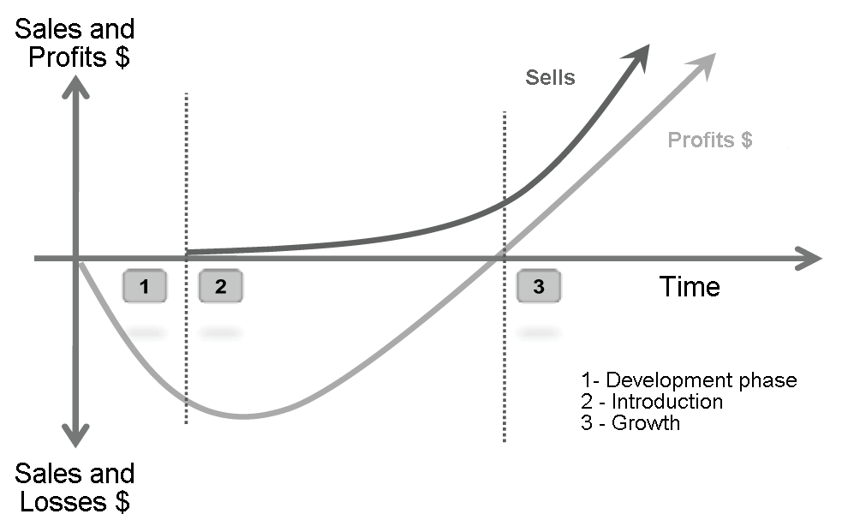

**Product.** This is the first ‘P’ that composes the model. This is the variable that defines all the productive and commercial scheme of a business because, it is through an adequate definition and design of the product that the needs of consumers are satisfied and the pro­ductive chain is structured. Products have a life cycle that has been shorter each time since the growing tendencies of industry to­gether with an disproportionate globalization, have made substitute products readily availa­ble each day. Life cycle of a product has five phases (Figure 2): Research and Development (Birth), Introduction to the market, Growth in the market, Maturity in the market and De­cay (Death) (Kotler and Keller, 2011). Bioethanol, although it has a long industrial development and has reach consolidation in the international sphere as a competitive energy source, is still in the initial phases of the product life cycle (Luo *et al.*, 2009).

Bioethanol release to the market, as massive commercialization product compared to other type of biofuels and fossil fuels, is very recent (Luo *et al*., 2009). This fact make it as a product in the phase of research and industrial, business and commercial develop­ment considering that its global structure still needs large economical and productive efforts. In terms of its growth in sales and its economic incursion in the market, bioethanol shows strong attitudes for introduction and growth. It was only in 1980 when it started to be consolidates as a direct substitute of petroleum. For bioethanol being in this phase means a relatively low level of sales but with growing tendencies, the productive pro­cess can be seen in Figure 3. In this phase the number of sales is limited because the productive capacity of bioethanol have not reached yet an industrial massification, as it is required for the population to substitute oil. It had a safe research and develop pro­cess, and more than 40 years of research had passed to forge knowledge about this well-structured product (Balat *et al.* 2008) (Table 6).

**Figure 1.** Marketing mix components.

**Source**: Kotler and Keller, 2011; Kotler and Armstrong, 2011.

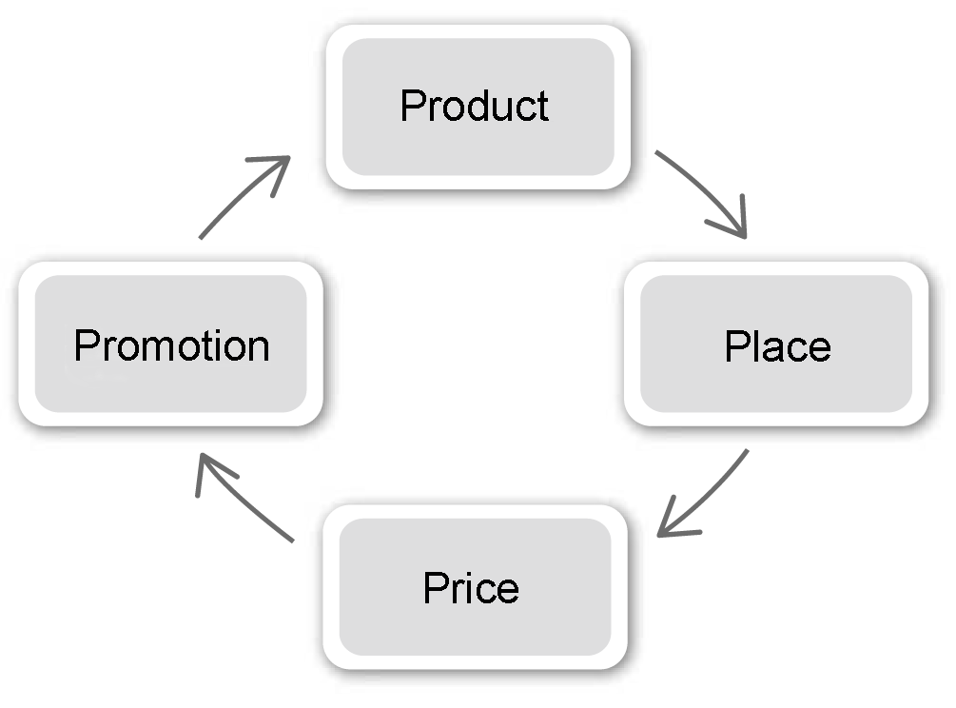

Bioethanol is currently in phase 2 of the product life cycle as sales are registered at the commercial level, but the profits are covering most of the investment done in re­search and development and infrastructure from the beginning of the productive process (Kotler and Keller, 2011). Potential in Colom­bia can be seen as increasing due to the potential in expanding sugarcane crops as is observed in Figure 4, where is pointed that from short to medium term is possible to in­crease sugarcane total area to 10,973,000 hectares.

|  |  |  |  |  |  |
| --- | --- | --- | --- | --- | --- |
| Table 6. Annual production of ethanol from sugarcane in Colombia. | | | | | |
| Indicator | **Year** | | | | |
| **2008** | **2009** | **2010** | **2011** | **2012a** |
| Hectares in sugarcane | 205,664 | 208,254 | 218,311 | 223,905 | nd |
| Grinded sugarcane in millions of tons | 19.20 | 23.58 | 20.27 | 22.72 | nd |
| Sugar production in millions TMVC | 2.03 | 2.359 | 2.07 | 2.34 | 2.4 |
| Ethanol production (millions of liters) | 255.84 | 326.84 | 291.28 | 336.95 | 370 |
| Ethanol sells (millions of liters) | 247.09 | 338.36 | 292.08 | 351.08 | nd |
| Sugar internal market in millions TMVC | 1.56 | 1.65 | 1.62 | 1.59 | nd |
| Sugar exports in millions TMVC | 0.48 | 1.05 | 0.69 | 0.94 | nd |
| TMVC: Metric tons of sugar in its equivalent to raw sugar. | | | | | |
| a. Estimated |  |  |  |  |  |
| Source: Fedebiocombustibles, 2012. | | | | | |

**Figure 3.** Mass flux of bioethanol production per 100 tons of sugarcane.

**Source**: BID, 2012.

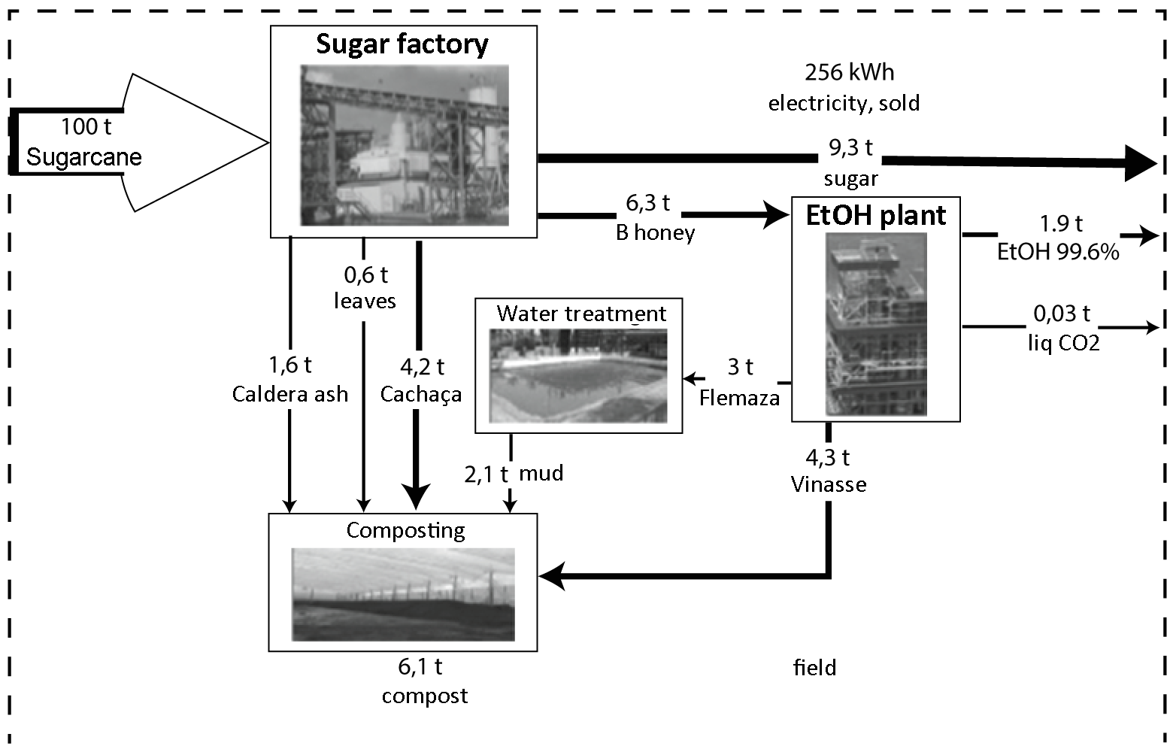

**Price*.***  The definition of Price is a fundamen­tal aspect and a task that requires a complete analysis of each part of industry, because is through evaluation of each process that an appropriate price could be inferred for the business to be sustainable and for the client to buy it (Kotler and Armstrong, 2011). This is the only variable of the mix marketing that provides a real and physical income to the production of a product. The definition of a product price starts is in essence the sum of the production, distribution and marketing costs.

Price definition is an important task in structural terms of the product market. Price should correspond to the payment capacities of consumers and should be in a price range where the substitute products and the competence are. On the other hand, depen­ding on the type of product or service that is offered and the market aiming to, there are different price rules that should meet some characteristics of the business environment. This means that the product price should be competitive but at the same time should offer tranquility to the consumer that is getting a quality product or service (Kotler and Keller, 2011). Till now, in Colombia each 1st day of the month the National Government, by means of the Ministry of Mines and Energy, fixes the price of biofuels ethanol and bio­diesel that will be apply during the month, as well as, the percentage in mixes. The price rule is established by: (1) a basic price annually adjusted with the wholesale price index and the exchange rate, ensuring to industry a minimum return rate; (2) a price that takes into account the price of the raw material plus a fixed cost for its industrial transformation and, (3) a price that depends on the hydrocarbon price that is replace by the biofuel plus the transformation cost (Table 7). To biofuels producers is paid the higher price resulting from these formulas (Fedebiocombustibles, 2012).

**Figure 4.** Sugarcane crop potential in Colombia.

**Source**: BID, 2012.

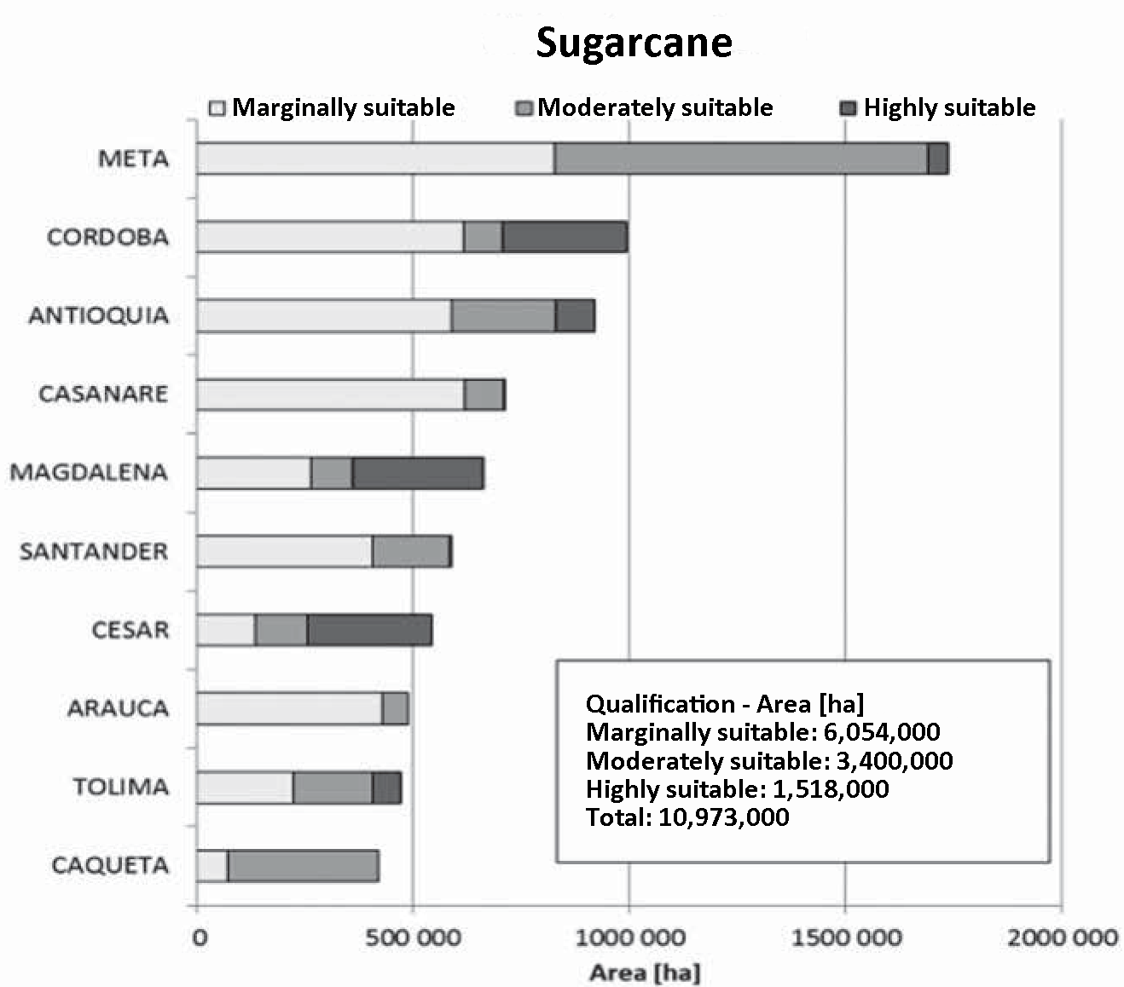

**Place.** The variable place indicates the specialized scenario where the product is sold and the sale is materialized. From a tech­nical aspect of the production and marketing chain, this is the moment where qualities are validated and the market approval is pre­sented (Kotler and Armstrong, 2011). Depending on the country security rules and the technical characteristics in the fabrics or ethanol distillers, the storage form can vary. As bioethanol has as priority goal to supply fuel for city cars, the space where this need is satisfy is in the gasoil stations. These are the places that can be called as marketing places for bioethanol. This place is shared with other type of fuels that are direct substitutes of bioethanol and that represent a stronger competition. In these stations is commercia­lized the strongest competitor of bioethanol, the gasoline.

Because it is a highly specialized and structured market, bioethanol is under strong pressure from the competition, causing that its sell abilities are in constant disadvantage compared to oil. If the business is one of the companies that at the same time owns the sales point and commercializes the product, the distribution is done directly. For ins­tance, in the Colombian case, bioethanol pro­ducers are the sugar mills that do not have distribution channels of established fuels and, in consequence, need to use indirect channels. Bioethanol distribution depends on a complex logistic that determines the best way for product transport and distribution according to available amount, times, desti­nies, resources, transportation, etc (Brimer, 1995). All this logistic is directed to optimize distribution times by a better coordination of the implicated areas looking for reducing risks and cost in product transportation. To offer an indirect distribution channel shows big challenges for bioethanol industry be­cause, the producer should ensure that product is transported and sold in the correct way keeping the quality standards imposed by industry and final consumers. However, as it is an industrial product in a market of few transactions and large and growing demands in time, biofuel industries are generating their own distribution and marketing chains. In the case of bioethanol, the producing indus­tries are setting distribution and marketing nets from the already established distribution nets for fossil fuels. The distribution chain is structured depending on the geographical location where the production plant is and the place where biofuel is sold ([Rakesh](http://www.bases.unal.edu.co:2065/action/doBasicSearch?Query=au%3A%22Rakesh+Agrawal%22&wc=on&acc=on) *et al.*, 2007). Depending on the geographical barri­ers imposed by the market some combination of transportation means are used. This distribution at global or local level should be focused on a massive and intense market. It should be aimed to sell bioethanol in all the possible locations provided that there are consumers with large use and buy habits. Massive selling places should be recognized and try to have a reserved selling place for bioethanol, looking for a commercial disposi­tion to exclusivity. In Colombia, the different production plants need truck transportation on an average distance of 129 km. The trans­portation distance between Buenaventura to Los Angeles harbor is 4903 km (Fedebiocom­bustibles, 2012). For the internal market, diesel is transported by pipelines from a refi­nery until the mixing station Puente Aranda in Bogotá. Transport process from the refi­nery is based on high quality data supplied by Ecopetrol, relative to GHG emissions and, the remaining emissions and entrances are based on data by defect from Ecoinvent21. The transportation distance was adapted to 509.07 km according to Colombia´s condi­tions (Fedebiocombustibles, 2012).

|  |  |  |
| --- | --- | --- |
| **Table 7.** Monthly prices of bioethanol in the national market of Colombia. | | |
| **Date** | **($col./gallon)a** |  | |
| 2006 | 4900.20 |  | |
| 2007 | 4744.69 |  | |
| 2008 | 4738.21 |  | |
| 2009 | 6581.51 |  | |
| 2010 | 7824.62 |  | |
| 2011 | 8392.18 |  | |
| 2012 | 8526.88 |  | |
| Until June 12 2012. a. Established price by resolution of the Ministry of Mines and Energy of Colombia. | | |
| **Source**: Ministry of Mines and Energy. | | |

**Promotion.** Promotion is a fundamental as­pect for a winner product in the market. The promotion and reception way determines the success potential. Promotional strength that joins the product and the exposure level in the market are determined by the target mar­ket, the industry desires and the economic leverage of the product (Buil *et al.*, 2008). These are some of the variables that should be taken into account initially in the moment of deciding the type of promotion or advertise­ment that is going to be used (Balakrishnan, 2009). By the product characteristics, indus­trial and economic backing of bioethanol and the market dimensions for biofuels, it can be said that the type of advertisement use for bioethanol industry is promotion at the se­lling points (direct marketing) (Kotler and Ke­ller, 2011). As it is on a market with a high competence index, it should be remembering its presence and participation in the fuel and biofuel market. Generally, bioethanol publi­city shows a consistent and complete me­ssage to the market (Jansson *et al.*, 2010). Bioethanol should transmit a message of renovation and change that persuades con­sumer to change habits towards a growing use of bioethanol. Most of the communica­tion associated with bioethanol is originated on environmental, scientific, economic and political news referring to benefits and defects of this product and, the environmental and social responsibility. There are also massive communications remembering or noticing the labels found on bioethanol industry, as it is done by oil industries that are diversifying its product portfolio and using bioethanol as renovation and modernization resource under a concept of environmental awareness.

As bioethanol is in its introduction to market phase, the advertisement should be strong and rigid and directed to specific mar­ket sectors, in order to aware the possible and future consumers about the benefits and attributes of the product, it means, it should be informed the most of the aspects related to the product to get customers wishing to con­sume it (Luo *et al.*, 2009).

**Productive and competitive capacity of bioethanol**

Colombian ethanol from sugarcane has an important potential since it only generates 26% of GHE emissions compared to fossil fuel, without considering the direct and indi­rect effects on land use. This good balance is related to relatively low emissions, good prac­tices and favorable climatic conditions in the main area of sugarcane crops in Colombia, along the Cauca River, resulting in high re­sources productivity and efficiency (BID, 2012).

According to Vergagni (2007) the current productive structure of bioethanol has been greatly favored by the technological advances in the area, which has represented industrial advantages as: higher yield rate in the etha­nol production by biomass unit used; higher yield rate in the productive conversion; lower generation of affluents; development of new coproducts; use of new raw material combinations (for instance, biomass from giant grasses); and the reduction on contami­nants emissions and residues.

Related to its industrial and marketing potential it is highlighted that bioethanol is on a very privileged productive position. In 2007 represented 94% of the global biofuels production, representing a 32% replacement on the global oil production (Balat *et al.*, 2008). This demonstrates a very strong posi­tioning that cannot be removed from the fu­ture analysis of bioethanol, considering that it shows a commercial and industrial scenario with great potential of growth (Demirbas, 2008; Fischer and Schrattenholzer, 2001).

* From the economic, management and in­dustrial point of view, bioethanol has a growth fronts: Raw material diversification for bioethanol production in order to generate a supplies net from diverse plants with a more efficient structure of costs. Reduction on production costs and sale price will help positioning bioethanol in the market (Haykiri-Acma and Yaman, 2010; Kim and Dale, 2004).
* Generation of a complete and integrated productive chain that can articulate each industrial and commercial aspect, from the raw material crops till the bioethanol placement in the market. Inclusive, a growth source is related to construction of biorefineries equipped with the latest technology, which can work integrally with other industrial biorefineries (Coppola *et al.*, 2009).
* Implementation of an aggressive and di­rect marketing proposal directed to governments and consumers, in order to achieve a larger participation in the mar­ket, better label remembering, promotion of customers loyalty and, government help to generate large scale changes (Soccol *et al.*, 2010).

Structuration of a work plan for long term in which these three pillars are the strategic goals of the production industry, framed un­der an international marketing scheme, could mean the consolidation of a predominant bio­ethanol industry in the global energetic sce­nario. The integration of a system based on a suitable configuration and coordination of the marketing mix at the national and interna­tional level, can contribute to accelerate the growing process pose by these three pillars (McCarthy and Perreault, 2000; Porter, 1986, 1990).

Bioethanol future could be determined by new technologies use that achieve the maxi­mum profit of raw materials and crop fields, as well as the increase in industrial demand of energy from biomass (Hernández and Kafa­rov, 2009; Rosillo, 2006).

Bioethanol competitive level in the market will be strong and direct, renewable sources of energy, for instance, pose a solid competi­tive and rivalry scenario since, until now, they are the ones reporting the greater environmental benefits. Additionally, they are the ones with more social and political acceptance; however, the current regulatory framework has not been enough to encourage biofuel use. The compulsory use of no-fossil fuels or less contaminant fuels, together with solid punitive measurements that protect the environment from the multiple attacks suffe­red in the last years, could increase bioetha­nol use and its development, which is curren­tly under its potential.

The government has an important role in this scenario, because Colombia has genera­ted a program for consolidation of the biofuel mixing program, a technical norm for bioethanol transport, the possibility to diver­sify the energetic options, good practices norms, biofuel market studies, among others (Rodado, 2011).

**Final considerations**

* Bioethanol as an energy alternative is one of the contemporaneous proposals with greater development opportunities in the fuel market, considering its huge marke­ting and industrial potential. Its multiple social, environmental, economic and scientific advantages, have made the etha­nol an excellent substitute for fossil ener­gy sources.
* Although the bioethanol has big challen­ges to overcome in the industry and mar­ket, the constant advances and proposal improvement, given the raw material diversification (multiple biomass types), have structured a really strong productive scheme. Despite of the disadvantages that can have the industrial production of bioethanol, the growing energy demand demands permanent supply. In conse­quence, diverse strategies have been crea­ted to improve product quality and to pro­mote the introduction of biofuels to the market. As example is the searching for alternative sources of raw materials, exploration of new production and proce­ssing methods, and the development of technological innovations at various lev­els.
* Now, the big advances in development of this industry are achieved thanks to scientific discoveries structures from studies on diverse raw materials to pro­duce ethanol. Nowadays, the industry ac­tion field for bioethanol is very wide be­cause it is still in its first developmental phases. The ones interested in participa­ting as competitors will face the challenge of developing growth strategies to reach new markets, new geographic zones, diversify the product line or apply changes to the existing structure, in order to im­prove productivity and cost structure.
* The companies that want to be part of the productive industry of bioethanol should understand the strategic and competitive challenges governing this economic sector. Understanding and defining the competi­tive strategy in the industry will allow companies to generate competitive advan­tages to survive in the bioethanol market (Porter, 1985).
* Energy industry shows a prosperous panorama for investors. The analysis per­formed shows that despite of requiring a large initial capital, the earnings scheme is progressive, making it an attractive business. Analyzing the bioethanol de­mand and supply growth, it is found that countries are focused on increasing the productive capacity of bioethanol, in order to reduce their dependence on no renewa­ble energy sources.
* On the other hand, there should be pro­moted social habits for utilization of re­sources that are more aware and friendly with the current environmental situation. Campaigns and scientific and technologi­cal programs should be generated to pro­mote and foster the development of new technologies for new methods that help the creation of sustainable energetic productive systems. Therefore, it should exist political disposition in the countries to expand these type of thoughts and ideas of change, considering that it is from this kind of proposals and measurements that societies are strengthen. This is no­ticed because thanks to this type of innovations and productive, scientific and industrial discoveries, positive changes in the economic composition of a specific in­dustrial sector are generated, and those are considerable benefits that lead to greater global profits in the economic sec­tor. These phenomena show the incorporation of more players from diverse knowing areas working to compose eco­nomic structures with higher horizontal transformation, which are the ones that can increase social development.

**References**

# Actividad Avipecuaria. 2012. FAO: Producción de etanol de maíz eleva los precios del grano en el mundo, ENERO 25/2012. Disponible en: <http://www.actualidadavipecuaria.com/noticias/fao-produccion-de-etanol-de-maiz-eleva-los-precios-del-grano-en-mundo.html>, consultado en: Junio 15 de 2012.

Asociación de Cultivadores de Caña de Azúcar. 2012. Balance azucarero colombiano Asocaña 2000 – 2012. Colombia. Disponible en: <http://www.asocana.org/>, consultado en: Junio 15 de 2012.

Asociación de Productores de Energías Renovables (APPA). 2007. Biocarburantes y Desarrollo sostenible Mitos y Realidades. Barcelona.

Asociación de Productores de Energías Renovables (APPA). 2009. Estudio del Impacto Macroeconómico de las energías Renovables en España. Barcelona.

Asociación de Productores de Energías Renovables (APPA). 2010. [APPA Biocarburantes](http://www.appa.es/03biocarburantes/03que_sona.php). España. Disponible en: <http://www.appa.es/03biocarburantes/03que_sona.php>, consultado en: Junio 15 de 2012.

Bahr, H. O. 1991. Máquina de vapor. Labor, Barcelona.

Balakrishnan, M. 2009. Strategic branding of destinations: a framework. European Journal of Marketing 43(5/6): 611 – 629.

Balat M.; Balat, H. and Oz, C. 2008. Progress in bioethanol processing. Progress in Energy and Combustion Science 34: 551 – 573.

BID, 2012. “Evaluación del ciclo de vida de la cadena de producción de biocombustibles en Colombia, Colombia. Disponible en: http://www.minminas.gov.co/minminas/downloads/UserFiles/File/hidrocarburos/Capitulo_0_Resumen_ejecutivo_final.pdf, consultado: Junio 15 de 2012

Blanco, I. and Azqueta, D. 2007. Can the environmental benefits of biomass support agriculture?. The case of cereals for electricity and bioethanol production in northern Spain. Energy Policy 36: 357 – 366.

Brimer, R. 1995. Logistics networking. A consideration of the components essential to an integrated logistics support network. Logistics Information Management 8(4): 8 – 11.

Bruszies, C. 2010. Biofuels Cluster in Colombia - A Proposal for the Establishment of a Biofuels Competence Network in Colombia. Industieberatung Consultores Empresariales. Bogotá.

Buil, I.; Chernatony, L. and Hem, L. 2008. Brand Extension Strategies: perceived fit, brand type, and culture influences. EuropeanJournal of Marketing 43(11/12): 1300 - 1324.

Clarke, A. and Gaston, K. 2006. Climate, Energy and Diversity. Proceedings: Biological Sciences 273(1599): 2257 - 2266.

Coppola, F.; Bastianoni, S. and Ostergard, H. 2009. Sustainability of bioethanol production from wheat with recycled residues as evaluated by emergy assessment. Biomass and Bioenergy 33: 1626 – 1642.

Demirbas, A. 2008. The Importance of bioethanol and biodiesel from biomass. Energy Sources, 3; 27-36.

Escobar, J.; Lora, E.; Venturini, O.; Yáñez, E., Castillo, E. and Almazan, O. 2009. Biofuels: environment, technology and food security. Renewable and Sustainable Energy Reviews 13: 1275 – 1287.

F.O. 2006. Licht’s World Ethanol and Biofuels Report.

Fedebiocombustibles, 2012. Cifras Informativas del Sector Biocombustibles ETANOL ANHIDRO DE CAÑA, Disponible en: http://www.fedebiocombustibles.com/files/Cifras%20Informativas%20del%20Sector%20Biocombustibles%20-%20ETANOL(38).pdf, Consultado: Junio 15 de 2012.

Fischer, G. and Schrattenholzer, L. 2001. Global bioenergy potentials through 2050. Biomass and Bioenergy 20: 19-32.

Grove, E. 1979. Present and Prehistoric Problems of Natural Resources. American Journal of Agricultural Economics 61(4): 612 - 619.

Hacisaligoglu, S. 2009. Ethanol–gasoline and ethanol–diesel fuel blends. Energy EduSciTechnol 22: 31 - 46.

Haykiri-Acma, H. and Yaman, S. 2010. Interaction between biomass and different rank coals during co-pyrolysis. Renewable Energy 35: 288 - 292.

Hektor, B. 2000. Planning models for bioenergy: Some general observations and comments. Biomass and Bioenergy 18: 279 - 282.

Hernandez, L. and Kafarov, V. 2009. Use of bioethanol for sustainable electrical energy production. International Journal of Hydrogen Energy 34: 7041 – 7050.

Hooper, R. and Li, J. 1996. Summary of the factors critical to the commercial application of bioenergy technologies. Biomass and Bioenergy 2(6): 469 – 474.

International Energy Statistics. 2012. Disponible en: [http://www.eia.gov/cfapps/ipdbproject/IEDIndex3.cfm?tid=5ypid=54yaid=4](http://www.eia.gov/cfapps/ipdbproject/IEDIndex3.cfm?tid=5&pid=54&aid=4), consultado 10 de junio de 2012

Jansson, J.; Marell, A. and Nordlund, A. 2010. Green consumer behavior: determinants of curtailment and eco-innovation adoption. Journal of Consumer Marketing 27(4): 358 – 370.

Kim, S. and Dale, E. 2004. Global potential bioethanol production from wasted crops and crop residues. Biomass and Bioenergy 26: 361 – 375.

Kotler, P. and Armstrong, G. 2011. Principles of Marketing, Pentice Hall, USA.

Kotler, P. and Keller, K. 2011. Marketing Management (14th Edition), Pearson, USA.

Luo, L.; Voet, E. and Huppes, G. 2009. Life cycle assessment and life cycle costing of bioethanol from sugarcane in Brazil. Renewable and Sustainable Energy Review 13: 1613 – 1619.

Malsa, J. and Freireb F. 2006. Renewability and life-cycle energy efficiency of bioethanol and bio-ethyl tertiary butyl ether (bioetbe): assessing the implications of allocation. Energy 31: 3362 – 3380.

McCarthy, E. y Perreault W Jr. 2000. Marketing, un enfoque global.Decimotercera Edición. México.

Millennium ecosystem assessment. 2005. Ecosystems and human well-being: synthesis. Washington, DC, Island press.

Miller, A. 2007. The Global Environment Facility program to commercialize new energy technologies. Energy for Sustainable Development 1(1): 5 – 12.

Ministerio de Medio Ambiente de España. 2005. Análisis del ciclo de vida de combustibles alternativos para el transporte. Fase i. análisis de ciclo de vida comparativo del etanol de cereales y de la gasolina. Energía y cambio climático. Madrid.

Ministerio de Minería y Energía de Chile. 2006. Biocombustibles, un aporte para la seguridad energética. Santiago de Chile.

Mohr, R. 2002. Technical Change, External Economies, and the Porter Hypothesis. Journal of Environmental Economics and Management 43:158 – 168.

Naik, S.; Goud, V.; Rout, P.; Jacobson, K. and Dalai, A. 2010. Characterization of canadian biomass for alternative renewable biofuel. RenewableEnergy 35: 1624 – 1631.

Páramo, D. 2004. Marketing, su esencia conceptual. Barranquilla.

Pimentel, D. and Patzek, T. 2005. Ethanol production using corn, switch-Grass, and wood; biodiesel production using soybean, and sunflower. Natural Resources Research 14:65 - 76.

Portafolio. 2011. A 10% limitarán mezcla obligatoria de gasolina con etanol, Mayo 13 de 2011. Disponible en: http://www.portafolio.co/economia/10-limitaran-mezcla-obligatoria-gasolina-etanol, Consultado: 15 de junio de 2012

Portafolio. 2012. Etanol de caña reduce en 74% de las emisiones, Enero de 2012. Disponible en: http://www.portafolio.co/negocios/etanol-cana-reduce-74-las-emisiones, Consultado en 15 de Junio de 2012

Porter, M. 1983. Industrial Organization and the Evolution of Concepts for Strategic Planning: The New Learning, Managerial and Decision Economics 4(3): 172 – 180.

Porter, M. 1985. Competitive advantage: Creating and sustaining superior performance. Free Press, EUA.

Porter, M. 1986. Competition in global industries. Harvard Business School Free Press, EUA.

Porter, M. 1987. From competitive advantage to corporate strategy, Harvard Business Review mayo/junio: 43 – 59.

Porter, M. 1990. The competitive advantage of nations. Free Press, EUA.

Porter, M. 1996. What Is Strategy?,Harvard Business Review noviembre/diciembre: 1 - 24.

Potocnik, J. 2007. Renewable Energy Sources and the Realities of Setting an Energy Agenda. [Science](http://www.bases.unal.edu.co:2065/action/showPublication?journalCode=science), New Series 315(5813): 810 - 811.

Prahalad, C. and Hamel, G. 1990. The Core Competence of The Corporation. Harvard Business Review, mayo – junio: 79 – 91.

Qiu, H.; Huang, J.; Yang, J.; Rozelle, S.; Zhang, Y. ; Zhang, Y.; Zhang Y. 2010. Bioethanol development in China and the potential impacts on its agricultural economy. Applied Energy 87: 76 – 83.

[Rakesh, A.;](http://www.bases.unal.edu.co:2065/action/doBasicSearch?Query=au%3A%22Rakesh+Agrawal%22&wc=on&acc=on) [Navneet, S.;](http://www.bases.unal.edu.co:2065/action/doBasicSearch?Query=au%3A%22Navneet+R.+Singh%22&wc=on&acc=on) [Fabio, R. and Nicholas, D. 2007.](http://www.bases.unal.edu.co:2065/action/doBasicSearch?Query=au%3A%22Fabio+H.+Ribeiro%22&wc=on&acc=on)  [Sustainable Fuel for the Transportation Sector](http://www.bases.unal.edu.co:2065/stable/25427104?&Search=yes&term=biofuels&term=distribution&list=hide&searchUri=%2Faction%2FdoBasicSearch%3FQuery%3Dbiofuels%2Bdistribution%26gw%3Djtx%26acc%3Don%26prq%3Dbioethanol%2Bdistribution%26hp%3D25%26wc%3Don&item=3&ttl=174&returnArticleService=showFullText). Proceedings of the National Academy of Sciences of the United States of America 104(12): 4828 – 4833.

Republica de Colombia, Conpes 3510, 2008. Disponible en: <http://www.minminas.gov.co/minminas/downloads/UserFiles/File/hidrocarburos/Biocombustible/Conpes203510.pdf>, consultado: 15 de junio de 2012

Republica de Colombia, Decreto 1135 de 2009. Disponible en: http://www.alcaldiabogota.gov.co/sisjur/normas/Norma1.jsp?i=35810#6 , consultado: 15 de Junio de 2012.

Republica de Colombia, Decreto 2629 de 2007, Disponible en: http://www.alcaldiabogota.gov.co/sisjur/normas/Norma1.jsp?i=25667, consultado: 15 de Junio de 2012.

Rodado, C. 2011, Política pública y perspectivas de los biocombustibles en el actual Gobierno, Ministro de Minas y Energía XXXIX Congreso Nacional de Cultivadores de Palma de Aceite Cali, 8 de junio de 2011

Roosa, A., Grahamb, R., Hektora, B. and Rakosc, C. 2000. Planning models for bioenergy: some general observations and comments.Biomass and Bioenergy 18: 279 - 282.

Rosillo, F. 2006. Global market for bioethanol: historical trends and future prospects. Energy for Sustainable Development 10(1): 20 – 32.

Rouch, D. and Santi, P. 2001. Competitive Intelligence Adds Value: Five Intelligence Attitudes. European Management Journal, Vol. 19, No. 5, 552–559.

Schubert, R. and Blasch, J. 2010. Sustainability standards for bioenergy - A means to reduce climate change risks? Energy Policy 38: 2797 – 2805.

Silveira, S. (2005). Promoting bioenergy through the clean development mechanisms. Biomass and Bioenergy 28:107 – 117.

Soccol, R.; Porto de Souza, L.; Pedroni, A.; Karp, S.; Buckeridge, M.; Pereira, L.; Pitarelo, A.; Ferreira, V.; Fortes, L.; Ferrara, M.; Pinto da Silva, E.; Pepe de Moraes, L.; de Amorim, J. and Gonçalves F. 2010. Bioethanol from lignocelluloses: Status and perspectives in Brazil. Bioresource Technology 101: 4820 – 4825.

Vergagni, G. 2007. Bioetanol desde el maíz – estado actual y nuevas tendencias, oportunidades y desafíos. Argentina: A y V Empresarios Desarrollos.

Zhou, P.; Ang, B. and Poh, K. 2006. Decision analysis in energy and environmental modeling: an update. Energy 31(2), 14 – 22.

1. Review article that belongs to the research line Research Group on Marketing, Innovation and Competitiveness in Agricultural Management MILAGRO of the Universidad Nacional de Colombia, Faculty of Agronomy - Bogota.