**Morpho-physiological characteristics of common bean (*Phaseolus vulgaris* L.) related to drought adaptation**

Características morfo-fisiológicas de frijol común (*Phaseolus vulgaris* L.) relacionadas con la adaptación a sequía

José A. Polanía1*, Idupulapati M. Rao1, Sara Mejía2, Stephen E. Beebe1, y César Cajiao1

1 International Center for Tropical Agriculture (CIAT), A.A. 6713, Cali, Valle del Cauca, Colombia.   
2 Department of Agricultural Sciences, Universidad Nacional de Colombia, A.A. 237, Palmira, Valle del Cauca, Colombia.   
*Corresponding author:  [j.a.polania@cgiar.org](mailto:j.a.polania@cgiar.org)

Rec.: 04.01.12 Acept.: 23.09.12

**Abstract**

Development of drought adapted common bean cultivars is a strategy to improve food security in bean producing areas under drought stress. Under greenhouse conditions at the International Center for Tropical Agriculture (CIAT), Palmira, Colombia, we evaluated the morphological and physiological traits of 21 common bean lines (*Phaseolus vulgaris* L.) that were subjected to drought stress and irrigated treatments using a soil cylinder system. The characteristics evaluated were visual rooting depth, total root length and distribution across the soil profile. In the field, using the same bean genotypes, we evaluated differences in water use efficiency (using carbon isotope discrimination) and grain yield. Under greenhouse conditions, we found that visual rooting depth and root length at soil depth of 60-75 cm correlated positively with shoot biomass (r = 0.56 and 0.50 respectively, P < 0.001) production when water supply was limiting. Under field conditions, grain yield under drought stress was positively associated with carbon isotope discrimination in grain (r = 0.32 P < 0.01). Five lines (NCB 226, SER 16, SEN 56 and SEA 15) had higher root length under drought stress (28, 24, 29 and 27 m/plant respectively) compared with the other lines evaluated, which allows greater water uptake and transpiration, and also in mobilization of photosynthate to greater production of grain. It is estimated that the visual rooting depth, root length at soil depth of 60 to 75 cm and carbon isotope discrimination in grain, are valuable traits as selection criteria in breeding for drought stress tolerance in common bean.

**Key words:** Carbon isotope discrimination, grain yield, root length, visual rooting depth.

**Resumen**

El desarrollo de variedades adaptadas es una de las estrategias que contribuye a garantizar la seguridad alimentaria en zonas productoras de frijol con estrés por sequía. En los invernaderos de cristal del Centro Internacional de Agricultura Tropical (CIAT), Palmira, Colombia, se evaluaron las características morfológicas y fisiológicas de raíces de 21 líneas de frijol (*Phaseolus vulgaris* L.) en condiciones de estrés por sequía e irrigación, utilizando un sistema de tubos plásticos desarrollado por el CIAT. Las características evaluadas fueron profundización visual, longitud total de raíces y distribución de raíces a través del perfil del suelo. En campo, utilizando los mismos genotipos de frijol, se evaluaron características relacionadas con la eficiencia de uso de agua mediante la técnica de discriminación de isótopo de carbono y producción de grano. Los resultados en invernadero mostraron que la profundización visual y longitud de raíces entre 60 y 75 cm tienen una correlación significativa (r = 0.56 y 0.50 respectivamente, P < 0.001) con la biomasa aérea de la planta en condiciones de estrés por sequía. En campo, la discriminación del isótopo de carbono en grano se correlacionó (r = 0.32, P < 0.01) con la producción de grano en condiciones igualmente de estrés por sequía. Las líneas de frijol NCB 226, SER 16, SEN 56 y SEA 15 presentaron una mayor longitud de raíces bajo estrés por sequía (28, 24, 29 y 27 m/planta respectivamente) en comparación con las demás líneas evaluadas, lo que les permite mayor transpiración y movilización de fotoasimilados, que favorecen una alta producción de granos. Se estima que la profundización visual, la longitud de raíces entre 60 y 75 cm y la discriminación de isótopo de carbono en grano, son características valiosas como criterios de selección en mejoramiento por tolerancia a estrés por sequía en frijol común.

**Palabras clave:** Discriminación de isótopo de carbono, longitud de raíz, producción de grano, profundización de raíz.

Introduction

Climate change is a progressive threat for food production, especially in the less developed regions. Among these threats are severe and frequent droughts and floods that favor the emergence of new pests and diseases and the increase of the ones that are already present. The most negative impacts of this situation are sensed by the small farmers in subsis­tence systems in the developing countries (Morton, 2007). Common bean (*Phaseolus vul­garis* L.) is the second most important legume for feeding in the tropic of Latin America and Eastern and Meridional Africa. Today, in these regions, the common bean is cultivated by small farmers frequently under no favorable conditions and with low inputs use (Beebe *et al*., 2008), it constitutes a cheap protein and calories source for the population (Rao, 2001). However, crop yields are affected by various aspects, among them droughts that can gene­rate crop losses between 10% and 100%. Around 60% of the common bean producing areas have long drought periods and it is the second most important cause of yield losses after diseases (Thung and Rao, 1999; Rao, 2001).

Development of cultivars that are adapted to these extreme conditions is a possible option to contribute to food security in a growing population that needs significant increases in food production (Polanía *et al*., 2009). The progress of the breeding programs relies on the precise selection of less frequent geno­types with new or improved traits (Sorrells, 2007), which means that a suitable pheno­typic characterization will remain as a column for breeding. There are some processes that can be used for water stress plant breeding, among them: (1) better movement of available water in the arable layer caused by roots; (2) more carbon acquisition (biomass) in ex­change of water transpired by the crop, or transpiration efficiency; and (3) better mobili­zation of the accumulated biomass to the har­vest produce (Condon *et al*., 2004).

Turner (1979) and Huang and Gao (2000) found that some plant characteristics improve drought adaptation, especially a vigorous root system. A higher access to available water secures high transpiration and growth rates.

Carbon isotope discrimination is a characte­ristic that allows the differentiation by trans­piration rate and water use efficiency. Iso­topes are atoms variants of one chemical component; in the case of carbon there are three isotopes: 12C, 13C and 14C, whose nuclei have the same number of protons (six) but, a different number of electrons (six, seven and eight, respectively), therefore despite of having similar chemical properties, they have a diffe­rent atomic mass; 13, 13 and 14 (Uriarte, 2003). Most the natural carbon is 12C and represents the 98.9% in nature, a small por­tion is 13C (1.1%) (Farquhar *et al*., 1989). An even smaller portion is 14C which is radioac­tive and unstable and it is used in paleochro­nology. During photosynthesis, plants dis­criminate and preferring CO2 with a lighter 12C, therefore most of the carbon in the plant biomass is of this type (Farquhar *et al*., 1989). Isotope discrimination is used in plant physio­logy as an indirect indicator of stomatal clo­sure and water use efficiency, since during water stress periods some plants tend to close their stomata to loss less water there is less CO2 input and therefore plants discriminate less the 13C, thus in sugars its concentration is higher (Uriarte, 2003).

Selection for low 13C discrimination has been proposed as a method to improve the water use efficiency in C3 crop breeding pro­grams (Khan *et al*., 2007). In the case of common bean (C3 crop) several evaluated ge­notypes under water stress showed higher 13C dis­crimination, similarly a positive correlation between this type of discrimination and root length density was found (White *et al*., 1990).

From the results of these studies led to the hypothesis that plants under water stress with capacity to produce deep roots and, therefore, accessing to a higher water volume, suffer less under this type of stress, resulting in a higher stomatal conductance and higher 13C discrimination; however this is a hypothe­sis that needs more detailed studies (Hall 2004; White *et al*., 1990; White 1993).

The main objective of this work was to eva­luate morpho-physiological characteristics of common bean such as deep rooting and car­bon isotope discrimination and its contribu­tion to a higher grain yield under drought stress, in order to incorporate these criteria in this crop breeding program.

Materials and methods

This research was done in the International Centre for Tropical Agriculture (CIAT) located in Palmira, Valle del Cauca, Colombia, 3° 31' N and 76° 19' W, 965 MASL. A group of 21 Mesoamerican genotypes of common bean (*P. vulgaris* L.) was used: BAT 477, Carioca, DOR 390, NCB 226, NCB 280, RCB 273, SEA 15, SEN 36, SEN 56, SER 109, SER 113, SER 118, SER 125, SER 16, SER 78, SXB 405, SXB 412, SXB 415, SXB 418 and Tío Canela 75 and G 40001 (*Phaseolus acutifolius*). To evaluate the traits related to deep rooting a greenhouse assay was conducted and for the carbon isotope discrimination and grain yield a field experiment was performed.

**In greenhouse.** The experiment was con­ducted between February and May 2010. Plants were grown in transparent plastic cy­linders of 8 cm diameter and 80 cm length, inserted in PVC tubes, with an oxisol soil from Santander de Quilichao, Colombia, without aluminum toxicity (pH 4.6, Al saturation < 5%) and compaction (bulk density 1.1 g/cc). The soil used in the experiment was not steri­lized neither had any inoculants but, it was fertilized with a doses equivalent (kg/ha) to 80 N, 50 P, 100 K, 101 Ca, 29.4 Mg, 20 S, 2 Zn, 2 Cu, 0.1 B and 0.1 Mo. Treatments were distributed in completely randomized block design, with two water supply levels: 80% field capacity (FC) (irrigated) and without irrigation (terminal drought) in three replicates. Plants are grown in optimal irrigation conditions (80% FC) during the first 10 days and after these terms plants are subjected to the water supply treatments. In the irrigation treatment the cylinders were weighted each two days and an amount of water equivalent to con­sumption was added. In the terminal drought treatment no irrigation was applied according to the methodology proposed by Butare *et al*. (2011) and Polanía *et al*. (2009). In the roots it was measured: visual depth measured with measuring tape once per week; plant aerial biomass; and total length and root distribu­tion along the soil profile in five depths (0 -10, 10 - 20, 20 - 40, 40 - 60 and 60 - 75 cm). Roots were separated from the soil by hand washing; they were cleaned and processed on an Epson Expression 10000 XL scanner. Root length per each soil profile (m/plant) was de­termined with the image analyzer WinRHIZO v. 2007.

**In the field.** The research was done in CIAT between June and September 2009, soil was a highly fertile Mollisol (Aquic Hapludoll), with an estimated available water storage capacity of 130 mm till 1 m depth, water between FC -0.03MPa and permanent wilting point -15MPa. A lattice 6 x 6 design was used (36 genotypes, including the 21 lines of the pre­vious experiment and 15 additional lines for observation), in three replicates. Each plot was represented by four rows 3.72 m length, 60 cm distance between rows and plant sepa­ration of 7.5 cm (15 seeds per row lineal me­ter). Plants had irrigation and drought stress treatments. To ensure the establishment of the plants under drought treatment they had three irrigations by gravity, approximately 35 mm each, the first one three days prior so­wing, and the next two at ten and twenty-one days after sowing. The irrigation treatment had in total eight irrigations with a maximum spacing of ten days.

Grain production as dry and wet weight was measured harvesting plants in 3 m of two central rows in each plot. In each replicate a grain sample was taken and dried out in an oven at 60 °C for 48 h prior grinding to be sent to the University of California, Davis, for 13C/12C analysis on a mass spectrophotome­ter that measures the deviation d13C of the isotopic concentration on the sample in com­parison with a standard measurement coming from the carbon present on calcium carbonate of a marine fossil shell called PDB (Pee Dee Belemnite) (Farquhar *et al*., 1989).

$$δ\text{13}C\left(0/{00}\right)=\frac{\left({\text{13}C}/{\text{12}C}\right)sample-\left({\text{13}C}/{\text{12}C}\right)standard}{\left({\text{13}C}/{\text{12}C}\right)standard}x1000$$

Discrimination is calculated by the fo­llowing relation that shows the magnitude of the iso­topic fractionation between the source and the product, in this case the air is the source which has a stable δ13C isotopic com­position of 8.

$$∆\text{13}C\left(0/{00}\right)= \frac{δ\text{13}C air- δ\text{13}C sample }{\left({1+δ\text{13}C sample}/{1000}\right)}$$

Carbon discrimination, Δ, is expressed in thousand units (0/00), an equivalent of 10-3, which is not a unit; therefore, the carbon iso­tope discrimination is dimensionless (Far­quhar *et al*., 1989).

Using the SAS statistical software v 9.2 (SAS Institute, 2008) correlations between the diffe­rent root traits and foliar biomass in the greenhouse, and similarly, between carbon isotope discrimination and grain yield were calculated. Data were subjected to an analysis of variance and were plotted to observe the relationships between the different traits.

Results and discussion

|  |  |  |
| --- | --- | --- |
| **Table 1.** Coefficients of correlation (r) between aerial biomass vs. root characteristics in 21 common bean genotypes under irrigated and drought conditions in the greenhouse. | | |
| **Root traits** | **r coefficient** | |
| **Irrigated** | **Drought** |
| Total length (m/plant) | 0.57*** | 0.29* |
| Visual depth -cm/plant- |  |  |
| (days after sowing): |  |  |
| (16) | 0.45*** | 0.70*** |
| (28) | 0.49*** | 0.56*** 0.56*** |
| (35) | 0.47*** | 0.57*** 0.56*** |
| (48) | 0.50*** | 0.57*** |
| Root length in depth -m/planta-: |  |  |
| Soil depth (cm): |  |  |
| (0-10) | 0.21 | -0.15 0.56*** |
| (10-20) | 0.21 | 0.09 0.56*** |
| (20-40) | 0.35** | -0.09 0.56*** |
| (40-60) | 0.62*** | 0.48*** 0.56*** |
| (60-75) | 0.48*** | 0.50*** |
| **, ***, **** Significance at 0.05, 0.01 and 0.001 probability, respectively. | | |

**In greenhouse.** During crop growth and de­velopment temperatures of maximum 32.4 °C and minimum 19.1 °C were registered. The soil water content at the end of the experi­ment (48 days after sowing) was 52% FC. In average, aerial biomass production under drought conditions was 1.67 g/plant, while under irrigated conditions was 4.65 g/plant, which is a reduction of 73% in plant biomass (stem, leaves and pods) due to stress; this indicates the severity and damage due to ter­minal drought (progressive soil drying). The total root length under drought conditions presented a positive correlation with aerial biomass production (P < 0.05) (Table 1), indi­cating that with increasing production of roots under drought the greater is the vigor of the plant in terms of aerial biomass. Previous works on common bean showed a relationship between plant aerial traits and the root and the importance of the latest one on bean adaptation to drought (White and Castillo, 1989). On the other hand, positive correla­tions were observed between aerial biomass and visual root depth at different plant growth times, both under optimal irrigation and drought stress (Table 1).

A suitable root development allows reduc­tion of the dehydration effects on plants, therefore, root deepening allows them to ex­plore a larger soil volume and extract available water from deeper profiles when the superfi­cial roots have drained all the available water at upper pro­files (Khan *et al*., 2010). Ho *et al*. (2005), Blum (2002), Huang and Gao (2000), Sponchiado *et al*. (1989), and Turner (1979) found that a deeper and vigorous root system is an im­portant trait of plants adapted to prolonged drought. In the particular case of common bean, deeper roots are a trait to im­prove drought adaptation (Beebe *et al*., 2010; Pola­nía *et al*., 2009; Beebe *et al*., 2008; White *et al*., 1994; Sponchiado *et al*., 1989). The geno­types with deeper roots, plant vigor and aerial development were SER 109, SEA 15, SXB 412, SEN 56 and SER 16 (Figure 1 and Figure 2).

**Figure 1.** Relationship between aerial biomass and root visual depth 35 days after sowing under drought conditions in 21 common bean lines grown in the greenhouse. Lines combining greater visual root deepening with larger aerial biomass are in the upper right quadrant.



**Root visual depth under drought 35 das (cm)**

**Aerial biomass under drought**

**(g plant-1)**

Genotypes as Tio Canela 75 and BAT 477 showed deep roots but, their aerial biomass was not sufficiently developed, indicating that the plant invest most of the energy getting water. Other genotypes showed shallow roots combined with low aerial biomass (Figure 1 and Figure 2). Khan *et al*., (2010) and Bruce *et al*. (2002) consider that imbalances caused by drought stress can be compensated by larger root growth with high use of photo­assimilates and higher water absorption.

**In the field.** During crop growth and deve­lopment it was registered, in average, 32.5 °C as maximum and 19.41 °C as minimum tem­peratures. Total rainfall in the crop was 58.7 mm and potential evaporation was 462.5 mm, therefore the crop was growing under terminal drought conditions. In average, grain produc­tion under these conditions was 989 Kg/ha vs. 2516 Kg/ha in optimal irrigation condi­tions, equivalent to 61% reduction (Table 2). Drought stress increased precocity in most of the evaluated lines, since under this condition the plant needed fewer days to reach physio­logical maturity.

**Grain yield.** In both systems, irrigated and drought, differences in grain production among genotypes were observed (P < 0.05). The relationship between systems allows the identification of the better drought adapted lines that also respond well to irrigation, among them: SEN 36, SEN 56, SER 16, SER 113 and NCB 226, which indicates that the selection for drought tolerance does not imply yield reduction under optimal growth condi­tions and, that water stress is not excluding for a good behavior under irrigation. SER 78, NCB 280, SEA 15 and SER 125 lines pre­sented very good adaptation to drought condi­tions but were not responsive to irrigation.

13C carbon isotope discrimination, a varia­ble related to water use efficiency in C3 plants such as common bean, presented a significant correlation (r = 0.32**) with grain yield under drought treatment. With larger 13C discrimi­nation there is lower water use efficiency, therefore this positive correlation indicates that in common bean higher productivity lines are those with higher transpiration and con­sequently have a less efficient water use. These results are similar to the ones found by White *et al*. (1990) that observed a positive relationship between high productivity co­mmon bean under drought stress with higher 13C discrimination. NCB 226, SER 125, SXB 415, NCB 280, SER 16, SEN 36, SEN 56 and SEA 15 genotypes combine high grain yield with high 13C discrimination under drought conditions, therefore, are less water efficient (Figure 3) and have higher transpiration, wa­ter use and gas exchange to get high vigor and grain production. NCB 226, SER 16, SEN 56 and SEA 15 showed high 13C discrimination and longer roots between 60 and 75 cm of soil depth when grown in the greenhouse under drought stress (Figure 2); this characteristic allows them to extract more water from deeper soil profiles while keeping high transpiration and gas exchange rates to produce more grain. White *et al*. (1990) also found a positive relationship between 13C discrimination and root length density. The hypothesis from this result on common bean suggest that water stress tolerant plants have the possibility of growing deeper roots, having more access to water and resulting in higher stomatic con­ductance and higher 13C discrimination (Hall 2004; White *et al*., 1990; White 1993).

**Figure 2.** Relationship between aerial biomass and root length in depth between 60 and 75 cm of 21 common bean lines grown under drought conditions in the greenhouse. Lines combining deeper roots with higher aerial biomass under drought are in the upper right quadrant.

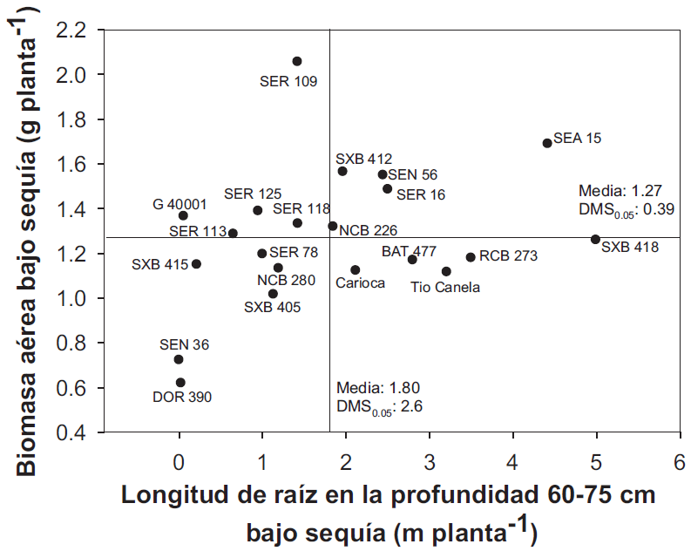

**Root length at 60-75 cm depth under drought (m plant-1)**

**Aerial biomass under drought (g plant-1)**

SER 78 line was outstanding in grain pro­duc­tion under drought and showed low 13C dis­crimination in grain, this reveals an effi­cient water use. DOR 390, Tío Canela 75 and Ca­rioca genotypes are a group with efficient wa­ter use, low carbon isotope discrimination, but have low grain yield (Figure 3); under irri­gation this characteristic was not correla­ting with grain yield (r = 0.04).

|  |  |  |  |  |  |  |
| --- | --- | --- | --- | --- | --- | --- |
| **Table 2.** Days to flowering, days to physiological maturity and grain production in 21 common bean lines under irrigated and drought conditions, 2009. | | | | | | |
| **Line** | **Days to flowering** | | **Days to physiological maturity** | | **Grain production (Kg/ha)** | |
|  | **Irrigated** | **Drought** | **Irrigated** | **Drought** | **Irrigated** | **Drought** |
| BAT 477 | 36 | 37 | 71 | 64 | 2213 | 722 |
| Carioca | 38 | 38 | 75 | 65 | 2563 | 797 |
| DOR 390 | 39 | 39 | 72 | 66 | 2345 | 674 |
| G 40001 | 32 | 30 | 60 | 56 | 2190 | 1144 |
| NCB 226 | 32 | 32 | 65 | 65 | 2571 | 1269 |
| NCB 280 | 31 | 30 | 64 | 57 | 2324 | 1229 |
| RCB 273 | 31 | 32 | 65 | 60 | 2289 | 835 |
| SEA 15 | 30 | 30 | 62 | 56 | 2368 | 1224 |
| SEN 36 | 34 | 35 | 68 | 65 | 3302 | 1158 |
| SEN 56 | 32 | 32 | 64 | 58 | 2888 | 1102 |
| SER 109 | 31 | 32 | 64 | 59 | 2375 | 991 |
| SER 113 | 36 | 35 | 68 | 61 | 2607 | 1066 |
| SER 118 | 34 | 35 | 68 | 61 | 2604 | 888 |
| SER 125 | 31 | 33 | 64 | 59 | 2439 | 1158 |
| SER 16 | 31 | 32 | 64 | 57 | 2696 | 1025 |
| SER 78 | 33 | 34 | 64 | 59 | 2352 | 1361 |
| SXB 405 | 37 | 38 | 71 | 65 | 2595 | 843 |
| SXB 412 | 37 | 36 | 71 | 62 | 2838 | 850 |
| SXB 415 | 37 | 37 | 69 | 63 | 2806 | 999 |
| SXB 418 | 37 | 36 | 71 | 66 | 2068 | 673 |
| Tío Canela 75 | 38 | 37 | 75 | 66 | 2398 | 771 |
| Mean | 34 | 34 | 67 | 61 | 2516 | 989 |
| MSD0.05 | 1.16*** | 1.15*** | 1.33*** | 1.43*** | 460*** | 338*** |

*** Significance at 0.001 probability.

Conclusions

* Under terminal drought conditions in the greenhouse, some common bean lines showed root morpho-physiological traits that were positively correlated with leaf biomass production, among them: total root length (cm/plant), root visual depth (cm) 35 days after sowing and, root length between 40 and 60 and between 60 and 75 cm of soil depth.
* The results allowed the characterization of a group of 21 common bean lines evalua­ted by their physiological expressions and identify traits related with high grain yield. Two black and small grain lines, SEN 56 and NCB 226, were characterized for ha­ving good root deepening and good vigor in the field, combined with a higher photo­synthate mobilization for pods and grain production and, therefore, a higher yield under terminal drought conditions. SER 16 and SER 109 with red and small grains, showed good root deepening under terminal drought, this allows them to have high transpiration rates and good plant vigor but, their pods and grain production was similar to the average showed by the evaluated lines. SER 78 had good water use efficiency, an important trait in envi­ron­ment where water is restricted. SEA 15 stood out in its root production and dee­pening under drought, combined with higher transpiration, showing that this is an optative line to be used as father plant for these characteristics.

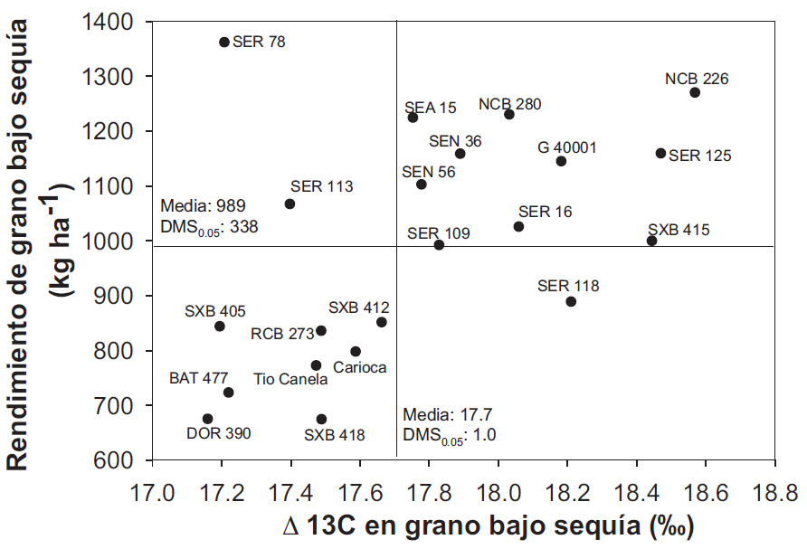

**Grain yield under drought (kg ha-1)**

**Figure 3.** Relationship between grain production and 13C carbon isotope discrimination of 21 common bean lines grown under drought conditions in the greenhouse. Lines combining larger 13C discrimination (lower water use efficiency) with higher grain production under drought are in the upper right quadrant.

**Δ13C in grain under drought (0/00)**

* BAT 477 and Tío Canela 75 control lines had good root production and deepening under terminal drought stress, combined with higher water use efficiency (lower carbon isotope discrimination), however its grain production was low showing that selecting only by root vigor is not enough to get better adaptation to drought on co­mmon bean.
* Greenhouse and field evaluations revealed several physiological traits associated with drought tolerance that can be used in common bean genetic breeding programs. Additionally, they allow the identification of outstand lines for those traits that can be used as parentals in the crossing pro­grams, therefore, it is recommended to combine different traits such as pho­toassimilate movilization and vigor.

Acknowledgments

Authors are grateful for the Generation Cha­llenge Program and the Bill and Melinda Gates Foundation funding in the Tropical Legumes I (TLI) Program: Improving Tropical Legume Productivity for Marginal Environments in sub-Saharan Africa and South Asia. They also thank Miguel Grajales, Mariela Rivera and María del Pilar Hurtado for their professional help.

References

Beebe, S.; Rao, I. M.; Cajiao, C.; and Grajales, M. 2008. Selection for drought resistance in co­mmon bean also improves yield in phosphorus limited and favorable environments. Crop Sci. 48:582 - 592.

Beebe, S. E.; Rao, I. M.; Blair, M. W.; and Acosta- Gallegos, J. A. 2010. Phenotyping common beans for adaptation to drought. En: J. M. Ribaut and P. Monneveux (eds.). Drought phenotyping in crops: from theory to practice. Generation Challenge Program Special Issue on Phenotyping. p. 311 - 334.

Blum, A. 2002. Drought tolerance - is it a complex trait? In: Saxena, N.P. y J.C. OToole (eds.). Field screening for drought tolerance in crop plants with emphasis on rice. Proc. International Workshop on Field Screening for Drought Tolerance in Rice, 11-14 Dic. 2000. ICRISAT, Patancheru y Rockefeller Foundation, Nueva York. p. 17 - 22.

Bruce, W. B.; Edmeades, G. O.; and Barker, T. C. 2002. Molecular and physiological approaches to maize improvement for drought tolerance. J. Exp. Bot. 53:13 - 25.

Butare, L.; Rao, I. M.; Lepoivre, P.; Polania, J.; Cajiao, C.; Cuasquer, J. B., and Beebe, S. 2011. New sources of resistance in Phaseolus species to individual and combined aluminium toxicity and progressive soil drying stresses. Euphytica 181:385 - 404.

Condon, A. G.; Richards, R. A.; Rebetzke, G. J.; and Farquhar, G. D. 2004. Breeding for high wateruse efficiency. J. Exp. Bot. 55:2447 - 2460.

Farquhar, G. D.; Ehleringer, J. R.; and Hubick, K. T. 1989. Carbon isotope discrimination and photosynthesis, Annu. Rev. Plant Physiol. Plant Mol. Biol. 40:503 - 37.

Hall, A. E. 2004. Comparative ecophysiology of cowpea, common bean and peanut. En: Physiology and biotechnology integration for plant breeding. Ed. Nguyen HT y Blum A. Marcel Dekker Inc. Nueva York. 271 - 325.

Ho, M. D.; Rosas, J. C.; Brown, K. M.; and Lynch, J. P. 2005. Root architecture tradeoffs for water and phosphorus acquisition. Funct. Plant Biol. 32:737 - 748.

Huang, B. and Gao, H. 2000. Root physiological characteristics associated with drought resistance in tall fescue cultivars. Crop Sci. 40:196 - 203.

Khan, H.; Link, W.; Hocking, T. J.; and Stoddard, F. L. 2007. Evaluation of physiological traits for improving drought tolerance in faba bean (Vicia faba L.). Plant Soil. 292:205 - 217.

Khan, H. R.; Paull, J. G.; Siddique, K. H.; Stoddard, F. L.. 2010. Faba bean breeding for drought-affected environments: a physiological and agronomic perspective. Field Crops Res. 115:279 - 286.

Morton, J. F. 2007. The impact of climate change on smallholder and subsistence agriculture. Proc. Nat. Acad. Sci. 104:19680 - 19685.

Polanía, J A.; Rao, I. M.; Beebe, S.; and García, R. 2009, Desarrollo y distribución de raíces bajo estrés por sequía en frijol común (*Phaseolus vulgari*s L.) en un sistema de tubos con suelo. Agron. Col. 27(1):25 - 32.

Rao, I. M. 2001. Role of physiology in improving crop adaptation to abiotic stresses in the tropics: The case of common bean and tropical forages. In: Pessarakli, M. (ed.). Handbook of Plant and Crop Physiology. Marcel Dekker, Inc., Nueva York. p. 583 - 613.

SAS Institute, 2008. Base SAS 9.2. Procedures Guide. Statistical procedures. SAS, Inst., Cary, NC, EE.UU.

Sorrells, M.E. 2007. Application of new knowledge, technologies, and strategies to wheat improvement. Euphytica 157:299 - 306.

Sponchiado, B.; White, J.; Castillo, J.; and Jones, P. 1989. Root growth of four common bean cultivars in relation to drought tolerance in environments with contrasting soil types. Exp. Agric. 25:249 - 257.

Thung, M. and Rao, I. M. 1999. Integrated management of abiotic stresses. En: Singh, S. (ed.). Common bean improvement in the twenty-first century. Kluwer Academic Publ., Dordrecht, Holanda. p. 331 - 370

Turner, N. C. 1979. Drought resistance and adaptation to water deficits in crop plants. En: H. Mussell y R.C. Staples, (eds.). Stress physiology in crop plants. Wiley Interscience, Nueva York. p. 343 - 372.

Uriarte, C. A. 2003. Historia del clima de la tierra. 1a. Edición. Servicio Central de Publicaciones del Gobierno Vasco. ISBN: 84-457-2079-1. 306 p.

White, J. W. and Castillo, J. A. 1989. Relative effect of root and shoot genotypes and yield on common bean under drought stress. Crop Sci. 29:360 - 362.

White, J. W.; Castillo, J. A.; and Ehleringer, J. R. 1990. Associations between productivity, root growth and carbon isotope discrimination in *Phaseolus vulgaris* under water deficit. Aust. J. Plant Physiol. 17:189 - 198.

White, J. W. 1993. Implications of carbon isotope discrimination studies for breeding common bean under water deficits. In: Stable isotopes and plant carbon-water relations. En: Ehleringer J. R.; Hall, A. E.; y Farquhar, G. D. (eds.). Academic Press. San Diego. p. 387 - 398.

White, J. W.; Ochoa, M. R.; Ibarra, P. F.; and Sing, S. P. 1994. Inheritance of seed yield, maturity and seed weight of common bean (*Phaseolus vulgaris*) under semi-arid rainfed conditions. J. Agric. Sci. 122:265 - 273.