Combining ability analysis for yield and yield components in bold grained rice (Oryza sativa L.) of Assam

R. Chakraborty,¹ Supriyo Chakraborty,¹ B.K. Dutta,² and S.B. Paul³

Department of Biotechnology,¹ Dept. of Ecology and Environmental Science,² Dept. of Chemistry,³ Assam University, Silchar-788 011. Assam, India. Corresponding author: supriyoc_2008@rediffmail.com

REC.: 10-09-08 ACEPT.: 02-02-09

ABSTRACT
Combining ability analysis for grain yield and its components was carried out in eight parental diallel crosses of bold grained rice excluding reciprocals. The general combining ability (GCA) and specific combining ability (SCA) effects were significant for all the characters indicating the importance of both additive and non-additive gene effects in their inheritance. The parents Ranjit followed by Matonga and Monohar Sali contributed significantly to high GCA effect towards high grain yield per hill. The superior specific cross combinations for high grain yield per hill were Matonga/Bar Madhava, originated from high x low GCA combination followed by Dhola Mula/ Ranjit (low x high gca), Chandmoni/Hathi Sali (low x high GCA), Dhola Mula/Mala (low x low gca), Matonga/Mala (high x low GCA), Bar Madhava/Hathi Sali (low x high GCA) and Matonga/Hathi Sali (high x high GCA). Further, these crosses exhibited high SCA effects for some other characters as well.
Key words: General combining ability; bold grained rice; yield component; yield.

INTRODUCTION
Economically backward hard working rural people always prefer bold grained rice. Genetic improvement of bold grained rice for yield is a long term demand of the hard working class. Bold grained traditional rice genotypes are low yielder. Combining ability analysis provides information on the nature and magnitude of gene effects governing grain yield and yield attributing characters. This analysis helps in the identification of potential parents and superior cross combinations and also assists in the formulation of a suitable time-bound effective breeding program for genetic enhancement of yield and yield components.
The present investigation was therefore, undertaken to study the combining ability effects of eight parents and their twenty eight crosses for grain yield and its components.
MATERIALS AND METHODS
The material for the present study comprised of 8 rice parents viz. Dhola Mula, Matonga, Chandmoni, Bar Madhava, Monohar Sali, Ranjit, Mala and Hathi Sali and their 28 F₁ progenies. All the parents and crosses were raised in randomized block design with three replications with crop geometry of 30cm X 20cm at Regional Agricultural Research Station (RARS), Akbarpur, Karimganj during kharif season 2006.
Twenty two days old seedlings were transplanted at the rate of one seedling per hill. Observations were recorded on five random plants per replication in parents and hybrids for days to 50% flowering, plant height (cm), flag leaf length (cm), flag leaf breadth (cm), effective branch tillers per hill, panicle length (cm), grains per panicle, sterility percentage and grain yield per hill (g). The combining ability analysis was carried out following Griffings (1956) method II (Parents and F₁s excluding reciprocals), model II.
RESULTS AND DISCUSSION
Analysis of variance for combining ability
The analysis revealed the significant gca and sca variances for all the characters, indicating the importance of both additive and non-additive gene actions in the expression of these characters (Tabla 1). The relatively higher magnitude of the gca variance indicated the predominant role of additive gene action for the characters like grains per panicle, plant height, days to 50% flowering, flag leaf length, effective branch tillers per hill, panicle length, grain yield per hill and sterility percentage.

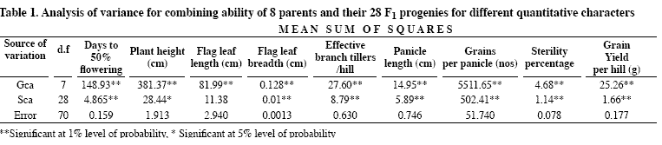
Kumar et al. (2007) observed that gca and sca variances were highly significant for yield and the yield attributing characters which indicated the importance of both additive and non-additive gene action. They observed the preponderance of additive gene action for the traits viz. plant height, days to 50% flowering, harvest index, 100-grain weight and grain length. Both additive and non-additive gene effects were almost equally important for grain yield per plant, grain length: breadth ratio. They further observed the preponderance of non-additive gene action for panicle length and grain length.
Shanthi et al. (2003) reported highly significant variance for combining ability in different characters among lines, testers and line x tester interactions. These were the indices of both additive and non-additive gene action in the inheritance of these characters. Selvi et al. (2001) and Ganesan and Rangaswamy (1998) reported similar findings. On the other hand, preponderance of non-additive gene action was observed for the characters like flag leaf breadth, grain length, grain breadth, grain L/B ratio, kernel length, kernel breadth, kernel L/B ratio, crude protein content, total soluble protein content and alkali digestion value.
Sharma et al. (2005) reported the major role of non-additive gene action in rice for plant height, days to 50% flowering, days to 80% maturity, panicle length, 1000-grain weight, grain breadth, filled grains per panicle, grain yield per plant, biological yield per plant and harvest index.
General combining ability effects of the parents
General combining ability of a parent is the average performance of a parent in a series of crosses (Tabla 2). All the parents had significant gca effect for grain yield per hill except Hathi Sali. Ranjit followed by Matonga and Monohar Sali contributed significant gca effect towards high grain yield per hill. Ranjit, Monohar Sali, Matonga and Hathi Sali contributed significant gca effect for effective branch tillers per hill, grain per panicle and flag leaf breadth. For early flowering, Ranjit followed by Hathi Sali, Bar Madhava and Mala were found to be good general combiner.
Ranjit was the best general combiner for dwarfing nature followed by the parents Monohar Sali, Bar Madhava and Matonga. Bar Madhava exhibited maximum gca effect for long flag leaf length followed by the parents Mala and Dhola Mula. Ranjit and Hathi Sali were found to be good general combiners for broad flag leaf breadth. Hathi Sali, Ranjit and Monohar Sali were the good general combiners for more effective branch tiller per hill. Bar Madhava, Ranjit and Dhola Mula registered as the best general combiner for long panicle length. The good general combiners for more grains per panicle were Ranjit followed by Chandmoni and Monohar Sali. Ranjit, Matonga and Dhola Mula were the good general combiners for lower grain sterility on percentage basis.

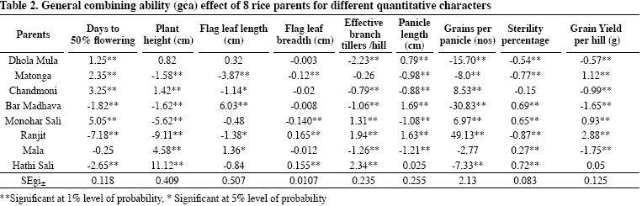

Specific combining ability effects of the F₁ progenies in diallel crosses
A comparison of the specific combining ability effects indicated that the following seven crosses exhibited significant sca effects for high grain yield per hill (Tabla 3):
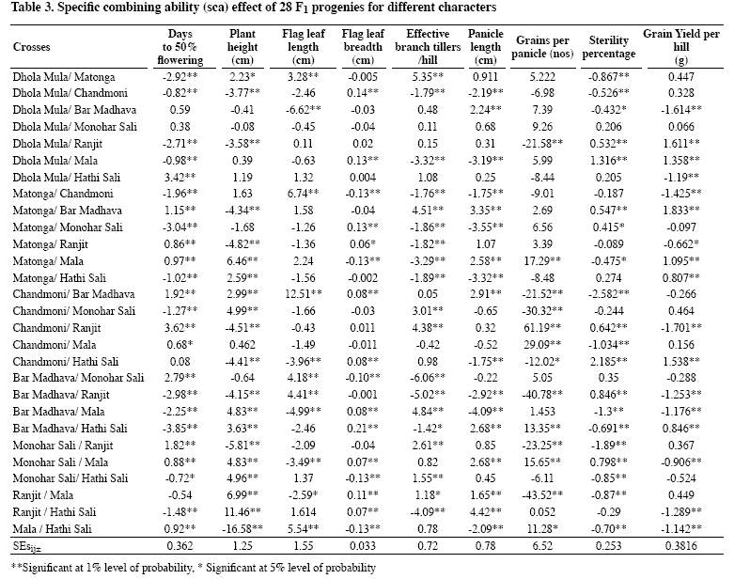
- Matonga/Bar Madhava, originated from high x low gca combination followed by
- Dhola Mula/Ranjit, originated from low x high gca combination,
- Chandmoni/Hathi Sali, originated from low x high gca combination,
- Dhola Mula/Mala, originated from low x low gca combination,
- Matonga/Mala, originated from high x low gca combination,
- Bar Madhava/Hathi Sali, originated from low x high gca combination and
- Matonga/Hathi Sali, originated from high x high gca combination. Further, these crosses exhibited high sca effects for some other characters as well.
The highest sca effect was observed for grain yield per hill in the cross Matonga/Bar Madhava, which originated from high x low gca combination. The cross Matonga/Hathi Sali originated only from high x high gca parents. The cross Dhola Mula/Mala originated from low x low gca combination. The rest of the crosses originated either from low x high or high x low gca combinations. The cross combinations generated from parents having different types of gca effect (viz. positive significant, negative significant and non-significant either positive or negative) and their corresponding sca effects were observed.
Parent with high, medium and low general combining ability produced hybrids with high sca. Almost all types of parental combinations for combining ability produced hybrids with positive and significant sca for grain yield. The high yield potential in cross combinations (high x low) could be attributed to the interaction between positive alleles in the good combiner and negative alleles in the poor combiner.
In the present study, low x low gca combination also produced hybrids with high sca and this could be attributed to overdominance or epistatic gene action. All these results revealed that there is no direct relation between gca effects of parents and sca effects of hybrid combinations. This could be explained from the point of view of gene action since gca is mostly due to additive gene action whereas sca is mostly due to overdominance and epistasis.
Venkatesan et al. (2007) conducted experiment on combining ability using eight lines and four testers in rice and observed non-additive gene action governing the characters viz., days to first flowering, plant height, panicle per plant, grain yield per plant and grain L/B ratio.
Rosamma and Vijayakumar (2005) reported that the grain yield per plant had high sca variance suggesting predominance of non-additive genetic variance, which could be exploited through heterosis breeding. They also revealed that there is no direct relationship between gca effects of parents and sca effects of hybrid combinations.
Sharma et al. (2005) reported the major role of non-additive component for the characters like plant height, days to 50% flowering, days to 80% maturity, panicle length, 1000-grain weight, grain breadth, filled grain per panicle, and grain yield per plant, biological yield per plant and harvest index.
The crosses that originated from high general combiner parents reflecting high sca effects are expected to produce useful transgressive segregants, which can be identified following simple conventional breeding technique like pedigree method of selection. The high sca effects of such crosses might be attributed to additive x additive type of gene action and the high yield potential of these crosses can be fixed in subsequent generations.
On the other hand, high sca effects of the crosses that resulted from high x low combining parents are attributed to additive x dominance type of gene action. The high yields from such crosses would be unfixable in subsequent generations and therefore cannot be exploited by standard selection procedure. However, these crosses would produce desirable transgressive segregants in later generations if efforts could be made to modify the conventional breeding methodologies to capitalize on both additive and non-additive genetic effects.
In view of this, it is suggested that a breeding procedure, which may take care of the fixable gene effects and at the same time, maintains considerable heterozygosity for exploiting the dominance effects, may prove most efficient for yield improvement. In this regard, recurrent selection that involves cyclic intermating of the selects appears to be the most desirable selection procedure. However, in self-pollinated crops like rice, recurrent selection in true sense is difficult to practise due to large number of hand emasculation and pollination. Under such a situation, biparental mating in early segregating generations might be practised to ensure higher utilization of both additive and non-additive gene actions. The high sca effects of the cross combinations involving low x low combiners could be due to overdominance and dominance x dominance type of gene action. Such specific crosses can be exploited for heterosis breeding.
It may be inferred from the present study that all the eight parents and the six crosses viz Matonga/Bar Madhava, Dhola Mula/Ranjit, Chandmoni/Hathi Sali, Matonga/Mala, Bar Madhava/Hathi Sali and Matonga/ Hathi Sali have considerable potential and can be exploited for breeding a variety with high yield by the above-mentioned appropriate breeding program. In the present study, it was observed for the character grain yield per hill that some high combiners turned out to be poor specific combiners as evident from the crosses, i.e. Matonga/Monohar Sali, Matonga/Ranjit, Monohar Sali/Hathi Sali and Ranjit/Hathi Sali reflecting negative sca effect and negative heterosis. However, high x low combinations were found to be the best. For other characters also, similar results were obtained.
The present investigation also indicated that the best parents with high gca were not always the best specific combiners. Moreover, the results further showed that the best parents were the best general combiner for a particular trait but none of the parents or specific crosses was the best for all the characters. Such results were observed by many investigators, namely, Selvi et al. (2001), Rosamma and Vijayakumar (2005), Sharma and Mani (2005), Panwar (2005) and Singh et al. (2007). The undesirable or non-significant sca effects exhibited by some crosses for different characters might be due to the presence of unfavorable genetic combinations of the parents for the characters.
Narrow sense heritability (h²_{ns})
Among the physio-morphological traits the highest heritability in narrow sense (h²_{ns}) was found for the character days to 50% flowering (84.8%) followed by the character grain yield/hill (74.41%), plant height (66.16%), grains per panicle (62.32%) and flag leaf breadth (61.98%) (Tabla 4). Moderate heritability in narrow sense (h²_{ns}) was found for the characters flag leaf length (45.01%) followed by sterility percentage (35.43%), effective branch tiller per hill (27.26%) and kernel breadth (25.36%).
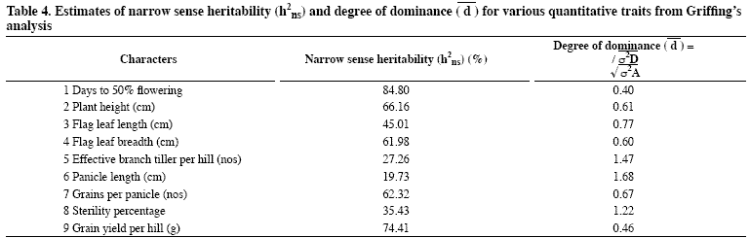
Low heritability in narrow sense (h²_{ns}) was observed for the character panicle length (19.73%). Subramanian and Rathinam (1984) reported high narrow sense heritability for number of grains per panicle, moderate for grain yield per plant and low for number of effective branch tillers per plant. Chakraborty et al. (1994) reported high narrow sense heritability for days to 50% flowering and number of spikelets per panicle.
Degree of dominance (đ)
Very high degree of dominance or overdominance was recorded for the characters panicle length (1.68) followed by the character effective branch tillers per hill (1.47) and sterility percentage (1.22) respectively. High degree of dominance was recorded for the trait flag leaf length (0.77) followed by the characters grains per panicle (0.67), plant height (0.61) and flag leaf breadth (0.60). Moderate degree of dominance was recorded for the character grain yield per hill (0.46) and days to 50% flowering (0.40) respectively.
BIBLIOGRAPHY
1. Chakraborty, S.; Hazarika, M.H.; Hazarika, G. N. 1994. Combining ability analysis in rice. Oryza 31(4): 281-283.
2. Ganesan, K. N.; Rangaswamy, M. 1998. Combining ability studies in rice involving wild abortive (WA) and Oryza perennis sources of CMS lines. Oryza 35: 113-116.
3. Griffing, B. 1956. Concepts of general and specific combining ability in relation to diallel crossing systems. Aust J Biol Sci 9: 463-493.
4. Kumar, S.; Singh, H. B.; Sharma, J. K. 2007. Combining ability analysis for grain yield and other associated traits in rice. Oryza 44(2): 108-114.
5. Panwar, L. L. 2005. Line x tester analysis of combining ability in rice (Oryza sativa L.). Indian J Genet 65(1): 51-52.
6. Rosamma, C.A.; Vijayakumar, N. K. 2005. Heterosis and combining ability in rice (Oryza sativa L.) hybrids developed for Kerala state. Indian J Genet 65(2): 119-120.
7. Selvi, B.; Rangasamy, P.; Nadaranjan, N. 2001. Combining ability analysis for physiological traits in rice. Oryza 38(1/2): 13-16.
8. Shanthi, P.; Shanmugasundaram, P.; Nagarajan, P. 2003. Combining ability analysis in rice. Oryza 40(1/2): 11-13.
9. Sharma, P.R.; Khoyumthem, P.; Singh, N.B.; Singh, N.K. 2005. Combining ability studies for grain yield and its component characters in rice (Oryza sativa L.). Indian J Genet 65(4): 290-292.
10. Sharma, R. K.; Mani, S.C. 2005. Combining ability and gene action for quality characters in Basmati rice (Oryza sativa L.). Indian J Genet 65(2): 123-124.
11.Singh, N. K.; Kumar, A.; Kumar, R. 2007. Combining ability for yield and yield components in rice.Oryza 44(2): 156-159.
12. Subramanian, S.; Rathinam, M. 1984. Studies on combining ability for yield components in rice. Madras Agric J 71: 427-430.
13. Venkatesan, M.; Anbuselvam, Y.; Elangaimannan, R.; Karthikeyan, P. 2007. Combining ability for yield and physical characters in rice. Oryza 44(4): 296-299.

