New Additions of the Tribe Eupariini (Coleoptera: Scarabaeidae: Aphodiinae) for Colombia

Doi: https://doi.org/10.15446/abc.v29n3.110249

To appear in: Acta Biológica Colombiana

Received Date: 26th August 2023 / 26 de agosto de 2023

Revised Date: / 11 de marzo de 2024

Accepted Date: / 02 de mayo de 2024

**Please cite this article as:** Clavijo-Bustos, J., Lopera-Toro, A., y Skelley, P.E. (2024). New Additions of the Tribe Eupariini (Coleoptera: Scarabaeidae: Aphodiinae) for Colombia. *Acta Biol. Colomb*., *29*(3), XX-XX. https://doi.org/10.15446/abc.v29n3.110249

This is a PDF file of an unedited manuscript accepted for publication. As a service to our readers, we are providing this early manuscript version. The manuscript will undergo copyediting, typesetting, and review of the resulting proof before it is published in its final form. Please note that during the production process errors may be discovered which could affect the content, and all legal disclaimers that apply to the journal pertain.

Este es un archivo PDF de un manuscrito sin editar que ha sido aceptado para su publicación. Como servicio a nuestros lectores, ponemos a su disposición esta versión preliminar del manuscrito. Este manuscrito se someterá a corrección de estilo, composición tipográfica y revisión de la prueba resultante antes de ser publicado en su forma definitiva. Tenga en cuenta que durante el proceso de producción pueden descubrirse errores que podrían afectar al contenido, y que se aplican todas las exenciones de responsabilidad legales que se aplican a la revista.

Acta Biol Colomb (2024); **29(3)**: pag–pag

Doi: https://doi.org/10.15446/abc.v29n3.110249

Available online at: <http://www.revistas.unal.edu.co/index.php/actabiol>

Copyright © 2024  Author(s) retain the copyright of this article. This article is published under the terms of the [Attribution-NonCommercial-ShareAlike 4.0](https://creativecommons.org/licenses/by-nc-sa/4.0/) international (CC BY-NC-SA **4.0**)

ARTÍCULO DE INVESTIGACIÓN / RESEARCH ARTICLE

**NEW ADDITIONS OF THE TRIBE EUPARIINI (COLEOPTERA: SCARABAEIDAE: APHODIINAE) FOR COLOMBIA**

**Nuevas adiciones de la tribu Eupariini (Coleoptera: Scarabaeidae: Aphodiinae) para Colombia**

**Running title:** **New additions of the tribe Eupariini for Colombia**

Julián Clavijo-Bustos1a*, Alejandro Lopera-Toro2b, Paul E. Skelley3c

1. Sección de Entomología, Colecciones Biológicas, Instituto de Investigación de Recursos Biológicos Alexander von Humboldt, Villa de Leyva, Boyacá, Colombia, jclavijo@humboldt.org.co.

2. Researcher, Climate Corridors NGO, Washington, DC. 20009, USA, alejandro.lopera@gmail.com.

3. Florida State Collection of Arthropods, Florida Department of Agriculture and Consumer Services, Division of Plant Industry P. O. Box 147100, Gainesville, FL 32614-7100, USA, Paul.Skelley@fdacs.gov.

a ORCID: <https://orcid.org/0000-0002-7453-9792>

b ORCID: <https://orcid.org/0000-0003-2687-6740>

c ORCID: <https://orcid.org/0000-0001-5097-1655>

* ***For correspondence:*** [jclavijo@humboldt.org.co](mailto:jclavijo@humboldt.org.co)

**Received**: 26th August 2023. **Returned for revision**: 11rd March 2024. **Accepted**: 02nd May 2024

**Associate Editor**: Allan Henry Smith Pardo

**Citation/ citar este artículo como:** Clavijo-Bustos, J., Lopera-Toro, A., y Skelley, P.E. (2024). New Additions of the Tribe Eupariini (Coleoptera: Scarabaeidae: Aphodiinae) for Colombia. *Acta Biol. Colomb*., *29*(3), XX-XX. https://doi.org/10.15446/abc.v29n3.1102489

**ABSTRACT**

The commonly known as small dung beetles belong to the subfamily Aphodiinae and its members are smaller in size when compared with its sister lineage Scarabaeinae. However, the subfamily is constituted by about 3300 species. Of the different tribes in America Eupariini is especially diverse with around 28 genera and 333 species. Colombia represents more than half of the species and a third of the genera of Aphodiinae reported for the country. For the first time in Colombia, four species and three genera of this tribe are recorded: *Euparixoides tachirensis*, *Iarupea nigricans*, *Lomanoxia canthonopsis*, and *Lomanoxia costulata*. Their distribution and natural history are briefly discussed. The number of genera and species of Aphodiinae for Colombia increased to 30 and 76, respectively, from which approximately three-quarters of the species and half of the genera belong to Eupariini.

**Keywords:** Distribution, Neotropics, New country records, Scarabs, Small dung beetles.

**RESUMEN**

Los comúnmente conocidos como pequeños escarabajos coprófagos pertenecen a la subfamilia Aphodiinae y sus miembros son de menor tamaño en comparación con su linaje hermano Scarabaeinae. Sin embargo, la subfamilia está constituida por alrededor de 3300 especies. De las diferentes tribus en América, Eupariini es especialmente diversa con alrededor de 28 géneros y 333 especies, y en Colombia representa más de la mitad de las especies y un tercio de los géneros de Aphodiinae reportados para el país. Por primera vez en Colombia son registrados cuatro especies y tres géneros de esta tribu: *Euparixoides tachirensis*, *Iarupea nigricans*, *Lomanoxia canthonopsis*, y *Lomanoxia costulata*. Su distribución e historia natural son brevemente discutidas. El número de géneros y especies de Aphodiinae para Colombia se incrementa a 30 y 76, respectivamente, de los cuales aproximadamente tres cuartos de las especies y la mitad de los géneros pertenecen a Eupariini.

**Palabras clave:** Distribución, Neotrópico, Nuevos registros de país, Escarabajos, Pequeños escarabajos coprófagos.

**INTRODUCTION**

Members of the subfamily Aphodiinae Leach, 1815 (Scarabaeidae) are commonly known as small dung beetles due to their small body size when compared with its sister lineage, Scarabaeinae (Scholtz and Grebennikov, 2016). However, the subfamily is relatively diverse within Scarabaeoidea, with around 3300 described species distributed worldwide (Scholtz and Grebennikov, 2016; Stebnicka, 2001). Of the tribes in America, Eupariini Schmidt, 1910 is the second richest in species and genera after Aphodiini Leach, 1815 (Minkina, 2020; Skelley, 2008; Stebnicka, 2009). About 28 genera and 333 species constitute Eupariini in the American continent, with members of the tribe having a wide variety of diets and behaviors (Chalumeau and Howden, 1984; Deloya, 2012; Schnepp and Ashman, 2020; Skelley and Vaz-de-Mello, 2020; Stebnicka, 2007a, 2009).

This paper reports new country records of Eupariini genera and species for Colombia. In this country has been reported 72 species from 27 genera of Aphodiinae, of which 45 species from 11 genera belong to Eupariini (Pardo-Locarno and Schoolmeesters, 2019; Clavijo- Bustos et al., 2021, 2024; Skelley and Keller, 2022; Skelley et al., 2022; Tovar et al., 2023; Minkina et al., 2024). However, the number of known species is lower than estimated, and it is expected that, with future sampling, the number of species will continue to increase.

**MATERIALS AND METHODS**

Examined specimens are housed in **IAvH-E** (Section of Entomology, Biological collections, Instituto de Investigación de Recursos Biológicos Alexander von Humboldt, Villa de Leyva, Boyacá, Colombia), and **CECC-ALT** (Colección de Escarabajos Coprófagos de Colombia - Alejandro Lopera Toro, Bogotá D.C., Colombia).

Photographs were taken with a Leica MC190 HD camera attached to a Leica S8-APO stereomicroscope, and then arranged into plates using Photoshop v.21.2.0. Maps were constructed on ArcMap 10.3, and geographic distributions were obtained from specimen’s labels and literature (Cartwright, 1967; Skelley and Howden, 2003; Stebnicka, 1999, 2009; Stebnicka and Skelley, 2005).

**RESULTS**

***Euparixoides* Hinton, 1936**

Members of the genus are distinguished from other Eupariini by their elongate shape constricted at the middle (pronotal and elytral base); clypeus rounded on each side of median emargination and with the margin finely serrate; broad pronotum, with sides explanate and lateral edge finely serrate and sinuate; elytra inflexed at intervals eight-nine, striae strongly punctured; meso- and metatibiae appearing to have a single large spur, but second spur reduced and held close to the large spur; and mesocoxae ventrally touching the elytra near base (Stebnicka, 2009).

Currently, the genus comprises five species distributed in Central America and the northern part of South America, from Honduras to Peru, now including Colombia (Stebnicka, 2009).

***Euparixoides tachirensis* Stebnicka and Skelley, 2005 (Figs. 1, 5)**

*Euparixoides tachirensis* Stebnicka and Skelley, 2005: 26–27 (original combination)

**New records.** COLOMBIA. Cundinamarca, Medina, Vereda Miralindo, Quebrada La Ardita, sitio Alto del Río Gazaunta, 04°35’N 73°25’W, 1500 m., 1997.iii.01, F. Escobar (1♀: IAvH-E-213340); Norte de Santander, Parque Nacional Natural Tamá, Río Táchira sector Orocué, sitio Sendero El Arenal, 07°25’31”N 72°26’38”W, Malaise, 1998.xi.06, A. Cortés (1♀: IAvH-E-213341), Santander, San Vicente de Chucurí, 06°52’5.452”N 73°23’41.884”W, En hojarasca, 2018.vii.03, D.F. Silva-Tavera (1♀: IAvH-E).

**Diagnosis.** *Euparixoides tachirensis* is characterized by its size (3.9–4.0 mm); body dorsally covered with long erect setae; lateral margins of pronotum nearly straight and complete, lacking a medial constriction; meso- and metatibiae with two apical spurs (outer one smaller) (Stebnicka and Skelley, 2005) (Fig. 1a–1c).

**Distributional and biological remarks.** The species was previously known only from the holotype and paratype, both females and from almost the same locality at Tachira, Venezuela (Fig. 5a) (Stebnicka and Skelley, 2007). With these new records, the distribution of the species is extended to Colombia with three new records (Fig. 5e).

All three specimens here reported are females; thus, the male remains undescribed. One specimen was collected with a Malaise trap, and the other manually on forest litter, similar to the holotype and paratype (Stebnicka and Skelley, 2007).

***Iarupea* Martínez, 1953**

Members of this genus are distinguished from other Eupariini by their elongate form; head with longitudinal wrinkles; pronotum distinctly explanate laterally and with lateral margins sinuate with dense fringe of short scale-like setae, the pronotal base with a wide marginal groove; and elytral base with the fifth interval prominent and the fifth stria grooved (Stebnicka, 2009).

Currently, the genus comprises five species distributed in South America, from Colombia to Argentina (Stebnicka, 2009).

***Iarupea nigricans* (Westwood, 1847) (Figs. 2, 5)**

*Euparia nigricans* Westwood, 1847: 240 (original combination)

*Euparia attenuata* Harold, 1870: 2328 (synonym)

**New records.** COLOMBIA. Meta, Puerto Gaitán, El Oasis, 3.784671°N 71.640298°W, 215 m, Colecta manual atraído a luz, 16/XI/2020, A. Lopera (1 Indet.: CECC-ALT).

**Diagnosis.** *Iarupea nigricans* is characterized by its size (4.8–5.0 mm); pronotum with coarse, irregular pits or punctures separated by less than one to three time its diameter, basal collar longitudinally strigose, each side of marginal groove convex and without prominent tubercle; elytral intervals five and seven carinate basally, lateral intervals impunctate, striae with punctures crenating the inner margins of the intervals; disc of pygidium eroded and longitudinally strigose; basal metatarsomere longer than upper tibial spur and the following three tarsomeres combined (Stebnicka, 2007b, 2009) (Figs. 2a–2b).

**Distributional and biological remarks.** *Iarupea nigricans* was known from Guyana, Surinam, and Brazil (Fig. 5b) (Stebnicka, 2009), but its distribution is now extended to Colombia with the new record presented here (Fig. 5e).

This species has been recorded in nests of *Atta sexdens* (Linnaeus, 1758) and light traps (Stebnicka, 2007b, 2009). We report the same latter collecting method.

***Lomanoxia* Martínez, 1951**

Members of the genus are distinguished from other Eupariini by their elongate oval to strongly oval form; clypeus with margin smooth and rounded on each side of median emargination; pronotum with sides explanate anteriorly, lateral edges with fringe of setae; elytra laterally inflexed over the interval eight; mesocoxae ventrally touching the elytra near the base; and meso- and metatibia with two apical spurs (Stebnicka, 2009).

Currently, the genus comprises seven species distributed from Central America (only in Costa Rica) to Argentina in South America (Stebnicka, 2009).

***Lomanoxia canthonopsis* Skelley and Howden, 2003 (Figs. 3, 5)**

*Lomanoxia canthonopsis* Skelley and Howden, 2003: 186–189 (original combination)

**New records.** COLOMBIA. Meta, Cubarral, Finca La Rosania, 03°49’46.56”N 73°49’59.21”W, 620 m, Luz en Establo, IV/2018, A. Lopera, W. Chamorro (1 Indet.: CECC-ALT).

**Diagnosis.** *Lomanoxia canthonopsis* is characterized by its size (4.3–5.0 mm); pronotum smooth; elytra covered with hair-like setae, all elytral intervals with rows of setae dense and almost contiguous (the distance between bases less than setal length); and only abdominal sternite five with longitudinal costulae (Skelley and Howden, 2003) (Figs. 3a–3c).

**Distributional remarks.** *Lomanoxia canthonopsis* was described from Costa Rica, however, specimens from Trinidad and Bolivia were considered as this species (Fig. 5c), but have subtle differences (Skelley and Howden, 2003; Stebnicka, 2009). It is reported for the first time in Colombia (Fig. 5e) based on one specimen, more similar to those from Trinidad, having a greatly reduced humeral denticles on the elytra.

***Lomanoxia costulata* (Harold, 1867) (Figs. 4, 5)**

*Euparia costulata* Harold, 1867: 82 (original combination)

**New records.** COLOMBIA. Meta, Cubarral, Finca La Rosania, 03°49’46.56”N 73°49’59.21”W, 620 m, Luz en Establo, IV/2018, A. Lopera, W. Chamorro (3 Indet.: CECC-ALT).

**Diagnosis.** *Lomanoxia costulata* is characterized by its size (4.5–5.0 mm); pronotum smooth, base of pronotum lobed at middle and sides continuously rounded, pronotal margins with unequal setae in size, the longest setae located over arcuate posterior angle; elytra covered with hair-like setae, all elytral intervals slightly tectiform with a median row of small granules, each bearing a short recurvate setae, and sparse and widely placed (the distance between bases greater than setal length); abdominal sternites four-five with longitudinal costae (Stebnicka, 1999; Skelley and Howden, 2003) (Figs. 4a–4c).

**Distributional remarks.** *Lomanoxia costulata* was known until now from Surinam, Brazil, Paraguay, Argentina (Fig. 5d) (Stebnicka, 1999, 2009), and the new record from Colombia represents the northernmost locality where it has been reported (Fig. 5e).

**DISCUSION**

The new country records increase the number of genera and species of Aphodiinae for Colombia from 27 and 72, up to 30 and 76, respectively. In this way, supporting the fact that Eupariini is the most diverse tribe of Colombian Aphodiinae (75 % of species and 47 % of genera).

The richness of Aphodiinae in Neotropical countries will probably increase as sampling efforts increase. Publications of the last years, including new country records for Colombia, distributional extensions of Neotropical species, and description of new taxa from Neotropical region (*e.g.*, Arias Buriticá and Vaz-de-Mello, 2016; Skelley and Vaz-de-Mello, 2020; Clavijo-Bustos et al., 2021, 2024; Skelley et al., 2022; Skelley and Keller, 2022; Minkina et al., 2024), support the importance of maintaining the study of the tribe and subfamily, to learn their true richness and diversity.

**CONCLUSIONS**

Aphodiinae in Colombia is now composed by 30 genera and 76 species. As well as for other countries in Neotropical region, Aphodiinae richness in Colombia will continue increasing with future discoveries, as much as sampling efforts increase.

**AUTHOR’S PARTICIPATION**

Conceptualization of the work JCB, ALT, PES; collection and processing of biological material JCB, PES; supervision ALT, PES; data analysis JCB, ALT, PES; writing and reviewing of the document JCB, ALT, PES.

**ACKNOWLEDGEMENTS**

Thanks to D. F. Silva Tavera for sharing distributional data about some species herein reported. Thanks to A. Smith (CMNC) for sharing the photos of *I. nigricans*. Also, to anonymous reviewers and L. L. Vargas for their comments on previous versions of this manuscript. We thank the Instituto de Investigación de Recursos Biológicos Alexander von Humboldt (Villa de Leyva, Boyacá, Colombia), and the Florida Department of Agriculture and Consumer Services, Division of Plant Industry, for supporting this work.

**CONFLICT OF INTEREST**

The authors declare no conflict of interest.

**REFERENCES**

Arias Buriticá, J. A. and Vaz-de-Mello, F. (2016). Primer registro de *Stebnickiella zosterixys* Skelley, 2007 (Coleoptera: Scarabaeidae: Aphodiinae: Odontholochini) para Colombia. *Entomotropica*. *31*(28), 234-236.

Cartwright, O. L. (1967). Two new species of *Cartwrightia* from Central and South America (Coleoptera: Scarabaeidae: Aphodiinae). *Proc U S Natl Mus*. *124*(3632), 1-8. <https://doi.org/10.5479/si.00963801.124-3632.1>

Chalumeau, F. and Howden, H. F. (1984). Le genre *Euparia* (Coleoptera: Scarabaeoidea: Aphodiinae) Saint-Fargeau & Serville, 1828. *Mitt Schweiz Entomol Ges*. *57*, 85-94.

Clavijo-Bustos, J., Bacca, T. and Canal, N. A. (2021). Nuevos registros de Aphodiinae (Coleoptera, Scarabaeidae) en Colombia. *Rev Acad Colomb Cienc Exactas Fis Nat*. *45*(176), 738-746. <http://doi.org/10.18257/raccefyn.1331>

Clavijo-Bustos, J., Gama, E. R. R., Bacca, T. and Skelley, P. E. (2024). New species and records of the genus *Ataenius* Harold, 1867 (Coleoptera: Scarabaeidae: Aphodiinae) from Colombia. *J. Insect Biodivers.* *55*(2), 45-54. <https://doi.org/10.12976/jib/2024.55.2.3>

Deloya, C. (2012). Description of a new species of *Ataenius* Harold, 1867 of the “*A. aequalis-platensis*” group (Coleoptera: Scarabaeidae: Aphodiinae: Eupariini) from Mexico. *Fla Entomol*. *95*(4), 1019-1023. <https://doi.org/10.1653/024.095.0430>

Minkina, L. (2020). Proposal of a new tribe for *Hornietus ventralis* (Horn, 1887) (Coleoptera: Scarabaeidae: Aphodiinae). *Stud Rep, Taxon Ser*. *16*(2), 443-449.

Minkina, L., Gama, E. R. R. and Skelley, P. E. (2024). Two new species of the genus *Ataenius* Schmidt, 1810 (Coleoptera: Scarabaeidae: Aphodiinae: Eupariini). *Coleopt. Bull.* *78*(2), 255-264. <http://doi.org/10.1649/0010-065X-78.2.255>

Pardo-Locarno, L. C. and Schoolmeesters, P. (2019). Small Dung Beetles of Colombia (Coleoptera Scarabaeoidea Aphodiinae) I: Preliminary Catalog and Key for Registered Species. *Bol Cient Mus His Nat*. *23*(1), 279-302. <https://doi.org/10.17151/bccm.2019.23.1.13>

Schnepp, K. E. and Ashman, K. L. (2020). A new species of *Ataenius* Harold (Coleoptera: Scarabaeidae: Aphodiinae) from the southeastern United States, with a lectotype designation. *Insecta Mundi*. *0841*, 1-7.

Scholtz, C. H. and Grebennikov, V. V. (2016). Scarabaeoidea Latreille, 1802. In: Beutel RG, Leschen RAB, editor(s). *Coleoptera, Beetles. Morphology and Systematics (Archostemata, Adephaga, Myxophaga, Polyphaga partim)*. 2 ed. Berlin: Walter de Gruyter GmbH.p. 443-525. <https://doi.org/10.1515/9783110373929-018>

Skelley, P. E. (2008). Scarabaeidae Aphodiinae. Generic Guide of New World Scarab Beetles [online]. <https://unsm-ento.unl.edu/Guide/Scarabaeoidea/Scarabaeoidea-pages/Scarabaeoidea-Overview/ScarabaeoideaO.html>

Skelley, P. E., Clavijo-Bustos, J. and Keller, O. (2022). Extinct or extant? A new species of *Termitodius* Wasmann, 1894, (Coleoptera: Scarabaeidae: Aphodiinae: Rhyparini) with a short review of the genus. *Insecta Mundi*. *0915*, 1-14.

Skelley, P. E. and Howden H. F. (2003). A new species of *Lomanoxia* Martínez from Costa Rica (Coleoptera: Scarabaeidae: Aphodiinae). *Insecta Mundi*. *17*(3-4), 185-190.

Skelley, P. E. and Keller, O. (2022). A third species of *Haroldiellus* Gordon and Skelley, 2007 from Mexico and Central America (Coleoptera: Scarabaeidae: Aphodiinae: Aphodiini). *Insecta Mundi*. *0916*, 1-11.

Skelley, P. E. and Vaz-de-Mello, F. Z. (2020). Review of *Aphotaenius* Cartwright, 1952 (Coleoptera: Scarabaeidae: Aphodiinae: Eupariini). *Coleopt Bull*. *74*(2), 389-403. <http://doi.org/10.1649/0010-065X-74.2.389>

Stebnicka, Z. (1999). *Lomanoxia* Martínez, 1951, and a new tribe Lomanoxiini with notes on comparative morphology (Coleoptera: Scarabaeoidea: Aphodiimae). *Acta zool cracov*. *42*(2), 279-286.

Stebnicka, Z T. (2001). Aphodiinae (Insecta: Coleoptera: Scarabaeidae). *Fauna N Z*. *42*, 1-64.

Stebnicka, Z. T. (2007a). *The genus* Ataenius *Harold, 1867 (Coleoptera: Scarabaeidae) of the world, Iconography*. Krakow: Institute of Systematics and Evolution of Animals, Polish Academy of Science, p. 5-9.

Stebnicka, Z. T. (2007b). New species of *Iarupea* Martínez and morphological specializations among related taxa associated with ants and termites (Coleoptera: Scarabaeidae: Eupariini). *Rev Suisse Zool*. *114*(3), 573-590. <https://doi.org/10.5962/bhl.part.80404>

Stebnicka, Z. T. (2009). *The Tribe Eupariini of New World (Coleoptera: Scarabaeidae: Aphodiinae), Iconography II*. Krakow: Institute of Systematics and Evolution of Animals, *Polish Academy of Sciences*. p. 5-65.

Stebnicka, Z. T. and Skelley, P. E. (2005). Review of some New World aphodiine genera and descriptions of new species (Coleoptera: Scarabaeidae: Aphodiinae). *Acta zool cracov*. *48B*(1-2), 23-42. <https://doi.org/10.3409/173491505783995671>

Tovar, H. L, Correa, C. M. A, Lumaret, J. -P., López-Bedoya, P. A., Navarro, B., Tovar, V. and Noriega, J. A. (2023). Effect of antiparasitc management of cattle on the diversity and functional structure of dung beetle (Coleoptera: Scarabaeidae) assemblages in the Colombian Caribbean. *Diversity*. *15*(4), 555. <https://doi.org/10.3390/d15040555>

**TABLES AND FIGURES.**

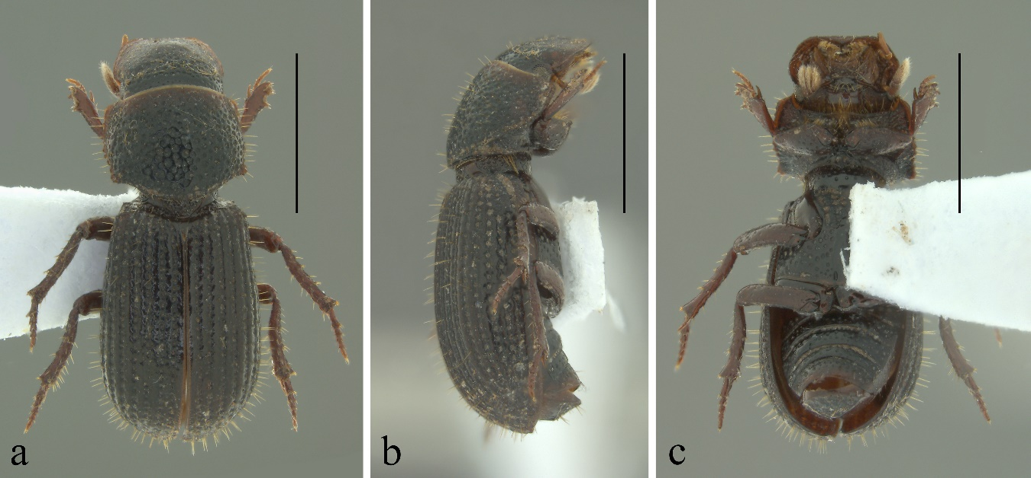

Figure 1. *Euparixoides tachirensis* Stebnicka and Skelley, 2005, specimen from Colombia. a) Dorsal view, b) Lateral view, c) Ventral view. Scale bars: 1 mm.

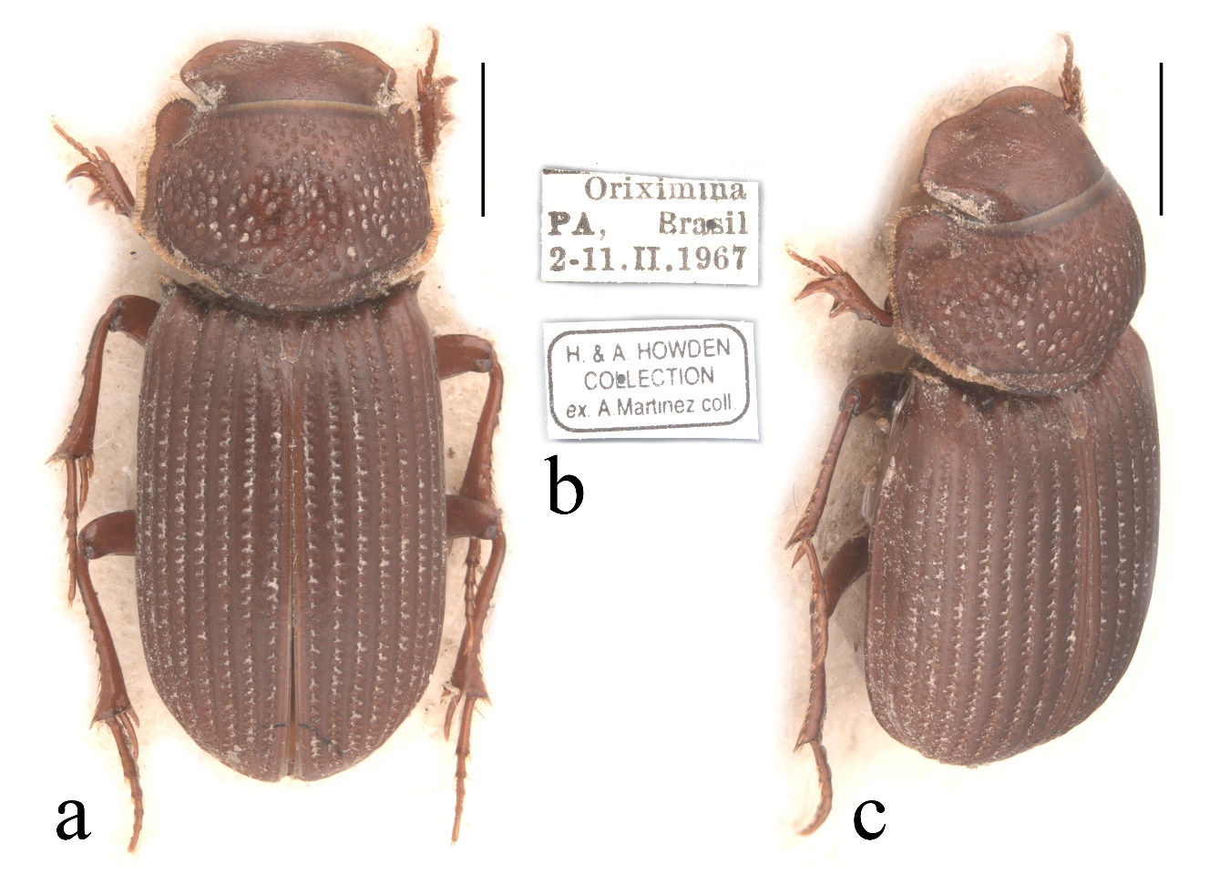

Figure 2. *Iarupea nigricans* (Westwood, 1847), specimen from Brazil. a) Dorsal view, b) Labels, c) Oblique view. Scale bars: 1 mm. Photos by A. B. T. Smith (Canadian Museum of Nature).

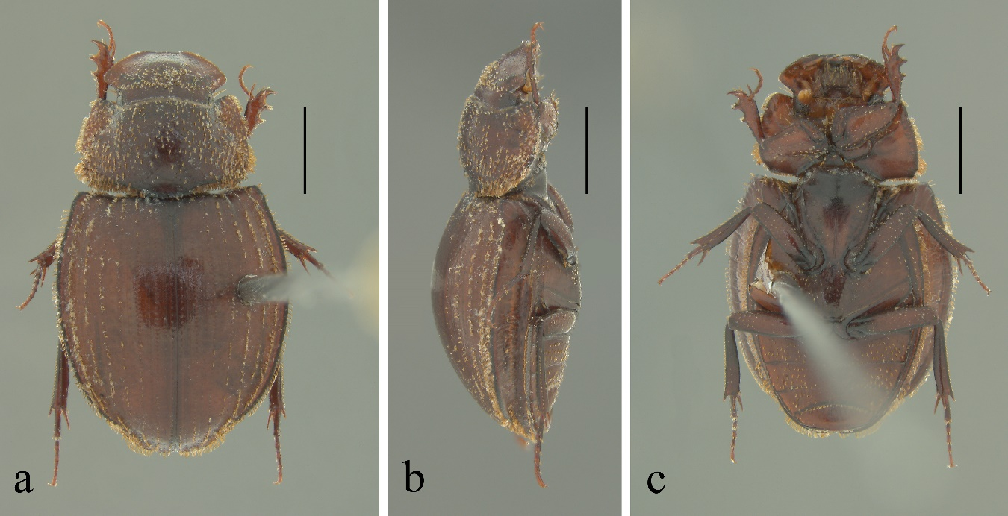

Figure 3. *Lomanoxia canthonopsis* Skelley and Howden, 2003, specimen from Colombia. a) Dorsal view, b) Lateral view, c) Ventral view. Scale bars: 1 mm.

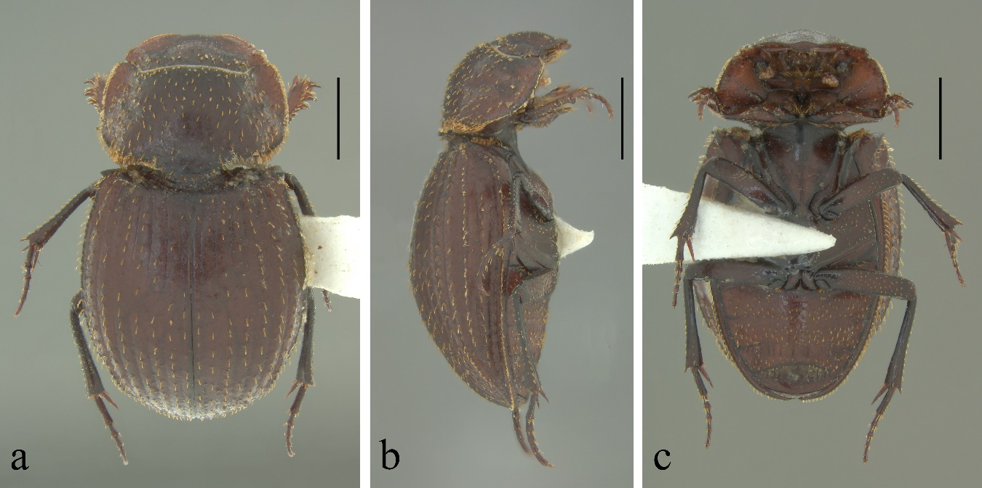

Figure 4. *Lomanoxia costulata* (Harold, 1867), specimen from Colombia. a) Dorsal view, b) Lateral view, c) Ventral view. Scale bars: 1 mm.

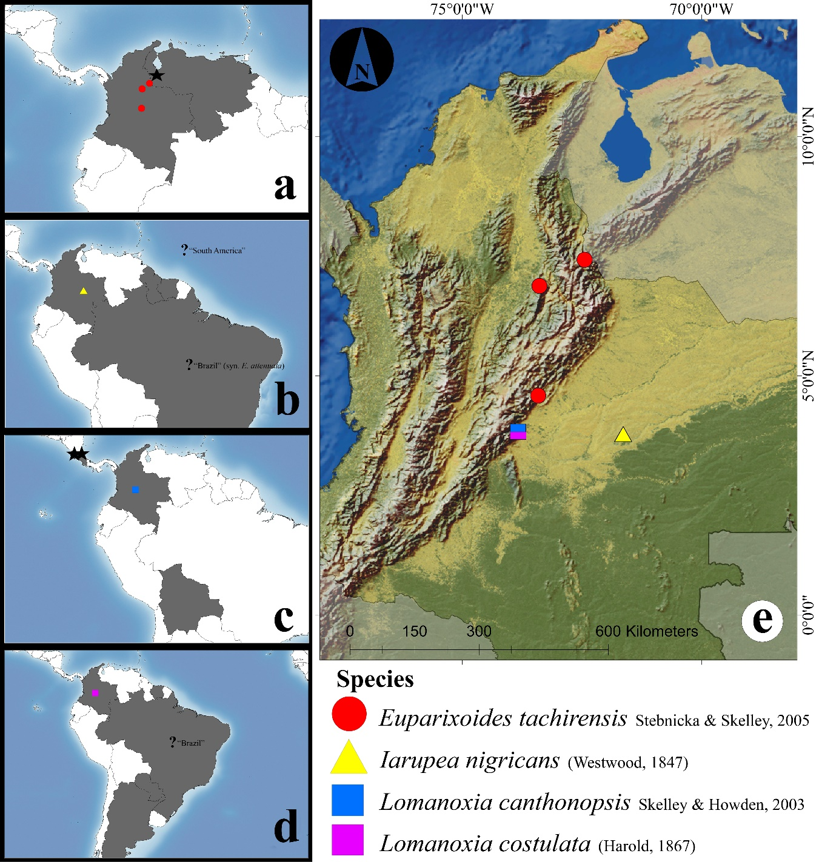

Figure 5. a-d) New records for Colombia and countries presence: a) *Euparixoides tachirensis* Stebnicka and Skelley, 2005, b) *Iarupea nigricans* (Westwood, 1847), c) *Lomanoxia canthonopsis* Skelley and Howden, 2003, d) *Lomanoxia costulata* (Harold, 1867). e) Distribution in Colombia of new country records; Black stars (★) denote accurate type localities, Question marks (?) denote wide-range type localities.