
Short note
Polistomorpha fasciata and its host Euglossa cordata: new records of the wasp for Maranhão, Brazil

Polistomorpha fasciata y su huésped Euglossa cordata: nuevos registros de la avispa para Maranhão, Brasil

¹André Luis Martins, Universidade Federal do Rio Grande do Sul; Departamento de Zoologia, Av. Bento Gonçalves, 91501-970, Agronomia, Porto Alegre - RS, Brazil
²André Luis Martins, Universidade Federal do Paraná Departamento de Zoologia, Curitiba, Brazil, andrelm3048@gmail.com, https://orcid.org/0000-0002-4794-0644
³Alessandro Rodrigues Lima, Universidade Federal de Minas Gerais, Centro de Coleções Taxonômicas, Av. Pres. Antônio Carlos, 6627, Belo Horizonte, Brazil, alerolima@gmail.com, https://orcid.org/0000-0002-5861-5273
⁴Harryson Correa Barros, Universidade Federal do Paraná, Programa de Pós-Graduação em
Ciências Biológicas (Entomologia), Curitiba-PR, Brazil, harryson.c.b@hotmail.com,
https://orcid.org/0000-0002-1849-5748

* For correspondence: andrelm3048@gmail.com
Received: 22 August 2024. Revised: 26 june 2025. Accepted: 20 october 2025
Associate Editor: María Isabel Arnaldos Sanabria

Citation/ citar este artículo como: Martins, A. L., Lima A. R. and Barros, H. C (2025). Polistomorpha fasciata and its host Euglossa cordata: new records of the wasp for Maranhão, Brazil. Acta Biol. Colomb. 30(3), XX-XX https://doi.org/10.15446/abc.v30n3.116319

ABSTRACT
The genus Polistomorpha (Hymenoptera: Leucospidae) is exclusive to the Neotropical region, comprising seven species. Polistomorpha fasciata has previously been recorded in the Brazilian states of Amapá, Amazonas, Pará, and São Paulo. This study presents the first record of P. fasciata from Northeast Brazil, parasitizing Euglossa cordata within a Restinga ecosystem. Additionally, it provides an extended diagnosis and illustrations of P. fasciata, E. cordata, and its nest.
Keywords: Apinae, Chalcidoidea, parasitoids, Restinga, trap nest.

RESUMEN
El género Polistomorpha (Hymenoptera: Leucospidae) es exclusivo de la región neotropical, con siete especies, seis de ellas en Brasil. Polistomorpha fasciata se registró anteriormente en Amapá, Amazonas, São Paulo y Pará. Este estudio proporciona el primer registro de P. fasciata en el Noreste de Brasil, parasitando a Euglossa cordata en un ecosistema de Restinga. También incluye un diagnóstico ampliado e ilustraciones de P. fasciata, E. cordata y su nido.
Palabras clave: Apinae, Chalcidoidea, Nido trampa, parasitoides, Restinga.

The genus Polistomorpha Westwood, 1839 (Hymenoptera: Leucospidae) is exclusive to the Neotropical region. Of the seven known species, six occur in Brazil: P. conura Bouček, 1974, and P. surinamensis (Westwood, 1839) in the Amazonas state; P. femorata Bouček, 1974, and P. nitidiventris Ducke, 1906 in the Pará state; P. sphegoides Walker, 1862 in Amazonas and Pará states; and P. fasciata (Westwood, 1874) in Amapá, Amazonas, Pará and São Paulo states. This species is the only one recorded outside the Amazon biome (Bouček, 1974; De Santis, 1980; Freiria et al., 2017). Among the Brazilian Polistomorpha species, only three (P. conura, P. fasciata, and P. surinamensis,) have host records, all parasitizing bees belonging to the genus Euglossa Latreille, 1802 (Apidae: Euglossini) (Table 1). Here, we present the first record of P. fasciata from Northeast Brazil, in the Restinga ecosystem, Atlantic Forest biome. We also provide a diagnosis of P. fasciata, along with illustrations of the parasitoid, its host species (E. cordata), and the host's nest.
Both P. fasciata and E. cordata are ecologically significant: the wasp is a parasitoid of Euglossini bees, while the bee is a key pollinator for various orchid species. Therefore, this study aims to present a record of P. fasciata parasitizing E. cordata in the state of Maranhão state, in addition to providing data on the species' distribution and compiling records of other species and hosts of the wasp and bee species.
The specimens from the state of Maranhão examined in this study were obtained from a survey involving 396 wooden trap nests, following the methodology described by Serrano and Garófalo (1978). These nests were suspended in the restinga vegetation of Ilha Grande do Paulino, located within the APA Delta do Parnaíba, Tutóia, Brazil, (2.7329°S 42.1857°W; Fig. 1). The nests were distributed across 22 sites and monitored monthly by the last author from August 2017 and July 2019, totaling 24 months.
Of all the nests provided, five were occupied by Euglossa (Euglossa) cordata Linnaeus, 1758 (Fig. 2a, b). From one of these nests, collected in July 2018 (entrance hole 12 mm; six brood cells), five bee specimens and one female Polistomorpha emerged, the latter emerging 10 days before the brood of E. cordata.
The parasitoid was identified using available keys (Bouček, 1974; Hanson, 2006), the original description (Westwood, 1874), and by comparison with type specimens. The label information was transcribed as follows: Single quotation marks (“ ”) enclose the data from each label; backslash symbol (\) indicates line break; two slashes (//) indicate information on the back of the label. Geographical distribution records were taken from the labels and the literature (Bouček, 1974; De Santis, 1980; Freiria et al., 2017). New occurrence records are indicated by an asterisk (*) in the “distribution” section.
Color pictures of P. fasciata and E. cordata were taken using a LEICA DFC295 digital camera attached to a stereomicroscope and stacked with Serena Stacker software (v.1.04 build). Scanning electron photomicrographs were obtained using a TESCAN VEGA3 SEM in low vacuum mode at the Electron Microscopy Center of the Universidade Federal do Paraná. All figures were prepared using Adobe Photoshop (version 11.0), and maps were created in the QGIS program, version 3.34.
Specimens examined in this study are deposited in the following institutions: LEACOL – Coleção de Abelhas do Laboratório de Estudos sobre Abelhas, Universidade Federal do Maranhão, São Luís, Brazil; NHMUK – Natural History Museum, London, UK; OUMNH – Oxford University Museum of Natural History, Oxford, UK; UFMG - Centro de Coleções Taxonômicas da UFMG, Belo Horizonte, Brazil; ZSJRP – Coleção de Hymenoptera do Departamento de Zoologia do Instituto de Biociências, Letras e Ciências Exatas – UNESP, São José do Rio Preto, São Paulo, Brazil.

Polistomorpha Westwood, 1839
Polistomorpha fasciata Westwood, 1874
(Figs. 3-4)
Polistomorpha fasciata Westwood 1874: 134. Holotype female. Brazil, Amazonas (OUMNH, examined by photographs). Designed by Bouček 1974.
Polistomorpha nigromaculata Cameron 1904: 96. Lectotype male. Panamá (NHMUK, examined by photographs). Synonymized by Bouček 1974.

Extended diagnosis: Polistomorpha fasciata is recognized by its predominantly yellow head and thorax (Figs. 3a, b, c), with brown antennae (Figs. 3a, c, d) and a black triangular macula between the inner eye margin and posterior ocelli (Figs. 3b, f); light brown areas and a triangle centrally on pronotum (Figs. 3b, f); three longitudinal black maculae on mesoscutum (Figs. 3b, f); dark brown band on the anterior margin and longitudinally in the midline on mesoscutellum; dorsellum quadrangular, with a dark brown transverse band (Fig. 3b); propodeum with two dark longitudinal bands. Metasomal tergites one and two brownish yellow, the rest darkened; three anterior sternites partially yellowish darkened, the rest darkened (Figs. 3a, g). Femures yellowish. Fore wing densely covered with dark pilosity (Figs. 3a-b). Body covered with fine and small pilosity (Figs. 3a; 4a, c). Antenna with nine flagellomeres (Fig. 3a). Body sculpture predominantly foveate (Figs. 3-4). Head: clypeus rounded apically; maxillary palp with two articles and an elongated bristle (Fig. 4b); mandible with two teeth; POL (= 40) 2.6× OL (= 15); occipital carina complete. Hind coxa about twice as long as mid coxa, with a tooth medially on the posterior margin (Figs. 3a, 4c-d). Hind femur with 7-8 teeth, the basal one 2-4× longer than the others (Figs. 3a; 4c, e) Tarsal claws with a row of teeth.
Material examined: Holotype: “Amazonas\ Bates\ (1986)” “HOLOTYPE O.U.M.” “Polistomorpha\ fasciata Westwi” “HOLOTYPE\ Polistomorpha\ fasciata\ Westwood 1874\ Boucek det. 1974” “Polistomorpha\ surinamensis\ macho West\ E. F. Rocha det. 1955” “TYPE Hym: 700\ Polistomorpha\ fasciata\ Westwood\ HOPE DEPT. OXFORD (OUMNH). Lectotype (P. nigromaculata): “LECTO\TYPE// Bouček \” “1972” “TYPE” “Cameron Coll.\ 1904-313” “Polistomorpha\ nigromaculata\ Ccim. Hipe\ Panama” “B.M. TYPE\ HYM.\ 5.106” “NHMUK 014444370” (NHMUK). Additional Material. [6♀]: Brazil, Maranhão: 1♀, “Brasil, MA, Tutóia, APA,\ Delta Parnaíba, Ilha\ Grande do Paulino,\ 2.7329°S 42.1857°W,\ 23.xi.2017, n. armadilha\ 0,8×15cm, H. C, Barros” (LEACOL); São Paulo: 2♀, “União Paulista, SP, Brasil, 8/x/2007 Noll col. Malaise’(UFMG); 1♀, “Votuporanga, SP, Brasil, 13/vii/2007 Noll col. Malaise” (ZSJRP); 1♀: “Planalto, SP, Brasil, 08/x/2007 Noll col. Malaise” (ZSJRP); 1♀, “União Paulista, SP, Brasil, 21/ix/2007 Noll col. Malaise” (ZSJRP).
Hosts. Euglossa (Euglossa) cordata (Fig. 3); Euglossa (Euglossa) townsendi Cockerell, 1904; Euglossa (Glossura) ignita Smith, 1874.
Distribution. Brazil: Amapá, Amazonas, Maranhão*, São Paulo and Pará. Panamá (Fig. 1).
Occurrence in Brazilian Biomes: Amazônia, Cerrado and Mata Atlântica (Fig. 1).
There are few records of P. fasciata restricted to North and Southeast Brazil (Freiria et al. 2017; Perioto and Lara 2024), mostly from trap nests (Table 1). In contrast, E. cordata (Fig. 2a) was recorded from all regions of Brazil (Oliveira et al., 2024). The wide distribution of the host suggests that P. fasciata potentially has a much wider distribution in Brazil. The new records presented are an important addition to the parasitoid knowledge, not only marking its first record in Northeast Brazil but also in the unique Restinga ecosystem. In addition to the new record, the illustrations of the parasitoid, host, and nest provided here will facilitate future identifications. The Restinga is one of the most threatened ecosystems in coastal Brazil. Their degradation compromises plant diversity and, consequently, the availability of nesting sites for associated bees and wasps. This finding alone underscores the need to preserve these habitats. Moreover, the records presented here also reinforce the idea that the diversity of this ecosystem is still greatly underestimated, and its preservation is essential so that this diversity does not become extinct before it is even known.

AUTHORS PARTICIPATION
A.L.M: Conceptualization, methodology, illustrations and writing;
A.R.L: Methodology and writing;
H.C.B: Visualization, conceptualization, methodology, illustrations, maps and writing.

ACKNOWLEDGEMENTS
We thank to James Hogan (Oxford University Museum of Natural History) and Joseph Monks (Natural History Museum) for take the photographys of Lectotype of P. fasciata and Holotype of P. fasciata. We thank Dr. Denilson Costa Martins for the taxonomic identification of the E. cordata specimens. Many thanks to Conselho Nacional de Desenvolvimento Científico e Tecnológico (CNPq) stipends for A.L.M. (process 51844/2022-4). We are grateful to Dr. Gabriel Melo (DZUP, curator of Hymenoptera) for providing the infrastructure needed to develop this study.

CONFLICT OF INTEREST
The authors declared that they have no conflict of interest.

REFERENCES
Bouček, Z. (1974). A revision of the Leucospidae (Hymenoptera: Chalcidoidea) of the world. Bulletin of the British Museum (Natural History) Entomology supp, 23(4): 1-246. https://doi.org/10.5962/p.140909
De Santis, L. (1980). Catalogo de los Himenopteros Brasilenos de la serie Parasitica incluyendo Bethyloidea. Curitiba, Editora da Universidade Federal do Paraná, 271p.
Dodson, C. H. (1966). Ethology of some bees of the tribe Euglossini (Hymenoptera: Apidae). Journal of the Kansas Entomological Society, 607-629.
Freiria, G. A., Rocha-Filho, L. C. da, Del Lama, M. A. and Garófalo, C. A. (2017). Surrounded by foes: Parasitism in Euglossa spp. (Apidae, Euglossini) caused by six species of natural enemies. Journal of Apicultural Research, 56(3), 255–261. https://doi.org/10.1080/00218839.2017.1302911
Grissell, E. E. (2007). Torymidae (Hymenoptera: Chalcidoidea) associated with bees (Apoidea), with a list of chalcidoid bee parasitoids. Journal Hymenoptera Research, 16(2), 234-265.
Hanson, P. E. 2006. Familia Leucospidae. In: Hanson, P. E. and Gauld, I. D. Hymenoptera de la Region Neotropical. 994p.
Oliveira, M. L., Nogueira, D. S. and Zanella, F. C. V. (may 22, 2024). Apidae in Catálogo Taxonômico da Fauna do Brasil. Disponível. http://fauna.jbrj.gov.br/fauna/faunadobrasil/22663
Perioto, N. W. and Lara, R. I. R. (may 22, 2024). Leucospidae in Catálogo Taxonômico da Fauna do Brasil. PNUD. Disponível em: http://fauna.jbrj.gov.br/fauna/faunadobrasil/48709
Roberts, R. B. and Dodson, C. H. (1967). Nesting biology of two communal bees, Euglossa imperialis and Euglossa ignita (Hymenoptera: Apidae), including description of larvae. Annals of the Entomological Society of America, 60(5): 1007-1014. https://doi.org/10.1093/aesa/60.5.1007
Serrano, J. C. and Garófalo, C. A. (1978). Utilização de ninhos artificiais para o estudo bionômico de abelhas e vespas solitárias. Ciência e Cultura, 30, 597-598.
Westwood, J. O. (1874). Thesaurus Entomologicus Oxoniensis: Or, Illustrations of New, Rare, and Interesting Insects, for the Most Part Contained in the Collections Presented to the University of Oxford by the Rev. FW Hope with Forty Plates from Drawings by the Author. Oxford, At the Clarendon Press. 205 pp. https://doi.org/10.5962/bhl.title.14077
Westwood, J.O. (1839) Die Hymenopteren-Gattung Leucospis, monographisch behandelt. Zeitschrift für Entomologie, 1 (2), 237-266.

Tables and figures
Table 1. Records of Polistomorpha (Hymenoptera, Leucospidae) species and hosts bees from Neotropical region.

Polistomorpha species | Hosts | Distribution | Reference
P. fasciata | Euglossa (Euglossa) townsendi | São Paulo, Brazil | Ferreira et al., 2017
P. fasciata | Euglossa sp. | São Paulo, Brazil | Ferreira et al., 2017
P. fasciata | Euglossa (Euglossa) cordata | São Paulo, Brazil | Ferreira et al., 2017
P. fasciata | Euglossa (Euglossa) cordata | Maranhão, Brazil | New records
P. fasciata | Euglossa (Glossura) ignita  Euglossa sp. | Panamá, Brazil | Grissell, 2007; Hanson, 2006
P. surinamensis | Euglossa (Glossura) ignita | Costa Rica | Dodson, C. H. (1966); Roberts and Dodson (1967)
P. conura | Euglossa sp. | Costa Rica | Grissell 2007
Figures and Legends

Figure 1. Occurrence of Polistomorpha fasciata. A. Limit of Brazilian federative units, with emphasis on the northeast region and adjacent countries; red circle indicates the locality of the holotype, black circles indicate literature records, and red triangles represent new records. B. APA Delta do Parnaíba, with details of Ilha Grande do Paulino, Tutoia-MA. C. Locations of new records for the state of São Paulo, Brazil.
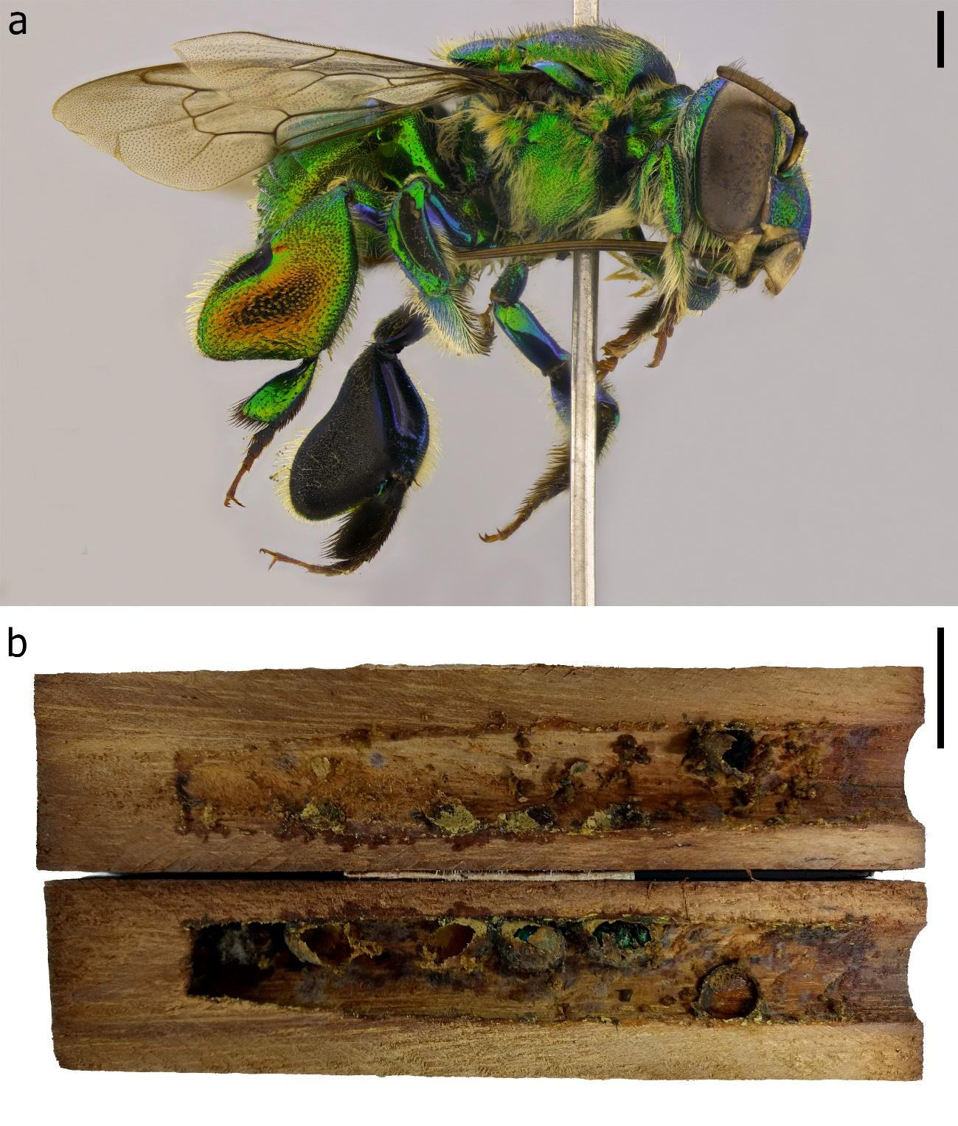
Figure 2. Euglossa cordata. A. Female habitus, lateral view; B. nest. Scale bar. a = 1.0mm and b = 15.0mm.

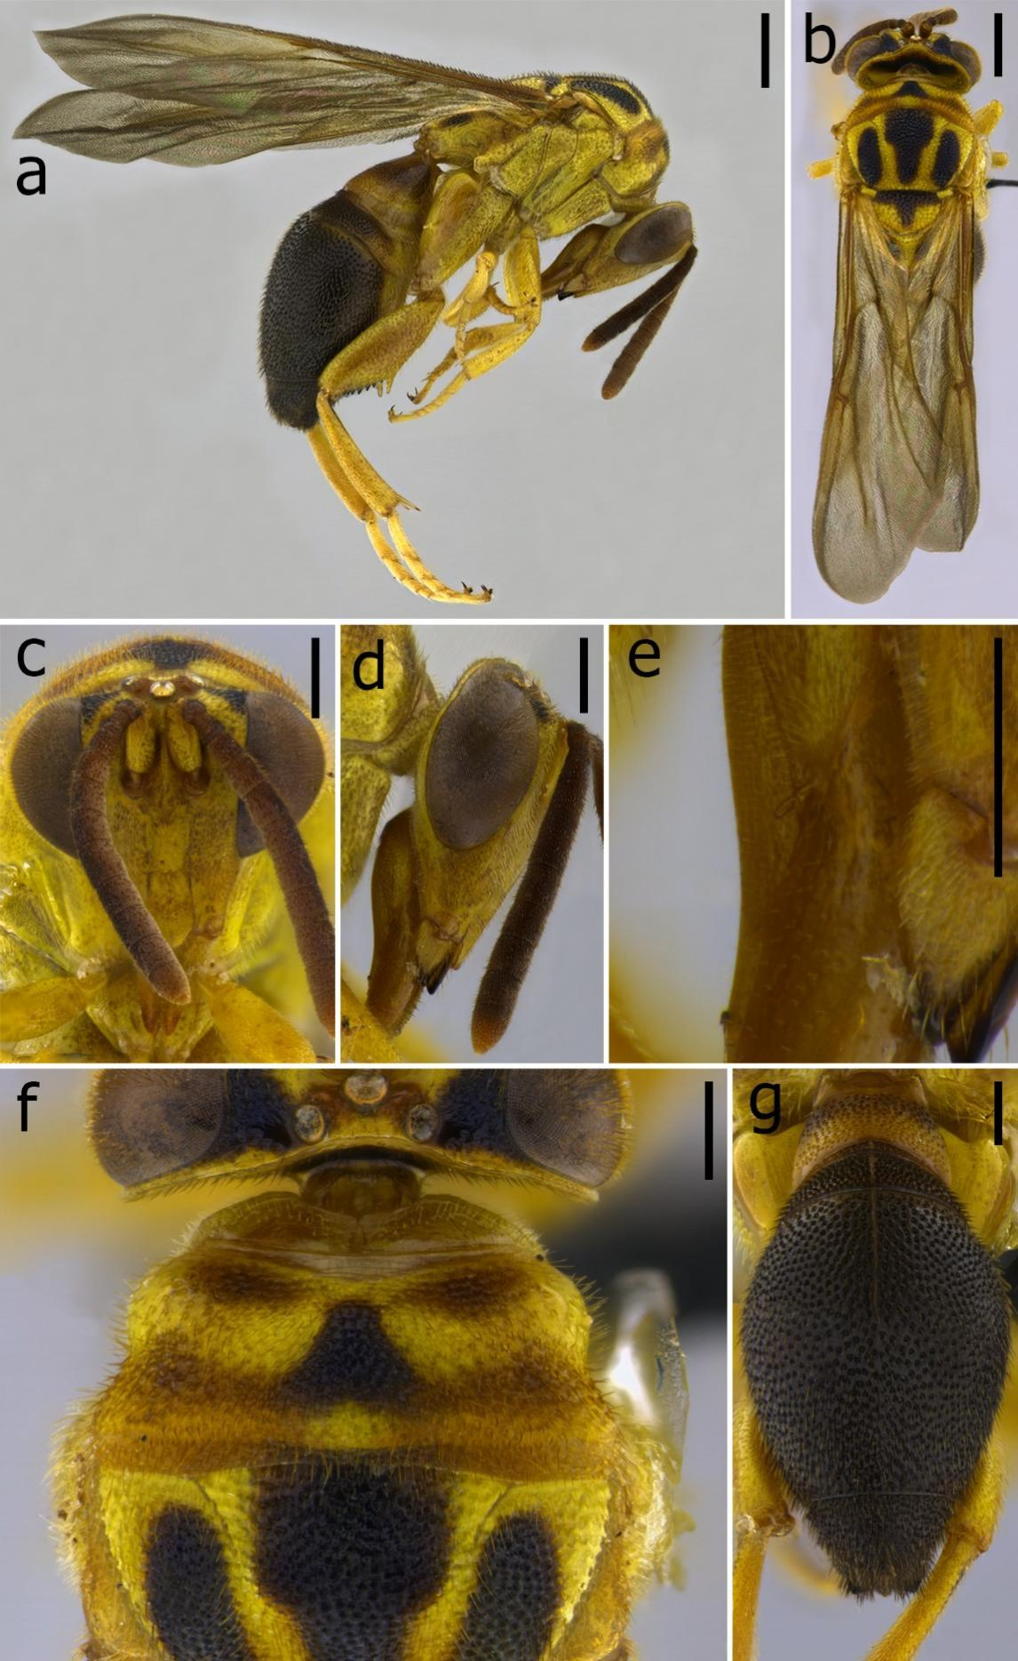
Figure 3. Female of Polistomorpha fasciata from Maranhão, Brazil. a) Habitus, lateral view; b) Habitus, dorsal view; c) Head, frontal view; d) Head, lateral view; e) Details of palpomeres; f) Part of head, pronotum, and part of mesoscutum, dorsal view; g) Metasoma, dorsal view. Scale bar: a, b, f = 1.0mm; c, d, e, g = 0.5mm.
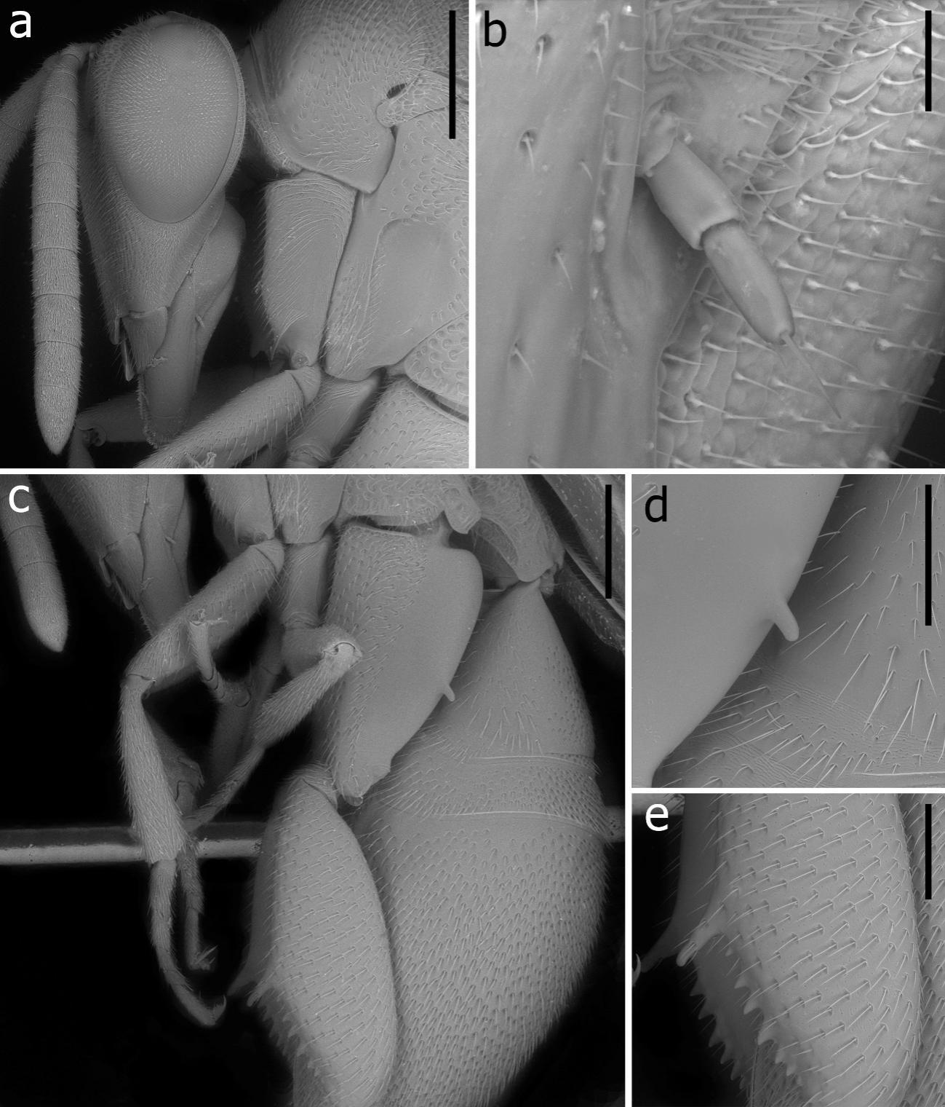
Figure 4. Electro-micrographs of Polistomorpha fasciata. a) Head and part of mesosoma, lateral view; b) Details of maxilar palpomeres; c) Metasoma and posterior coxa and femur, lateral view; d) Detail of posterior coxa tooth; e) detail of posterior femur teeth. Scale bar. a, c = 1000μm; b = 50μm; d, e = 500μm.

