
Research article
Gonopod morphology among of seven species of eubrachyuran crabs (Crustacea: Decapoda)
Morfología de gonópodos entre siete especies de cangrejos eubraquiuros (Crustacea: Decapoda)

¹Leonardo Peres de Souza; ²Cynthia Yuri Ogawa; ²José Roberto Feitosa Silva; ³Jussiara Candeira Spíndola Linhares; ¹Luciana Rocha Faustino; ³Andressa Freitas dos Santos Barreto; ⁴Maria Izabel Camargo Mathias

¹Federal University of the Parnaíba Delta, São Sebastião Avenue, 2819, Nossa Sra. de Fátima. Parnaíba, Piauí, Brazil.
leoperes@ufdpar.edu.br, lrfaustino@gmail.com.

²Federal University of Ceara, Mister Hull Avenue, s/n, Pici. Fortaleza, Ceará, Brazil. cynthiaogawa@gmail.com, robertofeitosa@ufc.br

³Federal University of Piauí, BR 343, KM 3,5, Meladão. Floriano, Piauí, Brazil jussiaralinhares@ufpi.edu.br.
⁴São Paulo State University, 24-A Avenue, 1515, Bela Vista. Rio Claro, São Paulo, Brazil maria.izabel@unesp.br.
¹https://orcid.org/0000-0002-9179-2925
²https://orcid.org/0000-0002-9577-6578
²https://orcid.org/0000-0002-6878-5516
³https://orcid.org/0000-0002-6745-8935
¹https://orcid.org/0000-0002-9452-9014
³https://orcid.org/0000-0003-1076-6424
⁴https://orcid.org/0000-0002-9418-8934
* For correspondence: andressa.freitas.sb@gmail.com

Received: 04th September 2024. Revised: 02nd October 2025. Accepted: 06th November 2025

Associate Editor: Mauricio Rodríguez Lanetty

Citation/citar este artículo como: Souza, L. P., Ogawa, C. Y., Silva, J. R. F., Linhares, J. C. S., Faustino, L. R., Barreto, A. F. S. and Camargo-Mathias, M. I. (2025). Gonopod morphology among of seven species of eubrachyuran crabs (Crustacea: Decapoda). Acta Biol. Colomb., 30(3), XX–XX. https://doi.org/10.15446/abc.v30n3.116484

ABSTRACT
The first and second gonopods (G1 and G2, respectively) in Eubrachyura crabs are covered with cuticular specializations that vary in shape and size. Describing these specializations would allow a better understanding of this organ and its role in copulation, especially if associated with the internal structure of the gonopods. Therefore, this study aims to contrast the morphology of the gonopods of seven species of Eubrachyura. The specimens were analyzed macroscopically, histologically, and microscopically using SEM. The G1 and the G2 in all species are formed by two segments, with G1 presenting an ejaculatory canal that is lacking in G2. Apical projections were observed in four species. The G2 endopodvaries in size among species. Five types of setae were observed: simple, pappose, papposerrate, conical, and paddle-shaped. Histologically, G1 and G2 are very similar, differing in that G1 presents the ejaculatory canal in longitudinal and transverse sections, as well as tegumentary glands, whereas G2 lacks both. There is a trend in the morphology of Eubrachyura crab’s gonopods which corresponds to the groups Thoracotremata and Heterotremata. The observed morphological variations suggest the presence of species-specific gonopod types.
Keywords: Copulatory structures, cuticular specializations, ejaculatory canal, setae types.

RESUMEN
Los primeros (G1) y segundos (G2) gonópodos en los cangrejos Eubrachyura están cubiertos con especializaciones cuticulares que varían en forma y tamaño. Describir dichas especializaciones permitiría una mejor comprensión de este órgano y su papel en la copulación, especialmente si se asocia con la estructura interna de los gonópodos. Por lo tanto, este estudio tiene como objetivo contrastar la morfología de los gonópodos entre siete especies de Eubrachyura. Los especímenes fueron analizados macroscópicamente e histológicamente por medio de microscopía electrónica de barrido (SEM). En todas las especies el G1 y el G2 están formados por dos segmentos, el G1 presenta un canal eyaculador, mientras que el G2 no lo presenta. Se observaron proyecciones apicales en cuatro especies. El endopodito G2 varía en tamaño entre las especies. Se observaron cinco tipos de setas: simples, papposas, papposerradas, cónicas y en forma de paleta. Histológicamente, el G1 y el G2 son muy similares, diferenciándose en que el G1 presenta el canal eyaculador en secciones longitudinales y transversales, y glándulas tegumentarias, mientras que el G2 carece de ambos. Existe una tendencia en la morfología de los gonópodos de los cangrejos Eubrachyura que corresponde a los grupos Thoracotremata y Heterotremata. Las variaciones observadas sugieren la existencia de estructuras gonopodales específicas para cada especie.
Palabras clave: Canal eyaculador, especializaciones cuticulares, estructuras copulatorias, tipos de setas.

INTRODUCTION
Species with internal fertilization present morphological variations in the genital structures of males (Hosken and Stockley, 2004; Taylor and Knouft, 2006). In Crustacea, the male genitalia morphology varies greatly, even among closely related groups (Guinot, 1979; Bauer, 1986; Martin and Abele, 1986). Male crabs (Brachyura) have two pairs of modified pleopods called gonopods (G1 and G2) that are used to transfer spermatophores during copulation. (Bauer, 1986; Hartnoll, 1969).
The gonopod surface has been described for several brachyuran species (Spalding, 1942; Martin and Abele, 1986; Brandis et al., 1999; Tsuchida and Fujikura, 2000; Lautenschlager et al., 2010; Becker et al., 2012), and its morphology is widely used in taxonomic studies, not only to classify into species but to acknowledge new ones (Pedraza et al., 2015; Yan et al., 2015). Comparative analyses of gonopods could be used in studies on evolution (Bauer, 1986) and phylogenetic (Hendrickx and Visauta-Girbau, 2013).
In Brachyura, both gonopods are covered with cuticular specializations. These structures may vary in shape and size and are responsible for the interaction between the individual and the environment (Garm, 2004). Most of these structures correspond to elongated projections which are articulated at their base, receiving several different names such as sensilla, hair, and setae, being the former the most widely used (Garm, 2004). Classification systems for the different types of cuticular specializations present on the surface of Decapoda, mainly the setae, were suggested by Thomas (1970), Farmer (1974), Watling (1989), and Garm (2004). However, the variety, distribution and morphological characterizations of these cuticular specializations in Brachyura gonopods are still lacking in records, especially using scanning electron microscopy (Beninger et al., 1991; Lautenschlager et al., 2010; Sal Moyano et al., 2011; Ewers-Saucedo et al., 2015; Kienbaum et al., 2017). These data would allow a better understanding of this organ and the role of cuticular projections in the reproductive process, such as copulation and fertilization, especially when associated with the study of the internal structure of gonopod specializations by histological examination, including the presence and characteristics of tegumental glands.
The internal structure of gonopods and the presence of tegumental glands has been reported by a few studies (Spalding, 1942; Beninger et al., 1991; Brandis et al., 1999). The tegumental gland is formed right below epidermal cells, and could be unicellular, tricellular, or multicellular (in this case, the shape is a rosette), it is associated with the cuticle and varies in structure among species (Felgenhauer, 1992).
Thus, the aim of the current study is to contrast the morphology of the gonopods among seven species of Eubrachyura crabs, focusing on the structure and distribution of cuticular specializations, as well as their histological organization, such as the presence and the characteristics of tegumental glands. Based on this information, the objective of this study is to elucidate the function of these structures during the reproductive process. The results obtained were also compared in order to find evidence of possible interspecific variation.
MATERIALS AND METHODS
Specimens of seven different species of eubrachyuran crabs were sampled, using as a criterion the relative size between the gonopods (G1 and G2), and ensuring the inclusion of individuals representing both patterns described by McLay and Becker (2015): 1. Sperm transfer with long G2 – Family Eriphiidae: Eriphia gonagra (Fabricius, 1781) and Family Menippidae: Menippe nodifrons (Stimpson, 1859); 2. Sperm transfer with short G2 – Family Portunidae: Callinectes bocourti (A. Milne-Edwards, 1879), Family Grapsidae: Goniopsis cruentata (Latreille, 1803), Family Gecarcinidae: Cardisoma guanhumi (Latreille, 1828), Family Ocypodidae: Uca maracoani (Latreille, 1802), and Family Ucididae: Ucides cordatus (Linnaeus, 1763).
Sampling was performed from 2010 to 2013 at Pacheco Beach, Ceará, Brazil (3°41′00″ S, 38°37′00″ W), and at the Jaguaribe River estuary, Ceará, Brazil (4°30′00″ S, 37°46′00″ W). Sampling authorization and materials transportation were granted by the national authorities (ICMBio #2418-3). Five mature males of each species were captured for this study, and their maturity was confirmed macroscopically and histologically.
After sampling, the animals were transported in plastic containers along with water from the sampling site and brought alive to the laboratory. In the laboratory, specimens were euthanized via cryoanesthesia at −20 °C, and the gonopods were removed. Then, the gonopods were photographed using a stereomicroscope equipped with a digital camera (Leica DFC925) to document external morphology before further processing.
Histological and histochemical analyses
Once removed, the gonopods fragments were prepared for histochemistry analyses, fixed for 24 hours in specific fixative solutions for each technique as suggested by Eltoum et al. (2001). Therefore, glutaraldehyde 2.5 % in cacodylic buffer (0.1 M) for general staining methods, paraformaldehyde 4 % to detect proteins, formaldehyde Ca 10 % for lipids and Bouin’s aqueous solution for polysaccharides. After fixation, fragments were decalcified for 72 h in an Ion Exchange Decal Unit (I.E.D Unit – Biocare Medical), followed by dehydration in an ethanol series, embedded in resin (Leica). For every ten sections, a slide was mounted using sections of 3 µm and 8 µm of each fragment.
The slides were stained with hematoxylin and eosin technique (adapted from Junqueira and Junqueira, 1983) (basophilic substances stain purple, acidophilic substances stain pink). For detection of proteins, glycoproteins and lipids, the samples were stained with bromophenol blue (adapted from Pearse, 1960), PAS (adapted from Junqueira and Junqueira, 1983) and Baker (adapted from Baker, 1946), respectively. The section was then analyzed and photographed using a light microscope (Leica DM 100) attached to a digital camera (Leica DFC925).
Scanning electron microscopy analysis
The gonopod fragments were fixed in 2.5% glutaraldehyde in cacodylate buffer (0.1 M), dehydrated in increasing concentrations of acetone (70–100%), subjected to critical point drying, mounted on an aluminum stub, and then gold-coated for examination under a scanning electron microscope (SEM) (Hitachi – TM3000). To better observe the surface of the gonopods, some setae were removed with a blade, and the exposed area was observed under a stereoscope microscope (Leica S8AP0).
As descriptive criteria, it was used the abdomen flexed below the cephalothorax region. Therefore, the gonopod surface facing the stern is named the sternal region while the surface facing the abdomen is the abdominal region. In the present study, it was used as a reference the nomenclature suggested by Thomas (1970) and Garm (2004) for the structures and projections present in the cuticle, as well as the classification of the different setae type.
RESULTS
External morphology of the G1
The G1 is formed by two segments: the protopodite (basal) and the endopodite (distal) (Fig 1a, c). In all species the endopodite of the G1 is elongated presenting an invagination of the cuticle which extends longitudinally, forming a duct, the ejaculatory canal (Fig. 1e). This invagination begins in a proximal opening and ends in another one in the terminal region (Fig. 2a, b, d). This region is also twisted, and when positioned in relation to the females, would be facing the female gonopore. Observations under a stereoscopic microscope show that a brown projection emerging from the terminal region is present in U. cordatus, G. cruentata, C. guanhumi, and U. maracoani, named the apical projection (Fig. 1f), differing in shape and size according to the species studied. In U. cordatus, this terminal structure is difficult to visualize due to the presence of a large number of setae inserted in the terminal region of the gonopod (Fig. 2c). After removal of setae with a blade, it was possible to observe the ejaculatory canal in the terminal projection (Fig. 1e).
External morphology of the G2
Like G1, the G2 is also formed by protopodite and endopodite segments (Figs. 1b; d). The endopodite is elongated and conically shaped in all studied species, without invagination forming the ejaculatory canal. The endopodite varies in size, depending on the species studied. In M. nodifrons and E. gonagra the endopodite was longer than the G1. In U. cordatus, G. cruentata, C. guanhumi and U. maracoani and Callinectes bocourti, the endopodite is short and presents an enlarged apical area forming the appendix masculina (Figs. 3a, c, d). In C. bocourti It is also possible to observe another extension of the terminal end of the G2 (Fig. 3d).
The appendix masculina differs in size, texture and distribution of the cuticular projections on the surface. The surface of the appendix masculina faces the G1 and presents cuticular projections, named denticles, in U. maracoani and C. guanhumi (Fig. 3a; b). In U. maracoani these projections are small flattened and sharpened and present a small curved filament (Fig. 3b). In U. cordatus the appendix masculina lacks denticles, however, presents longitudinal folds (Fig. 3c). In C. bocourti, these cuticular projections are thick (Fig. 3d).
In M. nodifrons and E. gonagra the terminal region of the second gonopod is elongated and thin, lacking an evident appendix masculina (Figs. 3e, f). Elongated cuticular projections directed towards the terminal region of the gonopod and with denticles are present in the abdominal surface of the subterminal region, shaped like a half-moon in M. nodifrons gonopod (Fig. 3g) and partially surrounding E. gonagra (Fig. 3h). In M. nodifrons, the sternal surface of these projections presents a hollow, which partially surrounds the gonopod, probably to allow the flexion of the terminal region of the gonopod (Fig. 3e, g).
Setae
On the gonopod surface, five types of setae were observed, described and classified as follows: simple, pappose, papposerrate (as suggested by Garm, 2004), conical (as suggested by Thomas, 1970) and paddle-shaped.
1) Simple: varies in length and thickness, being cylindrical or flattened dorsiventrally (Fig. 4a). It lacks subdivisions or cuticular projections; except in E. gonagra setae which had denticles projections (Fig. 4b). In all species studied, this type of setae was inserted in the gonopod in a ringlike shape in the cuticle (Fig. 4c) and a ring which surrounds the setae stem usually next to its median portion, the annulus (Fig. 4d). Simple setae are present mainly on G1 of all analyzed species.
2) Pappose: this type is also inserted in a ringlike structure in the gonopods and are very thin and elongated (Fig. 4e). Their main characteristic is the presence of flattened elongated projections, with a serrated edge, the setules (Fig. 4g). These are inserted in the setae, distributed randomly and are projected towards the terminal portion of it. Rarely it is possible to observe the annulus in the main stem of the seta due to the great amount of setules. This type of setae is observed mainly in the proximal region of the gonopods in all species. These structures are observed mainly in G1, forming an agglomerate in the basal opening of all studied species (Fig. 2a).
3) Papposerrate: this type of setae is elongated and slim. Their insertion is ringlike shape, presenting setule randomly distributed in medial and proximal region. Denticles are present on the edge of their distal portion (Figs. 4f; h). This type of setae was visualized in both gonopods of C. guanhumi.
4) Conical: are short and thick with a ringlike insertion in the cuticle. The annulus can be observed in the medial portion (Fig. 4i). They were only observed in the medium region of the G1 of C. bocourti.
5) Paddle-shaped: are shaped like a pad and face the proximal region of the gonopod. They present a central annulus, and their insertion occurs in a hollow shaped like a ring (Fig. 4j). It was only observed in C. bocourti, distributed in the external, terminal and lateral portions of the G1.
The setules are limited to the stem of the pappose and papposerrate setae. However, as mentioned before, the denticles were also observed on the surface of both gonopods, being present mainly in the terminal region of the G2 of G. cruentata, C. guanhumi, U. maracoani, U. cordatus and E. gonagra. They are present also in the G1 of M. nodifrons and E. gonagra.
Histological structure
The gonopods are lined by columnar or squamous epithelium covered externally by cuticle and filled internally by loose connective tissue (Fig. 5a). In transverse sections of the G1 endopodite of all analyzed species, it is possible to observe the ejaculatory canal (Fig. 5a), as well as in longitudinal sections, it is possible to observe that this canal is also present in the apical projection (Fig. 5b).
Embedded in connective tissue it is possible to observe nerve fibers. Three cell types were predominant in the matrix of the loose connective tissue: 1. Fibroblasts - oval cells, with not so evident cytoplasm and condensed chromatin nucleus (Fig. 5c); 2. Hyaline hemocytes - rounded cells presenting nucleus with very condensed chromatin, thin eosinophilic cytoplasm, without granules (Fig. 5c). This cell type could also be observed in the inside hemal vessels; and 3. Granulocytes - hemal cells usually with a compact nucleus and cytoplasm filled by eosinophilic granules (Fig. 5d).
The protopodite tissue components of G1 are distributed in a similar manner, filled by loose connective tissue and striated muscles. Whereas in the endopodite, the presence of muscle tissue is not observed, being filled mainly with loose connective tissue.
Regarding the tegmental glands, they are localized in the proximal region of the G1 endopodite of the analyzed species as multicellular glands formed by columnar cells with basophilic granules in the cytoplasm and a basal nucleus (Fig. 5e). In the central portion of the glands, there is a cell with a weak basophilic cytoplasm and with a nucleus greater in volume when compared to the other secretory cells (Fig. 5e). The histochemical analysis of all studied species showed that these glands stained weakly for polysaccharide, moderately to total proteins and did not react to lipids.
The G2 of analyzed species is filled with loose connective tissue and striated muscle; and differently from the G1, the G2 does not present multicellular tegumental gland. Inside the setae, there is a lumen that runs through its apical region all the way inside the gonopod, passing through orifices on the joint at the base of the setae and surface of the gonopod (Fig. 5f; g). The lumen of the setae extends up to the tip of the setae, where it seemed to be separated from the external medium by a thin layer of cuticle (Fig. 5g). Below the region where the stage is inserted, there is observed a group of sensorial cells with fusiform shape, with their cytoplasm extending until the entrance of the pores through which the setae communicate with the interior of the gonopods (Fig. 5h).
DISCUSSION
During mating of Eubrachyura crabs, the transference of spermatozoa to females occurs through the interaction of the penis papilla, G1 and G2. The G2 is inserted in the G1, functioning as a piston that pumps the spermatophoric mass from the proximal opening first into the opening present in the terminal region (Spalding, 1942; Ryan, 1967; Bauer, 1986; Beninger et al., 1991; Guinot et al., 2013). According to Hartnoll (1975) the size differences in the second gonopod reflect an evolutionary tendency in Brachyura copulatory system, i. e., reduction of the second gonopod. When analyzing the data from the present research and the results of other studies, it is possible to confirm this tendency. Representatives of Thoracotremata, considered a more derived group, present G2 shorter than the first (Lautenschlager et al., 2010; Becker et al., 2012), as observed in G. cruentata, C. guanhumi, U. maracoani and U. cordatus. In Heterothremata, representative species in this study are M. nodifrons, E. gonagra and C. bocourti, this condition varies, with individuals having G2 larger or smaller than the G1 (Spalding, 1942; Beninger et al., 1991; Brandis et al., 1999; Tsuchida and Fujukura, 2000; Sal Moyano et al., 2011).
The pair of G1 showed a duct, named in brachyuran crabs as the ejaculatory canal (Hartnoll, 1975; Beninger et al., 1991; Guinot et al., 2013). This canal lacks associated muscles or structures, such as cilia and flagella, which could move the semen to be ejaculated. The absence of these structures reinforces the need to pump to dislocate the spermatic material through the ejaculatory canal, a function which is performed by the muscular second gonopod.
The terminal region of the G1 of U. cordatus, G. cruentata, U. maracoani and C. guanhumi is large and has the presence of several setae that could make penetration difficult, suggests that in these species the gonopod is not inserted in the vagina. However, in E. gonagra and C. bocourti the terminal region of the G1 is filamentous and lacks setae, being possible its insertion in the female vagina. Through the ejaculatory canal, present in the apical projection, the spermatozoa would be transferred to the vagina. A similar apical projection found in the gonopods of analyzed Thoracotremata in this study was also observed in the genus Uca by Lautenschlager et al. (2010) and in Grapsoidea Percnon gibbesi (H. Milne Edwards, 1853) by Kienbaum et al. (2017). According to these authors this structure could have a mechanism similar to a key-lock, which ensures that males would only mate with females belonging to the same species. Although this study examined only one species per genus, the morphological patterns observed suggest the occurrence of a potential key-lock mechanism, possibly associated with reproductive compatibility and efficient sperm transfer in terrestrial environments. However, to confirm species-level specificity, and validate this mechanism with greater precision, more comprehensive analyses involving multiple species within each genus are required. The specific fitting facilitates the transfer of the ejaculated to the female vagina, minimizing the required liquid and the loss during copulation in a land environment (Lautenschlager et al., 2010). In fact, the apical projections occur in the semi-terrestrial species, i.e, U. cordatus, G. cruentata, U. maracoani and the land crab C. guanhumi.
We observed different kinds of setae in the present studypresent in Eubrachyura gonopods. There has been inconsistent description of the number of setae present in the gonopods, with six types described for Libinia spinosa (H. Milne-Edwards, 1834) (Sal Moyano et al., 2011) while eight have been described for Chionoecetes opilio (O. Fabricius, 1788) (Beninger et al., 1991). This difference between these studies and ours results from different criteria used to classify these structures. In the current study, we considered as setae all the projections that present the characteristics described by Thomas (1970) and Garm (2004), such as the presence of a ring insertion and annulus. Regarding this, the projections that lack these characteristics, such as denticles and setule were not considered setae, but cuticle projections.
The presence of simple type setae in the distal region of G1, observed in all Thoracotremata species analyzed in this study, suggests that these cuticular specializations function to stabilize and assist the fitting between the gonopod and the female gonopore during copulation (Beninger et al., 1991). These authors have also suggested that their insertion in a ringlike hollow would allow the movement in different directions, suggesting a mechanoreceptor function. Sal Moyano et al. (2011), who called the simple setae as type II, suggest that they would have the function to protect the gonopods against harmful events. A function that was evident mainly in the Thoracotremata analyzed in this study, in which simple setae were found concentrated in the distal region of the G1, covering mainly the terminal projection and promoting its protection for spermatozoa transfer.
In Thoracotremata, some papposa setae were observed throughout the G1, and probably they function as a vibration monitor, as suggest by Phillips and Macmilla (1987) for this type of setae. This same function was observed in the lobster antennae, as it was proposed by Beninger et al. (1991) for C. opilio. Papposerrate setae present in C. guanhumi are probably the ones performing this function.
Inside the gonopods, below the setae insertion region in the cuticle, the presence of a group of cells was observed. These cells have projections which are facing the cuticle pore through where the lumen runs. Altner et al. (1983) described, in the chelae, sensorial setae having eight sensorial bipolar cells each, where segments of dendrites extend to the setae apex. According to the same authors, of these cells, two would function as mechanoreceptors and the others would be chemoreceptors.
It is known that in some species, such as Portunus sanguinolentus (Herbst, 1783) (Ryan, 1967), Pachygrapsus crassipes (Randall, 1839) (Kittredge et al., 1971) and Carcinus maenas (Linnaeus, 1758) (Seifert, 1982), females release pheromones that induce the search for a partner for copulation, as well as courtship and pre-copulatory behavior. Therefore, the chemoreceptor function of the G1 could be associated with the perception of stimuli directed to reproductive process, as well as to the detection of adequate environmental conditions for spermatozoa transfer.
It was observed in the connective tissue of both pairs of gonopods the presence of two types of hemocytes: hyaline and granular, characterized by Johnson (1980) as the main types. Martin and Hose (1992) defined the function of the hemocytes as analogous to leucocytes in vertebrates, i.e. recognition and removal of foreign material, as well as coagulating hemolymph. These cells were present mainly in the G1, next to pores that connect to the setae lumen inside the gonopod, where they probably prevent the entrance of foreign bodies.
The location of the rosette-type glands observed in this study corresponds to what has been reported for other Brachyura (Beninger et al., 1991; Beninger and Larocque, 1998; Becker et al., 2012; Kienbaum et al., 2017), although it has been found to be distal in C. maenas (Beninger and Larocque, 1998) and L. spinosa (Sal Moyano et al., 2011). According to Beninger and Larocque (1998), rosette-type glands would occur in Brachyura being similar among species regarding: 1) the glands in rosette would be invariably grouped in the surrounding area or near to the ejaculatory canal, and 2) glands would communicate with the ejaculatory canal lumen through cuticle pores, not observed in other regions. These similarities were also confirmed in the present study.
Another observed characteristic of these glands in the species analyzed was the presence of secretory cells surrounding a central duct, which is similar to what has been observed in other Brachyura (Beninger et al., 1991; Beninger and Larocque, 1998; Brandis et al., 1999; Sal Moyano et al., 2011; Becker et al., 2012). The cell observed in the central region of the gland corresponds to a cell observed through the ultrastructure description of the tegumental gland (Johnson and Talbot, 1987). According to Felgenhauer (1992), cells located in the central portion of the rosette-type gland probably have the function to form a duct to transport secretion to the lumen of the ejaculatory canal.
It has been showed by histochemistry analysis that the secretion present in the female seminal receptacle are of glycoprotein origin due to its strong reaction to PAS (Souza et al., 2017). Therefore, even though the rosette-type gland does not react as strongly to PAS, this gland probably plays an important role contributing with substances present in this secretion. Glycoproteins are good energy sources besides being hygroscopic, an important property for the dehiscence of the spermatophore (Beninger et al., 1993). In addition, lipids were not observed in the secretion of tegumental glands. Usually, in invertebrates, besides being an important source of energy, lipids take part in stimulating motility in spermatozoa (Guraya, 1987). However, such function cannot be applied to the species herein analyzed, since no structure that could indicate motility in spermatozoa could be observed.
Spalding (1942) as well as Bawab and El-Shrief (1989) suggested that the secretions from rosette glands would form a hard structure, named spermatic plug, which would seal the female genital duct, prohibiting the fertilization by other males in following copulations. However, among the seven species studied, only in E. gonagra the presence of spermatic plug has been described (Souza et al., 2017). In addition, because this gland is located next to the proximal opening of G1, its secretions may act as a lubricant, facilitating the insertion of G2 into G1 and enabling the pumping movement through the spermatic canal (Sal Moyano et al., 2011).
CONCLUSIONS
The morphological analysis of the gonopods, integrating cuticular specializations and histological examination, reveals consistent patterns within Thoracotremata and Heterotremata. Thoracotremata species tend to be more uniform regarding the presence of the appendix masculina and simple-type setae, whereas Heterotremata exhibit greater diversity in the external morphology of the gonopods. In addition, the detailed structures of the gonopods vary substantially among species, indicating the possibility of species-specific morphological patterns. However, broader taxonomic sampling is required to test and confirm these trends.
ACKNOWLEDGMENT
The authors would like to thank laboratory technicians Antônio Teruyoshi Yabuki, Monika Iamonte, Pablo Barros Brito and Robson Jesus for their assistance in processing samples. The authors thank Dr. Luciana Rocha Faustino for revising the manuscript. This research was funded by FAPESP (Fundação de Amparo à Pesquisa do Estado de São Paulo) (#2009/52821-2).

REFERENCES
Altner, I., Hatt, H. and Altner, H. (1983). Structural properties of bimodal chemo- and mechanosensitive setae on the pereiopod chelae of the crayfish, Austropotamobius torrentium. Cell and Tissue Research, 228(2). https://doi.org/10.1007/BF00204885
Baker, J. R (1946). The histochemical recognition of lipine. Journal of Cell Science, 87(2), 441–470. https://doi.org/10.1242/jcs.s2-87.348.441
Bauer, R. T. (1986). Phylogenetic Trends in Sperm Transfer and Storage Complexity in Decapod Crustaceans. Journal of Crustacean Biology, 6(3), 313. https://doi.org/10.2307/1548173
Bawab, F. M. and El-Sherief, S. S. (1989). Contributions to the study of the origin, nature and formation of the plug in the spermatheca of the female crab Portunus pelagicus, (Linnaeus, 1766) (Decapoda, Brachyura). Crustaceana, 57(1), 9–24.
Becker, C., Türkay, M. and Brandis, D. (2012). The male copulatory system of european pea crabs (crustacea, brachyura, pinnotheridae). Journal of Morphology, 273(11), 1306–1318. https://doi.org/10.1002/jmor.20065
Beninger, P. G., Elner, R. W. and Poussart, Y. (1991). Gonopods of the Majid Crab Chionoecetes opilio (O. Fabricius). Journal of Crustacean Biology, 11(2), 217. https://doi.org/10.2307/1548359
Beninger, P. G. (1993). Reproductive Processes Revealed by Spermatophore Dehiscence Experiments and by Histology, Ultrastructure, and Histochemistry of the Female Reproductive System in the Snow Crab Chionoecetes opilio (O. Fabricius). Journal Of Crustacean Biology, 13(1).
Beninger, P. G. and Larocque, R. (1998). Gonopod tegumental glands: A new accessory sex gland in the Brachyura. Marine Biology, 132(3), 435–444. https://doi.org/10.1007/s002270050409
Brandis, D., Storch, V. and Türkay, M. (1999). Morphology and function of the copulatory system in freshwater crabs of the genus Potamon. Journal of Morphology, 239(2), 157–166. https://doi.org/10.1002/(SICI)1097-4687(199902)239:2<157::AID-JMOR4>3.0.CO;2-E
Eltoum, I., Fredenburgh, J., Myers, R. B. and Grizzle, W. E. 2001. Introduction to the theory and practice of fixation of tissues. Journal of Histotechnology, 24(3), 173–190.
Ewers‐Saucedo, C., Hayer, S. and Brandis, D. (2015). Functional morphology of the copulatory system of box crabs with long second gonopods (Calappidae, Eubrachyura, Decapoda, Crustacea). Journal of Morphology, 276(1), 77–89. https://doi.org/10.1002/jmor.20322
Farmer, A. S. (1974). The functional morphology of the mouthparts and pereiopods of Nephrops norvegicus (L.) (Decapoda: Nephropidae). Journal of Natural History, 8(2), 121–142. https://doi.org/10.1080/00222937400770091
Felgenhauer, B. E. 1992. External Anatomy and Integumentary Structures. In: Harrison, F. W. and Hume, A. G. eds. Microscopic Anatomy of Invertebrates. Decapoda Crustacea. New York, Wiley-Liss, 10,7-43.
Garm, A. (2004). Revising the definition of the crustacean seta and setal classification systems based on examinations of the mouthpart setae of seven species of decapods. Zoological Journal of the Linnean Society, 142(2), 233-252. https://doi.org/10.1111/j.1096-3642.2004.00132.x
Guinot, D. (1979). Données nouvelles sur la morphologie, la phylogenèse et la taxonomie des Crustacés Décapodes Brachyoures. Zoologie. 112. 1-354.
Guinot, D., Tavares, M. and Castro, P. (2013). Significance of the sexual openings and supplementary structures on the phylogeny of brachyuran crabs (Crustacea, Decapoda, Brachyura), with new nomina for higher-ranked podotreme taxa. Zootaxa, 3665(1). https://doi.org/10.11646/zootaxa.3665.1.1
Guraya, S. S. (1987). Biology of Spermatogenesis and Spermatozoa in Mammals, Springer-Verlag, New York, NY,1–429. https://doi.org/10.1007/978-3-642-71638-6_1
Hartnoll, R. G. (1969). Mating in the Brachyura. Crustaceana, 16 (2), 161-181. https://doi.org/10.1163/156854069X00420
Hartnoll, R. G. (1975). Copulatory structure and function in the Dromiacea, and their bearing on the evolution of Brachyura. Stazione Zoologica di Napoli, 39, 657–676.
Hendrickx, M. E. and Visauta-Girbau, E. V. (2013). New Record and Description of the Male Gonopods of Paeduma cylindraceum (Bell, 1859) from the Tropical Eastern Pacific (Decapoda, Brachyura, Hexapodidae). Zoosystema, 35(1), 89–96. https://doi.org/10.5252/z2013n1a7
Hosken, D. J. and Stockley, P. (2004). Sexual selection and genital evolution. Trends in Ecology & Evolution, 19(2), 87–93. https://doi.org/10.1016/j.tree.2003.11.012
Johnson, B. and Talbot, P. (1987). Ultrastructural analysis of the pleopod tegumental glands in male and female lobster, Homarus americanus. Journal of Crustacean Biology 7(2), 288–301. https://doi.org/10.1163/193724087X00243
Johnson, P. T. (1980). Histology of the blue crab, Callinectes sapidus: A model for the Decapoda. New York, Praeger Publishers.
Junqueira, L. C., & Junqueira, L. M. M. S. (1983). Técnicas básicas de citologia e histologia. Livraria e Editora Santos.
Kienbaum, K., Scholtz, G. and Becker, C. (2017). The morphology of the male and female reproductive system in two species of spider crabs (Decapoda: Brachyura: Majoidea) and the issue of the velum in majoid reproduction. Arthropod Systematics & Phylogeny, 75(2), 245-260.
Kittredge, J. S., Terry, M., and Takahashi, F. T. (1971). Sex pheromone activity of the molting hormone, crustecdysone, on male crabs (Pachygrapsus crassipes, Cancer antennarius, and C. anthonyi). Fishery Bulletin, 69, 337–343.
Lautenschlager, A. D., Brandis, D. and Storch, V. (2010). Morphology and function of the reproductive system of representatives of the genus Uca. Journal of Morphology, 271(11), 1281–1299. https://doi.org/10.1002/jmor.10869
Martin, G. G. and Hose, J. E. (1992). Vascular elements and blood (hemolymph). In: Harrison, F. W. & Hume, A. G. eds. Microscopic Anatomy of Invertebrates. Decapoda, Crustacea. New York, Wiley-Liss, v.10, p.117–146.
Martin, J. W. and Abele, L. G. (1986). Notes On Male Pleopod Morphology in the Brachyuran Crab Family Panopeidae Ortmann, 1893, Sensu Guinot (1978) (Decapoda). Crustaceana, 50(2), 182–198. https://doi.org/10.1163/156854086X00205
Mclay, C. L. and Becker. C. (2015). Reproduction in Brachyura. In: Castro, P., Davie, P. J. F., Guinot, D., Schram, F. R., Von Vaupel Klein, J. C. eds. Treatise on Zoology - Anatomy, Taxonomy, Biology - The Crustacea. Boston, Brill NV, p.185–243.
Pearse, A. G. E. (1960). Histochemistry: Theoretical and Applied (Vol. 2). J. & A. Churchill Ltd.
Pedraza, M., Martinelli-Filho, J. E. and Magalhães, C. (2015). A new species of Kingsleya (Crustacea: Decapoda: Pseudothelphusidae) from the Xingu River and range extension for Kingsleya junki, freshwater crabs from the southern Amazon basin. Zoologia (Curitiba), 32(1), 41–46. https://doi.org/10.1590/S1984-46702015000100006
Phillips, B. F. and Macmillan, D. L. (1987). Antennal Receptors in Puerulus and Postpuerulus Stages of the Rock Lobster Panulirus cygnus (Decapoda: Palinuridae) and Their Potential Role in Puerulus Navigation. Journal of Crustacean Biology, 7(1), 122. https://doi.org/10.2307/1548631
Ryan, E. P. (1967). Structure and function of the reproductive system of the crab Portunus sanguinolentus (Herbst) (Brachyura: Portunidae). II. The Female system. Proceedings of the Symposium on Crustacean, Marine Biology, 2, 522–544.
Sal Moyano, M. P., Gavio, M. A. and Cuartas, E. I. (2011). Copulatory system of the spider crab Libinia spinosa (Crustacea: Brachyura: Majoidea). Journal of the Marine Biological Association of the United Kingdom, 91(8), 1617–1625. https://doi.org/10.1017/S0025315411000257
Seifert, P. (1982). Studies on the sex pheromone of the shore crab, Carcinus maenas, with special regard to ecdysone excretion. Ophelia, 21(2), 147–158. https://doi.org/10.1080/00785326.1982.10426583
Souza, L. P., Ogawa, C. Y., Silva, J. R. F. and Camargo‐Mathias, M. I. (2017). Comparative morphology of the female genital ducts of seven eubrachyuran crabs (Saint Laurent, 1980). Acta Zoologica, 98(2), 125–135. https://doi.org/10.1111/azo.12154
Spalding, J. F. (1942). The nature and formation of the spermatophore and spem plug in Carcinus maenas. Journal of Cell Science, 83, 389–423.
Taylor, C. A. and Knouft, J. H. (2006). Historical influences on genital morphology among sympatric species: Gonopod evolution and reproductive isolation in the crayfish genus Orconectes (Cambaridae): Orconectes systematics and gonopod evolution. Biological Journal of the Linnean Society, 89(1), 1–12. https://doi.org/10.1111/j.1095-8312.2006.00637.x
Thomas, W. J. (1970). The setae of Austropotamobius pallipes (Crustacea: Astacidae). Journal of Zoology, 160(1), 91–142. https://doi.org/10.1111/j.1469-7998.1970.tb02899.x
Tsuchida, S. and Fujikura, K. (2000). Heterochely, relative growth, and goopod morphology in the bythograeid, Austinograea williamsi (Decapoda, Brachyura). Journal of Crustacean Biology, 20(2), 407–414. https://doi.org/10.1163/20021975-99990052
Yan, B., Kee, N. and Ng, P. K. L. (2015). The taxonomy of five species of Episesarma De Man, 1895, in Singapore (Crustacea: Decapoda: Brachyura: Sesarmidae). The Raffles bulletin of zoology. Supplement 31. 199–215.
Watling, L. A. (1989). Classification system for crustacean setae based on the homology concept. In: Felgenhauer, B., Watling, L. L. & Thistle, A. eds. Crustacean Issues 6, A.A. Rotterdam, Balkema, p.15–26. https://doi.org/10.1201/9781003079354-2

TABLAS Y FIGURAS
Figure 1. Gonopods in eubrachyuran crabs photographed at stereoscopic microscope. a) G1 of C. guanhumi; b) G2 of C. guanhumi; c) G1 of E. gonagra; d) G2 of E. gonagra; e) Transverse section of the apical projection of G1 in C. guanhumi showing the ejaculatory canal [EC]; f) Terminal region of the G1 of U. maracoani showing apical projection [AP] and setae [S]. Protopodite [P], Endopodite [E].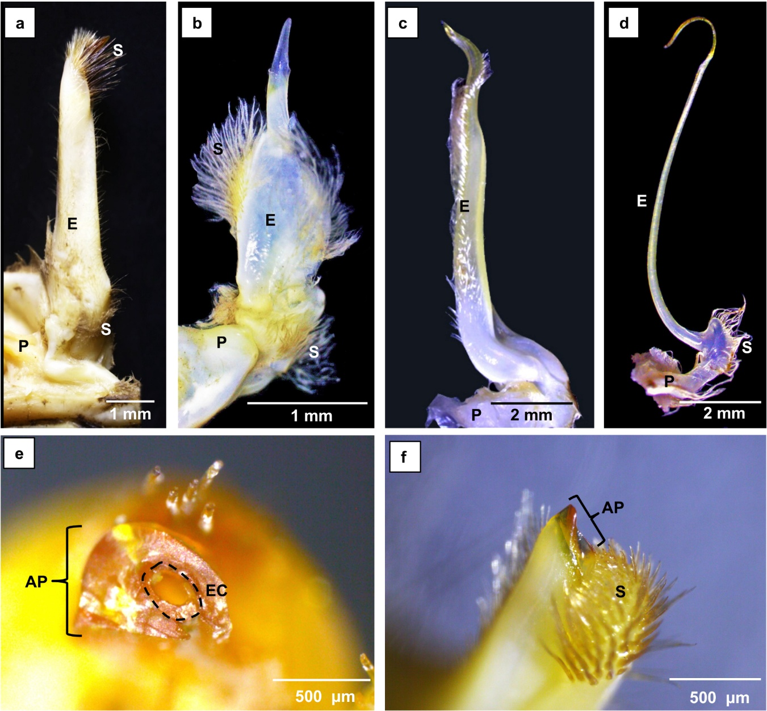

Figure 2. Scanning electron micrographs (SEM) of the G1 of Eubrachyura crabs. a) Proximal opening [PO] of the ejaculatory canal in C. bocourti; b) Terminal opening [TO] of the ejaculatory canal [EC with arrow] in M. nodifron. Simple setae [SS]; c) Terminal region of the first gonopod in U. cordatus; Apical projection [AP]; d) Terminal region in G1 of M. nodifrons evidencing the ejaculatory canal and terminal opening.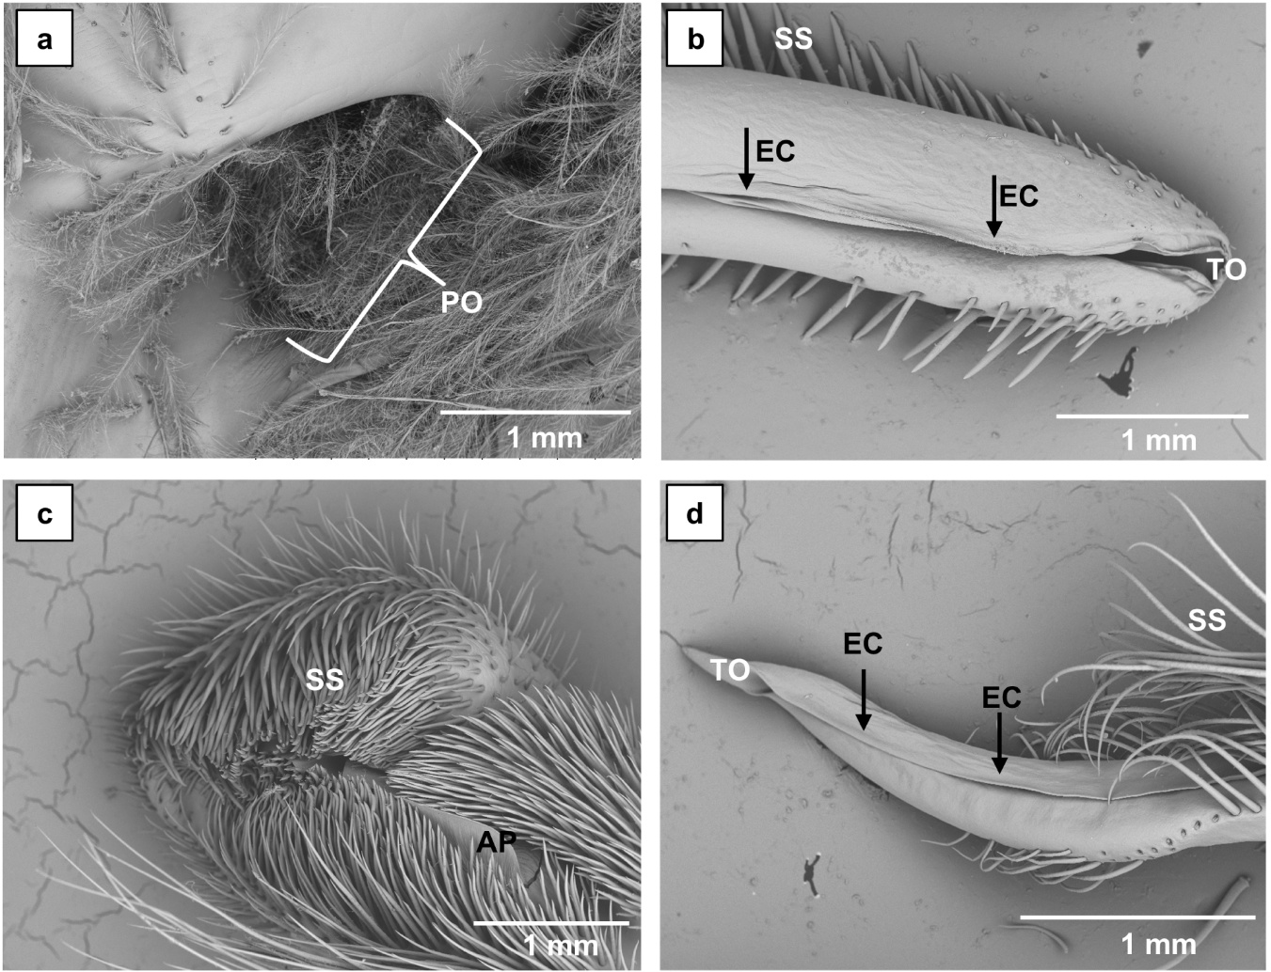

Figure 3. Scanning electron micrographs of the G2 of Eubrachyura crabs. a) Terminal region showing the appendix masculina [AM] in C. guanhumi; b) Appendix masculina in U. maracoani with denticules and curved filaments [arrow]; c) Appendix masculina in U. cordatus with longitudinal folding [dotted arrow]; d) Terminal region with a secondary projection [SP] beside the appendix masculina in C. bocourti; e) Sharpened terminal region [TR] and flexion zone [FZ] in M. nodifrons; f) Sharpened terminal region in E. gonagra; g) Denticulated projections [DP] in the subterminal region of M. nodifrons, with flexion zone on the opposite side; h) Denticulated projections [DP] in the subterminal region of E. gonagra.
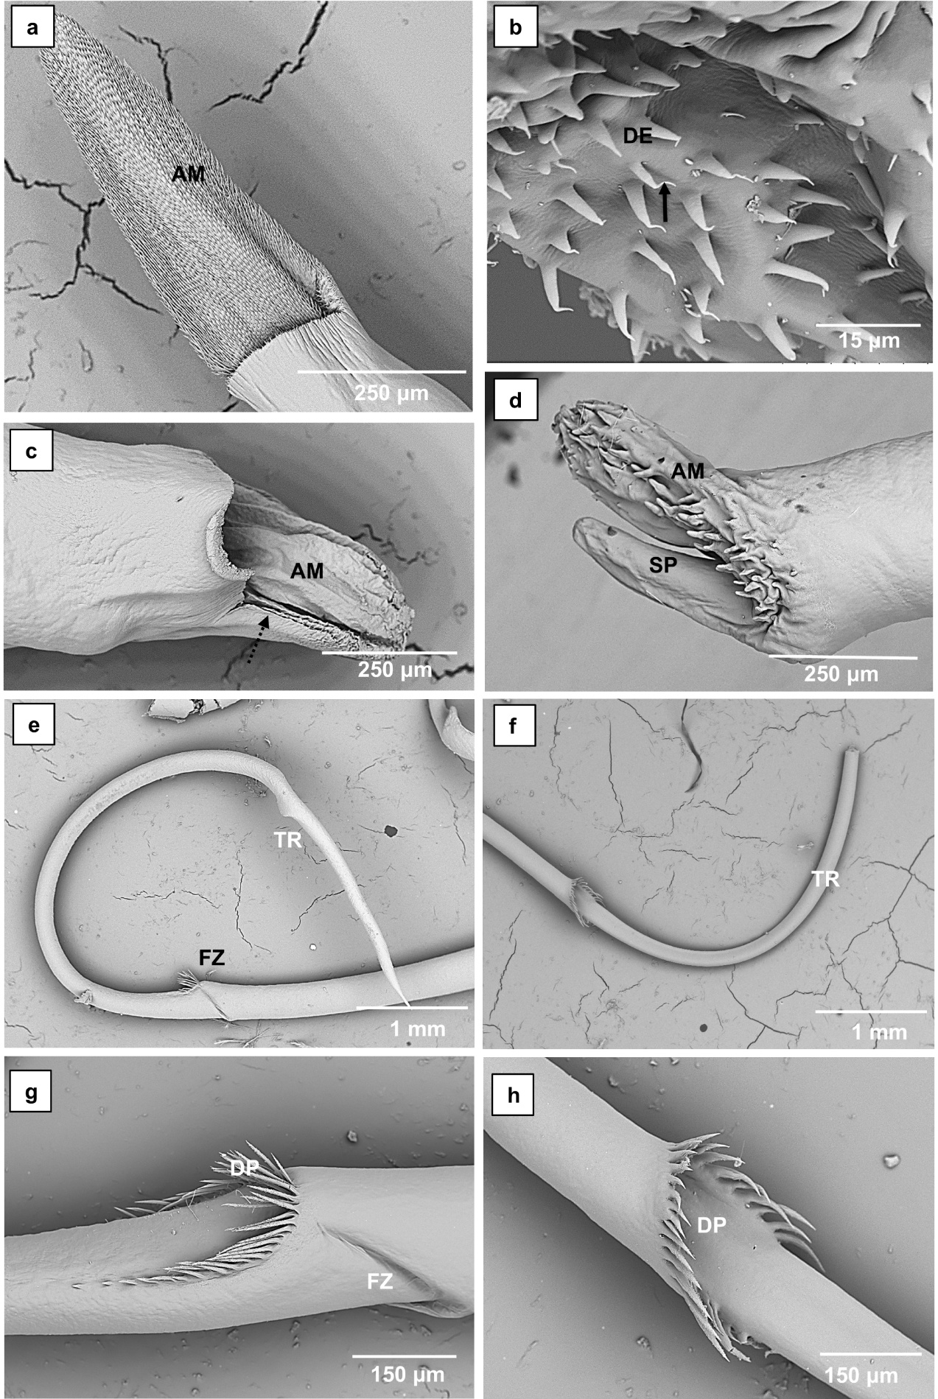
Figure 4. Scanning electron micrographs showing setae characteristics in Eubrachyura gonopods. a) Elongated simple setae [SS]; b) Denticules [DE] on the distal 2/3 of simple setae; c) Ringed insertion [RI] in the gonopod cuticle; d) Annulus [dotted arrow] in the mid-portion of simple setae in E. gonagra; e) Pappose setae [PS]; f) Papposerrate setae [PSS] with setules [SL] in proximal and mid-portion; g) Detail of setules [SL] in pappose setae; h) Terminal portion [TP] of papposerrate setae; i) Conate setae [CS] with central ringing; j) Paddle-shaped setae [PS] with central ringing [arrow] and ringed insertion [RI]. Species: a–d E. gonagra; e, g M. nodifrons; f, h–j C. bocourti.
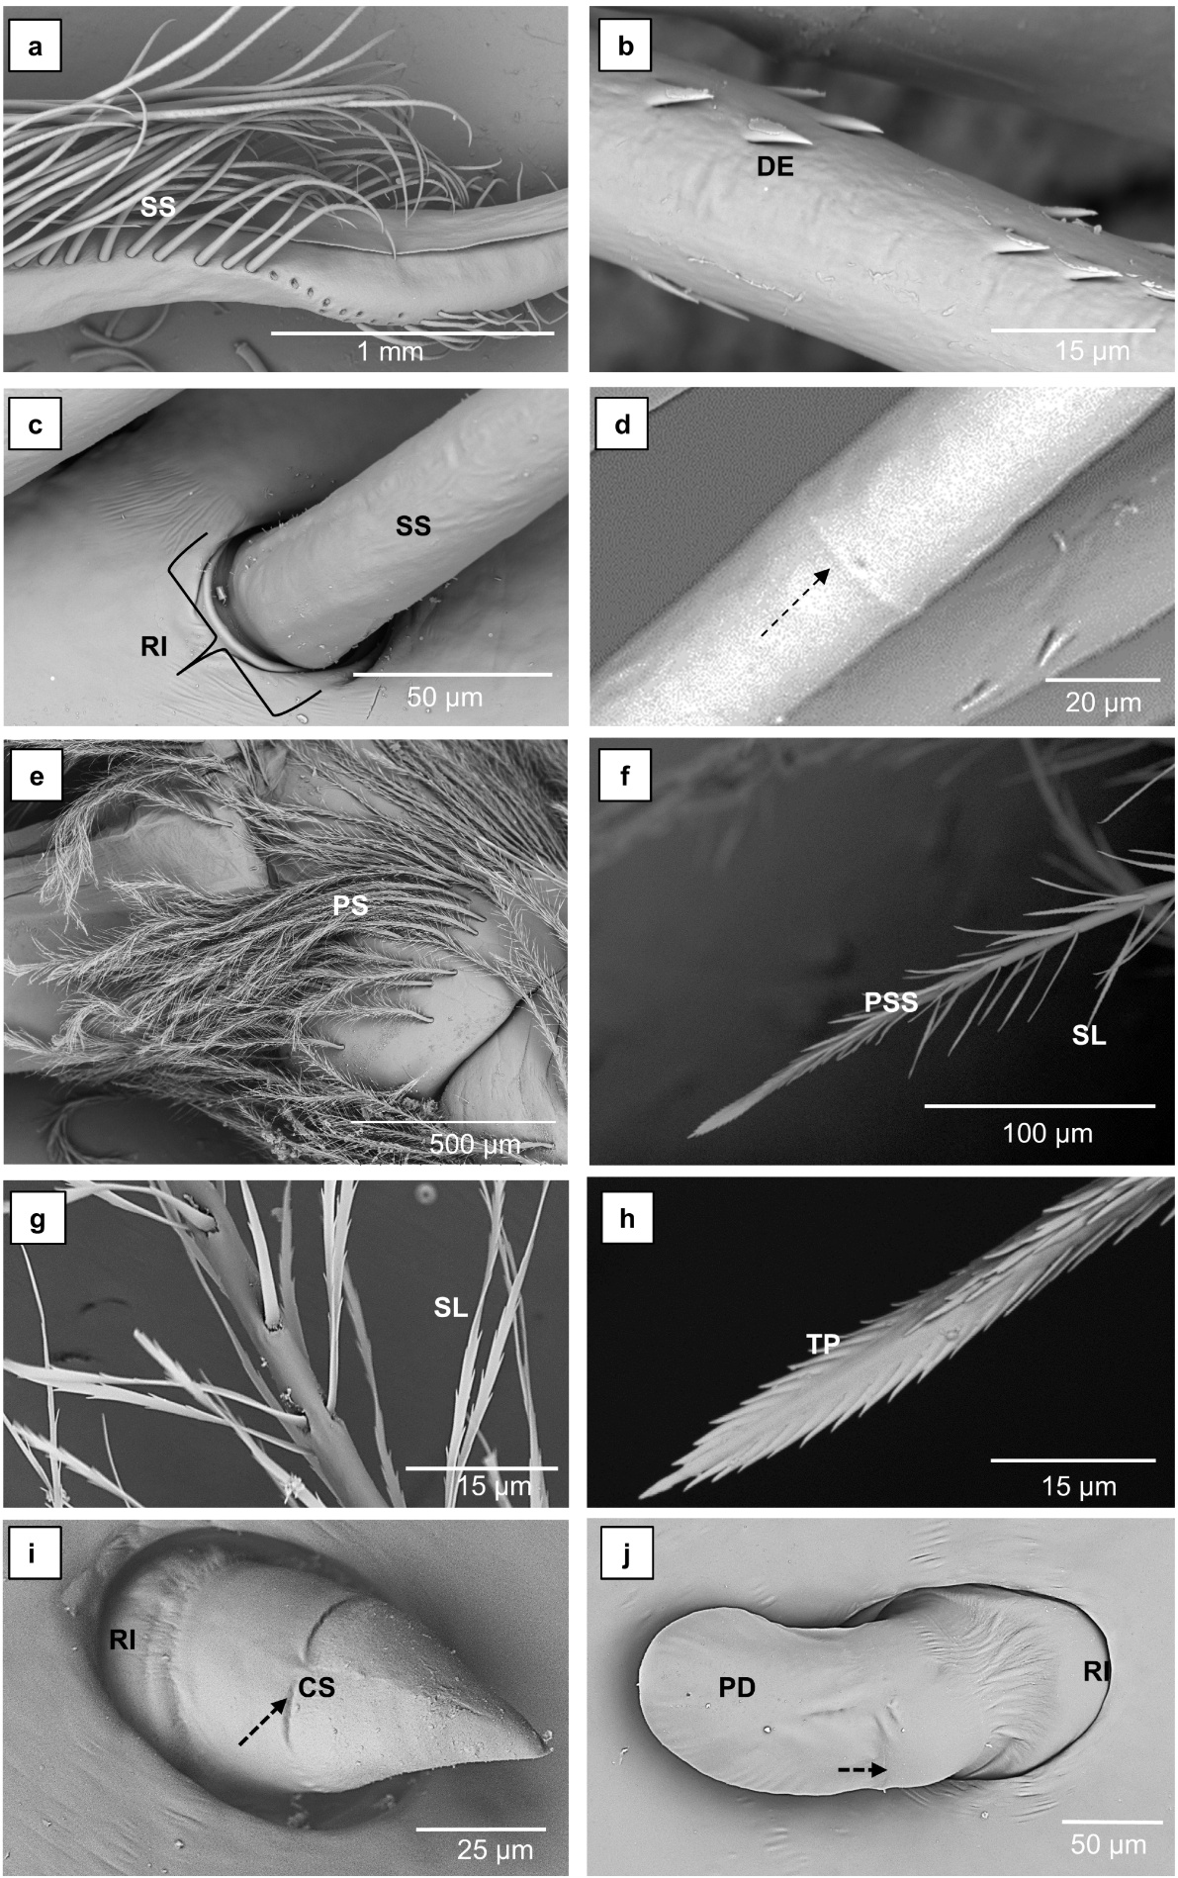

Figure 5. Photomicrographs of Eubrachyura gonopods. a) Ejaculatory canal [arrow] formed by cuticle [C] invagination; loose connective tissue [CT]; b) Apical projection [AP] showing the canal lumen [dashed arrow]; setae [S]; c) Fibroblasts [F] and hyaline hemocytes [H]; d) Granulocytes [GR]; e) Longitudinal section of rosette-type tegumental gland [RG] with duct [arrow] formed by the central cell [CC]; secretory cell [SE]; f) Terminal region of G1 showing setal lumen [arrow] passing through the cuticle [C]; g) Apical region of a seta in the G1 terminal region showing the setal lumen [arrow]; h) Terminal region of G1 with sensorial cells (SC) and setal lumen passing through the cuticle [arrow]. Staining: Hematoxylin–eosin. Species: G. cruentata, except (a) U. maracoani.
