
Research article
Catasetum × luanae (Orchidaceae, Catasetinae): a new nothospecies from the Brazilian Central Amazon
Catasetum × luanae (Orchidaceae, Catasetinae): una nueva notoespecie de la Amazonia Central Brasileña
¹Dayse Raiane Passos Krahl, Programa de Pós-Graduação em Biodiversidade e Biotecnologia da Rede BIONORTE, Universidade Federal do Amapá, Rodovia Josmar Chaves Pinto, Km 2, Jardim Marco Zero, 68903-419, Macapá, Brasil, dayseraiane@hotmail.com, https://orcid.org/0000-0003-2899-9453
²Philippe Schmal, Program of Forest and Management, Albert Ludwig University of Freiburg, Friedrichstr. 39, 79098, Freiburg, Alemania, ppschmal@yahoo.com.br, https://orcid.org/0000-0003-2993-6884
³Miguel Sena de Oliveira, Programa de Pós-graduação em Ciências Biológicas – Botânica Tropical, Universidade Federal Rural da Amazônia/Museu Paraense Emílio Goeldi, Avenida Perimetral, 1901, Terra Firme, 66077-830, Belém, Pará, Brasil, miguelsena@hotmail.com, https://orcid.org/0000-0001-8931-4978
⁴João Batista Fernandes Silva, Mineração Rio do Norte, Rua Rio Jari s/n°, 68.275-000, Porto Trombetas, Oriximiná, Pará, Brasil, jb.bina@gmail.com, https://orcid.org/0000-0002-1003-1041
⁵Guy Chiron, Université de Lyon 1, Herbiers, F-69622, Villeurbanne Cedex, Francia, g.r.chiron@wanadoo.fr, https://orcid.org/0000-0003-0971-4715
⁶Amauri Herbert Krahl, Programa de Pós-Graduação em Botânica, Instituto Nacional de Pesquisas da Amazônia, Av. André Araújo, 2936, Aleixo, 69060-001, Manaus, Amazonas, Brasil, amaurikrahl@hotmail.com, https://orcid.org/0000-0001-7862-9624
⁷Patrick de Castro Cantuária, Laboratório de Taxonomia Vegetal, Instituto de Pesquisas Científicas e Tecnológicas do Estado do Amapá, Rodovia Juscelino Kubitschek, Km 10, 68903-970, Macapá, Amapá, Brasil, patrickcantuaria@gmail.com, https://orcid.org/0000-0002-3676-7866
* For correspondence: miguelsena2010@hotmail.com

Received: 21 September 2024. Revised: 22 september 2025. Accepted: 02 October 2025
Associate Editor: Enrique Martinez Bustamante

Citation: Passos Krahl, D. R. P., Schmal, P., de Oliveira, M. S., da Silva, J. B. F., Chiron, G., Krahl, A. H and Cantuária, P. C. Catasetum × luanae (Orchidaceae, Catasetinae): una nueva notospecie de la Amazonia Central Brasileña. Acta Biol. Colomb., 30(3), XX-XX. https://doi.org/10.15446/abc.v30n3.116694

SHORT TITLE: A new Catasetum hybrid from the Brazilian Amazon
ABSTRACT
A new natural hybrid of Catasetum is illustrated with photographic plates and described here based on collections made in the Trombetas River basin, in the municipality of Oriximiná, state of Pará (Brazilian Amazon). It is compared with the parental species (C. galeritum and C. macrocarpum), with which it shares characteristics that are clearly intermediate between these two taxa. Data relating to the habitat, ecology and geographic distribution of the hybrid described here are also presented. This finding reinforces the Amazon region as a center of diversification for Catasetum.
Keywords: Amazon basin, biodiversity, natural hybrid, taxonomy, Trombetas River.

RESUMEN
Se describe e ilustra con láminas fotográficas un nuevo híbrido natural de Catasetum, a partir de colecciones realizadas en la cuenca del Río Trombetas, en el municipio de Oriximiná, estado de Pará (Amazonía brasileña). Se compara con las especies parentales (C. galeritum y C. macrocarpum), con las que comparte características claramente intermedias entre estos dos taxones. También se presentan datos relativos al hábitat, ecología y distribución geográfica del híbrido descrito aquí. Este descubrimiento refuerza a la Amazonía como centro de diversificación para Catasetum.
Palabras Clave: Biodiversidad, cuenca amazónica, híbrido natural, río Trombetas, taxonomía.
INTRODUCTION
The genus Catasetum Rich. ex Kunth is one of the larger genera within the subtribe Catasetinae with approximately 195 validly described species (Krahl et al., 2023a, 2023b, 2023c, 2023d, 2023e, 2024a, 2025a; POWO, 2024). Its members are widely distributed from Mexico to north of Argentina and south of Brazil (Romero and Carnevali, 2009). However, many of them are found within the Brazilian territory, that houses 105 species (Krahl et al., 2021a, 2021b, 2022a, 2022b, 2023a, 2023b, 2023c, 2023d, 2023e, 2023f, 2024a, 2024b, 2024c; Petini-Benelli, 2024). Catasetum members are characterized by fusiform, elliptic, ovate or conical pseudobulbs; leaves deciduous, plicate, usually elliptic or oblanceolate, with their several leaves distributed in the pseudobulb; basal, racemose inflorescences producing unisexual (staminate or pistillate) or rarely hermaphrodites (staminate + pistillate) flowers (Holst, 1999). Because of their weak variation, vegetative morphology as well as the characters of the female and/or the hermaphrodite flowers are considered as useless to identify the species (Walker-Larsen and Harder, 2000). Therefore, only the staminate flowers take on fundamental importance in the genus as their morphological characters, presenting a great variation according to each taxon (Holst, 1999), are essential to differentiate the species (Walker-Larsen and Harder, 2000).
Staminate flowers are characterized by the presence of two modified staminodes anterior to the gynostemium (=column) called “antennae” and whose primary function is to trigger the pollinarium into the body of the pollinator during the visit (Romero, 1992). Based on antennae, the genus has historically been divided into two subgenera: subgenus Pseudocatasetum (antennae poorly developed or absent) and subgenus Catasetum (antennae visibly developed). This second subgenus is subdivided into two different sections: section Catasetum (crossed and asymmetrical antennae) and section Isoceras (symmetrical antennae). Three subsections are recognized for the section Isoceras, namely: Isoceras, Divaricatae, and Convergentia. (Bicalho and Barros 1988; Senghas 1990, 1991). Interestingly, variation also exists in the placement of the pollinarium on pollinators: in species of Pseudocatasetum, for instance, the pollinarium is typically deposited on the ventral section of the bee’s thorax, while in the other groups the pollinarium is normally deposited on the back (Romero, 1992). However, recent phylogenetic studies indicate that the groups based on the morphology of this structure are not supported as natural clades in any of the available phylogenetic reconstructions, which proved to be polyphyletic lineages (Pérez-Escobar et al., 2017; Mauad et al., 2022). The species are thus best grouped according to biogeographical criteria (Mauad et al., 2022).
Catasetum is also a record holder when considering the number of registered nothospecies (POWO 2024). A total of 46 natural hybrids have been documented (Krahl et al., 2020, 2023a, 2024c, 2024d, 2025b, 2025c, 2025d; Cantuária et al., 2021; Ferreira and Malaspina, 2023a, b; Assis and Ferreira, 2024; POWO, 2024) of which 76,09 % (35 hybrids) are found in Brazil and 26 in the Brazilian Amazon (Krahl et al., 2020, 2023a, 2024c, 2024d, 2025b, 2025c, 2025d; Cantuária et al., 2021; Ferreira and Malaspina, 2023a, b; Petini-Benelli, 2024). Despite this high concentration of records, the state of Pará accounts for only four known natural hybrids, a surprisingly low number, given its vast territory and ecological heterogeneity. This scarcity highlights a significant knowledge gap regarding the hybrid diversity of Catasetum in the region (Krahl et al., 2020, 2023a; Cantuária et al., 2021; Petini-Benelli, 2024).
Thus, the present study aims to contribute to filling this gap by reporting a new natural hybrid from the Brazilian Amazon, more precisely from the Trombetas River basin, in the state of Pará. Specifically, we (1) provide a detailed morphological description of the new nothospecies, (2) compare it with its putative parental species, C. galeritum Rchb.f. and C. macrocarpum Rich. ex Kunth, and (3) present data on its geographical distribution, habitat, and ecology.

MATERIALS AND METHODS
The specimen here described was found and collected during occasional expeditions in the Trombetas River basin, in the municipality of Oriximiná, in northwest Pará, Brazil. When compared to the other members of the genus, mainly sympatric, we concluded that the specimen resulted from a cross between C. macrocarpum Rich. ex Kunth and C. galeritum Rchb.f. It is therefore described as a new natural hybrid for science and compared to its parents based on protocols and secondary literature. The specimen was prepared as an herbarium specimen according to the usual process described in Mori et al. (1989) and later deposited in the HUAM (acronym according to Thiers, 2024), located at the Federal University of Amazonas (UFAM). The descriptive terminology follows Dressler (1993) and Gonçalves and Lorenzi (2007). The comparison of the new nothospecies with its putative parents was carried out through the consultation of protologues and the analysis of materials deposited in the herbaria ALCB, BHCB, CEN, EAC, F, HUAM, HUEFS, HUESB, HUTO, IAN, INPA, K, MAC, MBML, MFS, MO, NY, RB, RBR, P, SAMES, SLUI, UPCB, and VIES (acronyms according to Thiers, 2024).
The map showing the type locality was made using the QGIS software (Version 3.28 Firenze) and the shapefile layers were obtained directly from the Ministério do Meio Ambiente do Brasil (MMA) and the Instituto Brasileiro de Geografia e Estatística (IBGE). The occurrence records of the supposed parental species were obtained through the SpeciesLink (Canhos et al., 2024), JABOT (Silva et al., 2017), and GBIF (Barve, 2023) databases, in order to delimit the occurrence zone of each species and evaluate the overlap in geographic distribution between them. Materials (consulted through SpeciesLink, JABOT and GBIF) from the herbaria ALCB, AMES, BHCB, CEN, CEPEC, CNMT, CVJBFZB, EAC, EAN, F, HABIT, HAMAB, HBRA, HEPH, HF, HRB, HTO, HUAM, HUEFS, HUTO, HSTM, IAN, INPA, IPA, JPB, K, L, LBMBP, MAC, MAR, MBM, MBML, MSF, MO, NY, R, RB, RBR, P, SAMES, SLUI, SP, UFMT, UFRN, UFP, UPCB, US, VIES and WAG (acronyms according to Thiers, 2024) were analyzed in order to determine the flowering period of the supposed parental species and evaluate an overlapping period in flowering.

RESULTS
Taxonomic treatment
Taxonomy: Catasetum × luanae D.R.P.Krahl, Krahl, M.S.Oliveira & Cantuária, nothosp. nov. (Fig. 1).
Type: BRAZIL. Pará: Oriximiná, Trombetas River, “igapó” forest (flooded forest), 1°41'01.7"S, 55°55'47.3"W, 01.III.2023, fl. ♂, Krahl & Krahl 1683 (Holotype: HUAM012683!).

Diagnosis
Hybrida naturalis inter Catasetum galeritum Rchb. f. et Catasetum macrocarpum Rich. ex Kunth cum characteribus intermediis: inflorescentia erecta, flores haud resupinati, labellum trilobatum, lobi laterales rotundati, lobus terminalis ovatus obtusus carnosus, antennae parallelae tantum apice contiguae.

Description
Plant epiphytic and caespitose. Roots whitish, thick, and with negative geotropism. Rhizome inconspicuous, short. Pseudobulb 7.4–1.6 × 2.5-3.6 cm, conical to fusiform, 5–7-leaved, covered by the leaf sheaths. Leaves 10.3–33.1 × 3.5–10.9 cm, oblanceolate, plicate, with 5–7 prominent nerves on the abaxial face, membranous, green, margin entire, apex acute. Staminate inflorescence 27.6–31.1 cm long, erect, lateral, racemose, 4–7 flowered, produced from foliated pseudobulbs; peduncle cylindrical, light green; floral bract ca. 1.4 × 0.8 cm, lanceolate, greenish, margin entire, apex acute. Staminate flowers wine-colored, labellum yellow, sepals and petals lightly greyish on the adaxial face, partly grouped on the first apical third, not resupinate, pedicelled; pedicel ca. 2.6 × 0.4 cm, cylindrical, erect to slightly sinuate, greenish; dorsal sepal ca. 3.9 × 1.5 cm, elliptic, concave, symmetrical, margin entire, apex acute; lateral sepals ca. 4.7 × 2.1 cm, broadly elliptic, concave, asymmetrical, margin entire, apex acute; petals ca. 4.7 × 1.7 cm, narrowly elliptic, slightly asymmetrical, margin entire, apex acute; labellum ca. 3.5 × 2.3 cm, 3-lobed, oval in scope, thick, smooth; labellum bottom ca. 1.5 cm deep, conical; lateral lobes ca. 2.3 × 1.9 cm, semi-elliptic to semi ovate, margin entire; midlobe ca. 0.8 × 1.3 cm, ovate to rhomboid, thick, symmetrical, margin entire, apex obtuse; column ca. 3.9 cm long, subtriangular, thick, wine-coloured, slightly contracted at the base, apex rostrate; antennae ca. 0.5 cm long, filiform, parallel, apically touching, wine-coloured; anther cap ca. 1.6 × 0.6 cm, subtriangular, wine-coloured at base and greenish at apex, apex rostrate; viscidium ca. 0.4 × 0.4 cm, subquadrate, sticky; stipe ca. 0.5 × 0.2 cm, laminar, rolled, yellowish; pollinia 2, ca. 0.4 × 0.2 cm, oblong, hard, sulcate, compressed, yellowish. Pistillate and hermaphrodite structures not seen. Fruit not seen.

Etymology
The specific epithet is in honor of Luana Passos Krahl (with her consent), daughter of the first two authors of the new nothotaxon name and a young woman fascinated by orchids and who helped in the cultivation of the plant until it bloomed.

Distribution, habitat and ecology
Hitherto, the taxon has been observed only in the type locality, i.e., Trombetas River basin. More precisely it has been found as an epiphytic plant in the forest of Igapó (flooded environment typical of the Amazonian region) of the left bank of this river, at about 10 km from the city of Oriximiná (Fig. 2). It is worth noting that this area is comprised within a region where the distribution areas of the parents overlap: C. macrocarpum is widely distributed on the Brazilian territory (occurring in the southeast, northeast, midwest and north of the country) as well as in Colombia, Venezuela, French Guiana, Guyana, Suriname and Trinidad & Tobago; C. galeritum is endemic to Brazilian Amazon, distributed from the east of Amazonas state to the western part of the Pará state and from the extreme north of the state of Mato Grosso to the north of Pará (Fig. 2) (Petini-Benelli, 2024; POWO, 2024). In this context, we further emphasize that both supposed parental species coexist in the same habitat (vázea and igapó) (Petini-Benelli, 2024).

Phenology and pollination
It was observed flowering in the first half of the year, between the months of March and June. Analysis of the herbarium materials revealed an overlap in the flowering period of the putative parents between April and May, coinciding with the end of flowering of C. macrocarpum (December to April), and the beginning of flowering of C. galeritum (April to July). This overlap highlights the possibility of cross-pollination between the two species.
The literature indicates that the parental species are initially visited by distinct groups of pollinators: C. macrocarpum is pollinated by bees of the genera Eulaema and Euglossa (Carvalho and Machado, 2002; Milet-Pinheiro and Gerlach, 2017), while C. galeritum is associated with bees of the genus Eufriesea (Milet-Pinheiro et al., 2018). However, personal observations have recorded the occasional visit of Eulaema nigrita to flowers of C. galeritum in cultivation. This bee species, already known as a floral visitor to C. macrocarpum (Carvalho and Machado, 2002), may have acted as a vector of cross-pollination between these two species, explaining the origin of the natural hybrid proposed here. Analogous situations have already been documented, as in the case of C. × joaquinianum Campacci & G.F.Carr, whose putative parents (C. hookeri Lindl. and C. fimbriatum (C.Morren) Lindl.) have different pollinator guilds (Krahl et al., 2024c).

DISCUSSION
It is possible to notice in the genus Catasetum the great influence of hybridization, a process partly responsible for the remarkable species richness observed today (Mauad et al., 2022). The crossing of different species can indeed produce fertile offspring with genetic and phenotypic variations that are relevant for adaptation in a given environment (Arnold, 1997), which, in turn, may lead to future speciation when these offspring manage to survive and perpetuate themselves (Seehausen, 2004; Arnold, 2006). This capacity for hybrid formation is also a consequence of the recent divergence of these taxa from a common ancestor, which has limited the accumulation of strong isolating barriers. Therefore, especially considering the high number of natural hybrids, it is clear that the pre and postzygotic barriers that would normally prevent interspecific reproduction remain weak in this genus. Consequently, the emergence of new nothospecies (for example, Valsko et al., 2019; Krahl et al., 2020, 2021a, b, 2022a, b, 2023a, b, c, d, e, 2024a, b, c; Cantuária et al., 2021; Ferreira and Malaspina, 2023a, b; Assis and Ferreira, 2024) is expected, as exemplified by C. × luanae, which corroborates this idea. Therefore, the origin of Catasetum can be understood as the result of a relatively recent evolutionary emergence, associated with neotropical geoclimatic events, combined with the adoption of a unique reproductive system whose plasticity contributed decisively to the rapid diversification of the genus (Pérez-Escobar et al., 2017; Mauad et al., 2022).
Hitherto, the genus contains 38 natural hybrids, which represents about 16 % of all valid taxa for Catasetum (Krahl et al., 2020, 2023a, 2024c; Cantuária et al., 2021; Ferreira and Malaspina, 2023a, b; Assis and Ferreira, 2024; POWO, 2024). However, these numbers should not be stationary as various hybrids may be found as highlighted and demonstrated by Krahl et al. (2023a, 2024c). These authors also predicted that several current species might prove to be hybrids and that the elucidation of these taxa will be done only with the use of other tools besides phylogeny (see Mauad et al., 2022), such as artificial crossing between different species with subsequent in vitro germination and comparison of the offspring with the current species.
Catasetum × luanae (Fig. 3a–f) exhibits morphological characters intermediate between those of its two congeneric and sympatric species from the Brazilian Amazon, C. galeritum (Fig. 3g–l) and C. macrocarpum (Fig. 3m–r) (Petini-Benelli, 2024). This supports its taxonomic status as a nothospecies. As in most Catasetum species (Holst, 1999), the new nothospecies shows no distinctive vegetative traits, as it shares the same vegetative morphology with its parental species and with most other members of the genus. Regarding the staminate flower morphology, several characters are intermediate between those of both putative parents, especially the flower color, the petal shape, the labellum structure, and the antennae disposition. Additional comparisons are presented in Table 1.
Catasetum × luanae presents an erect inflorescence with spaced flowers only present in the apical third, as it is observed in both parents. Flowers show a color pattern somewhat intermediate resembling some forms of C. galeritum, with wine-colored flowers with a light greyish hue on the outer surface. The labellum shows a yellowish color similar to that of C. macrocarpum. The sepals are similar to what we observe in C. galeritum and C. macrocarpum, i.e. dorsal sepal elliptic, concave, symmetrical and lateral ones broadly elliptic, concave, asymmetrical. The petals, narrowly elliptic, have a shape intermediate between those of the parents, oblong to elliptic in C. galeritum and elliptic in C. macrocarpum.
As expected, it is evident that the labellum of C. × luanae is the structure that exhibits the most intermediate characteristics between C. galeritum and C. macrocarpum. It is 3-lobed as in both parents and has an intermediate outline between an ovate shape in C. macrocarpum and an oblong shape in C. galeritum. Besides it has a deep conical base as in C. macrocarpum (vs. oblong and less deep in C. galeritum). The lateral lobes are semi-elliptic to semi-ovate and turned inwards, as observed in C. galeritum (vs. semi-ovate and turned outwards in C. macrocarpum). The midlobe is ovate to rhomboid whereas it is orbicular in C. galeritum and triangular to rhomboid in C. macrocarpum; its size is also intermediate (ca. 8 mm long vs. ca. 13 mm in C. galeritum and ca. 5 mm in C. macrocarpum). We may also observe on a longitudinal section of the lip a large thickening as happens in C. galeritum (Fig. 3) (Reichenbach, 1886; Kunth, 1822; Petini-Benelli, 2024). Antennae are symmetrical as in C. galeritum (vs. asymmetrical in C. macrocarpum) and almost parallel, i.e. parallel but touching at apex, whereas they are parallel in C. galeritum and crossed in C. macrocarpum.

Identification key for Catasetum species with symmetrical and parallel antennae occurring in the State of Pará. Occurrences based on Petini-Benelli (2024), Krahl et al. (2021a, 2021b, 2022a, 2023d, 2023e, 2024a, 2024b, 2025a).
1. Non-resupinate flowers (label facing upwards)….............................................................. 2
1`. Resupinate flowers (label facing downwards)................................................................... 3
2. Middle lobe of the labellum oval to rhomboid……………………………………………. …………………………………. C. × luanae D.R.P.Krahl, Krahl, M.S.Oliveira & Cantuária
2`. Middle lobe of the labellum orbicular……………………………….. C. galeritum Rchb.f.
3. Smooth labellum (without fimbriae) ................. C. maranhense K.G.Lacerda & J.B.F.Silva
3`. Labellum with fimbriae or with a denticulated margin……………....……………..……..4
4. Labellum without any type of callus inside......….… C. × guianense G.A. Romero & Jenny
4. Labellum with some type of callus inside…………….……………………………..……..5
5. Trilobate labellum…………………………………….…………………………………...6
5`. Entire labellum………………………………………………………………………….10
6. Base of the labellum with two calluses…………………..……...………….. C. boyi Mansf.
6`. Base of the labellum with a rounded or tripartite callus……………...……………...…….7
8. Margin of the labellum with multilacerated fimbriae at the apex……..……………………. …………………………………………………….…………... C. multifidum F.E.L.Miranda
8`. Margin of the labellum with simple fimbriae…………………….……….………………9
9. Apex of the labellum smooth………………………..…………..…… C. rolfeanum Mansf.
9`. Apex of the labellum provided with a set of 2–3 distinguishable fimbriae fused at the base………………………….……. C. binarum D.R.P.Krahl, Krahl, Cantuária & J.B.F.Silva
10. Labellum apex with a callus…………………..………………………………………...11
10`. Labellum apex without a callus………………………………………………………...15
11. Labellum basal callus 3-partite……………………………..…………………………..12
11`. Labellum basal callus acute and flanked with small “horns”…………..…………..…..13
12. Inflorescence dense; labellum ovate, with rather short fimbriae on the margin; lip apical callus bifid.............................................................C. marinhoi Krahl, Cantuária & J.B.F.Silva
12`. Inflorescence lax; labellum oblong to triangular or subtriangular fimbriate; lip apical callus simple, bifid or toothed ....................................................... C. barbatum (Lindl.) Lindl.
13. Labellum apical callus triangular ............................ C. tomasellii Campacci & J.B.F.Silva
13`. Labellum apical callus oblong, simple or bifurcate ........................................................14
14. Labellum obtriangular, with spaced fimbriae on the margin ................................................ ……....................................... C. nhamundaense D.R.P.Krahl, Krahl, Cantuária & J.B.F.Silva
14`. Labellum subtriangular, with fimbriae less spaced at the margin ……………………....... ......................................................... C. tavaresii Cantuária, D.R.P.Krahl, Krahl & J.B.F.Silva
15. Labellum surface fully covered by appendices ............................................................... 16
15`. Labellum surface glabrous .............................................................................................17
16. Labellum oblong to ovate and densely covered by thick, papillose crests ……………… ………………………………………………………………………….... C. cristatum Lindl.
16`. Labellum oblong and densely covered by thin fimbriae ..................................................... ................................................................ C. saracataquerense Krahl, Cantuária & J.B.F.Silva
17. Denticulated labellum margin………………... C. oriximinaense Campacci & J.B.F.Silva
17`. Fimbriated labellum margin…………………………………………………………...18
18. Labellum triangular or obtriangular ................................................................................ 19
18`. Labellum oblong ........................................................................................................... 20
19. Lip greenish and obtriangular; margin densely fimbriate .................................................... ...................................................... C. riosianum D.R.P.Krahl, Krahl, Cantuária & J.B.F.Silva
19`. Lip whitish and triangular; margin with relatively spaced fimbriae ................................... ........................................................................... C. taquerense Krahl, Cantuária & J.B.F.Silva
20. Lip apex with a globular concentration of thick fimbriae, slightly recurved ........................ ........................................................ C. queirozii D.R.P.Krahl, Krahl, Cantuária & J.B.F.Silva
20`. Lip apex acute and glabrous, strongly recurved ................................................................. .......................................................... C. cantuariae Krahl, D.R.P.Krahl, Chiron & J.B.F.Silva

CONCLUSIONS
The description of a new nothospecies of Catasetum from the Brazilian Amazon reinforces the idea that this biome is the center of diversity of the genus, where many taxa can be observed in the most diverse types of vegetation. Furthermore, with the discovery of C. × luanae and many other natural hybrids, it is also possible to infer that the genus may still be in the process of speciation. It is also reinforced the need for investment in sampling efforts of Amazonian flora and in the training of specialized taxonomists in Amazonian plants, so that many other previously unknown taxa can be described before they possibly disappear in an extensive and important biome that suffers intensely from negative action human being. In addition, future tests, such as phylogenetic analyses using molecular markers with different inheritance patterns or experimental crossings between the putative parents, could corroborate the morphological inferences presented here, helping to determine whether the progeny resembles one parent more closely or even represents a backcross.

ACKNOWLEDGEMENTS
The first author thanks the “Coordenação de Aperfeiçoamento de Pessoal de Nível Superior” (CAPES) for the doctoral scholarship (fellowship process no. 88887.823563/2023-00) and the “Programa de Pós-Graduação em Biodiversidade e Biotecnologia da Rede BIONORTE” (PPG-BIONORTE) and the “Universidade Federal do Amapá” (UNIFAP) for the support and logistics offered throughout the work.

CONFLICT OF INTEREST
The authors declare that they have no conflicts of interest.

AUTHORS PARTICIPATION
AHK, DRPK: writing the first draft of the text. AHK, PCC: made the figures. AHK, GC, PS, MSO: performed the morphological description and taxonomic comparison. AHK, DRPK, GC: analysis of geographical distribution, phenology and floral visitors. GC, JBFS, MSO, PCC, PS: final review of the manuscript. All authors approved the final version of the manuscript.

REFERENCES
Arnold, M. L. (1997). Natural Hybridization and Evolution. Oxford University Press, New York. https://doi.org/10.1093/oso/9780195099744.001.0001
Arnold, M. L. (2006). Evolution through genetic exchange. Oxford University Press, New York. https://doi.org/10.1093/acprof:oso/9780199229031.001.0001
Assis, L. C. and Ferreira, U. L. C. (2024). Um novo híbrido natural de Catasetum (Orchidaceae) descrito para o Brasil. Richardiana, nouvelle série, 8, 1–7.
Barve, V. (2023). Elevating the fitness of use of GBIF occurrence datasets: A proposal for peer review. Biodiversity Information Science and Standards, 7, e112237. https://doi.org/10.3897/biss.7.112237
Bicalho, H. D. and Barros, F. (1988). On the taxonomy of Catasetum subsection Isoceras. Lindleyana, 3, 87–92.
Canhos, D. A. L., Almeida, E. A., Assad, A. L., Cunha-Bustamante, M. M. D., Canhos, V. P., Chapman, A. D., Giovanni, R.D., Imperatriz-Fonseca, V. L., Lohmann, L. G., Maia, L. C., Miller, J. T., Nelson, G., Peterson, A. T., Pirani, J. R., Souza, S., Stehmann, J. R. and Thiers, B. (2022). SpeciesLink: Rich data and novel tools for digital assessments of biodiversity. Biota Neotropica, 22, 1–15. https://doi.org/10.1590/1676-0611-BN-2022-1394
Cantuária, P. C., Krahl, D. R. P., Krahl, A. H., Chiron, G. and Silva, J. B. F. (2021). Catasetum × sheyllae (Orchidaceae: Catasetinae), a new natural hybrid from Brazilian Amazon. Phytotaxa, 527(4), 257–265. https://doi.org/10.11646/phytotaxa.527.4.3
Carvalho, R. and Machado, I. C. (2002). Pollination of Catasetum macrocarpum (Orchidaceae) by Eulaema bombiformis (Euglossini). Lindleyana, 17, 85–90.
Dressler, R. L. (1993). Phylogeny and Classification of the Orchid Family. Dioscorides Press, Portland.
Ferreira, U. L. C. and Malaspina, T. K. (2023a). Catasetum × incarnatum U. L. C. Ferreira. and T. K. Malaspina hyb. nat. nov. Coletânea de Orquídeas Brasileiras, 19, 770–773.
Ferreira, U. L. C. and Malaspina, T. K. (2023b). Catasetum × ornaghiae U. L. C. Ferreira. and T. K. Malaspina hyb. nat. nov. Coletânea de Orquídeas Brasileiras, 19, 774–777.
Gonçalves, E. G. and Lorenzi, H. (2007). Morfologia vegetal: Organografia e dicionário ilustrado de morfologia das plantas vasculares. Instituto Plantarum, São Paulo.
Holst, A. W. (1999). The world of Catasetums. Timber Press, Portland.
Krahl, D. R. P., Krahl, A. H. and Chiron, G. (2020). Catasetum × louisiae (Orchidaceae, Catasetinae), a new natural hybrid for the Brazilian Amazon. Richardiana, nouvelle série, 4, 214–223.
Krahl, A. H., Krahl, D. R. P., Cantuária, P. C. and Silva, J. B. F. (2021a). Catasetum saracataquerense (Orchidaceae, Catasetinae), a new species of Brazilian Amazon. Richardiana, nouvelle série, 5, 206–216.
Krahl, A. H., Chiron, G., Cantuária, P. C. and Silva, J. B. F. (2021b). A new species of Catasetum (Orchidaceae, Catasetinae) for the Brazilian Amazon. Richardiana, nouvelle série, 5, 283–294.
Krahl, D. R. P., Krahl, A. H., Cantuária, P. C. and Silva, J. B. F. (2022a). Catasetum nhamundaense (Orchidaceae: Catasetinae), uma nova espécie da Amazônia Brasileira. Orquidário, 36, 24–36.
Krahl, A. H., Krahl, D. R. P., Cantuária, P. C., Chiron, G. and Silva, J. B. F. (2022b). Catasetum marinhoi (Orchidaceae, Catasetinae), a new species of Brazilian Amazon. Richardiana, nouvelle série, 6, 100–110.
Krahl, D. R. P., Schmal, P., Chiron, G., Silva, J. B. F., Krahl, A. H. and Cantuária, P. C. (2023a). Catasetum × grasineideae (Orchidaceae: Catasetinae), a new nothospecies from Brazilian Amazon and taxonomic notes for the genus. Phytotaxa, 594(2), 89–104. https://doi.org/10.11646/phytotaxa.594.2.1
Krahl, D. R. P., Oliveira, M. S., Silva, J. B. F., Chiron, G. and Cantuária, P. C. (2023b). Catasetum krahlii (Orchidaceae, Catasetinae): a new and threatened species from the Brazilian Amazon. Acta Botanica Brasilica, 37, e20220258. https://doi.org/10.1590/1677-941X-ABB-2022-0258
Krahl, D. R. P., Chiron, G., Silva, J. B. F., Krahl, A. H. and Cantuária, P. C. (2023c). Catasetum dianneae (Orchidaceae, Catasetinae): a new species of the C. barbatum complex for the Brazilian Amazon. Richardiana, nouvelle série, 7, 187–201.
Krahl, D. R. P., Krahl, A. H., Silva, J. B. F. and Cantuária, P. C. (2023d). Catasetum riosianum (Orchidaceae: Catasetinae), a new species for the Brazilian Amazon. Biota Amazônia, 13, 56–58.
Krahl, D. R. P., Oliveira, M. S., Schmal, P., Chiron, G., Silva, J. B. F., Krahl, A. H., Almeida, S. S. M. S. and Cantuária, P. C. (2023e). Catasetum tavaresii (Catasetinae), a new species from the Central Brazilian Amazon. Lankesteriana, 23(3), 485–493. https://doi.org/10.15517/lank.v23i3.55794
Krahl, D. R. P., Schmal, P., Chiron, G., Silva, J. B. F., Krahl, A. H. and Cantuária, P. C. (2023f). Taxonomic notes on Catasetum meeae (Orchidaceae: Catasetinae). Phytotaxa, 609(3), 240–246. https://doi.org/10.11646/phytotaxa.609.3.7
Krahl, D. R. P., Schmal, P., Chiron, G., Silva, J. B. F., Krahl, A. H. and Cantuária, P. C. (2024a). Catasetum queirozii (Orchidaceae: Catasetinae): a new species from the Brazilian Amazon. Acta Amazônica, 54(1), e54bc23180. https://doi.org/10.1590/1809-4392202301801
Krahl, D. R. P., Schmal, P., Oliveira, M. S., Silva, J. B. F., Chiron, G. and Krahl, A. H. (2024b). Catasetum cantuariae (Orchidaceae, Catasetinae), a new species from the Brazilian Amazonian biome. Kew Bulletin, 79, 583–595. https://doi.org/10.1007/s12225-024-10191-7
Krahl, D. R. P., Oliveira, M. S., Schmal, P., Chiron, G., Krahl, A. H., Silva, J. B. F. and Cantuária, P. C. (2024c). Revealing the true taxonomic status of Catasetum joaquinianum (Orchidaceae: Catasetinae). Phytotaxa, 664(2), 123–131. https://doi.org/10.11646/phytotaxa.664.2.4
Krahl, D. R. P., Oliveira, M. S., Schmal, P., Krahl, A. H., Chiron, G., Silva, J. B. F. and Cantuária, P. C. (2024d). Catasetum × vilhenense (Orchidaceae: Catasetinae), a new natural hybrid from the Amazon Forest. Darwiniana, nueva serie, 12(2), 308–317. https://doi.org/10.14522/darwiniana.2024.122.1251
Krahl, D. R. P, Schmal, P, Chiron, G, Silva, J. B. F., Oliveira, M. S., Krahl, A. H. and Cantuária P. C. (2025a). Catasetum binarum (Orchidaceae, Catasetinae): a new species from the Brazilian Amazon. Richardiana, nouvell série, 9, 43–60.
Krahl, D. R. P, Schmal, P, Chiron, G, Silva, J. B. F., Oliveira, M. S., Krahl, A. H. and Cantuária P. C. (2025b). Catasetum ×abreuanum (Orchidaceae, Catasetinae), a new nothospecies from the Brazilian Amazon belonging to the C. cristatum complex. Botany Letters, 172(3), 340–350. https://doi.org/10.1080/23818107.2025.2486760
Krahl, D. R. P., Oliveira, M. S., Schmal, P., Silva, J. B. F, Chiron, G., Krahl, A. H. and Cantuária, P. C. (2025c). Catasetum ×angelae (Orchidaceae: Catasetinae), a new nothospecies from the Brazilian Amazon in the subgenus Pseudocatasetum, and taxonomic notes for C. pusillum. New Zealand Journal of Botany, 63(5), 1347–1366. https://doi.org/10.1080/0028825X.2025.2469623
Krahl, D. R. P., Oliveira, M. S., Schmal, P., Silva, J. B. F, Chiron, G., Krahl, A. H. and Cantuária, P. C. (2025d). Catasetum × humaitaense (Orchidaceae: Catasetinae), a new nothospecies from the Brazilian Amazon. Biota Colombiana, 26, 1–14. https://doi.org/10.21068/26193124.1263
Kunth, K. S. (1822). Catasetum macrocarpum. Synopsis Plantarum, 1, 331.
Mauad, A. V. S. R., Petini-Benelli, A., Izzo, T. J. and Smidt, E. C. (2022). Phylogenetic and molecular dating analyses of Catasetum (Orchidaceae) indicate a recent origin and artificial subgeneric groups. Brazilian Journal of Botany, 45, 1235–1247. https://doi.org/10.1007/s40415-022-00840-1
Mori, S. A., Silva, L. A., Lisboa, G. and Coradin, L. (1989). Manual de Manejo do Herbário Fanerogâmico. CEPLAC, Ilhéus.
Milet-Pinheiro, P. and Gerlach, G. (2017). Biology of the Neotropical orchid genus Catasetum: A historical review on floral scent chemistry and pollinators. Perpectives in Plant Ecology, Evolution and Systematics, 27, 23–34. https://doi.org/10.1016/j.ppees.2017.05.004
Milet-Pinheiro, P, Silva, J. B. F., Navarro, D. M. A. F., Machado, I. C. S. and Gerlach, G. (2018). Notes on pollination ecology and floral scent chemistry of rare neotropical orchid Catasetum galeritum Rchb.f. Plant Species Biology, 33(2), 158–163. https://doi.org/10.1111/1442-1984.12202
Pérez-Escobar, O. A., Chomicki, G., Condamine, F. L., Vos, J., Martins, A., Smidt, E., Klitgård, B., Gerlach, G. and Heinrichs, J. (2017). Multiple geographical origins of environmental sex determination enhanced the diversification of Darwin’s favourite Orchids. Scientific Reports, 7, 12878. https://doi.org/10.1038/s41598-017-12300-y
Petini-Benelli, A. (2024). Catasetum. In Flora do Brasil 2020. Jardim Botânico do Rio de Janeiro. Available at: http://floradobrasil.jbrj.gov.br/reflora/floradobrasil/FB11312. Cited: 04 Sep 2024.
POWO (2024). Plants of the World Online. Royal Botanic Gardens, Kew. Available at: http://www.plantsoftheworldonline.org/. Cited: 04 Sep 2024.
Reichenbach, H. G. (1886). Catasetum galeritum. The Gardeners' Chronicle & Agricultural Gazette, 2, 616.
Romero, G. A. (1992). Non-functional flowers in Catasetum orchids (Catasetinae, Orchidaceae). Botanical Journal of the Linnean Society, 109(2), 305–313. https://doi.org/10.1111/j.1095-8339.1992.tb00274.x
Romero, G. A. and Carnevali, G. (2009). Catasetum. In: A. M. Pridgeon, P. J. Cribb, M. W. Chase and F. N. Rasmussen (Eds.), Genera Orchidearum, Epidendroidea Vol. 5 – Part II. (pp. 13–18). Oxford University Press, New York.
Seehausen, O. (2004). Hybridization and adaptive radiation. Trends in Ecology & Evolution, 19(4), 198–207. https://doi.org/10.1016/j.tree.2004.01.003
Senghas, K. (1990). Einige neue Arte naus der Subtribus Catasetinae I – Catasetum sektion Anisoceras. Die Orchidee, 41, 212–218.
Senghas, K. (1991). Einige neue Arte naus der Subtribus Catasetinae I – Catasetum sektion Isoceras. Die Orchidee, 42, 19–24.
Silva, L. A. E., Fraga, C. N., Almeida, T. M. H., Gonzalez, M., Lima, R. O., Rocha, M. S., Bellon, E., Ribeiro, E. S., Oliveira, F. A., Clemente, L. S., Magdalena, U. R., Medeiro, E. S. M. and Forzza, R. C. (2017). Jabot—Sistema de Gerenciamento de Coleções Botânicas: a experiência de uma década de desenvolvimento a avanços. Rodriguésia, 68(2), 391–410. https://doi.org/10.1590/2175-7860201768208
Thiers, B. (2024, continuously updated). Index Herbariorum: A Global Directory of Public Herbaria and Associated Staff. New York Botanical Garden’s Virtual Herbarium. Available at: http://sweetgum.nybg.org/science/ih/. Cited: 04 Sep 2024.
Valsko, J. J., Krahl, A. H., Petini-Benelli, A. and Chiron, G. (2019). Catasetum sophiae, a new species of Orchidaceae (Catasetinae) from northern Brazil. Phytotaxa, 402(2), 104–120. https://doi.org/10.11646/phytotaxa.402.2.5
Walker-Larsen, J. and Harder, L. D. (2000). The evolution of staminodes in Angiosperms: patterns of stamen reduction, loss, and functional re-invention. American Journal of Botany, 87(10), 1367–1384. https://doi.org/10.2307/2656866
FIGURES AND TABLES
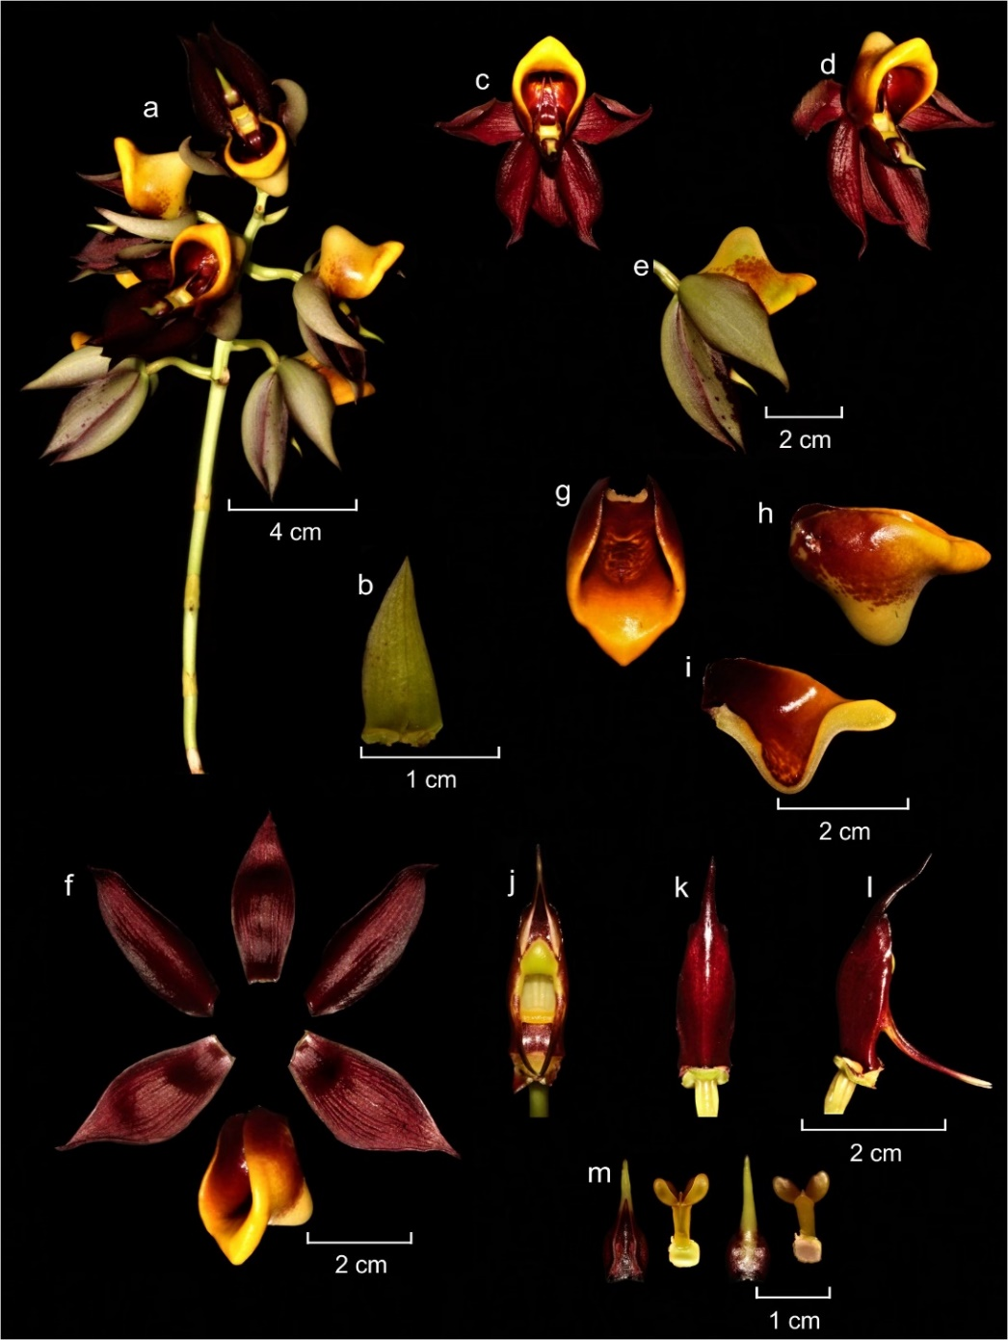
Figure 1. Composite color plate of Catasetum × luanae D.R.P.Krahl, Krahl, M.S.Oliveira & Cantuária. (a) inflorescence; (b) floral bract; (c–e) flowers; (f) floral segments; (g–i) labellum in front view, side view and longitudinal section; (j–l) column; (m) anther cap and pollinarium. Photos and plate by A. H. Krahl.
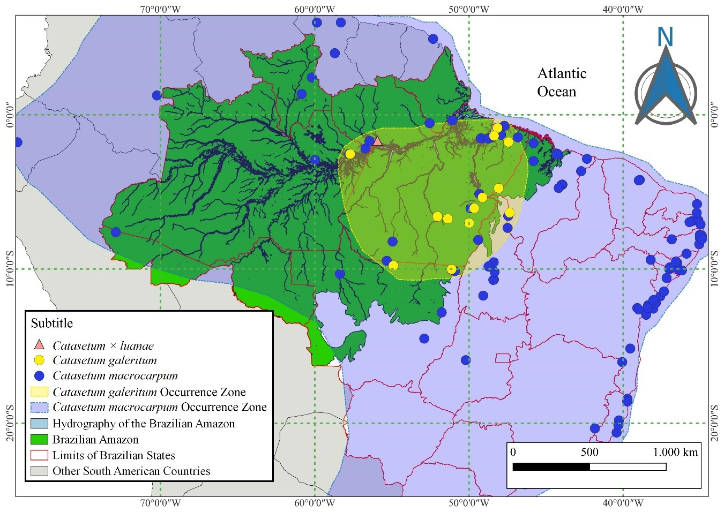
Figure 2. Geographic distribution of Catasetum × luanae D.R.P.Krahl, Krahl, M.S.Oliveira & Cantuária and its putative parents. Map by A. H. Krahl.
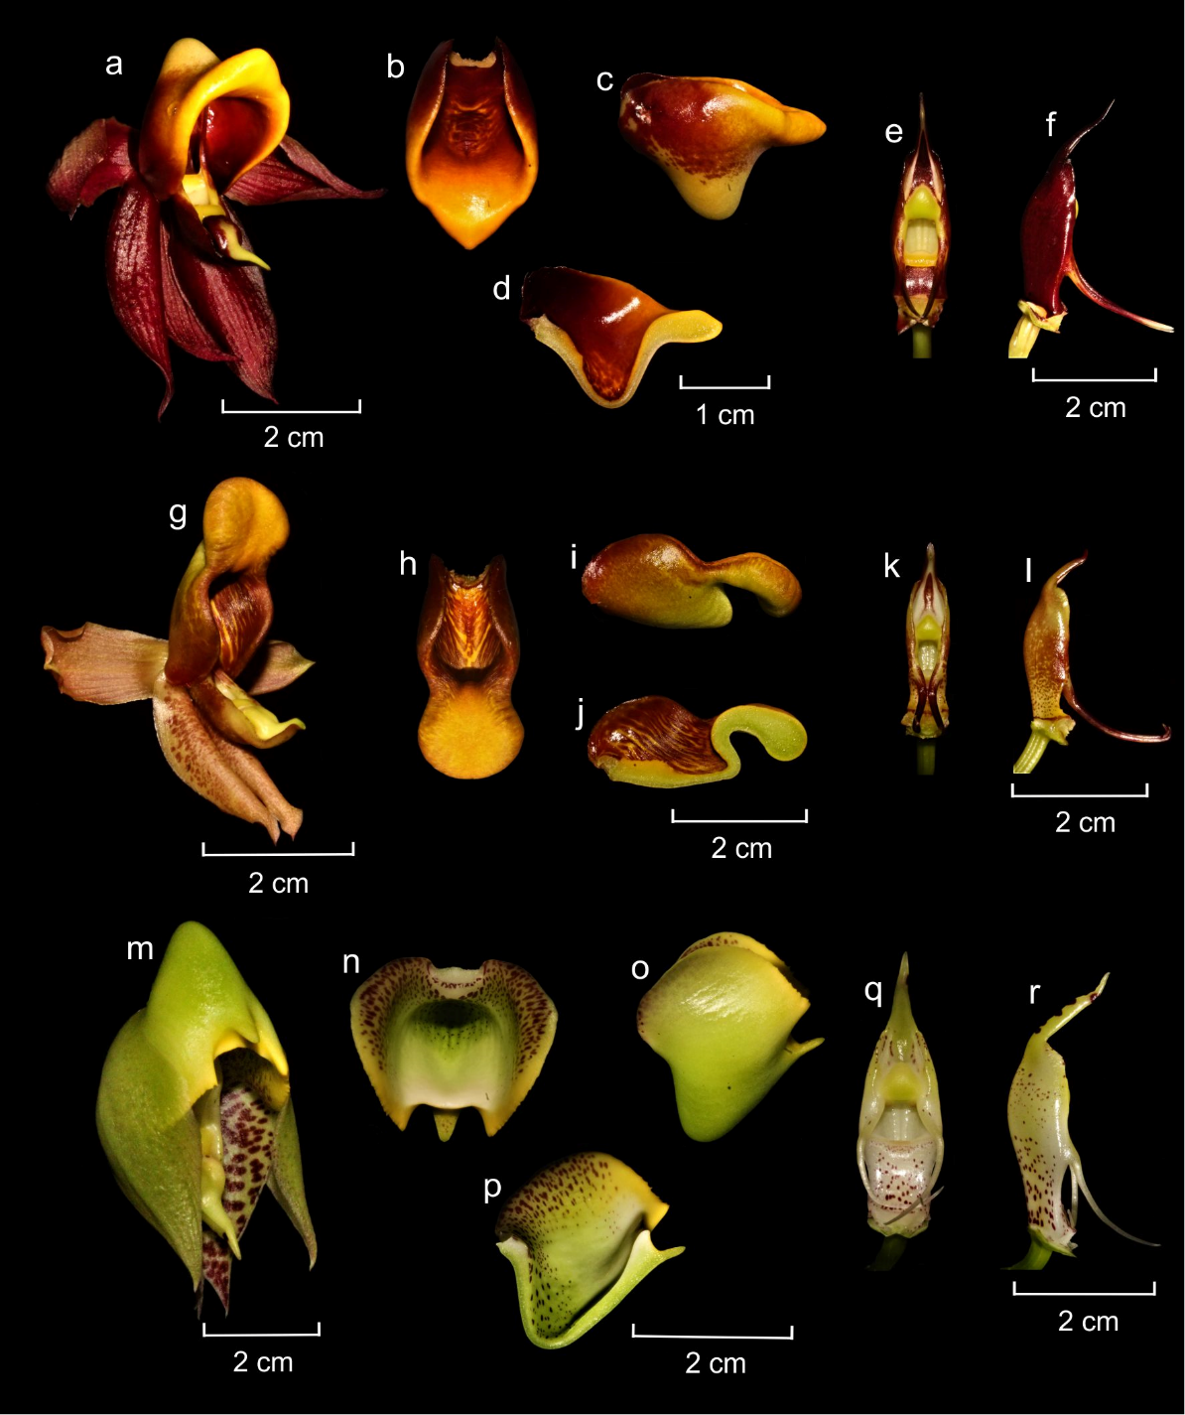
Figure 3. Color plate referring to the comparison between Catasetum × luanae D.R.P.Krahl, Krahl, M.S.Oliveira & Cantuária (a–f), Catasetum galeritum Rchb. f. (g–l) and Catasetum macrocarpum Rich. ex Kunth (m–r). (a) flower; (b–d) lip; (e–f) column; (g) flower; (h–j) labellum; (k–l) column; (m) flower; (n–p) lip; (q–r) column. Photos and plate by A. H. Krahl.

Table 1. Comparison between C. × luanae D.R.P.Krahl, Krahl, M.S.Oliveira & Cantuária and its parents.
CHARACTERS | TAXA
CHARACTERS | C. × luanae | C. galeritum | C. macrocarpum
Inflorescence | 27.6–31.1 cm long, erect, 4–7-flowered, peduncle light green | 15.6–21.9 cm long, erect to arched, 4–7-flowered, peduncle light green | 16.5–36.7 cm long, erect, 2–8-flowered, peduncle greenish
Flowers | Wine-colored with a yellowish hue on the lip, sepals and petals slightly greyish on the adaxial face, not resupinate, grouped in the apical third | From wine-coloured and lightly greyish outside to yellowish with wine-colored stripes, not resupinate, grouped in the apical third | Greenish yellow with wine-colored spots, not resupinate, grouped in the apical third
Dorsal sepal | ca. 3.9 × 1.5 cm, elliptic, concave, symmetrical, apex acute | ca. 3.4 × 1.5 cm, elliptic, concave, symmetrical, apex acute | ca. 3.4 × 1.5 cm, elliptic, concave, symmetrical, apex acute
Lateral sepals | ca. 4.7 × 2.1 cm, broadly elliptic, concave, asymmetrical, apex acute | ca. 3.9 × 1.5 cm, broadly elliptic, concave, asymmetrical, apex acute | 4.4 × 1.9 cm, broadly elliptic, concave, asymmetrical, apex acute
Petals | ca. 4.7 × 1.7 cm, narrowly elliptic, margin entire, slightly asymmetrical, apex acute | ca. 4.1 × 1.1 cm, oblong to elliptic, margin entire, apex acute | ca. 3.9 × 1.6 cm, elliptic, margin entire, slightly asymmetrical, apex acute
Labellum | ca. 3.5 × 2.3 cm, 3-lobed, outline oval, thick, smooth, with a conical bottom | ca. 3.1 × 1.6 cm, 3-lobed, outline oblong, thick, smooth, with an oblong bottom | ca. 2.5 × 2.3 cm, 3-lobed, outline ovate, thick, smooth, with a conical bottom
Lateral lobes | ca. 2.3 × 1.9 cm, semi-elliptic to semi-ovate, margin entire | ca. 1.6 × 0.6 cm, semi-elliptic to semi-ovate, margin entire | ca. 2.4 × 1.4 cm, semi-ovate, margin minutely denticulate to smooth
Midlobe | ca. 0.8 × 1.3 cm, ovate to rhomboid, thick, margin entire, symmetrical, apex obtuse | ca. 1.3 × 1.5 cm, orbicular, thick, margin entire, symmetrical, rounded | ca. 0.5 ×0.4 cm, triangular to rhomboid, thick, margin entire, symmetrical, apex obtuse
Column | ca. 3.9 cm long, wine-colored, apex rostrate | ca. 3.1 cm long, wine-colored, apex rostrate | ca. 3.5 cm long, greenish yellow, apex rostrate
Antennae | Symmetrical, parallel, apically converging | Symmetrical, parallel | Asymmetrical, crossed

