
Short note

Record of predation of the Brazilian yellow scorpion Tityus serrulatus (Buthidae) by the toad Rhinella diptycha (Bufonidae) in an urban area in southeastern Brazil

Registro de depredación del escorpión amarillo brasileño Tityus serrulatus (Buthidae) por el sapo Rhinella diptycha (Bufonidae) en un área urbana del sureste de Brasil

Glauco Cássio de Sousa Oliveira¹ https://orcid.org/0000-0001-9811-8485
Alexandre de Assis Hudson² https://orcid.org/0009-0005-4193-2124
Catalina do Nascimento Lopez³ https://orcid.org/0009-0003-7008-6890
Marcos Magalhães de Souza³ https://orcid.org/0000-0003-0415-1714
¹Universidade Federal de Lavras, Trevo Rotatório Professor Edmir Sá Santos, s/n., Lavras, Brasil.
²Universidade Federal de Juiz de Fora, Rua Eugênio do Nascimento, s/n., Juiz de Fora, Brasil.
³Universidade de Uberaba, Av. Nenê Sabino, 1801, Uberaba, Brasil.
⁴Instituto Federal do Sul de Minas Gerais, Praça Tiradentes, 416, Inconfidentes, Brasil.
* For correspondence: glaucomlds@hotmail.com

Received: 02 january 2025. Revised: 29 april 2025. Accepted: 04 may 2025

Associate Editor: Martha Patricia Ramírez Pinilla

Citation/citar este artículo como: Oliveira, G. C. S., Hudson, A. A., Lopez, C. N. and Souza, M. M. (2025). Record of predation of the Brazilian yellow scorpion Tityus serrulatus (Buthidae) by the toad Rhinella diptycha (Bufonidae) in an urban area in southeastern Brazil. Acta Biol. Colomb. 30(3), XX–XX. https://doi.org/10.15446/abc.v30n3.118190

ABSTRACT
Tityus serrulatus is one of the main causes of scorpionism in southeastern Brazil. However, little is known about its natural enemies, especially in urban areas, where this species is a major public health concern. We report a predation event of T. serrulatus by the toad Rhinella diptycha in an urban environment in the State of Minas Gerais, southeastern Brazil. Further studies may assess the feasibility of using R. diptycha for the biological control of T. serrulatus.

Keywords: biological control, interaction, scorpionism.

RESUMEN
Tityus serrulatus es uno de los principales causantes de escorpionismo en el sureste de Brasil. Sin embargo, se sabe poco sobre sus enemigos naturales, especialmente en áreas urbanas, donde esta especie es una importante preocupación de salud pública. Reportamos un evento de depredación de T. serrulatus por el sapo Rhinella diptycha en un ambiente urbano en el estado de Minas Gerais, sureste de Brasil. Nuevos estudios podrán evaluar la viabilidad de utilizar R. diptycha para el control biológico de T. serrulatus.

Palabras clave: control biológico, escorpionismo, interacción.

Scorpionism is one of the main causes of envenomation in humans by arachnids, and it is responsible for numerous cases of morbidity and mortality, especially in the elderly and children (Almeida et al., 2021). Brazil is one of the countries in the world with the highest risk of scorpion stings (Guerra-Duarte et al., 2023). Accidents typically occur in urban areas, especially where scorpions and their prey find suitable conditions to settle, such as cemeteries, trash and debris dumps, and homes with poor infrastructure (Ramires et al., 2011).
Tityus serrulatus (Lutz & Mello, 1922) (Scorpiones: Buthidae), commonly known as the Brazilian yellow scorpion, is one of the main species involved in scorpionism in Brazil (Guerra-Duarte et al., 2023). This species is native to the state of Minas Gerais in southeastern Brazil. However, it is undergoing significant expansion across the Brazilian territory (Ministério da Saúde 2009) due to deforestation and other anthropogenic activities facilitated by its generalist habits and the absence of natural competitors and predators (Lourenço et al., 1996). In this species, females primarily reproduce asexually through parthenogenesis (Braga-Pereira and Santos 2021), so most individuals found are parthenogenetic females.
Due to the increase in scorpionism, understanding natural predators, especially those inhabiting anthropized environments, may be crucial for implementing effective biological control programs for scorpion species that cause serious public health problems (Jared et al., 2020). Therefore, this study aims to report the predation of the Brazilian yellow scorpion T. serrulatus by the toad Rhinella diptycha (Cope, 1862) (Bufonidae) in southeastern Brazil.
On 26 December 2024, feces of R. diptycha were found in an urban environment in the municipality of Ritápolis, state of Minas Gerais, Brazil. The feces were washed in running water and sieved. Rhinella diptycha is the only toad in the urban area where the observation occurred, and its identification was carried out by AAH. Similarly, T. serrulatus is the only urban scorpion in the same region and, moreover, the species had already been reported in a previous record from the same area of this study (see Oliveira et al., 2024).
Upon analyzing the remains of its prey, several fragments of unidentified beetles (Coleoptera) and the presence of three fragments of T. serrulatus (one pedipalp fragment, one metasoma segment, and one telson) were observed (Fig. 1). The parts of T. serrulatus in the feces of R. diptycha suggest that the frog had predated on at least one individual of the scorpion. Based on the size of the fragments found, it is likely that the preyed individual was an adult female.
Although amphibians are predators of various invertebrates, evidence of scorpions in their diet are considered scarce. In this sense, Jared et al. (2020) reported that Rhinella icterica (Spix, 1824) (Bufonidae) has the potential to be an effective biological control agent for T. serrulatus which alling with other authors reports in countries such as Venezuela (Tampoa et al., 2024), Colombia (Botero-Trujillo 2006; Flórez D. and Blanco-Torres 2010), and the United States of America (Polis et al., 1981). Rhinella diptycha, a widely distributed species in Brazill (Di Tada and Sinsch, 2023), shares part of its range with T. serrulatus and exhibits synanthropic behavior (Mackenzie and Vladimirova 2022). Its diet is generalist and opportunistic, composed of different prey (Batista et al., 2011), including a record of an unidentified scorpion from the state of Mato Grosso do Sul, Brazil (Severgnini et al., 2020).
The main natural predators of scorpions are owls, lizards, and mice (Guerra et al., 2022); however, these animals are generally absent in urban environments (Lourenço et al., 1996). In Brazil, there it is popularly known that chickens Gallus gallus domesticus (Linnaeus, 1758) are good predators of scorpions (Guerra-Duarte et al., 2023). However, despite there have been promising results, including some immunity of chickens to scorpion venom (Murayama et al., 2022), these birds have diurnal habits, while scorpions are nocturnal (Guerra-Duarte et al., 2023). Therefore, the nocturnal habits of frogs like R. diptycha make them better alternatives for biological control in urban areas. Oliveira et al. (2024) also recorded the predation of an individual of T. serrulatus by the cob-web spider Parasteatoda tepidariorum (C. L. Koch, 1841) (Araneae: Theridiidae) in an urban area of ​​southeastern Brazil. Thus, these records reinforce the importance of maintaining and preserving these predators in urban areas for the potential biological control of urban pests that threaten human health.
Since our report was is a single record, new studies may indicate the frequency with which frogs with synanthropic habits feed on scorpions, as well as the feasibility of using these amphibians in the biocontrol of T. serrulatus.

ACKNOWLEDGMENT
We thank the anonymous reviewers and the associate editor for their valuable contributions to improving the quality of the manuscript.

AUTHOR PARTICIPATION
G.C.S.O., A.A.H., C.N.L. and M.M.S.: Investigation; Writing - original draft - review & editing; G.C.S.O.: Figure preparation and T. serrulatus identification; A.A.H.: R. diptycha identification.

CONFLICT OF INTEREST
The authors declare that they have no conflicts of interest.

REFERENCES
Almeida, A. C., Carvalho, F. M. and Mise, Y. F. (2021). Risk factors for fatal scorpion envenoming among Brazilian children: a case–control study. Transactions of the Royal Society of Tropical Medicine and Hygiene, 115(9), 975-983. https://doi.org/10.1093/trstmh/trab120
Batista, R. C., de-Carvalho, C. B., Freitas, E. B, Franco, S. C., Batista, C. C., Coelho, W. A. and Faria, R. G. (2011). Diet of Rhinella schneideri (Werner, 1894) (Anura: Bufonidae) in the Cerrado, Central Brazil. Herpetology Notes, 4, 17–21.
Botero-Trujillo, R. (2006). Anuran predators of scorpions: Bufo marinus (Linnaeus, 1758) (Anura: Bufonidae), first known natural enemy of Tityus nematochirus Mello-Leitão, 1940 (Scorpiones: Buthidae). Revista Ibérica de Aracnología, 13, 199-202.
Braga-Pereira, G. F. and Santos, A. J. (2021). Asexual reproduction in a sexual population of the Brazilian yellow scorpion (Tityus serrulatus, Buthidae) as evidence of facultative parthenogenesis. The Journal of Arachnology, 49(2), 85-190. https://doi.org/10.1636/JoA-S-20-001
Di Tada, I. E. and Sinsch, U. (2023). Geographical variation of advertisement and release calls in toads referred to as Rhinella diptycha (Anura: Bufonidae). Salamandra, 59(1), 96-101.
Flórez, E. and Blanco-Torres, A. (2010) Registros de escorpiones incluidos en la dieta de anuros en la costa atlántica colombiana. Revista Ibérica de Aracnología, 18, 105-106.
Guerra, R. O., Gonçalves, D. A., Moretti, B. and Bresciani, K. D. S. (2022). Prevention, surveillance, and scorpion accident control: an integrative review. Research, Society and Development, 11(10), e22111032302. http://doi.org/10.33448/rsd-v11i10.32302
Guerra-Duarte, C., Saavedra-Langer, R., Matavel, A., Oliveira-Mendes, B. B., Chavez-Olortegui, C. and Paiva, A. L. (2023). Scorpion envenomation in Brazil: Current scenario and perspectives for containing an increasing health problem. PLoS neglected tropical diseases, 17(2), e0011069. https://doi.org/10.1371/journal.pntd.0011069
Jared, C., Alexandre, C., Mailho-Fontana, P. L., Pimenta, D. C., Brodie Jr, E. D. and Antoniazzi, M. M. (2020). Toads prey upon scorpions and are resistant to their venom: A biological and ecological approach to scorpionism. Toxicon, 178, 4-7. https://doi.org/10.1016/j.toxicon.2020.02.013
Lourenço, W. R., Cloudsley-Thompson, J. L., Cuellar, O., Eickstedt, V. V., Barraviera, B. and Knox, M. B. (1996). The evolution of scorpionism in Brazil in recent years. Journal of Venomous Animals and Toxins, 2(2), 121-134. https://doi.org/10.1590/S0104-79301996000200005
Mackenzie, C. and Vladimirova, V. (2022). Food in the city: the urbanized diets of Rhinella diptycha (Anura: Bufonidae), Hemidactylus mabouia (Squamata: Gekkonidae), and Tropidurus torquatus (Squamata: Tropiduridae) in Pilar, Paraguay. Herpetology Notes, 15, 523-532.
Ministério da Saúde. Secretaria de Vigilância em Saúde. Departamento de
Vigilância Epidemiológica. (2009). Manual de controle de escorpiões. Série B. Textos Básicos de Saúde. https://bvsms.saude.gov.br/bvs/publicacoes/manual_controle_escorpioes.pdf
Murayama, G. P., Pagoti, G. F., Guadanucci, J. P. and Willemart, R. H. (2022). Voracity, reaction to stings, and survival of domestic hens when feeding on the yellow scorpion (Tityus serrulatus). Journal of Venomous Animals and Toxins including Tropical Diseases, 28, e20210050. https://doi.org/10.1590/1678-9199-JVATITD-2021-0050
Oliveira, G. C., Lara, J. N., Oliveira, S. E. and Souza, M. M. (2024). Record of the cob-wed spider Parasteatoda tepidariorum (C. L. Koch, 1841) (Araneae: Theridiidae) feeding on the scorpion Tityus serrulatus (Lutz & Mello 1922) (Scorpiones: Buthidae) in urban area of Brazil. Newsletter of the British Arachnological Society, 159, 5-7.
Polis, G. A., Sissom, W. D. and McCormick, S. J. (1981). Predators of scorpions: field data and a review. Journal of Arid Environments, 4(4), 309-326. https://doi.org/10.1016/S0140-1963(18)31477-0
Ramires, E. N., Navarro-Silva, M. A. and Assis Marques, F. (2011). Chemical Control of Spiders and Scorpions in Urban Areas. In Stoytcheva, M. (Ed.), Pesticides in the Modern World-Pests Control and Pesticides Exposure and Toxicity Assessment. (pp.13–24). IntechOpen.
Severgnini, M. R., Toledo Moroti, M., Pedrozo, M., Ceron, K. and Santana, D. J. (2020). Acerola fruit: An unusual food item for the Cururu toad Rhinella diptycha (Cope, 1862) (Anura: Bufonidae). Herpetology Notes, 13, 7-10. https://www.biotaxa.org/hn/article/view/55284/59166
Tampoa, J. A., Armas, L. F. and Castro, Y. (2024). Primer registro de escorpiones (Arachnida: Scorpiones) depredados por un anuro (Amphibia: Anura) en Venezuela. Revista Chilena de Entomología, 50(4), 639-644.https://doi.org/10.35249/rche.50.4.24.06

TABLES AND FIGURES

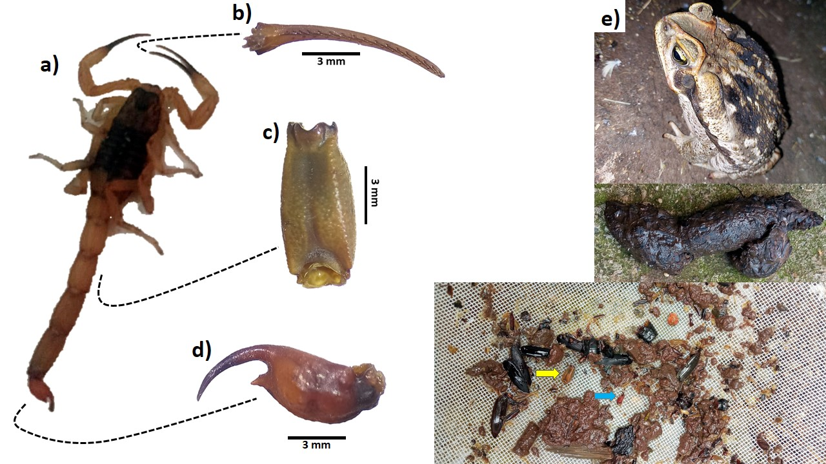
Fig. 1. Evidence of predation of Tityus serrulatus by Rhinella diptycha in an urban environment in southeastern Brazil. (a) Example of an individual of T. serrulatus; (b-d) fragments of T. serrulatus recovered from feces of R. diptycha; (b) Pedipalp fragment; (c) - metasoma segment (yellow arrow); (d) Telson (blue arrow); (e) R. diptycha and its feces.

