

Short Note

Histopathological study of the endophyte Colletotrichum tropicale in ripe mango fruit (Mangifera indica L. cv. Azúcar)
Estudio histopatológico del endófito Colletotrichum tropicale en fruto maduro de mango (Mangifera indica L. cv. Azúcar)

^{1,2*}Andrés Felipe Quintero-Mercado
²Alberto Rafael Páez-Redondo
¹Celsa García-Domínguez
¹Universidad Nacional de Colombia, Avenida Carrera 30 # 45-03, Bogotá D.C., Colombia, aquinterome@unal.edu.co. https://orcid.org/0000-0002-9907-3490
²Universidad de Magdalena, Carrera 32 No. 22 - 08, sector de San Pedro Alejandrino, Santa Marta, Colombia, apaez@unimagdalena.edu.co. https://orcid.org/0000-0001-9439-7448
¹Universidad Nacional de Colombia, Avenida Carrera 30 # 45-03, Bogotá D.C., Colombia, cgarciad@unal.edu.co. https://orcid.org/0000-0002-3321-7893
* For correspondence: aquinterome@unal.edu.co
Received: 23rd february 2025. Revised: 12th febreuary 2026. Accepted: 25th february 2026
Editor: Angélica Plata Rueda

Citation: Quintero-Mercado, A. F., Paéz-Redondo, A. R. and García-Domínguez, C. (2026). Histopathological study of the endophyte Colletotrichum tropicale in ripe mango fruit (Mangifera indica L. cv. Azúcar). Acta Biol. Colomb., 31(1), XX-XX https://doi.org/10.15446/abc.v31n1.121807

ABSTRACT
The mango cv. Azúcar is an economically important crop in the Magdalena region of Colombia. However, it is particularly affected during the postharvest stage by anthracnose, a disease caused by the phytopathogen Colletotrichum, with C. tropicale being an endophyte that can become highly virulent when inoculated into ripe fruits. The pathogenic process at the cellular level that allows this lifestyle shift remains poorly understood. This study aimed to histologically characterize the pathogenic process of the endophyte C. tropicale in ripe fruit of the mango cv. Azúcar. Fruits at phenological stage 801 were inoculated with the fungus at 0, 12, 24, and 36 hours post-inoculation (hpi), three for each time point with an absolute control. Histological sections were prepared in paraffin, stained with Astra blue–fuchsin, and observed under a light microscope. At 12 hpi, conidial germination and the formation of melanized appressoria on the cuticle were evident, as well as the emergence of thick hyphae in the epidermis, indicating the onset of a biotrophic phase (quiescence). At 24 hpi, secondary hyphae were observed invading parenchyma cells, marking the beginning of the necrotrophic phase. By 36 hpi, total cell destruction was evident. The endophyte C. tropicale behaves as a hemibiotroph, allowing it to act as a pathogen through a brief quiescent phase in ripe fruits of the mango cv. Azúcar.
Keywords: anthracnose, astra blue-fuchsin, hemibiotroph, postharvest, quiescence.

RESUMEN
El mango cv. Azúcar es un cultivo de importancia económica en el departamento del Magdalena, Colombia; sin embargo, se ve afectado, especialmente en poscosecha, por la antracnosis, enfermedad ocasionada por el fitopatógeno Colletotrichum, siendo la especie C. tropicale un endófito que puede volverse altamente virulento al ser inoculado en frutos maduros, sin que se conozca con claridad el proceso patogénico que desarrolla a nivel celular y que le permite cambiar su estilo de vida. El objetivo de este estudio fue caracterizar histológicamente el proceso patogénico del endófito C. tropicale en fruto maduro de mango cv. Azúcar. Se inocularon frutos en estado fenológico 801 con el hongo a las 0, 12, 24 y 36 horas posteriores a la inoculación (hpi), tres por cada tiempo con un testigo absoluto y se realizaron cortes histológicos en parafina, los cuales fueron teñidos con Astra blue-fucsina y observados al microscopio óptico. A las 12 hpi se evidenció la germinación de conidias y la formación de apresorios melanizados sobre la cutícula, así como la aparición de hifas gruesas en la epidermis, lo que indica el inicio de una fase biotrófica (quiescencia). A las 24 hpi se observó la invasión de las células del parénquima por hifas secundarias, dando inicio a la fase necrotrófica, y a las 36 hpi fue evidente la destrucción total de las células. El endófito C. tropicale se comporta como un hemibiótrofo, lo que le permite actuar como patógeno mediante una quiescencia corta en frutos maduros de mango cv. Azúcar.
Palabras clave: antracnosis, astra blue-fucsina, hemibiótrofo, poscosecha, quiescencia.

According to Ledesma and Campbell (2019), mango consumption (Mangifera indica L.) has increased internationally over the last thirty years, triggering growth in productive areas and the commercialization in new markets in Europe and the United States. In 2022, Colombia's harvested mango area was 33,615.56 hectares, producing 346,650.2 tons with an average yield of 10.31 tons per hectare and the top-producing regions were Cundinamarca (62,592 tons), Tolima (49,639 tons), and Magdalena (16,797 tons) (AGRONET, 2025). The production system of mango cv. Azúcar is the fourth most economically important crop in the Magdalena region (Colombia) after banana, African palm, and coffee (Salcedo, 2018). It is affected by a disease known as anthracnose, which is caused by species of the fungal genus Colletotrichum, and it is considered the most limiting factor in mango production in tropical and subtropical areas (Arauz, 2000; Ploetz, 2007; de Souza et al., 2013; Kamle et al 2013;). In Magdalena, it may cause losses ranging from 20 to 50 %, both in the field and during the post-harvest stage (Páez, 2003).
According to Dean et al. (2012), the genus Colletotrichum is ranked eighth in terms of economic importance, as it affects several crops worldwide. It uses an initial infection structure called melanized appressorium to penetrate host tissue by increasing turgor pressure and secreting pectinases and other enzymes that degrade the host cell wall (Kubo and Furusawa, 1991; Kleemann et al., 2008; Kubo and Takano, 2013; Crouch et al., 2014). The fungus generates primary hyphae intracellularly to colonize living host cells, such as those located in the epidermis and mesophyll; and sometimes it may develop an infective vesicle, resulting in an asymptomatic biotrophic phase Perfect et al., 2001; Vargas et al., 2012; Crouch et al., 2014; De Silva et al., 2017). Prusky et al. (2013) assert that Colletotrichum infections in unripe fruits lead to an asymptomatic biotrophic phase that is evidenced by quiescence of the pathogen. After the asymptomatic state, the pathogen enters a necrotrophic phase forming thinner hyphae and secreting lytic enzymes during colonization to break down the host tissue and trigger the development of symptoms (Wharton et al., 2001; Mims and Vaillancourt, 2002; Crouch et al., 2014). De Silva et al. (2017) indicate that Colletotrichum develops a subcuticular intramural necrotrophic phase, colonizing the periclinal and anticlinal walls without affecting the protoplast.
On the other hand, Colletotrichum acts as an endophyte that can become pathogenic, meaning that it transitions from a neutral to a parasitic relationship, which is a common occurrence among fungi belonging to the Ascomycota division (da Silva et al., 2020; Kogel et al., 2006; Higgins et al., 2007;). The state of endophytism in fungi is subject to change, depending on biochemical and physiological changes in the host, as well as environmental changes that disrupt the ecological balance underlying neutral or synergistic mutualistic relationships (Photita et al., 2004; Promputtha et al., 2007; Hardoim et al., 2015; De Silva et al., 2017; Chethana et al., 2021). According to Rodríguez et al. (2009), the genus Colletotrichum belongs to the non-Clavicipitaceous endophytic fungi and comprises classes 2 and 3. Class 2 fungi are characterized by the formation of appressoria or hyphae that can penetrate plant tissue intercellularly. This enables them to colonize with minimal impact on the cell, and they take advantage of the host's nutrients or photosynthetic resources from a mutualistic role (Rodríguez et al., 2009; Chethana et al., 2021).
In healthy plants, Rodríguez et al. (2009) state that fungi of this class produce fewer appressoria and sporulate faster during host senescence. Kogel et al. (2006) noted that the primary and secondary hyphae produced by Colletotrichum endophytes are located intercellularly. There are records of the endophyte/pathogenic change of Colletotrichum tropicale in mango when isolates obtained from asymptomatic leaves are inoculated into ripe fruits of the same plant, as described by Vieira et al. (2014) for the Tommy Atkins cultivar in Brazil, and by Páez-Redondo et al. (2024) in Colombia, as well as by Quintero-Mercado et al. (2019) for the Azúcar cultivar in the region of Magdalena. However, the pathogenic strategy that the endophyte develops within the plant cell to change the lifestyle in ripe fruit of mango is not clear. This study aimed to characterize histologically the pathogenic process of the endophyte C. tropicale in ripe fruit of mango cv. Azúcar.
Completely healthy, detached fruits at phenological stage 801 (ripe, initiating color change) according to the BBCH alphanumeric scale (Rajan et al., 2011) were used and disinfected following the methodology proposed by Quintero-Mercado et al. (2019). In the laminar flow chamber, the first step involved three immersions of the fruits (sterile distilled water for two minutes, followed by 1 % NaClO for one minute, and then sterile distilled water again for two minutes). Then, the fruits were sprayed with 70 % ethanol for one minute and once again immersed in sterile distilled water for two minutes. Once the washing process was complete, the fruits were placed on sterile kraft paper for approximately 45 minutes to allow any residual solution to be absorbed and/or drained, until the fruit was completely dry. Pure cultures grown for 20 days on a potato dextrose agar (PDA) plate containing antibiotic streptomycin sulfate (200 mg/L), at a temperature of 26°C and under conditions of 12 hours of light and 12 hours of darkness with 80 % humidity were later used.
The endophytic isolate was obtained from asymptomatic leaves of mango cv. Azúcar, the pathogenicity was confirmed, and it was identified as Colletotrichum tropicale, registered with identification code GenBank® OR563797.1. In a laminar flow chamber, 20 mL of sterile distilled water were poured onto the surface of each culture. Using a small sterile spatula, the surface of each plate was scraped to collect all fungal material while avoiding extraction of the culture medium. In addition, the suspension was gently agitated to prevent spillage and then transferred to a sterile glass container. It was macerated with a spatula, agitated in a vortex for three minutes, then filtered through sterile medical gauze and collected in an aseptic glass beaker. The fungal solution was adjusted to a concentration of 1 x 10⁶ conidia/mL.
The drop deposition inoculation technique was used at six equidistant spots on the epicarp of each fruit. It consisted of applying 10 µL of the fungal suspension to each spot, repeating this step until a total volume of 20 µL was poured. There were three fruits or replicates per hour post-inoculation (hpi), i.e. 0, 12, 24 and 36 hpi. One control was treated with sterile distilled water, while another fruit was inoculated with the fungal suspension and served as a control for the infective cycle until symptoms and signs were observed. The inoculated fruits were placed in humid chambers. These were made using plastic boxes of 19 cm long x 8 cm wide x 7 cm high, adding absorbent paper moistened at the base to guarantee favorable conditions for the infectious process at a temperature of 22 to 25°C and 80 % relative humidity in an environmental test chamber (Sanyo, now PHCbi)
For the histological study, a three-phase procedure was followed for each inoculated fruit and each evaluation time: tissue fixation; dehydration, infiltration and inclusion; cutting, staining and observation. Tissues from inoculated fruits at 0-, 12-, 24- and 36-hours post-inoculation (hpi) were cut into 2 cm squares using a sterile scalpel and fixed for 72 hours by mixing equal parts of fixative solution (A+B), the solution A was composed of chromic acid 1 % w/v and glacial acetic acid 7 % v/v, and solution B of neutral formaldehyde 30 % w/v. After tissue fixation, the tissues were dehydrated by sequential immersion in ethanol: 70 % (for 24 hours), 90 % (for 4 hours), 95 % (for 4 hours) and 100 % (4 hours).
Afterwards, these were saturated using the following ethanol ratios: HistoChoice® (90:10, 70:30, 50:50, 30:70, 10:90) each one for four hours, ending with two changes in HistoChoice® 100 % for 4 hours each change. Subsequently, a hot liquid histological paraffin was added at 60°C. Three changes with pure paraffin were performed, each lasting 12 hours and finally the tissues were ready for future preparation in a paraffin block. Three replicates of paraffin blocks with four inoculated cut spots were used for each time evaluated. Each paraffin block containing tissue was cut into 10 µm transverse sections using a SPENCER 820 rotary microtome. The sections were subjected to Astra Blue-Fuchsin staining, as proposed by Ortiz et al. (2014). Each section was then submerged in different solutions and dyes, as follows: xylol:ethanol; acidified Astra Blue 1 %; basic ethanolic fuchsin 0.1 %; ethanol:xylol; Cytoresin; and finally dried for at least three days prior to observation. Histological sections of the fruits, which had been fixed on microscope slides and stained, were examined using an optical microscope with a LEICA ICC50 camera (Leica Application Suite® LAS EZ, version 1.7.0) at magnifications of 10x, 40x and 100x. Three microscope slides were prepared for each inoculation time and examined six times to identify infective fungal structures such as conidia, appressoria, thick hyphae and secondary hyphae.
At zero hours post-inoculation (hpi) (Fig. 1a), the mango cv. Azúcar was completely healthy, showing no symptoms of anthracnose (Fig. 1a-a). The histopathological study showed parenchyma cells without any alterations (Fig. 1a-b). At 12 hpi (Fig. 1b), no symptoms were evident on the cuticle (Fig. 1b-a); the histopathological study revealed germinated conidia and the formation of circular or pyriform, melanized appressoria on the cuticle, as well as thick hyphae in the epidermis (Fig. 1b-b). A biotrophic phase or quiescence of the fungus was evident at this time. At 24 hpi (Fig. 2c), small necrotic lesions were already visible on the fruit (Fig. 2c-a), and thin secondary hyphae were observed invading the intracellular spaces of the parenchyma cells (Fig. 2c-b), which results in the necrotrophic stage. By 36 hpi (Fig. 2d), the fruit exhibits more advanced, circular necrotic lesions that are characteristic of anthracnose (Fig. 2d-a), as well as destroyed cuticle, epidermis and parenchyma tissue (Fig. 2d-b). The diagram (Fig. 3) illustrates the entire histological process of the endophyte C. tropicale in ripe mango fruits cv. Azúcar at 12-, 24- and 36-hours post-inoculation (hpi).
Our findings at the initial stages, 12 hpi, of the infective process of the endophyte C. tropicale on ripe fruit of mango cv. Azúcar are consistent with those reported by Páez-Redondo (2020). The author found that quiescent-endophytic morphospecies of Colletotrichum UMUN004, UMUN014 and UMUN021 inoculated on ripe fruits (scale 801) of mango cv. Azúcar, showed conidia formation and germination at 12 hpi or earlier; nonetheless, the quiescence phase was not evident. According to Alkan et al. (2015) the quiescence period of C. gloeosporioides on unripe tomato fruits is longer than on ripe fruits. The same author asserts that the quiescent or biotrophic stage of the fungus occurs in unripe fruit, and it transitions to a necrotrophic phase as the fruit ripens, or the ethylene levels increase. Prusky et al. (2013) emphasize that hemi-biotrophs such as Colletotrichum undergo a biotrophic phase in almost completely ripe fruits until the necrotrophic stage, and that in unripe fruits the infection results in quiescence. However, the authors suggest that this state should be defined according to the specific post-harvest interaction. In the case of this study, although the mango cv. Azúcar has already begun to ripen physiologically, a short biotrophic phase can be initiated through quiescence.
Alkan et al. (2015) state that the necrotrophic stage in ripe tomato fruits inoculated with C. gloeosporioides is caused by an invasion of long necrotrophic hyphae, as the ones observed in this study at 24 hpi. Several Colletotrichum species have been identified that use the hemibiotrophic lifestyle as a pathogenic strategy in fruits. For example, Moraes et al. (2015) studied C. gloeosporioides in guava fruit and found that intracellular vesicles and hyphae were generated in the epidermis triggering the necrotrophic transition. Kim et al. (2004) found that C. gloeosporioides destroyed cells through a necrotrophic phase of both intra- and intercellular colonization in paprika or chilli fruits infected with the fungus. Moreover, the histological studies published by Fang et al. (2021) indicate that C. gloeosporioides, which causes anthracnose in walnut fruit, can complete the lifestyle transition in a hemi-biotrophic manner. Using various microscopic techniques, such as confocal and fluorescent microscopy. Savi et al. (2019) investigated the colonization and pathogenicity mechanisms of C. abscissum in citrus flowers. They found that it acts as a hemibiotroph, forming biotrophic hyphae that colonize tissues and develop a dominant necrotrophic phase. From a histological point of view, it can be concluded that, when the endophyte C. tropicale is present on mango fruit cv. Azúcar at phenological stage 801 (ripe, initiating colour change), the fungus enters a state of quiescence, or a short asymptomatic biotrophic phase initiated by thick hyphae in the epidermal cells. At 24 hpi, it advances to the parenchyma cells by forming thin secondary hyphae, thereby initiating the necrotrophic phase. Later, at 36 hpi, cell wall degradation is observed, leading to complete tissue necrosis. Thus, the endophyte C. tropicale acts as hemibiotroph with short quiescence phase, as part of the pathogenicity strategy it developed in ripe mango cv. Azúcar fruit.
ACKNOWLEDGMENT
We thank Professors Xavier Marquínez and Adriana González from the Universidad Nacional de Colombia sede Bogotá, for their support during the experimental phase. We also extend our gratitude to engineer Andrea Galindo and engineer Juan Camilo Molina for their valuable assistance during the histopathology phase.
AUTHOR PARTICIPATION
A.Q.: Investigation; Experimentation pase; Formal analysis; Writing - original draft; review & editing. C.G.: Formal analysis; Writing - original draft; review & editing. A.P.: Formal analysis; Writing - original draft; review & editing.
CONFLICT OF INTEREST
All the authors declare that there is no conflict of interest.
REFERENCES
AGRONET. (January, 2025). Red de información y comunicación del sector Agropecuario Colombiano. Https://Www.Agronet.Gov.Co/Paginas/Inicio.Aspx
Alkan, N., Friedlander, G., Ment, D., Prusky, D. and Fluhr, R. (2015). Simultaneous transcriptome analysis of Colletotrichum gloeosporioides and tomato fruit pathosystem reveals novel fungal pathogenicity and fruit defense strategies. New Phytologist, 205(2), 801–815. https://doi.org/10.1111/nph.13087
Arauz, L. F. (2000). Mango Anthracnose: Economic Impact and Current Options For Integrated Managaement. Plant Disease, 84(6), 600–611. https://doi.org/10.1094/PDIS.2000.84.6.600
Chethana, K. W. T., Jayawardena, R. S., Chen, Y. J., Konta, S., Tibpromma, S., Phukhamsakda, C., Abeywickrama, P. D., Samarakoon, M. C., Senwanna, C., Mapook, A., Tang, X., Gomdola, D., Marasinghe, D. S., Padaruth, O. D., Balasuriya, A., Xu, J., Lumyong, S. and Hyde, K. D. (2021). Appressorial interactions with host and their evolution. In Fungal Diversity. Springer Science and Business Media B.V. https://doi.org/10.1007/s13225-021-00487-5
Crouch, J., O’Connell, R., Gan, P., Buiate, E., Torres, M. F., Beirn, L., Shirasu, K. and Vaillancourt, L. (2014). The Genomics of Colletotrichum. In Genomics of Plant-Associated Fungi: Monocot Pathogens. Springer Berlin Heidelberg. https://doi.org/10.1007/978-3-662-44053-7_3
da Silva, L. L., Moreno, H. L. A., Correia, H. L. N., Santana, M. F. and de Queiroz, M. V. (2020). Colletotrichum: species complexes, lifestyle, and peculiarities of some sources of genetic variability. In Applied Microbiology and Biotechnology, 104(5), 1891–1904. Springer. https://doi.org/10.1007/s00253-020-10363-y
De Silva, D. D., Crous, P. W., Ades, P. K., Hyde, K. D. and Taylor, P. W. J. (2017). Life styles of Colletotrichum species and implications for plant biosecurity. Fungal Biology Reviews, 31(3). https://doi.org/10.1016/j.fbr.2017.05.001
de Souza, A., Delphino Carboni, R. C., Wickert, E., de Macedo Lemos, E. G. and de Goes, A. (2013). Lack of host specificity of Colletotrichum spp. isolates associated with anthracnose symptoms on mango in Brazil. Plant Pathology, 62(5), 1038–1047. https://doi.org/10.1111/ppa.12021
Dean, R., Van Kan, J. A. L., Pretorius, Z. A., Hammond‐Kosack, K. E., Di Pietro, A., Spanu, P. D., Rudd, J. J., Dickman, M., Kahmann, R., Ellis, J. and Foster, G. D. (2012). The Top 10 fungal pathogens in molecular plant pathology. Molecular Plant Pathology, 13(4), 414–430. https://doi.org/10.1111/j.1364-3703.2011.00783.x
Fang, H., Liu, X., Dong, Y., Feng, S., Zhou, R., Wang, C., Ma, X., Liu, J. and Yang, K. Q. (2021). Transcriptome and proteome analysis of walnut (Juglans regia L.) fruit in response to infection by Colletotrichum gloeosporioides. BMC Plant Biology, 21(1). https://doi.org/10.1186/s12870-021-03042-1
Hardoim, P. R., van Overbeek, L. S., Berg, G., Pirttilä, A. M., Compant, S., Campisano, A., Döring, M. and Sessitsch, A. (2015). The Hidden World within Plants: Ecological and Evolutionary Considerations for Defining Functioning of Microbial Endophytes. Microbiology and Molecular Biology Reviews, 79(3), 293–320. https://doi.org/10.1128/MMBR.00050-14
Higgins, K. L., Arnold, A. E., Miadlikowska, J., Sarvate, S. D. and Lutzoni, F. (2007). Phylogenetic relationships, host affinity, and geographic structure of boreal and arctic endophytes from three major plant lineages. Molecular Phylogenetics and Evolution, 42(2), 543–555. https://doi.org/10.1016/j.ympev.2006.07.012
Kamle, M., Pandey, B. K., Kumar, P. and Kumar, M. (2013). A Species-Specific PCR Based Assay for Rapid Detection of Mango Anthracnose Pathogen Colletotrichum gloeosporioides Penz. and Sacc. Journal of Plant Pathology & Microbiology, 04(06). https://doi.org/10.4172/2157-7471.1000184
Kim, K.-H., Yoon, J.-B., Park, H.-G., Park, E. W. and Kim, Y. H. (2004). Structural Modifications and Programmed Cell Death of Chili Pepper Fruit Related to Resistance Responses to Colletotrichum gloeosporioides Infection. Phytopathology®, 94(12), 1295–1304. https://doi.org/10.1094/PHYTO.2004.94.12.1295
Kleemann, J., Takahara, H., Stüber, K. and O’Connell, R. (2008). Identification of soluble secreted proteins from appressoria of Colletotrichum higginsianum by analysis of expressed sequence tags. Microbiology, 154(4). https://doi.org/10.1099/mic.0.2007/014944-0
Kogel, K-H., Franken, P. and Hückelhoven, R. (2006). Endophyte or parasite - what decides? In Current Opinion in Plant Biology, 9(4), 358–363). https://doi.org/10.1016/j.pbi.2006.05.001
Kubo, Y. and Furusawa, I. (1991). Melanin Biosynthesis. In The Fungal Spore and Disease Initiation in Plants and Animals. Springer US. https://doi.org/10.1007/978-1-4899-2635-7_9
Kubo, Y. and Takano, Y. (2013). Dynamics of infection-related morphogenesis and pathogenesis in Colletotrichum orbiculare. Journal of General Plant Pathology, 79(4). https://doi.org/10.1007/s10327-013-0451-9
Ledesma, N. and Campbell, R. J. (2019). The status of mango cultivars, market perspectives and mango cultivar improvement for the future. Acta Horticulturae, 1244, 23–28. https://doi.org/10.17660/ActaHortic.2019.1244.3
Mims, C. W. and Vaillancourt, L. J. (2002). Ultrastructural Characterization of Infection and Colonization of Maize Leaves by Colletotrichum graminicola, and by a C. graminicola Pathogenicity Mutant. Phytopathology®, 92(7). https://doi.org/10.1094/PHYTO.2002.92.7.803
Moraes, S. R. G., Escanferla, M. E. and Massola, N. S. (2015). Prepenetration and Penetration of Colletotrichum gloeosporioides into Guava Fruit (Psidium guajava L.): Effects of Temperature, Wetness Period and Fruit Age. Journal of Phytopathology, 163(3), 149–159. https://doi.org/10.1111/jph.12294
Ortiz, E., Cruz, M., Melgarejo, L. M., Marquínez, X. and Hoyos-Carvajal, L. (2014). Histopathological features of infections caused by Fusarium oxysporum and F. solani in purple passionfruit plants (Passiflora edulis Sims). Summa Phytopathologica, 40(2), 134–140. https://doi.org/10.1590/0100-5405/1910
Páez, A. (2003). Tecnologías sostenibles para el manejo de la Antracnosis en papaya y mango. In G. Gómez Gámez (Ed.), [Boletín técnico n.º 8]. Corporación Colombiana de Investigación Agropecuaria (Corpoica (Produmedios, pp. 1–18). Corpoica Regional 3 / C.l. Motiloniam Codazzi, Cesar. https://bibliotecadigital.agronet.gov.co/handle/11348/6459
Páez- Redondo, A. R.(2020). Biología y manejo de estados quiescentes de Colletotrichum spp. en mango cultivar Azúcar, en el departamento del Magdalena, Colombia [Tesis]. Universidad Nacional de Colombia.
Páez-Redondo, A. R., García-Merchán, V. H., Rincón, J. D., Rodríguez, H. A., Morales, J. G. and Hoyos-Carvajal, L. M. (2024). Colletotrichum species associated with anthracnose disease on mango (Mangifera indica L.) cv. Azúcar in Colombia. Canadian Journal of Plant Pathology, 46(6), 616–631. https://doi.org/10.1080/07060661.2024.2402719
Perfect, S. E., Green, J. R. and O’Connell, R. J. (2001). Surface characteristics of necrotrophic secondary hyphae produced by the bean anthracnose fungus, Colletotrichum lindemuthianum. European Journal of Plant Pathology, 107(8). https://doi.org/10.1023/A:1012473823851
Photita, W., Lumyong, S., Lumyong, P., Mckenzie, E. H. C., Hyde, K. D., Photita, W., Lumyong, S., Lumyong, P. and Hyde, M. E. H. C. (2004). Fungal Diversity Are some endophytes of Musa acuminata latent pathogens? Fungal Diversity, 16, 131–140.
Ploetz, R. C. (2007). Diseases of Tropical Perennial Crops: Challenging Problems in Diverse Environments. Plant Disease, 91(6), 644–663. https://doi.org/10.1094/PDIS-91-6-0644
Promputtha, I., Lumyong, S., Dhanasekaran, V., McKenzie, E. H. C., Hyde, K. D. and Jeewon, R. (2007). A Phylogenetic Evaluation of Whether Endophytes Become Saprotrophs at Host Senescence. Microbial Ecology, 53(4), 579–590. https://doi.org/10.1007/s00248-006-9117-x
Prusky, D., Alkan, N., Mengiste, T. and Fluhr, R. (2013). Quiescent and Necrotrophic Lifestyle Choice During Postharvest Disease Development. Annual Review of Phytopathology, 51(1), 155–176. https://doi.org/10.1146/annurev-phyto-082712-102349
Quintero-Mercado, A., Dangon-Bernier, F. y Páez-Redondo, A. (2019). Aislamientos endofíticos de Colletotrichum spp. a partir de hojas y ramas de mango (Mangifera indica L.) cultivar Azúcar en el municipio de Ciénaga, Magdalena, Colombia. Revista de La Academia Colombiana de Ciencias Exactas, Físicas y Naturales, 43(166). https://doi.org/10.18257/raccefyn.788
Rajan, S., Tiwari, D., Singh, V. K., Saxena, P., Y. T. N. Reddy, S. S. Upreti, K. K., Burondkar, M. M., Bhagwan, A. and Kennedy, R. (2011). Application of extended BBCH Scale for phenological studies in mango (Mangifera indica L.). Journal of Applied Horticulture, 13(02), 108–114. https://doi.org/10.37855/jah.2011.v13i02.25
Rodríguez, R. J., White, J. F., Arnold, A. E. and Redman, R. S. (2009). Fungal endophytes: Diversity and functional roles: Tansley review. In New Phytologist, 182(2), 314–330. https://doi.org/10.1111/j.1469-8137.2009.02773.x
Salcedo, R. (2018). Revista de la asociación hortifrutícola de Colombia, ASOHOFRUCOL- FNFH. No. 57. Magdalena Fortalece Su Potencial Exportador de Frutas y Hortalizas, 27.
Savi, D. C., Rossi, B. J., Rossi, G. R., Ferreira-Maba, L. S., Bini, I. H., Trindade, E. da S., Goulin, E. H., Machado, M. A. and Glienke, C. (2019). Microscopic analysis of colonization of Colletotrichum abscissum in citrus tissues. Microbiological Research, 226, 27–33. https://doi.org/10.1016/j.micres.2019.05.005
Vargas, W. A., Martín, J. M. S., Rech, G. E., Rivera, L. P., Benito, E. P., Díaz-Mínguez, J. M., Thon, M. R. and Sukno, S. A. (2012). Plant Defense Mechanisms Are Activated during Biotrophic and Necrotrophic Development of Colletotricum graminicola in Maize. Plant Physiology, 158(3). https://doi.org/10.1104/pp.111.190397
Vieira, W. A. S., Michereff, S. J., de Morais, M. A., Hyde, K. D. and Câmara, M. P. S. (2014). Endophytic species of Colletotrichum associated with mango in northeastern Brazil. Fungal Diversity, 67(1), 181–202. https://doi.org/10.1007/s13225-014-0293-6
Wharton, P. S., Julian, A. M. and O’Connell, R. J. (2001). Ultrastructure of the Infection of Sorghum bicolor by Colletotrichum sublineolum. Phytopathology®, 91(2). https://doi.org/10.1094/PHYTO.2001.91.2.149
TABLES AND FIGURES
Figure 1. Histopathological process of the endophyte C. tropicale in ripe fruit of mango cv. Azúcar. a. 0 (hpi). a-a. Completely healthy fruit. a-b. Fully healthy cuticle, epidermis and parenchyma. b. 12 (hpi). b-a. Inoculation spot displaying asymptomatic tissue. b-b. Conidia and appressoria formation on cuticle; thick hyphae formation on epidermis (Co, Conidia; Ap, Appressorium; Th, thick hyphae; Cu, Cuticle; Ep, Epidermis; P, Parenchyma) (bar; 100 µm).

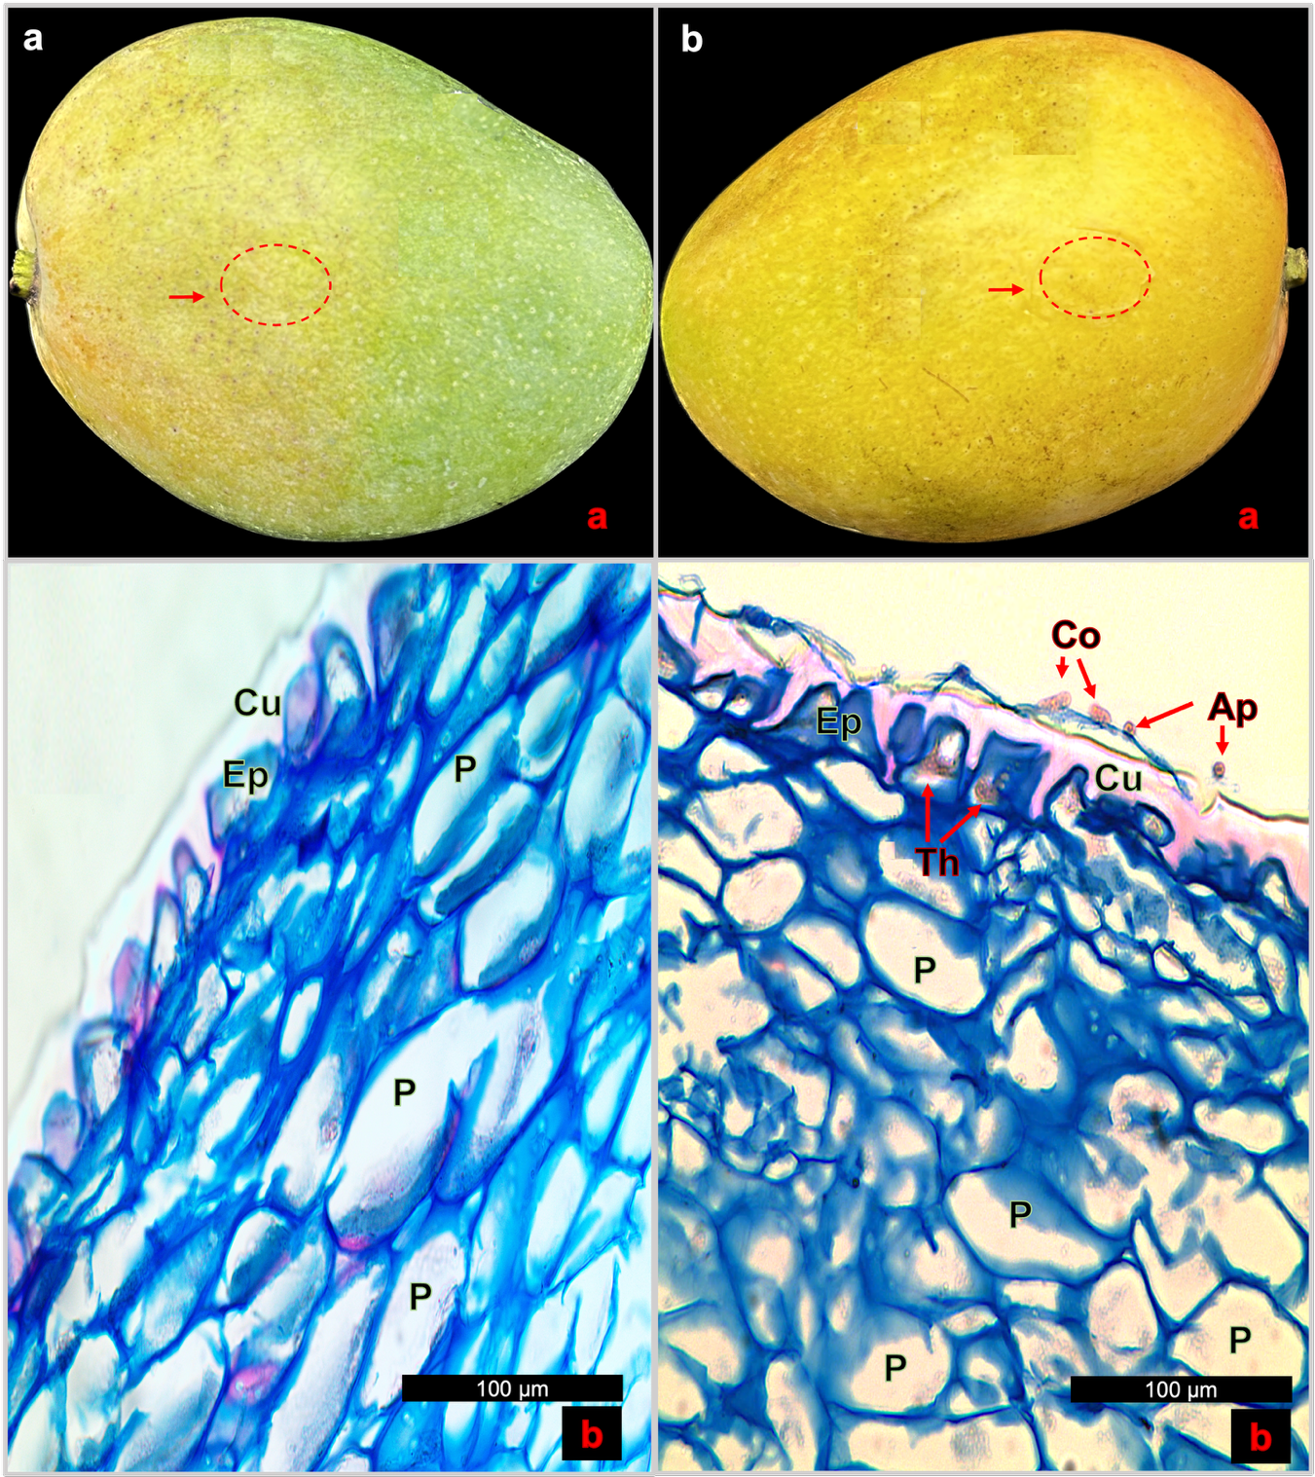

Figure 2. Histathological process of the endophyte C. tropicale in ripe fruit of mango cv. Azúcar. c. 24 (hpi). c-a. Fruit with initial symptoms of anthracnose indicated in red circle. c-b. Parenchyma cells invaded by elongated, slender secondary hyphae. d. 36 (hpi). d-a. Advanced anthracnose symptoms indicated in red circles. d-b. Degraded cuticle, epidermis and parenchyma (cuticle; Ep, epidermis; P, parenchyma; Sh, secondary hypha) (bar; 100 µm).

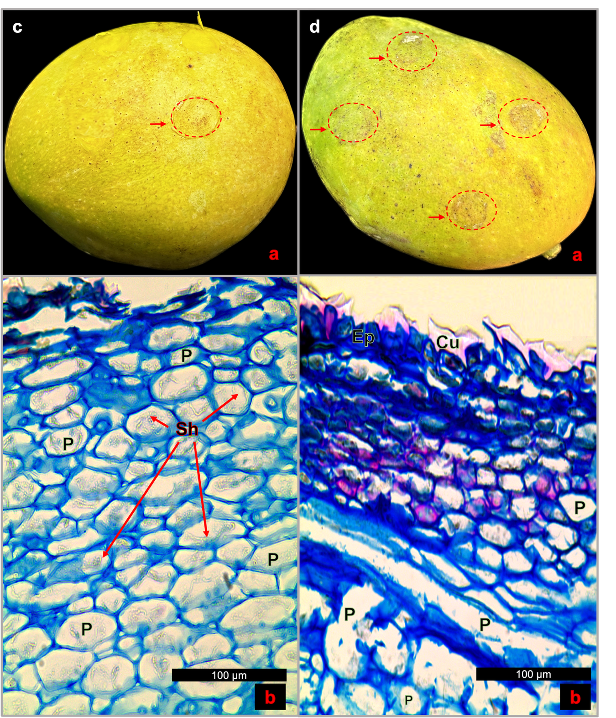

Figure 3. Histopathological process of the endophyte Colletotrichum tropicale in ripe fruit of mango cv. Azúcar. Diagram created on BioRender.com.
