To cite this article: Chaparro-Giraldo, A., J.T. Blanco M., and S.A. López-Pazos. 2015. Evidence of gene flow between transgenic and non-transgenic maize in Colombia. Agron. Colomb. 33(3). Doi: 10.15446/agron.colomb.v33n3.51505

Evidence of gene flow between transgenic and non-transgenic maize in Colombia

Evidencia de flujo de genes entre maíces transgénicos y no transgénicos in Colombia

Alejandro Chaparro-Giraldo¹, Jennifer Teresa Blanco M.¹, and Silvio Alejandro López-Pazos^{1, 2}

¹ Genetic Engineering of Plants Group, Biology Department and Genetics Institute, Universidad Nacional de Colombia. Bogota (Colombia)
² Faculty of Sciences, Universidad Antonio Nariño. Bogota (Colombia). alejandrolopezpazos@uan.edu.co

Received for publication: 24 June, 2015. Accepted for publication: 17 November, 2015.

ABSTRACT
Maize (Zea mays) is an important crop worldwide and is essential for industry. Many transgenic cultivars of maize have been developed over the years from this species, producing cultivars resistant to herbicides and insects, among other things. However, little is known about the gene flow processes that affect maize fields in Colombia, which is near the center of diversity for cultivated maize. We analyzed the gene flow phenomenon of 60 randomly chosen plots of maize, including farmer field landraces or other conventional varieties such as non-transgenic hybrids in Valle de San Juan (Colombia) using Inmunostrip®, PCR and ELISA tests on leaves (seed gene flow) and seeds (pollen gene flow). More than 88% of the plots were positive with the Inmunostrip® and PCR tests (35S promoter, Nos terminator and cry1F gene), using the leaves, while the remaining seven plots (12%) were positive for transgenic sequences in the seeds. The results indicated a significant level of overall transgene existence, which is consistent with gene flow from transgenic events. All of the field types (conventional maize, buffer zones, refuge, and Colombian landraces) showed evidence of a transgene presence. There are many problems that could increase the gene flow potential in Valle de San Juan, such as little respect for regulations (Colombian Decree 4525 on transgenic crops and biosafety), distance between transgenic and non-transgenic maize or use of refuge and/or buffer zones, high seed reuse and exchange and low technical assistance. Every policy decision must be made in light of scientific standards of judgment.

Key words: genetically modified crop, gene flow, Zea mays, conventional variety, landrace, introduced varieties, legal frameworks.

RESUMEN

El maíz (Zea mays) es un cultivo de importancia mundial para la alimentación, y es esencial para la industria. Varios cultivares transgénicos de maíz se han desarrollado durante los últimos años, para lograr resistencia a herbicidas y plagas entre otras características. Sin embargo, poco se conoce acerca de los procesos de flujo de genes que afectan a las poblaciones de maíz en campo, especialmente en Colombia, que está cerca de los centros de diversidad de este cultivo. Se analizó el fenómeno de flujo de genes en 60 parcelas de maíz (incluyendo variedades locales de agricultores y otras variedades convencionales) en el Valle de San Juan (Colombia) utilizando Inmunostrip®, PCR y ELISA sobre muestras de hojas (flujo de genes vía semilla) y semillas (flujo de genes vía polen). El 88% de las parcelas fueron positivas para las pruebas de Inmunostrip® y PCR (para identificación del promotor 35S, el terminador Nos y el gen cry1F) sobre hojas (flujo de genes vía semilla), mientras las siete parcelas restantes (12%) fueron positivas para transgenes en semillas (flujo de genes vía polen). Los resultados indicaron un nivel importante de presencia de secuencias transgénicas, consistente con flujo de genes. Todos los tipos de campo (maíz convencional, zonas de amortiguamiento, de refugio, y zonas con variedades locales colombianas) mostraron presencia de transgenes. Hay varios problemas identificados en el Valle de San Juan, como poco respeto por la normatividad legal (especialmente el decreto colombiano 4525 sobre cultivos transgénicos y bioseguridad), la falta de conservación de la distancia entre el maíz transgénico y no transgénico, o el uso de zonas refugio y/o de amortiguamiento, alta reutilización e intercambio de semillas y escasa asistencia técnica. En este contexto cada decisión para regulación de estos hallazgos debe hacerse a la luz de estándares científicos.

Palabras clave: cultivo genéticamente modificado, flujo de genes, Zea mays, variedad convencional, variedad local, introducción de variedades, marco jurídico.

Introduction
After coffee, maize (Zea mays) is the most important commercial crop in Colombia (MADR, 2004), but there is confusion about its history in this country (Roberts et al., 1957). Maize is grown throughout Colombia; the estimated area of maize crops grown in 2010 was almost 137,000 ha. This area produced more than 1.4 million t, with a total value of close to 1,500 US dollars per ha. Colombian maize production has increased the average production from 4.6 t ha⁻¹ (2007) to 5.2 t ha⁻¹ (2013). Colombia is a minor producer on the global scale, but it is becoming one of the world’s larger maize importers (~3.4 million t in 2010) (MAD, 2014; SICC, 2014). Colombia has recognized 23 maize varieties: two primitive (landraces), nine introduced and 12 Colombian hybrids (crossing). Colombian corn is related to Z. mays subsp. everata (named “reventones” in Colombia), from which the Colombian primitive varieties “Pollo” and “Pira” originated (Roberts et al., 1957). Most Colombian farmers cultivate small areas of these varieties (1-5 ha, almost 42% of production, ~0.66 million t) and have not adopted improved agronomic methods. Almost all the maize produced by the average farmer is consumed in the household. Industrial farmers have a substantial use of inputs, such as certified seeds, agrochemicals and machinery (150,000 ha with a production of ~0.8 million t), food and feed incomes include sales at the technical producer’s price (MADR, 2014). Smallholder farmers in Colombia play a vital role in growing maize; they work in open seed systems, similar to Mexico, related to genetic drift and selection (Bellon and Berthaud, 2004).

Colombia approved the YieldGard MON810, Round Ready and Herculex I genetically modified (GM) maize varieties in 2007 for commercial cultivation. In recent years, other GM maize products have been released in Colombia: MON810 (insect resistance), TC1507 (insect and herbicide resistance), NK603 (herbicide resistance), TC1507-NK603 (insect and herbicide resistance), MON810-NK603 (insect and herbicide resistance), and BT11 (insect and herbicide resistance), among others. In 2013, a total of 75,000 ha of GM corn were planted in 18 departments (Sucre, Cesar, Cordoba, Bolivar, Huila, Tolima, Antioquia, Risaralda, Caldas, Quindio, Valle del Cauca, Cauca, Cundinamarca, Santander, Norte de Santander, Meta, Casanare, and Vichada), where the average yield per ha was 6 t, while the average yield of landraces in Colombia can reach 4.4 t ha⁻¹. GM maize has been adopted by small and large scale farmers (Agrobio-CEGA, 2010; Avila et al., 2011; Chaparro-Giraldo, 2011; Agrobio, 2015). The Zenú de San Andrés de Sotavento indigenous reserve, located in the Cordoba and Sucre departments, was declared a “GM-free territory” in order to preserve the 25 maize landraces associated with the indigenous culture (Grain, 2005).

A legal framework for the commercial cultivation of GM maize was established in Colombia, specially law 740 (2002), related to The Cartagena Protocol on Biosafety from the Convention on Biological Diversity, a global pact that aims “to ensure the safe handling, transport and use of living, modified organisms resulting from modern biotechnology that may have adverse effects…” (http://bch.cbd.int/protocol/). Colombia operates with Decree 4525 (2005) for living, modified organisms to regulate GM crops and biosafety. Legal text 2894 (2010) provides a framework to ensure implementation of biosafety management for GM maize, including education and control strategies such as refuge use (distance of 500 m in a scheme with a 90/10 GM/conventional ratio) and resistance monitoring. Moreover, this act requires an isolation distance between GM and non-GM crops, which is a recommended at 300 m, with a difference in flowering time (15 d), and indigenous localities have now banned growing GM maize. This legal framework meets the education requirement for GM maize support (technical support has been recognized as a critical factor in GM crops), farmer’s duty to report seed excess, refuge strategy for Bacillus thuringiensis technology (genes of this entomopathogenic bacteria have been used in commercial crops for insect control), rules to prohibit the purchase, sale and storage of GM seeds, and a requirement for GM area details. The Instituto Colombiano de Agricultura (ICA, Spanish abbreviation) was created as the national executive organization and the competent authority, which has declared that violations will be punishable with destruction of vegetal material, successive fines, prohibition of cultivation, cancellation of license, and cancellation of technical support.

Maize has been placed in a high risk category for gene flow. The most important method for maize pollination is anemophily (wind pollination), occurring at up to ~20 m (although the maximum reported distance is 200 m) (Treu and Emberlin, 2000; Luna et al., 2001; Eastham and Sweet, 2002; Bannert and Stamp, 2007; Baltazar et al., 2015). Management schemes can be employed to reduce gene flow between GM and non-GM crops, especially spatial and temporal separation, isolation areas, cultivation barrier rows or other plant barriers (Eastham and Sweet, 2002; Andow et al., 2010). Under the current circumstances of rapid GM crop adoption, there is interest to evaluate the effects of pollen dispersal and spatial genetic changes (Sears et al., 2001; Goggi et al., 2006; Beckie and Hall, 2008; Dyer et al., 2009). Moreover, a lot of gene flow problems are encountered in seed dispersal (transport, harvest equipment, wind or animals) and the possibility of harvest mixing by farmers (Beckie et al., 2003; Jenczewski et al., 2003). The effects of hybridization and introgression between GM crops and wild crops could include fitness changes that depend on both the transgene (specific trait and the gene transfer probability) and the receptor organism, selective effect by level gene flow, susceptibility alteration on target and non-target organisms (such as plant-insect interactions in GM crops for pest resistance), dominance degrees, epistasis association, and variation in the genotype-environment interaction (Eastham and Sweet, 2002; Heuberger et al., 2010). Hybridization and introgression consequences are problematic for calculations, but could include genetic assimilation (it affects genetic diversity), demographic swamping (wild population decrease) and invasiveness (hybrid is more fertile than wild plants) (Haygood et al, 2003; Soleri et al., 2005; Baltazar et al., 2015). Specifically, GM maize release has risks associated with possible effects on crop diversity, farmer health, the environment and production, such as transgene introgression in landraces or evolution of resistant insects. Many facts are important for pollen dispersal in maize, including pollen field-recipient field distance, pollen origin-recipient field dimension, shape and orientation of pollen field- recipient field, weather conditions (wind, rain, and geography), pollen physiology (viability, fertility, flowering synchrony), and commercial status, among others. The presence of transgenic sequences (35S CaMV promoter and Nos terminator) has been reported in Mexican landrace maize (Quist and Chapela, 2001); however, subsequent research reported an absence of transgenes in the same area of Mexico (Ortiz-García et al., 2005). In 2009, a new report showed transgenes associated with the 35S CaMV promoter and Nos terminator sequences in Mexican landraces (Piñeyro-Nelson et al., 2009). Discrepancies can be associated with molecular methods or a cluster distribution of transgenes, affecting field sampling (Cleveland et al., 2005; Piñeyro-Nelson et al., 2009). A study in 15 counties of England (2000-2002) presented evidence of gene flow beyond 80 and 200 m for feed and sweet corn, respectively (Henry et al., 2000). A project in Africa aimed to respond to the problem of the level of GM maize cross-pollination to non-GM maize, using MON810 maize containing the cry1Ab gene (in a central plot of 0.0576 ha), in comparison with a conventional white maize hybrid (13.76 ha around of MON810 maize); the cross-pollination index fell by <1.0-0.1% at 45 m, <0.1-0.01% at 145 m, and <0.01-0.001% at 473 m (Viljoen and Chetty, 2011). The objective of this study was to contribute information on the presence of transgenes in Tolima (Colombia) maize landraces. The specific objectives of this study were (a) to establish a preliminary picture of the transgenic technologies in valley of San Juan (Tolima), (b) to perform tests for the detection of both seed and pollen gene flow, and to establish a relationship with legal standards.

Materials and methods
Maize sample: We conducted field samplings in 12 different municipal rural settlements of valley of San Juan, an important area for growing maize, located in Tolima- Colombia (Geographic coordinates 4º12’ N and 75º07’ W, at 600 m a.s.l.) in 2010: Cabuyal, Capote, Dinde, Egidos, Letras, Santa Rosa, El Neme, Hijo del Valle, La Manga, La Florida, Michu and Buena Vista Baja. The maize samples were obtained from 60 plots: conventional maize (114.2 ha), buffer zones or strip with conventional varieties (8.35 ha of conventional maize and 95 ha of GM maize), refuges or plots with conventional varieties (28 ha of conventional maize and 125.5 ha of GM maize), and Colombian landraces (2.25 ha). We sampled nine plants per plot with a zigzag pattern, with conventional maize hybrids (Impacto, 30F35, 30F32, 3041, P3862, DK 777 and DK7088) in 27 plots, 13 buffer and 16 refuge zones with GM maize (30F35WH and 30F32WH from Pioneer and DK4004 from Monsanto) and four Colombian landraces zones (Clavo variety) (Fig. 1).

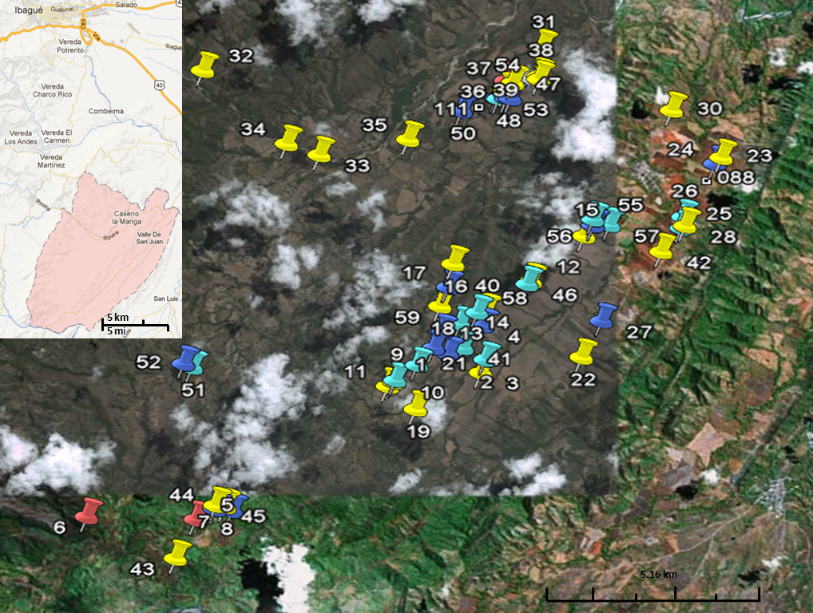
Figure 1. Valley of San Juan (Colombia) area and plots in the study. Yellow is conventional maize, dark blue is refuge (GM maize), light blue is buffer (GM maize), and red is landrace maize (Google maps).

GM detection: In general, three methods were applied to the evaluation of the valley of San Juan plots in terms of seed-mediated transgene flow, using leaves. The first method utilized immunoassay-based information tools. It was directed at determining the cry1F gene detection by analyzing the expression in the maize plants. The second strategy used a molecular approach to define the 35S promoter and Nos terminator DNA sequences. The pollen gene flow was analyzed by PCR (35S CaMV promoter and Nos terminator) and ELISA (Cry1F protein), using grains from negative plots in the seed gene flow phase (Fig. 2). The leaf DNA extraction was adapted from Phillips et al. (2003) and Falcón and Valera (2007). The seed DNA was extracted with a DNeasy Plant Maxi Kit (Qiagen, Santa Clarita, CA). The DNA was analyzed with PCR for presence of the 35S CaMV promoter and Nos terminator sequences. The PCR primers were: 35S (F: 5´-GCTCCTACAAATGCCATCA-3´, R: 5´-GATAGTGGGATTGTGCGTCA-3´; PCR product, 195 pb), Nos (F: 5´-GAATCCTGTTGCCGGTCTTG-3´, R: 5´-TTATCCTAGTTTGCGCGCTA-3´; PCR product, 180 pb) (Lipp et al., 1999). Moreover, the primers for the cry1F gen from B. thuringiensis (F: 5´-GAATCCTGTTGCCGGTCTTG-3´, R: 5´-TTATCCTAGTTTGCGCGCTA-3´; PCR product, 180 pb) (Porcar and Juárez-Pérez, 2003) were chosen to identify the transgenes in the events TC1507 and TC1507-NK603. A 329 bp zein gene was used as a positive control of the quality of the DNA used for the PCR test (primers F: 5'-TGCTTGCATTGTTCGCTCTCCTAG-3', R: 5'-GTCGCAGTGACATTGTGGCAT-3') (Rimachi et al., 2011). The standardized PCR protocol for the 25 μL reaction mixture included 1X PCR buffer, 0.2 mM dNTP mix, 2 mM MgCl₂ and 0.8 μM of each primer, 0.5 unit of Taq DNA polymerase, and 50 ng of DNA. The amplification was performed using a single denaturation step (3 min at 95ºC), followed by a 35-cycle program, with each cycle consisting of denaturation at 95ºC for 30 s, annealing at 59.6-64.4ºC for 30 s, and extension at 72ºC for 45 s; a final extension step (72ºC for 5 min) was also used. In each series of experiments, at least two controls, a conventional maize DNA (negative) control and a positive control (MON810-NK603 event) were processed in parallel.

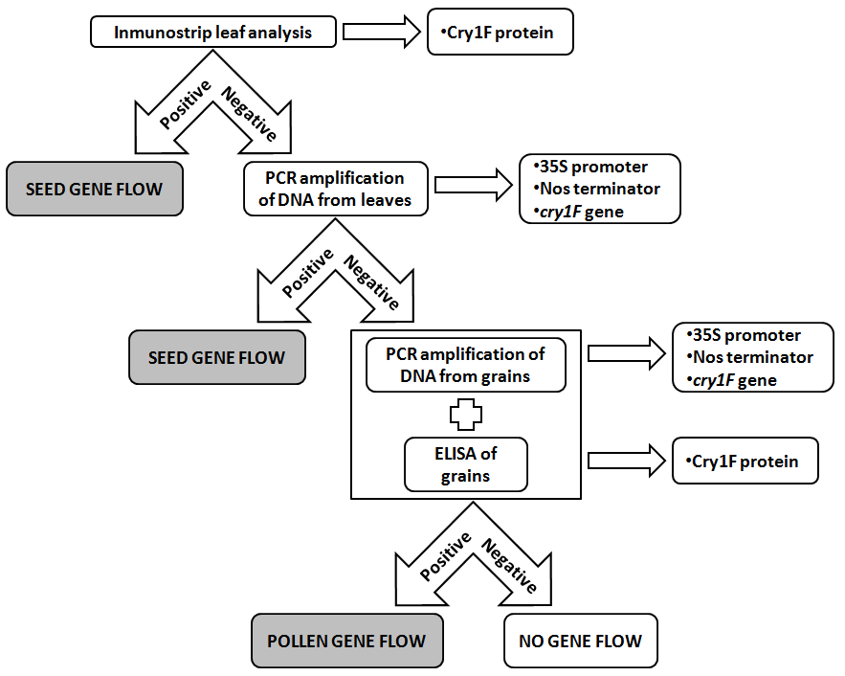
Figure 2. Scheme of the gene flow study in valley of San Juan (Colombia). The search for transgenic sequences in the maize was done with a basic strategy with molecular assays, using leaves and grains from cobs of landraces or other conventional varieties.

The Inmunostrip® (AGDIA, Elkhart, IN) test for the Cry1F protein transgenic presence was used because it is widely used throughout the country (Van den Bulcke et al., 2007). This test is intended for GM trait purposes to determine the presence of Cry1F protein from B. thuringiensis in GM maize from the TC1507 and TC1507-NK603 events.

The initial sample consisted of two leaves and one cob chosen for each plant (540 plants, 1,080 leaves, 540 cobs and 16,2000 grains) used for gene flow. In total, 44.12% of the households (25.57% of the total area) were sampled in valley of San Juan (according to Ministry of Agriculture and Rural Development of Colombia (MADR) and the National Federation of Grain and Oilseed Growers- Fenalce, Spanish abbreviation). The gene flow by pollen estimates contained grains pooled from nine cobs per plot. Each estimate represented the 35S CaMV promoter and Nos terminator PCR tests (as mentioned previously) and Cry1F transgenic protein detection using Qualitative DAS-ELISA (AGDIA, Elkhart, IN). The optical density was then read using a microplate reader (655 nm wavelength). All tests were performed in triplicate.

Results
Molecular assays performed in leaves and seeds are a useful strategy for gene flow recognition (Danson et al., 2006; Van den Bulcke et al., 2007). At first glance, the seed gene flow detection was performed with an Inmunostrip® test and PCR test in the leaf samples (35S CaMV promoter and Nos terminator sequences, and cry1F gene). All of the molecular tests that were performed with a GM view showed a gene flow effect on the maize crops in valley of San Juan (Colombia) (Fig. 3). Twenty-two of the 60 plots were positive for the Cry1F protein according to the Inmunostrip® test results (Fig. 3A), except for the Colombian landrace zones. The PCR analysis was performed for the samples that had been disqualified with a negative Inmunostrip® test result (38 plots), with 31 positive results for the 35S CaMV promoter and Nos terminator sequences (Fig. 3B). In this case, the PCR analysis was required to ensure that the Cry1F related-data were interpreted correctly; there was no difference between the Inmunostrip® and PCR tests (Van den Bulcke et al., 2007). We evaluated plots according to the criteria of zone type (conventional maize, buffer (GM), refuge (GM), and Colombian landrace). In the evaluation on the seed flow of the transgenic sequences, the majority of tests showed that the plots of the valley of San Juan were in conformity with the subject in terms of transgenic DNA presence. In this question, a majority of the plots (~88%) had seed gene flow (Fig. 3C). Moreover, the pollen gene flow analysis with PCR (35S CaMV promoter and Nos terminator) and ELISA (Cry1F protein) from seven negative plots in the seed gene flow phase showed that samples from all of the evaluated plots had transgenic sequences. There was a difference in the percentage of samples positive with the 35S CaMV promoter, Nos terminator and Cry1F protein (Fig. 3D).

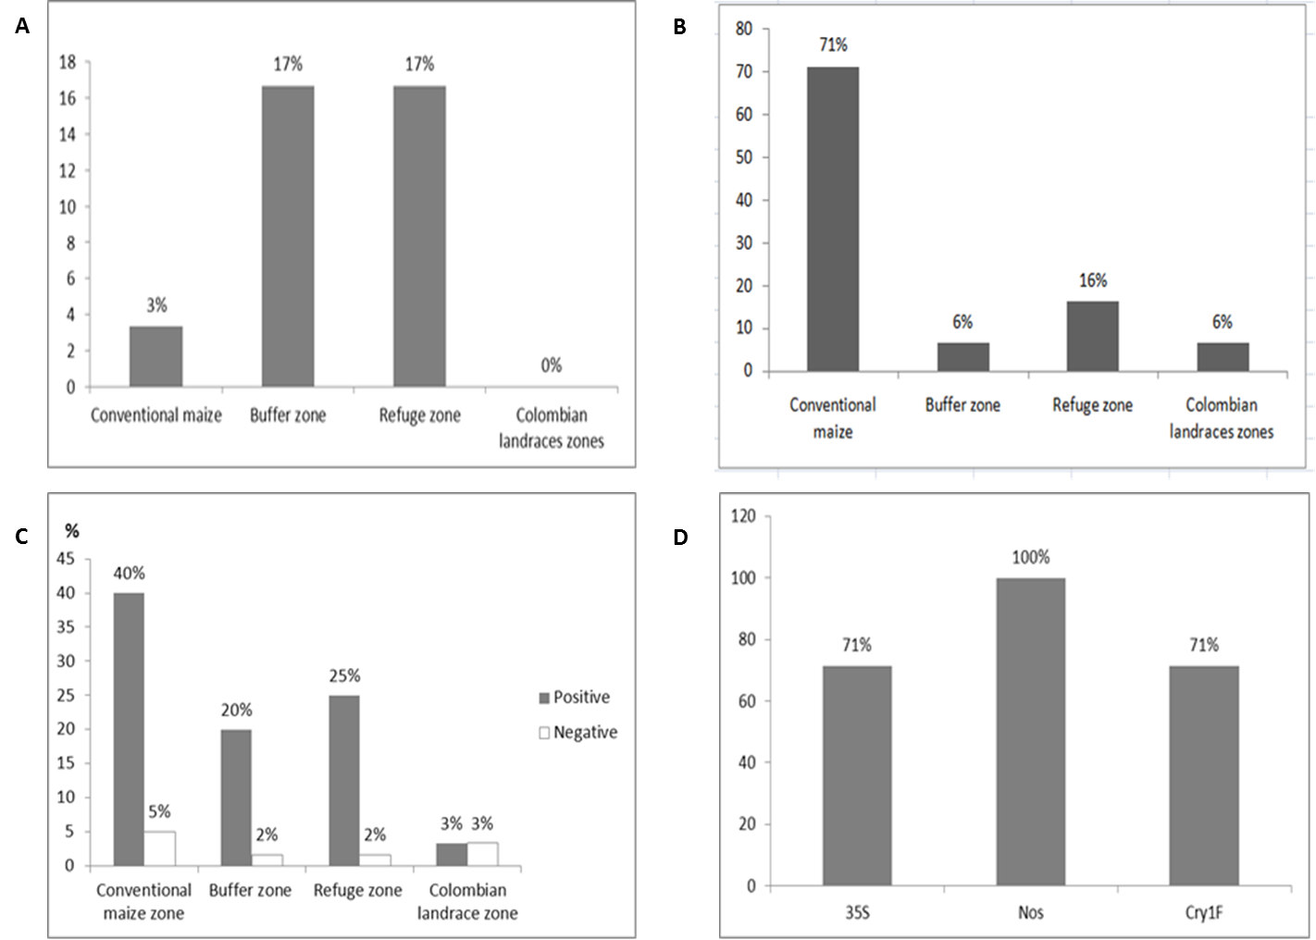
Figure 3. The gene flow analysis in valley of San Juan (Colombia). A, Inmunostrip® positive results for each maize field class. Conventional maize: 243 plants in 27 plots; Buffer zone (GM maize): 117 plants in 13 plots; Refuge zone: 144 plants in 16 plots; Colombian landrace zones: 36 plants in 4 plots. B, PCR test for the presence of the 35S CaMV promoter and Nos terminator for each maize area. Conventional maize: 198 plants in 22 plots; Buffer zone (GM maize): 18 plants in 2 plots; Refuge zone: 45 plants in 5 plots; Colombian landrace zones: 18 plants in 2 plots. C, seed transgene flow in Valle de San Juan (Colombia) plots. Positive results indicated that the transgenic trend in the conventional maize zone is of particular importance because most of it is very likely farmer-induced, directly or indirectly, and is proceeding at a high rate. D, pollen gene flow exploration on seed samples from negative plots for the seed gene flow tests. One hundred percent of the seed samples contained at least one transgenic sequence (PCR assay for presence of the 35S CaMV promoter and Nos terminator, and Cry1F detection by ELISA).

Discussion
Our study provides new evidence that this transgenic sequence presence could involve gene flow in valley of San Juan (Colombia). Context in gene flow studies is typically captured as the actual location and movement of the transgenes. The results showed a presence of transgenic sequences in leaves and seeds of non-GM maize plots. The crop practices of Colombian farmers are extensive and open to seed exchange. Maize production intensification uses varieties that are better adapted to economically-based production practices. The Valle de San Juan area is cultivated with local open-pollinated cultivars (conventional maize), landraces and transgenic events. Colombian law does not prohibit the application of conventional and GM maize in any territory. Moreover, definite fields for maize crops could be variable due to economic factors or land use. The use of hybrids or improved materials is common. Even though it is not designed to determine the transgene frequency in the field, the results suggest that GM sequences may persist within maize areas as has been recently noted elsewhere (Chilcutt and Tabashnik, 2004; Dyer et al., 2009; Piñeyro-Nelson et al., 2009).

This local varieties-transgenic event (especially for herbicide and insect resistance traits) interaction may cause gene flow in both directions. Future transgenic introgression seemed highly probable. A gene flow process in standard form always begins with the region or locality first, then the province (department in Colombia), and finishes with the entire maize area. According to the revision of the geographical location of non-GM maize plots, gene flow usually occurs over a finite distance (Baltazar et al., 2015). To evaluate gene flow changes in this case, Colombia needs to develop new strategies. One of the steps moving the theory towards practical approaches is taking into account the population of maize seeds planted, number of transgenic maize, or circumstances that can spread transgenes after the pollination of local maize (Serratos-Hernández et al., 2004; Goggi et al., 2006; Dalton, 2009). For Mexico, the diffusion rate was weighted 99 percent in 2015 (Serratos-Hernández et al., 2004). Additional studies are needed to evaluate introgression and frequency estimates of transgenes in Colombian maize cultivars.

The analysis of gene flow must consider the entire area of maize farming, including the environmental, geographical and social scenarios (Serratos-Hernández et al., 2004; Dyer et al., 2009). Hence, attention must be focused on appropriate regulations and control of farming efforts. The farming of GM maize in Europe has been limited to Spain. Europe has accepted the presence of GM material in non-GM products, up to a margin of 0.9%. To reduce pollen dispersal, the European Union approved a regulation that set out 200 m as the minimal isolation between the pollen source and receptor field (100 m using physical barriers) (Devos et al., 2005). The ICA established requirements to be fulfilled by farmers for transgenic crop use (Resolution 2894, ICA, 2010), including a separation distance of 500 m between local and transgenic maize fields and physical barriers (refuge and buffer zones) in a scheme of 10/90, among others. These standards are not respected when GM maize farming is developed. There are many factors, particularly in valley of San Juan (Colombia), where improper practices among farmers can result in rapid gene flow:
- There is no respect for the 500 m distance (GM and non-GM maize) or 10:90 ratio (conventional/GM).
- Little application of refuge and/or buffer zones.
- Seed re-use and dispersal by exchange (including local and transgenic varieties).
- Our information indicates that there is a presence of Monsanto and Pioneer events in several regions inside valley of San Juan (Colombia).
- There are no state technical programs for farmers performing maize production. The ICA and Pioneer conduct occasional visits. Maize management is based on farmer criteria.
- Xenia (effect of pollen on characteristics of the seed) has been observed across different plots of the Valle de San Juan (Colombia).

Biosafety politics for the supervision of GM crop applications comprise the policy on biotechnology, a special law for biosafety regulation, administrative organization for management applications and a mechanism for public involvement in biosafety decisions (Secretariat of the Convention on Biological Diversity, 2000). Europe allows a presence of authorized GM material in non-GM maize up to a 0.3% level. Also, the maize product must be labeled as being formed or produced from or containing GM maize (Devos et al., 2005). The Colombian legal framework for crop biotechnology is regularly reviewed to facilitate the implementation of science-based policies. Colombia allows field-testing for GM crops after a biosafety assessment. There is no policy for coexistence between GM and non-GM maize in Colombian crops. However, farmers apply the practice of buffer zones or refuges among crop plots. It is important to mention that Colombia adheres to intellectual property right guidelines (Paris Convention for the Protection of Industrial Property, the General Agreement on Tariffs and Trade, the International Union for the Protection of New Varieties of Plants, the G3 Agreement, and the Andean Pact), but violations of intellectual property regulations are not punished, affecting GM companies (Gilbert and Uribe, 2013).

An overall assessment is recommended for the importance of the maize farmer concerns, technical assistance and regulation. We agree with Cleveland et al. (2005) that “the detection of the presence or absence of transgenes and their frequencies […] is an important tool for understanding transgene flow to landraces and wild and weedy relative crop populations and its potential effects. However, statements on the presence or absence of transgenes in these populations need to be based on sound scientific methods and theory, especially if they are used as the basis for policy. Scientifically unjustified conclusions contribute to misunderstandings and may lead either to false alarms or false complacency”. Moreover, it is of course very important to consider new factors that may influence gene flow, such as the relevant size of receptor fields (Palaudelmàs et al., 2012).

Literature cited

Agro-bio. 2015. Estadísticas de cultivos GM en Colombia. In: http://agrobio.org.co/fend/index.php?op=YXA9I2JXbDQmaW09I016UT0; consulted: November, 2015.

Agrobio-CEGA. 2010. El beneficio económico por la adopción de la tecnología de OGM para maíz en Colombia. Universidad de los Andes, Bogota.

Andow, D.A., S.L. Farrell, and Y. Hu. 2010. Planting patterns of in-field refuges observed for Bt maize in Minnesota. J. Econ. Entomol. 103, 1394-1399. Doi: 10.1603/EC09201

Avila M., K., A. Chaparro-Giraldo, G. Reyes M., and C. Silva C. 2011. Production cost analysis and use of pesticides in the transgenic and conventional corn crop [Zea mays (L.)] in the valley of San Juan, Tolima. GM Crops 2, 163-168. Doi: 10.4161/gmcr.2.3.17591

Baltazar, BM, L. Castro E., A. Espinoza B., J.M. de la Fuente M., J.A. Garzón T., J. González G.,
M.A. Gutiérrez, J.L. Guzmán R., O. Heredia D., M.J. Horak, J.I. Madueño M., A.W. Schapaugh,
D. Stojšin, H.R. Uribe M., and F. Zavala G. 2015. Pollen-mediated gene flow in maize: implications for isolation requirements and coexistence in Mexico, the center of origin of maize. PloS ONE 10, e0131549. Doi: 10.1371/journal.pone.0131549

Bannert, M. and P. Stamp. 2007. Cross-pollination of maize at long distance. Eur. J. Agron. 27, 44-51. Doi: 10.1016/j.eja.2007.01.002

Beckie, H.J. and L.M. Hall. 2008. Simple to complex: modelling crop pollen-mediated gene flow. Plant Sci. 175, 615-628. Doi: 10.1016/j.plantsci.2008.05.021

Beckie, H.J., S.I. Warwick, H. Nair, and G. Ségin-Swartz. 2003. Gene flow in commercial fields of herbicide-resistant canola (Brassica napus). Ecol. Appl. 13, 1276-1294. Doi: 10.1890/02-5231

Bellon, M.R. and J. Berthaud. 2004. Transgenic maize and the evolution of landrace diversity in Mexico: the importance of farmers’ behavior. Plant Physiol. 134, 883-888. Doi: 10.1104/pp.103.038331

Chaparro-Giraldo, A. 2011. Cultivos transgénicos: entre los riesgos biológicos y los beneficios económicos. Acta Biol. Colomb. 16, 231-352.

Chilcutt, C.F. and B.E. Tabashnik. 2004. Contamination of refuges by Bacillus thuringiensis toxin genes from transgenic maize. Proc. Natl. Acad. Sci. USA 101, 7526-7529. Doi: 10.1073/pnas.0400546101

Cleveland, D.A., D. Soleri, F.A. Cuevas, J. Crossa, and P. Gepts. 2005. Detecting (trans)gene flow to landraces in centers of crop origin: lessons from the case of maize in Mexico. Environ. Biosafety Res. 4, 197-208. Doi: 10.1051/ebr:2006006

Dalton, R. 2009. Mexico's transgenic maize under fire. Nature 462, 404. Doi: 10.1038/462404a

Danson, J.W., M. Kimani, and M. Mbogori. 2006. Detection of Bacillus thuringiensis genes in transgenic maize for the PCR method and FTA paper technology. Afr. J. Biotechnol. 5, 2345-2349.

Devos, Y., D. Reheul, and A. De Schrijver. 2005. The co-existence between transgenic and non-transgenic maize in the European Union: a focus on pollen flow and cross-fertilization. Environ. Biosafety Res. 4, 71-87. Doi: 10.1051/ebr:2005013

Dyer, G.A., J.A. Serratos-Hernández, H.R. Perales, P. Gepts, A. Piñeyro-Nelson, A. Chávez, N. Salinas-Arreortua, A. Yúnez-Naude, J.E. Taylor, and E.R. Alvarez-Buylla. 2009. Dispersal of transgenes through maize seed systems in Mexico. PLoS ONE. 4, e5734. 10.1371/journal.pone.0005734

Eastham, K. and J. Sweet. 2002. Genetically modified organisms (GMOs): the significance of gene flow through pollen transfer. Environmental Issue Report No. 28. European Environment Agency (EEA), Copenhagen.

Falcón, L.I. and A. Valera. 2007. Extracción de ácidos nucleicos. pp. 499-515. In: Eguiarte, L.E., V. Souza, and X. Aguirre (eds.). Ecología molecular. Instituto Nacional de Ecología, Conabio, Mexico DF.

Gilbert, A.J. and A. Uribe. 2013. Colombia continues to expand its biotechnology frontier. Agricultural Biotechnology Annual, Colombia. USDA'S Global Agricultural Information Network (GAIN), Washington DC.

Goggi, A.S., P. Caragea, H. Lopez-Sanchez, M. Westgate, R. Arritt, and C. Clark. 2006. Statistical analysis of outcrossing between adjacente maize grain production fields. Field Crop Res. 99, 147-157. Doi: 10.1016/j.fcr.2006.04.005

Grain. 2005. Colombia: declaración del Resguardo Indígena Zenú, Córdoba y Sucre como territorio libre de transgénicos. In: grain.org; www.grain.org/es/article/entries/3729-colombia-declaracion-del-resguardo-indigena-zenu-cordoba-y-sucre-como-territorio-libre-de-transgenicos; consulted: November, 2015.

Haygood, R., A.R. Ives, and D.A. Andow. 2003. Consequences of recurrent gene flow from crops to wild relatives. Proc. R. Soc. Lond. Ser. B. 270, 1879-1886. Doi: 10.1098/rspb.2003.2426

Henry, C., D. Morgan, R. Weekes, R. Daniels, and C. Boffey. 2003. Farm scale evaluations of GM crops: monitoring gene flow from GM crops to non-GM equivalent crops in the vicinity (contract reference EPG 1/5/138). Part I: Forage Maize. Centre for Ecology and Hydrology; Department for Environment, Food & Rural Affairs (Defra); Central Science Laboratory, Sand Hutton, UK.

Heuberger, S., C.E. Ellers-Kirk, B.E. Tabashnik, Y. Carrière. 2010. Pollen- and seed-mediated transgene flow in commercial cotton seed production fields. PLoS ONE. 5, e1428. Doi: 10.1371/journal.pone.0014128

ICA, Instituto Colombiano Agropecuario. 2010. Resolución No. 2894, por medio de la cual se implementa el plan de manejo, bioseguridad y seguimiento para siembras controladas de maíz genéticamente modificado. Bogota.

Jenczewski, E., J. Ronfort, and A.-M. Chèvre, 2003. Crop-to-wild gene flow, introgression and possible fitness effects of transgenes. Environ. Biosafety Res. 2, 9-24. Doi: 10.1051/ebr:2003001

Lipp, M., P. Brodmann, K. Pietsch, J. Pauwels, and E. Anklam. 1999. IUPAC collaborative trial study of a method to detect genetically modified soy beans and maize in dried powder. J. AOAC Int. 82, 923-928.

Luna V., S., J. Figueroa M., B. Baltazar M., R. Gomez L., R. Townsend, and J.B. Schoper. 2001. Maize pollen longevity and distance isolation requirements for effective pollen control. Crop Sci. 41, 1551-1557. Doi: 10.2135/cropsci2001.4151551x

MADR, Ministerio de Agricultura y Desarrollo Rural de Colombia. 2004. El agro colombiano frente al TLC con los Estados Unidos. Bogota.

MADR, Ministerio de Agricultura y Desarrollo Rural de Colombia. 2014. Red de información y comunicación estratégica del sector agropecuario - AGRONET Colombia. In: Agronet, www.agronet.gov.co/; consulted: November, 2015.

Ortiz-García, S., E. Ezcurra, B. Schoel, F. Acevedo, J. Soberón, and A.A. Snow. 2005. Absence of detectable transgenes in local landraces of maize in Oaxaca, Mexico (2003-2004). Proc. Natl. Acad. Sci. USA 102, 12338-12343. Doi: 10.1073/pnas.0503356102

Palaudelmàs, M., E. Melé, A. Monfort, J. Serra, J. Salvia, and J. Messeguer. 2012. Assessment of the influence of field size on maize gene flow using SSR analysis. Transgenic Res. 21, 471-483. Doi: 10.1007/s11248-011-9549-z

Phillips, M.W., D.C. Astorga, and S.O. Quirós. 2003. Método 2X CTAB-minipreparaciones. Centro Agronómico Tropical de Investigación y Enseñanza (CATIE), Turrialba, Costa Rica.

Piñeyro-Nelson, A., J. Van Heerwaarden, H.R. Perales, J.A. Serratos-Hernández, A. Rangel, M.B. Hufford, P. Gepts, A. Garay-Arroyo, R. Rivera-Bustamante, and E.R. Álvarez-Buylla. 2009. Transgenes in Mexican maize: molecular evidence and methodological considerations for GMO detection in landrace populations. Mol. Ecol. 18, 750-761. Doi: 10.1111/j.1365-294X.2008.03993.x

Porcar, M. and V. Juárez-Pérez. 2003. PCR-based identification of Bacillus thuringiensis pesticidal crystal genes. FEMS Microbiol. Rev. 26, 419-432. Doi: 10.1111/j.1574-6976.2003.tb00624.x

Quist, D. and I.H. Chapela. 2001. Transgenic DNA introgressed into traditional maize landraces in Oaxaca, Mexico. Nature 414, 541-543. Doi: 10.1038/35107068

Rimachi G., L.F., J. Alcántara D., Y. Aquino V., and R. Ortiz. 2011. Detecting adventitious transgenic events in a maize center of diversity. Elect. J. Biotechnol. 14, 9. Doi: 10.2225/vol14-issue4-fulltext-12

Roberts, L.M., U.J. Grant, R. Ramirez E., W.H. Hatheway, D.L. Smith, and P.C. Mangelsdorf. 1957. Races of maize in Colombia. Publication No. 510. National Academy of Sciences (NAS); National Research Council (NRC), Washington, DC.

Sears, M.K., R.L. Hellmich, D.E. Stanley-Horn, K.S. Oberhauser, J.M. Pleasants, H.R. Mattila, B.D. Siegfried, and G.P. Dively. 2001. Impact of Bt corn pollen on monarch butterfly populations: a risk assessment. Proc. Natl. Acad. Sci. USA 98, 11937-11942. Doi: 10.1073/pnas.211329998

Secretariat of the Convention on Biological Diversity. 2000. Cartagena protocol on biosafety to the convention on biological diversity: text and annexes. Montreal, Canada.

Serratos-Hernández, J.A., F. Islas-Gutiérrez, E. Buendía-Rodríguez, and J. Berthaud. 2004. Gene flow scenarios with transgenic maize in Mexico. Environ. Biosafety Res. 3, 149-157. Doi: 10.1051/ebr:2004013

Soleri, D., D.A. Cleveland, F. Aragón C., M.R. Fuentes L., H. Ríos L., and S.H. Sweeney. 2005. Understanding the potential impact of transgenic crops in traditional agriculture: maize farmers’ perspectives in Cuba, Guatemala and Mexico. Environ. Biosafety Res. 4, 141-166. Doi: 10.1051/ebr:2005019

SICC, Superintendencia de Industria y Comercio de Colombia. 2014. Cadena productiva del maíz. Industrias de alimentos balanceados y harina de maíz. Bogota.

Treu, R. and J. Emberlin, 2000. Pollen dispersal in the crops maize (Zea mays), oil seed rape (Brassica napus ssp. oleifera), potatoes (Solanum tuberosum), sugar beet (Beta vulgaris ssp. vulgaris) and wheat (Triticum aestivum). Soil Association, Bristol, UK.

Van den Bulcke, M., A. De Schrijver, D. De Bernardi, Y. Devos, G. MbongoMbella, A.L. Casi, W. Moens, and M. Sneyers. 2007. Detection of genetically modified plant products by protein strip testing: an evaluation of real-life samples. Eur. Food Res. Technol. 225, 49-57. Doi: 10.1007/s00217-006-0381-2

Viljoen, C. and L. Chetty. 2011. A case study of GM maize gene flow in South Africa. Environ. Sci. Eur. 23, 1-8. Doi: 10.1186/2190-4715-23-8

