To cite this article: Martinez-Alava, J.O. and F. Serna. 2015. Running insect collections. Micropezidae (Diptera: Nerioidea) of the Entomological Museum UNAB. Agron. Colomb. 33(3). Doi: 10.15446/agron.colomb.v33n3.52432

Running insect collections. Micropezidae (Diptera: Nerioidea) of the Entomological Museum UNAB

Ejecución de las colecciones de insectos. Micropezidae (Diptera: Nerioidea) del Museo de Entomología UNAB

Javier O. Martinez-Alava¹ and Francisco Serna¹

¹ Museo Entomológico UNAB, Sistemática de Insectos Agronomía (SIA) Gruop. Faculty of Agricultural Sciences, Universidad Nacional de Colombia. Bogota (Colombia). jomartineza@unal.edu.co

Received for publication: 10 August, 2015. Accepted for publication: 17 November, 2015.

ABSTRACT
UNAB consists of several collections that seek to represent the insects of agricultural and forestry significance from the various regions of Colombia, especially the mountainous zone. In order to contribute to knowledge on the Diptera diversity of Colombia found in agricultural ecosystems, the present study looked at the Micropezidae contained in this museum, along with the represented taxa, as well as its current curatorial status and geographic distribution in the country. Currently, the Taxonomic Central Collection houses 107 specimens from the Micropezidae family, which belong to the genera Cardiacephala, Grallipeza, Grallomyia, Mesoconius, Micropeza, Plocoscelus, Paragrallomyia, Poecilotylus, Ptilosphen, Scipopus, and Taeniaptera, representing distribution in 57 municipalities and 12 departments (provinces) of the Colombian Andean region.

Key words: Andean region, Colombia, taxonomy, geographical distribution, agroecosystems, insecta.

RESUMEN
UNAB se compone de varias Colecciones que buscan representar la entomofauna de importancia agrícola y silvícola de varias regiones de Colombia, especialmente de su zona montañosa. Como aporte al conocimiento de la diversidad de Dípteros de Colombia que viven en agroecosistemas, en el presente estudio se estudian los Micropezidae de este Museo, y se registran los taxones representados, así como el estado de su curaduría y su distribución geográfica en el país. En la actualidad, la Colección Taxonómica Central cuenta con 107 especímenes de la familia Micropezidae, que corresponden a los géneros Cardiacephala, Grallipeza, Grallomyia, Mesoconius, Micropeza, Paragrallomyia, Plocoscelus, Poecilotylus, Ptilosphen, Scipopus y Taeniaptera, con registros para 57 municipios de 12 departamentos, principalmente de la Región andina de Colombia.

Palabras clave: Región andina, Colombia, taxonomía, distribución geográfica, agroecosistemas, insecta.

Introduction
The UNAB entomological museum currently contains several voucher collections of arthropods that are important to agriculture and forestry, coming from different regions of Colombia, especially the central area. It contains about 100,000 specimens from 20 orders and 160 families of Hexapoda and other Arthropoda. Among those specimens, there is an important representation of the Micropezidae family (Diptera: Nerioidea), leading to a preliminary understanding of the distribution of this family in Colombia.

Micropezidae is recognized by the following combination of characteristics (Fig. 1): stilt-legged flies; wings with veins R₄ ₊ ₅ and M converging toward the apex of the wing; absent ocellar setae and oral vibrissae; most neotropical species have a vertical row of setae, in a fan shape, in the posterior margin of the katepisternum; females with a seventh syntergosternite (fused 7 tergite and sternite), forming a rigid oviscape; male Micropezinae and Eurybatinae have a surstilus; and males of most species have a prominent bifurcated process in sternite 5 (Marshall, 2010).

They are flies with cosmopolitan distribution, with a great diversity of species in tropical regions (Steyskal 1966, 1987; Ferro and Carvalho, 2014). Within the family, about 700 species of 60 genera are grouped into five subfamilies, including Calycopteryginae, Calobatinae, Eurybatinae, Micropezinae and Taeniapterinae (Marshall, 2010, 2012; Steyskal, 1987). Eurybatinae, Micropezinae and Taeniapterinae are found in the Neotropics (Marshall, 2010, 2012, Ferro and Carvalho, 2014).

Studies of the Micropezidae family are few in Colombia. The latest and most extensive contribution came from Steyskal (1966), who recorded 11 genera and 40 species in this country.

Micropezidae exhibits a complex variety of feeding habits (Marshall, 2010, 2012). However, most species feed on decaying organic matter and some Mimegraffa species (Taeniapterinae) apparently affect healthy roots (Marshall 2010, 2012). Micropezidae flies are not considered of agricultural importance. While most species are associated with native forests, some are commonly found in highly disturbed habitats and are frequently collected in agroecosystems (Harterreiten-Souza et al., 2014). Based on this collecting practice, a significant representation of Micropezidaeis genera is housed in the UNAB Museum, a consideration that motivated us to produce the present contribution to knowledge of their distribution in Colombia.

Materials and methods

All specimens are individually point-mounted with a data-collecting label, placed into Ward-box cells with a green label containing the taxon name and a catalogue number (Fig. 1). To build a complete database with a digital program, each identification and dataset was given a Catalogue Number [UNAB No. Catal.]. In the present paper, we only transferred the collecting data.

Figure 1. Upper. Habitus of Plocoscelus sp. (Taeniapterinae). Lower. A Cornell’s type wooden drawer at the UNAB Museum, containing specimens of Micropezidae inside Ward’s box-cells with a green label marked with a taxon name and a Catalog number.

Morphological characteristics were studied with the aid of a NIKON SMZ660 stereomicroscope, following keys of Marshall (2010) and Ferro and Carvalho (2014). Also, for some descriptions and diagnoses, the methodologies of Merritt and James (1973), Merritt and Peterson (1976), Steyskal (1987), Marshall (2004, 2011, 2013, 2015), Harterreiten-Souza et al. (2014), and Jackson et al. (2015) were employed.

Seeking to represent the geographical distribution of genera in Colombia, we built maps for each genus by gathering the information on the labels and employing the freely available program QGIS (QGIS Development Team, 2015). The distribution based on altitude (meters above sea level) was depicted as well. Abbreviations for some data on the labels are as follows: Fca., Finca (farm); Hda., Hacienda, a large land for farming or ranching; m alt., meters of altitude above sea level; No. Catal., Catalog Number; Vda., Vereda (a small group of dwellings in a rural area connected by a narrow country road or district).

Results
We studied 107 specimens of the Micropezidae family, so far representing 11 genera for Colombia, including Micropeza of Micropezinae, and Cardiacephala, Grallipeza, Grallomyia, Mesoconius, Paragrallomyia, Plocoscelus, Poecilotylus, Ptilosphen, Scipopus, and Taeniaptera of Taeniapterinae.

Geographical distribution
Based on the information associated with the examined material, we reported the Micropezidae family in 57 municipalities in the departments of Antioquia, Bolívar, Caquetá, Cundinamarca, Huila, Meta, Nariño, Putumayo, Quindío, Risaralda, Tolima, and Valle del Cauca. The Paragrallomyia and Taeniaptera genera accounted for the largest number of recorded locations.

The Central Taxonomic Collection (CTC) of the Entomological Museum UNAB contains specimens mostly from the central regions of the country. Because of this, most Micropezidae genera are recorded from two departments. From Antioquia, the following genera are recorded: Mesoconius, Micropeza, Paragrallomyia, Poecilotylus, Ptilosphen, Scipopus, and Taeniaptera; while from Cundinamarca, the genera are: Cardiacephala, Micropeza, Paragrallomyia, Plocoscelus, Poecilotylus, Ptilosphen, and Taeniaptera. Genera registered from only one department include Scipopus and Mesoconius from Antioquia, Cardiacephala from Cundinamarca, and Grallipeza from Putumayo.

Distribution above sea level
Specimens were collected from 2 to 2,600 m alt., with a Median of 820 m alt. (Fig. 2). This finding showed that most records come from lowlands in Colombia. Micropeza, Paragrallomyia and Taeniaptera showed the widest altitudinal range, from lowlands to high mountains. Micropeza was seen from 2 to 2,600 m alt., with a Median of 1,285 m alt and Taeniaptera was found from 40 to 2,558 m alt., with a Median of 1,495, with these two genera commonly found in the Colombian coffee zone. On the other hand, Paragrallomyia is found from 7 to 2,599 m alt., with a Median of 496 m alt, which would suggest a possible concentration of species in the lowland regions of the central zone of the country.

We only recorded two specimens of Mesoconius at 1800 and 2,550 m alt. According to Marshall (2015), species of this genus belong to highlands, with several Andean species found from 2,500 to 3,000 m alt.

Figure 2. Altitudinal distribution of Micropezidae genera in Colombia, according to the data found in the specimens housed at the UNAB Museum.

Micropezinae

Micropeza Meigen, 1803
Micropeza (Micropeza) Meigen
Material examined (Fig. 3): Micropeza (Micropeza) sp., 1♀, COLOMBIA, Putumayo, Mocoa, Vda. Pueblo Viejo, Mocoariver shore, N 1º 11' 28.1'' W 76º 38' 43.3'', 700 m alt., 20-Mar-2015, W. Sierra, [UNAB No. Catal. 1535].

Micropeza (Neriocephalus) Enderlein
Material examined (Fig. 3): Micropeza (Neriocephalus) sp., 1♀, COLOMBIA, Antioquia, Envigado, N 6º 10' W 75º 35', 1,675 m alt., 5-May-1996, G. Parra, [UNAB No. Catal. 1519]; 1♂, Antioquia, Turbo, Uraba antioqueño, La Martina, N 8º 05' W 76º 43', 2 m alt., 2-Abr-2014, J. Díaz, [UNAB No. Catal. 1518]; 3♀♀, Antioquia, Yolombo, Vda. Sabanitas, Fca. San Bartolo-La Esperanza, N 6º 33' 13'' W 75º 05' 7.1'', 1,500 m alt., 5-9-Ene-2010, E. Vergara; F. Serna, [UNAB No. Catal. 1519]; 1♀, Cundinamarca, Bogota, Parque Cantarana, N 4º 29' W 74º 07', 2,600 m alt., 21-Ago-2011, L. Camacho, [UNAB No. Catal. 1518]; 1♂, Cundinamarca, Chipaque, Via Bogota-Villavicencio, N 4º 25' 18'' W 73º 59' 30'', 1,794 m alt., Oct-2009, D. Ramírez, [UNAB No. Catal. 1519]; 1♂, Cundinamarca, Villeta, N 5º 0' 29'' W 74º 28' 23'', 820 m alt., 16-May-2010, F. Padilla, [UNAB No. Catal. 1519]; 1♂, Huila, Neiva, Malecon el Mohan, N 2º 55' 37.2'' W 75º 17' 40.3'', 475 m alt., 19-Mar-2015, Z. Silva, [UNAB No. Catal. 1519]; 1♂, Putumayo, Villagarzon, Vda. San Fidel, Fca. La Cuca, N 0º 50' 14.9'' W 76º 38' 5.9'', 352 m alt., Manual, 27-Mar-2015, S. Cordoba, [UNAB No. Catal. 1519]; 1♂, Tolima, Ibague, N 4º 26' W 75º 14', 1,285 m alt., 4-Nov-2003, W. Pérez, [UNAB No. Catal. 1519].
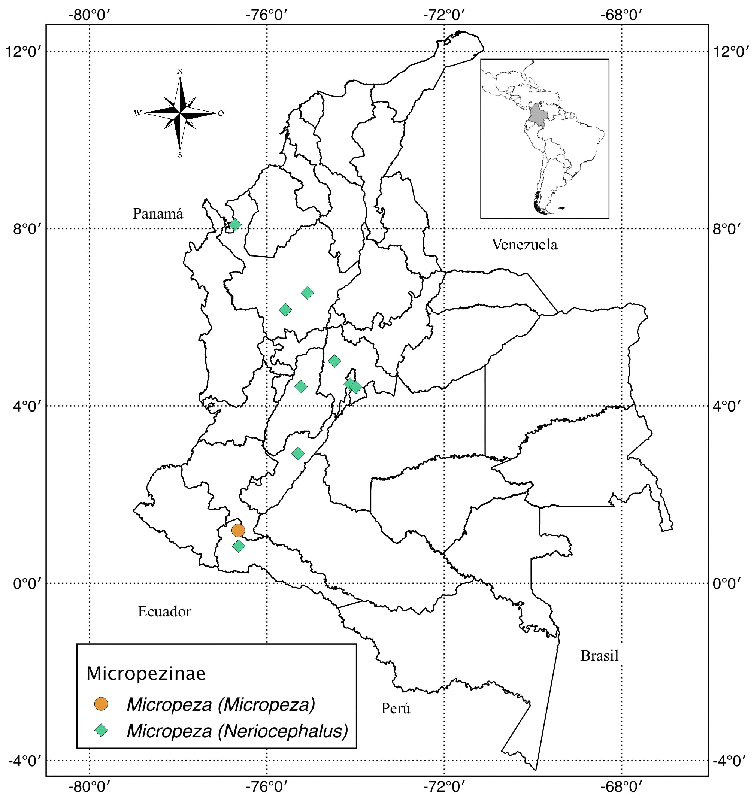
Figure 3. Collection sites for Micropeza (Micropeza) and Micropeza (Neriocephalus) in Colombia.

Taeniapterinae

Cardiacephala Macquart, 1843
Material examined (Fig. 4): Cardiacephala sp., 1♂, COLOMBIA, Cundinamarca, Nimaima, Vda. Cañadas, N 5º 07' 35'' W 74º 23' 08'', 1,185 m alt., 30-Dic-2011, Y. Sánchez, [UNAB No. Catal. 1527].

Grallipeza Rondani, 1850
Material examined (Fig. 4): Grallipeza sp., 1♀, COLOMBIA, Putumayo, Mocoa, Vda. Pueblo Viejo, Fca. Villa Loca, N 1º 11' W 76º 38', 700 m alt., 5-Mar-2015, M. Mendoza, [UNAB No. Catal. 1539].

Grallomyia Rondani, 1850
Material examined (Fig. 4): Grallomyiasp., 1♀, COLOMBIA, Bolivar, Cantagallo, Vda. La Feria, N 7º 22' W 73º 55', 60 m alt., 25-Jul-2011, J. Santa, [UNAB No. Catal. 1525]; 1♂, Putumayo, Villagarzon , Vda. San Fidel, Fca. La Cuca, N 0º 50' 14.9'' W 76º 38' 5.9'', 352 m alt., 27-Mar-2015, C. Triviño, [UNAB No. Catal. 1525]; 1♂, Quindio, Quimbaya, Fca. Ramada, N 4º 35' 37.7'' W 75º 49' 60.6'', 1,322 m alt., 16-Jun-2006, C. Delgado, [UNAB No. Catal. 1525]; 1♀, Valle del Cauca, Caicedonia, Club de Caza y Pesca, N 4º 20' 0'' W 75º 48' 0'', 1,320 m alt., 22-jul-2011, D. Rendon, [UNAB No. Catal. 1525].
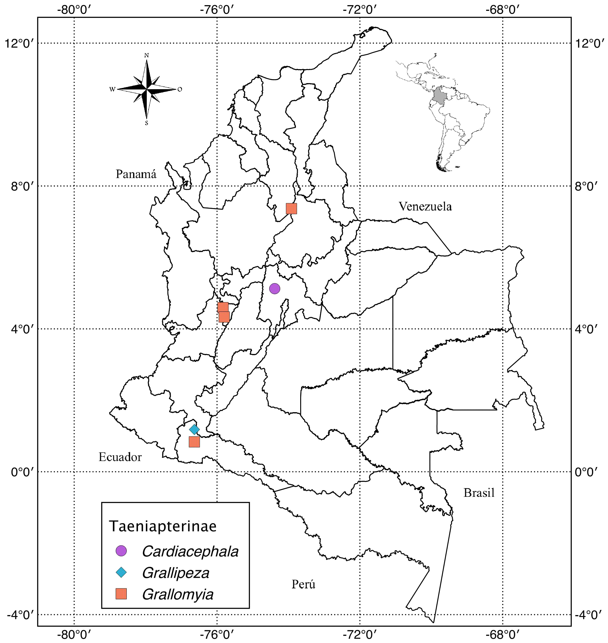
Figure 4. Collection sites for Cardiacephala, Grallipeza and Grallomyia) in Colombia.

Mesoconius Enderlein, 1922
Material examined (Fig. 5): Mesoconiussp., 1♀, COLOMBIA, Antioquia, Santa Barbara, Cgto. Versalles, Fca. Los Naranjos, N 5º 55' 60'' W 75º 34' 00'', 1,800 m alt., 15-Abr-2012, O. Ortiz, [UNAB No. Catal. 1540]; 1♂, Antioquia, Santa Rosa de Osos, N 6º 38' W 75º 27', 2,550 m alt., Dic-1989, F. Serna, [UNAB No. Catal. 1528].

Plocoscelus Enderlein, 1922
Material examined (Fig. 5): Plocoscelus sp., 4♀♀, COLOMBIA, Caqueta, Florencia, Vda. La Viciosa, Centro de Investigaciones Amazonicas Macagual, N 1º 29' 59'' W 75º 39' 47'', 257 m alt., 25-Oct-2014, M. Bermúdez, [UNAB No. Catal. 1523]; 2♀♀, Cundinamarca, Pacho, Vda. La Cabrera, N 5º 07' W 74º 09', 1,800 m alt., 22-Mar-2003, M. Murcia; C. Cortés, [UNAB No. Catal. 1523]; 1♀, Cundinamarca, Sasaima, Vda. Santa Ines, N 4º 54' 46'' W 74º 25' 09'', 1,740 m alt., 10-Abr-2011, I. Gomez, [UNAB No. Catal. 1523]; 1♀, Nariño, La Florida, Vda. Picacho, Fca. San Antonio, N 1º 20' W 77º 26', 1,646 m alt., 11-Jul-2013, L. Guerrero, [UNAB No. Catal. 1523]; 1♀, Putumayo, Orito, Vda. El Yarumo, Fca. El Limonar, N 0º 39' 26.7'' W 76º 47' 24'', 325 m alt., 26-Mar-2015, W. Sierra, [UNAB No. Catal. 1523]; 1♀, Valle del Cauca, Buenaventura, N 3º 53' 47'' W 77º 04' 40'', 7 m alt., 26-Sep-1999, S. Restrepo, [UNAB No. Catal. 1537].

Poecilotylus Hennig, 1934
Material examined (Fig. 5): Poecilotylus sp., 1♂, COLOMBIA, Antioquia, Carepa, Tulenapa, N 7º 46' W 76º 40', 25 m alt., 1-Abr-2014, M. Sierra, [UNAB No. Catal. 1522]; 1♂, Antioquia, Carepa, Fca. Tulenapa, N 7º 46' W 76º 40', 51 m alt., 31-Mar-2014, L. Hernández, [UNAB No. Catal. 1522]; 1♀, Antioquia, Santa Fe de Antioquia, Hda. Cotove, UNAL, N 6º 31' W 75º 49', 504 m alt., 6-Oct-2000, A. Botero; A. Gutiérrez; L. Arias; J. Guevara, [UNAB No. Catal. 1522]; 1, Antioquia, Santafe de Antioquia, Finca Cotove, Universidad Nacional de Colombia, N 6° 33' 31' W 75° 49' 32'', 600 m alt., 6-Oct-2000, L. Arias, [UNAB No. Catal. 2286]; 1♀, Cundinamarca, Anapoima, N 4º 32' W 74º 32', 710 m alt., 21-Abr-2012, M. Ramírez, [UNAB No. Catal. 1522]; 1♂, Cundinamarca, Guaduas, Sector San Jose, N 5º 4' W 74º 36', 992 m alt., 28-Mar-2014, L. Daza, [UNAB No. Catal. 1522]; 1♀, Cundinamarca, Guaduas, N 5º 04' W 74º 36', 1,016 m alt., 28-Mar-2014, J. Rojas, [UNAB No. Catal. 1522]; 1♂, Cundinamarca, Guaduas, Regional 50, N 5º 04' W 74º 35', 983 m alt., 28-Mar-2014, J. Velásquez, [UNAB No. Catal. 1522]; 1♂, Huila, Neiva, Melecon el Mohan, N 2º 55' W 75º 17', 475 m alt., 19-Mar-2015, P. Villamarin, [UNAB No. Catal. 1522]; 1♀, Meta, Vista Hermosa, N 3º 08' W 74º 45', 460 m alt., Mar-1997, V. Sánchez, [UNAB No. Catal. 1522]; 1♂, Putumayo, Puerto Asis, Vda. Nariño Nariño, Fca. Agua Negra, N 0º 29' W 76º 24', 273 m alt., 25-Mar-2015, P. Villamarin, [UNAB No. Catal. 1536]; 1♂, Putumayo, Puerto Asís, Vda. Nariño Nariño, Fca. Agua Negra, N 0º 29' 10.9'' W 76º 24' 23.6'', 273 m alt., 25-Mar-2015, S. Rodríguez, [UNAB No. Catal. 1536]; 1♀, Putumayo, Villagarzon, Vda. San Fidel, Fca. La Cuca, N 0º 50' 14.9'' W 76º 38' 5.9'', 352 m alt., 27-Mar-2015, J. García, [UNAB No. Catal. 1536].

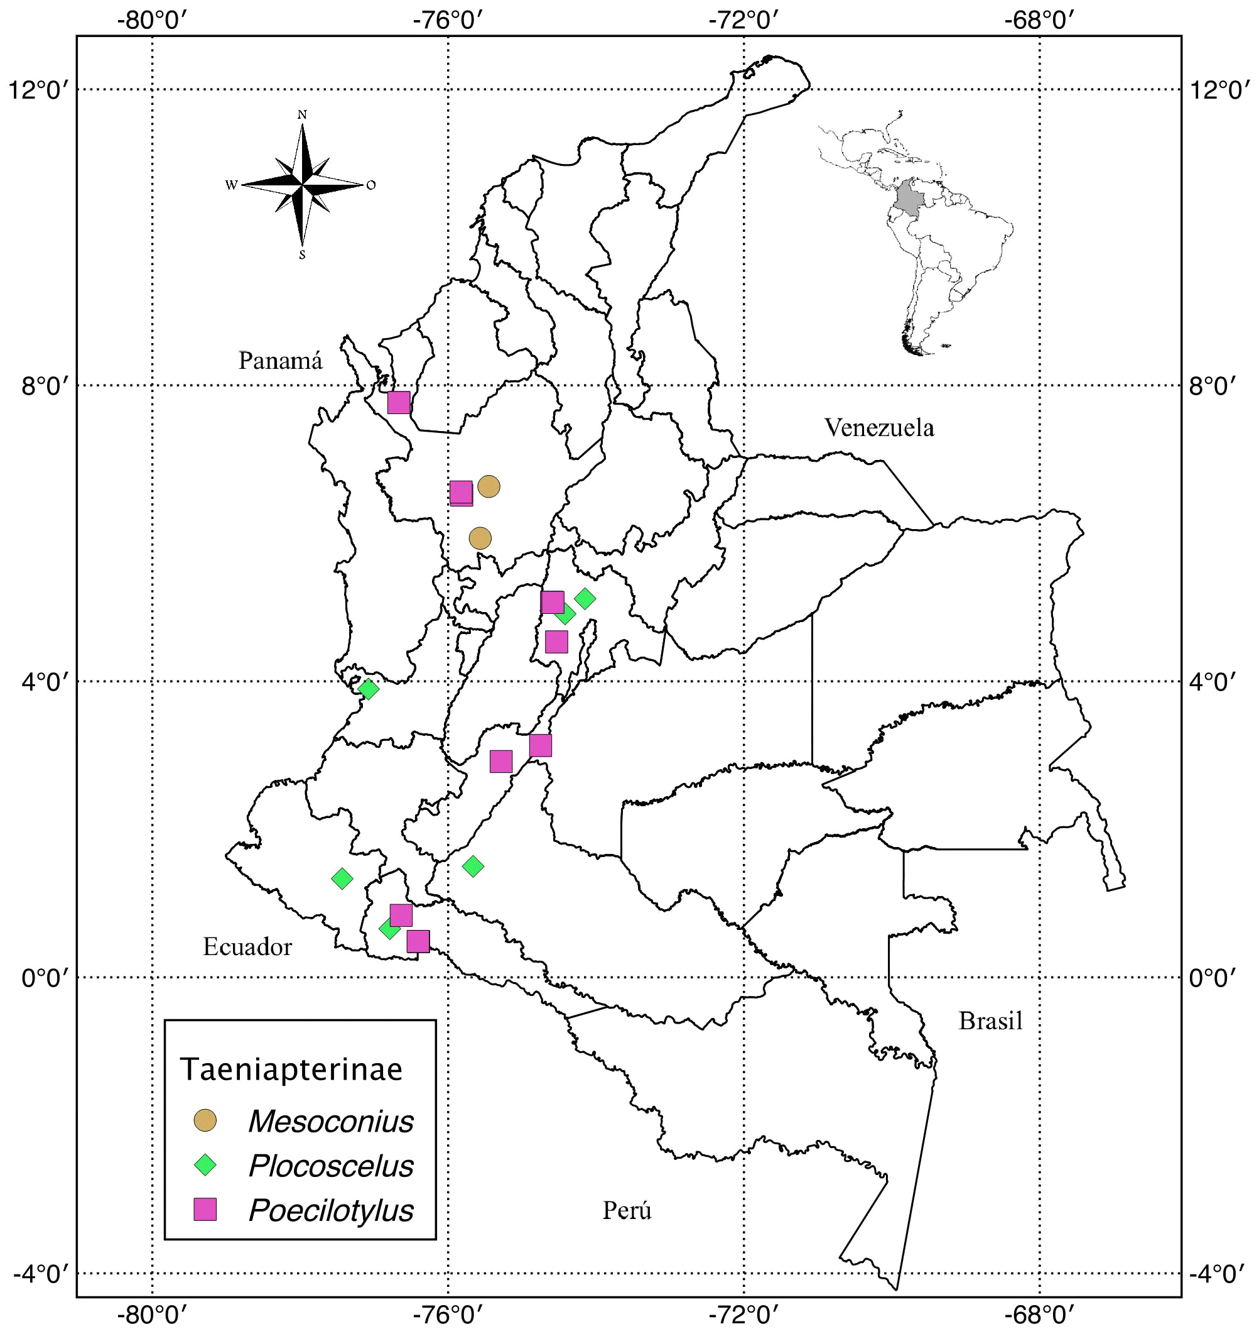
Figure 5. Collection sites for Mesoconius, Plocoscelus and Poecilotylus in Colombia.

Ptilosphen Enderlein, 1922
Material examined (Fig. 6): Ptilosphen sp., 1♀, COLOMBIA, Antioquia, Amaga, N 6° 1' 44.2842" W 75° 41' 38.6592", 1,570 m alt., 23-Nov-2012, J.M. Perilla, [UNAB No. Catal. 1524]; 1♀, Cundinamarca, Cachipay, Barrio El Progreso, N 4º 43' 52.15'' W 74º 26' 12.22'', 1,600 m alt., 20-May-2010, G. Poveda, [UNAB No. Catal. 1524]; 1♀, Cundinamarca, La Vega, Cgto. El Vino, N 4º 54' W 74º 18', 2,541 m alt., 30-Sep-2011, J. Cante, [UNAB No. Catal. 1524]; 1♀, Cundinamarca, San Antonio del Tequendama, Vda. Quebrada Grande, N 4º 37' W 74º 21', 1,540 m alt., 13-May-2012, A. Mayorga, [UNAB No. Catal. 1524]; 1♀, Cundinamarca, San Francisco, Vda. San Miguel, N 4º 59' W 74º 16', 1,673 m alt., 8-Abr-2004, S. Flórez, [UNAB No. Catal. 1524]; 1♂, Cundinamarca, Sasaima, N 4º 57' W 74º 26', 1,186 m alt., 22-Abr-2000, I. Gamboa, [UNAB No. Catal. 1538]; 1♂, Huila, San Agustín, Alrededores Parque Arqueologico San Agustin, N 1º 52' W 76º 16', 1,725 m alt., 24-Sep-2014, S. Rodríguez, [UNAB No. Catal. 1538]; 1♀, Meta, Cumaral, N 4º 16' W 73º 28', 565 m alt., 25-Sep-2004, G. Tinoco, [UNAB No. Catal. 1524]; 1♀, Meta, San Martin, La Pascualera, N 3º 46' W 73º 39', 379 m alt., 7-Abr-2004, F. López, [UNAB No. Catal. 1524]; 1♀, Meta, Villavicencio, Bosque de Bavaria, N 04º 10' 37.49'' W 73º 38' 56.59'', 467 m alt., 14-Abr-2012, J. Combita, [UNAB No. Catal. 1524]; 1♀, Meta, Villavicencio, Bosque de Bavaria, Antigua, N 04º 10' W 73º 39', 594 m alt., 14-Abr-2012, R. Delvalle, [UNAB No. Catal. 1524]; 1♀, Tolima, Piedras, Hda. El Chaco, N 4º 33' W 74º 53', 426 m alt., 30-Sep-2011, D. Páez, [UNAB No. Catal. 1524]; 1♂, Valle del Cauca, Palmira, N 3º 32' 5'' W 76º 17' 44'', 1001 m alt., 30-May-2012, A. Arévalo, [UNAB No. Catal. 1524].

Scipopus Enderlein, 1922
Material examined (Fig. 6): Scipopus sp., 1♂, COLOMBIA, Antioquia, Carepa, Fca. Tulenapa, N 7º 46' W 76º 39', 2 m alt., 31-Mar-2014, P. Bermeo, [UNAB No. Catal. 1520]; 1♀, Antioquia, Carepa, Fca. Tulenapa, N 7º 46' W 76º 40', 51 m alt., 31-Mar-2014, L. Hernández, [UNAB No. Catal. 1520]; 1♂, Antioquia, Carepa, Hda. Tulenapa, N 7º 46' W 76º 39', 27 m alt., 31-Mar-2014, S. Quevedo, [UNAB No. Catal. 1520]; 1♂, Antioquia, Carepa, Hda. Tulenapa, N 7º 46' W 76º 39', 27 m alt., 31-Mar-2014, S. Vergara, [UNAB No. Catal. 1520]; 1♂, Antioquia, San Luis, N 6º 02' W 74º 59', 1050 m alt., Ene-1986, F. Serna, [UNAB No. Catal. 1520].

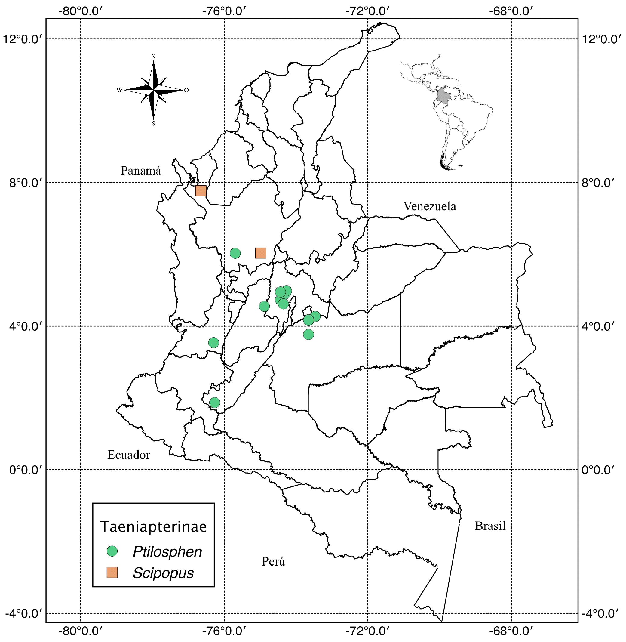
Figure 6. Collection sites for Ptilosphen and Scipopus in Colombia.

Paragrallomyia Hendel, 1933
Material examined (Fig. 7): Paragrallomyia sp., 1♂, COLOMBIA, Antioquia, Yolombó, Vda. Sabanitas, Fca. San Bartolo-La Esperanza, N 6º 33' 13'' W 75º 05' 7.1'', 1,500 m alt., 5-9-Ene-2010, E. Vergara, F. Serna, [UNAB No. Catal. 1521]; 2♂♂, Caqueta, Florencia, Vda. La Viciosa, Centro de Investigaciones Amazonicas Macagual, N 1º 29' 59'' W 75º 39' 47'', 257 m alt., 25-Oct-2014, M. Bermúdez, [UNAB No. Catal. 1521]; 2♀♀, Caqueta, San Vicente del Caguan, Vda. Palestro, Fca. El Limonar, N 2º 7' 11.90'' W 74º 45' 0.82'', 270 m alt., 9-Sep-2014, J. Martínez, [UNAB No. Catal. 1521]; 1♂, Cundinamarca, Bogota, Universidad Nacional de Colombia, N 4º 36' 56'' W 74º 04' 51'', 2,599 m alt., 24-Nov-2003, A. Molano, [UNAB No. Catal. 1521]; 1♂, Cundinamarca, Caparrapi, Huerta casera zona rural, N 5º 21' W 74º 30', 1,250 m alt., 29-Ene-2011, L. Rojas, [UNAB No. Catal. 1521]; 1♀, Cundinamarca, San Francisco de Sales, N 4º 52' W 74º 32', 152 m alt., 13-May-2011, L. Gomez, [UNAB No. Catal. 1521]; 1♀, Cundinamarca, Tibacuy, N 4º 20' W 74º 27', 1,633 m alt., 17-May-1997, Y. Reyes, [UNAB No. Catal. 1521]; 1♀, Cundinamarca, Villeta, N 5º 0' 29'' W 74º 28' 23'', 820 m alt., 16-May-2010, F. Padilla, [UNAB No. Catal. 1521]; 1♀, Cundinamarca, Villeta, N 5º 00' 29'' W 74º 28' 23'', 820 m alt., 16-May-2010, P. Pereira, [UNAB No. Catal. 1521]; 1♂, Cundinamarca, Villeta, N 5º 01' 09'' W 74º 28' 03'', 850 m alt., 16-May-2010, L. Lozano, [UNAB No. Catal. 1521]; 1♂, Huila, Neiva, Vda. Bajo Bejucal, N 2º 59' 55'' W 75º 18' 16'', 440 m alt., 18-23-Jul-2011, S. Castro, [UNAB No. Catal. 1521]; 1♀, Meta, Acacias, Vda. Santa Rosa, Hda. Mejorana, N 3º 59' W 73º 45', 498 m alt., 22-24-Sep-2000, UNAB, [UNAB No. Catal. 1521]; 1♂, Meta, Cubarral, Km. 8 via Cubarral-Villavicencio, N 3º 47' W 73º 46', 495 m alt., 16-Abr-2014, M. Sierra, [UNAB No. Catal. 1521]; 1♂, Meta, Villavicencio, Vda. La Llanerita, Fca. Villa Franca de Oria, N 4º 05' 38.01'' W 73º 11' 22.09'', 306 m alt., 9-Oct-2011, L. Ojeda, [UNAB No. Catal. 1521]; 2♀♀, Meta, Villavicencio, Vda. Buenos Aires, Fca. La Esmeralda, N 4º 7' 56.85'' W 73º 39', 561 m alt., 17-Ago-2014, S. Rodríguez, [UNAB No. Catal. 1521]; 1♀, Putumayo, Orito, Vda. El Yarumo, km 35 via Fca. El Limonar, N 0º 39' 26.7'' W 76º 47' 24.1'', 325 m alt., 26-Mar-2015, J. García, [UNAB No. Catal. 1521]; 1♂, Putumayo, Puerto Asís, Vda. Brisas de Hong Kong, Fca. La Y, N 0º 28' 55.6'' W 76º 30' 17.7'', 270 m alt., 25-Mar-2015, B. Blanco, [UNAB No. Catal. 1521]; 1♀, Tolima, Ibague, La Esperanza, N 4º 26' W 75º 18', 1,000 m alt., 18-Nov-2003, O. Guataquira, [UNAB No. Catal. 1521]; 1♀, Tolima, Mariquita, N 5º 11' W 74º 53', 495 m alt., 16-Sep-1976, N. Montoya, [UNAB No. Catal. 1521]; 1♀, Tolima, Melgar, N 4º 12' W 74º 39', 323 m alt., 16-May-2012, A. Ariza, [UNAB No. Catal. 1521]; 1♀, Valle del Cauca, Buenaventura, N 3º 53' 47'' W 77º 04' 40'', 7 m alt., 26-Sep-1999, S. Restrepo, [UNAB No. Catal. 1521].

Taeniaptera Macquart, 1835
Material examined (Fig. 7): Taeniaptera sp., 1♂, COLOMBIA, Antioquia, Carepa, Fca. Tulenapa, N 7º 46' W 76º 39', 40 m alt., 30-Mar-2014, J. Velásquez, [UNAB No. Catal. 1521]; 1♂, Antioquia, Medellin, Pueblito Paisa, N 6º 14' W 75º 34', 1552 m alt., Jul-2011, A. Prieto; C. Prieto, [UNAB No. Catal. 1526]; 2♂♂, Caqueta, Florencia, Vda. La Viciosa, Centro de Investigaciones Amazonicas Macagual, N 1º 29' 59'' W 75º 39' 47'', 257 m alt., 25-Oct-2014, M. Bermúdez, [UNAB No. Catal. 1521]; 1♀, Cundinamarca, Bogota, Universidad Nacional, Facultad de Biología, N 4º 38' 25'' W 74º 4' 24'', 2,558 m alt., 21-May-2010, O. García, [UNAB No. Catal. 1526]; 1♂, Cundinamarca, Choachi, N 4º 31' W 73º 55', 1,923 m alt., 18-May-1996, G. Ascencio; C. Álverez, [UNAB No. Catal. 1526]; 1♂, Cundinamarca, Fusagasuga, N 4º 20' W 74º 21', 1,728 m alt., 8-May-2010, J. Díaz, [UNAB No. Catal. 1521]; 1♂, Cundinamarca, Guayabal de Síquima, Casco urbano, N 4º 52' 57.88'' W 74º 28' 0.85'', 1,624 m alt., 5-Mar-2011, D. Lopez, [UNAB No. Catal. 1526]; 1♀, Cundinamarca, San Francisco de Sales, N 4º 58' W 74º 17', 1,520 m alt., 2-Jun-1997, X. Medina, [UNAB No. Catal. 1526]; 1♀, Cundinamarca, Sasaima, Vda. Santa Ana, N 4° 57' 59" W 76° 26' 15", 1,221 m alt., 31-Ene-1998, V. Bernal; K Turriago, [UNAB No. Catal. 2292]; 1♀, Cundinamarca, Silvania, Km 47 vía Bogota Fusagasuga, N 4º 24' W 74º 23' , 1,470 m alt., 6-May-2010, E. Avellaneda, [UNAB No. Catal. 1526]; 1♂, Cundinamarca, Ubala, Vda. Betania, N 4º 44' W 73º 32', 1,900 m alt., 12-Oct-2003, O. Guataquira, [UNAB No. Catal. 1526]; 1♂, Cundinamarca, Zipacon, Vda. Laguna Verde, N 4º 43' W 74º 25', 1,600 m alt., 21-Feb-1998, V. Bernal; K. Turriago, [UNAB No. Catal. 1526]; 1♀, Meta, Guamal, Vda. Orotoy, via Guamal carretera antigua, N 3º 54' W 73º 48', 610 m alt., 16-May-2010, L. Boyaca, [UNAB No. Catal. 1526]; 1♂, Risaralda, Pereira, Fca. Calamar, N 4º 48' W 75º 41', 1,411 m alt., 28-May-1999, C. Forero, [UNAB No. Catal. 1526]; 1♂, Valle del Cauca, La Union, N 4º 32' W 76º 06', 975 m alt., 18-Nov-1999, S. Restrepo, [UNAB No. Catal. 1526]; 1♂, Valle del Cauca, La Unión, Grajales, N 4º 32' W 76º 06', 975 m alt., 16-Oct-2003, P. Rodriguez, [UNAB No. Catal. 1526].

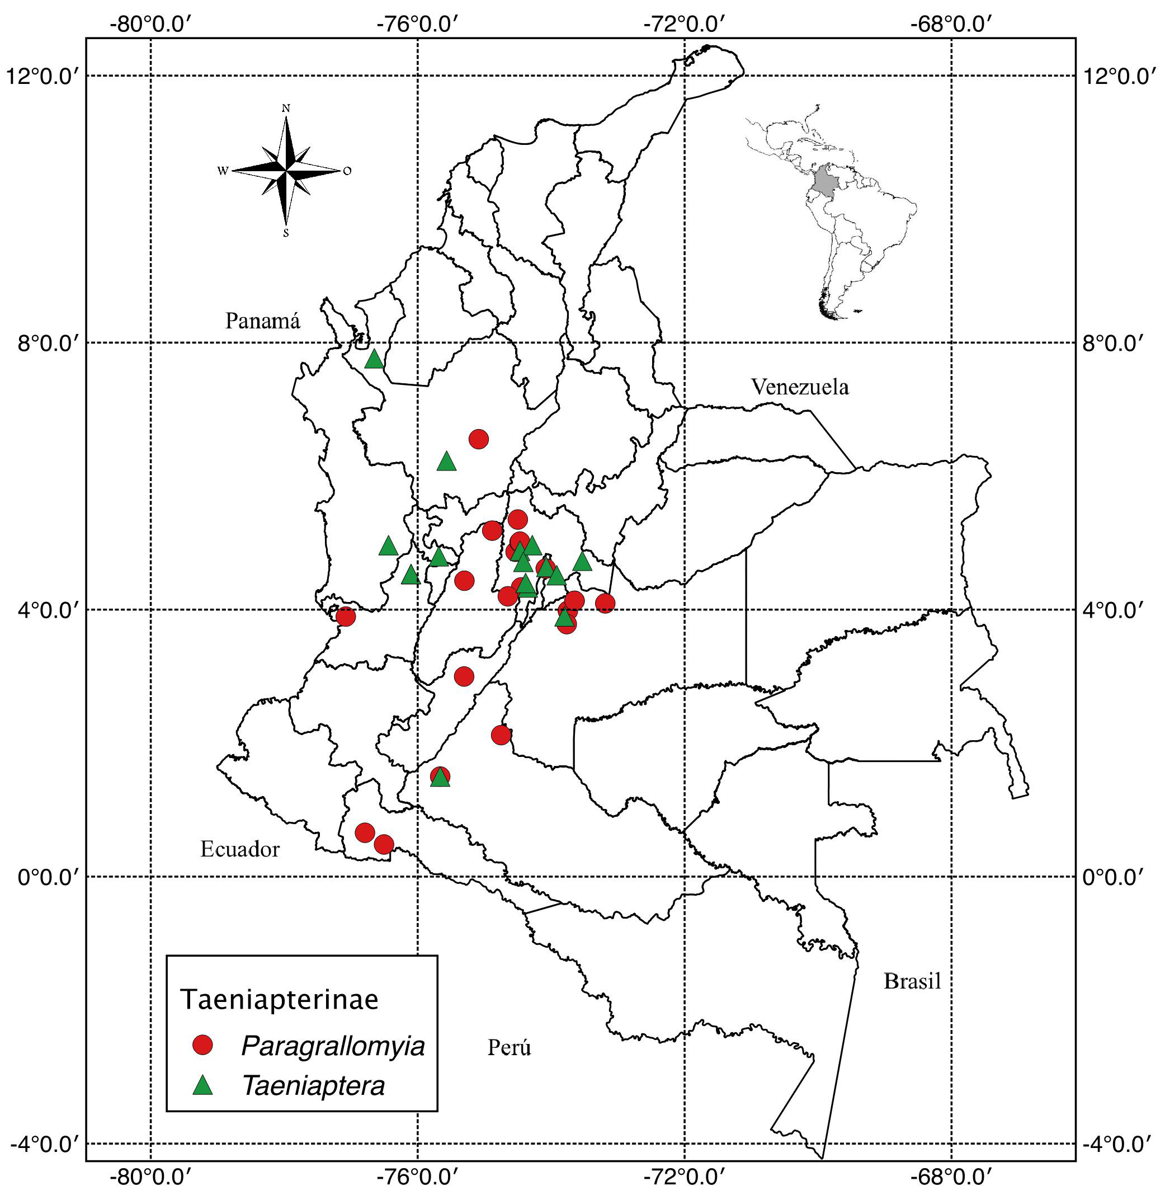
Figure 7. Collection sites for Paragrallomyia and Taeniaptera in Colombia.

Taeniaptera and Paragrallomyia

Taeniaptera sensu Steyskal (1966) used to be considered the largest and, taxonomically, one of the most complex genus in the Taeniapterinae subfamily. At the UNAB Museum, Taeniaptera Taeniaptera sensu Steyskal (1966) was represented by 39 specimens from 30 municipalities and nine departments. However, very recently, Jackson et al. (2105) proposed a reclassification of the Taeniapterinae subfamily, raising Paragrallomyia to the genus level and including within it many species that were previously considered as part of Taeniaptera sensu lato. Therefore, Taeniaptera is currently represented in UNAB by 16 specimens from the following departments: Antioquia, Caqueta, Cundinamarca, Meta, Risaralda, and Valle del Cauca, whereas Paragrallomyia is now the best represented genus at this Museum, containing 23 specimens from 18 municipalities from the departments of Antioquia, Caquetá, Cundinamarca, Huila, Meta, Putumayo, Tolima, and Valle del Cauca.

To identify the Paragrallomyia genus, Jackson et al. (2105) considered the following combination of morphological characteristics: maxillarpalp maxilar securiform, R₄₊₅ cellopen at the margin of the wing, and having at least one dorsocentral seta (Fig. 8).

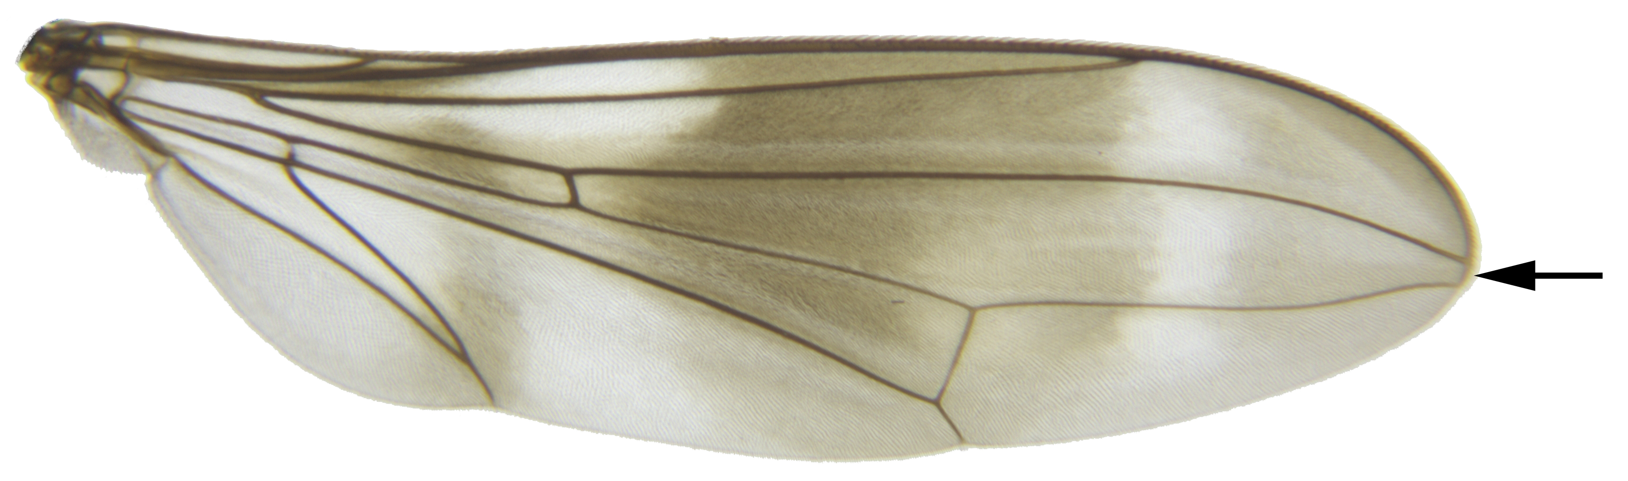A
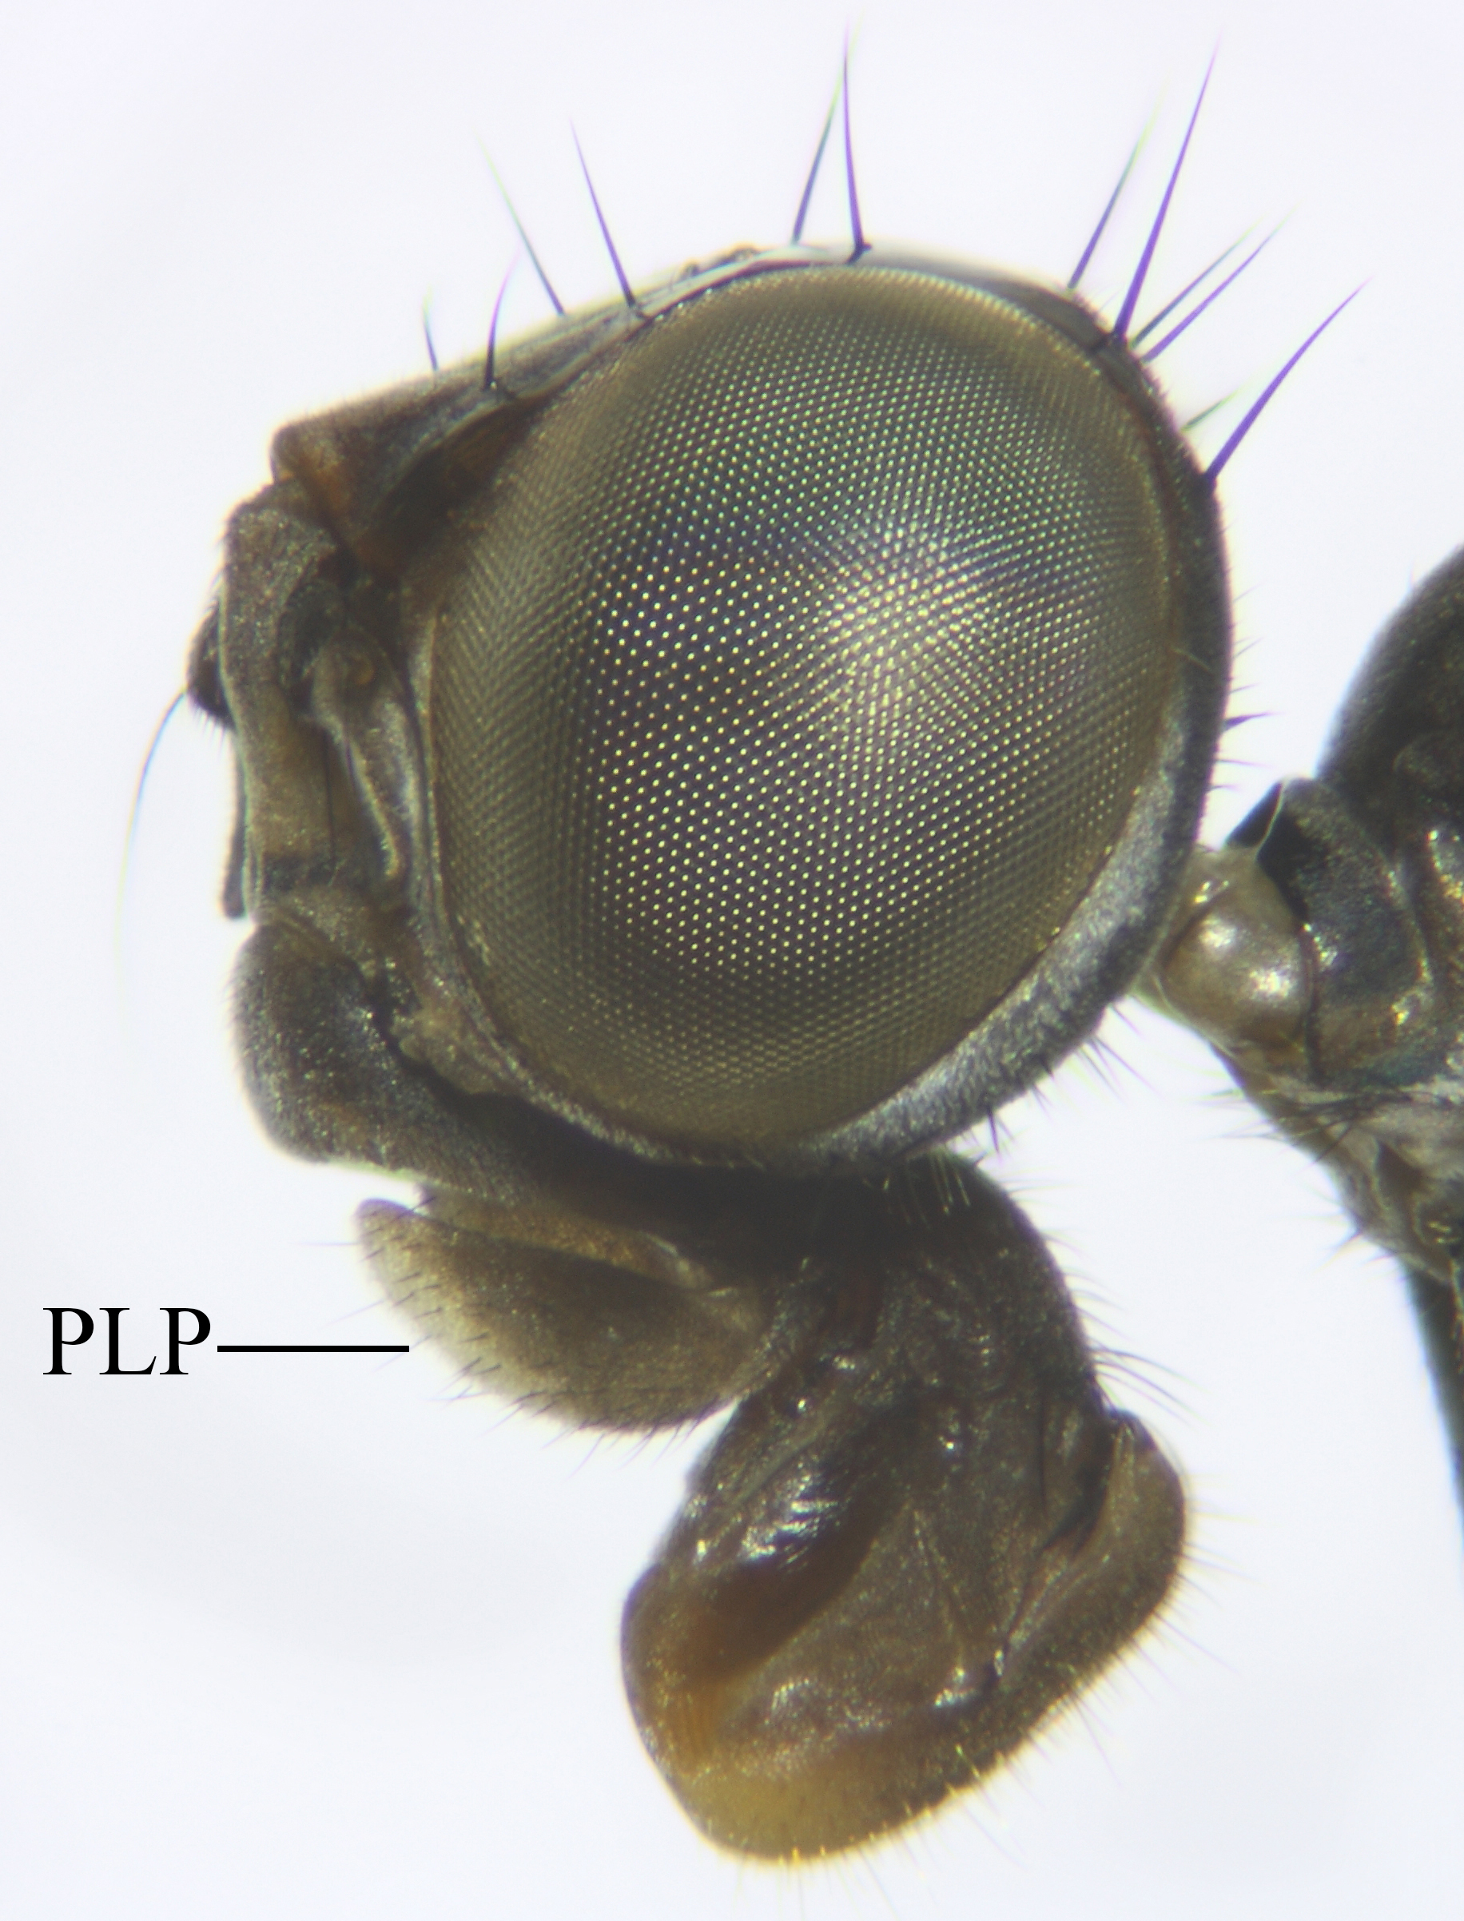B | 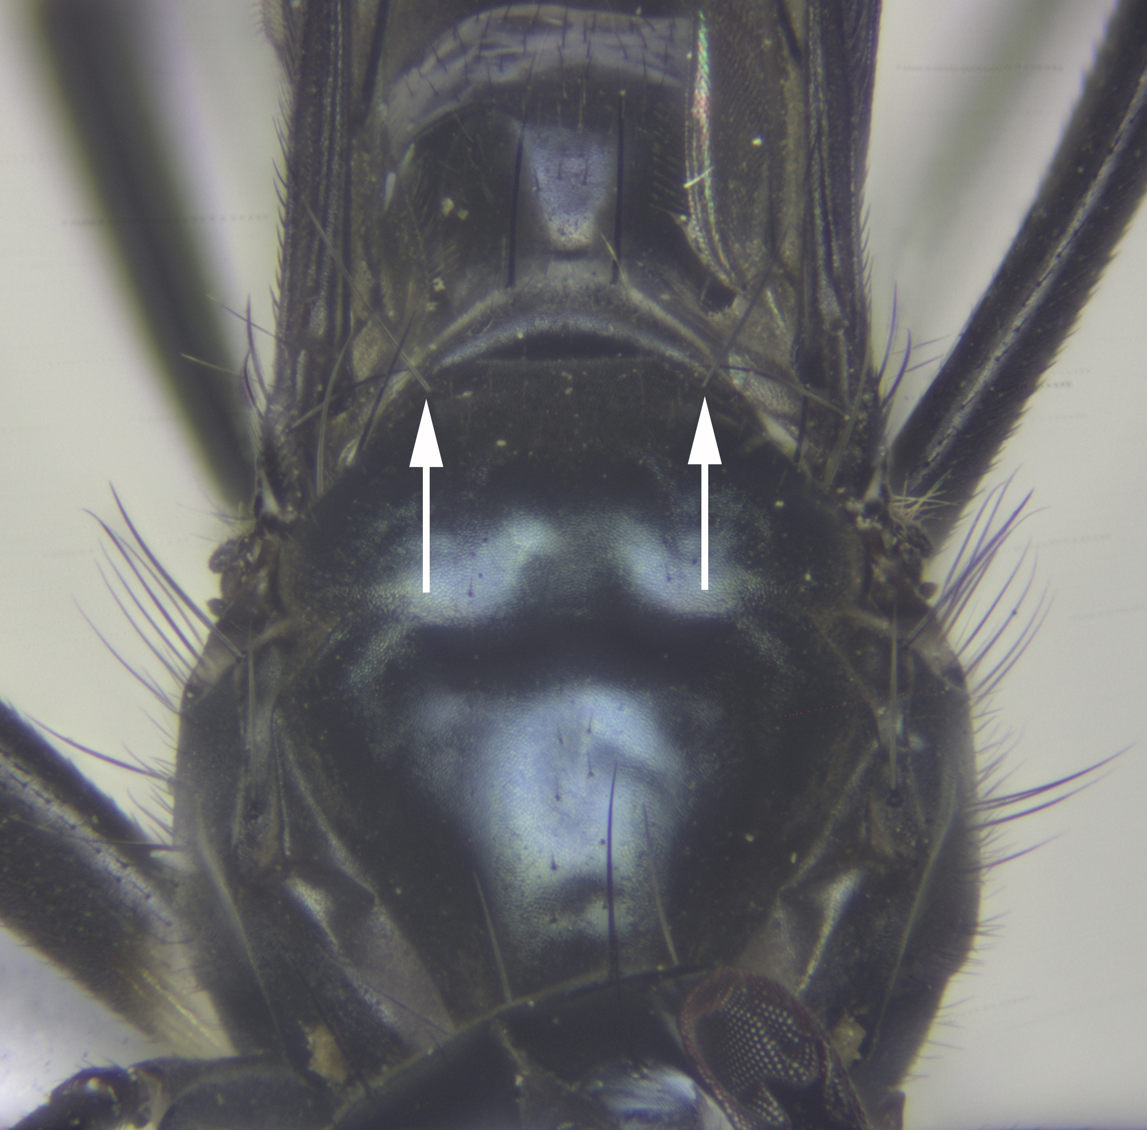C
Figure 8. Morphological characteristics used to recognize Paragrallomyia sensu Jackson et al. (2105). A. wing, the arrow indicates a R₄₊₅ cell open at the wing margin. B. Lateral Head view, showing a securiformpalp (PLP). C. Mesonotum dorsal view, arrows pointing out two dorsocentral setae.

Our results represent an approach to the geographical distribution of Micropezidae in Colombia and will aid studies involving taxonomy, biodiversity, ecology and conservation in Colombia and the Neotropics.

Acknowledgements
The authors thank the UNAB (Universidad Nacional de Colombia, Bogotá) Entomological Museum for providing the necessary tools for the identification of specimens and for the curatorial process. Colciencias and Universidad Nacional sponsored the first author for his doctorate under the Doctoral Training Program in Colombia.

Literature cited
Ferro, G.B. and C.J.B. Carvalho. 2014. A pictorial key and diagnosis of the Brazilian genera of Micropezidae (Diptera, Nerioidea). Rev. Bras. Entomol. 58, 52-62. Doi: 10.1590/S0085-56262014000100009

Harterreiten-Souza, E.S., E.R. Sujii, and J.R. Pujol-Luz. 2014. A new species of the genus Micropeza Meigen (Diptera: Micropezidae) from Brazil. Zootaxa 3827, 392-396. Doi: 10.11646/zootaxa.3827.3.9

Jackson, M.D., S.A. Marshall, and J.H. Skevington. 2015. Molecular phylogeny of the Taeniapterini (Diptera: Micropezidae) using nuclear and mitochondrial DNA, with a reclassification of the genus Taeniaptera Macquart. Insect Syst. Evol. 46, 411-430. Doi: 10.1163/1876312X-45032125

Marshall, S.A. 2004. A review of the genus Metasphen Frey including Globomyia Hennig syn. nov. (Diptera, Micropezidae). Stud. Dipterol. 11, 529-536.

Marshall, S.A. 2010. Micropezidae (stilt-legged flies). pp. 805-813. In: Brown, B.V., A. Borkent, J.M. Cumming, D.M. Wood, N.E. Woodley, and M. Zumbado (eds.). Manual of Central American Diptera. Vol. 2. NRC Research Press, Ottawa.

Marshall, S.A. 2011. A review of the genus Hoplocheiloma Cresson (Diptera: Micropezidae). Zootaxa 2806, 1-23.

Marshall, S.A. 2012. Flies: the natural history and diversity of Diptera. Firefly Books. Richmond Hill, Canada.

Marshall, S.A. 2013. Grallipeza Rondani (Diptera: Micropezidae: Taeniapterinae) of the Caribbean and North America. Zootaxa 3682, 45-84.

Marshall, S.A. 2015. Mesoconius Enderlein (Diptera, Micropezidae, Taeniapterinae) of Central America. Zootaxa 3914, 525-540. Doi: 10.11646/zootaxa.3914.5.2

Merritt, R.W. and M.T. James. 1973. The Micropezidae of California (Diptera). Bull. Calif. Insect Surv. 14, 1-27.

Merritt, R.W. and B.V. Peterson. 1976. A synopsis of the Micropezidae (Diptera) of Canada and Alaska, with descriptions of four new species. Can J. Zool. 54, 1488-1506. Doi: 10.1139/z76-172

QGIS Development Team. 2015. QGIS Geographic Information System. In: Open Source Geospatial Foundation Project: http://qgis.osgeo.org; consulted: April, 2015.

Steyskal, G.C. 1966. Family Micropezidae pp. 48.1-48.33. In: Vanzolini, P.E. and N. Papavero (eds.). A catalogue of the Diptera of the Americas South of the United States. Departamento de Zoologia, Secretaria da Agricultura do Estado de São Paulo, São Paulo, Brazil.

Steyskal, G.C. 1987. Micropezidae. pp. 761-767. In: McAlpine, J.F. (ed.) Manual of Neartic Diptera. Vol. 2. Monograph No. 28. Biosystematics Research Centre, Agriculture Canada, Otawa.

