Characterization of a Mutant Bacillus thuringiensis δ−endotoxin With Enhanced Stability and Toxicity

Syed−Rehan A. Hussain,, Álvaro M. Flórez , Cristina Osorio, Donald H. Dean^{1,5}, Óscar Alzate^{4,,,}*
(Verificar si los nombres deben quedar referenciados con números o con asteriscos a pie de página como en otros artículos)
Summary
The centrally located α−helix 5 of Bacillus thuringiensis δ−endotoxins is critical for insect toxicity through ion-channel formation. We analyzed the role of the highly conserved residue Histidine 168 (H168) using molecular biology, electrophysiology and biophysical techniques. Toxin H168R was ~3-fold more toxic than the wild type (wt) protein whereas H168Q was 3 times less toxic against Manduca sexta. Spectroscopic analysis revealed that the H168Q and H168R mutations did not produce gross structural alterations, and that H168R (T_{m}= 59 °C) was more stable than H168Q (T_{m}= 57.5 °C) or than the wt (T_{m}= 56 °C) toxins. These three toxins had similar binding affinities for larval midgut vesicles (K_{com}) suggesting that the differences in toxicity did not result from changes in initial receptor binding. Dissociation binding assays and voltage clamping analysis suggest that the reduced toxicity of the H168Q toxin may result from reduced insertion and/or ion channel formation. In contrast, the H168R toxin had a greater inhibition of the short circuit current than the wt toxin and an increased rate of irreversible binding (k_{obs}), consistent with its lower LC₅₀ value. Molecular modeling analysis suggested that both the H168Q and H168R toxins could form additional hydrogen bonds that could account for their greater thermal stability. In addition to this, it is likely that H168R has an extra positive charge exposed to the surface which could increase its rate of insertion into susceptible membranes.

Key words: α-helix 5, Circular dichroism, molecular modeling, site-directed mutagenesis, thermal stability, Bacillus thuringiensis

Resumen
La α-Hélice 5 del domino I de las δ−endotoxinas de Bacillus thuringiensis, es crítica para la toxicidad de las toxinas contra insectos al participar en la formación de canales iónicos. La participación en la función tóxica del residuo Histidina 168 (H168) –el cual es altamente conservado– fue estudiada mediante técnicas de biología molecular, electrofisiología y biofísica. La toxina mutante H168R fue ~ 3 veces más tóxica que la toxina silvestre (ts) en Manduca sexta, mientras que H168Q fue 3 veces menos tóxica. Los análisis espectroscópicos indicaron que las mutaciones no producen alteraciones estructurales significativas y que la toxina H168R (T_{m}= 59 °C) es más estable que las toxinas H168Q (T_{m}= 57.5 °C) y wt (T_{m}= 56 °C). Las tres toxinas exhibieron uniones de afinidad similares (K_{com}) en vesículas de intestino de larvas de insecto, indicando que las diferencias en la toxicidad no se deben a cambios en la unión inicial al receptor. Los ensayos de unión/disociación y fijación de voltaje mostraron que la reducción de la toxicidad de la toxina H168Q se puede atribuir a una disminución en la inserción y/o en la formación de canales iónicos. De otro lado, H168R mostró una inhibición a la corriente de corto circuito mayor que la ts y un aumento en unión irreversible (k_{obs}), lo cual es consistente con un menor valor de CL₅₀. La modelación molecular sugiere que H168Q y H168R forman puentes de hidrógeno adicionales, lo que les confiere mayor estabilidad térmica. Adicionalmente, es probable que H168R tenga una carga positiva extra expuesta en la superficie, lo cual aumentaría su tasa de inserción en membranas susceptibles.

Palabras clave: α-hélice 5, dicroísmo circular, modelamiento molecular, mutagénesis sitio dirigida, estabilidad térmica, Bacillus thuringiensis

Recibido: marzo 5 de 2011
Aprobado: noviembre 30 de 2011

Introduction
Bacillus thuringiensis (Bt) is a gram-positive bacterium which forms crystalline inclusion bodies during sporulation. These inclusions are comprised of several classes of entomocidal proteins (more than 500 sequenced genes and 218 holotypes for 68 cry families) known as Bt δ-endotoxins or Cry proteins (Crickmore 2011; Sanahuja et al., 2011). These proteins are activated in the alkaline and reducing conditions of the larval midgut (Crickmore et al., 1998). The solubilized Cry1 protoxins are proteolytically processed by gut proteases (Tojo and Aizawa, 1993). The activated toxins bind with high affinity to receptors present on the microvillar membrane of susceptible insect larvae (Hofmann et al., 1998). Subsequently the toxins insert into the membrane and form non-specific pores or ion channels, causing loss of homeostasis across the brush border membrane leading to gross structural changes in the midgut and eventually death of the larvae (Arnold et al., 2001; Aronson et al., 2000; Bauer et al., 1992; Schwartz et al., 1993; reviewed in Crickmore et al., 1998).
The Bt δ-endotoxins contain five highly conserved regions adopting similar tertiary structures (Crickmore et al., 1998; Grochulski et al., 1995; Li et al., 1991; Morse et al., 1998). The amphipathic α-helical domain I is involved in membrane insertion, pore formation and ion transport (Alzate et al., 2010; Alzate et al., 2009; Alzate et al., 2006; Cummings et al., 1994; Gazit et al., 1998; Walter et al., 1993). The centrally located α-helix 5 is the most hydrophobic helix in this domain and is located on the highly conserved block 1 (Crickmore et al., 1998; Li et al., 1991; Morse et al., 1998). Point mutations in the α-helix 5 resulted in reduced toxicity with no alteration of binding to the larval midgut membrane (Ahmad and Ellar, 1990; Hussain, S-R et al., 1996; Wu et al., 1992) whereas other point mutation increased the toxicity by increasing the rate of portioning into larval midgut (Alzate et al., 2010). Several studies have argued that most mutations in α−helix residues do not affect the protein conformation in aqueous environment but it does impact conformational transition necessary for membrane insertion (Alzate et al., 2006; Girard et al., 2009; Rodríguez-Almazán et al., 2009). Furthermore, we have proposed that α−helix 5 may contribute asymmetrically to the ion-channel activity of the toxin (Alzate et al., 2009).
H168, located in the middle of the α-helix is of particular interest for the Cry1Aa toxin function because substituting H168 with Q, N, or R had different effects on toxicity. In particular, there was an increase in toxicity for M. sexta by the H168R toxin (Wu and Aronson, 1992). It was suggested that since H168 is in the middle of the hydrophobic face of α-helix it may be important for sub-unit interactions within the membrane (Aronson et al., 1999).
In this study we characterized the H168Q and H168R mutations in Cry1Ac and the effects they may have on toxicity, protein-receptor interactions and ion-transport activities. We also utilized computational techniques to investigate the potential conformational changes introduced by these mutations and their correlation with Cry1Ac function. In particular, we found that the increase in toxicity of the H168R toxin correlates with better ion conductance, greater thermal stability and faster rate of insertion into susceptible membranes. These properties could be affected by changes in the electrostatic charge in the hydrophobic face of α−helix 5. These results may be affected by electrostatic re-arrangement as suggested by molecular modeling.

Materials and Methods
Mutagenesis and Expression of Mutant Proteins: Cry1Ac mutants, H168Q and H168R, were prepared as described earlier (Hussain et al., 2010). Site directed mutagenesis was carried out according to the method of Kunkel (Kunkel, 1985). For the expression of mutant genes, a 1.3 kb NsiI-SacI fragment was subcloned into the vector pOS4201. The construction of pOS4201 and expression in E. coli has been described (Hussain et al., 2010). This vector carried the wild type cry1Ac gene and the NsiI-SacI fragment was replaced with that from the mutants. The mutant proteins H168Q and H168R were over expressed in the E. coli host strain MV1190.
Purification and Protease Digestion of Protoxin. The wild type Cry1Ac and mutant toxins were purified by the method described elsewhere (Hussain et al., 2010). After solubilization of the crystals in 50 mM sodium bicarbonate buffer (pH 9.6) supplemented with 10 mM dithiothreitol (DTT), the protoxin concentration was determined by the Coomassie protein assay reagent (Pierce, Rockford, IL) with BSA as standard. The solubilized protoxin was then converted to toxin with a trypsin/protoxin ratio of 1:30 (w/w) at 37 °C for 2h. Protoxins and toxins were analyzed by SDS-polyacrylamide gel (12.5%) electrophoresis (PAGE) as described (Laemmli, 1970). The stability of the wild type (wt) and mutant toxins to enzymatic digestion was also determined by treating with M. sexta gut juice as described (Alcantara et al, 2001).
Toxicity Assay. Bioassays on M. sexta were performed by the surface contamination method as described (Alzate et al., 2010). Briefly, three-day-old larvae were confined in 24-well sterile dishes (Falcon) containing solidified artificial diet surface-contaminated with activated toxin. Five to six toxin concentrations were prepared for each assay. Twenty M. sexta larvae were used for each concentration. Mortalities were scored after 5 days. The median lethal concentration (LC₅₀) was calculated by Probit method by using the program SoftTox (WindowChem Software, Inc.). Each assay was repeated three times after the appropriate toxic range was determined.
Preparation of Brush Border Membrane Vesicles (BBMV). The midguts were isolated from fifth instar M. sexta larvae. BBMV were prepared from these isolated midguts by the differential magnesium precipitation method (Wolfersberger et al., 1987). The BBMV were either used immediately or stored in liquid nitrogen until use. BBMV concentration was determined by measuring the amount of total membrane protein using coommassie protein assay (Pierce) with BSA as standard.
Iodination of Toxin. Activated toxins were labeled with iodine using IODO-BEADS (Pierce) as described (Alcantara et al., 2001). One mCi of Na-¹²⁵-I (Amersham) was used to label 25 μg of each toxin. After the labeling reaction, the ¹²⁵I -labeled toxin was separated using an Excellulose column (Pierce). The purity of the labeled toxins was determined by electrophoresis in 12.5% SDS-PAGE. The specific activities were determined by excising the gel fragment and counting in a gamma-counter (Beckman Instruments). The specific activities for the wild type Cry1Ac and mutant toxins ranged from 0.046 to 0.051 mCi/mg.
Competition Binding Assay. Heterologous competition assays were performed as described elsewhere (Lee et al., 1992) using 200 μg/ml of M. sexta BBMV and 1 nM of ¹²⁵I -Cry1Ac. Binding affinities (K_{com}) and binding site concentrations (B_{max}) were evaluated by simultaneous non-linear least-squares regression analysis by the LIGAND program (Munson and Rodbard, 1980). K_{com} describes the binding constant derived specifically from competition studies of Cry toxins with BBMV which involves both reversible and irreversible binding (Wu and Dean, 1996).
Dissociation assay and the rate of irreversible binding. Dissociation and irreversible binding assays were performed as described (Rajamohan et al., 1996). For dissociation assays 1 nM of ¹²⁵I -toxin and 200 μg/ml of M. sexta BBMV were used. The ¹²⁵I -toxin-BBMV mixture was incubated for 1h and then competed at different time intervals (0 – 60 min) with a 400-fold excess of unlabeled toxin. The BBMV was then centrifuged, washed, and counted in a gamma counter 4000. Irreversible binding rates were determined as follows, ¹²⁵I -toxin was incubated with M. sexta BBMV for different times (0 – 80 min) and then chased with a 400-fold excess of unlabeled toxin for 1h. BBMV was then pelleted, washed, and the radioactivity measured in a gamma counter. Each assay was repeated three times. Statistical differences between wild-type and mutant strains were assessed using a paired Student's t-test. The results were considered statistically significant when P<0.05.
Voltage Clamp Analysis. Voltage clamping was used to determine the rate of inhibition of short circuit current (I_{sc}) by wt and mutant toxins across the M. sexta midgut membrane (Alzate et al., 2009). The anterior midgut of a freshly dissected larva was mounted on an orifice (0.25 cm diameter) and inserted into the voltage clamping chamber. After stabilizing the current, 50 ng/ml of either wt or mutant toxin was added to the luminal side of the chamber. The recorded data were plotted as the percent inhibition of I_{sc} vs. time. Each assay was repeated three times. Statistical differences between wild-type and Cry1Ac toxins were assessed using a paired Student's t-test. The results were considered statistically significant when P<0.05.
Circular Dichroism Spectroscopy (CD). Activated wt and mutant toxins were purified by HPLC using a Bio-Gel/SEC30-XL (300x7.8mm) (BioRad). The toxin was eluted with pre-filtered 40mM phosphate buffer, pH6.8. CD spectra for the wild type Cry1Ac and mutant toxins, H168Q and H168R, were recorded on a Jasco J-500A spectropolarimeter. Molar ellipticity was calibrated with 26.69 mM d−10-camphorsulfonic acid. Temperature was controlled with a NESLAB operating temperature system connected to a NESLAB water bath RTE-100 and a NESLAB bath/computer interface M-RS-232. HELLMA quartz cuvettes of 1.0 cm path length (total volume 3.0 mL) were employed containing 100 μg of toxin in 10 mM sodium phosphate buffer (pH 9.5). The wavelength scanned ranged from 200 – 265 nm at room temperature. The data were transformed into molar ellipticity with the equation [θ]= 100 θ/lc (Woody, 1995). Where [θ]: is Molar Ellipticity [deg. cm². dmol⁻¹]; θ: Ellipticity (mdeg); l: cell path (cm); and c: molar concentration.
Thermal denaturation profiles of the mutant toxins as compared to the wild type toxin were followed at 223 nm with temperatures ranging from 40°C to 80°C in 2 °C increments. The data were smoothed with the program SigmaPlot (Jandel Scientific), then the fraction of denatured protein as a function of temperature was calculated using the equation f_{D}= {[θ] − [θ]_{Ν}}/{[θ]_{D} - [θ]_{Ν}} (Pace, 1986). Where [θ]: is Molar Ellipticity [deg. cm¹. dmol⁻¹]; and [θ]_{D} and [θ]_{Ν} are the values of molar ellipticity for native and denatured proteins, respectively. Each assay was repeated three times. Statistical differences between wild-type and each mutant were assessed using a paired Student's t-test. The results were considered statistically significant when P<0.05.
Molecular modeling. Molecular modeling was performed using Quanta 4.0 (Molecular Simulations, Inc.) in a Silicon Graphics Indigo (SGI) workstation. The atomic coordinates of Cry1Aa toxin (PDB code 1CIY) were used as a template to model 3-D structure of Cry1Ac. The model was used to investigate the effect of mutations on electrostatic interactions as describe (Alcantara et al., 1991).

Results
Stability and toxicity of Mutant Proteins. The wild type Cry1Ac and its mutant protoxins H168Q and H168R produced stable toxins when digested with trypsin. All of these toxins were equally resistant to treatment with diluted M. sexta gut juice (data not shown). Bioassays were performed with M. sexta larvae (table 1). The LC₅₀ values indicate that the H168R toxin is 2.5-fold more toxic than the wt (Wu and Aronson, 1992). On the other hand, the H168Q toxin was ~ 3-fold less toxic (table 1).
Competition Binding Studies. Heterologous competition binding assays were performed in order to determine whether or not the mutant toxins have altered initial binding to M. sexta BBMV. ¹²⁵I-Cry1Ac toxin was competed with unlabeled wt and mutant toxins (figure 1). The initial binding of the H168Q toxin (K_{com} = 3.65 nM) was not significantly different from that of the wt toxin (K_{com} = 2.4 nM) even though the former was less toxic for M. sexta larvae. The more toxic mutant H168R, also had a binding affinity (1.96 nM) comparable to that of the wt toxin. The concentration of binding sites (B_{max}) was also similar for the three toxins indicating that the increased toxicity of H168R against M. sexta did not result from differences in either binding affinity or the number of binding sites (table 1).
Dissociation Assay and the Rate of Irreversible Binding. Dissociation binding experiments were performed in order to determine the percentage of toxin remaining irreversibly bound to the BBMV after prolonged incubation with labeled toxin. In the presence of 400-fold excess of the corresponding unlabeled toxin, the wt and H168R toxins showed less dissociation with greater than 92% and 85%, respectively, remaining bound to the BBMV after 60 min. On the other hand, the less toxic mutant H168Q had a greater dissociation with only 68% remaining bound after 60 min (figure 2).
The rate of irreversible binding (k_{obs}) was measured to determine if the greater toxicity of the H168R toxin correlated with more rapid insertion into M. sexta BBMV (table 1). The H168R toxin had a faster insertion rate (0.29 min⁻¹) as compared to the wild type toxin (0.034 min⁻¹).
CD Spectra of Wild Type and Mutant Toxins. The spectra measured between 200 and 265 nm of the proteins showed changes in the conformations of the mutants compared to the wt protein. It is seen that the π-π∗ and the n-π∗ transitions show differences in the α-helical conformation of the proteins (figure 3). These structural changes were expected from the structural differences between residues R and Q compared to H, and also because the residue 168 is almost totally buried in the hydrophobic core of the α-helix 5, with only its tip exposed to the solvent. It is seen from the molecular modeling of Cry1Ac, displayed in figure 6, that the side chain of Q168 becomes exposed to the solvent a little more than H168 and less than R168. This disruption of the α-helical conformation may account for the observed differences in the CD spectra. However the overall spectra of the three proteins consistently showed a well organized protein (figure 3). Calculations of the α-helical, β-sheet and random coil contents in all of the proteins with the program k2D (Andrade et al., 1993) gave less than 7% variation in these tertiary structures.
Thermal CD Analysis. In order to further examine the structural stability of the mutant toxins compared to the wt toxin, each protein was exposed to temperature increases from 40 to 80°C and structural changes were monitored by CD spectroscopy (figure 4). The wild type Cry1Ac toxin and the H168Q toxin had similar melting temperatures (T_{m}) with 50% unfolded protein at 56 °C and 57.4 °C, respectively. The H168R toxin, however, had a shift in T_{m} which was 2.8 °C and 1.7 °C higher than the melting temperatures of the Cry1Ac and H168Q toxins, respectively.
Effect on the inhibition of Isc. Possible effects of the mutations on ion-conductance were examined by voltage clamp analyses with isolated midguts from M. sexta larvae. At a toxin concentration of 200 ng/ml, there was a greater inhibition of the slope of Isc with the H168R toxin (slope -32.0 μA/min/cm²) than with the wild type toxin (slope -15.2 μA/min/cm²). In contrast, the H168Q toxin caused a slower decline in I_{sc} (slope -5.42 μA/min/cm², table 1; figure 5).

Discussion
Because α-helix 5 of Bt δ-endotoxins has such a critical role in toxicity, the effects of specific mutations on the highly conserved residue H168 were extensively analyzed. It is likely that this helix serves as a transmembrane pore-lining segment and H168, being in the center of the helix, may be involved in ion channel function as well as sub-unit interactions (Gazit and Shai, 1995; Wu and Aronson, 1992; Alzate et al., 2006).
Both mutant H168R and H168Q protoxins were converted to stable, trypsin-resistant toxins. The CD spectra of the mutants showed small changes in the α-helical region; however the gross conformation of the toxin was not affected (figure 3). The helical content calculated with the program k2D, using the raw CD data, gave 29, 31 and 32% for wt, H168Q and H168R, respectivelly. Incubation of these toxins with M. sexta gut juice indicated that the mutants were as stable as the wt toxin to "in vivo" digestion conditions (data not shown). Therefore, gross structural alterations are not a likely explanation for the greater than two folds higher toxicity of the H168R toxin for M. sexta (table 1).
The mutations had no significant effect on initial binding affinities, K_{com}, for insect midgut membranes (table 1; figure 1). Studies with other Cry1A toxins have shown that mutations in domain I may have drastic effects on toxicity without altering the initial receptor binding (Wu and Aronson, 1992; Chen et al., 1995) indicating that domain I is not directly involved in the initial binding to the membrane.
Binding of toxins to BBMV also includes a second perhaps more specific irreversible binding step (Ihara et al., 1993; Liang et al., 1995). This latter step is indicative of toxin insertion into the membrane (Chen et al., 1995; Ihara et al., 1993; Van Rie et al., 1989; Wolfersberger et al., 1987). The relatively lower irreversible association of the H168Q toxin (68% bound) as compared to the wild type Cry1Ac (92%) and H168R (85%) toxins suggests a defect in insertion into the membrane of the less active H168Q toxin and may account for its lower toxicity (table 1; figure 2).
The rate of irreversible binding is another criterion for measuring the efficient insertion of toxin into the membrane. The k_{obs} value for the wild type toxin was less than that of the H168R toxin (table 1), in agreement with the 2- to 3-fold greater toxicity of the latter. The mutant H168Q had lower toxicity and weaker dissociation binding. Therefore, irreversible binding was of minor value because rate of irreversible binding was one criterion for measuring the efficient insertion of toxin. Since H168Q was already showing much less dissociation at very early time point (figure 2), rate of irreversible binding [ Kobs] would be much lower than either wild type or H168R and would not have provided any additional information regarding why it is showing lower toxicity.
Voltage clamping was done in order to compare the channel forming efficiency of the wt and mutant toxins. A two fold difference in the inhibition of I_{sc} was found (table 1) in good correlation with toxicity differences. Similarly, the three fold less toxic H168Q mutant caused a shallower drop in I_{sc} (table 1; figure 5). Therefore, differences in the properties of the ion channels can account for the toxicity differences. In addition, the mutant toxins were found to have higher thermal stability. Both the H168R and H168Q toxins had higher thermal transitions than the wt toxin (figure 4).
A molecular modeling analysis was done in order to determine the basis for the increased thermostability. There is extensive similarity in structure of the Cry3A (Li et al., 1991) and Cry1Aa toxins (Grochulski et al., 1995) despite the fact that they have different insect specificities and have only 37% sequence homology. In particular, the domains I and III are highly superimposible. Furthermore, Cry1Ac is more than 89% homologous to Cry1Aa, therefore it is considered to have similar 3-D structure. The coordinates for the crystal structure of the Cry1Aa toxin (PDB code 1CIY) were used to model the 3-D structure of Cry1Ac (figure 6A) with the computer program Quanta (Molecular Simulations Inc.) as described (Alcantara et al., 2001). Then, this model was used to investigate the effects of the R and Q substitutions on electrostatic interactions. It was found that in the wt toxin H168 forms hydrogen bonds only with the two alanine residues A164 and A165, within the α−helix 5 (figure 6B). Mutant toxin H168Q has a more extensive hydrogen bonding interaction than the wt toxin with two additional H-bonds with the highly conserved Y203 in α−helix 6 and a F in α-helix 4 (Fig. 6B). Mutant H168R, besides forming H-bonds with A164, A165 and Y203, is also likely to form a salt bridge with E136 in α−helix 4 (Fig. 6B). Because α−helix 5 is a central helix, the forming of a salt bridge with α−helix 4 and an H-bond with α−helix 6 may increase the stabilization energy of domain I. These factors probably account for the higher thermostability of the mutant toxins.
There are several possible explanations for the increase in toxicity of the mutant toxin H168R. The increase in charge in the substitution of H to R fits well with the increase of k_{obs}. The H168 residue is facing the outside of the helix bundle (figure 6B), it seems likely that in the mutant H168R the arginine residue becomes even more exposed, potentially affecting the oligomeric and the ion conductance properties of the protein, leading to both, a better insertion (larger k_{obs} ) and decrease in I_{sc}. Oligomerization due to α−helix residues have been contributed to the toxin pore formation in insect larvae (Jiménez-Juárez et al., 2007). Furthermore, the role of the charge at this position was previously proposed (Wu and Aronson, 1992), for both R168 and D168. The H168D mutant was found to be less toxic than the wild type protein, suggesting that the presence of the positive charge leads to higher toxicity. Alternatively, the difference in pKa of H, Q and R indicates that the charge on residue 168 may play a direct role in ion-conductance.
In summary, substitution of the highly conserved H168 by Q or R in α−helix 5 of the Cry1Ac toxin resulted in changes in toxicity and stability which have helped to define better the role of this key amino acid residue in the properties and function of the Cry1Ac δ−endotoxin. Mutating H168 to R increased toxicity, ion conductance and thermostability. In contrast, the H168Q toxin had increased thermostability but less irreversible binding, a lower inhibition of the short-circuit current and less toxicity for M. sexta. Increased stability of domain I per se do not necessarily mean increased toxicity. It appears rather than a mutation of H168 which enhances the positive charge of the hydrophobic face of the central α−helix 5 affects the interaction of the toxin molecule with the membrane so that ion channel function is directly or indirectly enhanced.

Acknowledgment
Funding was provided by the National Institute of Health, Allergies and Infectious Diseases (RO1 AI 29092) to DHD. O. Alzate has being a fellow of “Departamento Administrativo de Ciencia, Tecnología e Innovación, (COLCIENCIAS)”.
References

- Ahmed, W., Ellar, D.J. 1990. Directed Mutagenesis of selected Regions of Bacillus thuringeinsis entomocidal proteins. FEMS Microbiol Lett 68:97-104.
- Alcantara, E., Alzate, O., Lee, M. K., Curtiss, A., Dean, D. H. 2001. Role of α-helix 7 of Bacillus thuringiensis Cry1Ab d-endotoxin in membrane insertion, structural stability, and ion channel activity. Biochemistry 40: 2540-2547.
- Alzate, O., Hemann, C. F., Osorio, C., Dean, D. H. 2009. Ser170 of Bacillus thuringiensis Cry1Ab δ-endotoxin becomes anchored in a hydrophobic moiety upon insertion of this protein into Manduca sexta brush border membranes. BMC Biochem Oct 19; 10-25.
- Alzate, O., Osorio, C., Florez, A. M., Dean, D. H. 2010. Participation of Valine 171 in α-helix 5 of Bacillus thuringiensis Cry1Ab δ-endotoxin in translocation of toxin into Lymantria dispar midgut membranes. Appl. Environm. Microbiol 76: 7878 - 7880.
- Alzate, O., You, T., Claybon, M., Osorio, C., Curtiss, A., Dean, D. H. 2006. Effects of disulfide bridges in Domain I of Bacillus thuringiensis Cry1Aa δ-endotoxin on ion-channel formation in biological membranes. Biochemistry 45: 13597 - 13605.
- Andrade, M. A., Chacon, P., Merelo, J. J., Moran, F. 1993. Evaluation of secondary structure of proteins from UV circular dichroism spectra using an unsupervised learning neural network. Protein Eng 6:383-90.
- Aronson, A.I. 2000. Incorporation of protease K into larval insect membrane vesicles does not result in disruption of function of the pore-forming Bacillus thuringiensis δ-endotoxins. Appl. Environ. Microbiol 66: 4568-4570.
- Aronson, A. I., Wu, D., Zhang, C. 1995. Mutagenesis of specificity and toxicity regions of a Bacillus thuringiensis protoxin gene. J. Bacteriol 177: 4059-4065.
- Aronson, A.I., Geng, C., Wu, L. 1999. Aggregation of Bacillus thuringiensis Cry1A toxins upon Binding to Target Insect Larval Midgut Vesicles. Appl. Environ. Microbiol 65:2503-2507.
- Arnold, S., Curtiss, A., Dean, D. H. Alzate, O. 2001. The role of a proline-induced broken-helix motif in α-helix 2 of Bacillus thuringiensis δ-endotoxins. FEBS Letts 490: 70-74.
- Bauer, L.S., Pankratz, H.S. 1992. Ultrastructural Effects of Bacillus thuringiensis var. san diego on
Midgut Cells of the Cottonwood Leaf Beetle. J. Invertebr. Pathol 60:15-25.
- Chen, X.J., Lee, M.K., Dean, D.H. 1993. Site-directed mutations in a highly conserved region of Bacillus thuringiensis δ−endotoxin affect inhibition of short circuit current across Bombyx mori midguts. Proc. Natl. Acad. Sci 90:9041-9045.
- Crickmore, N., Zeigler, D. R., Feitelson, J., Schnepf, E., Van Rie, J., Lereclus, D. Baum, J., Dean, D. H. 1998. Revision of the nomenclature for the Bacillus thuringiensis pesticidal crystal proteins. Microbiol. Mol. Biol. Rev 62:807-813.
- Crickmore N., Zeigler, D.R., Schnepf, E., Van Rie, J., Lereclus, D., Baum, J., Bravo, A. Dean, D.H. 2011 Bt toxin nomenclature. http://www.lifesci.sussex.ac.uk/Home/Neil_Crickmore/Bt/.
- Cummings, C. E., Armstrong, G., Hodgman, T. C., Ellar, D. J. 1994. Structural and functional studies of a synthetic peptide mimicking a proposed membrane inserting region of a Bacillus thuringiensis delta-endotoxin. Mol. Membr. Biol 11:87-92.
- Gazit, E., LaRocca, P., Sansom, M. S. P., Shai, Y. 1998. The structure and organization within the membrane of the helices composing the pore-forming domain of Bacillus thuringiensis δ-endotoxin are consistent with an "umbrella-like" structure of the pore. Proc. Natl. Acad. Sci 95:12289-12294.
- Gazit, E., Shai, Y. 1993. Structural characterization of membrane interaction, and specific assembly within phospholipid membranes of hydrophobic segments from Bacillus thuringiensis var. israliensis cytolytic toxin. Biochemistry 32:12363-12371.
- Ge, A.Z., Rivers, D., Miline, R., Dean, D.H. 1991 Functional domains of Bacillus thuringiensis insecticidal crystal proteins. Refinement of Heliothis virescens and Trichoplusia ni specificity domains on CryIA(c). J Biol. Chem 266:17954-17958.
- Ge, A. Z., Shivarova, N. I., Dean, D. H. 1989. Location of the Bombyx mori specificity domain on a Bacillus thuringiensis δ-endotoxin protein. Proc. Natl. Acad. Sci. USA 86: 4037-4041.
- Girard, F., Vachon, V., Préfontaine, G., Marceau, L., Sschwartz, J. L., Masson, L., Laprade, R., 2009. Helix α-4 of the Bacillus thuringiensis Cry1Aa toxin plays a critical role in the postbinding steps of pore formation. Appl. Environm. Microbiol 75(2): 359 - 365.
- Grochulski, P., Masson, L., Borisova, S., Pusztai-Carey, M., Schwartz, J.-L., Brousseau, R., Cygler, M. 1995. Bacillus thuringiensis CryIA(a) insecticidal toxin: crystal structure and channel formation. J. Mol. Biol 254: 447-464.
- Hofmann, C., Lüthy, P., Hütter, R., Pliska, V. 1988. Binding of the delta-endotoxin from Bacillus thuringiensis to brush-border membrane vesicles of the cabbage butterfly (Pieris brassicae). Eur. J. Biochem 173: 85-91.
- Hussain, S. R., Aronson, A. I., Dean, D. H. 1996. Substitution of residues on the proximal side of Cry1A Bacillus thuringiensis delta-endotoxins affects irreversible binding to Manduca sexta midgut membrane. Biochem. Biophys. Res. Commun 226:8-14.
- Hussain, S. R., Florez, A. M., Dean, D. H., Alzate, O. 2010. Preferential protection of Domains II and III of Bacillus thuringiensis Cry1Aa toxin by brush border membrane vesicles. Rev. Col. Biotec 12:14-26.
- Ihara, H., Kuroda, E., Wadano, A., Himeno, M. 1993. Specific toxicity of δ-endotoxin from Bacillus thuringiensis to Bombyx mori. Biosci. Biotech. Biochem 57:200-204.
- Jiménez-Juárez, N., Muñoz-Garay, C., Gómez, I., Saab-Rincón, G., Damian-Almazo, J. Y., Gill, S. S., Soberón, M., Bravo, A. 2007. Bacillus thuringiensis Cry1Ab mutants affecting oligomer formation are non-toxic to Manduca sexta larvae. J. Biol. Chem 282(29): 21222 - 21229.
- Kunkel, T. A. 1985. Rapid and efficient site-specific mutagenesis without phenotypic selection. Proc. Natl. Acad. Sci. U S A 82:488-92.
- Laemmli, U. K. 1970. Cleavage of structural proteins during the assembly of the head of bacteriophage T4. Nature 227: 680-685.
- Lee, M. K., Milne, R. E., Ge, A. Z., Dean, D. H. 1992. Location of a Bombyx mori receptor binding region on a Bacillus thuringiensis d-endotoxin. J. Biol. Chem 267: 3115-3121.
- Li, J., Carroll, J., Ellar, D. J. 1991. Crystal structure of insecticidal δ-endotoxin from Bacillus thuringiensis at 2.5 Å resolution. Nature 353: 815-821.
- Liang, Y., Patel, S. S., Dean, D. H. 1995. Irreversible binding kinetics of Bacillus thuringiensis CryIA δ-endotoxins to gypsy moth brush border membrane vesicles is directly correlated to toxicity. J. Biol. Chem 270: 24719-24724.
- Morse, R. J., Powell, G., Ramalingam, V., Yamamoto, T., Stroud R. M. Society for Invertebrate Pathology, Annual Meeting. Japan, August. 1998.
- Munson, P. J., Rodbard, D. 1980. Ligand: a versatile computerized approach for characterization of ligand-binding systems. Anal. Biochem 107:220-39.
- Pace, C. N.1986. Determination and analysis of urea and guanidine hydrochloride denaturation curves. In Methods in Enzymology 131:266-280.
- Rajamohan, F., Alzate, O., Cotrill, J.A., Curtiss, A., Dean, D.H. 1996. Protein engineering of Bacillus thuringiensisd-Endotoxin: Mutations at domain II of Cry1Ab enhance receptor affinity and toxicity towards gypsy moth larvae. Proc. Natl. Acad. Sci. USA 93:14338-14343.
- Rodríguez-Almazán, C., Zavala, L. E., Muñoz-Garay, C., Jiménez-Juárez, N., Pacheco, S., Masson, L., Soberón, M., Bravo, A. 2009. Dominant negative mutants of Bacillus thuringiensis Cry1Ab toxin function as anti-toxins: demonstration of the role of oligomerization in toxicity. PLoS One 4: 5545.
- Sanahuja G., Banakar R., Twyman R.M., Capell T., Christou P. 2011 Bacillus thuringiensis: a century of research, development and commercial applications. Plant Biotechnol J 9 (3):283-300
- Schwartz, J.L., Garneau, L., Savaria, D., Masson, L., Brousseau, R., Rousseau, E. 1993. Lepidopteran-specific crystal toxins from Bacillus thuringiensis form cation- and anion-selective channels in planar lipid bilayers. J. Membrane Biol 132: 53-62.
- Tojo, A., Aizawa, K. 1983. Dissolution and degradation of Bacillus thuringiensis δ-endotoxin by gut juice protease of the silkworm Bombyx mori. Appl. Environ. Microbiol 45: 576-580.
- Van rie, J., Jansens, S., Höfte, H., Degheele, D., Van Mellaert, H. 1989. Specificity of Bacillus thuringiensis δ-endotoxin: Importance of specific receptors on the brush border membrane of the midgut of target insects. Eur. J. Biochem 186: 239-247.
- Walters, F. S., Slatin, S. L., Kulesza, C. A. English, L. H. 1993. Ion channel activity of N-terminal fragments from CryIA(c) delta-endotoxin. Biochem. Biophys. Res. Commun 196:921-926.
- Wolfersberger, M., Lüthy, P., Maurer, A., Parenti, P., Sacchi, F. V., Giordana, B., Hanozet, G. M. 1987. Preparation and partial characterization of amino acid transporting brush border membrane vesicles from the larval midgut of the cabbage butterfly (Pieris brassicae). Comp. Biochem. Physiol 86A: 301-308.
- Woody, R.W. 1995 Circular Dicroism. In Methods in Enzymology 246:34-71. Academic Press Limited.
- Wu, D. and Aronson, A.I. 1992. Localized Mutagenesis Defines Regions of the Bacillus thuringiensis δ−endotoxin Involved in Toxicity and Specificity. J. Biol. Chem 267: 2311-2317.
- Wu, S.-J., Dean, D. H. 1996 Functional significance of loops in the receptor binding domain of Bacillus thuringiensis CryIIIA δ-endotoxin. J. Mol. Biol 255:628-640.
Table 1. The effect of mutations of the H168 residue of Cry1Ac on larval toxicity and binding to midgut membranes and short circuit current.

Toxin ªLC₅₀ K_{com} ^{c}B_{max} ^{d}k_{obs} I_{sc}slope
(ng/cm²) (nM) (pmol/mg) (min⁻¹) μA/min/cm²
Cry1Ac 5.25 (3.1-7.9) ^{b}2.45 ±0.8 62.2 ±1.4 0.034 -15.2 ±2.3
H168Q 15.5 (11.1-20.2) 3.65 ±0.6 60.4 ±1.7 ^{e}ND -5.42 ±1.5
H168R 2.04 (1.1-3.2) 1.95 ±0.7 59.6 ±1.6 0.29 -32.0 ±4.2

ª50% lethal concentration (95% fiducial limit). ^{b}Heterologous competition with labeled H168R and unlabeled Cry1Ac. ^{c}Binding site concentration on BBMV. ^{d}Rate of irreversible binding. ^{e}Not determined. The values are expressed as the mean of three measurements.

Figure Legends:

Figure 1. Competition binding assay of 125I-labeled Cry1Ac. Binding is expressed as the percentage of labeled toxin bound to M. sexta BBMV after competing with increasing amounts of mutant toxins as indicated on the figure.

Figure 2. Dissociation assays of the Cry1Ac mutant toxins. Binding is expressed as the percentage of toxin remaining bound to BBMV after adding a 400 fold excess of the corresponding unlabeled toxin for the chase times indicated. Non-specific binding counts (cpm) was subtracted from the total binding. n=3; * p < 0.05 relative to the Cry1Ac wt toxin.

Figure 3. Circular dichroism spectra in the far UV regions of the wild type and mutant toxins. Measurements were made in 10 mM sodium phosphate buffer (pH 9.5). The protein concentration was 0.1 mg/ml.

Figure 4. Change in free Energy of denaturation ( ΔG_{D} ) upon thermal denaturation of wild type and mutant toxins, obtained from the CD spectra measured at 223 nm. The conversion to ΔG_{D} from molar ellipticity is described in experimental procedures. n=3; * p < 0.05 for Cry1Ac wt toxin relative to both H168R and H168Q Cry1Ac mutant toxins.

Figure 5. Inhibition of the short circuit current (I_{sc}) across M. sexta midguts. Wild type and mutant toxins were applied on the luminal side of the voltage clamp chamber. The final concentration for each toxin was 200 ng/ml. A control experiment without any toxin was also done. Time zero is the time of addition of toxin. n=3; * p < 0.05 relative to Cry1Ac wt toxin.

Figure 6. Molecular model of Cry1Ac generated using coordinates from Cry1Aa as a template (PDB code 1CIY) (A). Electrostatic interactions (H-bonds and salt bridges) around the conserved H residue at position 168 in the Cry1A toxin are shown from side-chain atoms. H168Q, with arrows indicating the additional H-bonds and H168R, the arrow shows the additional salt-bridge (B). Molecular modeling was performed with the program Quanta 4.0 (Molecular Simulations Inc.).

Figure 1, Hussain et al.
Figure 2, Hussain et al.
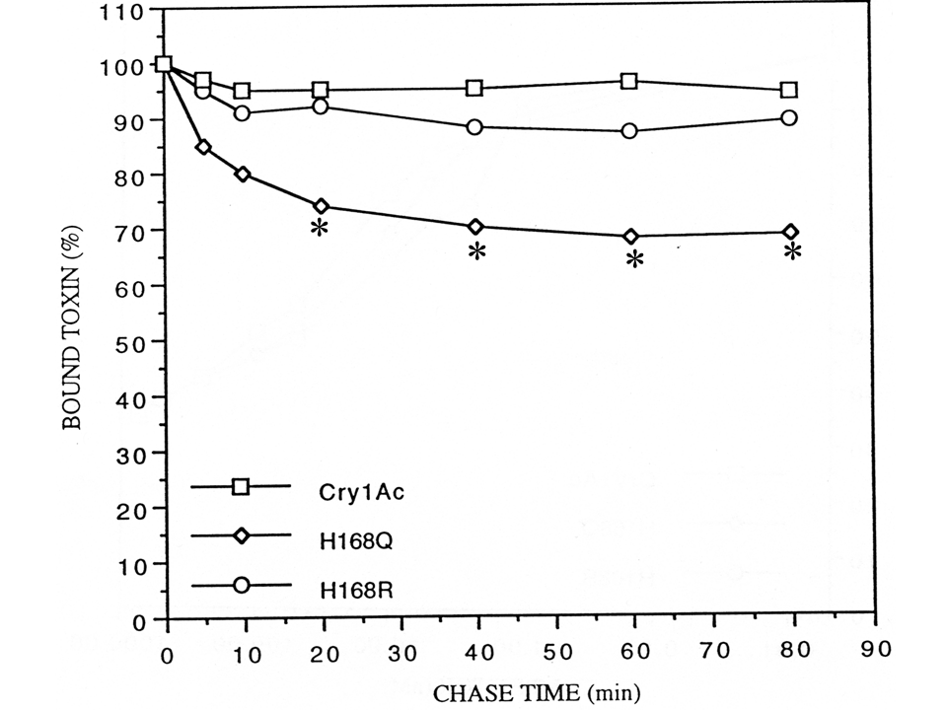
Figure 3, Hussain et al.
Figure 4, Hussain et al.
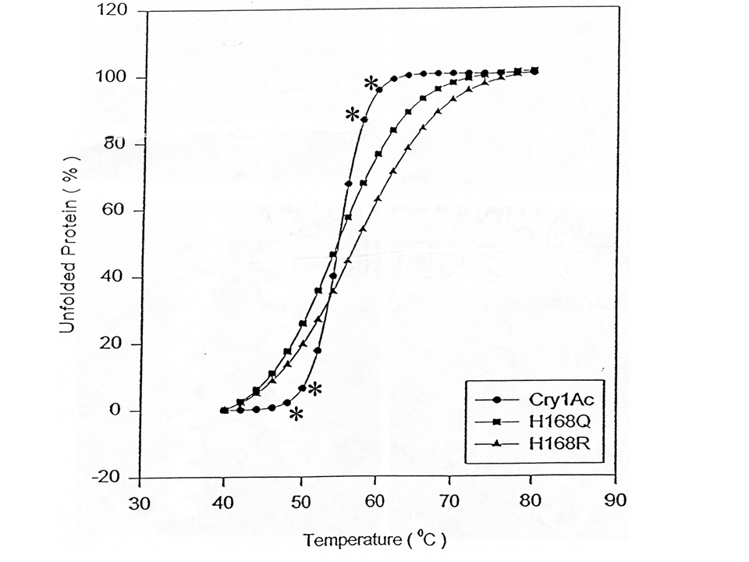
Figure 5, Hussain et al.
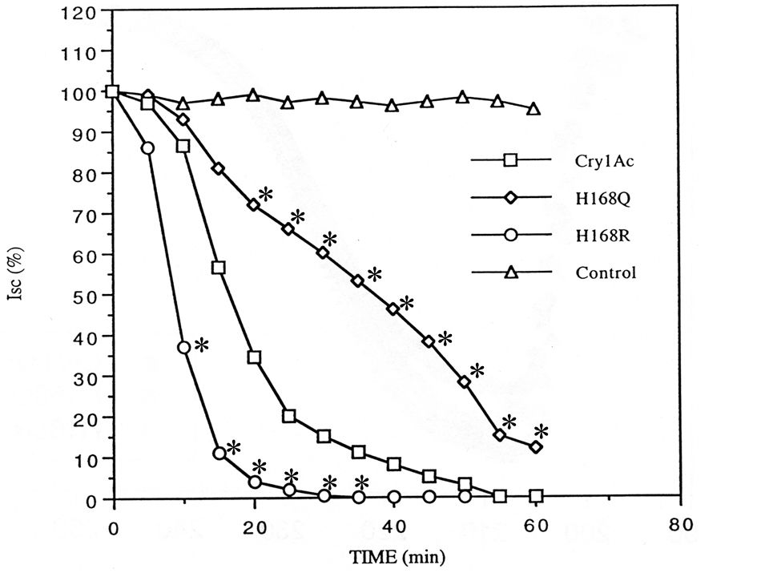
Figure 6, Hussain et al.
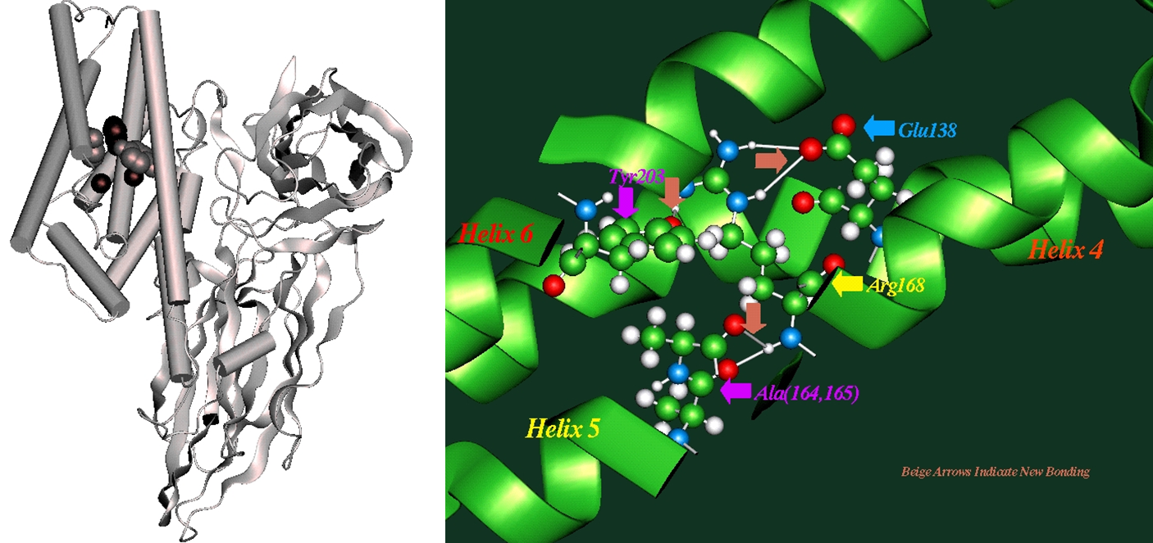
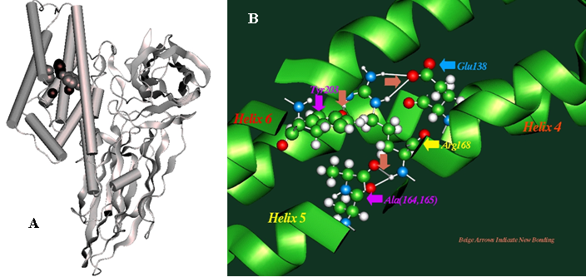
A
B
Beige arrows indicate new bonds

Molecular, Cellular and Developmental Biology (MCDB) Program, The Ohio State University, Columbus, OH 43210, USA.
Center for Gene Therapy, The Research Institute at Nationwide Children’s Hospital, Columbus, OH 43205, USA.
Laboratorio de Biología Molecular y Biotecnología, Facultad de Medicina, Universidad de Santander, UDES, Campus Universitario, Lagos del Cacique, Bloque Arahuaco, piso 2. Bucaramanga, Colombia.
Program in Molecular Biology and Biotechnology, University of North Carolina, Chapel Hill, NC 27599.
Department of Biochemistry, The Ohio State University, Columbus, OH 43210, USA.
Universidad Pontificia Bolivariana, Medellín, Colombia. * Correspondence author: Lab: (919) 962 -3697. E-mail: alzate@med.unc.edu

