Lighting the anaerobic digestion process in rural areas: struvite from cattle manure digestate

Lighting the anaerobic digestion process in rural areas: struvite from cattle manure digestate

Liliana del Pilar Castro-Molano*, Kenia Paola Vecino-Gutiérrez**, Luisa Jasbleidy Diaz- Moyano***, Jaime Jaimes-Estévez**** and Humberto Escalante-Hernández*****

* PhD. Ingeniería química, Universidad Industrial de Santander, Cra 27 Calle 9 Ciudad Universitaria, licasmol@uis.edu.co.
** Ingeniera Química, Universidad Industrial de Santander, Cra 27 Calle 9 Ciudad Universitaria, Kenia.vecino@gmail.com.
*** Ingeniera Química, Universidad Industrial de Santander, Cra 27 Calle 9 Ciudad Universitaria, jasbleidy.1126@gmail.com.
**** Maestría en Ingeniería Química, Universidad Industrial de Santander, Cra 27 Calle 9 Ciudad Universitaria, jamestev7@gmail.com.
***** PhD. Ingeniería química, Universidad Industrial de Santander, Cra 27 Calle 9 Ciudad Universitaria, escala@uis.edu.co.

ABSTRACT

The aim of this research was recovery nutrients (PO₄³⁻ and NH₄⁺ ions) in form of struvite, used cattle manure digestate from low cost anaerobic digester. In order to determinate operating variables (Mg₂⁺: PO₄³⁻ molar ratio, reaction time and stirring speed) an experimental design was developed. Struvite crystal was identified by mean of petrographic microscopy and infrared radiation. The highest recovery rates of 55±4.94 % and 58±7.72 % for NH₄⁺ and PO₄³⁻, respectively was achieved at 1.5 molar ratio, 50 minutes reaction time and 450 rpm stirring speed. Struvite yield was 295.75 mg/L. These results show that the highest phosphate recovery is achieved with the magnesium concentration (153 mg/L) contained in the cattle manure digestate.

Key words: cattle manure, digestate; household digester; struvite.

RESUMEN

El objetivo de esta investigación fue obtener estruvita a partir del digerido de un digestor rural, alimentado con estiércol bovino. Con el fin de determinar las variables de operación para recuperar estruvita (iones PO₄³⁻ y NH₄⁺), se desarrolló un diseño de experimentos, en el cual se evaluó el efecto combinado de la relación molar de Mg₂⁺:PO₄³⁻ (1.5:1, 2.5:1 y 3.5:1), tiempo de reacción (10, 50 y 90 min) y velocidad de agitación (100, 450 y 800 rpm). Las condiciones determinadas como favorables fueron relación molar 1.5, tiempo de reacción 50 min y una velocidad de agitación de 450 rpm. Estos resultados muestran que la recuperación de fosfato más alta es alcanzada el contenido de Mg ya presente en el digerido de estiércol bovino (153 mg / L). Los porcentajes de recuperación obtenidos fueron 55 ± 4.94 % y 58 ± 7.72 % para NH₄⁺ y PO₄³⁻ respectivamente. La formación y composición de cristales de estruvita se confirmó mediante microscopia petrografía, microscopía electrónica de barrido (SEM) y radiación infrarroja. El rendimiento de estruvita obteniendo fue 295.75 mg/L de digerido utilizado.

Palabras clave: digestor; digerido; estiércol bovino; estruvita.

RESUMO
O intuito desta investigação foi obter estruvita partindo do digerido de um digestor rural, alimentado com esterco bovino. A fim de determinar as variáveis de operação para recuperar a estruvita (íons PO₄³⁻ e NH₄⁺), foi desenvolvido um delineamento experimental, no qual foi avaliado o efeito combinado da razão molar de Mg₂⁺: PO₄³⁻ (1.5:1, 2.5:1 e 3.5: 1), tempo de reação (10, 50 e 90 min) e a velocidade de agitação (100, 450 e 800 rpm). A combinação de condições determinadas como favoráveis foram: relação molar de 1.5, tempo de reação de 50 minutos e velocidade de agitação de 450 rpm. Estes resultados indicam que a maior recuperação de fosfato é obtida com a concentração de magnésio (153 mg / L) contida no esterco bovino digerido. As porcentagens de recuperação obtidas foram de 55 ± 4.94% e 58 ± 7.72% para NH₄⁺ e PO₄³⁻ respectivamente. A formação e composição de cristais de estruvita foram confirmadas por meio de microscopia de petrografia, microscopia eletrônica de varredura (SEM) e radiação infravermelha. O rendimento da estruvita obtida foi de 295.75 mg /L de digerido utilizado.

Palavras chave: digestor; esterco bovino; estruvita; matéria digerida.

Recibido: marzo 21 de 2018 Aprobado: noviembre 21 de 2018

INTRODUCTION

Low-cost digesters are part of an attractive technology for anaerobic waste treatments in developing countries. There are a number of advantages to small-scale biogas production on farms, including savings on firewood or fossil fuels and reductions in odour and greenhouse gas emissions. Currently in Latin America, there are approximately 1.000 low cost digesters installed, with a capacity ranging from 2 to 100 m³ (Martí-Herrero, et al., 2016). These systems are mainly fed with cattle manure to produce biogas (a CH₄-CO₂ mixture) which is mainly used to cook (Kinyua, Ergas, & Rowse, 2016). Anaerobic digestion (AD) produces biogas (30% of the digestion product) and digestate or biogas sludge that corresponds to 70%. In the last decades, AD is energy focused contrasting with a low attention on nutrient recovery. The biogas sludge contains most of the nutrients (N and P) of the original substrate (Rivera et al., 2012).

Nowadays, the use of digestate in developing countries has been focused on direct applications or using phase separation (liquid portion and solid portion). However, the agronomic uses previously described are limited because of pollution risks, storage and transport cost (Warnars & Oppenoorth, 2014). Pollution problems may be microbiological, physicochemical and agronomic. Among these inconveniences, the most highlighted are methane emissions, nutrient lixiviation, young seedling loss, phytotoxicity problems, salinization risks, nutrient competition and the presence of pathogenic agents (Moreno et al., 2014).

In this sense, the continuous increase in fertilizer prices (mainly formed of N, P and K) has raised interest on nutrient recovery from digestate. The use of anaerobic digestates as organic fertilizer or soil conditioner seem to be the best option for nutrient recycling (Romero-Güiza et al., 2015). Anaerobically digested cattle manure is rich in ammonium, orthophosphates, and magnesium (Castro et al., 2017), indicating its high potential for struvite recovery.

Struvite precipitation is a useful process for both N and P recovery, where research is done to investigate the feasibility of using magnesium by-products as cost-effective Mg₂⁺ source. The slower nutrient leaching loss and its fertilizer quality make struvite an eco-friendly fertilizer.

Struvite is formed based on an NH₄⁺, Mg²⁺ and PO₄³⁻ equimolar concentration in accordance with the following reaction:

Struvite formation occurs in two stages: nucleation and crystal growth. Predicting or controlling these mechanisms is complex since they are controlled by a combination of physical–chemical parameters such as pH of the solution from which struvite precipitates, supersaturation, mixing energy, temperature, presence of foreign ions (Ca²⁺), Mg²⁺: PO₄³⁻ ratio and reaction time (Pastor et al., 2010; Ariyanto, Sen, & Ang, 2014).

Production of struvite from digestates and its utilization as fertilizer provides benefit in several ways: (i) reduction of eutrophication hazard in the water bodies by removing nitrogen and phosphorus, (ii) mitigation of N₂O emission as compared to urea (1/3) due to slow releasing nature (Hussein, 2014), (iii) sustainable phosphorus recovery (production to replace increasingly scarce and more expensive phosphate rock) and reuse (Cordell et al., 2011).

The Mg²⁺ is the limiting reagent for struvite formation, because this ion is related with the P recovery, since P is the most attractive nutrient to be recovered (higher cost). Struvite precipitation technique has been applied to several substrates (table 1). MgCl₂, Mg (OH)₂ and MgO are among the most used Mg²⁺ precursors at different degrees of purity (Battistoni et al., 2002; Romero-Güiza et al., 2015).

The small scale decentralised operations are emerging technologies to nutrients recovery, such as developments to precipitate struvite from source-separated urine from household digester in Sweden (Ganrot, Broberg, & Bydén, 2009) and Nepal (Neset & Cordell, 2010). Regarding to household biogas digesters in Latin America, knowledge about nutrient recovery through struvite precipitation from low cost digestate is limited. This is due to the lack of information about the benefits of struvite as a fertilizer, its value on the market, and problems related to the crystallization process such as the need to control the pH and the cost of reagents.

According to the scenario described above, it is necessary to adapt a nutrient recycling technology that can be implemented in rural zones to manage and valorise the digestate produced in rural digesters. The aim of this research was to determine the operating conditions to precipitate struvite from a real digestate obtained in a household digester.

METHODOLOGY

Description of the location and digester characteristics

This study was conducted at a farm named "Finca Marcella" (9 Hectares), located in Santander, Colombia, 9 km from the urban Zone, at a 959-m.a.s.l. altitude (Lat. N 7°01 '0.07' Long. W 73°08' 13.3") with a 692-mm/m² of average precipitation and a 23±5°C room temperature. The farm has a tubular low-cost digester that uses cattle manure as substrate (figure 1). Table 2 summarizes the design parameters of the digester.

The digester reaches an average biogas production of 0.85 m³/d with a CH₄ content of 65.6%. Additionally, the process generates 0.14 m³/d of digestate, which its main nutrients content were Mg²⁺: 153 mg/L; NH₄⁺: 123 mg/L and PO₄³⁻: 338 mg/L (Castro et al., 2017).

Experimental design and statistical analysis

To evaluate struvite precipitation potential, digestate samples were collected weekly (for one month) and they were refrigerated at 4 °C.

Aiming to evaluate the effect of the variables that influence struvite precipitation, the study used a 2³ factorial design with a central point. Each assay was carried out by triplicate. Three variables were co-related at high (+1) and low levels (-1): Reaction time (10; 90 min), stirring speed (100; 800 rpm) and a Mg²⁺:PO₄³⁻ molar ratio (1.5:1; 3.5:1) (table 3 shows all experimental units). MgCl₂ was used as a source of Mg²⁺. The molar ratio, stirring speed and reaction time used were chosen in accordance to what was reported in the literature (Ariyanto, Sen, & Ang, 2014; Barbosa et al., 2016; Doyle & Parsons, 2002; Taddeo, Kolppo, & Lepistö, 2016 ). The experiments were conducted in 500 mL beakers (200 mL volume of work).

From the results obtained in the experimental design, a new assay (batch experiment by triplicate) was conducted in order to validate nutrient recovery percentages (PO₄³⁻ and NH₄⁺) at a higher scale. This validation was performed in a 0.002 m³ polypropylene reactor (1 L volume of work with a 0.130 m diameter).

Response surface and statistical analyses were conducted using a trial version of Stat graphics Software for Windows 7. The performance of the model suggested was evaluated based on PO₄³⁻ recovery percentage.

Description of struvite precipitation process

First, the phosphorus sedimentation was estimated: a test was conducted (blank) which was not stirred and Mg²⁺ was not added. Some samples were analyzed at different times (0.5, 1 and 24 h) in order to estimate the PO₄³⁻ recovery. Secondly, the effect of the variables defined in the experimental design was evaluated: digested matter samples were filtered (0.1 mm mesh sieve) and the liquid phase was stored to future analysis. As a pre-treatment, the study followed the methodology proposed by Zhao et al., (2010). In this case, a pH treatment was conducted to protonate the phosphate ions found in the sample. Then, MgCl₂ was added to the different Mg²⁺: PO₄³⁻ molar ratio and increased the pH to 9. The Mg²⁺ dose was calculated based on the starting PO₄³⁻ concentration. After that, the solution was stirred during the reaction time established in the experimental design and it was allowed to sediment during 30 minutes (Barbosa et al., 2016).

Once the sedimentation time finished, crystals were separated from the liquid (residual digestate). The liquid was poured into another recipient and the precipitated crystals remained in the recipient used at the beginning. The crystals were collected in Petri dishes and finally dried in an incubator at 36±1°C, for further analysis.

Phosphate has a lower concentration in digestate, compared to the Mg²⁺ and NH₄⁺ ions concentrations. Therefore, PO₄³⁻ acts as a limiting reagent and indicated the maximum amount of struvite that could be formed (Escalante et al., 2018). Thus, phosphate recovery percentage was taken as response variable in the experimental design and in the blank test.

The percentage of nutrient recovery (PO₄³⁻ and NH₄⁺) was calculated having into account the initial and final PO₄³⁻ and NH₄⁺ concentrations during the struvite precipitation process (photometric methods: APHA 4500-NH₃ y APHA 4500-P E (APHA, 2005). To calculate the percentage of nutrients recovery, equation (1) was proposed:

(1)

It is important to mention that NH₄⁺ content was determined only in the experiment with the most favorable conditions, because it is one of the main nutrients in struvite precipitation. The experiments were conducted at room temperature and at atmospheric pressure.

Qualitative and Quantitative Analysis of Struvite Crystals

Qualitative and quantitative analyses were carried out for the precipitated obtained from the most favorable conditions. This precipitate is a measurement of the nutritional potential that digestate has for struvite precipitation. Whereby crystals were determined using qualitative analysis. The petrographic analysis was the description of the samples collected using a petrographic microscope with polarized light (LEICA DM750). Crystals were also characterized using infrared radiation with an FTIR-8400S infrared using Fourier Transform. Quantitative analysis corresponds to determining the struvite potential (SP). This estimate was made based on the following equation (Equation 2).

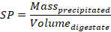 | (2)

Where is the struvite mass and corresponds to digestate volume.

Economic potential of struvite precipitation

Based on the experimental results and theoretical yields of struvite precipitation reached in this study, an economic analysis was performed. Struvite would be precipitated without using stirring and a magnesium source, and pH adjustment with HCl and NaOH according to the methodology described by Zhao et al., (2010). The cost of equipment for capital expenditures (CAPEX) calculation was considered based on the Colombian market for 2018 (personal communication). The other assumptions for operating expenses (OPEX) calculation were based on the data reported by Yetilmezsoy et al., (2017) and Tao et al., (2016). The economic components used in the calculation of the total investment costs are presented in Table 4. Economic aspects included the biogas supply for cooking food.

RESULTS

PO₄³⁻ and NH₄⁺ recovery as struvite from biogas digestate

The digestate from the cattle manure studied contained dissolved ion concentrations of Mg₂⁺ (6 mM), PO₄³⁻ (4 mM), NH₄⁺ (7 mM) and Ca⁺² (22 mM) and Mg²⁺:PO₄³⁻ molar ratio equal to 1.5 with a pH around 7.37 ± 0.23. These characteristics promoted phosphorus sedimentation, reflected in the percentage removal of PO₄³⁻ without adding chemical reactive and with 0 rpm (figure 2). Digestate pretreatment was not necessary due to total solids were 9.93 g/L. Previous studies suggest a pretreatment for digestates with total solids between 15-92 g/L (Tao, Fattah, & Huchzermeier, 2016).

In struvite precipitation processes, the highest recovery percentages can be seen from hour 16 to hour 25, about 80% to 93% and 88% to 93%for NH₄⁺ and PO₄³⁻ respectively (Lee et al., 2015; Rahman, et al., 2014; Ryu & Lee, 2010). In this study after 24 hours, a 26% PO₄³⁻ recovery was obtained, figure 2. This percentage represented low process performance; therefore, it was recommended to increase precipitation time. Nonetheless, a technical-economic analysis must be conducted to decide if the spontaneous process is profitable and suitable to manage (Escalante et al., 2018).

Co-relation of the variables implicated in the Struvite Precipitation Process

The effects of the operating variables were modeled statistically with adjustment near to 95%, results of model are observed in figure 3. These results show favorable process conditions at Mg²⁺:PO₄³⁻ molar ratio of 1.5, a 450 rpm stirring speed and a 50 minute reaction time.

The most influential variable in PO₄³⁻ recovery was a Mg²⁺:PO₄³⁻ ratio (1.5) with a reliability of 95%. These results show that the highest phosphate recovery is achieved with the magnesium concentration (153 mg /L) contained in the cattle manure digestate. Based on above, a supplement Mg²⁺ was not necessary and the pH changes were the struvite promoter. Similar results were described by Tao, Fattah, & Huchzermeier (2016).

Using a stirring speed of 450 rpm, and reaction time of 50 min, the PO₄³⁻ and NH₄⁺ recoveries were around 55±4.94 and 58±7.72 %, respectively. Calcium concentration is a hindered for struvite formation, hence phosphate precipitation could had been affected (Pastor et al., 2010). Thus, the effect of the Mg²⁺:PO₄³⁻ relation in the digestate allowed a magnesium-content supersaturation of the medium, and it was favorable to allow the first crystal seed (primary nucleation) (Mehta & Batstone, 2013). Literature reports PO₄³⁻ recoveries from 60% to 83% for cattle -manure digestate. Nevertheless, yields in these studies were reached as a result of pre-thermochemical treatments using microwaves and adding sources of Mg²⁺ and PO₄³⁻ (Jin, Hu, & Wen, 2009; Zeng & Li, 2006).

Precipitate Characterization and Identification

Petrographic microscopic analysis evidenced possible struvite formation (figure 4). 4A and 4B images correspond to the passing of non-polarized light at 4x and 10x magnification, respectively. With this preliminary assay is possible to observe crystal formation that could be struvite (figure 4) and some impurities that can be attributed to the type of substrate used and type of sampling. Because of the low availability of researches on struvite analysis using petrographic microscopy, results could not be compared.

Microscopic images showed that the form of the precipitate was not uniform. Chauhan & Joshi (2013) conducted a study on struvite growth. In that study, the authors stated that struvite could be found in different morphologies (drawer shaped, pyramidal, prismatic, needle-shaped, feather shaped, etc.) which strongly depend on growth parameters (Chauhan & Joshi, 2013). These images in figure 4 agree with the research studies on struvite crystallization (Heraldy et al., 2017; Barbosa et al., 2016).

Figure 5 shows an infrared spectrum of struvite crystals obtained under the favorable operating conditions (Mg²⁺:PO₄³⁻:1.5; 450 rpm; 50-min), compared to a struvite pattern (Stefov et al., 2005). The spectrum shows the absorption bands corresponding to the different elements or components found in the crystal. The absorptions that take place in the range 3240 to 3529 cm⁻¹ are due to vibrations resulting from O-H and N-H elongation. This also suggests the presence of hydration water. The absorptions produced in 2854±1 and 2925±1 cm⁻¹ are due to the NH₄⁺ ion. The observations that take place in 511±2, 1010±1 and 1083±2 cm⁻¹ correspond to PO₄³⁻ ions and the peak produced at 461±1 y 691±1 cm⁻¹ take part of Mg-oxygen bonds (Chauhan et al., 2008).

Previous struvite precipitation studies based on human urine presented absorptions that occurred in (2920.9, .2970 and 2889.26 cm⁻¹), (500, 1006 and 1064.5 cm⁻¹), (683.97 and 509.4 cm⁻¹), and (3276.9 to 3520.6) correspond to NH₄⁺, PO₄³⁻, Mg²⁺ and H₂O respectively (Kurtulus & Tas, 2011; Muryanto, Sutanti, & Kasmiyatun, 2016). The values obtained in literature are related to the ones obtained in the present study, proving the presence of these ions as struvite.

In addition, struvite was analyzed quantitatively. Struvite potential in this research was 297.75 mg struvite/L from the digestate used. Results confirm that cattle manure digestate has high nutritional potential for struvite precipitation thanks to its high nutrient content (PO₄³⁻ and NH₄⁺). In comparison with the results obtained in the present study, Jaffer et al., (2002), reported a struvite potential of 198 mg/L and 140 mg/L at a pH of 9, for mud digested matter and centrifuged wastewater liquor, respectively.

With the results previously obtained, the presence of struvite was proven. Therefore, it is possible to recycle nutrients (Mg²⁺, PO₄³⁻ and NH₄⁺) available in cattle manure digested matter. In this study, researchers adapted a low-cost struvite precipitation process (without adding Mg source, and with low energy use) so that it may be profitable and suitable for biogas digester users.

Economic consideration

The household digester is located in a rural area (difficult to access due to tertiary roads). This digester provides both biogas and digestate. The net present value (NPV) was USD $ 40/year. In this case, biogas is used for cooking with propane saving around USD $ 75/month (purchasing and transporting costs). Concerning to digestate, it could be used to precipitate struvite which represents fertilizing saving around USD $ 94/month (purchasing and transporting costs).

CONCLUSIONS

The optimal operation conditions to nutrients recovery from real digestate via struvite precipitation were determined by a composed central design. A statistical analysis revealed that the maximum phosphate recovery was obtained at a Mg²⁺:PO₄³⁻ molar ratio of 1.5 (this ratio don’t require external source of Mg²⁺), with a 450 rpm stirring speed and a 50 minute reaction time. The results are quite promising, due to Mg²⁺ content in cattle digestate is favorable for phosphate recovery through struvite precipitation at the optimal settings. Under these conditions, the study reached a recovery of 55±4.94 and 58±7.72 % of PO₄³⁻ and NH₄⁺ respectively. The petrography and infrared spectrum analyses confirmed that the precipitate formed was struvite with some impurities.

In agreement with the present research, household digester presents an integrative solution to cattle manure management. In this case, the low cost digester was fed with 50 kg/d of cattle manure to produced renewable energy in form of biogas (0.85 Nm³ biogas/d with 65.6% methane), and to recycle nutrients as struvite, providing energy and fertilizer savings of 76% and 80% (using all digestate volume for crop irrigation), respectively.

REFERENCES

APHA. (2005). Standard methods for the examination of water and wastewater. American Public Health Association, Washington.

Ariyanto, E., Sen, T. K., & Ang, H. M. (2014). The influence of various physico-chemical process parameters on kinetics and growth mechanism of struvite crystallisation. Advanced Powder Technology, 25, 682-694.

Barbosa, S. G., Peixoto, L., Meulman, B., Alves, M. M., & Pereira, M. A. (2016). A design of experiments to assess phosphorous removal and crystal properties in struvite precipitation of source separated urine using different Mg sources. Chemical Engineering Journal, 298 , 146-153.

Battistoni, P., Angelis, A. D., Prisciandaro, M., Boccadoro, R., & Bolzonella, D. (2002). Removal from anaerobic supernatants by struvite crystallization: long term validation and process modelling. Water Res, 36, 1927-1938.

Castro, L., Escalante, H., Jaimes-Estévez, J., Díaz, J., Vecino, K., Rojas, G., & Mantilla, L. (2017). Low cost digester monitoring under realistic conditions: Rural use of biogas and digestate quality. Bioresource Technology 239, 311–317.

Chauhan, C. K., & Joshi, M. J. (2013). In vitro crystallization, characterization and growth-inhibition study of urinary type struvite crystals. Journal of Crystal Growth, 362 2013, 330-337.

Chauhan, C., Joseph, K., Parekh, B., & Joshi, M. (2008). Growth and characterization of struvite crystals. Indian Journal of Pure & Applied Physics, 46, 507-512.

Cordell, C., Rosemarin, A., Schröder, J., & Smit, A. (2011). Towards global phosphorus security: A systems framework for phosphorus recovery and reuse options. Chemosphere, 84, 747–758.

Doyle, J. D., & Parsons, S. A. (2002). Struvite formation, control and recovery. Water Research, 36, 3925-3940.

Escalante, H., Castro, L., Amaya, M., Jaimes, L., & Jaimes-Estévez, J. (2018). Anaerobic digestion of cheese whey: Energetic and nutritional potential for the dairy sector in developing countries. Waste Management, 711–718.

Etter, B., Tilley, E., Khadka, R., & Udert, K. (2011). Low-cost struvite production using source-separated urine in Nepal. Water research, 45, 852-862.

Ganrot, Z., Broberg, J., & Bydén, S. (2009). Energy efficient nutrient recovery from household wastewater using struvite precipitation and zeolite adsorption techniques: A pilot plant study in Sweden. London, UK: IWA Publishing.

Heraldy, E., Rahmawati, F., Heriyanto, & Putra, D. P. (2017). Preparation of struvite from desalination waste. Journal of Environmental Chemical Engineering, 5, 1666-1675.

Huang, H., Xu, C., & Zhang, W. (2011). Removal of nutrients from piggery wastewater using struvite precipitation and pyrogenation technology. Bioresource technology, 102(3), 2523-2528.

Huang, H., Zhang, P., Zhang, Z., Liu, J., Xiao, J., & Gao, F. (2016). Simultaneous removal of ammonia nitrogen and recovery of phosphate from swine wastewater by struvite electrochemical precipitation and recycling technology. Journal of Cleaner Production, 127, 302-310.

Hussein, F. (2014). Environmental Chemistry is the Importance of Chemistry to the Environment. Arabian Journal of Chemistry 7, 1-4.

Jaffer, Y., Clark, T., Pearce, P., & Parsons, S. (2002). Potential phosphorus recovery by struvite formation. Water Research, 36, 1834–1842.

Jin, Y., Hu, Z., & Wen, Z. (2009). Enhancing anaerobic digestibility and phosphorus recovery of dairy manure through microwave-based thermochemical pretreatment. Water Research, 43(14), 3493–3502.

Kinyua, M. N., Ergas, S. J., & Rowse, L. (2016). Review of small-scale tubular anaerobic digester streating livestock waste in the developing world. Renewable and Sustainable Energy Reviews, 58, 896-910.

Kurtulus, G., & Tas, A. (2011). Transformations of neat and heated struvite (MgNH4PO4⋅6H2O). Materials Letters, 65, 2883-2886.

Lee, E. Y., Oh, M. H., Yang, S.-H., & Yoon, T. H. (2015). Struvite crystallization of anaerobic digestive fluid of swine manure containing highly concentrated nitrogen. Asian-Australasian Journal of Animal Sciences, 28(7), 1053-1060.

Martí-Herrero, J., Donoso, M. P., Mendoza, L. G., Pedraza, G. X., Jiménez, L. R., & Arias, J. V. (2016). Oportunidades para el desarrollo de un sector sostenible de biodigestores de pequeña y mediana escala en LAC. Redbiolac. Retrieved Septiembre 8, 2017, from www.redbilac.org

Mehta, C. M., & Batstone, D. J. (2013 ). Nucleation and growth kinetics of struvite crystallization. Water research, 47, 2890-2900.

Moreno, J., Moral, R., García, J., Pascual, J., & Bernal, M. (2014). De residuo a recurso: el camino hacia la sostenibilidad. Barcelona, España: Aedos, sa.

Muryanto, S., Sutanti, S., & Kasmiyatun, M. (2016). Inhibition of struvite crystal growth in the presence of herbal extract orthosiphon aristatus BL.MIQ. MATEC Web of Conferences, 18, 1-5.

Neset, T., & Cordell, D. (2010). Phosphorus and global food security: a synthesis. Linköping University Electronic Press.

Pastor, L., Mangin, D., Ferrer, J., & Seco, A. (2010). Struvite formation from the supernatants of an anaerobic digestion pilot plant. Bioresource Technology 101, 118–125.

Quintana, M., Colmenarejo, M., Sánchez, J. B., García, G., Travieso, L., & Borja, R. (2008). Removal of phosphorus through struvite precipitation using a by-product of magnesium oxide production (BMP): Effect of the mode of BMP preparation. Chemical Engineering Journal, 136, 204-209.

Quintana, M., Sanchez, E., Colmenarejo, M., Barrera, J., Garcia, G., & Borja, R. (2005). Kinetics of phosphorus removal and struvite formation by the utilization of by-product of magnesium oxide production. Chemical Engineering Journal, 111(1), 45-52.

Rahman, M. M., Salleh, M. A., Rashid, U., Ahsan, A., Hossain, M. M., & Ra, C. S. (2014). Production of slow release crystal fertilizer from wastewaters through struvite crystallization – A review. Arabian Journal of Chemistry, 7, 139-155.

Rivera, D., Plata, L., Guzman, C., Castro, L., & Escalante, H. (2012). Application of solid by-product generated in fique´s bagasse (furcraea macrophylla) anaerobic digestion for soil improvement. Ion, 25(1), 25-34.

Romero-Güiza, M. S., Astals, S., Mata-Alvarez, J., & Chimenos, J. m. (2015). Feasibility of coupling anaerobic digestion and struvite precipitation in the same reactor: Evaluation of different magnesium sources. Chemical Engineering Journal, 270, 542-548.

Romero-Güiza, Maycoll, Mata-Alvarez, J., Chimenos-Rivera, J., & Astals, S. (2015). Nutrient recovery technologies for anaerobic digestion systems: An overview. Ion, 7-26.

Ryu, H.-D., & Lee, S.-I. (2010). Application of struvite precipitation as a pretreatment in treating swine wastewater. Process Biochemistry, 45, 563-572.

Stefov, V., Šoptrajanov, B., Kuzmanovski, I., Lutz, H. D., & Engelen, B. (2005). Infrared and Raman spectra of magnesium ammonium phosphate hexahydrate (struvite) and its isomorphous analogues. III. Spectra of protiated and partially deuterated magnesium ammonium phosphate hexahydrate. Journal of Molecular Structure, 752(1-3), 60-67.

Taddeo, R., Kolppo, K., & Lepistö, R. (2016 ). Sustainable nutrients recovery and recycling by optimizing the chemical addition sequence for struvite precipitation from raw swine slurries. Journal of Environmental Management , 180 , 52-58.

Tao, W., Fattah, K. P., & Huchzermeier, M. P. (2016). Struvite recovery from anaerobically digested dairy manure: A review of application potential and hindrances. Journal of Environmental Management, 169, 46-57.

Uysal, A., Yilmazel, Y., & Demirer, G. (2010). The determination of fertilizer quality of the formed struvite from effluent of a sewage sludge anaerobic digester. Journal of Hazardous Materials, 181, 248-254.

Warnars, L., & Oppenoorth, H. (2014). El biol: el fertilizante supremo. Quantes.

Yetilmezsoy, K., Ilhan, F., Kocak, E., & Akbin, H. (2017). Feasibility of struvite recovery process for fertilizer industry: A study of financial and economic analysis. Journal of cleaner production, 152, 88-102.

Zeng, L., & Li, X. (2006). Nutrient removal from anaerobically digested cattle manure by struvite precipitation. Journal of Environmental Engineering and Science, 5(4), 285-294.

Zhang, X., Hu, J., Spanjers, H., & Lier, J. B. (2016). Struvite crystallization under a marine/brackish aquaculture condition. Bioresource Technology, 218, 1151-1156.

Zhao, Q., Zhang, T., Frear, C., Bowers, K., Harrison, J., & Chen, S. (2010). Phosphorous recovery technology in conjunction with dairy anaerobic digestion. Climate Friendly Farming, 1, 1-34.

Table 1. Struvite precipitation from different substrates.
Substrate | Mg²⁺ sources | Mg²⁺ to PO₄³⁻ molar ratio | Type of reactor and process conditions | % of PO₄³ ⁻ recovery | Reference
Municipal wasatewater | LG-MgO | 3.6 | 1 L beaker with stirring at 120 rpm and 240 minutes | 96 | Quintana et al., (2005)
Digested Swine manure | MgCl₂ | 1 | Conical bottom reactor with 750 rpm magnetic stirring, during 30-minutes. | >90 | Quintana et al., (2008)
Cochineal insects processing | **LG-MgO | 3.7 | 0.45 L beaker with stirring | 100 | Uysal, Yilmazel, & Demirer, (2010)
Digested cattle manure | * | 1.02 | Batch reactor with magnetic stirring, addition of Ethylenediamine-tetra-acetic acid (EDTA) and pH adjustment | 62 | Zhao, et al., (2010)
Waste Waters | MgO | 1.6 | CSTR Reactor with magnetic stirring at 120 rpm (1 hour) and airing system to increase pH | 90 | Etter et al., (2011)
Digested Swine manure | Mg Anode | * | CSTR Reactor with a pH measuring system and a pair of electrodes, 70 minutes of magnetic stirring (150 rpm). | 93 | Huang et al., (2016)
Piggery wastewater | Struvite pyrolysate | 2.5 | Jar with an airtight lid and stirring during 10 minutes. | 96 | Huang, Xu, & Zhang, (2016)
Human urine | MgO | 1.1 | Cylindrical propylene reactor with a conical bottom and an external filtering system. 10-minute manual stirring (60 rpm). | 90 | Taddeo, Kolppo, & Lepistö (2016)

Table 2. Design parameters of the digester studied.

Parameters |  | Unit | Value
Ditch dimensions | top width | m | 1
Ditch dimensions | bottom width | m | 0.8
Ditch dimensions | length | m | 7.5
Ditch dimensions | depth | m | 1
Diameter |  | m | 1.3
Length |  | m | 7.5
Digester Volume |  | m³ | 9.5
Reservoir |  | m³ | 5.1
Operating time |  | 24 | months

Table 3. Experimental design matrix to recover struvite.
Mg²⁺: PO₄³⁻ molar ratio (mol/mol) | stirring speed (rpm) | reaction time (min)
1.5 | 800 | 10
1.5 | 100 | 90
1.5 | 450 | 50
1.5 | 800 | 90
1.5 | 100 | 10
2.5 | 800 | 50
2.5 | 450 | 90
2.5 | 450 | 10
2.5 | 100 | 50
2.5 | 450 | 50
3.5 | 100 | 90
3.5 | 100 | 10
3.5 | 800 | 10
3.5 | 450 | 50
3.5 | 800 | 90

Table 4. Economic parameters and assumptions for the economic study.
Parameter | Unit | Value
Assumptions for CAPEX calculation
Equipment for struvite precipitation | US$ | 1000
Storage equipment | US$ | 1160
Assumptions for OPEX calculation
Struvite | US$/kg | 1.88
Biogas | US$/m³ | 0.65
NaOH | US$/kg | 0.503
HCl | US$/L | 3.4
Assumptions for NPV calculation
Equipment life | Year | 7
Inflation | % | 4
Discount rate i | % | 6
Digestate flow | m³/d | 0.14
PPS | g _{struvite}/l _{digestate} | 0.29

Figure 1. Tubular digester setup located on "Marcella" farm.
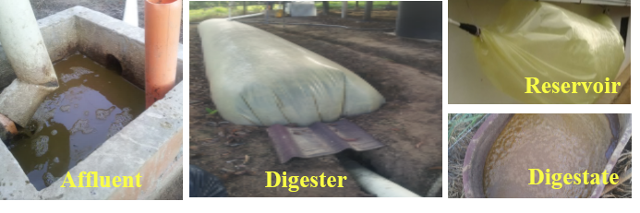

Figure 2. Phosphate ion recovery (as percentage) through spontaneous struvite precipitation. Bars represents standard deviation.

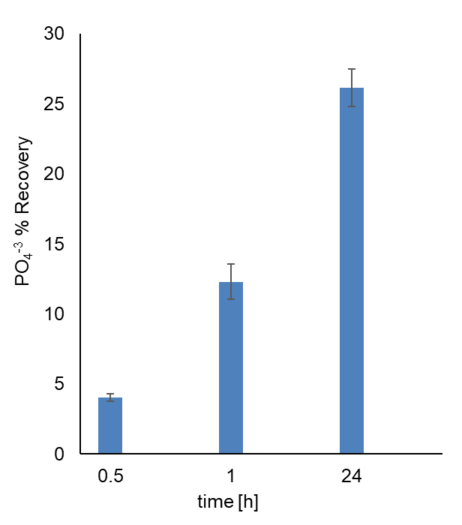

Figure 3. Surface response of the experimental PO₄³⁻ recovery design.

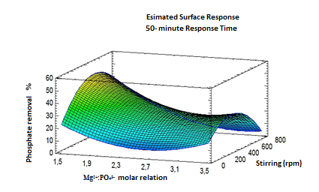

Figure 4. Micrographs of precipitate obtained from optimal conditions assay. A: Non-polarized light at 4x magnification; B: Non-polarized light at 10x magnification.
A  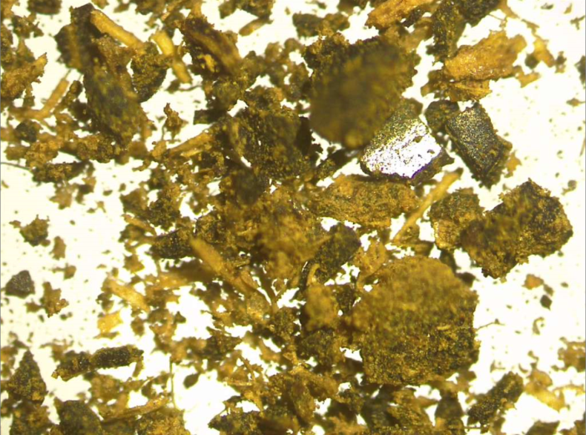 | B  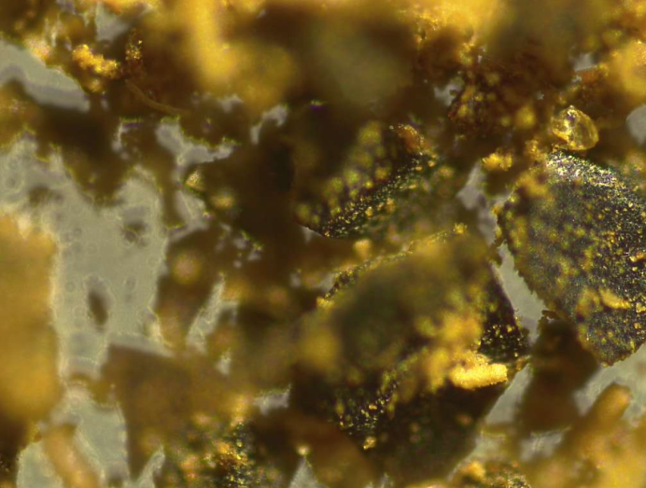
Taken from different regions of the sample using a LEICA DM750 microscope.

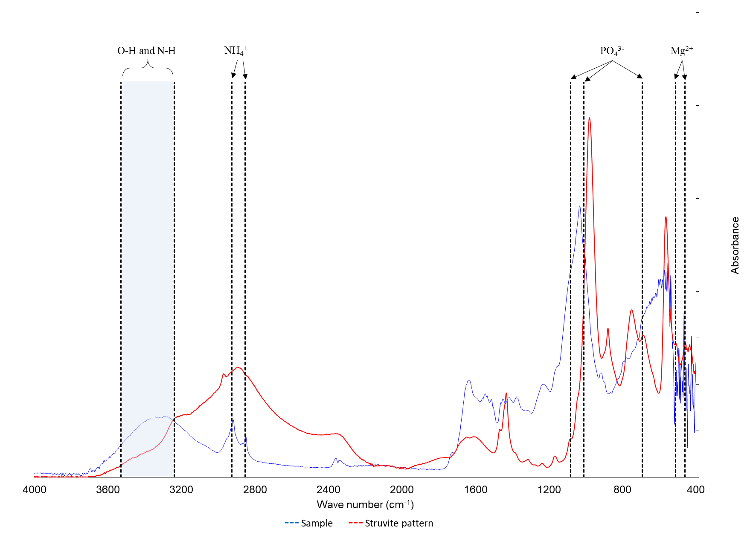
Figure 5. Infrared Radiation spectra of precipitate obtained of the optimal conditions assay (using FTIR-8400S infrared equipment)

