Article formatting example

Ejemplo del formato de un artículo

Néstor Rojas-Reyesª , Sandra Díaz-Belloª , Adrián Gómez- Zapata^{b}

ª Institute of Minerals – CIMEX, Faculty of Mines, National University of Colombia, , Medellín, Colombia, nrrojasr@unal.edu.co, fbolanosm@unal.edu.co
^{b} Institución Universitaria Pascual Bravo, Facultad de Ingeniería, Medellín, Colombia. adrian.gomez@pascualbravo.edu.co

Received: June 6th, 2025. Received in revised form: November 1th, 2025. Accepted: November 25th, 2025.

Abstract
This is an example of an article formatted for our journal. Note that this text is typed in Times New Roman, size 9, justified, with the word Abstract in bold, Type title and in a separate line. Abstract length does not exceed 150 words. Also, note that keywords are separated by semicolon.

Keywords: manuscript formatting; camera-ready manuscript.

Resumen
Este es un ejemplo de un artículo formateado para nuestra revista. Note que este texto es digitado en Times New Roman, tamaño 9, justificado, con la palabra Resumen en negrilla, Tipo título y en una línea separada. La longitud del resumen no excede 150 palabras. También, note que las palabras clave están separadas por un punto y coma.

Palabras clave: formato del manuscrito; manuscrito listo para impresión.

1 Formating

1.1 Paper size, margins, columns and paragraphs

Manuscript must be prepared in letter size paper with margins of 2.2 cm in the upper and lower sides, of 1.69 cm in inner and outer sides and 0.7 cm Binding. The text is typeset in two columns with 0.40 cm of spacing between columns. All texts in the manuscript are typeset using Time New Roman fonts.
Use Time New Roman font with size of 10 points for normal text paragraphs. The first line of each paragraph is indented 0.5 cm.

1.2 Headings

The maximum allowed deep of headings in the manuscript is three. Headings are numerated using Arabic numbers. Primary headings use bold face, and size 10. Secondary headings use bold face, italics and size 10. Tertiary headings use normal text and size 10, for example [1]:

1.2.1 Example of a tertiary heading

2 Tables and Figures

All tables and figures occupy the entire width of the column. Use figures and tables of two columns of width only when absolutely necessary. Tables have the title above and figures have the title below. All tables and figures are numerated consecutively using Arabic numbers. We present an example of correct formatting of tables and figures in the Table 1 and Fig. 1. Locate tables and figures close to the first reference to them, preferably at the beginning or end of each column. No use abbreviations in column headings. For table and figure captions, and the text in tables, use Times New Roman font with size of 8 points. Use only horizontal lines. Avoid text in boldface. Figures with colors are not allowed [2].

Table 1.
Example of a table.
Model | Fitting  MAD (RMSE) | Forecasting  MAD (RMSE)
SARIMA | 36.11 (52.30) | 51.88 (60.20)
Proposed model | 35.93 (50.89) | 47.68 (60.06)
Source: Adapted from Dvorak and Ferraz-Mello, 2004.

3 Equations

All equations must be numbered consecutively. Use the built-in equation editor provided by Microsoft Word. Use the standard convention for typesetting mathematics: letters in italics for scalar variables and constants, bold lowercase letters for vectors and bold uppercase letters for matrixes. For example, all variables in eq. (1) are scalars.

$$f\left(x\right)=\frac{1}{σ\sqrt{2π}}expexp \left[-\frac{1}{2}{\left(\frac{x-μ}{σ}\right)}^{2}\right]$$ | (1)

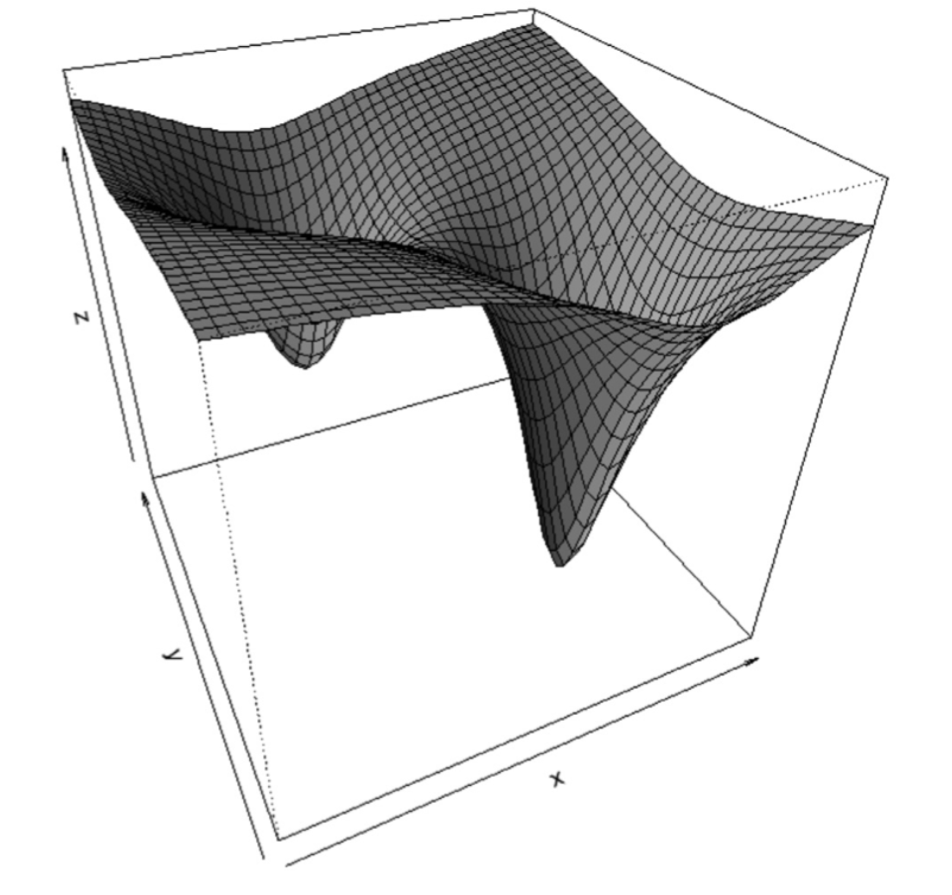
Figure 1. Plot of a nonlinear surface.
Source: Anderson, 1998.

4 Referencing bibliography, tables and figures

En el texto, las referencias bibliográficas utilizan [1,2] en vez de [1][2]; [1-3] en lugar de [1][2][3] o [1,2,3] o [1], [2], [3]. Para referencias de figuras use Fig. 1 en cambio de la Figura 1; Fig. 1, 2, 5 en lugar de la Figura 1, Figura 2 y Figura 5, o Figuras 1, 2 y 5. Utilice la Fig. 1-5 en vez de la Fig. 1, 2, 3, 4 y 5.
Para ecuaciones use eq. (1) en lugar de ecuación 1; usar (eq. 1) en cambio de (ecuación 1); Utilice la Ec. (1)-(5) en vez de la Ec. (1), (2), (3), (4), (5).

5 Estándar de citación

Utilice el siguiente estándar de citación en las referencias.

Para libros:
- Masters, T. Neural Network Recipes in C++. Academic Press, New York, USA, 1993.
- Dvorak, R. and Ferraz-Mello, S., Eds., A comparison of the dynamical evolution of planetary systems, Springer, Austria, 2004. DOI: https://doi.org/10.1007/1-4020-4466-6
Para el capítulo en un libro impreso:
- Moyor, M.A., Evaluación del lenguaje de ingeniería, en: Verdugo–Alonso, J., Evaluación curricular: una guía para la intervención del ingeniero, 2ª ed., Salvat, Madrid, España, 1994, pp. 324-344.
- Hoyles, C., and Noss, R., What can digital technologies take from and bring to research in mathematics education? in: Bishop, A.J., et al., Second International Handbook of Mathematics Education, 2nd edition, Kluwer Academic, Dordrecht, Netherlands, 2003, pp. 323-349. DOI: https://doi.org/10.1007/978-94-010-0273-8_11
Para artículos de conferencias:
- Jeng, J.-T., Chuang, C.-C., and Chuang, C.-T., Support vector regression based LTS-CPBUM neural networks, Proceedings of SICE Annual Conference (SICE), pp. 215-220, 2011.
- Kobus, M., Guerrero, C.D., Labrador, M.A., and Pérez, R.A., CSTEP: Transferring Computer Science Community College Students to Four-year Universities. ASEE Annual Conference and Exposition, (ASEE 2009), Austin, TX., 2009. https://soa.asee.org/paper/conference/paper-view.cfm?id=12459..
Para libro electrónico:
- Pumarino, A., La propiedad intelectual en ambientes digitales educativos [en línea], Revisión sistemática, DoucUC, Santiago, Chile, 2004. [consulta, 18 de octubre de 2005]. Disponible en: https://www.uca.es/dept/psicologia/bvsss/csalud/memoria/pdf/tecnologia.htlm
Para el capítulo en libro electrónico
- Anderson, S., Multimedia en Internet [en línea], Agencia de Evaluación de Tecnologías Multimedia, California, USA, 1998 [date of reference: May 16th of 1998], Cap. 6, Formación y acreditación de modelos multimedia. Available at: https://www.usu.edu./sanderso/multinet.pdf
Para tesis y disertaciones:
- Kawasaki, N., Parametric study of thermal and chemical nonequilibrium nozzle flow, MSc. Thesis, Department of Electronic Engineering, Osaka University, Osaka, Japan, 1993.
- Williams, J.O., Narrow-band analyzer, PhD Dissertation, Department of Electrical Engineering, Harvard University, Cambridge, MA, USA, 1993.
Para revistas:
- Ghiassi, M., Saidane, H., and Zimbra, D.K., A dynamic artificial neural network for forecasting time series events. International Journal of Forecasting, 21(2), pp. 341-362, 2005. DOI: https://doi.org/10.1016/j.ijforecast.2004.10.008
Para Revista Electrónica sin DOI:
- Sánchez, A., and Delgado, L., Estado oclusal y rendimiento masticatorio. Acta Odontológica Venezolana, [Online]. 44(2), pp.176-183, .2006. [date of reference July 25th of 2007]. Available at: http://ve.scielo.org/scielo.php?script=sci_arttext&pid=S0001-63652006000200005&lng=es
Para Revista Electrónica con DOI:
- Gonçalves, M., Fox, E., and Watson, L., Towards a digital library theory: a formal digital library ontology, International Journal on Digital Libraries, 8(2), pp. 91-114, 2008. DOI: https://doi.org/10.1007/s00799-008-0033-1
Para informe:
- García–Guadarrama, J., Informe de Ingeniería Ambiental, División de Estudios de Posgrados de la Facultad de Ingeniería, UNAM, México DF, México, 2007, 89 P.

References

- Velásquez-Henao, J.D., and Branch-Bedoya, J.W., Examples in the classroom: pattern classification using the R language, DYNA, 79(173), pp. 81-88, 2012.
- Velásquez-Henao, J.D., Rueda-Mejía, V.M., and Franco-Cardona, J.D., Electricity demand forecasting using a SARIMA- multiplicative single neuron hybrid model, DYNA, 80(180), pp. 4-8, 2013.

N. Rojas-Reyes: is a BSc. Eng. in Metallurgical Engineering from the Universidad Pedagógica y Tecnológica de Colombia. He earned his MSc. in
Engineering Sciences, with a specialization in Extractive Metallurgy, from the Universidad de Concepción, Chile, and completed his DSc. In Engineering Sciences with a
focus on Materials Science at the Universidad Nacional de Colombia. He is
currently a Full Professor at the Universidad Nacional de Colombia, Medellín campus, and is a researcher at the CIMEX Mineral Institute. His research interests encompass the characterization of minerals, the hydrometallurgy of precious metals, the recovery of metals from waste materials, and the rheology
of mineral suspensions.
ORCID: 0000-0002-1644-471X

S.C. Diaz-Bello, is BSc. Eng. in Metallurgical Engineering from the Universidad Pedagógica y Tecnológica de Colombia, Tunja, Colombia. She has a MSc. in Metallurgy and Materials science and a PhD in Engineering, Materials Science and Materials Technology. She teaches in the Faculty of Environmental Engineering and is a member of the CIGAN research group, all at the Universidad Santo Tomás, Tunja, Colombia. Her research focuses on new construction materials, renewable energies, circular economies and extractive metallurgy.
ORCID: 0000-0002-2982-6717

A.A. Gómez-Zapata, is an Industrial Instrumentation Technologist and BSc. Eng. in Instrumentation and Control Engineer all of them from the Politécnico Colombiano Jaime Isaza Cadavid, Medellín, Colombia. He has a MSc. and PhD in Engineering, Materials and Processes, and Materials Science and Technology from the Universidad Nacional de Colombia, Medellín campus. He is an Occasional Full Time Professor at the Institutción Universitaria Pascual Bravo, Medellín. He is particularly interested and experienced in the synthesis and characterization of nanostructured materials for applications in energy, mining, biomaterials, alternative energies, agro- industrial waste, environmental and -in general- the solution or mitigation of negative environmental effects.
ORCID: 0000-0002-3536-1629

