Supplemental Data 2
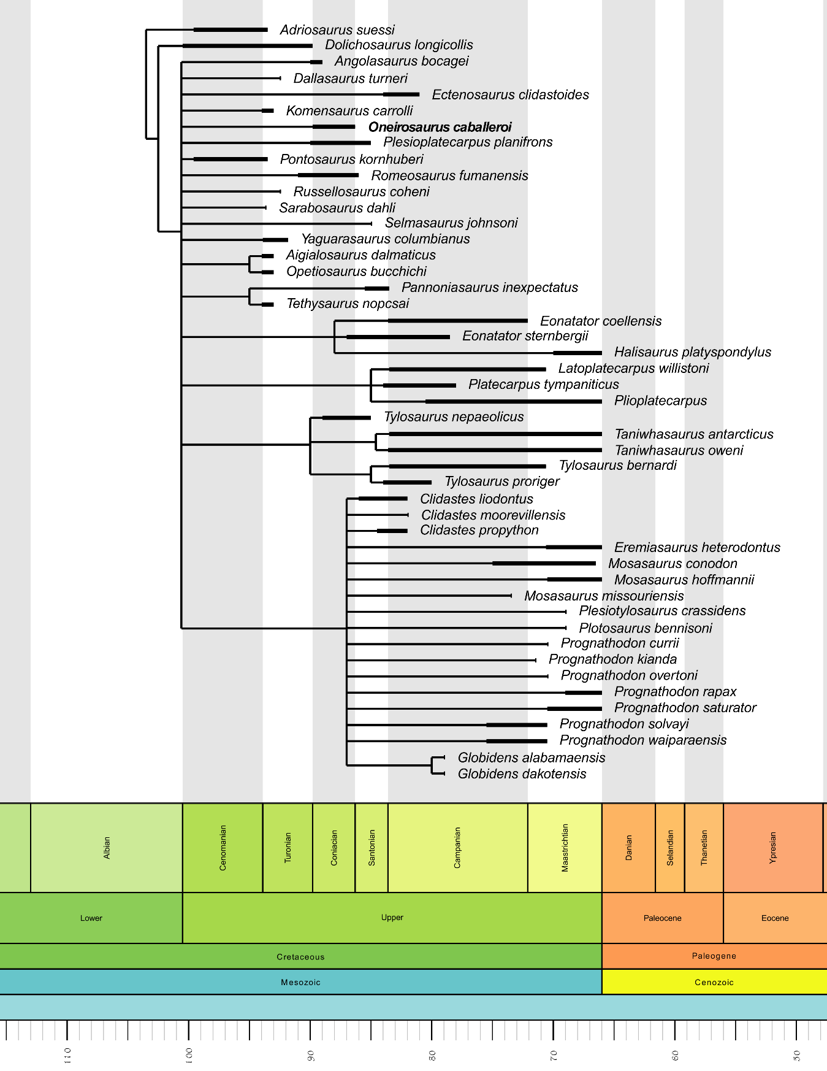
The results of the second cladistic analysis are shown in Figure S1, see the Materials and Methods and Phylogenetic analyses section of the main text for more information.
Figure S1. Phylogeny of Mosasauridae showing the position of Oneirosaurus caballeroi gen. et sp. nov. Time calibrated strict consensus from 72 most parsimonious trees (501 steps) with 47 OTUs and 125 characters (see Materials and Methods) recovered from the analysis of the full dataset including Sarabosaurus dahli.

