CONTENT GUIDE

This documents aims to support the writing process of author’s submitting articles to the online journal Matices. It takes into account the Publication Manual of the American Psychological Association (2019) and the indexing parameters for an online scientific-academic journal in international databases.
The author will find a guide to choose keywords and write the abstract as well as the form and style to reference tables, figures, and bibliography, with examples.
For Matices, it is important that the author understands the format requirements for his/her article. We invite you to consult this document as well as the original source: The Publication Manual of the American Psychological Association, 7th Edition.
KEYWORDS
These must clearly reflect the topic of the article.
Keywords must comply with the following guidelines:
- There must be between four and ten keywords.
- They must be located below the article abstract.
- They must be used in the text of the abstract.
- Keywords must be in the language in which the article was written as well as Spanish and English.
- They must be arranged in alphabetical order.

Keywords must be chosen well; they are the basis for entry into international data bases to facilitate search and classification of the article.

ABSTRACT
This is a brief presentation of the content of the article and serves to awaken the interest of the reader. It succinctly presents the most relevant objectives, participants, methodology, results and conclusions.
- The length of the abstract should not be more than 250 words.
- Repetition of the content of the abstract must be avoided in the introduction of the article.
- In order to facilitate searches through online data bases, the keywords should be used in the abstract.
- The abstract must not contain tables, figures or references.

FIGURES AND TABLES
Theses aid in better understanding the information and present extensive and complicated data in a concentrated and concrete manner.
Relation of the tables and figures with the text
References to the figure, graph, table, etc. in the article should be the same as the title. For example, if the illustration has the title: Table 1, the author must use “table 1” in the text.

All the tables and figures must be mentioned in the text and the reader must be told what to look for when referred to a figure or table.
- Reference in the text to the table or figure: Always mention the table and corresponding number; avoid expressions like “in the previous table or table of page 3”. In addition, focus on the central point. Do not explain all the variables of the tables, only what is necessary.
Example: as can be seen in Table 3, the number of children affected is 60%, which signifies an increase in the issue from the prior year.
Figures
Types of figures. This category includes:
- Graphs
- Diagrams
- Drawings
- Photographs

Guidelines for the presentation of figures according to Manual of the American Psychological Association, 7th:

1. The figure must not exceed the margins of the page.
2. The figure must include the following aspects:

- Figure 1 (2,3…) in bold above de figure.
- Title in Times New Roman, 12, below the number of the figure. It must be short, simple and descriptive.
- Place a note beneath the figure, if necessary. Times New Roman, 10.
- If the figure is not the author’s, the original author or the publication must be indicated in the note. Use “Retrieved from” to introduce the source. If the figure is the author’s, indicate it too (e.g. Source: own elaboration)

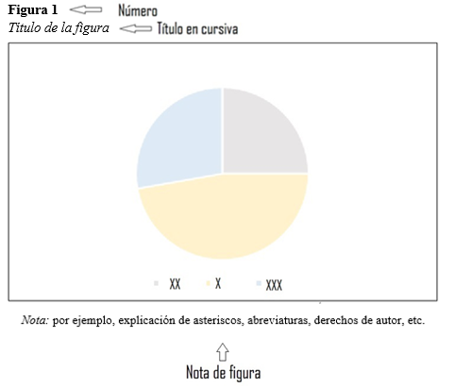
Tables

Guidelines for the presentation of tables according to Manual of the American Psychological Association, 7th Edition:

- The number of the table is placed above the table and the name; “Table” and the number of the table are indicated. Example: “Table 1”.

- The name of the table corresponds to the title of the table, it must be short, simple and descriptive. It is written in italics and is placed below the number of the table.

- The table must be organized in three horizontal lines, upper, lower and one that separates the first row of the data. Each column must have a title at the top that describes the data.

- The table note is located below the lower line. Here a brief description of the table or explanation of abbreviations or important information is given.

- If the table is not the author’s, the original author or the publication must be indicated in the note. Use “Retrieved from” or “Taken from” to introduce the source. If the figure is the author’s, indicate it too (e.g. Source: own elaboration)
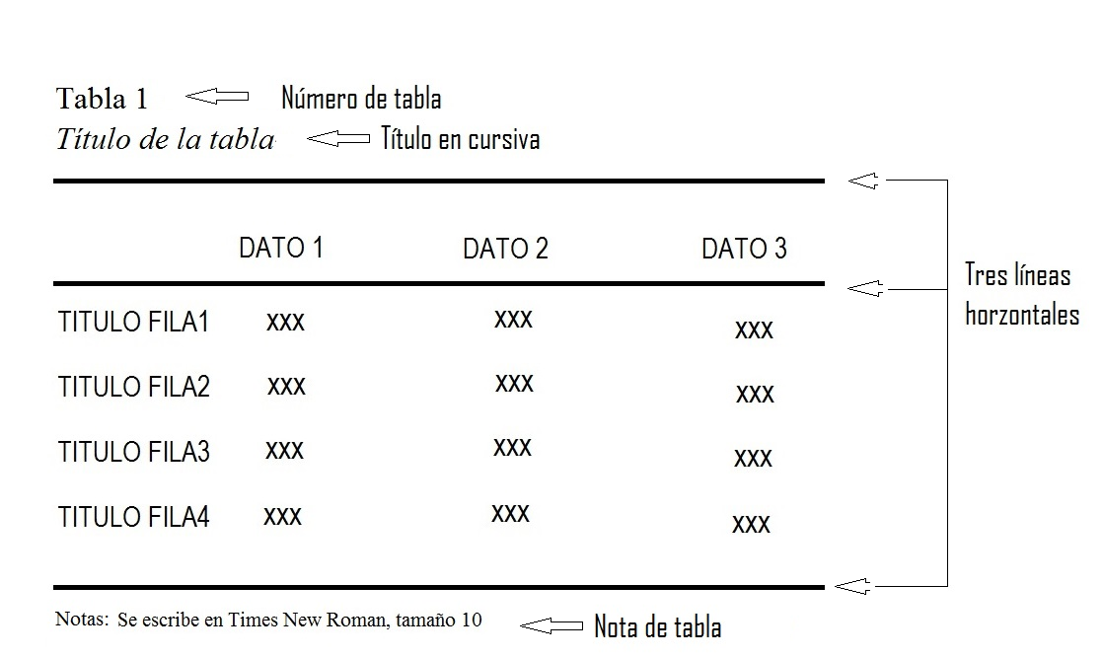
Other

- Videos are not accepted.

- Following the guidelines of the revue, we advice our authors to use the most up-to-date released versions of Microsoft Word, that is to say, from version 11 (year 2003) to the latest.

BIBLIOGRAPHICAL REFERENCES AND CITATIONS

- Credit must be given to authors to avoid plagiarism and self-plagiarism; appropriate citation must be made following APA seventh edition norms.

- Citations are made when the ideas, theories or research of other authors contribute to the work and are incorporated in it. Works of the author are also cited.

Direct Citations

The direct citation is exact information taken from the source document; it is textual information exactly as written or said by the corresponding author.

- Brief citations are less than 40 words; quotation marks are used and the citation must not be italicized. The author(s) last name, year and page follow the citation (Author, Year, Page). Example: (García, 2010, p. 20)

- Extensive citations are 40 words or longer and must be placed in a block independent of the text; left margins of 2.54 cm are applied; no quotation marks are used and the citation must not be italicized. The author(s) last name, year and page follow the citation (Author, Year, Page). Example: (García, 2010, p. 20)

Indirect Citations

The indirect citation is the synthesis of information; the information is not presented exactly as it was written or said but rephrased.

- This indirect citation is paraphrasing or summarizing the information.
- This paraphrasing can begin with: According to Garcia (2010), followed by the summarized or paraphrased information.
- Page number is not required.

References

This is an alphabetical list of authors and sources consulted for the article. Format each reference with a hanging indent (1,27 cm.) and double space.

Digital Object Identifier (DOI) must be included if the sources have it. You can verify if your consulted sources have DOI using the following link: https://doi.crossref.org/simpleTextQuery.

Reference function, APA style of Microsoft Word should be used to organize the citations in the body of the document and in the list of References.

This list follows the body of the article and precedes the annexes, with the following citation formats according to the source:

- Complete printed book. All links must be active.

Author, A.A. (year). Title of the book or work in italics (edition number, if applicable). Publisher.
Example: Márquez, G. G. (2001). El coronel no tiene quien le escriba. RBA.
- Various authors. All links must be active.

Author, A.A., & Author, B.B. (year). Title of the book or work in italics (edition number, if applicable). Publisher.
Example: Martínez, J., & Fuentes, C. (1973). En la fuente del alma. Abeja blanca.
If the consulted book is in electronic version or it is presented only in this version, the Web address must be given (generally these books are in pdf version, reason why the exact address must be indicated to find the book).

- Articles published in websites journals: All links must be active.

Author, A.A. (year). Title of article. Title of the publication in italics, Vol(No.), first page-last page of the article. http://xxxxxxxx
Example: Curmen-Rojas, E. A. (2019). Enseñanza del alemán a personas ciegas. Matices En Lenguas Extranjeras, (13), 6-44. https://doi.org/10.15446/male.n13.89607

- Websites and webpages. All links must be active.

Author. (date of last update). Title of the work in italics. Website name. http://xxxxxxxx
Example: Scribbr. (2020, Noviembre 4). APA citation (7th edition) quick guide | In-text citations & references. https://www.scribbr.com/category/apa-style/

Tables and Figures

Reference is made in the same way as with authors, books and others, with the following items. All links must be active.

Author, A.A. (year). Original title of the image. [Type of image]. Retrieved from http://xxxxx
Example: Retrieved from Moreno, D. & Carrillo, J. (2019). Normas APA 7. ª edición. Guía de citación y referenciación. Universidad Central. [Figura]. https://www.ucentral.edu.co/sites/default/files/inline-files/guia-normas-apa-7-ed-2020-08-12.pdf

Sources

Biblioteca Universidad Complutense. (2020, October 5th). Biblioguía de citas en estilo APA, 7ª edición. https://biblioguias.ucm.es/estilo-apa-septima/inicio#s-lg-box-15190309
Moreno, D. y Carrillo, J. (2019). Normas APA 7. ª edición. Guía de citación y referenciación. Universidad Central. https://www.ucentral.edu.co/sites/default/files/inline-files/guia-normas-apa-7-ed-2020-08-12.pdf
Sánchez, C. (2019, February 8th). Normas APA – 7ma (séptima) edición. Normas APA (7ma edición). https://normas-apa.org/
Scribbr. (2020, November 4th). APA citation (7th edition) quick guide | In-text citations & references. https://www.scribbr.com/category/apa-style/

Updated 29/01/2021
If the author and the name of the website are the same, skip the latter.

